Swansea Foreshore Restaurant, Café Bar & Ice-Cream Parlour Site Investigation Case study

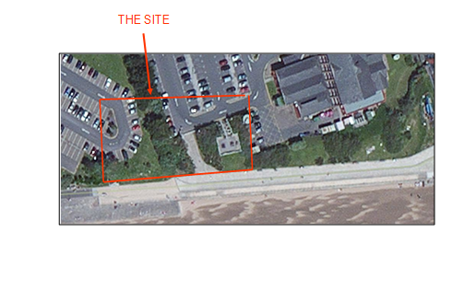
Summary
This report is a feasibility-stage preliminary desktop study for a joint development between the City and County of Swansea and Marriott Hotels International. The proposal is a ground-floor restaurant, café bar and ice-cream parlour (gross internal area approx. 2,000 m²) with a manager’s apartment, meeting rooms and staff welfare facilities on the first floor level. The site is on the Swansea foreshore between the Civic Centre, County Hall and the Delta by Marriott Hotel within the Maritime Quarter.

The foreshore location and the area’s industrial legacy (South Dock and the Lower Tawe Valley copper-smelting belt) create geotechnical and geo-environmental risks that must be confirmed before detailed design. This study summarises available historical, geological and regulatory information to define a targeted site investigation and outline an initial foundation approach.

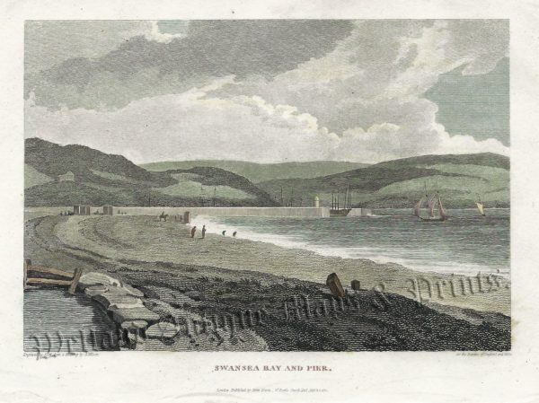
Historical Background
The Preindustrial and Early Victorian Foreshore (pre-1852)
Before the mid-1800s, this area was an open tidal foreshore at the western edge of the River Tawe estuary mouth. Historic mapping shows no significant structures on the immediate foreshore, with a natural, mobile shoreline influenced by storm conditions that remain relevant to foundation design.
(Wellandantiquemaps.co.uk. 2026).

Industrialisation and the South Dock (1852–1890)
From the 1700s, Swansea became a major centre for copper smelting and related heavy industry. The South Dock was constructed from 1852 (completed 1859), involving extensive reclamation and placement of made ground and dock infill over the natural foreshore deposits.
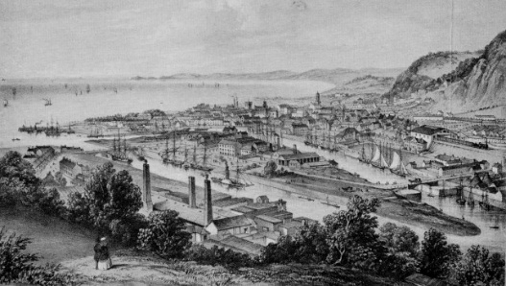
To accommodate rapidly escalating trade volumes, the Swansea Dock Company began the construction of the South Dock on the foreshore west of the River Tawe in 1852, and financial difficulties leading to its completion under the Swansea Harbour Trust in 1859
(www.swanseadocks.co.uk. n.d.). The South Dock was designed by Scottish engineer James Abernethy and required significant land reclamation and foreshore engineering. This construction activity involved the placement of large volumes of made ground and dock infill material directly onto the natural alluvial foreshore deposits.
Much of the site is nineteenth-century reclamation: a heterogeneous mix of dock spoil, industrial slag/ash and dredged sediments, typically placed without modern compaction control. This variability is a key driver for settlement and contamination risk.
(Swansea.ac.uk. 2026).

Peak Industrial Activity and Environmental Legacy (1890–1960)
By the late 1800s to mid-1900s, metallurgical spoil and slag were widely used as fill across Swansea. Long-term smelting activity left a legacy of elevated metals (Cu, Zn, Pb, Cd, Ni) in soils and sediments, which may have affected the foreshore deposits at and around the site.
South Dock operations and dredging could have redistributed contaminated estuarine sediments locally, increasing the likelihood of heavy metals within made ground and nearshore deposits. (Bowen, C. 2026).

Dock Closure, Dereliction, and Early Regeneration (1960–1982)
The South Dock closed in 1969, and the area was later redeveloped as a marina (opened 1982). During dereliction, groundwater movement through infill could have leached contaminants from slag and ash into the underlying alluvium and sands (historypoints.org, n.d.).
County Hall is on reclaimed land in an aggressive marine environment, and the adjacent site history includes a former railway goods yard, introducing additional made ground and potential hydrocarbon sources.

Maritime Quarter Regeneration and Current Site Context (1982–Present)
The Maritime Quarter was redeveloped in the early 1980s. Nearby developments were constructed on reclaimed/remediated foreshore land. For this study, the Meridian Tower borehole information is used as the closest available proxy for anticipated stratigraphy.
The site is a narrow strip between the Civic Centre and Marriott car parks, fronting the promenade. It lies at the western edge of the former South Dock footprint, within an area of long-term industrial use and reclamation.

Detailed Site Investigation
Made Ground and Reclamation Fill
The main geotechnical risk is the thickness and variability of made ground/reclamation fill overlying natural foreshore deposits. The site has been raised and infilled repeatedly using slag, ash/cinders, dock spoil and dredged sediments, which commonly form a heterogeneous, potentially contaminative layer. Such fill is often unevenly compacted and may contain voids and obstructions (Construction, in 2025). Settlement may be variable and ongoing, creating a high differential-settlement risk for a large footprint building with a glazed façade.
Recommended investigation
Undertake cable percussion boreholes to establish the deep ground profile and identify hazards at depth, with a minimum of six boreholes to at least 15 m on a grid across the footprint. Excavate trial pits (3–4 m) where accessible to inspect near-surface strata and obtain representative samples, particularly where visual assessment of variability and potential contamination is needed. Carry out SPTs at 1.0 m intervals within the made ground to assess density and strength. Obtain disturbed and undisturbed samples for laboratory testing. Use DPSH dynamic probing between boreholes to map lateral variability and highlight localised weak zones or changes in fill composition (Jones & Wagener UK. 2024).

Contamination and Geo-environmental Assessment
Given the history of smelting, dock operations and nearby rail use, made ground should be assumed to contain elevated heavy metals (Cu, Zn, Pb, Cd, Ni, As) and potentially hydrocarbons. A risk-based assessment will be required to confirm impacts and identify any remediation or protection measures. Because the development includes food premises and a residential flat, it should be treated as a high-sensitivity end use. The investigation must therefore address ground gas (methane/CO₂), leachable metals, and hydrocarbons/volatile compounds where present.
Recommended investigation
Monitor ground gas for at least six weeks using data loggers to confirm methane/CO₂ and how levels vary, tide-driven air-pressure changes can also influence readings (GGS. 2024). Complete bulk leachate testing to assess whether contaminants could dissolve and migrate into groundwater and services. Undertake TOC (carbon) screening to identify organic material and hydrocarbons, and whether targeted hydrocarbon testing is needed.

Coastal and Tidal Groundwater
The site is on the foreshore, so groundwater levels and pore pressures are likely to fluctuate with the tide. The drift deposits (alluvium and sands/gravels) form a Minor Aquifer with variable permeability (British Geological Survey, n.d.). Tidal fluctuation can create an aggressive environment for buried concrete and steel. Measure groundwater levels across a tidal cycle and install four vibrating-wire piezometers to monitor fluctuations. Take groundwater samples for pH, sulphate, chloride and dissolved metals.

Deep Soil and Natural Foundation Layers
Meridian Tower borehole information suggests a sequence of made ground/dock infill over alluvium (soft clays/silts with sand lenses), underlain by denser sands/gravels and rockhead at depth. The alluvium is expected to be compressible and unsuitable for shallow founding.
Complete deeper boreholes to at least 25 m, with rotary coring through alluvium to prove competent founding strata. Test undisturbed alluvium samples for strength and compressibility, and use CPT to provide a continuous profile between boreholes (Data.gov.uk. 2024).

Obstructions and Archaeological Remains
Buried dock infrastructure, quay walls, rail remains, and services may be present and could obstruct piling and excavation (Piling and Archaeology Guidance and Good Practice, n.d.). Heritage considerations mean potential maritime features should be assessed before intrusive works.
Recommended investigation: complete a geophysical survey (GPR and electromagnetic conductivity) across the site before intrusive works to identify anomalies and reduce the risk of striking heritage assets or live services (Historic England, 2019).

Building Regulations, Codes of Practice, and Local Authority Requirements
Applicable Standards and Codes
Standard / Code | Application
BS 5930:2015+A1:2020 Code of Practice for Ground Investigations | Primary standard governing the content and conduct of the site investigation programme.
BS EN 1997-1:2004 Eurocode 7 Pt 1 Geotechnical Design: General Rules | Geotechnical design of foundations, ground classification, limit state approach.
BS EN 1997-2:2007 (corr. 2010) Eurocode 7 Pt 2 Ground Investigation & Testing | Field and laboratory testing requirements, borehole and CPT procedures.
Building Regulations 2010 Approved Document A: Structure | Structural requirements, foundation suitability for classification of ground conditions.
Building Regulations 2010 Approved Document C: Site Preparation & Resistance to Contaminants | Assessment and remediation of contamination; protection of buildings from ground gases.
BS 8485:2015+A1:2019 Code of Practice for Ground Gas Verification | Assessment and management of ground gas risk (methane, CO₂).
CLR 11 / DEFRA & EA Contaminated Land Report No. 11 (Model Procedures) | Risk-based assessment methodology for contaminated land.
BS 1377:2016 Methods of Test for Soils | Laboratory testing of soil samples obtained during the investigation.
BS EN ISO 22476: Parts 1–12 | Field testing — SPT, CPT, pressuremeter, and other in-situ tests.

Local Authority and Regulatory Contacts
The following organisations should be formally notified and engaged during the feasibility and site investigation stages -
Authority / Body | Role | Contact
City and County of Swansea — Planning Department | Planning permission, contaminated land search, and pre-application advice. | 01792 635000 planning@swansea.gov.uk
Natural Resources Wales (NRW) | Environmental permitting, marine and coastal development consent and groundwater protection. | 0300 065 3000 enquiries@naturalresourceswales.gov.uk
Cadw (Welsh Government Historic Environment Service) | Assessment of maritime archaeological assets, and scheduled monument consent if applicable. | 0300 025 6000  cadw@gov.wales
Dŵr Cymru / Welsh Water | Asset protection, sewers, water mains, groundwater licensing. | 0800 052 0130
British Geological Survey (BGS) | Geological mapping data, borehole records (National Well Record Archive). | 0115 936 3143  enquiries@bgs.ac.uk

Foundation Recommendation
Summary of Ground Conditions
Drawing upon the archival evidence previously presented and the analogous stratigraphic sequence from the Meridian Tower borehole data, the anticipated ground profile beneath the proposed development is as -
Stratum | Approx. Depth (m) | Description | Assessment
1 | 0.0 – 3.5+ m | Made Ground, heterogeneous dock fill, ash, slag, cinders, debris | Variable, weak, potentially contaminated. NOT suitable for founding.
2 | 3.5 – 8.0+ m | Alluvium, soft to firm silty clay and peat lenses, possible organic material | Highly compressible, low shear strength. NOT suitable for founding.
3 | 8.0 – 14.0+ m | River Terrace Deposits, medium dense sands and gravels | Potentially suitable bearing stratum. Requires proof by investigation.
4 | >14.0 m | Bedrock, Coal Measures / Pennant Sandstone | Excellent bearing stratum. Ultimate pile founding horizon.
Recommended Foundation Type: Bored Reinforced Concrete Piled Foundation
A bored reinforced-concrete piled foundation is recommended, with piles bearing in competent River Terrace sands/gravels or, if required, extended to bedrock. This aligns with solutions adopted for nearby reclaimed-foreshore developments in the Maritime Quarter.

Justification
Shallow foundations are unsuitable because made ground and alluvium may extend to 8+ m and are likely to settle unevenly; glazed façades are particularly sensitive to differential movement. Driven piles are less suitable due to likely buried obstructions and heritage features and vibration poses a large risk to adjacent structures. CFA or rotary bored piles minimise both vibration and noise and can be designed to carry the building loads in a contaminated coastal setting. Use pile caps and ground beams to form a stable platform, with cap soffits above groundwater where practicable to reduce tidal effects on temporary works. Specify concrete for aggressive ground conditions (e.g., XA3 to BS EN 206 / BS 8500): typically C40/50 with a low water/cement ratio and GGBS for improved sulphate resistance.
For early design, allow building loads of about 20–40 kN/m² (2,000 m² restaurant plus upper-floor flat, meeting rooms and plant). In medium-dense sands/gravels at ~12 m depth, a single pile may carry roughly 600–1,500 kN. Initial layouts often use 2.5–3.5 m spacing, e.g., 300–450 mm CFA piles, subject to confirmation in the Geotechnical Design Report once SI results are available (BS EN 1997-1, Clause 2.8). (Concretecalculate.co.uk. 2026).

Additional Design Considerations
Glazed façades are highly sensitive to foundation movement, making it essential to manage both overall settlement and differential settlement (tilt). The standard tilt tolerance is typically 1 in 500, which should be verified against anticipated pile-group settlement. (ArchDaily. 2023).

References
ArchDaily. (2023). Glazed Façades and How They Protect Against Wind, Cold and Noise. Available at: https://www.archdaily.com/997231/glazed-facades-and-how-they-protect-against-wind-cold-and-noise Accessed 29 Apr. 2026.
Bowen, C. (2026). Written Evidence: The environmental and economic legacy of Wales’ industrial past. Bridges.earth. Available at: https://bridges.earth/news/post/written-evidence-environmental-and-economic-legacy-wales-industrial-past Accessed 29 April 2026.
British Geological Survey. (n.d.). Aquifer designation data. Available at: https://www.bgs.ac.uk/datasets/aquifer-designation-data/. Accessed 29 April 2026.
Concretecalculate.co.uk. (2026). Structural Load Calculator (Domestic) -Concretecalculate.co.uk. Available at: https://concretecalculate.co.uk/building-regulations-calculators/structural-load-calculator-domestic/. Accessed 29 April 2026.
Construction, in (2025). Civil Engineered for Success. Civil Engineered for Success. Available at: https://www.civilengineeredforsuccess.co.uk/civil-engineered-for-success-blog/dealing-with-made-ground-risks-and-mitigation-tactics. Accessed 29 April 2026.
Data.gov.uk. (2024). 2004 Strategic Environmental Assessment SEA6 SV Meridian SEA6 Survey B (or Leg 2) - geophysical survey (Irish Sea) - data.gov.uk. Available at: https://www.data.gov.uk/dataset/07ef2dda-5ec8-4b89-bbfa-fbb409398b2c/2004-strategic-environmental-assessment-sea6-sv-meridian-sea6-survey-b-or-leg-2-geophysical-sur Accessed 27April 2026.
GGS. (2024). Continuous monitoring and data capture - Ground Gas Solutions (GGS). Available at: https://ggs-uk.com/services/continuous-monitoring-data/. Accessed 27 April 2026.
Historic England (2019). Geophysical Techniques | Historic England. Historicengland.org.uk. Available at: https://historicengland.org.uk/research/methods/terrestrial-remote-sensing/geophysical-techniques/. Accessed 27 April 2026.
historypoints.org. (n.d.). History Points - Swansea marina. Available at: https://historypoints.org/index.php?page=swansea-marina. Accessed 29 April 2026.
Jones & Wagener UK. (2024). Disturbed and Undisturbed Soil Sampling - Jones & Wagener UK. Available at: https://www.jonesandwagener.co.uk/geotechnical-site-investigations-services/disturbed-and-undisturbed-soil-sampling/. Accessed 28 April 2026Piling and Archaeology Guidance and Good Practice. (n.d.). Available at: https://historicengland.org.uk/images-books/publications/piling-and-archaeology/heag270-piling-and-archaeology/. Accessed 29 April 2026.
Swansea.ac.uk. (2026). Available at: https://www.swansea.ac.uk/media/Overview-of-Harbour-1852.jpg Accessed 29 April 2026.
Wellandantiquemaps.co.uk. (2026). Available at: https://www.wellandantiquemaps.co.uk/wp-content/uploads/2023/01/Swansea-BoEW-001-copy-600x449.jpg Accessed 27 April 2026.
www.swanseadocks.co.uk. (n.d.). Swansea and Port Talbot Docks Website. Available at: http://www.swanseadocks.co.uk/docksnewsite/history.html. Accessed 22 April 2026.

