

Topic: Causes, effects and management of anxiety in children

Name: Sadaf Rashid
Student number: 1814941
Module code: BMHP5005
Abstract
The current research has been developed for promoting the mental healthcare of the children as anxiety is observed among the children in the current times. In recent days, after the immense effect of the Covid-19 outbreak in the global aspect, the level of anxiety among the children has increased among the children by removing physical interaction with acquaintances and being stuck in the rooms. Regarding these problems, this research has developed a systematic literature review by designing the research aim and objectives in the first chapter. The research questions, rationale and problem statement have been elaborated in the background chapter. The applied research methods have been discussed in the methodology chapter by mentioning the ethical aspects of this research. Moreover, a thematic analysis has been done on the depicted themes from the research objectives with the findings of the analysis. In the last chapter, a conclusion has been presented by presenting a link with the objectives and providing recommendations to ensure the research success in developing the mental healthcare of the children.

Table of Contents
Background 3
Rationale 3
Problem statement 3
Aim 4
Objectives 4
Research Questions 4
Significance 4
Methodology 5
Philosophy 5
Design 5
Data collection method 5
Sampling 6
Data analysis technique 6
Research Timeline 6
Ethical practice in research 7
Thematic review 7
Theme 1: Anxiety symptomatology among the children of primary-school-age 7
Theme 2: Effects of Psychosocial Interventions and treating anxiety among children 9
Theme 3: Art therapy and clown visits are important to reduce anxiety among children 10
Findings and discussions 12
Conclusions and recommendations 13
Conclusion 13
Linking with objectives 13
Recommendations 14
References 15

Background

Rationale
According to Grist et al. (2019), anxiety is the most unexpected and observed trouble of sleeping among people despite their age and gender and irrespective of any social standard. Anxiety is observed as a combination of multiple physical and mental troubles that could be addressed by understanding the series of problems among the patients of anxiety. Unlike the adults, dealing with anxiety on special occasions causes much trouble for the children as per lack of experiences and guidance to deal with the problems (Postorino et al., 2017). Regarding the symptoms of anxiety, the children find it difficult for expressing their troubles such as to find it difficult for concentrating.
Moreover, lack of sleeping or having bad dreams creates trauma in their mind that is not easy to overcome until they would grow up. All the troubles and hurdles faced due to anxiety not only disturb the mental health of the children but also harms their physical health by reducing the food craving and normal eating capacity as a result of stress in their personal life and relationships with the parents and friends. The main reasons behind anxiety have been evaluated in this study for reducing the level of anxiety from the children to make their mental health better with the aspect towards a bright future (Postorino et al., 2017).

Problem statement
Children deserve a life without stress under the guidance of their parents or guardians to determine a better future by developing academic credentials in childhood. Hence, it is obvious that the current lifestyle of people is observing an immense increase of stress despite their age or professional lifestyle. After the Covid-19 outbreak in the global aspect, the recent problem has been observed among the children to live with the fear of being contaminated with or without touch (Pınar Senkalfa et al., 2020). The continuous fear of getting affected by the virus has enhanced the stress level and anxiety among the children with the uncertainty observed among their family members and their discussions. However, this problem is increasing an imbalance in the perception of the children to deal with the current increase of anxiety in their life. This research has been developed by evaluating the problem as part of improving the mental health of the children in current times.

Aim
This research aims to identify the causes and effects of anxiety among children and find out effective management techniques to reduce anxiety from their psychological understanding.

Objectives
- To understand the reasons for anxiety observed among children rather than the adults
- To comprehend the effects of anxiety as the major threats to the mental health of children
- To evaluate better strategies for reducing anxiety from children for improving their mental health

Research Questions
Primary research question is:
- What are the causes and effects of anxiety in children, and how can it be managed?
Sub-questions are:
- What are the major causes behind anxiety observed as a part of life among children?
- What are the notable effects of anxiety on the mental health of children regarding the modern lifestyle?
- What could be better strategies for reducing anxiety that can promote the mental health of children?

Significance
The importance of this study is to measure the reduction of anxiety from the children that can promote their mental health for improving both their career and personal life in the upcoming future. The current analysis in this research has followed the credentials of secondary research to observe the literary aspects earlier discussed the results of anxiety in the mental health of the children. Moreover, the causes and effects of anxiety are required to understand as essentials to reduce and manage the effects of anxiety in the children's mental health. The aims and objectives of this study have been designed to promote the right access to the mental health of the children by reducing anxiety from their daily life.

Methodology

Philosophy
According to Ryan (2018), interpretivism philosophy is accepted as the ideal one for analysing the research methods based on secondary research processes. The main advantage of interpretivism philosophy is to evaluate the meanings that emerged from earlier research. The results concluded concrete findings and observations in the earlier published journals are accepted in the application of interpretivism philosophy to determine better analysis in the secondary research method. The current research has followed the best access to interpretivism philosophy for ensuring the involvement of researchers that can interpret better elements about reducing anxiety from the children as the major access to the appropriate results of this study. This indicates that human involvement is the major component for using interpretivism philosophy in this research.

Design
As opined by Birks et al. (2017), the application of the right research design develops the purpose and quality of research that is dependent on the credentials of available data in the research area. The use of both descriptive and exploratory design is found effective in the specified areas of primary and secondary research. The current research has been based on the effective terms of the descriptive research design. This design has been observed effective for achieving the right results in secondary research methods. In this study, the descriptive design has been used for describing the phenomena of anxiety as a major threat to the mental health of children.

Data collection method
The right choice of data collection method establishes the significance of the research to ensure adequate data involved in the project. Considering the requirements of human involvement in the research, the choice of primary and secondary data collection method determines the result accomplishment and success measures of the research (Johnston, 2017). The current research has followed the implementation of secondary data collection methods. The use of secondary methods has used peer-reviewed article journals earlier published on the causes and effects of anxiety for children. Moreover, the researcher assessed the required data from the books and PDFs discussing the necessary measures of reducing anxiety to develop the mental health of the children in a global aspect.

Sampling
As per collecting data from the secondary data sources, sampling is an evident method to make the research results effective in the further process. In this research, the researcher has tried to select the right sampling technique to use the effective sample size of data in the process. A purposive sampling technique has been used in this study to accommodate the target sample of 50 article journals (Sharma, 2017). Among those, 30 article journals have been accepted as the concrete data sources in the study to provide the best and effective data about the threats of anxiety on the mental health of children.

Data analysis technique
As per conducting this research as a systematic literature review on the current problems of anxiety observed in the mental health of children, the data collected by secondary data collection methods have been assessed better with the aid of thematic analysis technique (Terry et al., 2017). The researcher has identified three major themes based on the literary sources available that have discussed the causes, effects and possible strategies for anxiety observed among children. The thematic analysis technique has been used to depict the right explanation of the literature used in this research as the major data source for establishing the requirements of reducing anxiety among children.

Research Timeline
Task | Start Date | Duration
Developing Project Plan (Task 1) | 9-Jan-21 | 3
Initiating Cost, resources, and configuring risks | 12-Jan-21 | 10
Developing the WBS and Gantt chart | 22-Jan-21 | 3
Starting Research Project (Task 2) | 25-Jan-21 | 15
Developing research objectives/ questions | 9-Feb-21 | 15
Starting the research method | 24-Feb-21 | 12
Collecting data from literature | 8-Mar-21 | 7
Analysing data from Discussions | 15-Mar-21 | 2
Writing Conclusions and Recommendations | 17-Mar-21 | 2
Final Submission | 19-Mar-21 | 1

Table 1: Research timeline
(Source: Learner)

Figure 1: Gantt chart
(Source: Learner)

Ethical practice in research
The current research has maintained all the necessary ethical terms for using the sources written by other authors. Each data used in the analysis has been cited properly to avoid plagiarism. Moreover, the researcher has not copied any direct data from the literary sources while the components have been extracted to support the reasons for reducing anxiety from children's mental health. Moreover, all results in the data analysis process have been protected in the personal system of the researcher with strong and encrypted passwords. There was no scope of losing any important data to measure the success of the research (Vehviläinen et al., 2018).

Thematic review

Theme 1: Anxiety symptomatology among the children of primary-school-age
Analysis: Anxiety is a condition of the mind that creates mental disorder and it affects the quality of life of any individual. Thus, according to Sorvo et al. (2017), anxiety can lead to excessive nervousness, apprehension, fear and worry within him or herself. Therefore, this can affect the day-to-day life of any person and it is observed that most people are unaware of their mental health. In the opinion of Caviola et al. (2017), the symptoms of anxiety among the children at the time of primary school are various and different due to various reasons. Thus, some of the symptoms are panic disorder, social anxiety disorder and separation anxiety disorder.
Findings: According to Sorvo et al. (2017), at the time of primary school age the mental condition of a child remains undeveloped or in the developing stage. Therefore, at this time the separation of parents, experiencing any intense fear or life-threatening event or the natural disaster could influence a great impact on a child's mind. Therefore, that child could exhibit some abnormal behaviour in front of society and if it does not cure that may stay with him or her for long-term. Thus, Caviola et al. (2017) depict that the early treatment of a child can avoid any unnatural behaviour from them.
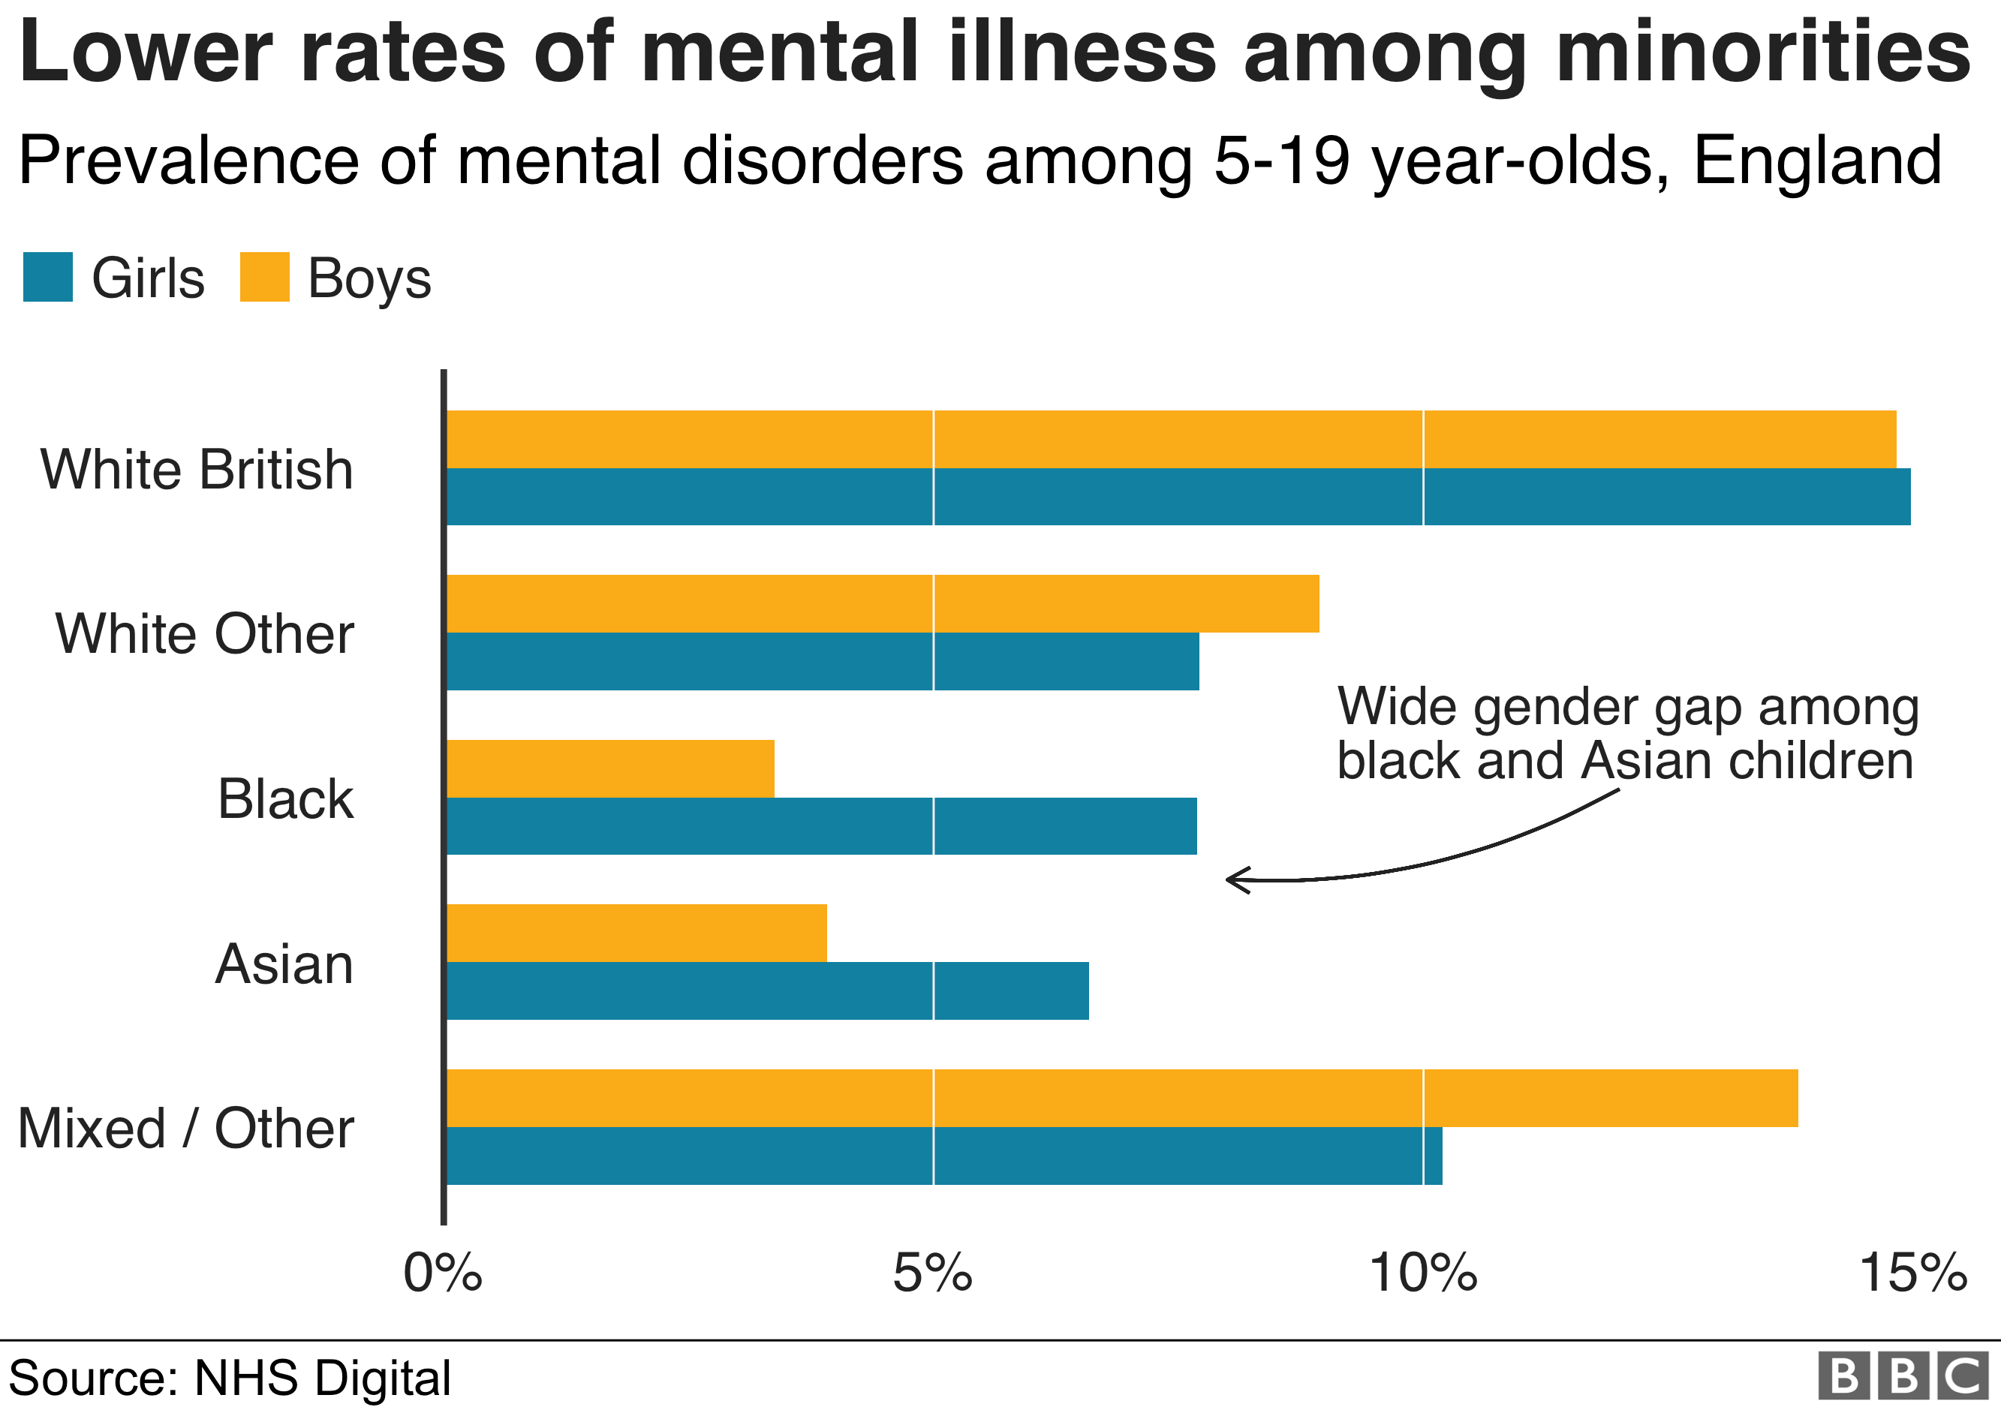
Figure 2: Children's Mental Health Report
(Source: Guibourg and Jeavans, 2018)
Link with literature: According to Adams et al. (2018), anxiety has different aspects and different forms that exhibit in children as well as in adults. In this context, the autism spectrum disorder among children at primary school age is very much prevalent nowadays. Hence, in the opinion of Sorvo et al. (2017), it is such a disorder whose symptoms are like the repetitive behaviour of any pattern, reluctance to attend any social gathering and communicating with society. However, the fact is due to the limited research on this topic the teachers are unable to set any program for this topic. It is opined by Adams et al. (2018) that there is a result on a survey that has been done with the 92 children aged 5-12. A pack of questionnaires depending upon the Anxiety Scale-Teacher Rating has been done and that shows a significant result upon the disorder but further experimentation is necessary.
Link with objectives: According to Adams et al. (2018), the reasons for the anxiety among the children are various and some of them are separated from the family members, experiencing any brutal incidents, metabolic imbalance and exposure to any heavy metals and the toxic environment. Thus, due to those reasons the reluctance with the social gatherings, aggression, causing self-injury, short attention time and impulsivity are the effects of the autism spectrum disorder. However, in the opinion of Sorvo et al. (2017), medication, mental counselling and more research on the root causes of anxiety among the children will make a great impact on the healing of anxiety among the children.

Theme 2: Effects of Psychosocial Interventions and treating anxiety among children
Analysis: Following the opinion of Dennis et al. (2017), it has been observed that the results of maternal anxiety have a long-term effect on the mental health of children as it is directly transmitted among them during the pregnancy period. The negative results of anxiety have been observed in the well-being of the children as a barrier in their upbringing and further education as well. In the analysis of perinatal anxiety, the most important aspect could be observed where the families consist of a continuous flow of anxiety among almost every member, the mothers’ mental health with anxiety causes major harm to the children in their growing age (Mihika, 2021). The results of anxiety are a serious concern to resolve at the earlier stage that could improve the lifestyle of the adults as well to establish a better future for the students.
Findings: According to Stanczykiewicz et al. (2019), anxiety works as the continuous trigger to harm the regular and normal lifestyle of people from childhood. Children growing up in the atmosphere of depression or lack of attention or disturbances can get affected by anxiety at a very earlier stage. The results of anxiety may not be observed in the regular habits or activities of the children (Klein-Tasman and Mervis, 2018). Hence, the negative results of this mental health disturbance may lead to long-term damage in the education, career and personal life of the children for a lifetime.
Link with literature: The purpose of evaluating the results of anxiety is to increase the awareness of reducing anxiety from the children. Uppendahl et al. (2020) argued that this is the most important part discussed in the assessed literature about the results of anxiety is the inadequate sleep and insomnia that directly affects the physical health of the children. Regarding the causes and the situations they suffer from in regular life, the used literature has followed some of those to speculate the right observation on the results of anxiety as the major threat in the social development of the next generation (Uppendahl et al., 2020).
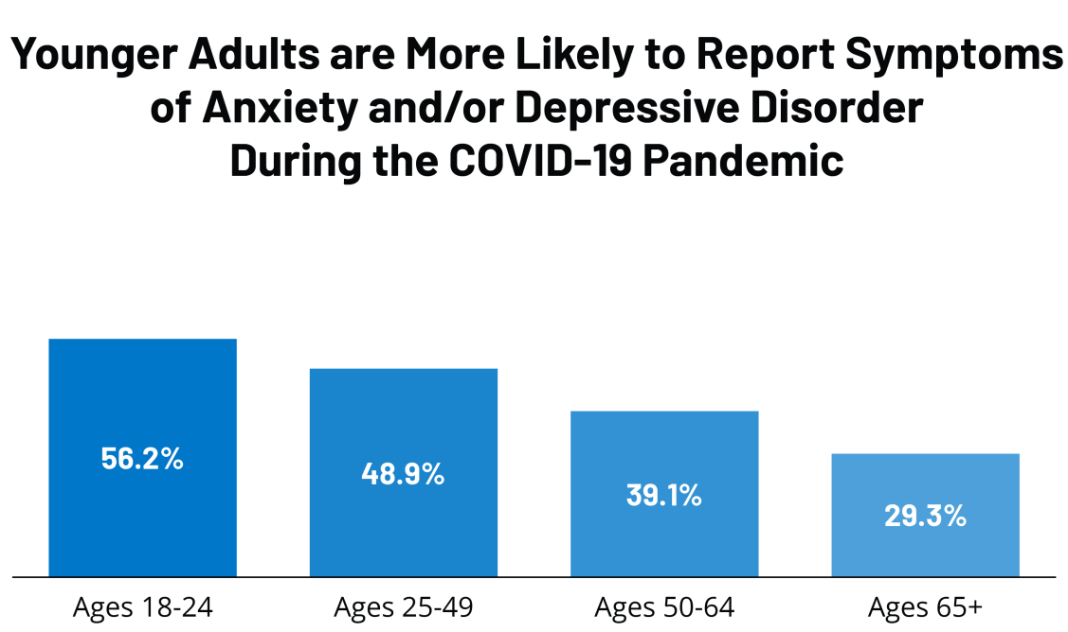
Figure 3: Anxiety observed in pandemic among children
(Source: Nirmita et al., 2021)
Link with objectives: The second objective in this research has been designed to comprehend the effects of anxiety as the major threats to the mental health of children. In this context, the current theme has been developed to analyse the second objective with all the best approaches to identifying the results of anxiety in the process. Moreover, Imran et al. (2020) argued that the literature used as the best data sources in the analysis of the objective has been focused on the credentials of anxiety that is currently harming the mental health of the children.

Theme 3: Art therapy and clown visits are important to reduce anxiety among children
Analysis: Regarding the causes and effects of anxiety in the mental health of the children, the most effective terms in this aspect have been observed while reducing anxiety is the major criteria in the childcare and health programs. As opined by Dionigi and Gremigni (2017), anxiety does not grow up in a single day while it is built with continuous stress, grief and disturbances in the daily lives of the children. The most important factor for reducing anxiety from the children could be possible by taking the right aid of refreshment activities to promote their mental health at a better level. Dionigi and Gremigni (2017) opined that the major problem in this aspect is to determine the results of anxiety among children suffering from autism. The special care and treatment they need in these terms could be better assessed with the aid of art therapy and enhancing clown visits during their health sessions at the therapists' places.
Findings: According to Dionigi (2017), the age group from 3-11 years is the most crucial aspect in people's lives that determine the right strategy of building the right mental health for further development in their personal life and contribution towards society. One observation was commonly found in the main literary sources that anxiety occurs from any certain incident that has a major and long-term effect on building up better mental health of the people in the process. However, Cameron and Turner (2017) opined that art therapy is not capable of resolving the effects of anxiety from the mind of children in a single day. The process to promote the lifestyle of the children should be continuous, and it should involve them in the activities to keep away stress and tensions that increase anxiety in mental health as the most disturbing situation.
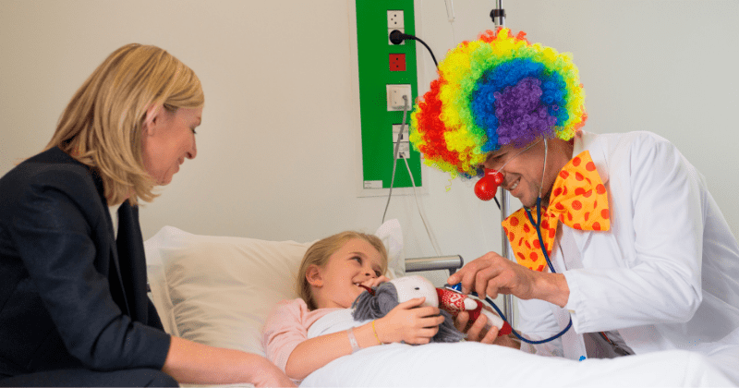
Figure 4: Clown therapy for children
(Source: Mihika, 2021)
Link with literature: The main aspect in the literature has been observed while finding the effect of art therapy for reducing anxiety from the children as a serious measure to determine the proper mental health of the children. The literature used in the current analysis is focused on determining the reduction of anxiety from children by involving them in art therapy and promoting their perception to enjoy life with happiness. According to Arriaga et al. (2019), the children participating in the surveys for determining the level of anxiety have faced surgery in their lives. Moreover, surgery is a crucial process in people's lives while children are not so matured to handle the tensions and pressures in certain and major conditions of their life.
Link with objectives: The third objective set in this research has been covered and analysed with the support of the literature explaining the requirements of art therapy and clown visits to the children suffering from anxiety. These activities have been highlighted to aware the parents and guardians taking care of the children for maintaining their mental health in the process of removing anxiety gradually from their lives (Mihika, 2021).

Findings and discussions
The entire evaluation of the strategies for reducing anxiety is the major success term in this research as per evaluating the causes and effects of anxiety in the mental health of children. The literature used in this research has aided to speculate the identified themes and those have pointed out that perinatal anxiety is transmitted from the mothers to the children as a continuous process of transferring negativity in the mental health of the families. As people have become more careful about maintaining their mental health, the perception of anxiety has developed to make the lifestyle better from childhood. Moreover, taking children to the art therapy sessions could be addressed as a comprehensive solution that can promote their lifestyle and involvement in creativities to get rid of anxiety in major cases. However, this problem has no immediate solution, as the provided remedies are time-consuming processes that should be developed with the constantly changing perception of children towards their lives. The only stagnant process in this analysis that could be observed is the patience of the parents in developing the mental health of their children.

Conclusions and recommendations

Conclusion
The entire evaluation has found out some major reasons and their outcomes for the presence of anxiety among the children. Hence, the problems may be different among the children depending on their perception of life. This is observed as per their parents’ guidance and upbringing styles on the children. However, the major aspects of reducing anxiety from the children have been developed in this study to promote their lifestyles in future. Considering the problems of growing up with anxiety observed in the parents, the reducing factors have included the importance of art therapy and clown visits to the children for changing lifestyle and improving their mental health with refreshment and activities as the major solutions.

Linking with objectives
Objective 1: To understand the reasons for anxiety observed among children rather than the adults
This objective is the base of this research as it is vital for understanding the reasons behind anxiety that can disturb the healthy lifestyle of children in the crucial stage of their growing period. Depending on this objective, the first theme of the analysis has been designed in the research for depicting the anxiety symptomatology among the children at primary-school-age. The literature used in the thematic analysis has supported this objective by evaluating that initial symptoms of anxiety should be handled with special care to maintain the mental health of the children.
Objective 2: To comprehend the effects of anxiety as the major threats to the mental health of children
Considering the reasons for anxiety, the immediate next objective in the research has been designed for understanding the effects of these reasons on the mental health of the children. The second theme in the thematic analysis has been developed with the credentials of Psychological interventions among the people as it transmits anxiety from adults to children living in the same family. The long-term effects of anxiety among the adults are easily transmitted to the children while the continuous pressure of anxiety causes lack of sleep and the disorders like walking in sleep could be identified in recent times.
Objective 3: To evaluate better strategies for reducing anxiety from children for improving their mental health
After analysing the causes and effects of anxiety among the children observed as a major disturbance in the upbringing of the children, the final objective has been set to recommend better strategies for resolving anxiety from the children as the major concern in this research. In support of the final objective, the last theme has been designed by showing that art therapy and clown visits are important to reduce anxiety among children.

Recommendations
Recommendation 1: The first recommendation in this research is to determine better activities in the daily lifestyle of the children that can reduce anxiety and help them to concentrate on studies and enhance social interaction.
Recommendation 2: Regarding the improvement of mental health among the children, the further research aspect could be extended for reducing anxiety from their parents and guardians as well. The interactive sessions while consulting sessions for the children should look after the problems of the parents as well as it provides long-term impacts on the bonding and relationship of the parents and children suffering from such disorder.
Recommendation 3: The educational institutions and guides such as the teachers of the children can play a great role in motivating them in creative activities to keep out stress from their lives to achieve the best results in their further career.

References
Adams, D., Simpson, K. and Keen, D. (2018). School-related anxiety symptomatology in a community sample of primary-school-aged children on the autism spectrum. Journal of school psychology, 70, pp.64-73.
Arriaga, P., Melo, A.S. and Caires, S. (2019). The effects of hospital clowning on physical and emotional states of pediatric patients during chemotherapy treatment. In Child & Youth Care Forum (pp. 1-17). Springer US.
Birks, M., Bagley, T., Park, T., Burkot, C. and Mills, J. (2017). The impact of clinical placement model on learning in nursing: A descriptive exploratory study. Australian Journal of Advanced Nursing, The, 34(3), p.16.
Cameron, L. and Turner, R.N. (2017). Intergroup contact among children. Intergroup contact theory: Recent developments and future directions, pp.151-168.
Caviola, S., Primi, C., Chiesi, F. and Mammarella, I.C., (2017). Psychometric properties of the Abbreviated Math Anxiety Scale (AMAS) in Italian primary school children. Learning and Individual Differences, 55, pp.174-182.
Dennis, C.L., Falah-Hassani, K. and Shiri, R. (2017). Prevalence of antenatal and postnatal anxiety: systematic review and meta-analysis. The British Journal of Psychiatry, 210(5), pp.315-323.
Dionigi, A. (2017). Clowning as a complementary approach for reducing iatrogenic effects in pediatrics. AMA journal of ethics, 19(8), pp.775-782.
Dionigi, A. and Gremigni, P. (2017). A combined intervention of art therapy and clown visits to reduce preoperative anxiety in children. Journal of Clinical Nursing, 26(5-6), pp.632-640.
Grist, R., Croker, A., Denne, M. and Stallard, P. (2019). Technology delivered interventions for depression and anxiety in children and adolescents: a systematic review and meta-analysis. Clinical Child and Family Psychology Review, 22(2), pp.147-171.
Guibourg, C. and Jeavans, C., (2018). In charts: Report into children's mental health. [online] BBC News. Available at: https://www.bbc.com/news/health-46306241 [Accessed 6 March 2021].
Imran, N., Aamer, I., Sharif, M.I., Bodla, Z.H. and Naveed, S. (2020). Psychological burden of quarantine in children and adolescents: A rapid systematic review and proposed solutions. Pakistan journal of medical sciences, 36(5), p.1106.
Johnston, M.P. (2017). Secondary data analysis: A method of which the time has come. Qualitative and quantitative methods in libraries, 3(3), pp.619-626.
Klein-Tasman, B.P. and Mervis, C.B. (2018). Autism spectrum symptomatology among children with duplication 7q11. 23 syndrome. Journal of autism and developmental disorders, 48(6), pp.1982-1994.
Mihika, B., (2021). New study reveals why having a clown by your child's hospital bed can help. [online] MEAWW. Available at: https://meaww.com/can-clowns-help-kids-cope-pain-hospital-treatment-reduce-anxiety-study-says-possible [Accessed 6 March 2021].
Nirmita, P., Rabah, K., Cynthia, C. and Rachel, G., (2021). The Implications of COVID-19 for Mental Health and Substance Use. [online] KFF. Available at: https://www.kff.org/coronavirus-covid-19/issue-brief/the-implications-of-covid-19-for-mental-health-and-substance-use/ [Accessed 6 March 2021].
Pınar Senkalfa, B., Sismanlar Eyuboglu, T., Aslan, A.T., Ramaslı Gursoy, T., Soysal, A.S., Yapar, D. and Ilhan, M.N. (2020). Effect of the COVID‐19 pandemic on anxiety among children with cystic fibrosis and their mothers. Pediatric pulmonology, 55(8), pp.2128-2134.
Postorino, V., Kerns, C.M., Vivanti, G., Bradshaw, J., Siracusano, M. and Mazzone, L. (2017). Anxiety disorders and obsessive-compulsive disorder in individuals with autism spectrum disorder. Current psychiatry reports, 19(12), pp.1-8.
Ryan, G. (2018). Introduction to positivism, interpretivism and critical theory. Nurse researcher, 25(4), pp.41-49.
Sharma, G. (2017). Pros and cons of different sampling techniques. International journal of applied research, 3(7), pp.749-752.
Sorvo, R., Koponen, T., Viholainen, H., Aro, T., Räikkönen, E., Peura, P., Dowker, A. and Aro, M., (2017). Math anxiety and its relationship with basic arithmetic skills among primary school children. British Journal of Educational Psychology, 87(3), pp.309-327.
Stanczykiewicz, B., Banik, A., Knoll, N., Keller, J., Hohl, D.H., Rosińczuk, J. and Luszczynska, A. (2019). Sedentary behaviors and anxiety among children, adolescents and adults: a systematic review and meta-analysis. BMC Public Health, 19(1), pp.1-22.
Terry, G., Hayfield, N., Clarke, V. and Braun, V. (2017). Thematic analysis. The Sage handbook of qualitative research in psychology, pp.17-37.
Uppendahl, J.R., Alozkan-Sever, C., Cuijpers, P., de Vries, R. and Sijbrandij, M. (2020). Psychological and psychosocial interventions for PTSD, depression and anxiety among children and adolescents in low-and middle-income countries: A meta-analysis. Frontiers in psychiatry, 10, p.933.
Vehviläinen, S., Löfström, E. and Nevgi, A. (2018). Dealing with plagiarism in the academic community: Emotional engagement and moral distress. Higher Education, 75(1), pp.1-18.

