Community Engagement

Name: Dorina Muresan

Student Number: 1815752

Module title: Community Engagement

Assignment Title: NHS employer

Module Lecturer’s Name: Tanja Nathan
Table of Contents
Introduction 3
The concept of Reflective Practice 3
Role Play 5
Conclusion 7
References 8
Appendix 1 9
Feedback from Tutor 9

Introduction
The following report will outline the role played by me as a NHS Employee. It will state the methods and approaches a registered nurse in NHS need to perform to improve the working in the given situation. In academics, role play gives people the skills to hold the difficult social contacts, which may happen as they grow in their life and career. Engaging me in the role play assisted me in developing the way of thinking and also assisted me in developing the feelings of empathy. With the role play, I acknowledge how the real life situation could be and also enriched my language and communication skills. I also learned on how to improve my physical approaches and developed my social and emotional skills. In this report, a reflection will also be outlined regarding the knowledge I have gained through the role play. Furthermore, the significance of reflective practices will also be outlined in the report according to the feedbacks received from the tutors.

The concept of Reflective Practice
According to Davies 2012, reflective practice is the capability to replicate on one’s performance for engage in the course of continuous learning. He also assured that it includes paying notice to the critical principles and theory which notify the daily actions by groping the exercise reflexively and reflectively. Reflective practice is very beneficial in rising self-consciousness which is the key element of emotional intelligencer and also develops superior understanding of the others. It is also helpful in developing the creative thinking skills and also brings active commitment in the work procedures. In simple words, reflective practice is thinking about and reflecting on what a person does. It is related with the idea of learning from the knowledge. Over the years, different academic have touched the reflective practice and experimental learning to a better extent. According to Finlay 2008, reflection on past experiences required different skills such as communication skills, active listening skills and others. From the reflection, an individual can get many benefits such as increment in the self-awareness, which is one of the key elements of emotional intelligence and also helps in having a better knowledge of others.
For the reflection, of the most prominent model is the Gibbs’ Reflective Cycle. The cycle was developed by Graham Gibbs in 1988 for giving a formation to learning from the

experiences (Husebø, O'Regan & Nestel, 2015). The model provides a frame for investigating the experiences. The cyclical experience lends individuals with repeated experiences allowing them to learn and plan for the things that either went will or not. The cycle cover 6 phase, namely, description of the experience, feeling about the experience, evaluation of the experience regarding its good and bad, analysis of the situation, conclusion regarding what have been learned through the experience and lastly the action plan regarding how to covenant with alike situation in the future (Husebø, O'Regan & Nestel, 2015).
The hypothesis of Gibbs Reflective likewise accepts that to learn; the main experience isn't sufficient. For this, it requires reflecting practice and without this, it can lose its learning potential or it can overlook the picked up experience rapidly (Hargreaves, 2004). It is through the contemplations and emotions creating by this reflection that rearrangements of ideas can be made. Gibb's reflective cycle delineates that reflective creating is something that associates and helpers a person in improving their show level subject to past activities and its experiences. This learning cycle recommends that reflection truly deals with the person in getting an activity by the past mistakes similarly as to help with learning a couple of contemplations used in past experiences (Husebø, O'Regan & Nestel, 2015). This theory suggests that learning cycle gives a strong experience upon individual examination and discernment.
Reflective practices can be considered as the capacity to consummate technique of picking up with respect to the accomplished private and expert life people and furthermore the understudies. The customary routine with regards to this will guarantee the vitality and efficient as it corresponds with past encounters (Gregory, 2013). So as to pass on this strategy into life, the reflection is required to produce a medium inside comparative encounters so that, it tends to have the option to work together the scholastic abilities and experience. Reflection is something that is implied as the system by which an individual takes in and experiences from their past activities. A reflective writing is basically a kind of enlightening action under which a specialist is critical in understanding explicit data and starting their forward, delineating the conditions. Reflection supports a person in taking in and getting experiences from their past conditions (Gregory, 2013). It is on a very basic

level about getting nuances from having past activities, learning and misunderstandings as well. This incorporates perceiving how past activities or conditions happened in that very certain way. In respect of reasoning, perusing and learning are that it permits to distinguish the shortcomings and the qualities, perceive what and how to realize through the past experience, record the improvement, arranging improvement, producing mindfulness, articulate the abilities and furthermore to learn different ones, learning and improving by understanding the past errors and comprehension about yourself and the people (Hattie, 2013). Reflection practice is an extraordinary method for contemplating own encounters to improve the way one works.

Role Play
The experience selected during the role play was of a registered nurse at NHS. The role was too played in two different situations. The first role was to handle a difficult client at NHS and the second role was for negotiation with the manager for flexible work hours. As per the Gibbs’ reflective cycle, the first’s stage is about the description of the experience. On this I could say that my experience during the role play was very positive. I got the opportunity to play a role of a registered nurse and the interactions in two different situations. In the first role, I had to handle a difficult client at the NHS. In the second role, I had to negotiate with my manager for flexible work hours.
The second phase of the reflective cycle is feelings. In this, I learned how a registered nurse handles different situation and how to communicate with different people. Prior to the role play, I was quite nervous on how to present myself in front of the teachers and had been working on to present myself in an effective way. I think that my increased level of nervous boosted me to engage myself completely in the role. Moreover, I was surprised that I was able to play both the role in an effective way and was appreciated my teachers.
The third stage of the Gibbs’ reflective cycle is evaluation of the experience. During a role play, an individual can experience both good and bad elements. From the role play, I had much good experience. From the first role play in interacting with a difficult client, I evaluated that a registered nurse has to handle these kinds of situations very often. The client was concerned for the safety and security of her relative. From the second role play,

I learned that negotiating with manager for flexible working hours requires different communication skills than handling a difficult client. Before convincing the manager on the flexible working hours, I had to first state the benefits of flexible working hours and the importance of work-life balance.
Doing an analysis of the situation is the fourth stage of the Gibbs’ learning cycle. I analysed that as an individual, we learn from our experiences and from social interaction. Bolton 2010 states that the roles and responsibilities of a registered nurse at NHS are widespread. The main role of the nurse is to support and care for the individuals regarding of their origins or regional backgrounds. They also have the responsibility of recording the medical history and symptom and collaborate with other staffs of the NHS to plan for the patient care. I also analysed that a registered nurse had to report to their seniors regarding the patient care and their recovery details. They also have the responsibilities of operating medial equipments and performing the diagnostic tests. During the role play of handling a difficult client, I learned that the best way to calm an angry client is to actively listen to their concern and to provide them with best available options. From the second role play of negotiating on flexible working hours, I laid down the importance of it to the staff and rise in the services of NHS to the manager.
For the conclusion, I could say that I have learned different skills from the role play. I learned how to handle a difficult client and also how to negotiate with the manager. I am now more aware towards the real life situations and also learned the importance of being assertive and to be an exert professional in the practice. The insight that I have gained from the experience of role play means that I am now more conscious of the implication of not acting right away and the significance of acting in the finest interest of the clients and colleagues. As per the feedback received from the peers, I was very confident during the role play and presented the situations in a very effective way (Appendix 1). I was also very confident with my communication. However, during the role play, I think I could be more detailed on the role of a registered nurse and handle the situation more confidently.
From the feedbacks I learned that for handling these kinds of situations, finding the solution in a professional manner is very important. Handling real life situations with professionalism could surely enhance skills of an individual. As per the feedback received

by one of my tutor, I analysed that I was not very confident and a bit nervous during the role play. I could also have detailed down the role of registered nurse more accordingly. The sixth stage of the cycle the Action Plan states about how to handle similar situations in future (Fowler, 2015). In the future, I am to be more proactive in dealing with the situation. If I have given with the similar situation in the future, the applied method will be similar but with more confidence and more details. I would try to improve my communication skills, tone for engaging with the audiences in more effective way. For boosting up my confidence level, I will try to think positive of the outcomes and will try to remove all the negative thoughts. In future, I will try to stay calm with more self- affirmations and to act more positively. Furthermore, for improving my presentation skills, I would try to attend others presentation and would view it with positive visualisation.

Conclusion
In conclusion, it could be said that from the module and from the role play, I have learned wide range of skills and also gain knowledge. With the role play, I acknowledge how the real life situation could be and also enriched my language and communication skills. I also learned on how to improve my physical approaches and developed my social and emotional skills. With presentation, interpersonal and communication skills, I also learned to think from another person perspective. Furthermore, the Gibbs’s Reflective Cycle helped in writing down this reflection and also showed how an individual can learn from his or her past experiences. After understanding the cycle, I was able to appraise my basic learning and writing skills. It is also stated that in future, I would try to make the discussions and presentations more interactive and will try to improve my confidence level.

References
Bolton, G. (2010). Reflective practice: Writing and professional development. Sage publications.
Davies, S. (2012). Embracing reflective practice. Education for Primary Care, 23(1), 9-12. Finlay, L. (2008). Reflecting on reflective practice. PBPL paper, 52, 1-27.
Fowler, J. (2015). Reflection. Part 1: the importance of reflection. Dental Nursing, 11(3), pp.168-170.
Gregory, H. (2013). Teamwork. North Mankato, Minn.: Capstone Press.

Hargreaves, J. (2004). So how do you feel about that? Assessing reflective practice. Nurse Education Today, 24(3), 196-201.
Hattie, J. (2013). Calibration and confidence: where to next?. Learning and Instruction, 24, 62-66.
Husebø, S. E., O'Regan, S., & Nestel, D. (2015). Reflective practice and its role in simulation. Clinical Simulation in Nursing, 11(8), 368-375.

Appendix 1

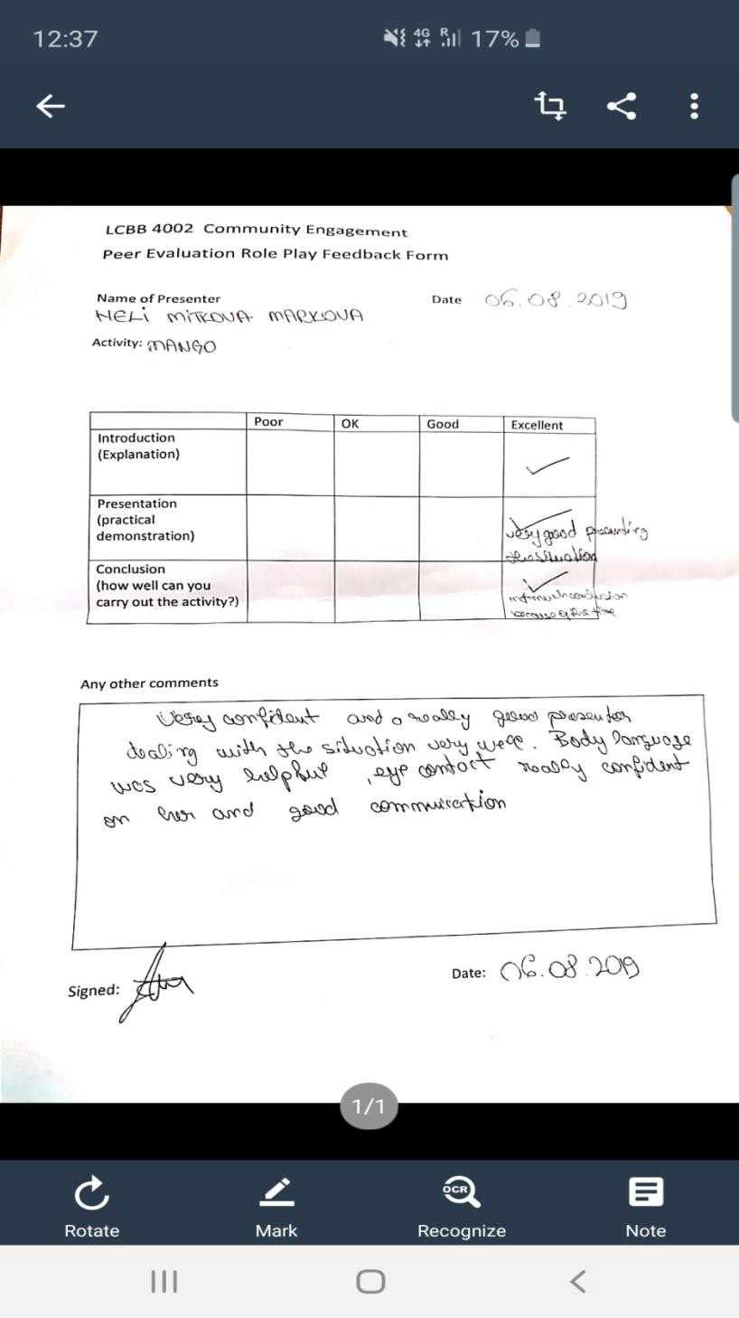
Feedback from Tutor



