

Professional Career Development

STUDENT NAME: ENACHE DANIELA MIHAELA

STUDENT NUMBER: 1908328

LECTURE NAME: MALANI GUNARATNAM
MODULE NAME: PROFESSIONAL CAREER DEVELOPMENT
MODULE CODE: BMSW 4005 LONDON

Table of Contents

Introduction 2
Reflection on your role play 2
Self evaluation review – self motivation and learning styles 3
Personal development planning SWOT analysis 5
SMART objectives 6
Johari window 7
Review of your understanding and expectations of the world of employment 9
Career ambitions and aspirations 9
Personal Development plan to enable you to achieve your ambitions 10
Conclusion 11
Reference 12

Introduction
The assignment will cover the personal reflection of a hair stylist who operates within the work sphere and will help in the planning of the professional development that demonstrates the utilization and significance of the skills possessed by the individual professional. I was a fashion freak from a very tender age and that helped me to take up the profession of a hair stylist. I was interested in the profession of becoming a hair stylist as I possessed good sense of matching styles with fashion features. I also had quality interpersonal skills that I used to great effect. I feel that I need to improve upon the skills of acquiring technical prowess. The readiness acquired by me to operate within my limits will be considered. The assignment will highlight the skills I possess and will align with the personalized perspective that I possess within the social sphere. The skills and the gaps within them that I possess will be reflected upon to help in designing a personal development plan. The personal development plan will help me to reduce the flaws and improve my skills to execute the tasks allotted to me within the boundaries of my profession.

Reflection on your role play
The role play which I had to do was executed to perfection. I applied for the role of a hair stylist in an organization where my interview was taken. I told the interviewer that I could reflect upon the skills which I possessed to help in carrying out the tasks in the role of a hair stylist. I was confident enough while dealing with my clients. I had good quality interpersonal skills that would support me to achieve the well-defined goals being devised by the authorities. I have the tenacity to patiently listen to each and every client and provide timely services that catered to their needs.
The questions related to the role play were specific (Asriyani et al., 2019). I acquired knowledge about the modernized techniques that proved to be efficient for the smooth functioning of the hairdressing and hairstyling activities. I could answer the questions which were asked to me by the interviewer to recruit me as a candidate. I also could effectively play my role as an interviewee and logically replied about the reason why I was interested in taking up the job of a hair stylist. The skills that were required for a hairdresser was discussed (Ward et al., 2016).

Self evaluation review – self motivation and learning styles

I adhered to the practices of self motivation and the specific styles of learning that helped me to play the role of a hair stylist perfectly. Kolb’s learning styles and its integral features have been utilized to good effect to learn the wide range of skills in a specific way to meet the goals (Miniano and Rui 2020). Features of intrinsic and extrinsic forms of motivation were utilized in a perfect way (Waheed et al., 2016). I got the desired self motivation from both the intrinsic and extrinsic forms of motivational aspects. I wanted to learn more about hairdressing and hair styling as I was interested about elements of fashion being adopted and utilized perfectly. I also developed interest to work as a hair stylist in future because of following some successful professionals who have become popular in the social circle. I also got the motivation from watching fashion associated videos from an earlier age that provided the impetus to perform the tasks in an effective manner. The learning styles devised the steps that proved to be very effective (Gemmell, 2017).
Kolb’s learning styles of preferential learning was demonstrated and applied by me to effectively design the most prospective steps that helped me to acquire the beneficial steps and processes of learning about hairstyling and hairdressing in a systematic way. The four respective roles of accommodators, divergers, convergers and assimilators were devised and used to great effect (Sudria et al., 2018). The role of accommodators helped me to learn by taking active participation in a role as a hair stylist. I acquired the steps and could devise the strategies to apply the learning skills to quality effect. As a diverger, I observed how the hairdressing and styling was done. In the role of a converger, I could learn the effective concepts aligned with experimentation being done effectively to achieve the goals. Lastly, as an assimilator, I learnt the nuances and procedures of performing the allotted tasks linked to hairstyling.

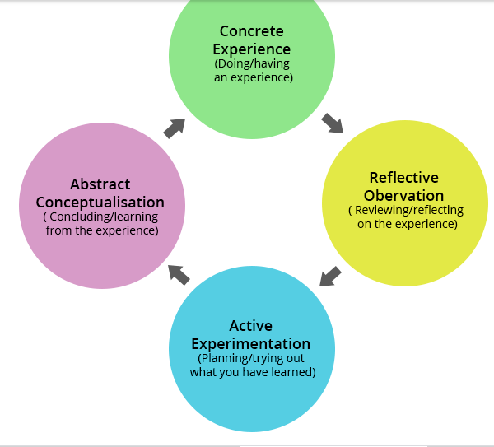

Figure 1: Kolb’s learning styles
(Source: Waheed et al., 2016)

Personal development planning SWOT analysis
I could plan to adopt the most effective practices and strategies that would help me to plan about my personal development. I would utilize the personal SWOT analysis and incorporate its features to ensure the smooth functioning as a hair stylist. The SWOT Analysis would help to identify the strong and weak points alongside the opportunities and threats that would provide the basis for improve the personal skills (Sarsby, 2016).

Strengths | Weaknesses
I possessed strong interpersonal skills that helped me to communicate well with the clients  I also could negotiate well with the clients about any dispute linked to the services provided by me | I lacked the skill of taking initiative to perform the tasks with great efficacy  I faltered in managing time in an effective way
Opportunities | Threats
I possessed the opportunity to sharpen my skills by discussing my flaws with the management  I also had the chance to reduce my flaws by attending workshops related to hairdressing and hairstyling that would enhance my quality of work. | Less knowledge about few of the modern techniques can affect future prospects of progress as a hair stylist (Rees, 2018).  I can also fail to perform my work with accuracy as I do not possess enough knowledge about the new fashion market and hair stylist trends that exist.

Table 1: Personal Development Planning by SWOT Analysis
(Source: Created by learner)

SMART objectives
The SMART Objectives will be designed that would help me to carry out the activities as a hairstylist in a perfect and well-guided way. The SMART Objectives are as follows:

SMART Objectives | Examples
Specific | To learn the technical skills that would help in providing modernized services to the clients
Measurable | To be able to attend to more than 20 clients in a day
Achievable | To be able to incorporate sustainable practices within the services provided to the clients
Realistic | To acquire the skills that ensure the provision of timely services to the clients
Timely | To be able to become a quality hairdresser within one year of working

Table 2: SMART Objectives
(Source: Created by learner)

Johari window
“Johari Window” is a specialized tool that aids the individuals to acquire knowledge about themselves and others in the social circle by adhering to the basic norms and policies (Singh, 2018).Johari Window was designed by Luft and Ingham and proved to be very much effective (Tseng et al., 2019). The ability to communicate and interact can be divided into four regions and they are the Arena, Façade, Blind Spot and Unknown (Oliver and Duncan 2019).
Arena
This aspect related to our personal lives is very well known by us as well as by other third party individuals. The features and details of arena are linked to family aspects, possession of personality and capabilities (McLain and Lewis 2018). This region aids in expressing ourselves perfectly. I could use this aspect well to help in devising the effective communication with the clients to provide the services of hairdressing in a methodical way.
Façade
This aspect of Johari Window reflects upon the aspect that is kept as a secret from others but not from us (Tran, 2016). The thoughts and feelings about our colleagues and managers that we hide have an impact upon the smooth functioning of the operations (Gamayanto et al., 2018). It also had an influence upon the quality of performance I delivered.
Blind Spot
This aspect covers the activities which we do not know but others know about them (Nofriza, 2017). As a hair stylist, I had to accept the critical comments and other allegations of the customers with patience. I should not remain blind to the different occurrences that are executed around me.
Unknown
This aspect relates to the different features and tasks that are not known to me and to other individuals in the social circle. The inner feelings and the prejudiced activities fall under the unknown aspect (Adizes et al., 2017). I did not know about the future actions that I was going to take to make progress. It was also not known to others as well.

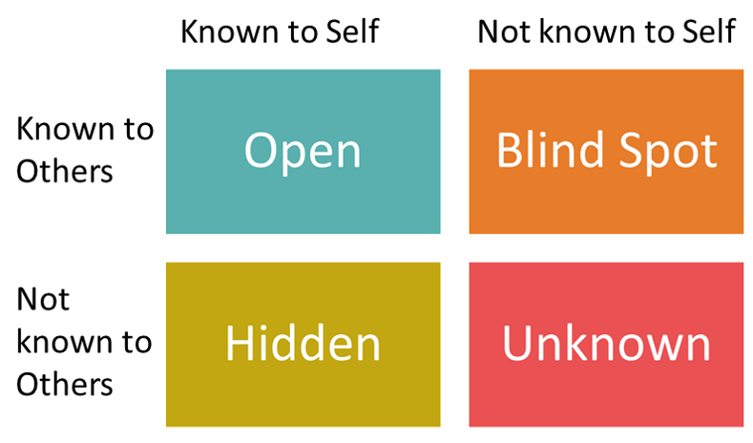

Figure 2: Johari Window
(Source: Singh, 2018).

Review of your understanding and expectations of the world of employment
I felt that the world of employment was very challenging and competitive. In the modern days, I feel that there are numerous individuals who are talented and skilful. I have to acquire the beneficial traits and develop some of the employability skills to help in getting employed by adhering to the most effective steps and strategies. The skills associated to employability are learnt with the help of receiving appropriate training procedures (Quendler and Lamb 2016). I also accepted the fact that I need to know about what the employer expects of me while making an effort to get selected in any Company. The employment arena also involves partial treatment of some candidates who apply within the organizations through some source (Follmer et al., 2020). I needed to possess the perfect aspirations that would help me to develop a prospective career and achieve my goals in a systematic way. As an employee also, I would have the required expectations of receiving the salary within the stipulated time and also to receive the support from the management so that I could learn how to go about things in a methodical way within the market. Flexibility and versatility was required to get employed (Chifamba, 2020).

Career ambitions and aspirations
I possessed the career ambition of becoming a quality and talented hair stylist who would provide proper beauty tips and would ensure provision of effective services to their clients. As mentioned earlier, I had a passion towards adopting the efficient styles and fashion aspects that drove me towards having a career in hair dressing and styling. The ambitions and aspirations related to the personal career can be aligned with skills adoption and management (Best et al., 2016). I sharpened my skills of interpersonal communication that helped me to develop both personally and professionally as a hair stylist. I wanted to achieve the well-defined targets that were set up by the authorities in the market. I also wanted to know about the modernized techniques of hair dressing that would help me to satisfy the high profile customers and enhance the image of the organization I work. I have a dream of becoming one of the best hair stylist in the world within 6 years time by providing quality services.

Personal Development plan to enable you to achieve your ambitions
A personal development plan has to be framed that would help me to achieve my ambitions in a proper way. The flaws which existed could be removed and I could effectively bring about my functioning within the organization as a hair stylist.
Skills that need to be improved | Steps to be taken for improvement | Duration
Skills that help me in taking initiative | Certain workshops need to be attended by me to make me learn about how to take initiatives. | 10 months
Skills of managing time | I can use the different time drills and tools of time management that would help me to complete the tasks in time. | 8 months
Skills and expertise related to learning about modernized style techniques | I can attend the effective training sessions and methods to acquire knowledge about effectively implementing methods of training | 6 months
Table 3: Personal Development Plan
(Source: Created by learner)

Conclusion
The assignment reflected upon the skills set that helped me to get properly guided in making a career as a hair stylist. The reflection of my role as a hair stylist was effectively demonstrated. The review of the self motivation possessed by me helped to design the activities in an effective way. Johari Window was applied to help in demonstrating the features related to my job role and its execution perfectly. SMART Objectives were aligned which helped me to accomplish the tasks in a methodical pattern. The ambitions and aspirations linked to my career were demonstrated and a personal development plan was designed to effectively utilize my skills my removing the flaws.

Reference:
Adizes, I., Cudanov, M. and Rodic, D., 2017. Timing of Proactive Organizational Consulting: Difference between Organizational Perception and Behaviour. Amfiteatru Economic, 19(44), p.232.
Asriyani, R., Suryawati, D.A. and Anggayana, I.W.A., 2019. USING ROLE PLAY TECHNIQUES IN IMPROVING ENGLISH SPEAKING COMPETENCY ON THE PERSONALITY TYPES. In International Conference on Cultural Studies (Vol. 2, pp. 44-48).
Best, D., Beswick, T., Hodgkins, S. and Idle, M., 2016. Recovery, ambitions, and aspirations: an exploratory project to build a recovery community by generating a skilled recovery workforce. Alcoholism Treatment Quarterly, 34(1), pp.3-14.
Chifamba, C., 2020. Career Flexibility: A Panacea to Skills Obsolescence. Asian Journal of Education and Social Studies, pp.12-16.
Follmer, K.B., Sabat, I.E. and Siuta, R.L., 2020. Disclosure of stigmatized identities at work: An interdisciplinary review and agenda for future research. Journal of Organizational Behavior, 41(2), pp.169-184.
Gamayanto, I., Christian, H., Wibowo, S. and Sukamto, T.S., 2018. Developing ‘Culture Intelligence (CI3) Framework’Inside Social Media Using Johari Window Methods. Indones. J. Inf. Syst, 1(1), pp.1-12.
Gemmell, R.M., 2017. Learning styles of entrepreneurs in knowledge-intensive industries. International Journal of Entrepreneurial Behavior & Research.
McLain, C.M. and Lewis, J.P., 2018. Professional behaviors and dispositions: Counseling competencies and lifelong growth. Routledge.
Miniano, C.M.B. and Rui, X.Y., 2020. Kolb’s Learning Styles and Managerial Concern for People and Task: A Reflective Measurement Model.
Nofriza, F., 2017. Development of training guide johari windows in improving student self-disclosure. Indonesian Journal of School Counseling, 2(1), pp.41-47.
Oliver, S. and Duncan, S., 2019. Looking through the Johari window. Research for All, 3(1), pp.1-6.
Quendler, E. and Lamb, M., 2016. Learning as a lifelong process-meeting the challenges of the changing employability landscape: competences, skills and knowledge for sustainable development. International Journal of Continuing Engineering Education and Life Long Learning, 26(3), pp.273-293
Rees, M., 2018. On the future: prospects for humanity. Princeton University Press.
Sarsby, A., 2016. SWOT analysis. Lulu. com.
Singh, S.K., 2018. Career Selection-A Basic Insight.Panther House Publication.
Sudria, I.B.N., Redhana, I.W., Kirna, I. and Aini, D., 2018. Effect of Kolb's Learning Styles under Inductive Guided-Inquiry Learning on Learning Outcomes. International Journal of Instruction, 11(1), pp.89-102.
Tran, B., 2016. Communication: The Role of the Johari Window on Effective Leadership Communication in Multinational Corporations. In Handbook of research on effective communication, leadership, and conflict resolution (pp. 405-429). IGI Global.
Tseng, E.K., Jo, D., Shih, A.W., De Wit, K. and Chan, T.M., 2019. Window to the unknown: using storytelling to identify learning needs for the intrinsic competencies within an online needs assessment. AEM education and training, 3(2), pp.179-187.
Waheed, M., Kaur, K., Ain, N. and Hussain, N., 2016. Perceived learning outcomes from Moodle: An empirical study of intrinsic and extrinsic motivating factors. Information Development, 32(4), pp.1001-1013.
Ward, R., Campbell, S. and Keady, J., 2016. Assembling the salon: Learning from alternative forms of body work in dementia care. Sociology of health & illness, 38(8), pp.1287-1302.

