University of Wales Trinity Saint David
School of Engineering



Title of Coursework: Analysis of Student Grades using Statistical Methods in MATLAB
Module Name and Code: Engineering Applications and Study Skills ACMA4007

Student Name: Owen Bell
Student Number: 2316885
Date: 28/05/2024


Contents
1 Introduction 1
2 Data Import and Summary Statistics 2
2.1 Data Import 2
2.2 Summary Statistics 3
3 Correlation Analysis 6
4 Grouped Data 9
4.1 Histcounts & Histograms 9
4.2 Ogives 11
5 Discussion 13
6 Conclusion 14
7 References 15
8 Appendix 16
8.1 MATLAB Script 16

Figure 1 – Raw Data Table Function, Script. 2
Figure 2 – Raw Data Table Function, Command Window. 2
Figure 3 – Extracting Raw Data and Creating Overall Score, Script. 3
Figure 4 – RVN and Raw Table Functions, Script. 3
Figure 5 – RVN and Raw Table Functions, Command Window. 3
Figure 6 – Descriptive Statistics, Script. 4
Figure 7 - Summary Statistic Table, Script. 5
Figure 8 – Summary Statistics Table, Command Window. 5
Figure 9 – Correlation Matrix and Correlation Plot, Script. 6
Figure 10 – Correlation Matrix, Command Window. 6
Figure 11 - Correlation Plot, Plot. 7
Figure 12 – Male & Female Overall Scores, Script. 7
Figure 13 – Hypothesis Test, Script. 8
Figure 14 – Hypothesis Test, Command Window. 8
Figure 15 – Setting Class Width and Limits, Script. 9
Figure 16 – Histcounts, Script. 9
Figure 17 – Histograms, Script. 10
Figure 18 – Histograms, Plot. 10
Figure 19 – Cumulative Frequencies and Inverse Cumulative Frequencies, Script. 11
Figure 20 - Plotting First Exam Ogives, Script. 11
Figure 21 – Plotting Second Exam Ogives, Script. 11
Figure 22 – Plotting Overall Score Ogive, Script. 12
Figure 23 – Ogives, Plot 12

Introduction
This report will investigate the application of various statistical methods to analyse 100 student grades across a variety of Exams. Using a data set provided “student_grades.csv”, and the software MATLAB the following columns will be imported; “Student ID”, “Gender”, “Age”, “Attendance”, 1st Exam Score”, and “2nd Exam Score” for every student within the data set. Moreover, an additional new column will be created named “Overall Score” which will be the sum of the two exams for each student.

A variety of statistical methods will be implemented using the software MATLAB to perform both, descriptive statistics which “refers to a set of methods used to summarize and describe the main features of a data set, such as its central tendency, variability, and distribution. These methods provide an overview of the data and help identify patterns and relationships” (Simplilearn, 2023) and inferential statistics which “allow you to use your sample data to assess whether the patterns contained within it are likely to be present in the broader population, and potentially, to make predictions about that population” (GradCoach, 2023).

Data Import and Summary Statistics

Data Import
To begin importing the data set “student_grades.csv”, MATLAB needs to read the data set as a table, assigned to the function named “RawDataTable”. By doing this MATLAB will create an exact copy of the data set provided in tabular form.
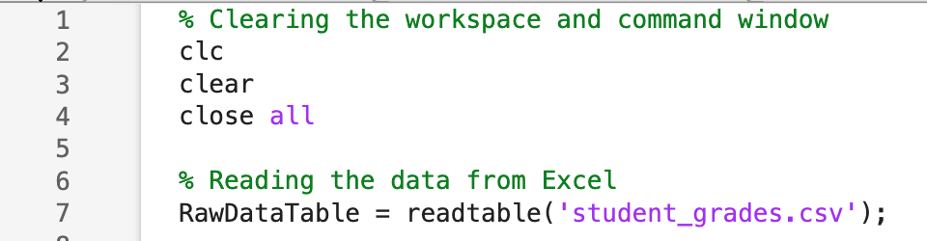
Figure 1 – Raw Data Table Function, Script.
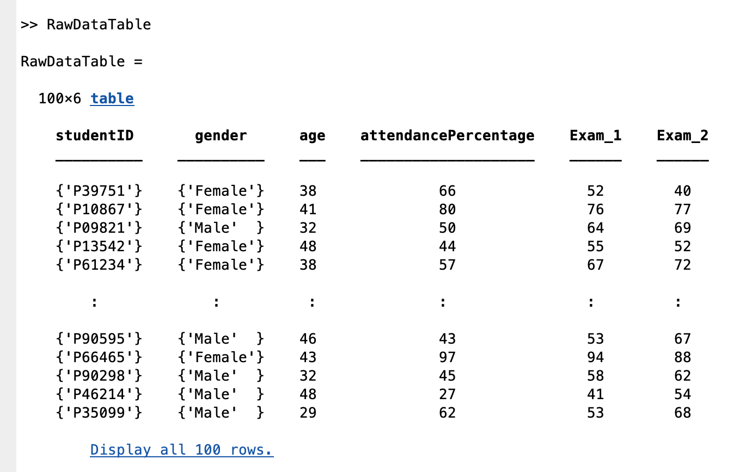
Figure 2 – Raw Data Table Function, Command Window.
Once a copy of the data set has been imported, MATLAB is instructed to extract each column of “RawDataTable” this is done to create an additional data column called “OverallScore” which will add the scores from the data sets “Exam_1” and “Exam_2” and then halve the sum
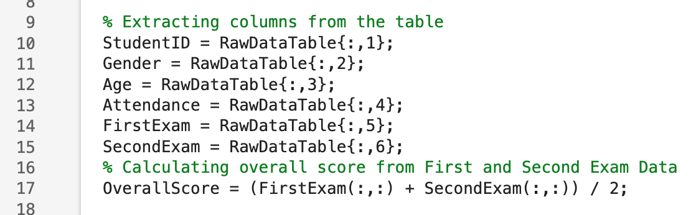
Figure 3 – Extracting Raw Data and Creating Overall Score, Script.
MATLAB can now generate a table containing the original data set with an additional column displaying the Overall Scores of every student within the dataset. This is carried out by creating table headers assigned to the function named “RVN”. The function “RawTable” is then assigned to create a table with the previously extracted data shown in Fig.3 naming the corresponding extracted data to the variable within “RVN”.
Figure 4 – RVN and Raw Table Functions, Script.
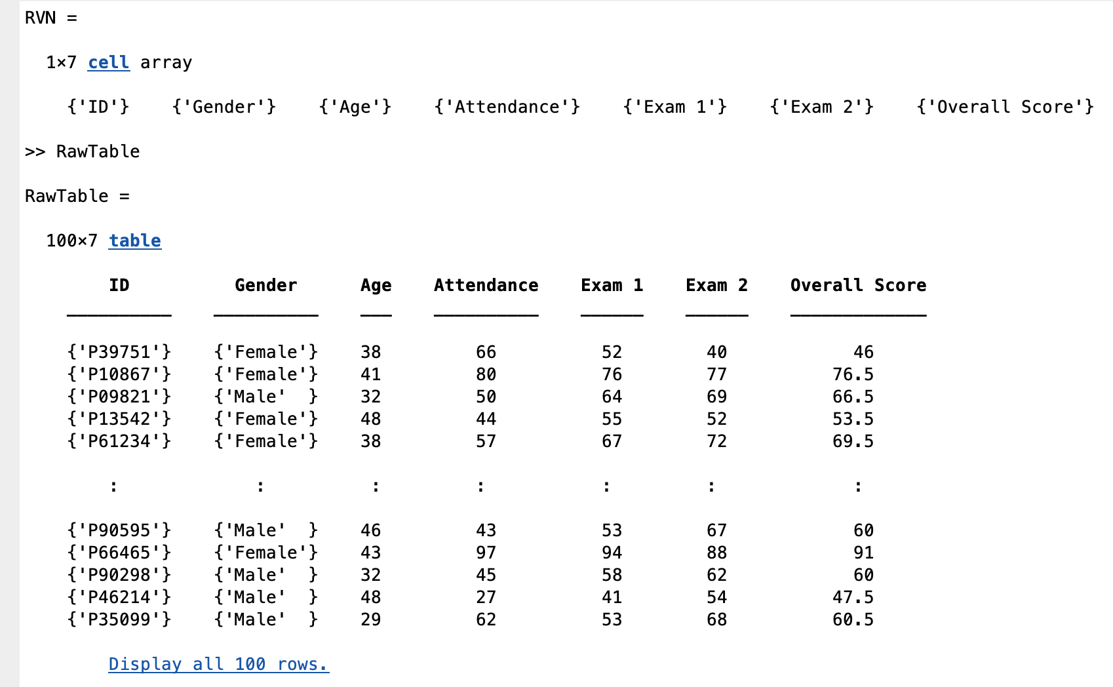
Figure 5 – RVN and Raw Table Functions, Command Window.

Summary Statistics
MATLAB can now be used to identify a variety of descriptive statistics defined below.

- Mean
$$\overline{x}=\frac{∑varible values}{∑Observations}=\frac{∑x_{i}}{n}$$
Equation 1 – Mean.

$$\overline{x}=\frac{∑(f_{i}×m_{i})}{∑f_{i}}$$
Equation 2 – Mean for Grouped Data.
- $\overline{x}$is the mean
- m is the class mark
- f is the frequency
- Median
$$Median=L+\left(\frac{\frac{∑f_{i}}{2}-B}{f_{median}}\right)∙W$$
Equation 3 – Median.
- L is the lower class limit of the median class
- $∑f_{i}$ is the total number of observations in a data set
- B is the sum of the frequencies of all classes lower than the medina class
- $f_{median}$ is the frequency of the median class
- W is the width of the median class
- Mode of a data set is the value which occurs with the greatest frequency
- Range of a data set is the difference between the largest and smallest numbers in the data set
- Standard Deviation
$$σ=\sqrt{\frac{∑{\left(x_{i}-\overline{x}\right)}^{2}}{n-1}}$$
Equation 4 – Standard Deviation.
This is completed using the embedded MATLAB functions for each of the descriptive statistics and applying each function to the “RawTable” columns “Age”, “Attendance”, “Exam 1”, “Exam 2” and “Overall Score”.
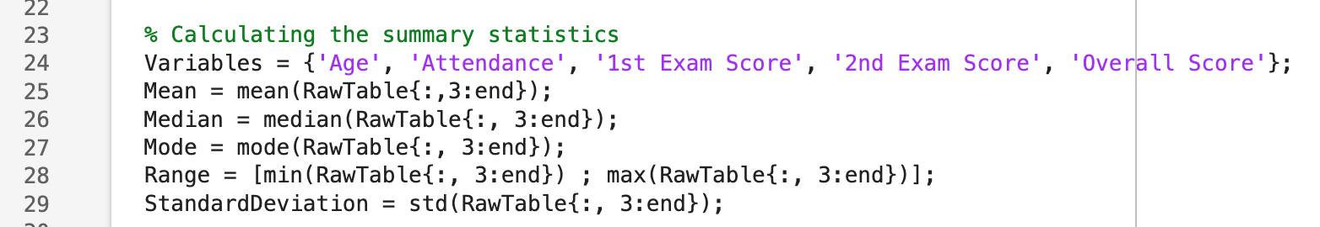
Figure 6 – Descriptive Statistics, Script.
Once the statistics have been calculated the MATLAB script creates a new table assigned to the function “SummaryTable”, which is then displayed in the command window using the function “disp”.
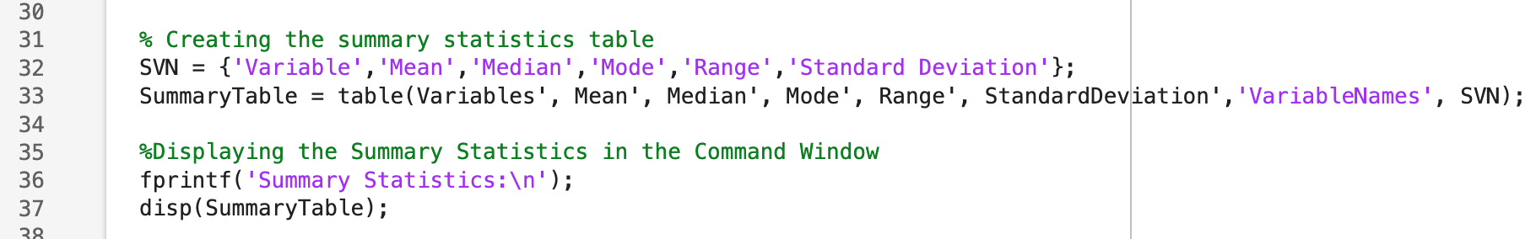
Figure 7 - Summary Statistic Table, Script.
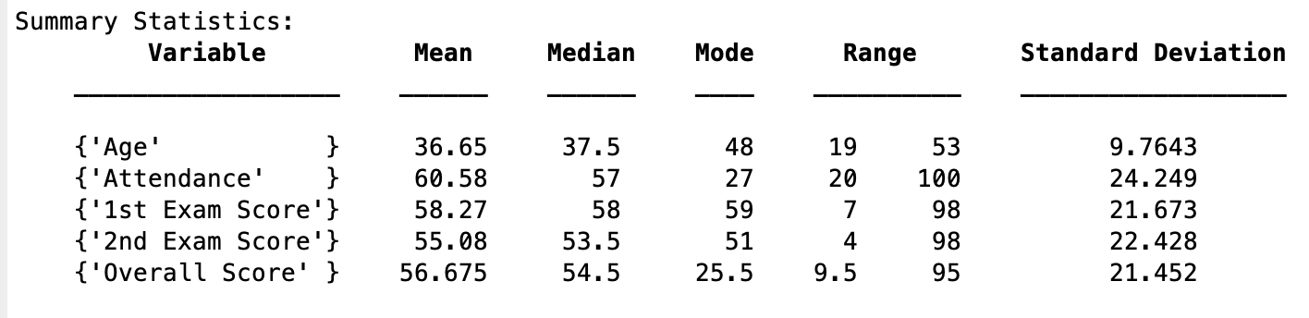
Figure 8 – Summary Statistics Table, Command Window.
Looking at the “Summary Statistics Table” seen in Fig. 8, we can use the descriptive statistics to quickly summarise main characteristics such as the range to find the extremes for each variable whilst also making an overall comparison between Exams with the 1st Exam having a higher average score and the most common score being 59 which is 8 more than the most common score of 51 in the 2nd Exam.

However, some of the limitations with these descriptive statistics are that we cannot identify if the age or attendance of a student impacts student exam scores. Further, limitations are that we are not able to cross reference each students scores across exams and cannot determine if the lowest scoring student in the 1st Exam is the lowest or highest scoring student in the 2nd Exam.

Correlation Analysis
A correlation analysis can be conducted to find if “there is a relationship between two or more variables. This does not imply, however, that there is necessarily a cause or effect relationship between them. Instead, it simply means that there is some type of relationship, meaning they change together at a constant rate.” (Cherry, 2023).

A correlation analysis can be carried out in MATLAB using the embedded functions “corr” to create a correlation coefficient between the summary statistics variables and “corrplot” to visualise the correlation matrix highlighting the variables which have a relationship using the embedded function “TestR = “ON”” as shown in Fig. 9, 10 & 11.
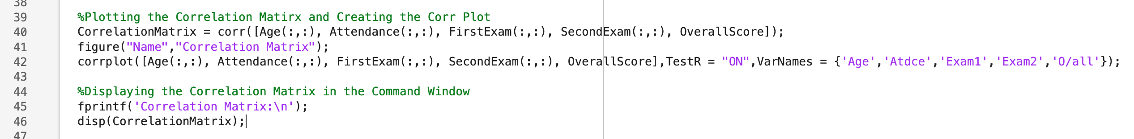
Figure 9 – Correlation Matrix and Correlation Plot, Script.
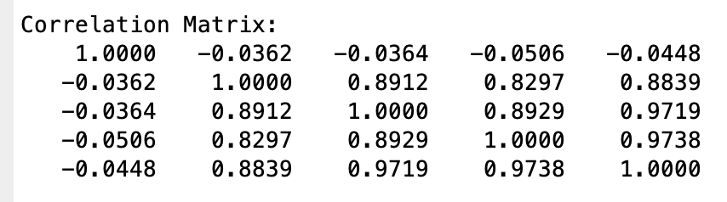
Figure 10 – Correlation Matrix, Command Window.
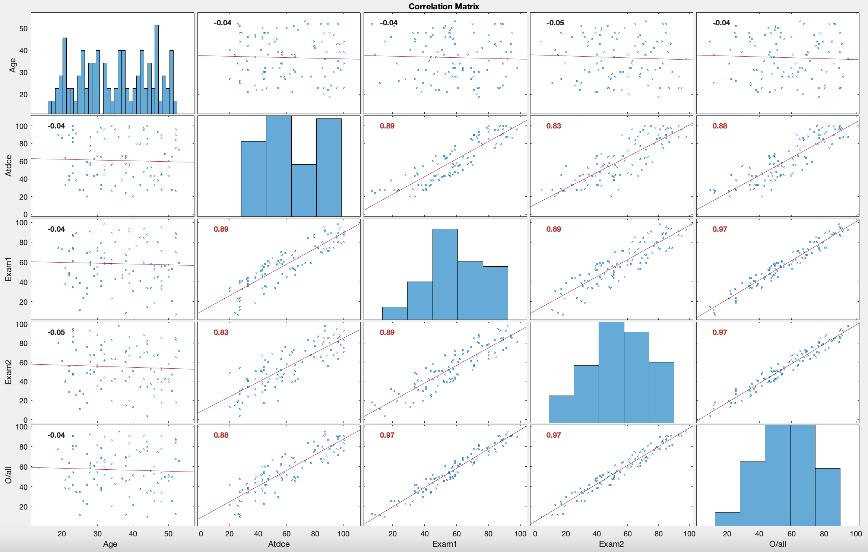
Figure 11 - Correlation Plot, Plot.
From looking at Fig. 10 & 11, it implies that there is a strong relationship between Attendance, Exam 1, Exam 2, and Overall Score. This suggests that as a student’s attendance decrease so will their scores in the exams. The figures also imply that the age of the student as no impact on the attendance or scores in the exams.

Furthermore, using inferential statistics such as a hypothesis test MATLAB can identify if there is a relationship between the Overall Score and Gender of the student. The null hypothesis is that there is no correlation between the Gender and Overall Score of the students. This is performed in MATLAB by categorising the Overall Score data by Gender as shown in Fig. 12.
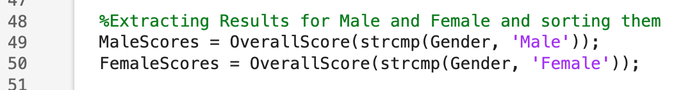
Figure 12 – Male & Female Overall Scores, Script.
Once the data has been categorised, MATLAB will use the embedded function “ttest2” which will compare the Male and Female overall scores against each other and will output a hypothesis value which will display if the null hypothesis has been rejected. This is driven from the “PValue” where, “A p-value less than 0.05 is typically considered to be statistically significant, in which case the null hypothesis should be rejected.” (Beers, 2024). This is carried out in the MATLAB script shown in Fig. 13.
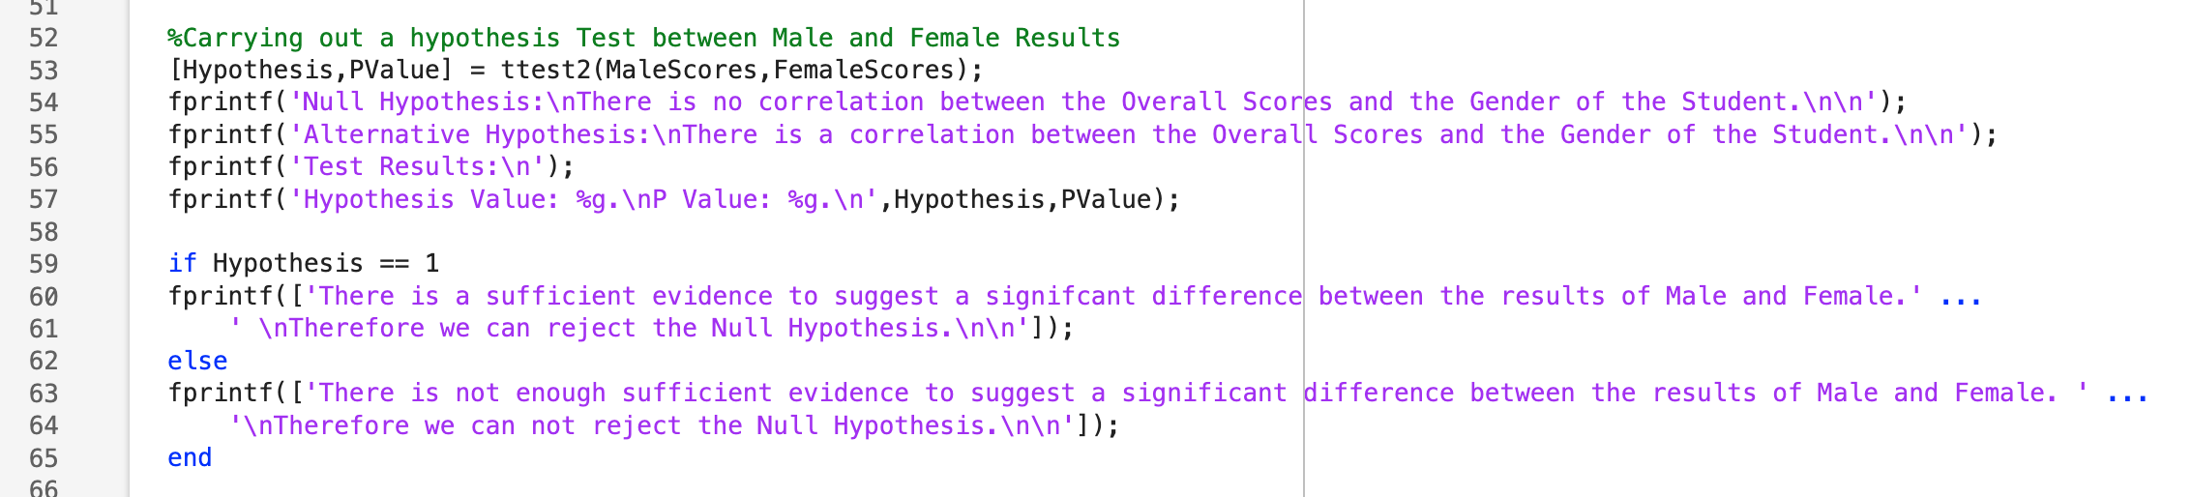
Figure 13 – Hypothesis Test, Script.
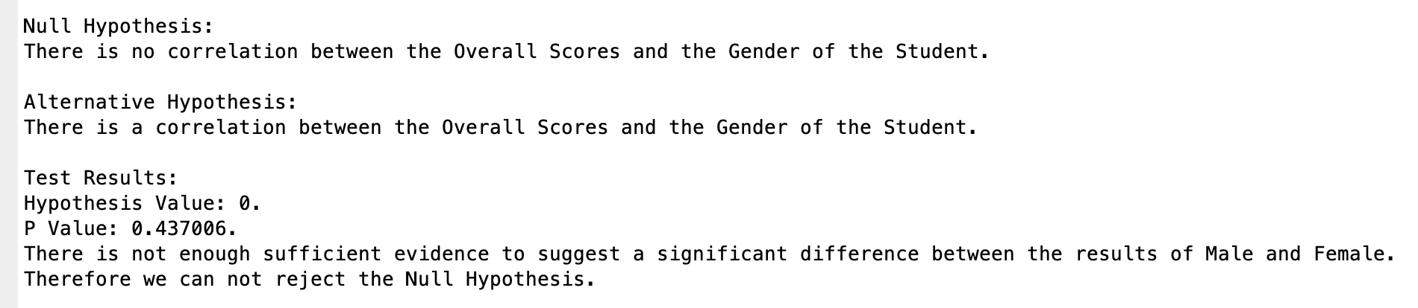
Figure 14 – Hypothesis Test, Command Window.
Shown in Fig. 14, MATLABs command window displays that the null hypothesis cannot be rejected with a P Value of 0.437006 which is far greater than the 0.05 advised to reject the null hypothesis, implying that there is no relationship between Gender and the Overall Scores on the exams.

Grouped Data

Histcounts & Histograms
To visualise the grouped data, MATLAB first needs to set the Class Width and Class Limits which will later be used to generate Histcounts, Histograms and Ogives. This is done in Fig. 15.
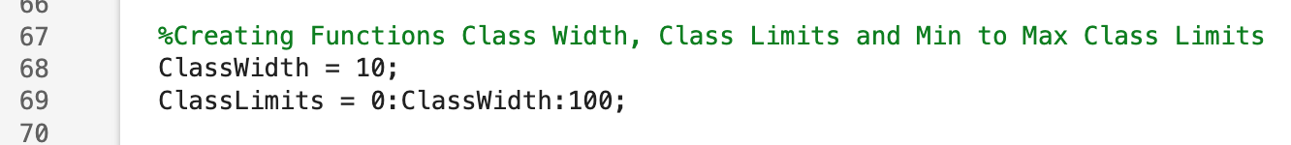
Figure 15 – Setting Class Width and Limits, Script.
After creating these functions, MATLAB can use the embedded function “histcounts” to identify the number of students who had a score every 10% between 0% and 100% for each of 1st Exam, 2nd Exam and Overall Score as seen in Fig. 16.
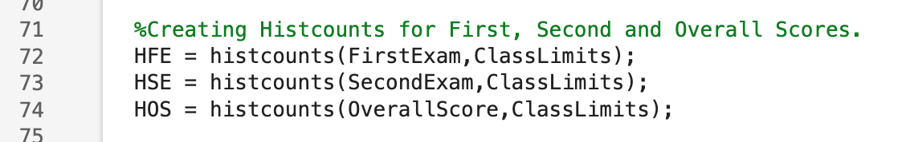
Figure 16 – Histcounts, Script.
MATLAB can group and present this as a figure using the embedded functions “figure”, “tiledlayout(“horizontal”)” and “histogram” to plot histograms for 1st Exam, 2nd Exam and Overall Score all into 1 figure as seen in Fig. 17.

By displaying the results as a histogram, a better understanding of the trend amongst student’s overall performance can be identified in comparison to the “Summary Statistics Table” with over 90% of students scoring more than 30% in the 1st Exam which previously could not have been determined from the “Summary Statistics Table” shown in Fig. 18.

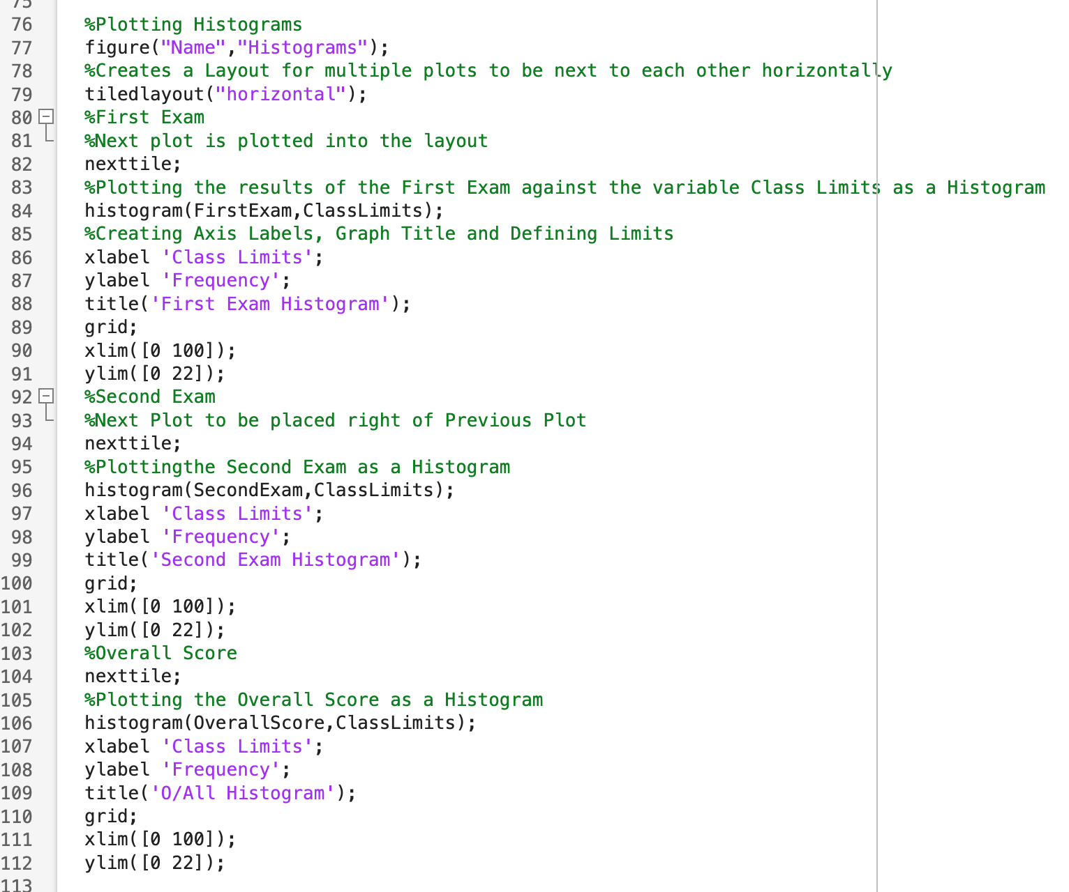
Figure 17 – Histograms, Script.
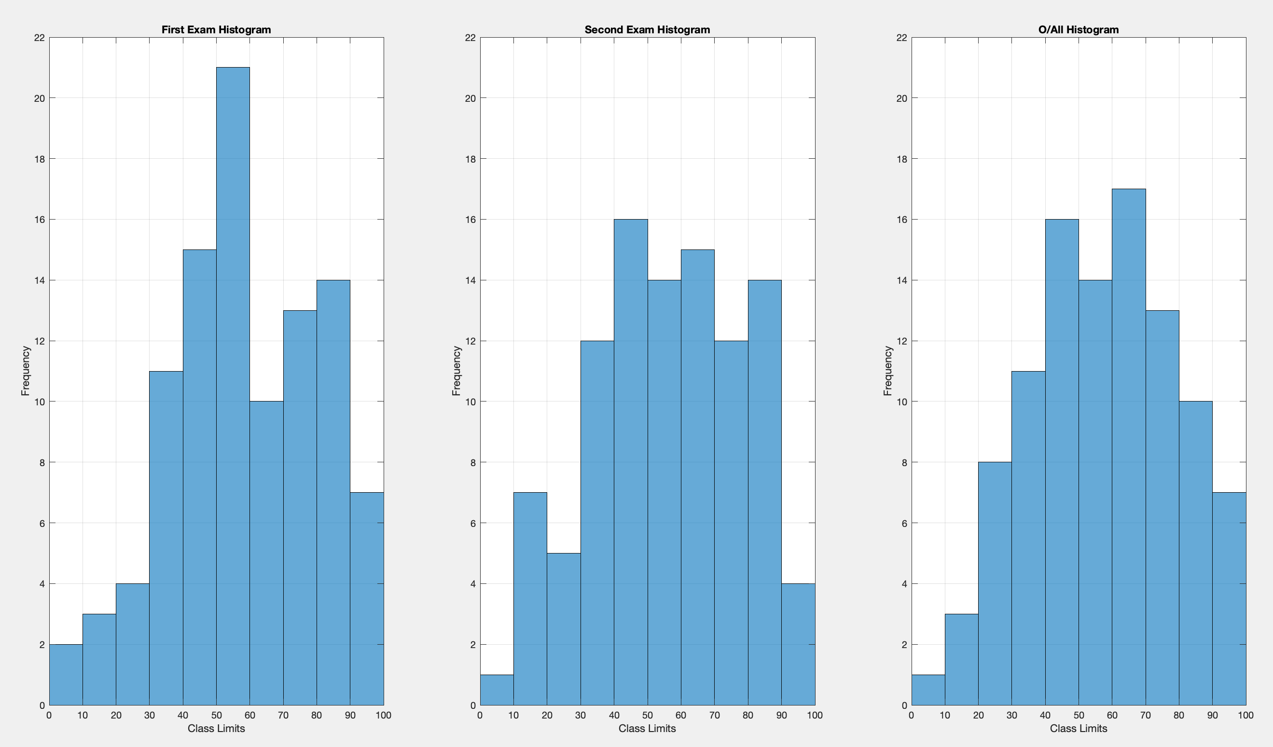
Figure 18 – Histograms, Plot.

Ogives
Like, the histograms, Ogives can be plotted and grouped using MATLAB by creating functions to find the cumulative frequency and inverse cumulative frequency for all the histcounts previously made as seen in Fig. 16 & 19.
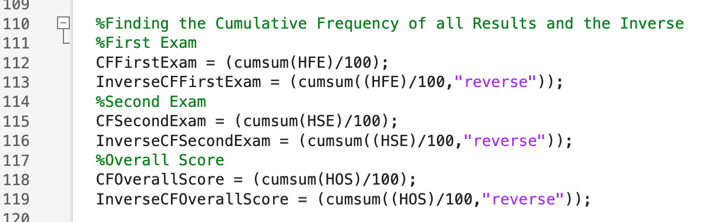
Figure 19 – Cumulative Frequencies and Inverse Cumulative Frequencies, Script.
After creating these functions, MATLAB can begin plotting the Ogives by adding zero values to the cumulative frequencies assigned to the functions “ZeroCFFirstExam” and “ZeroInverseCFFirstExam”, shown in Fig. 20. Then using the embedded function “plot” MATLAB can plot the class limits by the zero cumulative frequencies for the First Exam, with the less than ogive plotted in red and the more than ogive plotted in blue. This is then repeated for the Second Exam and Overall Scores as shown in Fig. 21 & 22.
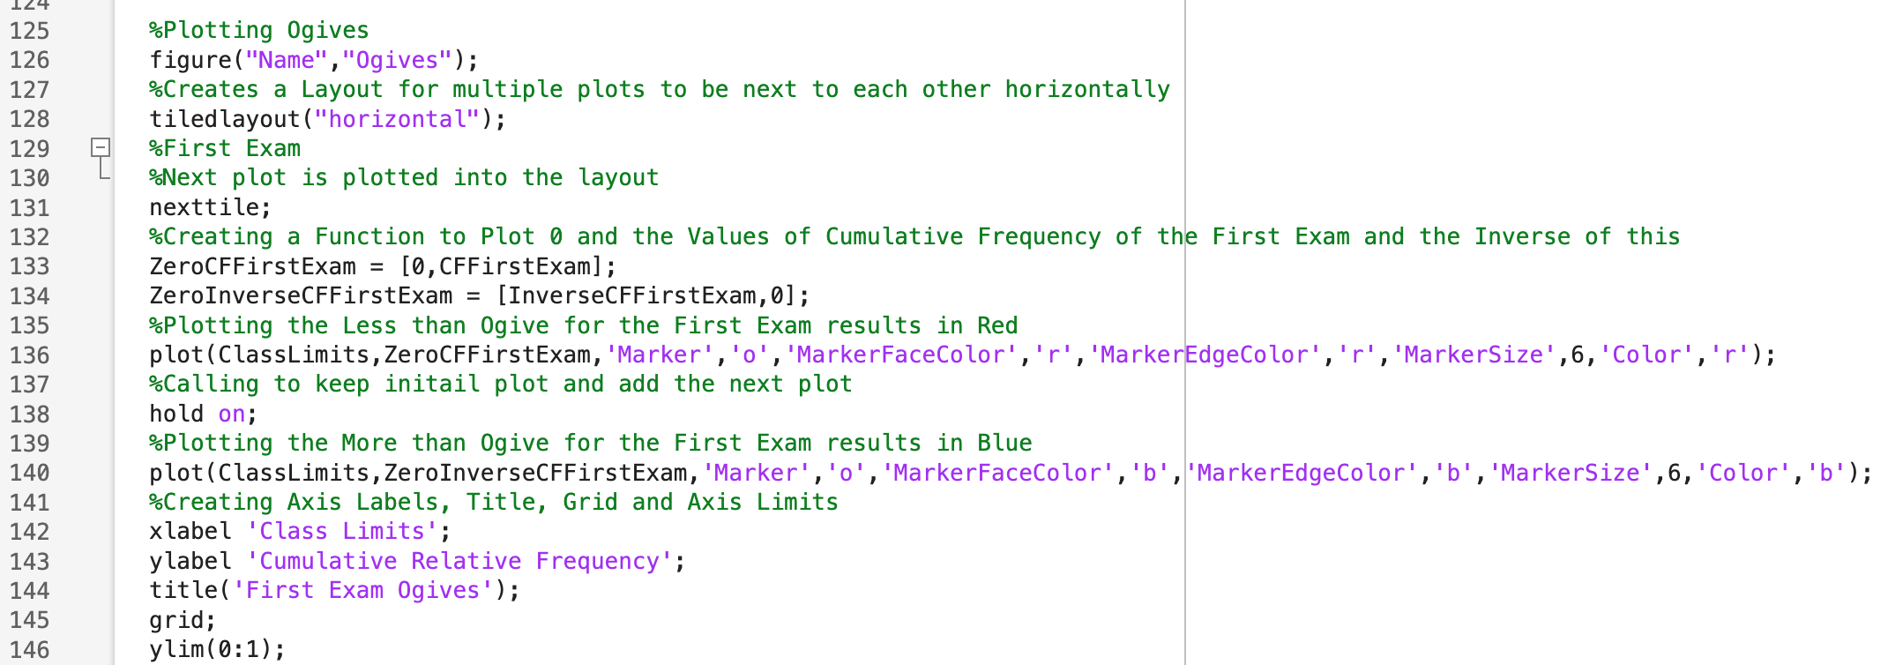
Figure 20 - Plotting First Exam Ogives, Script.
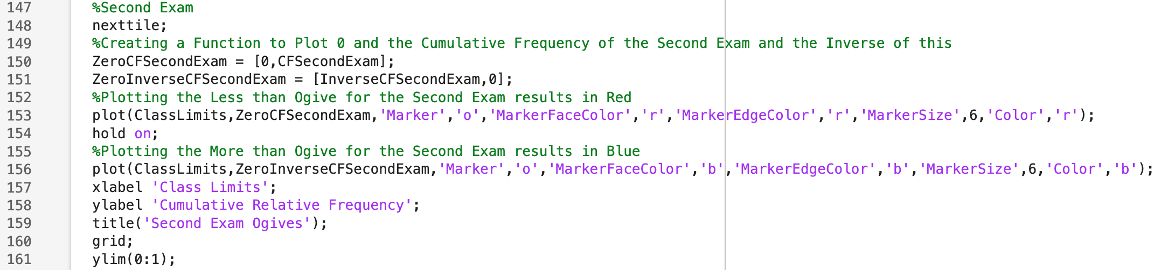
Figure 21 – Plotting Second Exam Ogives, Script.
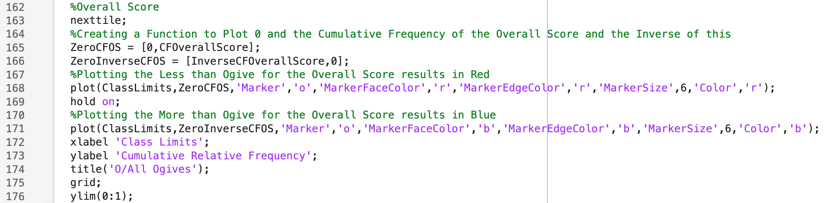
Figure 22 – Plotting Overall Score Ogive, Script.
Similarly, by visualising the results as ogives it can be easily identified where the median point of the data set is being where the more than and less than ogives intersect as displayed in Fig. 23. Moreover, the ogives can help with determining trends within the data set through how steep the ogives become.
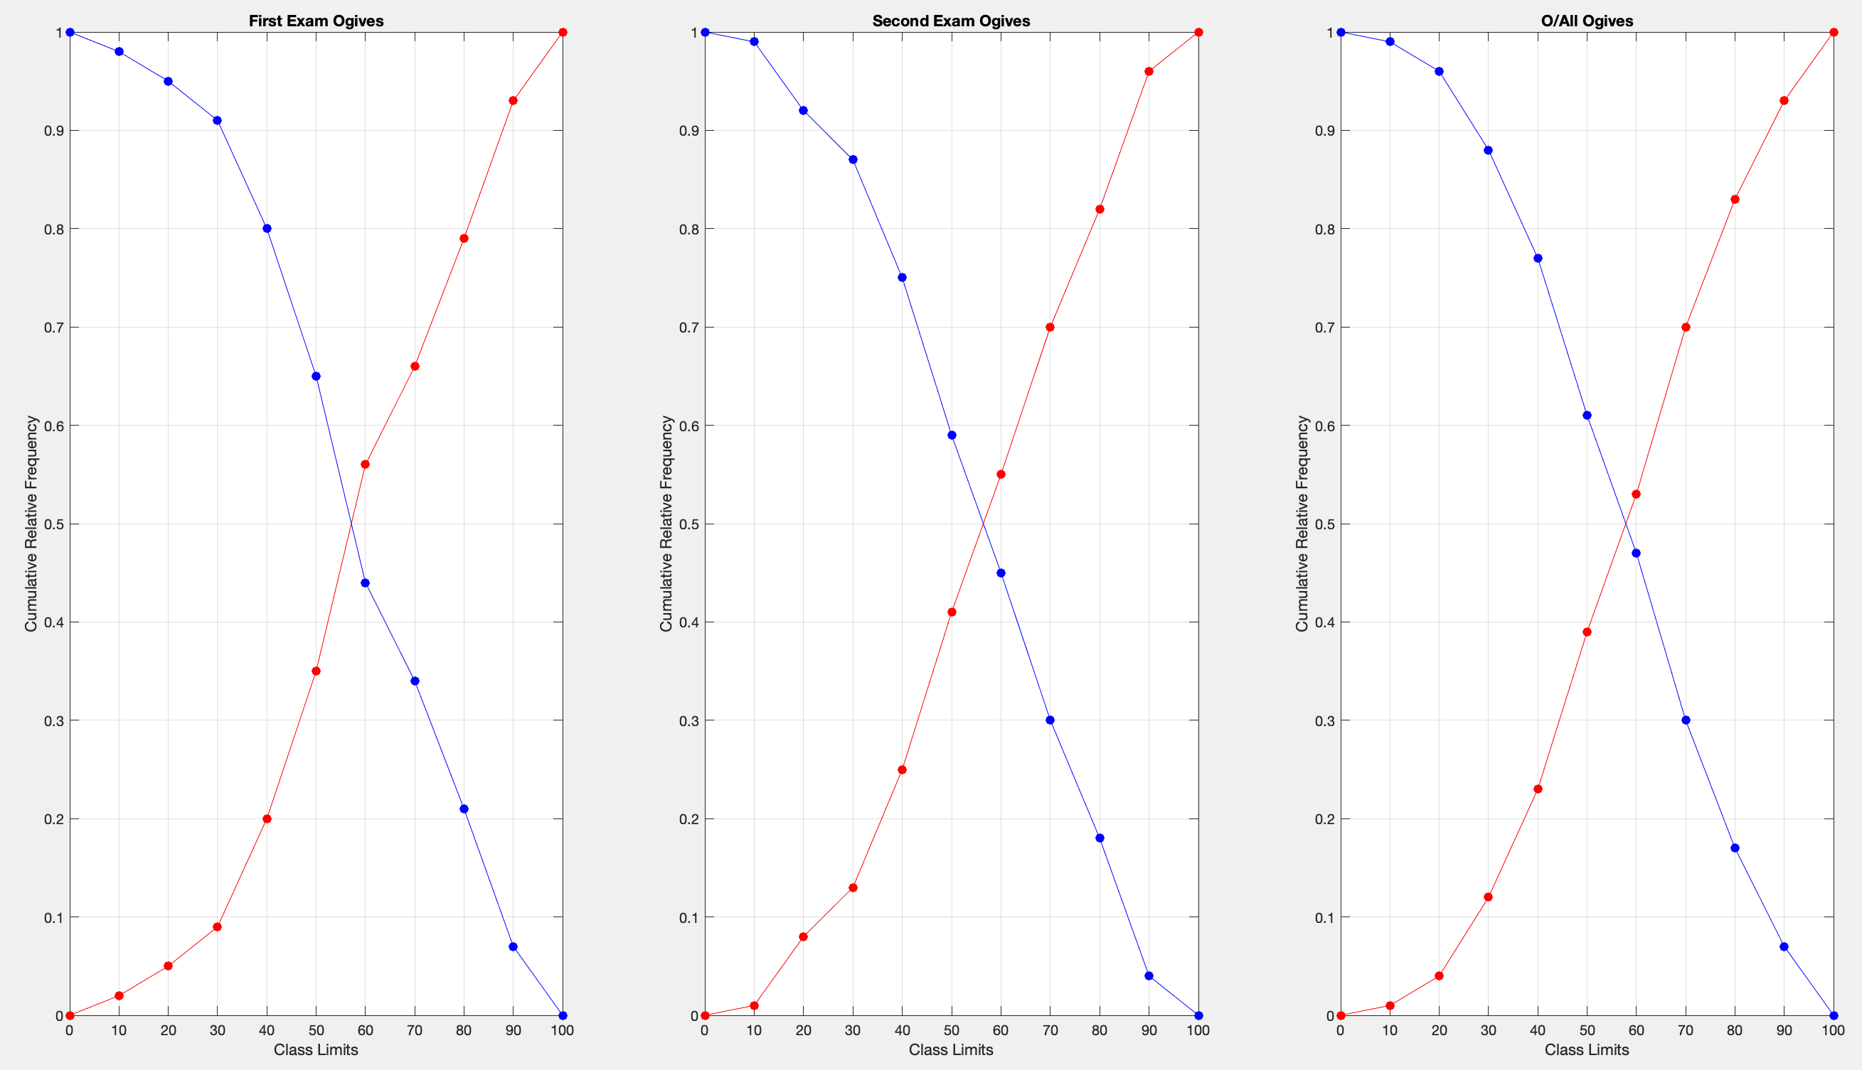
Figure 23 – Ogives, Plot
The advantages to grouping the data for both the histograms and the ogives are that “from the statistical point of view, graphic presentation is preferred by the investigators as it provides a more accurate and appropriate presentation of data. The graphic presentation of data facilitates the process of comparison of two or more situations.” (GeeksforGeeks, 2023) this enables for more accurate estimation and assumption to be made about a dataset.

Discussion
When looking at the “Summary Statistics Table” (Figure 8) MATLAB displayed that students typically performed better during the 1st Exam through descriptive statistics such as, mean which showed the average score in Exam 1 in comparison to Exam 2 was 3.19 higher, the 1st Exams median value of 58 being 4.5 greater than the 2nd Exams, being further supported by the mode of the 2nd Exam being lower than the mean by 4.08 whereas the 1st Exams mode was 0.73 greater than the mean and the ranges having the same highest score but Exam 1 having a lowest score of 7 compared to the lowest score of 4 for Exam 2.

By plotting a correlation matrix, the relationship between variables from the data set can be visualised and highlight the variables which do correlate (Figures 10 & 11). From the correlation matrix it is seen that in this data set “Age” has no correlation to any other variable but in contrast there is a strong correlation between every other variable within the correlation matrix implying that if a student has a lower attendance during the lessons there is a strong likelihood that the students Exam score will be lower compared to a student who has a higher attendance but is not guaranteed with students with lower attendance having higher scores than some students with a greater attendance as seen in Fig. 11.

Whilst using inferential statistics such as a ttest (hypothesis test) comparisons between Male and Female overall results could be made (Figures 12, 13 & 14), it was calculated that the null hypothesis had a P Value of 0.437006. This implied, the null hypothesis “There is no correlation between the Overall Score and students Gender” was correct and cannot be rejected further implying that the Gender of the Student made no significant impact in results within the data set.

Through grouping the plots for histograms and ogives (Figures 18 & 23), it became easier to make comparisons between “Exam 1”, “Exam 2” and “Overall Score” due to the data set being broken down to show the spread of results more precisely, meaning more accurate estimations being made. With the data being presented graphically it shows that Exam 2 had approximately 45% of students scoring greater than 60. Whereas, Exam 1 had approximately 44% of students scoring more than 60. Implying that the students’ performance across the two exams are closer than initially thought.

Conclusion
To conclude, using descriptive statistics such as mean, median, mode, range and standard deviation the main characteristics of an entire data set can be identified. This is a great statistical method to establish a general understanding of a data set. Contrastingly, the limitations of using only descriptive statistics are that, for the range and standard deviation descriptive statistics only show the extremes of the data, which does not give a complete picture with trends and patterns within a data set unable to be identified along with understanding how variables within a data set can correlate with one and another.

Moreover, by creating a correlation matrix alongside the descriptive statistics an understanding of the relationships between variables can begin to form enabling for estimations to start attaining some accuracy with MATLAB establishing there are correlations between the attendance of a student and scores during the exams. Despite the correlation matrix conducted still having limitations with no consideration for the gender of the student or any other consideration to categorical data.

Including inferential statistics such as a ttest (hypothesis test), enables comparisons to be made between categorical data such as gender, which when tested was determined to not have an impact on the overall score a student achieved. Nonetheless, there are still limitations with the ttest, with it only being conducted on the overall scores of the students it does not disprove if the gender of the student impacts the score of “Exam 1” and “Exam 2”. But strongly suggests that the result would correspond.

Finally, by grouping the data it can improve the accuracy of estimations and predictions about the data set and how it will perform on a larger scale with a greater sample size.

Overall, the combination of all these statistical methods enables the user to understand the data set provided with the help of descriptive statistics and with the aid of inferential statistics can make precise predictions and estimations on how a larger sample could perform with considerations towards categorical data and the impact in which it may have.

References
Simplilearn (2023) What is Descriptive Statistics: Definition, Types, Applications, and Examples. Available at: https://www.simplilearn.com/what-is-descriptive-statistics-article#:~:text=Frequently%20Asked%20Questions-,1.,help%20identify%20patterns%20and%20relationships. (Accessed: 17th May 2024).

GradCoach (2023) Quant Analysis 101: Inferential Statistics. Available at: https://gradcoach.com/inferential-statistics/. (Accessed: 17th May 2024).

Cherry, K. (2023) What is a Correlation? Available at: https://www.verywellmind.com/what-is-correlation-2794986#:~:text=A%20correlation%20means%20that%20there,together%20at%20a%20constant%20rate. (Accessed: 17th May 2024).

Beers, B. (2024) P-Value: What It Is, How to Calculate It, and Why It Matters Available at: https://www.investopedia.com/terms/p/p-value.asp#:~:text=A%20p%2Dvalue%20less%20than,null%20hypothesis%20is%20not%20rejected. (Accessed: 18th May 2024).

GeeksforGeeks (2023) Ogive (Cumulative Frequency Curve) and its Types. Available at: https://www.geeksforgeeks.org/ogive-cumulative-frequency-curve-and-its-types/. (Accessed: 18th May 2024).

Appendix

MATLAB Script
% Clearing the workspace and command window
clc
clear
close all

% Reading the data from Excel
RawDataTable = readtable('student_grades.csv');

% Extracting columns from the table
StudentID = RawDataTable{:,1};
Gender = RawDataTable{:,2};
Age = RawDataTable{:,3};
Attendance = RawDataTable{:,4};
FirstExam = RawDataTable{:,5};
SecondExam = RawDataTable{:,6};
% Calculating overall score from First and Second Exam Data
OverallScore = (FirstExam(:,:) + SecondExam(:,:)) / 2;

% Creating a table with appropriate variable names
RVN = {'ID','Gender','Age','Attendance','Exam 1','Exam 2','Overall Score'};
RawTable = table(StudentID, Gender, Age, Attendance, FirstExam, SecondExam, OverallScore, 'VariableNames', RVN);

% Calculating the summary statistics
Variables = {'Age', 'Attendance', '1st Exam Score', '2nd Exam Score', 'Overall Score'};
Mean = mean(RawTable{:,3:end});
Median = median(RawTable{:, 3:end});
Mode = mode(RawTable{:, 3:end});
Range = [min(RawTable{:, 3:end}) ; max(RawTable{:, 3:end})];
StandardDeviation = std(RawTable{:, 3:end});

% Creating the summary statistics table
SVN = {'Variable','Mean','Median','Mode','Range','Standard Deviation'};
SummaryTable = table(Variables', Mean', Median', Mode', Range', StandardDeviation','VariableNames', SVN);

%Displaying the Summary Statistics in the Command Window
fprintf('Summary Statistics:\n');
disp(SummaryTable);

%Plotting the Correlation Matirx and Creating the Corr Plot
CorrelationMatrix = corr([Age(:,:), Attendance(:,:), FirstExam(:,:), SecondExam(:,:), OverallScore]);
figure("Name","Correlation Matrix");
corrplot([Age(:,:), Attendance(:,:), FirstExam(:,:), SecondExam(:,:), OverallScore],TestR = "ON",VarNames = {'Age','Atdce','Exam1','Exam2','O/all'});

%Displaying the Correlation Matrix in the Command Window
fprintf('Correlation Matrix:\n');
disp(CorrelationMatrix);

%Extracting Results for Male and Female and sorting them
MaleScores = OverallScore(strcmp(Gender, 'Male'));
FemaleScores = OverallScore(strcmp(Gender, 'Female'));

%Carrying out a hypothesis Test between Male and Female Results
[Hypothesis,PValue] = ttest2(MaleScores,FemaleScores);
fprintf('Null Hypothesis:\nThere is no correlation between the Overall Scores and the Gender of the Student.\n\n');
fprintf('Alternative Hypothesis:\nThere is a correlation between the Overall Scores and the Gender of the Student.\n\n');
fprintf('Test Results:\n');
fprintf('Hypothesis Value: %g.\nP Value: %g.\n',Hypothesis,PValue);

if Hypothesis == 1
fprintf('There is a sufficient evidence to suggest a signifcant difference between the results of Male and Female. \nTherefore we can reject the Null Hypothesis.\n\n');
else
fprintf('There is not enough sufficient evidence to suggest a significant difference between the results of Male and Female. \nTherefore we can not reject the Null Hypothesis.\n\n');
end

%Creating Functions Class Width, Class Limits and Min to Max Class Limits
ClassWidth = 10;
ClassLimits = 0:ClassWidth:100;

%Creating Histcounts for First, Second and Overall Scores.
HFE = histcounts(FirstExam,ClassLimits);
HSE = histcounts(SecondExam,ClassLimits);
HOS = histcounts(OverallScore,ClassLimits);

%Plotting Histograms
figure("Name","Histograms");
%Creates a Layout for multiple plots to be next to each other horizontally
tiledlayout("horizontal");
%First Exam
%Next plot is plotted into the layout
nexttile;
%Plotting the results of the First Exam against the variable Class Limits as a Histogram
histogram(FirstExam,ClassLimits);
%Creating Axis Labels, Graph Title and Defining Limits
xlabel 'Class Limits';
ylabel 'Frequency';
title('First Exam Histogram');
grid;
xlim([0 100]);
ylim([0 22]);
%Second Exam
%Next Plot to be placed right of Previous Plot
nexttile;
%Plottingthe Second Exam as a Histogram
histogram(SecondExam,ClassLimits);
xlabel 'Class Limits';
ylabel 'Frequency';
title('Second Exam Histogram');
grid;
xlim([0 100]);
ylim([0 22]);
%Overall Score
nexttile;
%Plotting the Overall Score as a Histogram
histogram(OverallScore,ClassLimits);
xlabel 'Class Limits';
ylabel 'Frequency';
title('O/All Histogram');
grid;
xlim([0 100]);
ylim([0 22]);

%Finding the Cumulative Frequency of all Results and the Inverse
%First Exam
CFFirstExam = (cumsum(HFE)/100);
InverseCFFirstExam = (cumsum((HFE)/100,"reverse"));
%Second Exam
CFSecondExam = (cumsum(HSE)/100);
InverseCFSecondExam = (cumsum((HSE)/100,"reverse"));
%Overall Score
CFOverallScore = (cumsum(HOS)/100);
InverseCFOverallScore = (cumsum((HOS)/100,"reverse"));

%Plotting Ogives
figure("Name","Ogives");
%Creates a Layout for multiple plots to be next to each other horizontally
tiledlayout("horizontal");
%First Exam
%Next plot is plotted into the layout
nexttile;
%Creating a Function to Plot 0 and the Values of Cumulative Frequency of the First Exam and the Inverse of this
ZeroCFFirstExam = [0,CFFirstExam];
ZeroInverseCFFirstExam = [InverseCFFirstExam,0];
%Plotting the Less than Ogive for the First Exam results in Red
plot(ClassLimits,ZeroCFFirstExam,'Marker','o','MarkerFaceColor','r','MarkerEdgeColor','r','MarkerSize',6,'Color','r');
%Calling to keep initail plot and add the next plot
hold on;
%Plotting the More than Ogive for the First Exam results in Blue
plot(ClassLimits,ZeroInverseCFFirstExam,'Marker','o','MarkerFaceColor','b','MarkerEdgeColor','b','MarkerSize',6,'Color','b');
%Creating Axis Labels, Title, Grid and Axis Limits
xlabel 'Class Limits';
ylabel 'Cumulative Relative Frequency';
title('First Exam Ogives');
grid;
ylim(0:1);
%Second Exam
nexttile;
%Creating a Function to Plot 0 and the Cumulative Frequency of the Second Exam and the Inverse of this
ZeroCFSecondExam = [0,CFSecondExam];
ZeroInverseCFSecondExam = [InverseCFSecondExam,0];
%Plotting the Less than Ogive for the Second Exam results in Red
plot(ClassLimits,ZeroCFSecondExam,'Marker','o','MarkerFaceColor','r','MarkerEdgeColor','r','MarkerSize',6,'Color','r');
hold on;
%Plotting the More than Ogive for the Second Exam results in Blue
plot(ClassLimits,ZeroInverseCFSecondExam,'Marker','o','MarkerFaceColor','b','MarkerEdgeColor','b','MarkerSize',6,'Color','b');
xlabel 'Class Limits';
ylabel 'Cumulative Relative Frequency';
title('Second Exam Ogives');
grid;
ylim(0:1);
%Overall Score
nexttile;
%Creating a Function to Plot 0 and the Cumulative Frequency of the Overall Score and the Inverse of this
ZeroCFOS = [0,CFOverallScore];
ZeroInverseCFOS = [InverseCFOverallScore,0];
%Plotting the Less than Ogive for the Overall Score results in Red
plot(ClassLimits,ZeroCFOS,'Marker','o','MarkerFaceColor','r','MarkerEdgeColor','r','MarkerSize',6,'Color','r');
hold on;
%Plotting the More than Ogive for the Overall Score results in Blue
plot(ClassLimits,ZeroInverseCFOS,'Marker','o','MarkerFaceColor','b','MarkerEdgeColor','b','MarkerSize',6,'Color','b');
xlabel 'Class Limits';
ylabel 'Cumulative Relative Frequency';
title('O/All Ogives');
grid;
ylim(0:1);

