

Assessment 1 – Reading Task Template
PART 1: Upload your photo of your A3 in-class notes here:
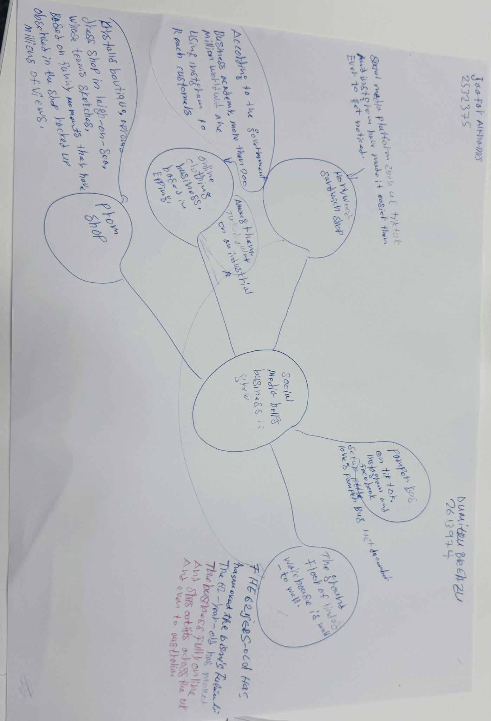

PART 2:
- Answer every question below in 1-3 full sentences.
- Use your own words. Do not use generative AI to answer these questions.
- Include a specific detail from the text when asked.
REMINDER
- The main idea is the overall message of the whole text.
- A key point helps to explain the main idea.
- A specific detail or example from the text shows that the key point is true.

- What is the main idea of the whole text?
How can social media influence and make a huge difference
on business.

- What is one key point that supports the main idea, and which specific example from the text shows this?
Social media and business.
For example, Lindy Loos Boutique is an online clothes shop because of the
Social media, the business is now worldwide and has fully moved online.

- What is a different key point that supports the main idea, and which specific example from the text shows this?
The different point is that people buy from people.
Faye Martin, a marketing expert from Laindon
Says social media has made it easier than ever,
for traders to reach new customers.

- Which part of the text do you think is most important, and why?
How can social media influence and affect the business
I believe this is the most important part because the goal
Is to understand business movement and to reach more customers
Social media is a solution to this.

Reflection:
- What did you find difficult in this task (including in-class components), and why was it difficult? The most difficult thing I faced was taking the right notes and understanding the subject more clearly because, for me, it was hard to find the right answer to the question

- What helped you with this difficulty, and how did it help you? My lecturer,
Explained how to take notes and scan reading.

