

Module Code: LCBB5001
Entrepreneurship
Assignment Title
Assessment component 1: Business Plan
Student name: Andrei Florin Stefan
Student ID: 2027355
Lecturer: Vasilios Tavlaridis

Contents
Executive Summary 2
Introduction 3
Business Description 3
Ownership And Legal Formats 3
Management of the Business 4
Evaluating the business idea using SWOT Analysis 4
Assessing the current external environment of Crystal Car Wash using PESTLE Analysis Model 5
Identifying the key marketing functions of Crystal Car Wash using Marketing Mix of 4Ps 8
Explanation of the target market and marketing strategies of Crystal Car Wash 9
Financial Forecast 10
Conclusion 12
References……………………………………………………………………………………………….13

Executive Summary
Crystal Car Wash is a car washing workshop in Maine Road, Manchester. Through generous investments it offers different types of auto caring services. It provides better quality car washing service with affordable prices in the Greater Manchester area. It is a sole proprietor company and starts with 5 additional employees. All the initial investment is invested by the Owner. It provides car washing services to residential households. Nearby upper-class households are our primary targeted segment (La Rocca and Snehota, 2021). They are willing to pay a premium price for better quality service because of our professionalism and trustworthiness. Crystal Car Wash Auto Care’s growth rate will be exceptionally high with respectable profit margins. After one year we also include an additional 5 employees as our business will grow exceptionally.

Introduction
Starting a new venture always brings risks and proper managerial skill is needed to convert these risks into favourable returns. Car washing businesses are now a growing one in the United Kingdom but there are few quality service providers. So, a new enterprise which prioritizes providing quality and premium service will be able to attract large amounts of potential customers (Landqvist, and Lind, 2022). Crystal Car Wash will be that kind of premium quality car washing service provider in the Maine Road Area of Manchester.

Business Description
This enterprise will be registered and the registration number will be 745*****. The business is located at 54 Maine Road, Manchester. The business will be a sole proprietorship business (Bratianu et al., 2021). This enterprise will employ 5 people and will add an additional 5 after one year. The owner will serve as the General Manager and will be responsible for all customer care services and will be associated with all dissatisfactory subjects.

Ownership And Legal Formats
This enterprise is a sole proprietor and it's registered under UK Law. The enterprise must comply with the arrangements set out in significant enactment with respect to work practices and compensation as well as worker security and wellbeing. Crystal Car Wash needs to follow in its operations are as takes after: The occupational health and safety Act, No. 85 of 1993 Consumers Affairs (Unfair Business Practices Act), No. 71 of 1998. Income Tax Act, No. 58 of 1962, Labour Relations Act, No. 66 of 1995, Short-Term Insurance Act, No. 53 of 1998 (Hardman and Rowell, 2021).

Management of the Business
Execution:The owner of any business organization execute and handle overall business procedures in marketplace. He provide effective directions to all business units like-marketing department, management unit, financial services and so on.
Employees:
Crystal Car Wash will start with 5 full time employees and will be able to add mobile workers during busy months in the winter season.
Professional Service/experts requirement:
Crystal Car need to maintain effective relationship with suppler and other business organization to take materials and conduct activities in business place.

Evaluating the business idea using SWOT Analysis
SWOT Analysis Model is one the best tools and techniques used in Strategic Management for creating and forecasting business plans. SWOT stands for Strengths, Weakness, Opportunities and Threats. It is a very useful tool for analysing the external and internal environment of business (Rahadi et al., 2020)
Strengths:  - Solid Management skills of the owner.  - Skilled and trained employees with technical excellence.  - Financial Support from the owner to easily reach break-even.  - Repeated customers.  - Professionalism and trustworthiness (Andrade et al., 2022). | Weaknesses:  - Would Not able to operate 24/7  - Few numbers of regular operational employees.
Opportunities:  - Nearby Upper-class residential households who are willing to pay a premium price for quality service.  - Located in busy area of Maine Road  - The Maine Road Area is commercially important and always filled with a large number of vehicles (Taherdoost and Madanchian, 2021).  - As there were no other car washing services workshop's nearby Maine Road, all the possible opportunities were easily taken by Crystal Car Wash. | Threats:  - Potential entry of new enterprise  - Mobile workers might not be available all the time  - Existing rivals in greater locality

Assessing the current external environment of Crystal Car Wash using PESTLE Analysis Model
PESTLE is one of the fundamental tools used in strategic business planning. PESTLE is an acronym which stands for the analysis of Political, Economic, Socio-cultural, Technological, Legal and Environmental factors. 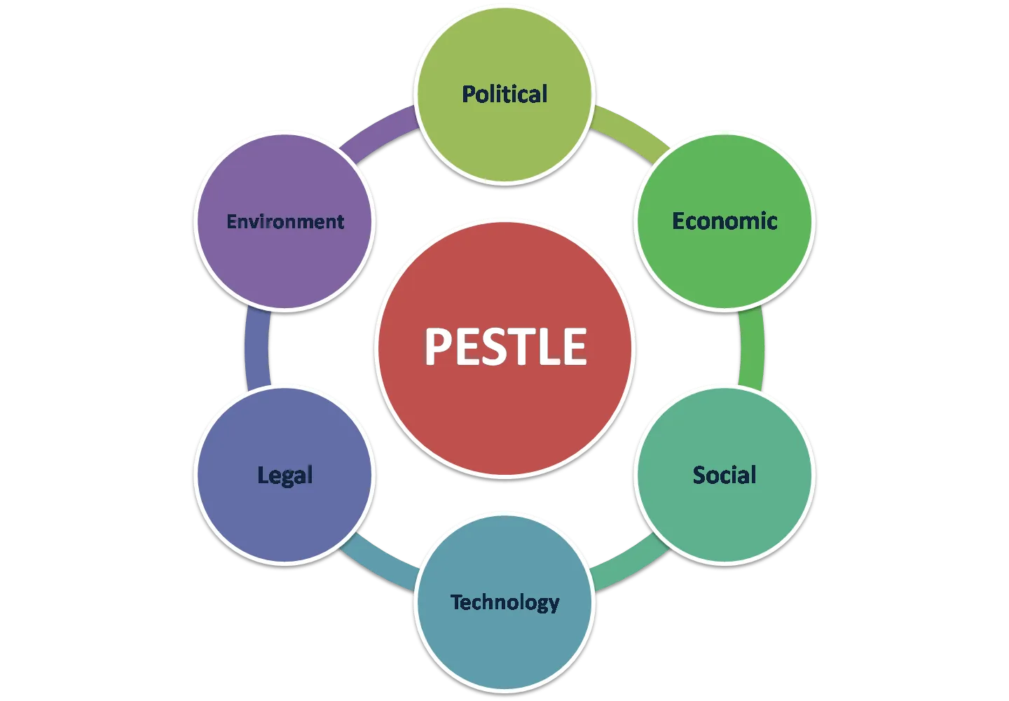
Figure 1source:(Rahadi 2022)
It includes the external environmental analysis of the business ((De Roche, 2021).)

P | Political Factors:  Political Factors included government legislation, political situation and these factors which were driven by the Central and local government actions and policies.  - The Greater Manchester area is politically stable.  - As a sole proprietorship business enterprise there will be no trade union directly concerned with Crystal Car Wash (Rahadi et al.,2020)
E | Economic Factors:  Economic Factors are somewhat related to the broader area of economy and it includes Inflation Rate, Interest Rate, Exchange Rate, Employment Rate and so on.  - The increasing unemployment rate will be a good opportunity to find employees.  - After COVID-19 pandemic there were lots of unemployed experienced car servicing employees who sought work.  - Income Tax rate is also another important and crucial factor.  - Repeated upper-class household customers will be exceptionally good opportunities for Crystal Car Wash (De Roche, 2021).
S | Socio-cultural Factors:  Socio-cultural Factors are these factors which have some influence over the society. Lifestyle, Demographic consideration, Attitudes and Culture trends all included by these factors.  - Nearby Upper-class residential households are leading luxury lifestyle  - Manchester has a cultural trend of spending more time with people rather than doing household work (Straw, 2020).
T | Technological Factors:  Today's world is moving faster and technology changes our world rapidly.  - Crystal Car Wash will use all the products from the authentic suppliers who also serve throughout the country.  - Crystal Car Wash will use the latest car washing products (MacKay et al., 2020).
L | Legal Factors:  Legal Factors are related to the regulatory requirements and the laws which should follow to conduct business in a particular area.  - All the employees will be treated equally.  - No matter of concern about the discrimination laws.  - Health and safety laws also followed strictly (Masola et al., 2019).
E | Environmental Factors:  Nowadays environmental factors are also a matter of concern because everyone wants to be more careful about nature and environment.  - All the products used by Crystal Car Wash will be safe and have no safety issues.  - All the wastage will be dumped and wastage Management will be one of our key focus areas because Crystal Car Wash will strictly follow environment friendly products (Mustchin and Martinez Lucio, 2020).

Identifying the key marketing functions of Crystal Car Wash using Marketing Mix of 4Ps
The 4Ps of the marketing mix includes: Product, Price, Promotion and Place. Using these four Ps is a very useful tool for analysing the marketing environment and making forecasts ((Asdi and Putra, 2020) The initial marketing will include advertising nearby Billboard in the Maine Road Area. This enterprise will provide various car washing services at different margins. Crystal Car Wash will operate from 07:00 AM to 08:00 PM on weekdays and 04:00 PM to 09:00 PM at weekends. The target market includes nearby upper-class households and all the vehicle operators and owners pass through by Maine Road.
Product:
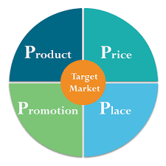
Product means what the firm will be offering to its targeted customers and here Crystal Car Wash will provide services as its products. Crystal Car Wash will provide two types of services. The very first one includes car washing at its workshop and the other one will be providing car washing services at nearby upper-class households' houses (Asdi and Putra, 2020).
Figure 2source (Naisir & Madani 2020)
Price:
Differentiation pricing strategy will be followed and there will be different pricing options for particular services. Crystal Car Wash will charge a premium price for better quality car washing services at households and will charge comparatively lower price for the services given at the workshop. This company need to sell different model car with very reasonable price than another business organization in marketplace. Sometimes this company also should offer different discounts program to attract consumers in complex business environment (Naisir & Madani, H., 2015)
Promotion:
There will be very few promotional activities. Promotional activities include various advertising budgets, direct marketing and also public relations. Crystal Car Wash will advertise in local popular newspapers and also in the Maine Road Circle Billboard. Later direct marketing also included using business cards given to those who visit workshops. The promotional activities also include some sort of social media advertising in the Greater Manchester area (Niazi et al., 2021).
Place:
Crystal Car Wash workshop at The Maine Road will be the primary location from where it will provide washing services. All the activities are monitored and executed from the workshop though it will provide services at nearby upper-class households' houses.

Explanation of the target market and marketing strategies of Crystal Car Wash
Market Segmentation:
Market Segmentation is another crucial factor because it will help to focus on targeted customers and to meet their expectations. Crystal Car Wash will not run to capture the whole pie rather it will strictly follow targeted segments from the potential customers (Gitahi, 2020). Crystal Car Wash potential targeted segment followed:
- Nearby Upper-class residential households
- Nearby Taxi Operators
Marketing Strategies
Strategic Marketing helps to formulate marketing strategies. Crystal car wash will follow Niche Marketing strategy to attract potential customers. Niche Marketing Strategy broadly it also called Differentiation Strategy which will be the primary focus. For conducting this the firm will highly focus on niche marketing to serve its core customers who don’t want to go for the workshop to wash their cars, where the firm will provide home service to the upper-class residential households (Morales, 2019).

Financial Forecast
All the initial investment will be made by the Owner. The total budget for the opening operating year will be nearby £50,000. The cost will include the initial one needed to start the business and the later one will be the operating cost needed for running the business for one year.
Fixed Cost:
Workshop Rent  12×£1000 | £12,000
Machinery Equipment | £6,000
Total Fixed Cost | £18,000
Variable Cost:
Car washing products | £500
Employees Salary | £2,000
Variable Cost per Month | £2,500
Total Variable Cost  (12×£2,500) | £30,000
Total Operating Cost: | £48,000

Crystal Car Wash will rent a place which will get prepared by the lender and it will cost £12,000 for one year. The contract will be further extended by the end of the year. Initial machinery equipment will cost another £6,000. After one year the operating cost will be near £48,000. And the sales forecast shows that Crystal Car Wash will be able to generate £6,000 per month which makes total revenue £72,000 by the end of the first operating year.
Regular Car Wash will cost £10 & the premium service will cost £30.
Regular Car Wash | £10
Premium Car Wash | £50
Regular Car Wash Projection per Month | 150
Premium Car Wash Projection per Month | 90
Revenue from Regular Car Wash Service | £1,500
Revenue from Premium Car Wash Service | £4,500
Total Revenue  Per Month | £6,000
Total Revenue:  (12× £6,000) | £72,000

This Projection shows that Crystal Car Wash will be able to generate £24,000 gross profit without taxation.
Total Sales Revenue | £72,000
Total Operating Cost | £48,000
Net Income Without Tax | £24,000

Conclusion
Crystal Car Wash will be able to 150% profit from its initial investment shown by the projection. This Projection is made by the primary data analysis using statistical software. All these data are collected from The Greater Manchester Area. Solid and proper management skills will be needed to generate profit and attract projected customers which will make Crystal Car Wash a successful new venture.

References list
Andrade, J.F., Kalakou, S. and Lopes da Costa, R., 2022. Exploratory analysis of seaplane operations in Greece: insights of a survey and SWOT analysis. European Planning Studies, pp.1-21.
Asdi, A. and Putra, A.H.P.K., 2020. The Effect of Marketing Mix (4P) on Buying Decision: Empirical Study on Brand of Samsung Smartphone Product. Point Of View Research Management, 1(4), pp.121-130.
Bratianu, C., Stanescu, D.F. and Mocanu, R., 2021. Exploring the knowledge management impact on business education. Sustainability, 13(4), p.2313.
De Roche, J., 2021. How Can Technology and Innovation Be Used to Alleviate the Climate Crisis in Developing Countries Through Mitigation and Adaptation? (Doctoral dissertation, Southern Connecticut State University).
Gitahi, W., 2020. Effect of Digital Marketing Strategies on Competitive Advantage of Transport Firms in Kenya: A Case of Uber (Doctoral dissertation, United States International University-Africa).
Hardman, J. and Rowell, N., 2021. The UK's director daisy chain: Empirical evidence of the interconnectivity of directors of UK publicly traded companies. European Business Law Review.
La Rocca, A. and Snehota, I., 2021. Mobilizing suppliers when starting up a new business venture. Industrial Marketing Management, 93, pp.401-412.
Landqvist, M. and Lind, F., 2022. Resource renewal in heavy business networks: the case of Modvion starting up in the Swedish wind energy context. Journal of Business & Industrial Marketing.
MacKay, B., Arevuo, M., Meadows, M. and Mackay, D., 2020. Strategy: Theory, Practice, Implementation. Oxford University Press, USA.
Masola, K., Rashied, N., Janse van Rensburg, N. and Venter, M., 2019. The impact of shebeens on the local economy: Evidence from Soweto, South Africa. Journal of Public Administration, 54(4-1), pp.861-872.
Morales, G., 2019. Marketing plan of the graphic design industry for small-business owners in the Central Valley (Doctoral dissertation).
Mustchin, S. and Martínez Lucio, M., 2020. The evolving nature of labour inspection, enforcement of employment rights and the regulatory reach of the state in Britain. Journal of Industrial Relations, 62(5), pp.735-757.
Niazi, N., Rashid, M. and Shamugia, Z., 2021. Role of Marketing Mix (4Ps) in Building Brand Equity: Case Study of Shell Petrol, UK. International Journal of Applied Business and Management Studies, 6(1), p.2021.
Rahadi, R.A., Hasibuan, M.A.H., Rahmawati, D., Aziz, R.H.A., Damayanti, S.M. and Witdarmono, G., 2020. Financial Feasibility Study for the Second Merchandise Store of PT Persib Bandung Bermartabat. International Journal of Criminology and Sociology, 9, pp.2031-2042.
Straw, A.M., 2020. Eye. Earth Pro (Beta v1. 0) Application Development and Spatial Financial Analysis Utilizing the Pestelm Framework (Doctoral dissertation, University of Southern California).
Taherdoost, H. and Madanchian, M., 2021. Determination of Business Strategies Using SWOT Analysis; Planning and Managing the Organizational Resources to Enhance Growth and Profitability. Macro Management & Public Policies, 3(1).
Naisir, M.T. and Madani, H., 2015. 4Ps: A strategy to secure customers' loyalty via customer satisfaction. International Journal of Marketing Studies, 7(4), p.78.

