Name | Student Number | Date | Lecturer’s Name | Your score
Petar Stanchev | 2505752 | 26.10.2025 | Arshad Sher | To be filled by the marker  ___/40
You will have 75 minutes to complete this assessment. It is divided into three sections: note-taking, paraphrasing and writing a paragraph.
---------------------------------------------------------------------------------------------------------------------
1. Take diagrammatic notes from the passage below using the space provided:

The university experience is not just about subject knowledge, but also about developing skills that will equip you for your future life. For starters, it's impossible to graduate without a range of people skills under your belt. You'll meet new people from different backgrounds. You'll also interact with lecturers, tutors and university staff almost daily. Another life lesson that university teaches you is taking responsibility for yourself, your own schedule and learning. A lot of university study is self-directed - it's up to you to plan and organise your work, juggle multiple projects and manage deadlines – you will need to develop self-motivation if you want to succeed. Let’s not forget learning how to overcome obstacles; whether academic, work-related or personal, you'll face your fair share of hurdles as a student, but you will develop resourcefulness and resilience in the process. If you were a bit unorganised before you went to university, you won't be by the time you leave. To successfully navigate student life you'll need to handle a variety of study, work, social and personal commitments and the only way to do this is with organisation and time management. Finally, university provides plenty of opportunities to work on and boost your confidence: you'll work in groups, deliver presentations, complete assessments and maybe even become a class representative.
Adapted from: https://www.prospects.ac.uk/applying-for-university/university-life/7-life-skills-youll-learn-at-university

Space for your notes (max 12 marks):
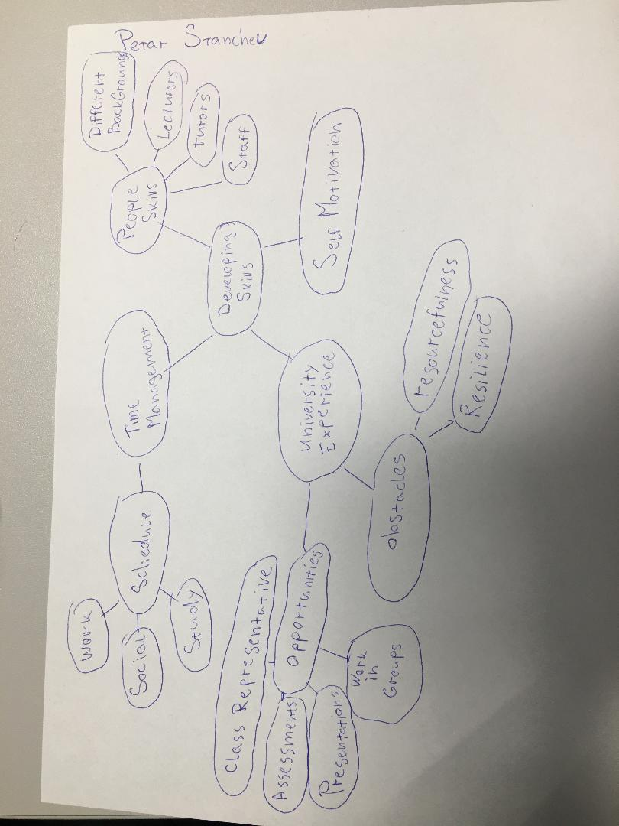

2. Paraphrase the following sentences (max 3 marks for each, max 12 marks in total):

a) To successfully navigate student life you will need to handle a variety commitments.

In order to success in as a student, one must overcome multiple challenges.

b) You will need to develop self-motivation if you want to succeed at university.
Developing self-motivation is key factor in order success in the university.

c) Many students find it challenging to manage stress during assessment periods.
Managing stress during assessment periods is found to be challenging from many students.

d) Frequent reading can help you become a more effective communicator.

One way that might help to become more effective communicator is to read frequently.

3. Write a well-structured paragraph (8 sentences) on the following topic:

Effective time management techniques for university students

Your paragraph must be written in full sentences (no bullet points) and in an academic style.

(max 16 marks in total)

_______________________________________________________________________________________________
One of the most effective time management techniques is the Eisenhower technique.
By using that technique, students can separate the tasks in four groups and determine their importance. That can help one to focus on more pressing or important task, free more time by deleting non-important task or delegating work that needs to be done, but the matter is not pressing. The technique can help the students to reduce stress, avoid being overwhelmed by vast amount of work. Eisenhower’s technique also can increase productivity and the ability to learn more effectively by freeing the student’s mind from minor task and helping to organize his time more effectively. This technique is not the only one that can help students to effectively organize their time, but is fair to say that it is one of the student’s top choices.

