Gareth Jenkins
Student number 99091195

October 18, 2023
A reflective response to a field trip experience from the perspective of my chosen discipline - archaeology.
Exploring the Humanities. HPHP4018. Block 1.
A reflective response to a field trip experience from the perspective of my chosen discipline - archaeology.
This essay will highlight the many emotions that I experienced during a recent field trip to Strata Florida Abbey and its twelfth century remains. (Austin, 2022 p.3-6)
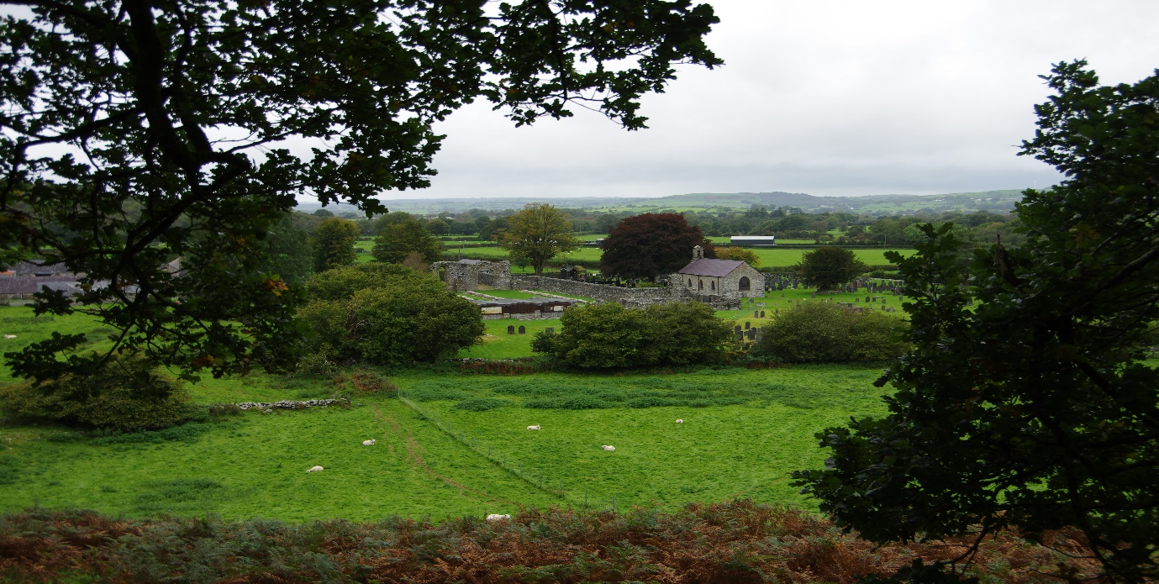
Figure 1 (Authors own 2023.)
Nestled in the middle of a Mid-Wales farming community, surrounded by the Cambrian mountains, with Iron Age hillforts, and evidence of early industry nearby, this is a historical landscape, a mystical landscape, which evokes several mixed emotions. One is immediately struck by its remoteness. There is absolute peace, only interrupted by the wind or an occasional bird song. (Austin, 2022 p.3-6) (Williams, 1889)
On a hill we are watched by a traveller, a pilgrim. Resolute in his gait against the wind, and, circled by soaring Red Kites, they watch the visitor below. 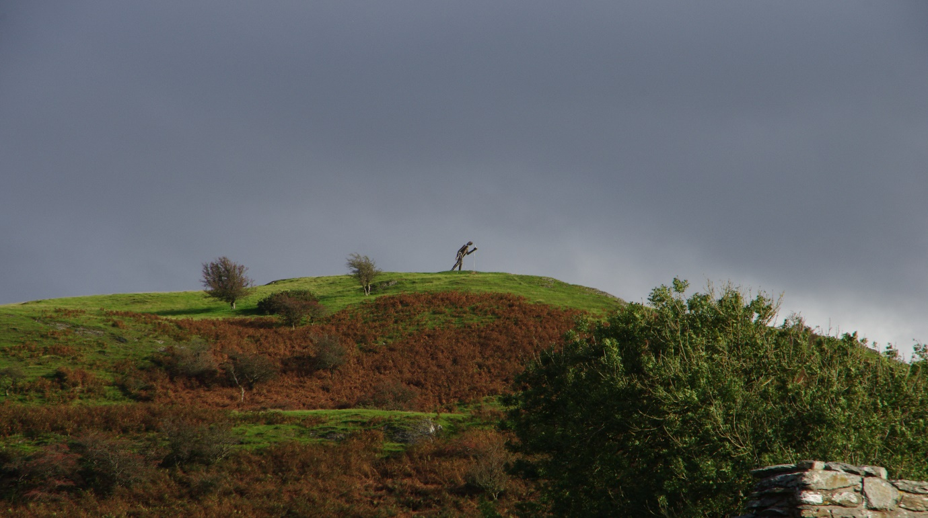
Figure 2 (Authors own, 2023)
In some ways this is a forgotten place, the abbey left to decay over time. But in other ways it is rejuvenated, by the work of the Strata Florida Trust. They are bringing the past back to life, in their museum and in the manner that they care for the abbey remains and promote its legacy to the history of Wales. (Robinson & Platt, 2007 p.3-55)
It is a place where archaeologists dig and look for answers to many questions. Hoping to solve the puzzles of the past. We are told of exciting new discoveries; radiocarbon result older than first thought! (Drew, 2023) Some are sceptical, others excited.
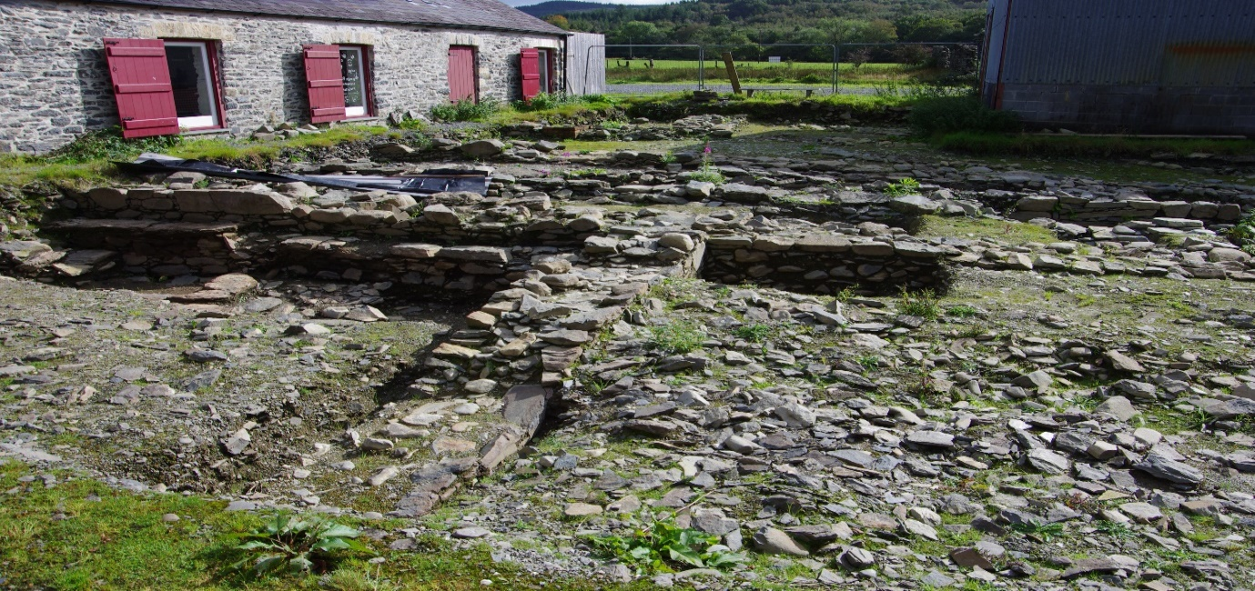
Figure 3 (Authors own, 2023)
There is a sense of sadness that what was an architecturally stunning abbey has been reduced to trace ruins. The west arch remains, in part, and gives us a hint of what once was. The guidebooks provide reconstructions of the size and status of the buildings. One can only stand in awe and imagine how the abbey once dominated the landscape. (Robinson & Platt, 2007 p.3-55)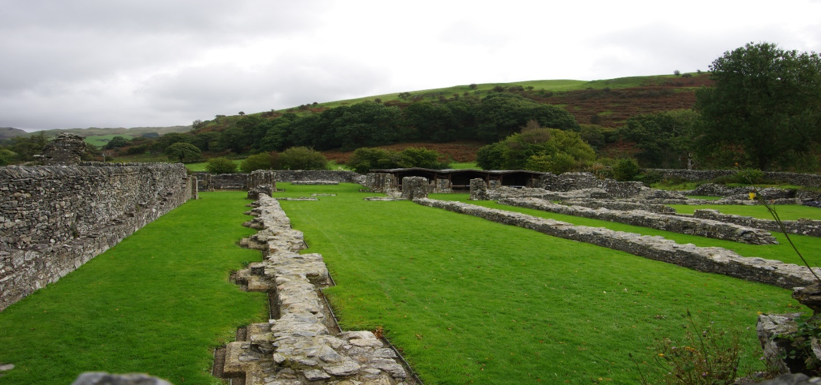
Figure 4 (Authors own, 2023)
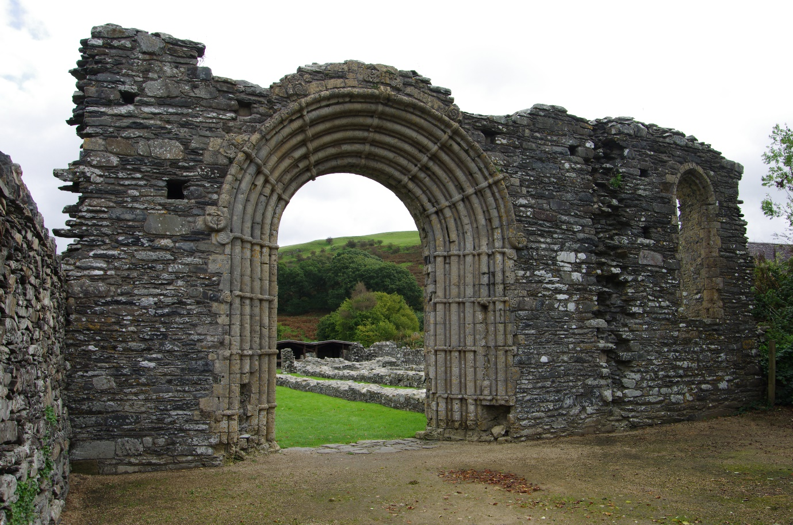
Figure 5 (Authors own, 2023)
The past has been re-used. There are several examples of the use of stone from the abbey in the construction of later farm buildings.
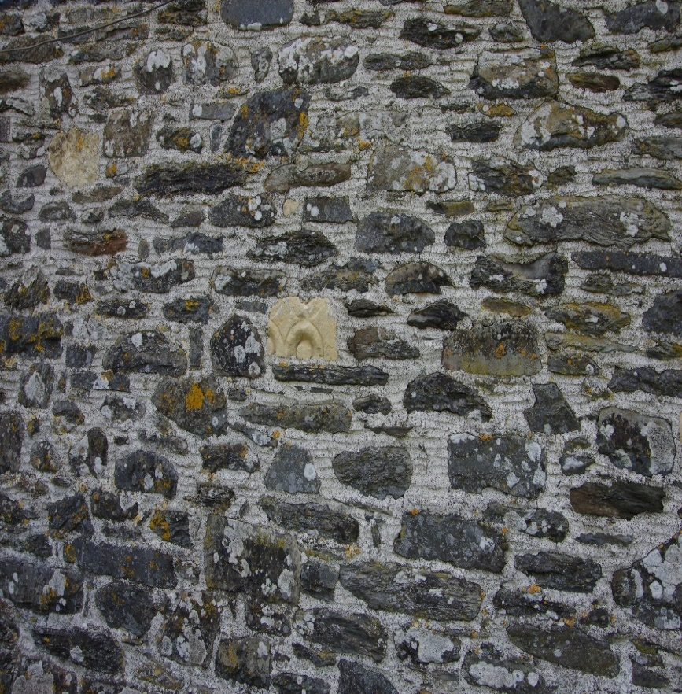
Figure 6 (Authors own, 2023)
The garden wall of the Abbey farmhouse is made of what appear to be parts of the abbey pillars, similar to the stones in the west arch. Does this show a lack of respect and irrelevance of the past or is it an example of early recycling and human ingenuity.
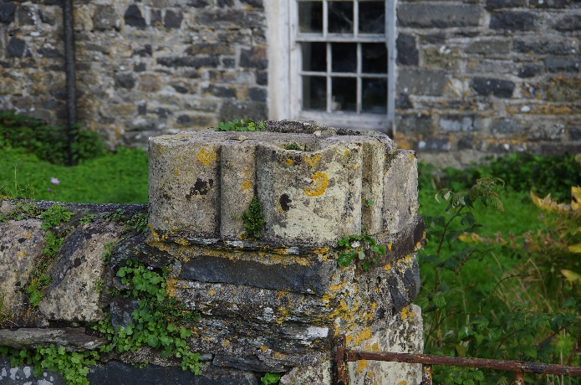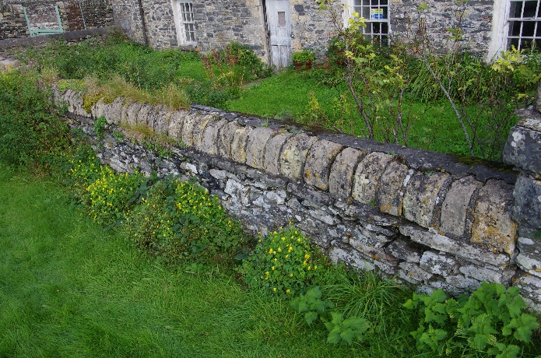
Figure 7 (Authors own, 2023)
There is an overwhelming feeling of remembrance, generated by the large cemetery that surrounds the abbey. Where Princes and commoner lie together. Remembered and commemorated in their own way. The Princes of Deheubarth buried near the altar of God within the abbey precinct. A statement of their royal status, and their belief in their god. (Austin, 2022 p.306) (Robinson & Platt, 2007 p.3-55)

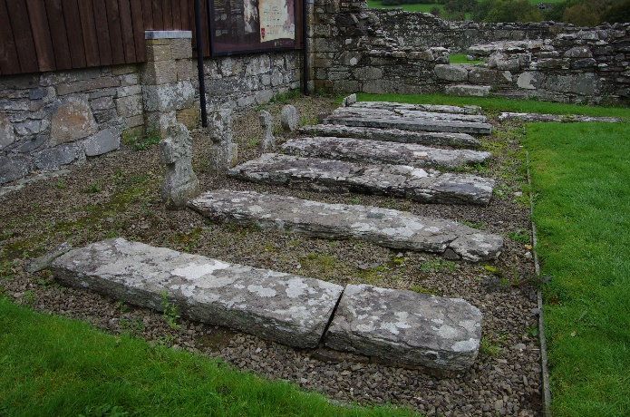
Figure 8 (Authors own, 2023)

In the nearby cemetery of St Mary’s church, Geoffrey Randall Calderbank is remembered as a ‘Husband, Father, Son, Brother, Priest and Friend.’ Both evoke a powerful story in their own way.
Also remembered are the fallen of conflict, a war fought in a distant land.
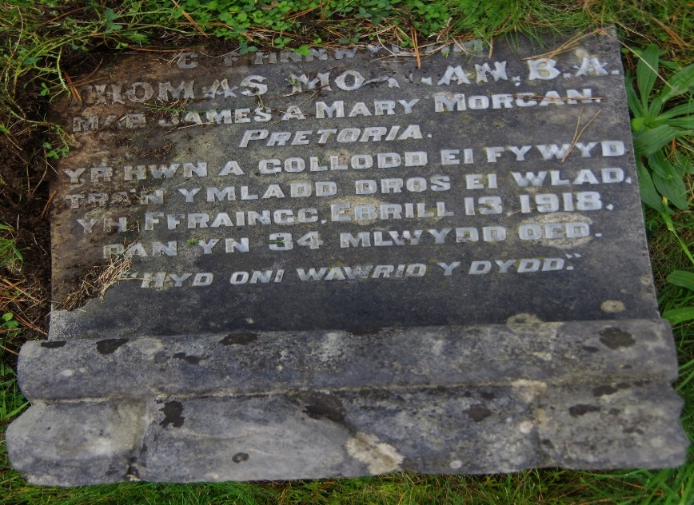
Figure 9 (Authors own, 2023)
Remembrance can evoke feelings of sadness and regret, of humour and love. From my own personal experience, I was here at St Mary’s church some thirty years ago to escort the coffin of my former sister-in-law at her funeral. She lies in the cemetery. Having returned for the first time since, I had to find her grave, just to say hello.
On a happier note, one cannot help but feel artistic inspiration when standing in this place. A peaceful, pastoral landscape. The mysticism of a remote and religious sanctuary. Architectural excellence and craft still visible, particularly in the construction of the west arch, and in the remains of the huge columns that once adorned the main structure.
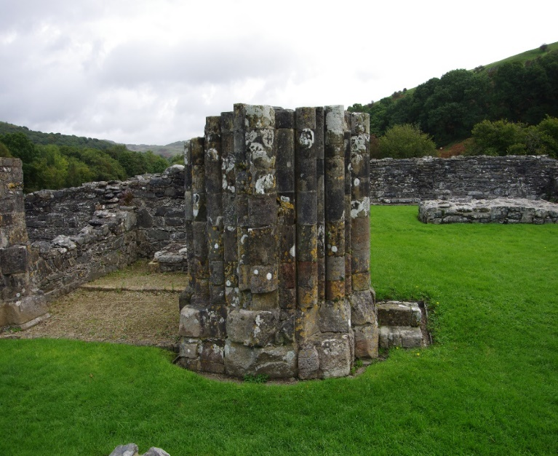
Figure 10 (Authors own, 2023)
The beautiful fourteenth-century floor tiles, with their designs and patterns which would have paved the floors of the abbey. Intrinsic in their message regarding the history of the abbey and its royal benefactors. (Williams, 1889 p.226) (Robinson & Platt, 2007 p.3-55)
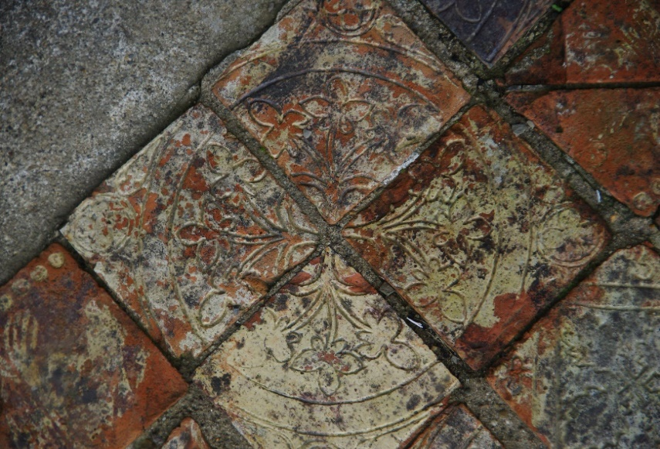
Figure 11 (Authors own, 2023)
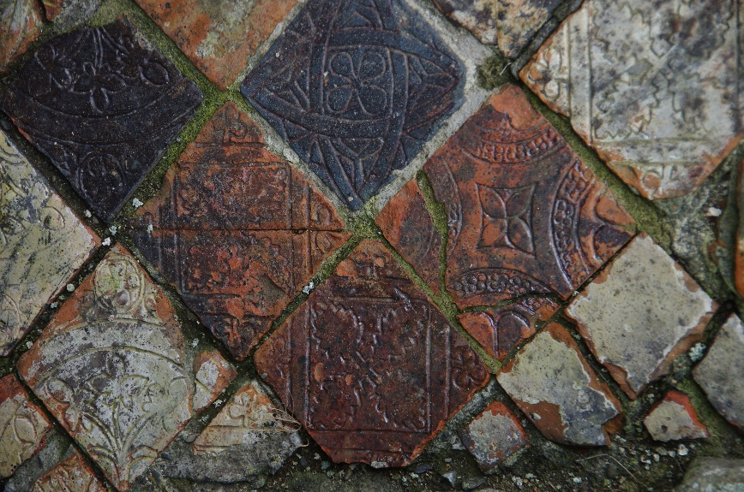
Figure 12 (Authors own, 2023)
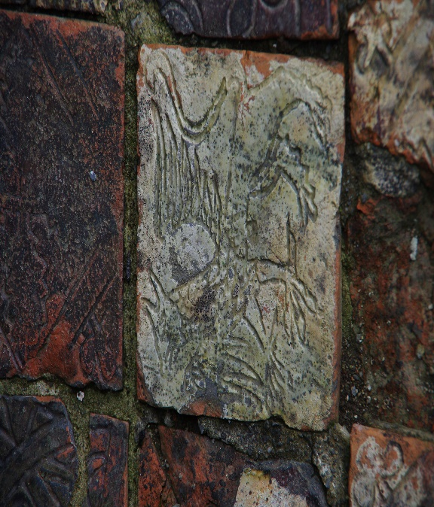
Figure 13 (Authors own, 2023)
Craftsmanship is everywhere if one chose to look. As does the graffiti of unscrupulous men. Is it disrespectful or is it a personal expression of being there, in that space, at that time. Believing or hoping that some future persons will see it and ask who?
Or does it have another, deeper meaning?
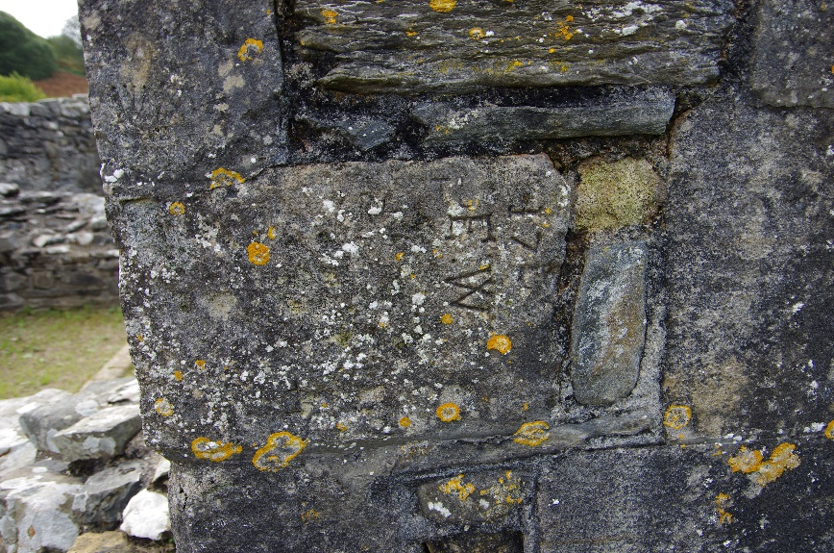
Figure 14 (Authors own, 2023)
The marks of the craftsmen, the masons, are still visible on some of the dressed stones. Serving to identify the mason or possibly to make sure the correct order and installation of the stones. Some may even say that they are there to ward off evil spirits. Whatever the reason they offer a unique connection to the construction of the abbey hundreds of years ago. (Williams, 1889 p.218-219)
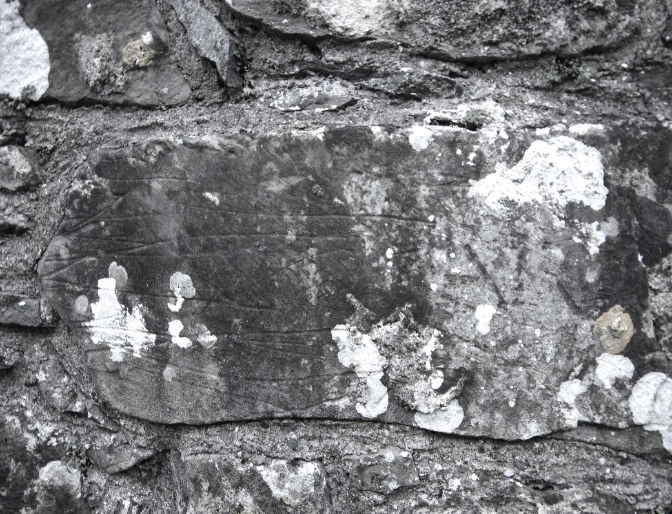
Figure 15 (Authors own, 2023)
They are not alone in providing a glimpse of the techniques used by the builders of the abbey. Where there were once windows at the rear of the Book store and Sacristy, evidence of holes drilled to hold metal bars with the lead infill still visible.
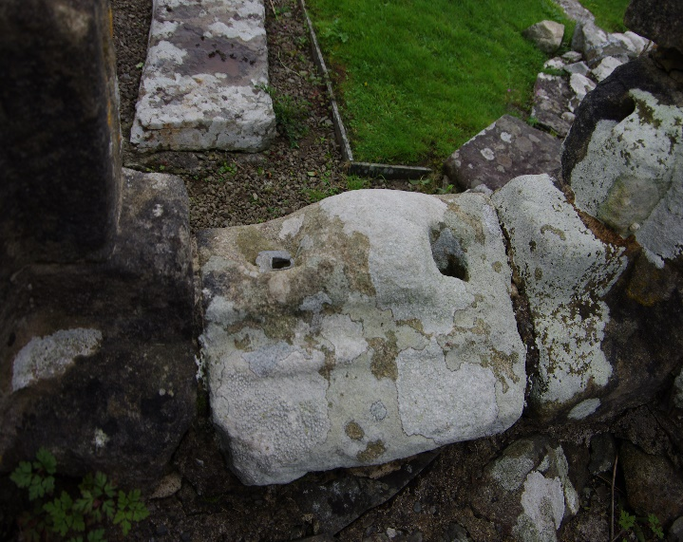
Figure 16 (Authors own, 2023)
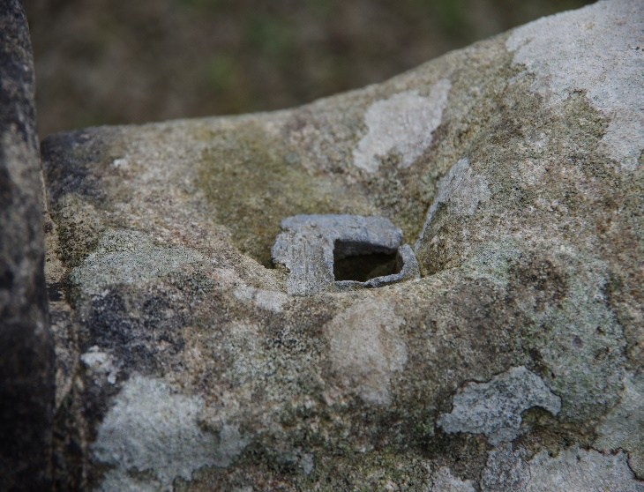
Figure 17 (Authors own, 2023)
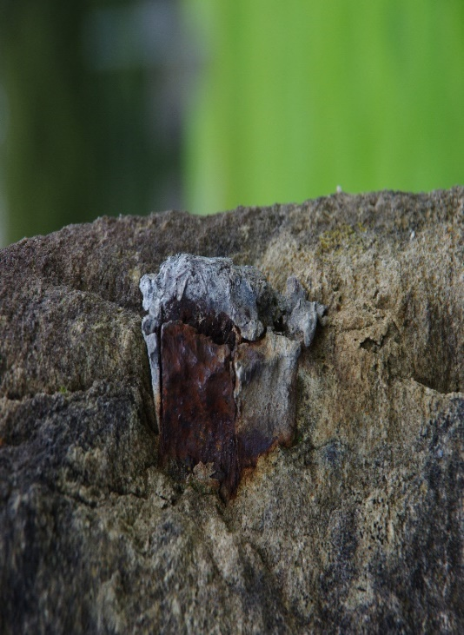
Figure 18 (Authors own, 2023)
Modern artists also express their feelings, with intricate stained glass inserts on a heavy and beautifully crafted iron gate. Adorned with exquisite patterns in iron, it gives the visitor an initial glimpse of what may lie beyond.
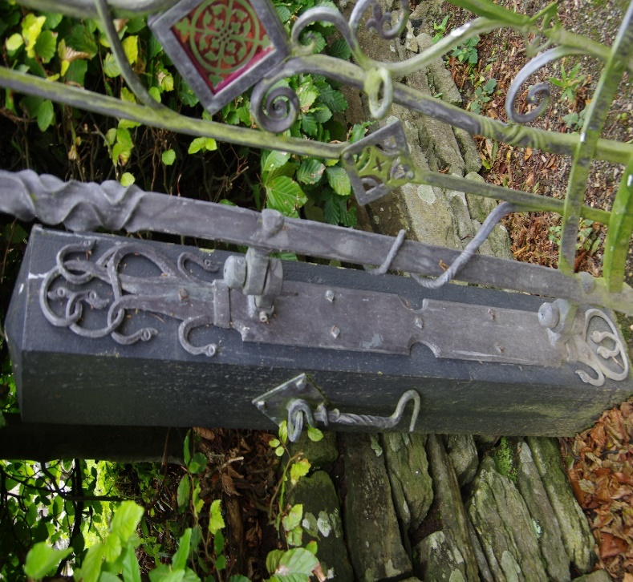
Figure 19 (Authors own, 2023)
It certainly inspired me to try something different, to be creative. A photograph taken through a glass orb to create an unusual illusion of the landscape. Did it work, I think so. It’s different!
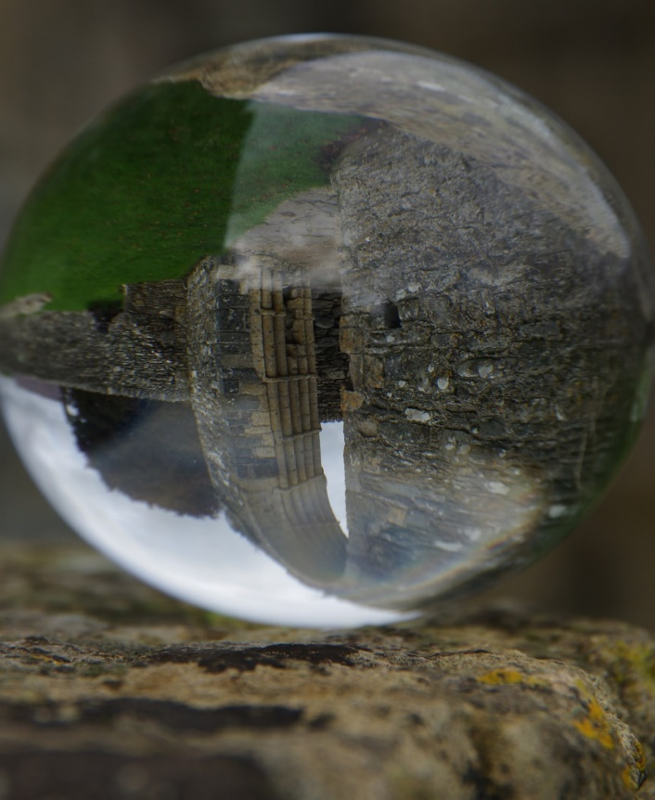
Figure 20 (Authors own, 2023)
There is a special relationship between the abbey, St Mary’s Church and the Abbey farm. They are inter-connected throughout history. (Austin, 2022 p.3-6) It is like reading a timeline of the history of this place. A timeline that continues with the work of the Trust. There are strong links to the wider farming community and to the landscape. My visit to Strata Florida has, for me, exposed a variety of deep emotions. A mixture of good memories and sadness, and a desire, perhaps even an obsession, to learn more about its origins, its architecture and its historical significance. It has awoken a buried artistic vision that I once had. It is an inspirational place. I have been back since the field trip, and I intend going again, to further experience its magic and for some peaceful reflection.

(1125 words)
Bibliography.
Austin, D. (2022), Strata Florida: The History and Landscape of a Welsh Monastery. Strata Florida Books Vol.2. Ceredigion: The Strata Florida Trust.
Burton, J. (2023), Life in a Medieval Cistercian Monastery. Strata Florida Books Vol.4. Ceredigion: The Strata Florida Trust.
Drew, Q. (2023), During conversation with group of students at Strata Florida. September 2023.
Kightly, C. (1988), A Mirror of Medieval Wales. Gerald of Wales and His Journey of 1188. Cardiff: Cadw.
Mynachlog Fawr in 30 Objects. Ceredigion: The Strata Florida Trust.
Roberts, G. [Vicar of Monmouth]. (1848), Strata Florida Abbey. Archaeologia Cambrensis, A Record of The Antiquities of Wales and It’s Marches, and The Journal of The Cambrian Archaeological Association. Vol.3 p.110- 136. London: W.Pickering.
Robinson,D.M. & Platt, C. (2007), Strata Florida Abbey [and] Talley Abbey, 3rd. ed.(rev.) Cardiff: Cadw.
Williams, S. W. (1889), The Cistercian Abbey of Strata Florida: Its History, And An Account Of The Recent Excavations Made On Its site, London: Whiting & Co.

