Name: Rebecca Cowley

Student Number: 1708411
BA Course Title: Illustration
Module: Research Practices
Assignment: Practices In Context

Word Count: 2407

Is it appropriate for children’s picture books to address subjects of a sensitive/ difficult nature?

Thinkers:

Babra Badar- Author of American Picturebooks from Noah’s Ark to the Beast Within (1976)
Joseph H. Schwarcz- Author of The Picture Comes Of Age: Looking At Childhood Through The Art Of Illustration. (1991)
Zhihui Fang- Author of ‘Reading Horizons’: Illustrations, Text, and the Child Reader, What are Pictures in Children's Storybooks for? (1996)

Key words:

Picture books
Cognitive Development
Censorship

Introduction

In my dissertation I will be discussing children’s picture books and whether it is appropriate to address sensitive/ difficult subjects to the reader. Within my research I will look at the history of children’s picture books throughout the past century and compare them to the modern, focusing on the use/ relationship of word and image as well as the trending topics of the time. I will also be looking into censorship within children’s picture books and the limitations of the subjects being discussed as well as how picture books affect the cognitive development in children. My aim for this dissertation is to come to a conclusion whether difficult subjects should be addressed to young children in picture books and/or should there be a limitation on subjects being addressed.

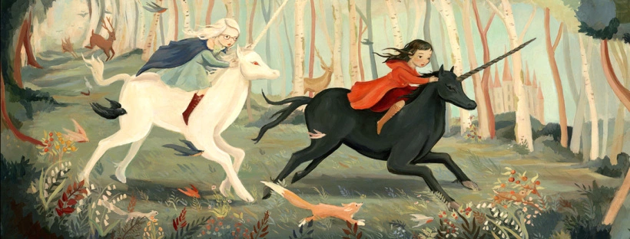
Day Dreamers: A Journey of Imagination, Emily Winfield Martin (2014)

Cognitive Development

“Visual perception is, so scientists assure us, our most important sense.”
( Schwarcz,1991, p.1)

In today’s age, our society is becoming increasingly saturated by material that is of both good and bad nature, which can directly influence our actions and decisions. In the last century with the rise of satellite TV, internet and social media, it has become increasingly easier for us to become exposed to visuals seen as controversial in nature. As we continue to consume this visual information throughout our adult lives for purposes such as entertainment, this also has an affect on younger generations of our society, as children are constantly taking in new information as part of their early development.

Unable to filter specific information, a child’s brain is quite similar to a sponge, meaning that all information is ‘absorbed’ and retained. New sights and sounds, colours and new forms/figures are all fundamental to the first stages of learning, and so from a young age picture books can play a massive role in our early development and learning process by introducing key skills fundamental for later life. In his book The Picture Book Comes of Age, Schwarcz states “...in order to safeguard the development of the child’s whole personality, we have to ensure a more or less balanced progression of the young person’s verbal and sensory, emotional and intellectual capabilities”. (Schwarcz, 1991, p. 3)

Picture books allow children to analyse the illustrations in depth, if they are struggling with a particular word/sentence, the image helps them along thus encouraging them to problem solve and link the image to the word; “In a way picture books provide this basic education about looking at and evaluating visual text.” (Karaman, 2012 p. 6), This can also correspond to early language skills which can help with fluency and comprehension, as the rhythm and rhyme of the words can aid them in understanding the sentences easier and making the story more enjoyable to read. Simple semiotics, signs, symbols and their meanings can also be introduced to the reader through the illustrations, for example, the traffic light system and how the colour green signifies the meaning of ‘go’ and the colour red for ‘stop’. From a 2015 study, researchers found that when comparing children who were interacting with picture books with parents to those that were not, the language picked up from reading picture books included more unique types of words;

“The text of picture books may be an important source of vocabulary for young children, and these findings suggest a mechanism that underlies the language benefits associated with reading to children”. (Montag, 2015)

As a result of these findings, we can deduce that not only do picture books help children read but also increase their vocabulary.

Children are also more likely to relate to characters in picture books if they are going through a similar situation, thus helping them engage with their emotions and coping mechanism to new situations in their lives. Sandmann explains in Multiculturalism and My Two Uncles: Promoting Understanding (1997, p. 22-30): “When children find a book that features a character whose situation they identify with, there is a release which enables them to take control and find a solution to their own problem.” As well as this, Another benefit to using picture books as a tool to help aid early childhood development is that it helps promote creativity and boost imagination. A great example of this can be seen in Day Dreamers: A Journey of Imagination (Martin, 2014), a picture book with this idea in mind, where children are encouraged to let the book’s illustration take them on a journey through the pages. In a sense, a picture book can be described as "a perfect vehicle for opening a child's eyes to the beauty and power of art" (Jacobs and Tunnell, 1996, p. 34). Not only can creativity be promoted by picture books through make-believe and play but also through an academic point of view as it helps them become visual thinkers as well as boosting their engagement in the classroom, encouraging them to act out what’s happening in the story through their own interpretation.

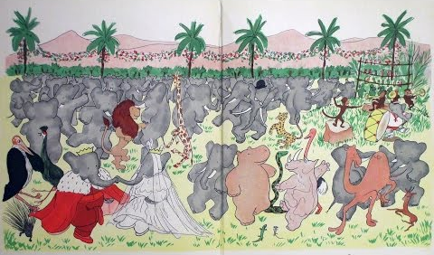
The Story Of Babar, The Little Elephant (Jean de Brunho, 1933)

Picture books

“...the picture book, which appears to be cosiest and most gentle of genres, actually produces the greatest social and aesthetic tensions in the whole eld of children’s literature.”
(Egoff, 1981, p. 248)

Picture books are a popular genre of book where stories are told through imagery/illustration rather than relying on text alone. This genre of book is loved by both children and adults for their range of inviting illustrations that appeal to our emotions and sense of wonder. Picture books set the foundation for a child’s key understanding of the correlation between text and imagery. As Bader defines, “As an art form, it hinges on the interdependence of pictures and words...On its own terms its possibilities are limitless.” (Badar, 1976)

As we are all aware, pictorial communication has been around for centuries, dating back to as far as the earliest prehistoric paintings where people would draw on cave walls using the material such as charcoal and burnt bone. Since then, Illustrations has been found accompanying many texts in books throughout history but only being but small accents and borders. It's not until recently that the concept of the modern picture book has taken shape, making its first appearance in the 18th century by John Newbury with his book A Little Pretty Pocket-Book in 1744. This would be the first of many books that were aimed primarily towards children, filled with enjoyable stories, rhymes and songs. These features would be accompanied by pleasing and colourful illustrations, with the sole intent to entertain its readers and as popularity grew, this new style of book followed through to the 20th century where the genre developed further.

As printing techniques and colour reproduction massively improved between the 19th and 20th century, writers and illustrators began increasing their focus on the illustrations instead of text, using the imagery to convey narrative and meaning. The push of demand for visual narrative/ storytelling could possibly be attributed to the rising popularity of the film industry around this time. With the lack of much text in the picture books, writers and illustrators were now creating more than just illustrations to support text but beginning to develop deeper narratives within the pictures. “Besides showing in visuals what the words say, illustrators develop ideas, giving additional details, and sometimes show more than the words tell... which the reader/viewer must then make sense of.” (Stewig, 1995, p. 5) An example of this can be seen in books such as The Story Of Babar: The Little Elephant (1933). This children’s picture book was iconic for the large, colourful illustrations that covered the full double page spreads.

Up until this time, childhood in the eyes of society was considered idealistic, carefree and a period of our lives for pure enjoyment. As Kiefer comments, the implied target audience at the time were Caucasian children, particularly from middle-class families and so certain themes were considered rather taboo such as the mentions of war and death:

“The Great Depression, World War II, and the Korean War were not in evidence in the picture books selected as Medal and Honor Books during this time, nor were death, divorce, or dispute...The content of the books was lyrical or humorous, clearly meant to inspire or delight children books.” The Art Of The Picture Book: Past, Present, and Future (Kiefer, p.15)

Yet, as time progressed, with the development of technology and social changes in the 1960s, children began learning about more serious themes in the world, most notable being the Vietnam War and the Civil Rights Movement. This caused a significant change in how picture books were being consumed. Writers and illustrators started referencing more themes that reflected real life ending the age of idealised childhood. More books such as Where The Wild Things Are (1963) started appearing on the market, discussing more serious themes such as isolation, longing, loss and escapism. Moreover, since the picture book has evolved so significantly through the years it is no wonder that it has attracted people from other groups/ ages; Schwarcz explains: “A stage has been reached where significant picture books are being created that are of interest to adults, not only as parents, or in any professional capacity, but as persons open to the influence of the arts.” (Schwarchz, 1991, p. 6). Perhaps this could also explain the dramatic change of themes being discussed in the books, to appeal to the now wider audience.

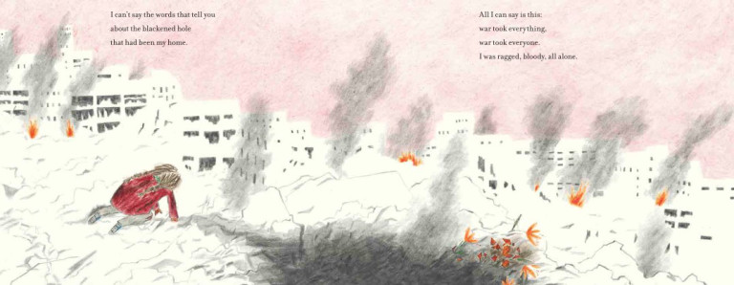The Day The War Came, (Nicola Davies, 2018)

Censorship

Following onto my final keyword of choice. ‘Censorship’. The act of censoring is the prohibition of a section from a book/ tv show or any other form of entertainment deemed as inappropriate/obscene. Themes of difficult and sensitive topics have increasingly appeared in children’s literature through recent years, mostly discussing social issues and family issues such as divorce, loss and separation etc.

Censorship in children’s picture books has always been a point of debate but heightened since the release of books from the early 1960s that touched on more real-life problems and issues that children face. In April 2016 a set of panel talks in New York City took place to discuss this called ‘Who Are You to Say? Children’s Literature and the Censorship Conversation.’ In this discussion, a group of authors, children’s literature experts and experts gave their opinion and experience with the topic. The author behind Beyond Magenta (Susan Kuklin, 2014) a children’s book about transgender teenagers, expresses her reasons for writing the book. “Kids are getting hurt; some are getting murdered, and no one has a voice...It’s a very odd feeling, coming from the inside out.” (Kuklin, 2016). The publisher of the book, Hillary Van Dusen also states that publishing Beyond Magenta “...was a groundbreaking proposal”.

Many books such as this have been ‘challenged’ through the past years for their controversial themes. For a book to be ‘challenged’, it can be defined by saying: “a formal, written complaint, filed with a library or school requesting that materials be removed because of content or appropriateness.” (Pen America, 2016) This act can threaten children’s knowledge of the world around them immensely as some themes are just easier to explain to children in the form of imagery, especially if the child is able to identify with the situation being portrayed. In The Analysis of Visual Storytelling On Children’s Books, Author Aylin Karaman (2012) argues “The perception of appropriate content for children is a significant issue about the picture books. That perceptions are rapidly changing by the time. As well, they are different from across the cultures. That’s why there isn’t any absolute right content for them.” (pg. 1)

Books touching on sensitive topics such as sexuality, puberty and the transgender community have been challenged time and time again. An example of a book that was challenged for homosexual themes was And Tango Makes Three by Justin Richardson (2003). This was a book based on a real-life story of two male penguins that raised a foster chick in New York Central Park Zoo. Themes that also caused it to be challenged were that is was "anti-family" as well as "promoting the gay agenda.” (WendyLibrarian, 2018). A suggestion for this may be because the idea of these themes goes against the beliefs of the population with religious backgrounds or perhaps simply their culture is against it. In contrast to this, books containing themes as such allows the young readers to “open up their personalities to the complex social realities surrounding them; to recognise other persons, other groups and strata, other people and cultures.” (Schwarcz, 1991, p. 12)

Some books that focus on the topic of war and modern conflict for example, on the other hand, seem to be totally appropriate. Nicola Davies’ The Day The War Came (2018) is about a young girl, fleeing war and becoming a refugee, however, the story and imagery does not go into detail but uses simple metaphors and change in colour to imply tension and difficulty. As a result, the book received positive feedback and has become a book designed to help children through times where they feel lost or alone. This can also relate back to Schwarcz’ comments where he talks about how certain problems and stress factors can “appear in a child’s life suddenly and harshly” (Schwarcz, 1991, pg. 21) therefore a certain degree of stress is unavoidable in childhood whether it be a loss of a family member or like with the book mentioned, war and conflict.

Conclusion

In conclusion, it is clear to see that the picture book has come a long way from its original form, needless to say, “...The picture book is well on its way to becoming a genuine new art form.” (Schwarcz, 1991, p. 5) But with the endless exposure to sensitive issues through social media, news and real-life events that are happening around us, we begin questioning whether the idea of ‘challenging’ a children’s book which discusses the same issues is becoming redundant if children are already being exposed to these themes through other sources. We could also question whether it’s truly acceptable for children’s books to continue being censored for certain themes considered as ‘inappropriate’, especially if these themes go without explanation to a child’s curiosity and developing knowledge. This has led me to the question I will be exploring further in my dissertation; ‘Is it appropriate for children’s picture books to address subjects of a sensitive/ difficult nature?’

Bibliography

Schwarcz, J.H (1991) The Picture Comes Of Age: Looking At Childhood Through The Art Of Illustration. Chicago: American Library Association

Karaman, A. (2012) The Analysis of Visual Storytelling On Children’s Books. Available at: https://www.researchgate.net/publication/310766498_The_Analysis_of_Visual_Storytelling_on_Children's_Books
(Accessed 8th May 2019)

Egoff, S. (1981) Thursdays Child. p.248 Cited in Karaman, A. (2012) The Analysis of Visual Storytelling On Children’s Books. Available at: https://www.researchgate.net/publication/310766498_The_Analysis_of_Visual_Storytelling_on_Children's_Books
(Accessed 8th May 2019)

Badar, B. (1976) American Picturebooks from Noah’s Ark to the Beast Within. New York: Macmillan Publishing.

Stewig, J.W. (1995) Looking At Picture Books. Wisconsin: Highsmith Press.
Sandmann, A. (1997) Multiculturalism and My Two Uncles: Promoting Understanding. Review 33 22-30. Cited in Bowen, D.N. (2007) Addressing Sensitive Issues through Picture Books. Available at: https://encompass.eku.edu/cgi/viewcontent.cgi?article=1015&context=ci_fsresearch
(Accessed: 7th May 2019)

Fang, Z (1996) ‘Reading Horizons’: Illustrations, Text, and the Child Reader, What are Pictures in Children's Storybooks for? available at: https://scholarworks.wmich.edu/cgi/viewcontent.cgi?article=1280&context=reading_horizons
(Accessed: 7th May 2019)

Jacobs and Tunnell, (1996) p. 34 cited in Fang, Z (1996) ‘Reading Horizons’: Illustrations, Text, and the Child Reader, What are Pictures in Children's Storybooks for? available at: https://scholarworks.wmich.edu/cgi/viewcontent.cgi?article=1280&context=reading_horizons
(Accessed: 7th May 2019)

‘Top Ten Frequently Challenged Books Lists of the 21st Century’, American Library Association,
http://www.ala .org/bbooks/frequentlychallengedbooks/top10. Cited in Pen America, (2016) Missing From The Shelf, Book Challenges and Lack of Diversity in Children's Literature Available at: https://pen.org/sites/default/files/PEN_childrens_lit_report_FINAL_online.pdf (Accessed: 7th May 2019)

Burnett, M. (2016) ‘Children's Literature and the Censorship Conversation: Dialogues on Challenged Books’ Available at: https://www.publishersweekly.com/pw/by-topic/childrens/childrens-industry-news/article/70037-children-s-literature-and-the-censorship-conversation-dialogues-on-challenged-books.html (Accessed: 7th May 2019)

Kuklin, S. and Dusen, H.V. (2016) Cited in Burnett, M. (2016) ‘Children's Literature and the Censorship Conversation: Dialogues on Challenged Books’ Available at: https://www.publishersweekly.com/pw/by-topic/childrens/childrens-industry-news/article/70037-children-s-literature-and-the-censorship-conversation-dialogues-on-challenged-books.html (Accessed: 7th May 2019)

Kiefer, B. (2011) The Art Of The Picture Book: Past, Present, and Future from The Newbery & Caldecott Awards 2011. Chicago: American Library Association

Montag, J.L (2015) The Words Children Hear: Picture Books and the Statistics for Language Learning. Available at:http://www.readingrockets.org/research-by-topic/words-children-hear-picture-books-and-statistics-language-learning
(Accessed: 8th May 2019)
WendyLibrarian (2018) Banned And Challenged Children’s Books. Available at: https://epl.bibliocommons.com/list/share/69128707/70680896?page=2
(Accessed: 8th May 2019)

