Managing Projects in the Organisation
BMSW 5104

Student - Rume Meah
ID - 1813924
Lecturer – Paul Ranson



Table of Contents
Page
- Aim…………………………………………………………………………………………...3
- Method……………………………………………………………………………….………3
- Introduction……………………………………………………………………….…………3
- The Iron Triangle…………………………………………………………….……………..4
- Working out the SCOPE……………………………………………………..……………6
  - Steering Group……………………………………………………………………………..6
  - User Stories………………………………………………………………………..……….8
  - Waterfall Technique………………………………………………………………………..9
  - Chevron Technique………………………………………………………………………..10
  - Microsoft Planner…………………………………………………………….……………11
  - Gantt Chart…………………………………………………………………………………13
  - Estimating Time with Wisdom of the Crowd…………………………..………………..14
  - Estimating Cost with Wisdom of the Crowd……………………………………………15
- Conclusion……………………………………………………………………..………….18
- References………………………………………………………………………..……….19

- Aim
The aim of this project is to reallocate to the Sparkhill Warehouse as smoothly as possible, whilst running the existing shop the

- Methodology
To achieve this, I will be using various tool and methods to streamline the relocation. We will be looking into the methodology of the iron triangle; this explains the criteria that we will be working towards. In addition, we will be utilising Microsoft planner (like Trello), this will help prioritise tasks, how long it can be expected to take. “Wisdom of the crowd” theory and Polleverywhere (website), these will help with the costing and time tasks can take. Gnatt chart, is a visual chart that shows the progression of the tasks.

- Introduction

Vintners Antiques is a well-known trusted, long established family brand run by 3rd Generation, Doreen and Denis Vintners. Doreen is an accredited accountant, and Denis is the company purchaser, travelling all over the UK to acquire stock. The staff are experienced in their expert area, Suha Omani oversees customer service, Omar King is the shop floor manager but has valuable working knowledge of all functions of the business.

At present high street shops are closing and demand are geared towards internet buying. Vintners are in the process of selling their high street shop to Tesco’s and relocating to their warehouse in Sparkhill. Vintners have decided to make the move to predominantly sell online but will be receiving customers at the warehouse premises. Vintners need to refurbish their Warehouse to make additional offices and customer friendly.

- The Iron Triangle

The Iron Triangle is (Pollack, Helm and Adler, 2018) is a project management tool which helps define the restrictions within a project. It incorporates the 3 key basic elements (fig 1) required manage a project. Movement of one element will put pressure on the remaining two i.e. If Vintners wanted to build a hi spec office regarding design and furniture, trying to acquire the right material will put pressure on Time as opposed to buying high street office furniture. The Iron Triangle is only as good as the user, input. It has been noted that effective management is the central part project success.

SCOPE – TIME
All projects have a scope which meet the requirements of the project as in information, materials, software etc. The larger the scope the more time is required. If there is not enough time, then it will limit the Scope. Scope needs to entail what is an important requirement for the project, what needs you have, what you would like, what you would like but not need.

TIME – COST
If you have high quality expectations then you require more money and time, if your time is restricted then you have less scope, but this will impact your quality. The resources that you have impact time, skilful staff equates to less time require to do a task. You cannot quicken a process if you need a certain amount of time. A sequence of certain tasks are wholly dependent on the previous task being completed.

COST – SCOPE
You can favour cost over scope or vice versa but this is dependent on the skills of your staff. The costing will be on the things that are needed. Costing does not necessarily improve functionality so Quality can be lessened.

Once all your requirements of SCOPE-TIME-COST are established, it will impact the internal change of your project.
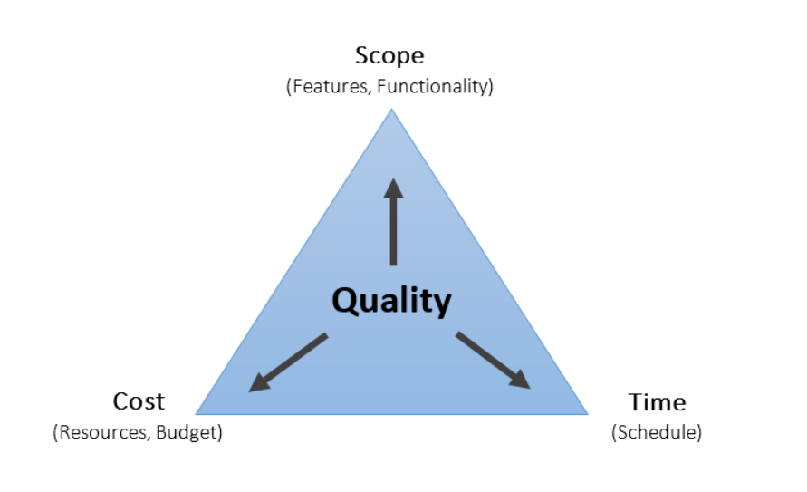
Fig 1

- Working out the SCOPE

5.1 Steering Group

- Why have a steering group?

Steering Group are made up of stakeholders, internal and external, they can strategically direct and govern and support the project manager. (Karlsen, 2020) in turn building trust.
Our Steering Group is the advisory Committee who will provide guidance on key issues, this includes all members of staff. Each staff will be accountable to the task that are given (fig 9). These key tasks have been allocated due to staff experience as everyone has a specialist area.

Steering Group

Roles and responsibilities –

Nominee | Role | Duties | Why
Doreen Vintners | Executive Sponsor | Ultimate responsibility to  approves changes to scope/ deliverables  Provides the budget | Owns the Company, budget is defined by Doreen
Rume Meah | Project Manager | Reports to Sponsor.  Receives directive from Sponsor.  Participates and approves plans.  Provides status/ progression update to Sponsor.  Manage and supervisors team members.  Reporting, provides recommendation, monitor, approves jobs order, risk analysis.  Motivates/ Mediate team members, set milestones  Makes sure to deliver on time, within budget to achieve goal. | Specialist in Project managing, 5 years’ experience, have had various successful projects implemented.
Omar King | Project team Leader | Assigned to team activities Responsible to contribute given objectives and deliverables | He has value of knowledge and expertise in the upkeep of the shop due to being an allrounder, he knows customers, handling of antiques etc
Suha Madani | Project Team member | Assigned to team activities Responsible to contribute given objectives and deliverables | Is the face of the company, customer services, has years of experience.
Denis Vintners | Project Team member | Assigned to team activities –  Responsible to contribute given objectives and deliverables | Has wealth of experience to products and external consumers.

Another approach that can be used is the agile approach which focuses on results rather than a predefined process. Kanban is an agile framework leaning towards complex projects. As this project is relatively straightforward procedure, we will be using the traditional method. Traditional management approaches are based on (Linke, 2019) planning and prefabricated organisation. The agile approach relies on self-organisation and distinguishing what is considered important, not less important.

5.2 User Stories

User Stories are (Brinkkemper et al. 2016) a popular method for representing requirements using a simple template such “as a (role) I want (goal), so that (benefit)”.

These are tasks that you deem important to the project, everyone has their own expertise, collaboration with stakeholders and staff is the key to success to minimise potential problems when planning your user stories. There are attributes to consider when writing stories, they must be independent - avoid dependences between stories, Negotiable – they are not requirement or a contract that it must be implemented, stories are meant to be functional, reminders, Valuable to Users/ stakeholders, Estimatable – must be able to guess how big the story is and how it impacts on the whole. Small – if the story is too big then you cannot use them in planning, Testable – they must be testable, once they pass the test only then are, they are usable.

I will invite via email, external stakeholders (implement user stories workshop), and staff to contribute tasks/ ideas through Microsoft Planner, this provides a feel of what type of tasks we could require. This would be in the format of user stories i.e. I as a MANAGER, I WANT to hire removal van to transport my antiques BECAUSE they are delicate and can break.

There will be many user stories but how do you prioritise, there are numerous techniques available as User stories will be evolving, throughout the project (Cohn, n.d.). A set of techniques for gathering can be applied to lead in the right direction. User stories should be short and direct, once done, open ended questions will be asked to understand the essence of the users needs. Open ended questions provide an infinite array of answers, they also are instrumental in encouraging (Sabilah and Manoy, 2018) intellectual potential, you can also provide multiple correct answers, ultimately, we choose which one is most beneficial. Providing questionnaires is also another way of gathering information you have about user stories, if you have a large user population, questionnaires can help prioritise.

The risk to user stories is that if we do not look at the root of the problem then more than likely we will end up end up in quick fixes. For long term sustainability we need to look at the symptoms rather than the problem. User stories does not necessarily help users (Hudson, 2013) as these are usually written about adoptive roles not considering the needs and requirements of the real users, if they are written by the wrong people at the wrong time then the project will suffer. The timing and the understanding the input of people is very important or else we will have a flawed product.

5.3 Waterfall Technique

This is a traditional technique (Battoia, 2019) which depicts the flow of a waterfall by a one-way dependent sequence (fig 4). The basic principle is to allow users to add to this method, you cannot schedule something that is not consistent, it must agree with the plan.

The advantages of the waterfall method are that it can adapt to shifting teams and provide a more robust scope. It is structured and provides time to change your objectives, on the downside it is not adaptable and has design constraints, it may delay user feedback until is too late because of the step-by-step method. I advise that these can be minimised due to collaboration with the team when providing root cause, user stories.

Agile approach is the most effective and fitting software approach, but software engineers prefer the Waterfall technique in comparison because (Chan, 2021), it does not place, or require participation from the client. Developmental Software in essence is a step-by-step process, you must complete one task before you can go to the next task. Because of its simplicity, software engineers have real time data to process at any given time. However, Waterfall does not guarantee client satisfaction, if the planning of user stories is not scrutinised then you will have a product that does not deliver

5.4 Chevron Technique

Once we have acquired all the tasks necessary to complete this project, the next task is to use the chevron technique (Heagney, 2016) which defines the importance your task in accordance with what is a MUST HAVE, WANT TO HAVE and NICE TO HAVE (fig 2),

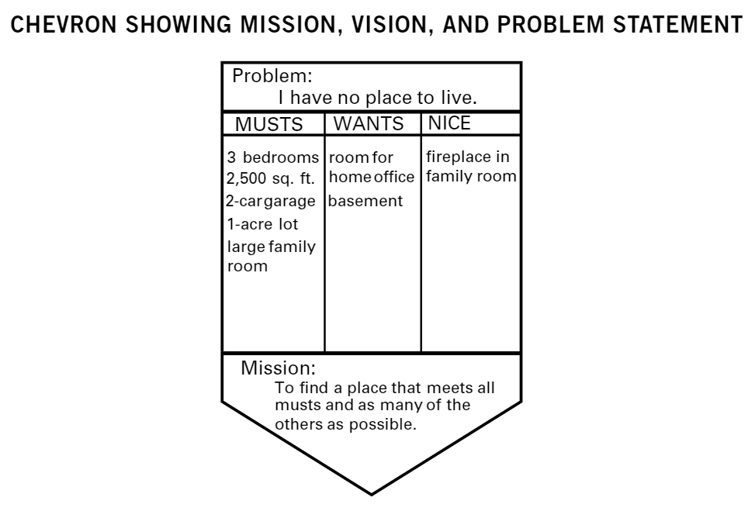
Fig 2 (Heagney, 2016)

Problem – High street shop, want to relocate to Sparkhill Warehouse, but there are no plans in process yet.

- Must have – Utilities up and running in warehouse, removal vans etc
- Wants to have – Studio room in Warehouse to take photos of antiques etc
- Nice to have – State of the Art Surveillance cameras fitted etc

All the user stories that we have accumulated will now be categorised into each swim lane, this is now the start of the process, of who does what.

Mission – To be up and running in the Warehouse in 3 Months (2 weeks contingency)
  - Microsoft planner

This is a software tool we will be using (fig 3), like the Trello software. As shown in the presentation, Trello uses story boards, stakeholder input etc. But there is many planning software available but essentially all projects use the same data to be manipulated to each software. We will be using Microsoft planner, like Trello (fig 4), invites to relevant stakeholders is required. I will require team input on the tasks that they feel are essential/ non-essential requirements.

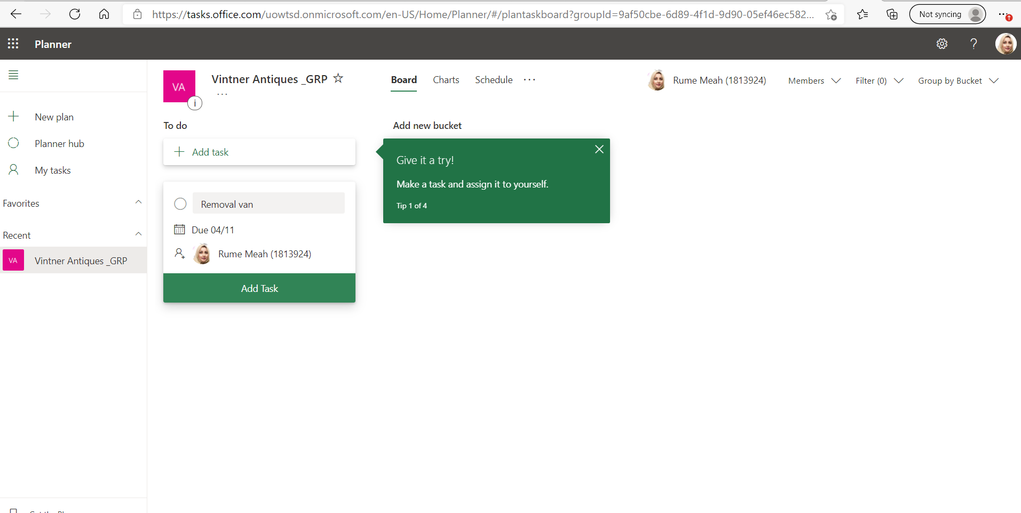
Fig 3

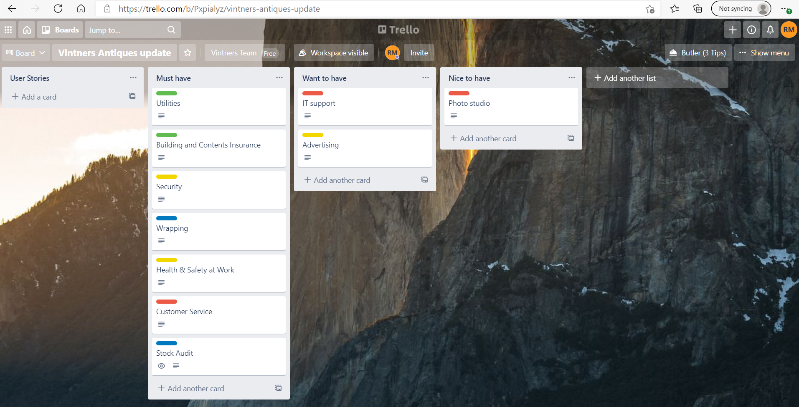
Fig 4
Using a software planner reduces any inconsistences that may arise when using a paper planner as real time tasks can be cross checked with other tasks. They help reduce time, provide forecasting, improve team collaboration by discussing dependences, task, timeline etc. Software planners have inbuilt algorithms, which help sustain the flow of your tasks.

Fot this project, meetings will be held daily to discuss where we are and where we are going, have we met our present objectives? We will use the stand-up 10-minute meeting protocol (Stray, Sjøberg and Dybå, 2016), this is an agile practice meeting where everyone stands up and delivers what they have done and what they are doing on each given day. This improves communication and everyone one knows where everyone is at i.e., if a task delayed, how soon it can take place etc. However, findings have depicted that participants were only slightly more satisfied than dissatisfied, as the concern was that time is wasted relative to gain of these meetings. But as we are a small team, we will not be affected by this.

5.6 Gantt Chart
The next tool we will be using is the GANTT chart (fig 5), this is a scheduling tool (Trojanowska and Dostatni, 2017) that provides a visual illustration of our schedule to help, plan, coordinate and track our process. This tool helps you assess how long a project should take, determine the resources needed, and plan the date order in which you'll complete tasks. They're also helpful for managing the dependencies between tasks. i.e., Until the Kitchen units are fitted, you cannot paint the walls, one cannot go ahead unless the primary task has been dealt with.

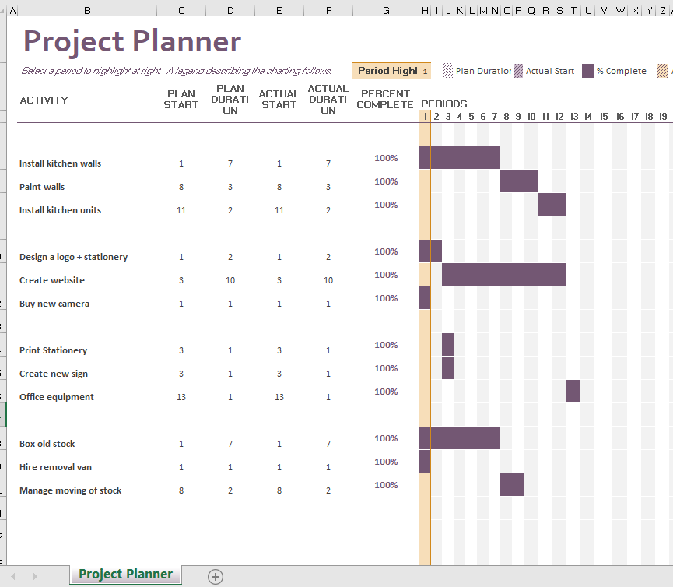 Fig 5

5.7 Estimating Time with “Wisdom Of the Crowd”

To estimate the time to complete a task, we will be using a technique called “Wisdom of the Crowd”. This requires all participants to provide their idea of an approximate cost for something, then averaging out the output. (Fiechter and Kornell, 2021) The Wisdom of the Crowds bases its logic on that the average value of multiple estimates tends to be more accurate than any one single estimate.

Participates will be invited to website by myself to Poll Everywhere, this uses the Delphi Technique (Hsu and Sandford, 2007) which was developed in 1963, this a widely used method for obtaining an opinion solicited from experts.

i.e., Question – How many days will it take to fit in a new Kitchen? Figure 6 is a table which users can pinpoint what they feel is the correct answer - 1 to 12 days. This is defined by the Complexity and Size that you feel would take to undertake this task.

Once everyone provides their input, the answer with the most votes, is acknowledged as the outcome. This technique is (Roberts, 2011) is dependent on a person’s previous knowledge, this table is constructed to determine the effort needed by estimating its size and complexity.

Complexity is across  Size is below | Low | Medium | High
Small | 1 days | 2 days | 3 days
Medium | 4 days | 5 days | 6 days
Large | 7 days | 8 days | 9 days

Fig 6

This method can be also used to collaborate with stakeholders, dependent on which areas you require their input.
5.8 Estimating Cost with “Wisdom of the Crowd”

“The price is Right”, (Lee, Shi and Zhang, 2010) is a game show that players bid a price on an item. The person with the closest bid wins. As this is of a competitive nature, what people bid isn’t necessarily what they know but an assumption is made by combining hidden knowledge than by combining observed bids. Using the same technique, all participates will be required to estimate a cost of what they think it should be, again averaging it out.

For Example – Find out the cost of removal vans, daily hire. This task is relatively easy to deduce as most people at some point or another have used this service but for this example removal costs (fig 7, 8 and 9) provides a basic average of what would be required dependant on your requirements. This will be manageable by Poll Everywhere.

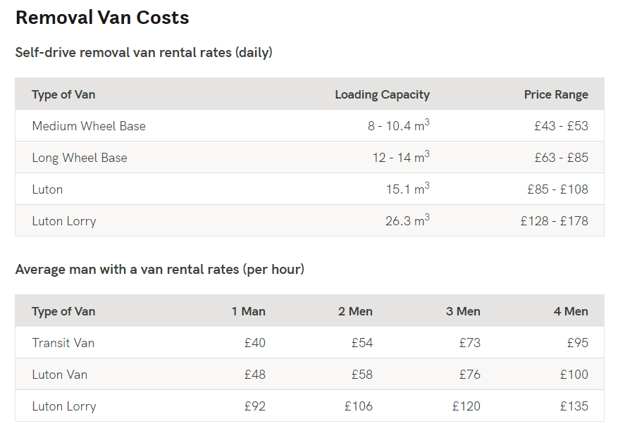
Fig 7 (What Are The Removal Van Costs For Your Move?, 2021)

Complexity is across  Size is below | Low | Medium | High
Small | 50 | 60 | 70
Medium | 80 | 90 | 100
Large | 110 | 120 | 130

Fig 8

However, if users are not knowledgeable or have the experience then it will impact the outcome. So, it is important that we have the right people in the right places to be successful.

Allocated to | Area | Item/ Tasks | Cost
Doreen Vintners | Project Manager Salary | Salary | Reed website - 50,751
Doreen Vintners | Office Design | Legal Fees | 260
 |  | Architect | 300
 |  | Interior Design | 300
 |  | Planning Permit | 150
 |  | Regularity Fees | 300
Doreen Vintners | Warehouse conversion materials | Interior | 1,120
 |  | Exterior | 1,100
 | New Office | Interior | 1000
 |  | Exterior Construction | 1000
Omar King | Physical Relocation | Temporary Storage | 100
 |  | Removal Vans | *300 (100 x 3 days – self-drive)
 |  | Insurance | 170
Suha Madani | Cleaning locations | Shop | 70
 |  | Warehouse | 100
Suha Madani | Marketing | Letterheads | 100
 |  | Business Cards | 30
 |  | Website Conversion | 100
Denis Vintners | Communications | Network, cabling | 150
 |  | Additional Equipment | 100
 | Total |  | £57,401
Fig 9
- Conclusion

As the project manager I am responsible for the planning and execution of this project, with your help we will run this project as smoothy as possible. I have over 5 years’ experience as a project manager and have contributed to many successful projects.

I envision that this project should take no more that 2 months (2 weeks contingency) if we all follow the planning.

I am not the overall decision maker, that will be Doreen our Sponsor. I am responsible for coordinating and managing this project, including the standard of work required from the team. I will identify and manage risk to ensure that this project is carried out on time. I will be delegating tasks to employees based on experience and knowledge, and encouragement and support will be provided where required. We will have daily and weekly updates, to see if we are on track, as the project will be completed within given timescale and budget as advised by Doreen Vintners.

The pitfalls that we may encounter could be from 3rd party negotiations, but a contingency plan will be incorporated to adapt this, this will however impact on the deliverable scope of the plan. So initial planning is key, the more user stories that we can obtain in all scenarios from all stakeholders will minimise any problems we may encounter.

There are many methods and theories available that work in project management but the ones that I have suggested in this report will be competent to deliver the end goal of this project. Working together in collaboration is key to the success of this project.

- References

Battoia, N., 2019. Innovation in Agile and Waterfall project management: a qualitative analysis. [online] Tesi.cab.unipd.it. Available at: <http://tesi.cab.unipd.it/62482/1/Battoia_Nicola_1156430.pdf> [Accessed 8 April 2021].

Brinkkemper, S., Dalpiaz, F., Lucassen, G. and Van Der Werf, J., 2016. Requirements Engineering: Foundation for Software Quality. Lecture Notes in Computer Science, [online] pp.205-222. Available at: <http://file:///C:/Users/rumem/Downloads/REFSQ2016_Proceedings_Springer_Book_-Editors_Maya_Daneva_and_Oscar_Pastor.pdf> [Accessed 9 April 2021].

Chan, L., 2021. Research Paper: Selection of Waterfall and Agile Methodologies in Software Testing. [online] Engpaper.com. Available at: <https://www.engpaper.com/download/selection-of-waterfall-and-agile-methodologies-in-software-testing.pdf> [Accessed 10 April 2021].

Cohn, M., n.d. User stories applied. 12th ed. Indiana: RR Donnelley Crawfordsville, pp.43-53.

Fiechter, J. and Kornell, N., 2021. How the wisdom of crowds, and of the crowd within, are affected by expertise. Cognitive Research: Principles and Implications, [online] 6(1), p.1. Available at: <https://cognitiveresearchjournal.springeropen.com/track/pdf/10.1186/s41235-021-00273-6.pdf> [Accessed 8 April 2021].

GetaMover.co.uk. 2021. What Are The Removal Van Costs For Your Move?. [online] Available at: <https://www.getamover.co.uk/removal-van/removal-van-costs/> [Accessed 9 April 2021].

Heagney, J., 2016. Fundamentals of Project Management, 5th Edition. 5th ed. New York: American Management Association, p.61.

Hsu, C. and Sandford, B., 2007. The Delphi Technique: Making Sense of Consensus. Practical Assessment Research & Evaluation, [online] 12(10), p.1. Available at: <https://scholarworks.umass.edu/cgi/viewcontent.cgi?article=1177&context=pare> [Accessed 9 April 2021].

Hudson, W., 2013. User Stories Don’t Help Users: Introducing Persona Stories. [online] syntagm.co.uk. Available at: <https://syntagm.co.uk/design/articles/personastories-fullref.pdf> [Accessed 10 April 2021].

Karlsen, J.T., 2020. The project steering committee, project governance and trust: insights from a practical case study. Management Research Review.

Lee, M., Shi, J and Zhang, S., 2010. The Wisdom of the crowd playing The Price is Right, Available at: https://link.springer.com/content/pdf/10.3758/s13421-010-0059-7.pdf [Accessed 10 April 2021].

Linke, K., 2019. Traditional and Agile Management Approaches. In 12th ILERA European Congress, Düsseldorf, Deutschland.

Pollack, J., Helm, J. and Adler, D., 2018. What is the Iron Triangle, and how has it changed? International Journal of Managing Projects in Business, [online] 11(2), pp.527-547. Available at: <http://file:///C:/Users/rumem/Downloads/PollackHelmAdler2018.pdf> [Accessed 7 April 2021].

Roberts, P., 2011. Effective project management. London, UK: Kogan Page, p.119.

Sabilah, I. and Manoy, J., 2018. The Use of Open-Ended Questions with Giving Feedback (OEQGF) for Effective Mathematic Learning. Journal of Physics: Conference Series, [online] 947, p.012032. Available at: <https://iopscience.iop.org/article/10.1088/1742-6596/947/1/012032/pdf> [Accessed 12 April 2021].

Stray, V., Sjøberg, D. and Dybå, T., 2016. The daily stand-up meeting: A grounded theory study. Journal of Systems and Software, [online] 114, pp.101-124. Available at: <https://reader.elsevier.com/reader/sd/pii/S0164121216000066?token=50CE46AE022859359F41B9BDAB0E96B50F3BB699DE6B62D4949B2874A4169DC05A531851C1B1561B4E5F7BD89116ABF5&originRegion=eu-west-1&originCreation=20210409124750> [Accessed 9 April 2021].

Trojanowska, J. and Dostatni, E., 2017. Application of the Theory of Constraints for Project Management. Management and Production Engineering Review, [online] 8(3), pp.87-95. Available at: <http://file:///C:/Users/rumem/Downloads/trojanowska_dostatni_application_3_2017.pdf> [Accessed 8 April 2021].

