Business Plan for

Bean & Bounce Cafe

Produced By:

GROUP MEMBERS:
Student Name | Student No.
Ana Maria Stoica | 2245028
Sheila Begum Laskar | 2245345
Fatema Uddin | 2131514
Madalaina Cananau | 2243593

Dated: 15/11/24

Module Name: Entrepreneurship
Module Code: BMIH5001
Lecturer Name: Charlotte Joyner

CONTENTS

 |  |  |  | PAGE
1. | Executive Summary |  |  | 3
2. | The Business Idea |  |  | 4
3. | The Team |  |  | 7
4. | Market Research |  |  | 9
5. | Marketing Plan |  |  | 12
6. | Key Resources |  |  | 14
7. | Finances & Start-Up Support |  |  | 15
APPENDICES:
Appendix A |  |  |  | SWOT Analysis
Appendix B |  |  |  | PEST Analysis
Appendix C |  |  |  | Copy of Pitch Supporting Material (presentation slides and speaker notes) premises location, photos of cafe, logo of cafe

AI Declaration:

We confirm that we have not used any AI tools in the research and creation of this assignment. We confirm that we have not presented any AI generated materials as my own work. We confirm that we have copies of our drafts, notes, and other resources that we used, which we may be asked to provide in evidence.

1. EXECUTIVE SUMMARY

Bean & Bounce is a unique café with halal and vegan food and drinks, and there is also a play area for young children. The café will be situated at 1175 High Road, Romford, London, RM6 4AL, where the location is always busy as there are many other shops, and many people want healthy food such as vegan and halal. Therefore, the core service offering of the café is, “Quality products with responsibility, your friendly café for grown-ups and kids”. There is a cafe menu which includes breakfast, lunch, and dinner. The business will reach customer satisfaction and communities to overcome the competitions; it aims to be a place to provide good quality dining combined with family services. Bean and Bounce café is different from the rest.

2. THE BUSINESS IDEA
2.1 The Product/Service
Bean & Bounce café will be operating in a formally affluent family area. It will be more of an extension of parents and particularly, young children who will be able to enjoy a cafè like setting as kids get to play safely in a play area. The business will focus on families since it will serve breakfast and lunch options as halal or vegan.

The service will serve the purpose of allowing the parents to dine, have a great cup of the specialty coffee while the children play within the contained play area. Some of the essentials of the business offers a selective of halal and vegan food menu, which offers fresh and healthy breakfast and lunch menu and has an innovative fun-filled play area for children.

The business will be located on 1175 High Road, RM6 4AL, London. The area offers a comfortable living for young professionals, families and students as well as small, individualistic shops and fine houses for the well to do. These features in turn make the location easily accessible by families, which is all the more suitable for the family based café.
The value proposition is based on convenience, accessibility for everybody, and friendly environment for families; parents can enjoy tasty dishes and coffee with their children who can play in the safe area. Bean & Bounce will be unique in its approach by making it a central place of interest where everyone can get what they need. Parents and kids are all welcome in a laid-back atmosphere where they can enjoy their coffee, juice or snack.
2.2 SWOT Analysis Summary
New opportunities for Bean & Bounce include the opportunity to develop a food concept based on a play area and the ability to offer halal and vegan foods, which are popular amongst people who care about their health and Muslims culture (Ferreira et al., 2021). However, some threats like higher operating costs and the ever demanding process of keeping the play area clean and safe for the children can prove costly and reduce the overall overheads (Graham et al., 2020; Oscilowicz et al., 2020).
Bean & Bounce is a relatively young brand so it will have to garner the people’s trust within the community. Therefore, the business opportunities will be aimed at the expanding market segment of family-centered or healthy eating locations. It is planning to sponsor events and engage in community relations and events so that the target market notes the existence of the organisation. Possible revenue sources should be considered to offset operating quantities especially in new lines of business aimed at family entertainment. When it comes to risk management, the company must pay special attention to the threat of competition and therefore focus on the key selling point of the restaurant which is family-friendly food options that cater to almost everyone’s dietary needs (De Jong et al., 2021; Behera et al., 2022).

3. THE TEAM
3.1 Key Personnel
Name and Company Position | Skills and Experience | Role and Responsibilities
Ana Maria Stoica Manager | Ana has extensive experience in business management and quality control, with a strong background in the hospitality industry and customer service. | Ana will oversee daily operations, manage staff, develop the menu, and ensure that high-quality customer service and satisfaction are maintained.
Sheila Begum Laskar, Head Chef | Sheila is a culinary expert with over 5 years of experience in food preparation, specialising in creating innovative vegan and halal dishes. | Sheila will create and manage the menu, ensure food quality standards are met, and oversee kitchen operations and food safety.
Fatema Uddin, Marketing Manager | Fatema has a strong background in digital marketing and social media management. | Fatema will develop and implement marketing strategies, manage the business’s social media presence, and promote community events and partnerships.
Madalina Cananau, Finance Manager | Madalina is a Certified Accountant with experience in managing the financial health of small businesses. Her expertise includes budgeting, financial planning, and ensuring compliance with financial regulations. | Madalina will be responsible for financial planning, budgeting, accounting, and ensuring the financial sustainability and compliance of the business.

3.2 Skills Gaps & Key Partners
- Specialisation in coffee production will meet the need of training baristas and creating standards for quality and work rate.
- Play Area Attendant will make sure that the children’s play area zone is safe and regularly washed down and/or sanitised, and of course well-monitored by a responsible, Qualified Play Area Attendant at all times.

3.2.2 Training and Development:
- The kitchen team will have to be trained on Food Safety and Hygiene that must be obtained from a certified BFDA such as the Food Standards Agency. This will help to make sure that the business has complied with all existing Health and Safety Standards.
- Customer services working at the front of the house will be required to attend a course offered by The Institute of Customer Service. Staff training is very important to increase job satisfaction and reduce turnover.
- The Play Area Attendant will undergo Safeguarding and First Aid Training with the Royal Society for the Prevent of Accidents.
3.2.3 Outsourced Support / Key Partners:
- For accounting and payroll, the business will hire an outside firm.
- A social media assistance and web campaigns will be supported through the partnership between the companies.
- Outsourcing of kitchen equipments and play area facilities’ maintenance will be awarded to CaterQuip as it is an industry specific company dealing in commercial equipment maintenance services.
4. MARKET RESEARCH
4.1 Market Information, Trends and External Factors
The plant-based meat consumption market in the UK was estimated to be worth about £475m in 2022 (Statista, 2024). These customers have taken position globally across the food industries and consume halal foods and beverages worth £1.4 trillion in 2017 and will consume £2.6 trillion in 2023 (Statista, 2024a). Given current trends related to restaurants that accommodate families and restaurants that are appropriate for parents with children. Bean & Bounce is located to target comfortable areas for families to dine.
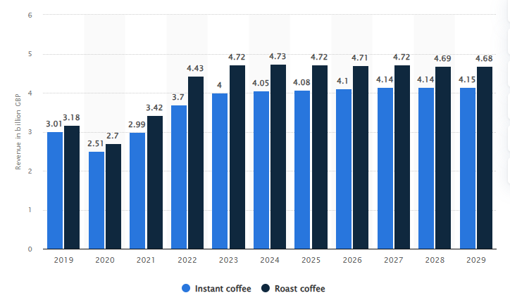
Figure 1: Revenue of the coffee market in the United Kingdom from 2018 to 2028, by segment
Source: Statista (2024)

The pressure from customer groups, especially the younger generation, consumers are becoming more conscious about keeping healthier and eating ethical foods therefore, food such as plant based and halal foods is on the rise (Kowalska et al., 2021; Abderahman et al., 2021). Consumers are totally over the idea of eating out just to be fed; what they look for today is the experience (Gu et al., 2023). Play areas are gaining increased popularity as more families seek venues that can accommodate kids as well as adults (Adeniran et al., 2022; Chevtaeva and Denizci Guillet, 2024).
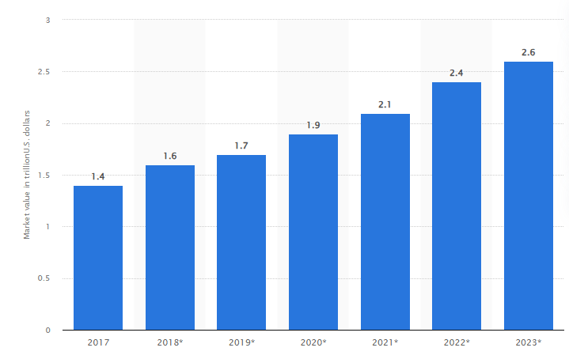
Figure 2: Market value of halal foods worldwide from 2017 to 2023
Source: Statista (2024a)
4.2 Customer Profiles
Customer Profile | Demographics | Likes, Habits, and Behaviors | Why They Might Use Bean & Bounce
Health-Conscious Families | Families with young children with a middle-income. | Families prioritise healthy eating, enjoy spending time together at places that offer activities for children. | Bean & Bounce offers a safe and engaging play area for kids, combined with a healthy menu featuring vegan and halal options.
Young Professionals | Young adults aged 22-35 years old | They tend to prefer plant-based or halal food options, enjoy working remotely from cafés, and seek out quiet and cozy environments with good coffee. | Bean & Bounce provides a relaxing ambiance with a menu that caters to dietary preferences, as well as fast Wi-Fi, making it perfect for young professionals who want to work or meet casually.
Community-Oriented Parents | Parents aged 30–45-year-olds, middle-income | These parents value social spaces where both parent and their children can interact, and they appreciate affordable meal options for family dining. | Bean & Bounce offers a welcoming environment that includes family-friendly events, affordable pricing, and healthy food choices, which makes it an attractive spot for community-focused parents.

4.3 Competitor Profiles
Competitors | How Are They Different? | How Will Business Compete? | USP
Starbucks | Starbucks focuses primarily on coffee and takeaway services, with less emphasis on offering a family-friendly dining experience (Starbucks, 2024). | Bean & Bounce will differentiate itself by providing a family-friendly space with a play area, along with vegan and halal food options (Zhou, 2024). | Bean & Bounce unique value lies in combining a family-oriented environment with a health-conscious menu that caters to vegan and halal preferences.
Greggs | Greggs primarily operates as a grab-and-go bakery, focused on fast food items like pastries, sandwiches, and sausage rolls. | Bean & Bounce will offer a relaxed, family-friendly atmosphere with spacious seating and an inviting play area where children can play safely. | Bean & Bounce will be a family-centered café experience, offering a safe play area for children and diverse dietary options, designed specifically to cater to family needs.
Costa Coffee | Costa Coffee offers a casual café atmosphere with a focus on coffee drinks, pastries, and snacks, but it is not specifically geared toward families, and it lacks facilities for young children to play (Costa Coffee, 2024). | Bean & Bounce will differentiate itself by providing a family-friendly environment where parents can relax while their children play safely in a dedicated playground area. | Bean & Bounce unique play area and family-centric dining experience will meet the needs of parents and children looking for a comfortable, inclusive café setting.

5. MARKETING PLAN
5.1 Price
At Bean & Bounce products will be affordably priced in a bid to appeal to a customers’ wide market and at the same time maximise earnings in the long-run. Breakfast will be served through vegan wraps and halal pastries costing between £7 and £9 and give a sense of luxury at affordable prices. The identified meals that will be offered at lunch include plant-based burgers and salads will be priced between £12 and £16 which will put the business on a slightly lower tier than the vegan café and family restaurant but above fast food restaurants. By using this pricing strategy, Bean & Bounce can continue to meet its aim of providing meals of good quality to the public as well as maintaining its vision of procuring its food items from reputable sources yet be affordable to many consumers.
5.2 Product
Bean & Bounce will incorporate a clean and modern look with the addition of specificity that targets families. Café will have a rather warm pallet with soft furniture replacing part of the chairs and an area for kids to stay in a café will be provided. When it comes to takeaway items, containers for packaging will be fully recyclable; cups, bags, and utensils will be biodegradable to embrace the concept of sustainability. Branding will stick to the basics and carry tremendous flavoring. The logo is catchy and to the point. B for Bean (represents coffee) and B for Bounce (represents kids bouncing castle, toys)
5.3 Placement
Bean & Bounce physical store location will focus on families, as well as announced collaborations with delivery services such as UberEats and Deliveroo. They will also have the convenience of direct order through the website, where portfolio of menu options will be displayed, and customers can order direct from the website. Also, catering services will include various products for local occasions and functions to enable guests purchase the products and through different delivery services.

5.4 Promotion
Bean & Bounce adoption will entail the following marketing strategies; digital and community market promotion. Displaying their menu on the social media sites like Instagram and Facebook, they will conduct social media marketing by featuring family events, promoting the packaging as being eco-friendly through attractive images and creative feeds. To reach out to such audiences, the business will engage various stakeholders especially the parents and followers of veganism. As for developing customer loyalty, the business will establish a system of customer bonuses, which will allow regular customers to make a discount. Moreover, Bean & Bounce will organise local promotions, like Stay and Play - parent & child mornings, so they can build partnerships with customers permanently.

6. KEY RESOURCES
6.1 Premises
Bean & Bounce will need an extensive physical space to provide a dining area, child play area, kitchen, and storage facilities. It will have sales areas, food preparation, and administrative workspaces. The business will have a space of around 1,500 to 2,000 square feet to have sufficient room not only for the dining area but also for the play area so that families can be accommodated well and efficiently run the business.
6.2 Equipment
For Bean & Bounce to be more efficient it is important to invest in some basic equipment. Electric Oven (£209.99) will be essential for oven ccoked meals - various breakfast and lunch will be possible since the appliance has 65-liters and being equipped by the grill. This small oven will suit the needs of the café’s kitchen as well as offering top-quality baking and roasting in a very efficient and space-saving appliance. The Espresso Coffee Machine (£86.00) is another necessity, as, of course, good quality espresso is a must in a café. This low profile machine allows consumers to get their coffee fix without giving up a lot of counter space. Also, the SumUp POS Lite +Solo Card Reader is priced at £399.99 which is relatively reasonable, can be easily styled to meet the family’s needs and delivers fast, which is vital in an operation involving a number of people. A Polar U-Series Upright Fridge (£1,100) is required for proper storage of food stuffs to avoid compromise of their quality in meal and beverages preparation. In addition, Blender (£600) is useful for the café’s menu as it helps to make smoothies and blended meals that clients are interested in their health needs.

Industrial Oven
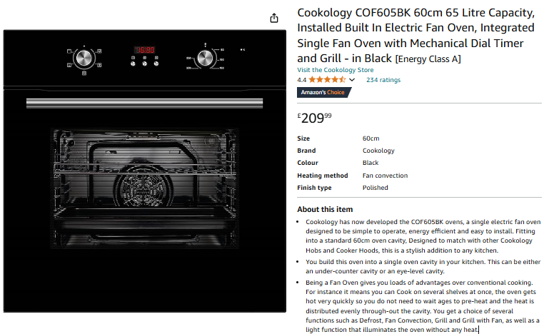
(Source: Amazon, 2024)

Espresso-Making Machine
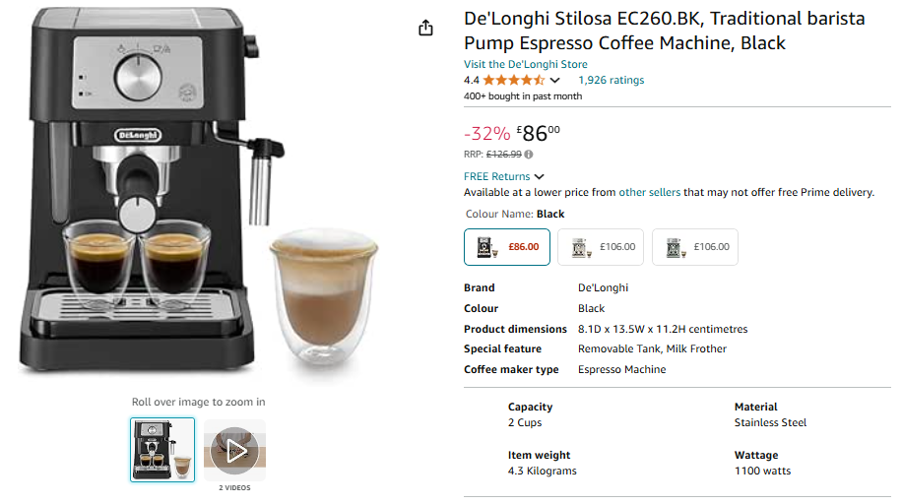
(Source: Amazon, 2024a)

Coffee Blenders
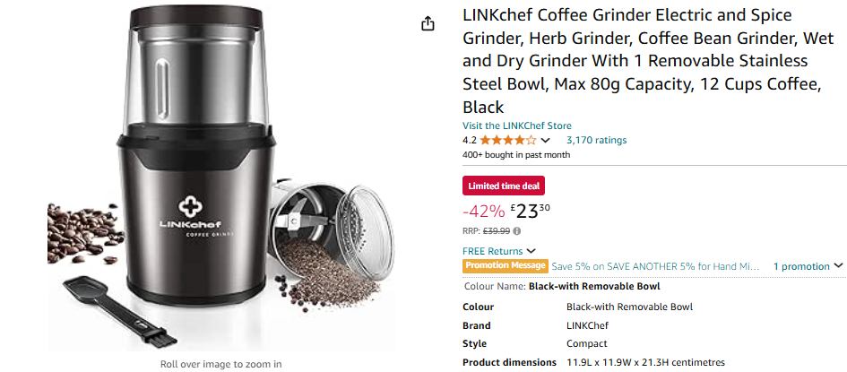
(Source: Amazon, 2024b)

Tables and Chairs for Seating

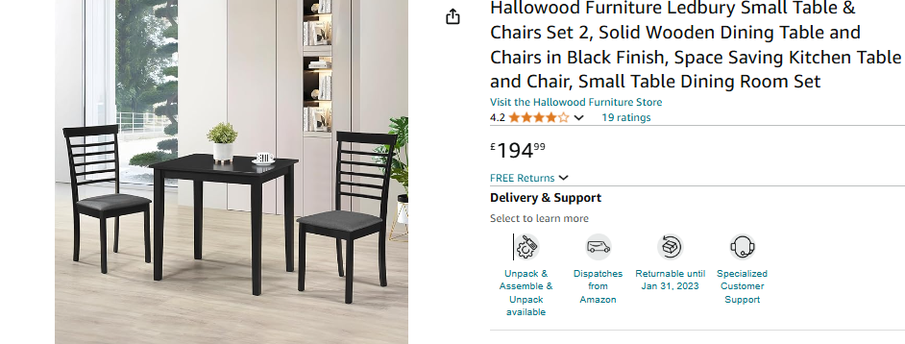
(Source: Amazon, 2024c)
Point-of-Sale (POS) System
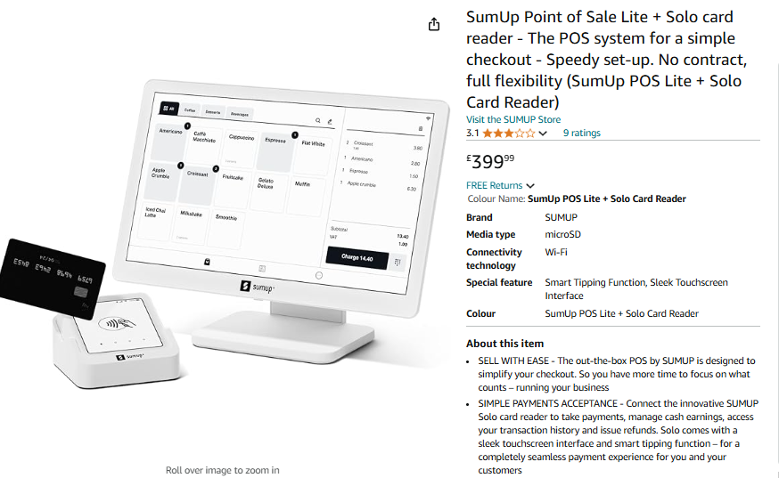
(Source: Amazon, 2024d)
6.3 Key Suppliers

Bean & Bounce will depend on key suppliers for both ingredients and day-to-day running. Halal meats, and also plant-based ingredients, will be sourced from suppliers such as Bidfood UK and The Vegan Kind-both famous for offering quality products (Bidfood, 2024; Vegankind, 2024). Bidfood's halal product line is competitively priced, and buying bulk meat is approximately £3,000 monthly, while The Vegan Kind is set to provide plant ingredients for about £2,000 monthly. Also, the business will supply biodegradable from companies like Vegware at an approximate cost of £1,500 monthly. This is with the fact that Bean & Bounce are partnering with such reliable suppliers who will give their customers high-quality offerings.

7. FINANCES AND START-UP SUPPORT
EXPENDITURE | Year 1  £
Company Registration | £119
Rent/Rates | £130,000
Staff Wages | £100,000
Travel/Accomodation | £1,500
Telephone (mobile) | £600
Broadband | £500
Utilities | £5,000
Marketing and materials | £10,000
Insurance | £2,000
Capital Expenditure/Equipment | £7,000
Training & Development | £3,000
Accounting/Legal | £2,500
Outside Services | £1,500
Stock/Materials Purchases | £30,000
Bank Charges | £300
Office Consumables | £500
Loans Repayments | £10,000
Total Expenditure | £304,519
INCOME | Year 1  £
Sales A Breakfasts | £105,000
Sales B Lunches | £135,000
Sales C Play area fees | £40,000
Capital Introduced | £10,000
Funding | £15,000
Loans/Borrowing | £50,000
Total Income | £355,000

YEAR ONE PROFIT/LOSS | £
Total Income | £355,000
Total Expenditure | £304,519
Profit/Loss | £50,481

7.1 Financial Summary
The company registration fee £119 which is also, a one off, cost of registering a limited company with companies house. The assumption for Rent/rates at £130,000 per annum was based on an average price for commercial properties in the regions that have facilities that can accommodate families in different geographical areas and size of the proposed buildings. Staff wages were estimated at £100,000; power of staff depends on number of staff, the BCG assumed to have 3-4 employees, and wages depended on the standard pay fare for a café and hospitality employee in London. To arrive at £7,000, capital expenditure has been estimated from purchases of quality ovens, coffee machines as well as POS Systems. Business income is calculated on estimated operating sales from breakfast and lunches (£240,000) and play area charges (£40,000) which is one of the income sources for an organisation with a special emphasis on families. The start-up support is £20,000 from the Government Grant Scheme to start up the business. These figures have been chosen based on the effectiveness of research to ensure that the business gets operational and market-rated values.

APPENDICES
Appendix A – SWOT Analysis
Strengths:
- Bean & Bounce is a coffee shop with a play area for children and families who want to have a cup of coffee with children playing in a safe and clean environment.
- Offering halal and vegan meals that many people believe are healthy, the café attracts a diverse and large number of customers.
- The café offers freshly made and healthy food that is tasty with addition to specialty coffee solution which are not easily available in competitors. We use special infused beans for an unforgettable taste.
Weaknesses:
- Both running a café and a play area can take on new cost levels that may result in operational loses to the business.
- The business caters for families with young children, which can reduce the market base to a small base, hence reducing the revenues.
Opportunities:
- More consumers pay attention to vegan and halaal food, thus pursuing healthier lifestyles, Bean & Bounce will discover even more consumers to target.
- The café can offer the space for family-related events, like birthday celebrations, Play and Stay mom and toddler mornings, or children’s classes, thus including new income opportunities.
Threats:
- Existing established large scale coffee selling companies, restaurants with a stable number of consumers could restrain opportunities for coffee selling for a new café such as Bean & Bounce.
- Changes in population eating out trends, for instance owing to shift from eating out to eating in, or health trends that can alter people’s eating habits.
Appendix B – PEST Analysis
Political
- There are threats associated with an increase in consumption of food, including Safety and Regulatory Standards which include the halal certification that can affect business operations.
- Sustaining quality in all products will be indispensable essential to guarantee that all delivered food corresponds to the proper certification for customers who consider being halal or vegan sensitive.
Economic
- Consumption expenses can end up a challenge in UK hence translating to spending on non-essential commodities such as café.
Social
- Currently, there is a heightened awareness of preferred special and family group enviromental requirements.
Technological
- The delivery of marketing content broadens its use of the digital platform.
- There are various ways in which businesses can embrace technology, using home delivery services – Uber Eats and Deliveroo, providing phone and online bookings, and use of social media marketing to target the identified tech-cultured consumers.

Appendix C – Copy of Pitch Supporting Material
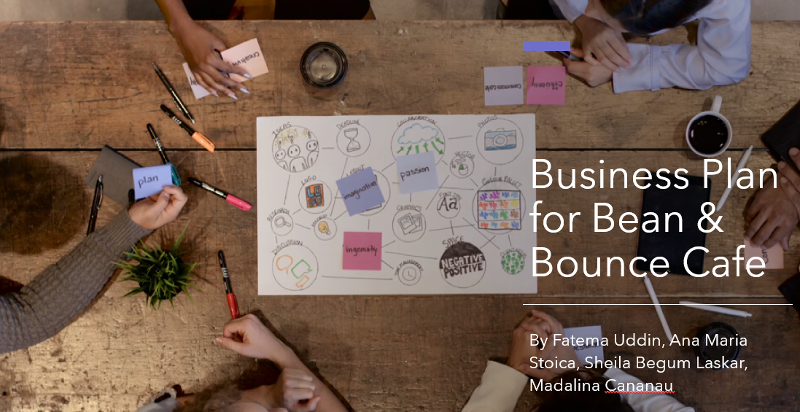

Slide 1: Introduction (Ana)
Welcome everyone and thank you for joining us today to talk about Bean and Bounce Café. Our concept is a unique, family-friendly café designed to create a safe, enjoyable space for adults to relax and children to play.
Let’s go through the key elements of our business model.

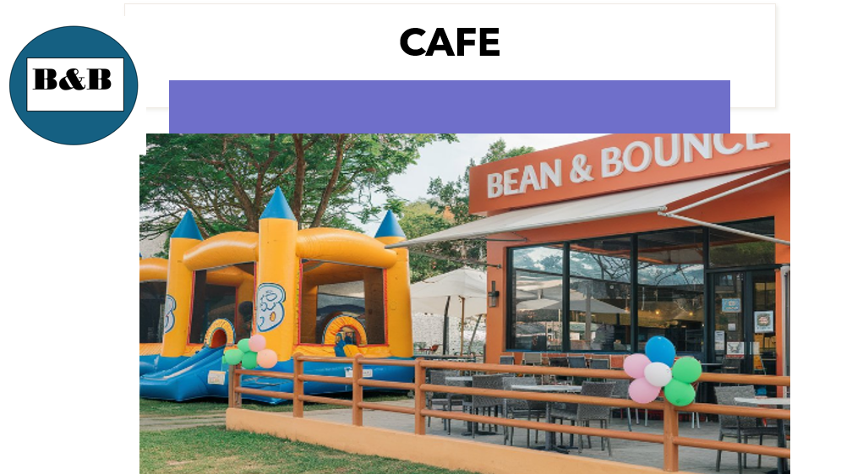

Slide 2: The Product/Service (Ana)
Bean and Bounce will be located in Romford in London, a family-oriented area focusing on serving families with young children.
We’re not just a regular café. Alongside coffee and a variety of non-alcoholic beverages such as smoothies, we’ll also offer a full menu with halal and vegan options.
The café will feature a contained play area, allowing parents to relax and dine while their children play safely under supervision.
We aim to create a community space where parents can unwind and kids can have fun, fostering a relaxed, inclusive atmosphere.
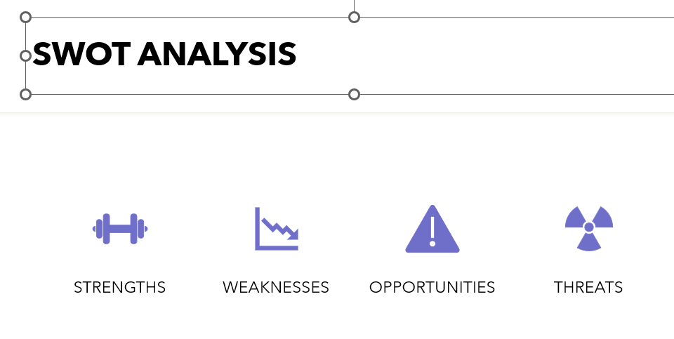
Slide 3: SWOT Analysis (Ana)
Let's take a closer look at our strengths, weaknesses, opportunities, and threats.
Strengths: Our key strength is the unique concept that combines halal and vegan food options with a play area, setting us apart in the local market.
Weaknesses: Operating a play area comes with added costs for cleaning and maintenance, which may increase our overheads.
Opportunities: We plan to sponsor community events, helping to build a strong brand presence within our target market.
Threats: Competitors might respond with similar concepts, so staying unique and continuously engaging with our community will be essential.
We can then use this information to turn threats into opportunities for our business.

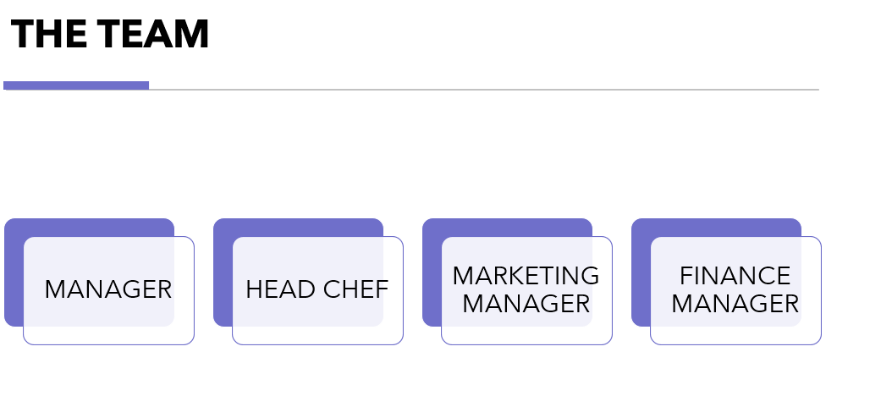
Slide 4: The Team: Key Personnel (Shila)
Our team is vital in delivering the Bean and Bounce Cafe experience.
Manager (Ana Maria Stoica): With extensive experience in the hospitality industry, Ana will handle daily operations and ensure a high level of customer service.
Head Chef (Sheila Begum Laskar): Sheila an expert in culinary arts, will design and manage our menu, focusing on vegan and halal dishes.
Marketing Manager (Fatema Uddin): Fatema will manage our digital presence and develop marketing campaigns to attract our target audience.
Finance Manager (Madalina Cananau): Madalina will ensure financial health, from budgeting to compliance, allowing us to operate smoothly.
Each of these roles plays a crucial part in making Bean and Bounce a success.


Slide 5: Market Research - Trends and External Factors (Shila)
Our market research highlights several key trends.
The UK’s plant-based market is growing rapidly, reaching £475 million in 2022, showing a strong demand for vegan options.
Halal food consumption is also rising globally, expected to reach £2.6 trillion in 2023, making halal-friendly menus a smart choice for us.
Customers now expect more than just food; they want a memorable dining experience, which is where our play area and family-friendly environment come in.
Additionally, play areas are increasingly popular as families look for spaces that cater to both kids and adults. This way parents will be stress free while they enjoy our specialty coffee or anything else on our menu.

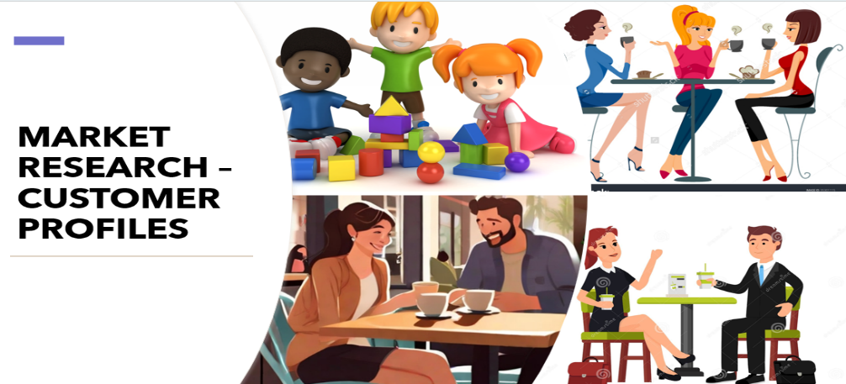

Slide 6: Market Research - Customer Profiles (Fatema)
We’ve identified three primary customer profiles:
Health-Conscious Families: Typically middle-income families with young children who prioritise healthy eating and activities for kids.
Young Professionals: Individuals aged 22-35 who prefer remote work options and value a relaxing café environment.
Community-Oriented Parents: Parents aged 30-45 who enjoy social space that accommodate both children and affordable dining options.
By understanding these profiles, we can better tailor our menu, services, and ambiance to meet their specific needs. If customers are satisfied it is less likely that the business will fail. Therefore, customer feedback helps to make improvements, and we will do this by contacting all our customers after their visit.
We also offer loyalty reward offers and discounts to our regular customers. This will encourage customers to return many times. We aim to deliver professional customer services to all our customers.

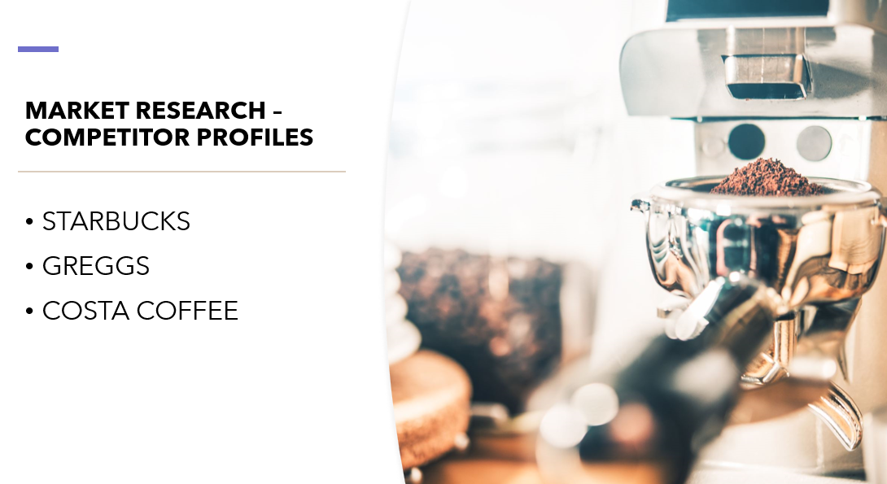
Slide 7: Market Research - Competitor Profiles (Fatema)
We analysed key competitors to identify our unique selling points:
Starbucks: Known for coffee but lacks family-focused amenities like a play area or vegan/halal menu options.
Greggs: Operates on a grab and go bakery, focused on fast food. They have vegan options but not halal. They do not have a facilitate for children.
Costa Coffee: Offers a casual café atmosphere with a focus on coffee, drinks, pastries and snacks but it is not targeted to young children play area.
Bean and Bounce differentiates itself by offering a blend of vegan, halal, and family-friendly dining, combined with a safe and enjoyable play area for kids. It is well located in a busy town where customers will most likely want to come and take a break after shopping, working or just to socialise with family and friends. Peace of mind with the play area is always here. Our café stands out from the rest.


Slide 8: Marketing Plan - The 4 Ps (Madalina)
Our marketing strategy is built around the 4 Ps: Price, Product, Place, and Promotion.
Price: We’ll keep pricing competitive while maintaining high-quality ingredients.
Product: The brand will have a modern look, with family-friendly branding that’s welcoming and memorable.
Place: We’re located in a family-centric area, and we’ll also leverage delivery services like Uber Eats and Deliveroo for wider reach.
Promotion: We’ll use digital marketing and engage in local promotions, such as hosting Parent & Child events, to create a loyal customer base.
These strategies will help build brand recognition and attract our target market.

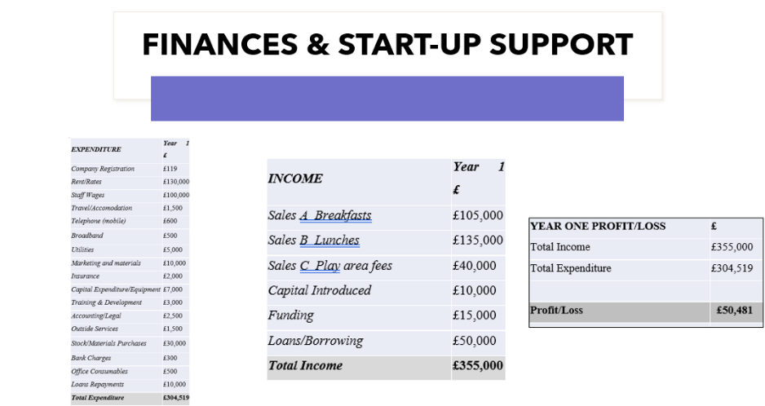
Slide 9: Finances and Start-up Support (Madalina)
Finally, let’s review the financials for Bean and Bounce Cafe.
Start-up expenses include registration, rent, staff wages, marketing, equipment, and more, totaling approximately £304,519 for the first year.
Our projected income streams include sales from breakfast, lunch, and play area fees, estimating a total income of £355,000 in the first year.
With these projections, we anticipate a first-year profit of about £50,481
This financial plan demonstrates the viability of Bean and Bounce Cafe, especially given the rising demand for our unique offerings.


Speaker Notes: (Shila)
Slide 10: Conclusion
By looking at our financial analysis, we will be making a profit therefore we will be opening more branches in the country and maybe abroad too. We will be providing other events such as children’s birthday and theme parties for the children.
To wrap up, Bean and Bounce isn’t just another café. It’s a vibrant, family-friendly space where parents can relax, children can play, and everyone can enjoy high-quality, diverse food options.
We believe Bean and Bounce has the potential to become a community hub, offering a unique blend of dining and family-oriented activities.


Slide 11: Thank you, we will be happy to answer any questions

Premises

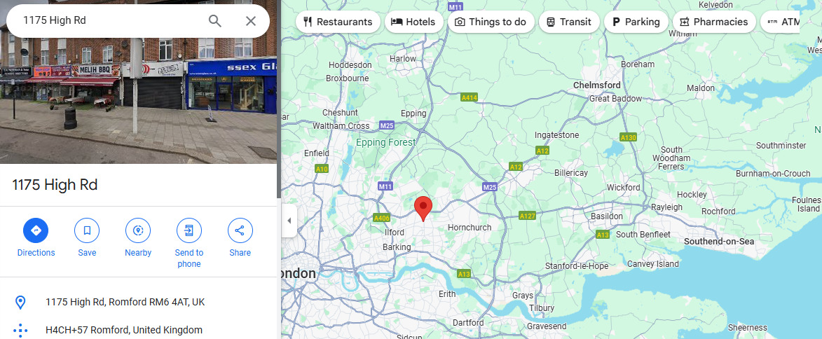

Photos of Cafe

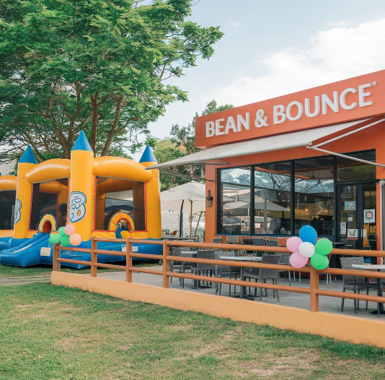

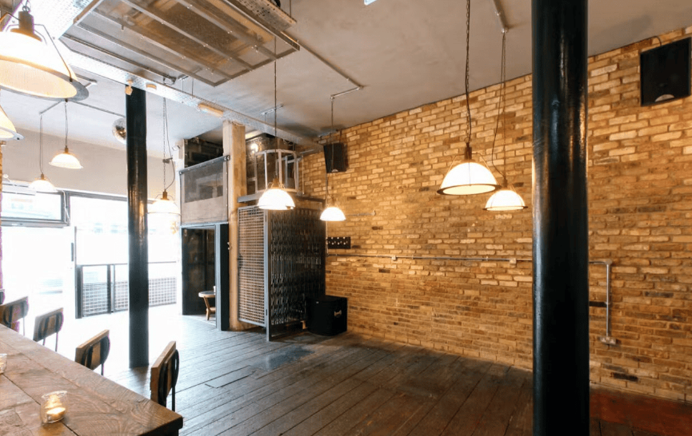
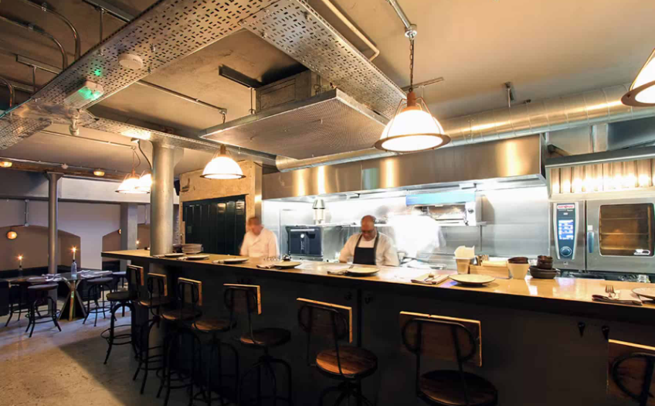
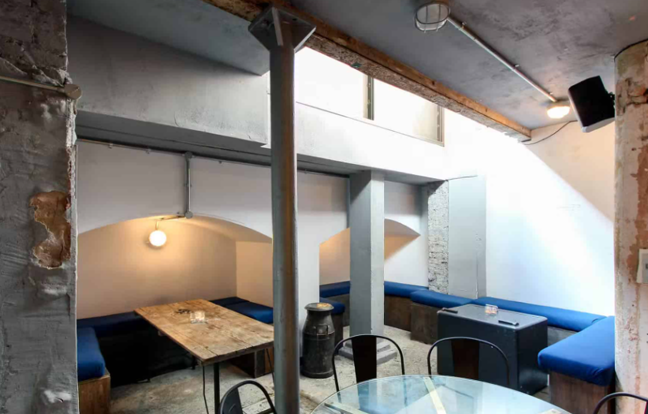

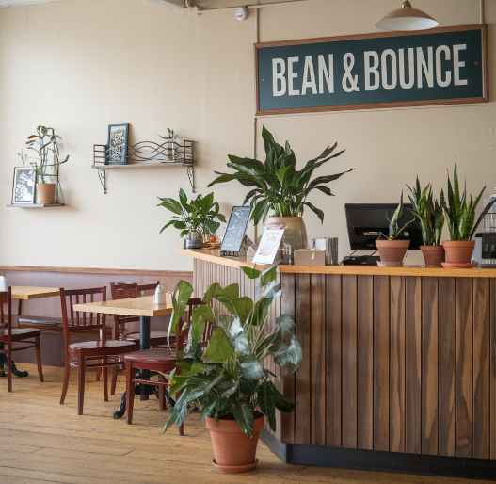


Logo of Bean & Bounce café

REFERENCE LIST:

Abderahman, R., Karim, R. and Kevin, D., 2021. Halal food supply chains: A literature review of sustainable measures and future research directions. Foods and Raw materials, 9(1), pp.106-116. (Accessed on 7th Nov 2024)
Adeniran, A.M., Burodo, M.S. and Suleiman, S., 2022. Customer satisfaction with the point of sale (POS) system: Moderating role of age. Gusau Journal of Business Administration, 1(2), pp.10-10. (Accessed on 7th Nov 2024)
Amazon, 2024. Installed Built In Electric Fan Oven. [Online] Available at < https://www.amazon.co.uk/Cookology-Built-Electric-Single-COF605BK/dp/B01N6ILRE0/ref=sr_1_2 [Accessed on 6th Nov 2024].
Amazon, 2024a. De'Longhi Stilosa EC260.BK, Traditional barista Pump Espresso Coffee Machine, Black. [Online] Available at < https://www.amazon.co.uk/DeLonghi-Stilosa-EC260-BK-Traditional-Espresso/dp/B085J8LBXF/ref=sr_1_2 [Accessed on 6th Nov 2024].
Amazon, 2024b. LINKchef Coffee Grinder Electric and Spice Grinder, Herb Grinder. [Online] Available at < https://www.amazon.co.uk/LINKChef-Electric-Capacity-Detachable-Stainless/dp/B07DXFS43F/ref=sr_1_4 [Accessed on 6th Nov 2024].
Amazon, 2024c. Hallowood Furniture Ledbury Small Table & Chairs Set 2. [Online] Available at < https://www.amazon.co.uk/Hallowood-Furniture-Ledbury-Wooden-Finishing/dp/B0BZQCTLHD/ref=sr_1_1_sspa [Accessed on 6th Nov 2024].
Amazon, 2024d. SumUp Point of Sale Lite + Solo card reader. [Online] Available at < https://www.amazon.co.uk/SumUp-Point-Sale-Lite-reader-POS-Solo-Card/dp/B0C45RB91W/ref=sr_1_1 [Accessed on 6th Nov 2024].
Behera, R.K., Bala, P.K., Rana, N.P. and Kizgin, H., 2022. Cognitive computing based ethical principles for improving organisational reputation: A B2B digital marketing perspective. Journal of business research, 141, pp.685-701. (Accessed on 10 November 2024)
Bidfood, 2024. Our products. [Online] Available at < https://www.bidfood.co.uk/our-products/ [Accessed on 8th Nov 2024].
Chevtaeva, E. and Denizci Guillet, B., 2024. Conceptualizing Parents’ Joined Recollected Experiences of Family Travel With Children: Memorability, Storytelling, and Imagination. Journal of Hospitality & Tourism Research, 48(8), pp.1404-1423. (Accessed on 10th November 2024)
Costa Coffee, 2024. The better the coffee, the brighter the day. [Online] Available at <https://www.costa.co.uk/> [Accessed on 6th Nov 2024].
De Jong, A., De Ruyter, K., Keeling, D.I., Polyakova, A. and Ringberg, T., 2021. Key trends in business-to-business services marketing strategies: Developing a practice-based research agenda. Industrial Marketing Management, 93, pp.1-9. (Accessed on 7th November 2024)
Ferreira, J., Ferreira, C. and Bos, E., 2021. Spaces of consumption, connection, and community: Exploring the role of the coffee shop in urban lives. Geoforum, 119, pp.21-29. (Accessed on 7th November 2024)
Graham, F., Barker, M., Menon, M. and Holdsworth, M., 2020. Acceptability and feasibility of a café-based sustainable food intervention in the UK. Health Promotion International, 35(6), pp.1507-1518. (Accessed on 7th November 2024)
Gu, Q., Li, M. and Huang, S., 2023. An exploratory investigation of technology-assisted dining experiences from the consumer perspective. International Journal of Contemporary Hospitality Management, 35(3), pp.1010-1029. (Accessed on 8th November 2024)
Kowalska, A., Ratajczyk, M., Manning, L., Bieniek, M. and Mącik, R., 2021. “Young and Green” a study of consumers’ perceptions and reported purchasing behaviour towards organic food in Poland and the United Kingdom. Sustainability, 13(23), p.13022. (Accessed on 8th November 2024)
Oscilowicz, E., Honey-Rosés, J., Anguelovski, I., Triguero-Mas, M. and Cole, H., 2020. Young families and children in gentrifying neighbourhoods: how gentrification reshapes use and perception of green play spaces. Local environment, 25(10), pp.765-786. (Accessed on 8th November 2024)
Starbucks, 2024. About us. [Online] Available at <https://www.starbucks.co.uk/about-us> [Accessed on 6th Nov 2024].
Statista, 2024. Revenue of the coffee market in the United Kingdom from 2018 to 2028, by segment. [Online] Available at < https://www.statista.com/forecasts/1413255/united-kingdom-revenue-of-coffee-market-by-type [Accessed on 25th Oct 2024].
Statista, 2024a. Sales of plant-based food products in the United Kingdom in 2022, by category. [Online] Available at < https://www.statista.com/statistics/1453295/plant-based-food-sales-by-category-in-the-uk/ [Accessed on 25th Oct 2024].
Vegankind, 2024. Find the best plant-based products. [Online] Available at < https://vegankind.com/ [Accessed on 8th Nov 2024].
Zhou, Q., 2024. The Impact and Investigation of Starbucks’ Profit Generation Strategies. In SHS Web of Conferences (Vol. 185, p. 03020). EDP Sciences.
(Accessed on 8th November 2024)

