Cover Page

Shabnam Kausar
2319036
Component 2: Assignment (Report)
BMHP5015
Changemakers: Building your Personal Brand for Sustainable Employment

Introduction
This report explores the employability requirements, core skills, and development needs involved in progressing into a combined Phlebotomist and Healthcare Assistant (HCA) role within the UK health and social care system. Both roles play an important part in frontline patient care and involve supporting individuals who may be unwell, anxious, or preparing for clinical procedures. Phlebotomists are responsible for safely and accurately collecting blood samples, while HCAs assist with tasks such as taking observations, helping with mobility, promoting patient comfort, and updating essential clinical records. Together, these duties contribute to the effective running of healthcare services, improve patient experience, and provide vital support to the wider multidisciplinary team (NHS Health Careers, 2023).
I am particularly drawn to this career pathway because I enjoy working directly with patients and supporting their physical and emotional needs. I find it fulfilling to reassure people who may feel nervous and to help create a calm, respectful environment during their care. My previous phlebotomy experience in a GP practice has increased my confidence with clinical procedures, while my background in adult care and childcare has strengthened my communication, patience, and resilience. These experiences have motivated me to continue developing my skills and work towards a long-term career within the NHS. This report will outline the key skills required, assess my current abilities, identify areas for improvement, and present a clear action plan to support my career progression.

Job Advertisement Summary
This report is based on a real NHS job advertisement for a Phlebotomist / Healthcare Assistant role. The advert includes a detailed job description and person specification, which I will attach as a screenshot in the final submission. The job description outlines the main duties, including venepuncture, taking patient observations, maintaining accurate records, following infection control policies, and working closely with multidisciplinary teams. It emphasises the need for compassion, professionalism, and the ability to work with patients from different backgrounds.
The person specification lists essential criteria such as good communication skills, the ability to work flexibly, understanding confidentiality, and being able to stay calm under pressure. Desirable criteria include previous experience in phlebotomy or care, using NHS digital systems, and having relevant training or qualifications. This advert helped me understand more clearly the expectations of the role and how my existing skills align with NHS requirements (NHS Jobs, 2024).

Job Advertisement Screenshot
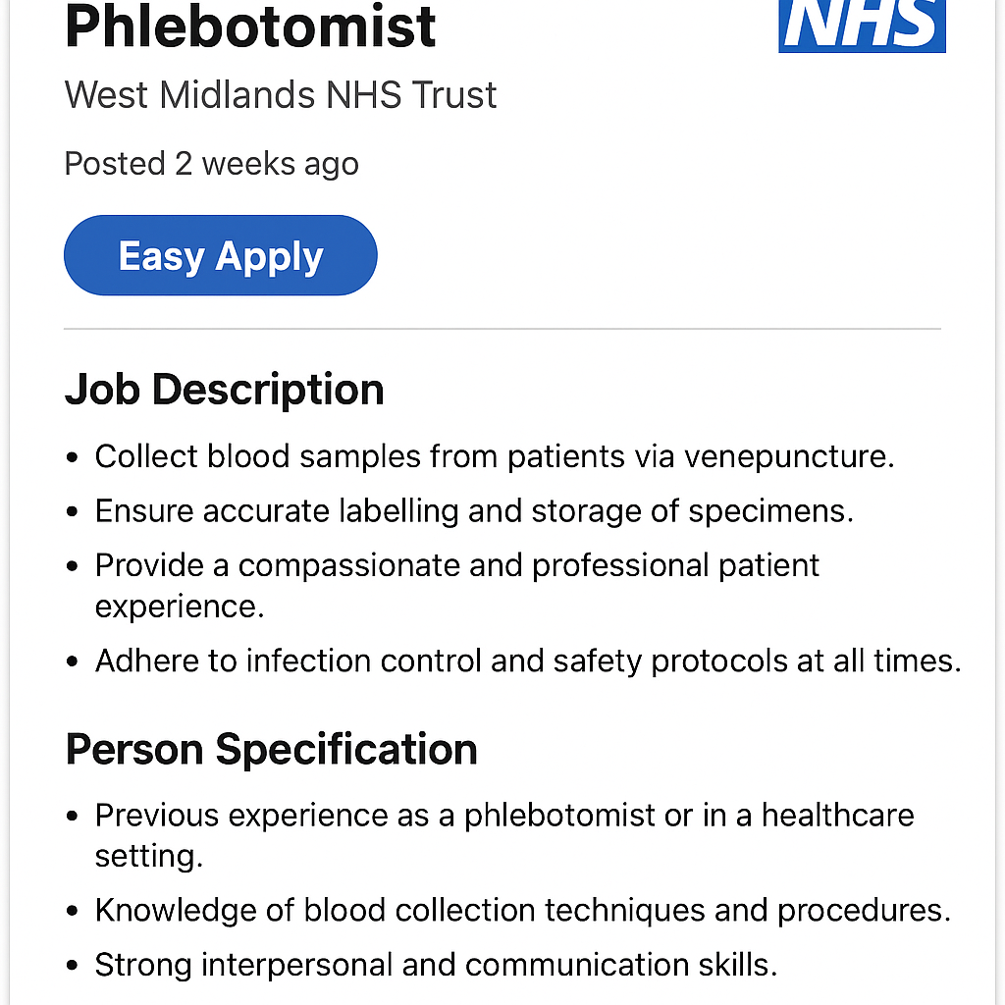

Job Role Employability Skills
A combined Phlebotomist/HCA role demands a range of employability skills that support safe and effective patient care. One of the most important is communication, as clinical staff frequently interact with patients who may be uncertain, distressed, or unfamiliar with healthcare procedures. Clear explanations, active listening, and respectful interactions all help build trust and reduce anxiety. Effective communication is also necessary for sharing information accurately with nurses, doctors, and laboratory teams (NICE, 2023).
Teamwork is another essential skill because both phlebotomists and HCAs work closely with multidisciplinary teams. Working cooperatively helps ensure smooth patient flow, reduces waiting times, and improves patient outcomes. Time management is important too, especially when working in busy clinics or dealing with large numbers of patients in a short timeframe.
Accuracy and attention to detail are critical aspects of the role. Mistakes in labelling blood samples or recording vital signs can lead to delays in diagnosis or inappropriate treatment. Adhering to correct procedures helps protect patient safety (Royal College of Pathologists, 2023).
Technical competence is central to both roles. Phlebotomists must be confident in venepuncture techniques, infection prevention, and safe handling of clinical equipment. HCAs require skills in taking blood pressure, temperature, pulse, and respiratory rate. Both roles require a solid understanding of infection control, as this is essential to reduce the risk of healthcare-associated infections (NHS England, 2022).
Professionalism, empathy, and confidentiality are also key employability attributes. Treating every patient with dignity, protecting privacy, and demonstrating respect support positive patient experiences. These values align with NHS expectations and contribute to high-quality care across all settings (NMC, 2023).

Self-Assessment: Evaluation of My Own Skills
Reflecting on my own abilities, I believe I already have a strong foundation for progressing into a combined Phlebotomist/HCA role. My two years of experience working as a phlebotomist in a GP surgery equipped me with practical knowledge in venepuncture, infection control, patient reassurance, and accurate recording of clinical details. This experience helped me understand the importance of safety, precision, and professionalism in clinical environments (NHS, 2023).
I am confident using EMIS and System One, which is useful because digital documentation is an essential part of modern healthcare. My experience in adult care strengthened my understanding of safeguarding, dignity, and person-centred practice. I learned how to support individuals with different needs and respond sensitively in challenging situations. Additionally, my 14 years as a nursery assistant developed communication skills, patience, and the ability to build positive relationships with people from a variety of backgrounds.
Strengths
One of my key strengths is my ability to communicate clearly and confidently with patients and colleagues. I am comfortable speaking to individuals who may feel anxious or unsure, and I use a calm, reassuring approach to help put them at ease, especially during blood tests or clinical procedures. I am also naturally empathetic, which allows me to understand people’s feelings and respond in a supportive and respectful manner.
Another strength is my ability to remain composed under pressure. Healthcare environments can be busy and unpredictable, yet I am able to stay focused and carry out tasks safely without becoming overwhelmed. My strong work ethic means I take responsibility for my duties and consistently aim to provide the best care I can. In addition, I am well organised and manage my time effectively, which helps me work efficiently during busy clinics. My attention to detail ensures that samples are labelled correctly, records are accurate, and procedures are followed safely.
Areas for Improvement
Although I have strong foundations, I recognise several areas to improve. I want to increase my confidence with taking basic clinical observations, such as blood pressure and oxygen saturation. I also aim to develop a deeper understanding of anatomy and physiology to support my clinical reasoning. Gaining experience in wider settings, such as hospital outpatient departments, would help broaden my practical knowledge. These improvements will make me more confident in taking on the full responsibilities of an HCA.
Sources of Support
To support my development, I can access NHS training, e-learning programmes, mentorship from senior staff, and shadowing opportunities. The NHS Health Careers website also provides guidance on career progression and relevant qualifications (NHS Health Careers, 2023).

Action Plan and Timeline
To achieve my career goal, I have developed a structured action plan with short-, medium-, and long-term targets.
Short-Term Goals (0–12 months)
My initial focus is to complete additional training that will strengthen my clinical skills. I plan to complete the Care Certificate, which covers the fundamental standards expected in care roles, including infection control, safeguarding, record-keeping, and communication (Skills for Health, 2022). I also want to develop my competence in taking clinical observations by completing relevant training.
Alongside this, I will start an online anatomy and physiology course to strengthen my scientific understanding of the circulatory and respiratory systems. I also intend to update my CV and LinkedIn profile so that my professional identity is clear and reflects my skills and goals. Using NHS e-Learning for Healthcare modules will help me improve my knowledge of policies and best practices (e-Learning for Healthcare, 2023).
Medium-Term Goals (1–3 years)
Over the next few years, I plan to gain broader experience by shadowing HCAs and nurses in hospital wards or outpatient clinics. Observing different clinical environments will help me understand the rhythms of healthcare settings and increase my confidence. I also aim to complete additional training in skills such as ECG recording, manual handling, and basic wound care.
During this time, I will continue reflecting on my progress, seeking feedback from mentors, and building a strong CPD portfolio.
Long-Term Goals (3–5 years)
My long-term aim is to work towards more senior positions, such as Senior HCA or Assistant Practitioner. To support this, I plan to undertake a Level 3 or 4 healthcare qualification. Continuing professional development will be important at this stage, and I intend to engage in regular training to maintain high standards of patient care.

Building My Personal Brand
A personal brand communicates who I am as a professional and what I stand for in my work. For healthcare roles, it is important that my personal brand reflects compassion, professionalism, and a commitment to providing safe, respectful care.
One of the most effective tools for developing my personal brand is LinkedIn. By keeping my profile updated with training, certificates, experience, and achievements, I can demonstrate my development and make myself more visible to employers. Sharing reflections or updates about skills I am learning can also show my motivation and enthusiasm (RCN, 2023).
Maintaining a professional CV and cover letter helps present my strengths clearly. Engaging in NHS open days, online webinars, and recruitment fairs also allows me to show interest in the sector and learn about expectations. A strong personal brand will help me stand out during recruitment and demonstrate that I am committed to delivering high-quality care.

Promoting My Professional Identity
Promoting my professional identity involves presenting myself confidently to employers, colleagues, and other healthcare professionals. Tailoring my CV and cover letters to highlight relevant experience—such as my phlebotomy background, record-keeping skills, and patient care experience—helps communicate my competence. Including details about training and certificates demonstrates that I take my development seriously.
Having a clear, professional online presence also plays a role. Updating my LinkedIn profile, connecting with healthcare workers, and engaging positively online helps me stay informed about new opportunities and NHS developments. Attending training sessions, networking events, and open days can further strengthen my identity by showing that I am proactive and committed to continuous improvement.
Overall, promoting my professional identity supports my confidence and helps me progress towards my long-term career goals.

Building a Network for Successful Employment
This report explores the employability expectations, core skills, and development needs involved in progressing into a combined Phlebotomist and Healthcare Assistant (HCA) role within the UK health and social care system. Both positions play a vital part in frontline services and involve close interaction with individuals who may be unwell, anxious, or preparing for clinical procedures. Phlebotomists focus on collecting blood samples safely, accurately, and in line with professional standards, while HCAs support wider aspects of patient care such as taking basic observations, assisting with mobility, promoting comfort, and updating clinical records. These responsibilities help healthcare environments run smoothly, contribute to positive patient experiences, and ensure that clinical teams receive the support they need in delivering high-quality care (NHS Health Careers, 2023).
I am particularly drawn to this career path because I enjoy working face-to-face with patients and supporting their physical, emotional, and psychological wellbeing. I find it rewarding to reassure people who may feel nervous about procedures and to help create a calm, respectful atmosphere during their care. My previous phlebotomy experience in a GP practice has strengthened my confidence with clinical procedures, while my background in adult care and childcare has developed my communication, patience, and resilience. These experiences motivate me to continue developing my skills and work towards a long-term career within the NHS.

Conclusion
This report has explored the main employability requirements, development needs, and progression routes associated with pursuing a combined Phlebotomist and Healthcare Assistant role within the NHS. Examining the job advertisement helped me understand the essential expectations of the role, such as effective communication, accuracy when handling clinical information, teamwork within multidisciplinary settings, and the technical skills required for venepuncture and basic patient observations. The self-assessment allowed me to reflect on the strengths I already bring to the role, including my phlebotomy experience, digital record-keeping skills, and ability to support patients calmly. It also highlighted the areas where I need further development, such as expanding my clinical knowledge and gaining more experience across different healthcare environments.
The action plan outlined clear short-, medium-, and long-term steps to build my competence, including completing mandatory training, increasing my exposure to clinical settings, and continuing my professional development. Strengthening my personal brand, promoting my professional identity, and building a wider professional network will also enhance my career prospects and support my confidence as I progress.
Overall, I am committed to improving my skills and becoming a capable, compassionate, and confident Phlebotomist/HCA. This report has clarified the path I need to follow to achieve my long-term career goal within the NHS.

Reference List
Care Quality Commission (2023) Fundamentals of care. Available at: https://www.cqc.org.uk (Accessed: 23 November 2025).
Department of Health and Social Care (2022) NHS workforce guidance. Available at: https://www.gov.uk (Accessed: 23 November 2025).
e-Learning for Healthcare (2023) About e-LfH. Available at: https://www.e-lfh.org.uk (Accessed: 23 November 2025).
General Medical Council (2023) Good medical practice. Available at: https://www.gmc-uk.org (Accessed: 23 November 2025).
Health Education England (2023) Careers and training. Available at: https://www.hee.nhs.uk (Accessed: 23 November 2025).
LinkedIn (2024) Building a professional profile. Available at: https://www.linkedin.com (Accessed: 23 November 2025).
Mind (2023) Anxiety: support and information. Available at: https://www.mind.org.uk (Accessed: 23 November 2025).
National Association of Phlebotomists (2023) Standards and guidance. Available at: https://www.phlebotomy.org (Accessed: 23 November 2025).
NHS (2023) Blood tests and phlebotomy guidance. Available at: https://www.nhs.uk (Accessed: 23 November 2025).
NHS (2023) Working in health and social care. Available at: https://www.healthcareers.nhs.uk (Accessed: 23 November 2025).
NHS Careers (2023) Healthcare support roles. Available at: https://www.healthcareers.nhs.uk (Accessed: 23 November 2025).
NHS Digital (2023) Primary care IT systems. Available at: https://digital.nhs.uk (Accessed: 23 November 2025).
NHS England (2022) Infection prevention and control manual. Available at: https://www.england.nhs.uk (Accessed: 23 November 2025).
NHS England (2023) Patient care and safety. Available at: https://www.england.nhs.uk (Accessed: 23 November 2025).
NHS Jobs (2024) Phlebotomist / HCA job vacancy. Available at: https://www.jobs.nhs.uk (Accessed: 23 November 2025).
NICE (2023) Patient experience in adult NHS services. Available at: https://www.nice.org.uk (Accessed: 23 November 2025).
Nursing and Midwifery Council (2023) The Code: standards of conduct. Available at: https://www.nmc.org.uk (Accessed: 23 November 2025).
Public Health England (2021) Infection control guidance. Available at: https://www.gov.uk (Accessed: 23 November 2025).
RCN (2023) Healthcare assistant roles and responsibilities. Available at: https://www.rcn.org.uk (Accessed: 23 November 2025).
Royal College of Pathologists (2023) Standards for specimen handling. Available at: https://www.rcpath.org (Accessed: 23 November 2025).
Skills for Health (2022) The Care Certificate standards. Available at: https://www.skillsforhealth.org.uk (Accessed: 23 November 2025).
UK Health Security Agency (2023) Infection prevention guidance. Available at: https://www.gov.uk (Accessed: 23 November 2025).
World Health Organization (2023) Infection prevention in healthcare. Available at: https://www.who.int (Accessed: 23 November 2025).

