Is 360 video worth it?
CAMF6002
1400859

Contents

What is the difference between 360 video and Virtual Reality? 3
360 Video today: 5
360-Degree Video Case Study: 8
360 Video vs Regular Video: Case Study 12
360 Google Spotlight Stories: HELP 16
Refugees 360 Documentary by Scopic: 21
Where’s Waldo 360: 26

Is 360 Video Worth It?

Media and the way in which we interact with it is rapidly changing, however one thing that hasn’t changed is our need to tell stories. As Margret Atwood mentions in the short film, A State of Wonder: How Technology Shapes Story (2015), the idea that we as humans naturally tell stories, but the way in which we tell them has changed. In The Medium Is The Message (1967) Marshall McLuhan and Quentin stated “an understanding of social and cultural change is impossible without a knowledge of the way media work as environments” Today, technology has become a gateway in which to express ourselves and tell stories in new and exciting ways. However, as Atwood mentions, it all comes down to “what is it good for? And who’s going to prevail?” Every platform is useful for something, but sometimes the invention of a technology comes about long before we found the most effective way of using it. 360 video is a relatively new platform that has gained substantial popularity over the last few years, but even now people are still trying to work out what the best use of it is. In the book Remediation: Understanding New Media (1999) by Jay David Bolter & Richard Grusin they state that, “the ultimate purpose of media is indeed to transfer sense experiences from one person to another”. 360 video is a technology that some large technology companies, such as Google, have tried to utilise in their campaigns, however it can be said that 360 video technology has not yet found its purpose. At the moment it is being used mostly for advertising, marketing and entertainment, such as the BMW 360° VR Commercial ft. Gigi Hadid by 360° Viral Media, although there are times in which you might ask yourself, does the video benefit from being 360? And if so why? It can be argued that 360 videos are a great example of participatory culture, which by definition means “a culture in which private individuals (the public) do not act as consumers only, but also as contributors or producers (prosumers)”, however Participatory Culture is a term that is rejected by many critics. 360 video is an immersive medium that relies on the participation of the audience, otherwise what is the point of it? In the book Participatory Culture in a Networked Era (Henry Jenkins, Mizuko Ito, Danah Boyd 2016) it is stated that “it is abundantly clear that not all forms of participation are equally meaningful or empowering”, it could be said that just because this new medium requires audience participation doesn’t mean that it’s a better form because of it. The purpose of this experiment is to try and answer this question of Is 360 Video Worth It? By analysing three short 360 videos, each showing a different approach to the technology: the first for educational purposes, the second for entertainment (game), and lastly one for observation, to test whether 360 video is only useful for a sense of atmosphere. These will be analysed in a number of ways through observations made by myself from a media student’s perspective by watching the films, as well at looking at how the films were produced and how that impacts how the film is received by audiences. Lastly, I will be asking others to watch the films and present their feedback based on their own findings; these include peers and the general public from different age ranges. I have chosen this because my peers will be able to look at it from more of a professional standpoint, having studied film themselves, whereas others who haven’t studied it might focus more on usability and entertainment. The feedback will be collected through a questionnaire style form, where they will be asked about user experience, immersion and enjoyment. For example, did you find the film engaging? Was it easy to navigate/ follow? Etc. firstly, I will talk about the differences between 360 video and Virtual Reality.

What is the difference between 360 video and Virtual Reality?
Often, the terms 360 video and Virtual Reality (VR) are used interchangeably, as though meaning the same thing, however they are totally different experiences even if they do have some overlap. In some occasions the opposite term is used to explain what the other is. For example, when conducting this experiment, people (generally older than the millennial generation) asked me what I meant by 360 Video and I would find myself either using VR with a headset or Google Street View as an example. VR is always viewed through a VR headset and generally 360 videos are too, however they can also be viewed and experienced without. Often, audiences who watch 360 videos on YouTube or Facebook are not doing so through a headset. When viewing a 360 video you are fixed in one position, only being able to move your head or scroll right, left, up and down, but VR allows you to go beyond this, allowing the user to move and interact with the environment, such as open doors and picking up an object and interact with it. Lev Manovich stated in The Language of New Media (2002) that “VR imprisons the body to an unprecedented extent”. With VR you are in control of what you do and where you go, whereas 360 is following a predetermined journey that we as a view must follow, much like when watching a regular film you follow the story as the director or filmmaker intended. In his article titled What’s the difference? Demystifying 360 vs. VR (March 2017), Dana states when talking about VR that “it’s often used for different kinds of experiences: VR holds a lot of value for simulations, for example, that teach the viewer. The most popular forms being training protocols for flight pilots, or rehabilitation exercises.” Furthermore, VR experiences use digital environments that mimic the real world, however 360 videos are generally filmed in the real world, even if they do have digital elements in them, for example Attenborough and The Giant Dinosaur (2016), where the dinosaur was digital animation, but Attenborough was very much real [figure 1]. When talking about virtual reality in Remediation: Understanding New Media (1999) Jay David Bolter & Richard Grusin stated that “virtual reality is the clearest (most transparent) example of the logic of transparent immediacy. The immediacy of virtual reality comes from the illusion of three-dimensional immersion and from the capacity for interaction. virtual reality depends upon our ability to compare it to both earlier visual media and, such as film, and to earlier experiences of mediated environments, such as game arcades.” Although both terms are confusingly used interchangeably they do share similar traits and technology i.e. headsets; they are however different experiences all together. McLuhan and Fiore in The Medium Is The Message (1967) say that “all media are extensions of some human faculty- psychic or physical… The environment that man creates becomes his medium for defining his role in it”. just like with any other medium, we use media platforms to reflect our own lives. They also state that “by altering the environment, evoke in us their unique ratios of sense perceptions. The extension of any one sense alters the way we perceive the world”.
In this experiment I will be primarily looking at 360 video and comparing it to that of regular filmmaking in terms of user experience and enjoyment. In order to talk about 360 video and whether it can influence the future, we must first look at how the technology is currently being used.

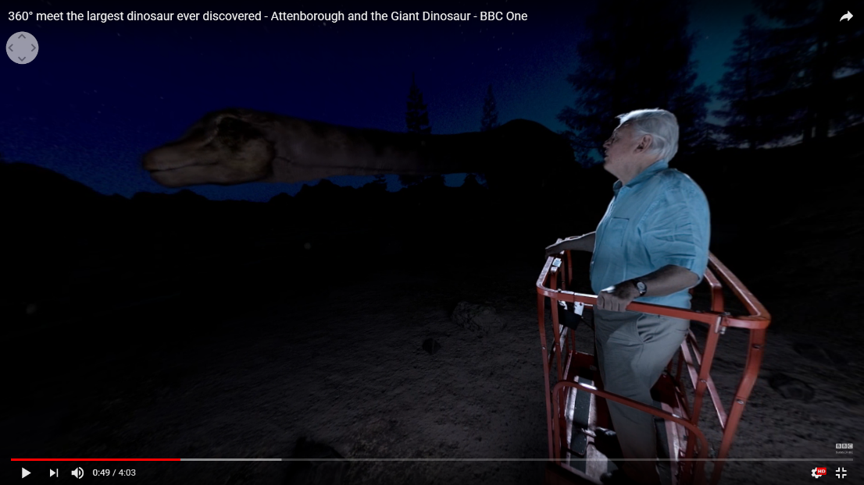
[Figure 1]

360 Video today:
Today, 360 video is already being used by brands in a number of ways, for example advertising both the brand itself and experiences. For example, Samsung used 360 by posting a snowboarding video as part of their Gear VR launch. It is also being used in virtual tours, especially in real estate to show off properties on the market, without actually going to the location. This is especially useful as it means that people can decide whether or not it is worth viewing in person, as most will be able to decide instantly whether it might be suitable or not, just by seeing the space. Unlike regular pictures or videos, 360 allows the viewer to see the space and how the room connects to others more efficiently and accurately, this is known as Spatial immersion. It also means that if you are a person who is unable to physically go to the location and see it for yourself, you still have the option to see much more clearly what it is like. When talking about interactivity Lev Manovich states in Language of New Media (2002) that “The literal interpretation of interactivity is just the latest example of a larger modern trend to externalize mental life”. Lanier claimed that VR will lead to the age of ‘post-symbolic communication’ communication without language or any other symbols. 360 video is also being used in entertainment of both fact and fiction, however the most popular, and some might argue, the most effective, is for observational documentary filmmaking, where viewer is placed among lions in Africa for example and are able to look around and experience the atmosphere in scenarios that would be far too dangerous to do in person and allows for an experience that very few would have the opportunity of experiencing. In the future as 360 video continues to grow, both in popularity and in its usefulness, it is possible that it could be used for much more. For example, in news coverage, where it could prove useful in ‘on the scene’ scenarios, such as a protest or large event like a festival, where there are a lot of people and a lot of ground, angles and perspectives to cover. It could also be used in the military in a similar fashion, to have perspectives from multiple geographical points.
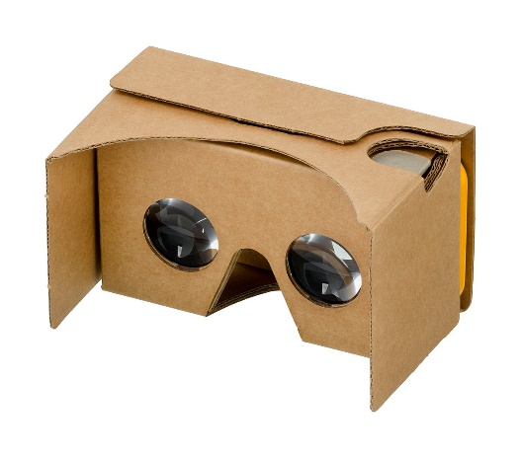
With the creation of 360 technology came the creation of 360 video cameras and software to edit these new video formats. A number of successful companies created their own versions of the cameras when 360 video started to become popular, as well as headsets to view them on. One of the most popular being Google Cardboard viewer headsets [Figure 2] that was released in 2014 for £15 in the UK. This brought with it a rise in VR videos watched on YouTube and VR applications being made on mobile device app stores. Popular 360 video cameras include the Ricoh Theta, GoPro Fusion and Samsung Gear 360 just to name a few. There are so many to choose from now, all ranging greatly in price and image quality. For example, the Ricoh Theta V currently prices at around £350 [figure 3], where as an Axis outdoor 360 camera can cost over £1000 at least, the Axis Q6128-E currently stands at £3427 [figure 4].
[Figure 2]

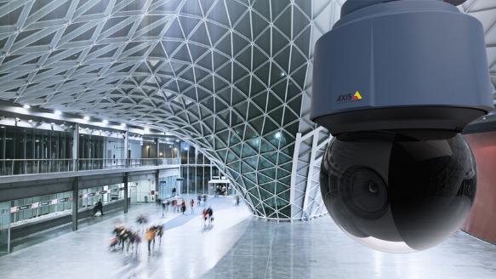
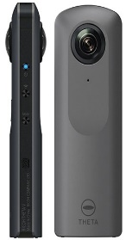
[Figure 4]
[Figure 3]

Some may argue that 360 cameras are a gimmick and although they are good at their job and can be bought quite cheaply, especially if it is being used for a business, they are far less useful for an average consumer who wants to test out the technology as they might not want to use it after the initial excitement and intrigue has worn off. In Participatory Culture in the Networked Era, Henry Jenkins said that “if you weren’t fascinated, you wouldn’t engage as a fan”. But what happens after that? Eric Adams in his article titled Most Virtual Reality Is Not Virtual Reality he makes a bold claim that “As is the case with drone technology, most 360 cams will eventually end up sitting on the shelves at home while the enthusiasts enjoy 360 experiences created by actual professional-level creators”. It could also be argued that the cheaper side of the 360 camera market are not as good as the much more expensive ones, for example the GoPro Fusion films in 4k unlike most affordable 360 camera on the market, therefore it is pointless for an average consumer to buy one because they don’t have the experience nor the financial aid to compete with “professional level creators”. However, I think that this could also be seen as an over-generalisation, because there is user generated content on YouTube that have reached or are close to industry standard content.
Along with Headsets and Cameras, came technology that can allow you to edit and manipulate spherical videos. Some popular companies such as Adobe have incorporated 360 video into their current package, where Adobe Premiere Pro has a feature to edit 360 videos and VR experiences [figure 5]. This demonstrates its acceptance in mainstream media. Other popular applications include Kolor for Mac and Windows users or even apps for your phones for example VeeR editor, V360, Collect etc. Although many may agree with the above argument that 360 video equipment is more for businesses, however in my opinion, there is enough affordable yet useful and good quality cameras and software out there, for anyone to make an interesting and immersive video. At the moment, I feel that although some people feel as though 360 video has yet to reach its potential, due to blurry visuals for example. In my opinion, viewers are still very fascinated by the technology and want to see more, not because it is without faults by because they are intrigued by the idea of it, that you can explore an environment at all angles and even see perspectives that we might not be able to see without it. As well as this, I feel that as the popularity and interest in the technology continues to grow, the technology will not only get better, but cheaper too. With cheap software available not only cheap ones such as phone applications, but also free ones as well, allowing a person to experiment with the technology as many companies and regular people alike have done to try and answer the same questions; is 360 worth it? And will 360 video change the way in which we interact with media in the future?
To begin my analysis of currently available 360 Videos, I first look at case studies looking the answer the same question; Is 360 Video Worth It?
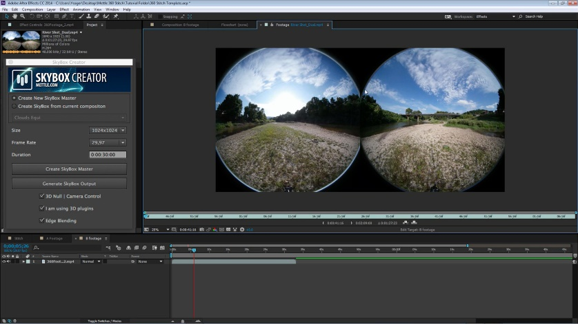

[Figure 5]

360-Degree Video Case Study:
In 2016, StoryUP, a native VR company based in Missouri, commissioned the digital marketing company Magnifyre to conduct an independent case study to put 360 video and regular videos up against each other and try to find out whether people watch a 360 video longer than they do a fixed frame video, even without a headset. In their online post, written by Magnifyre about the experiment Forbes stated that “Online video is undoubtedly changing the way audiences engage with content, ads, and brands, and small businesses and enterprises alike are starting to take advantage.” As previously mentioned, the importance of storytelling is vital in order to make content that is engaging to an audience. The post asks the question, “So what accounts for the success of video as a marketing medium? The answer is storytelling.” Whether the aim of a video is to sell a brand or company, a person or an idea, they all are telling a story. The post goes on to say that “though important, the numbers [percentages, pie charts, bar graphs] are just aiming to quantify engagement in the stories we’re telling. The test consisted of an identical video featuring a ballet dancer on stage and promoted dancers between 18-65 on Facebook (with the ads being optimized for video views). The only difference between the two was the format it was filmed in, everything including the video thumbnail remained the same [figure 6]. The cost per 1,000 impressions (CPM) Is notably lower for the 360 video at $4.20 vs $1.74 for the flat frame video. The click thru rate (CTR) was significantly higher for 360 video (4.51% vs 0.56%) despite the fact that the thumbnail image and copy was identical for each. For the 360 video the percentage viewed was higher by 28.81%, and double the viewers watched the video to 100%. The data suggests that people are intrigued but the format/ experience of the 360 format, making them more encouraged to click. The format itself is designed to be a fully immersive experience, meaning that not only do people want to start watching the video, but are likely to watch more of it because the flat frame video only allows the views to see the performance from one angle, whereas the 360 video allows them to be on stage with the dancer and look around them, not just as the stage but the seats, lights, atmosphere as well. The writer states that “The 360 video gives power to the viewer. It makes them a part of the story.” The post also states that the 360 video received 170 shares, however gives no comparison value to the flat framed video, making the statistic irrelevant to the experiment. In conclusion to the 360 video’s victory in the experiment, Magnifyre sums it up by saying “when it comes to connecting audiences to a cause, 360 degree video is the closest thing to placing the viewer in the subject’s shoes, short of going there themselves.” It is unclear as to whether 360 video will continue to intrigue people with the excitement of new technology as people are surrounded by it more and more every day, especially on social media platforms where content is available wherever and whenever, nonetheless the engagement and immersive nature of 360 video means that it encourages people to stay watching.
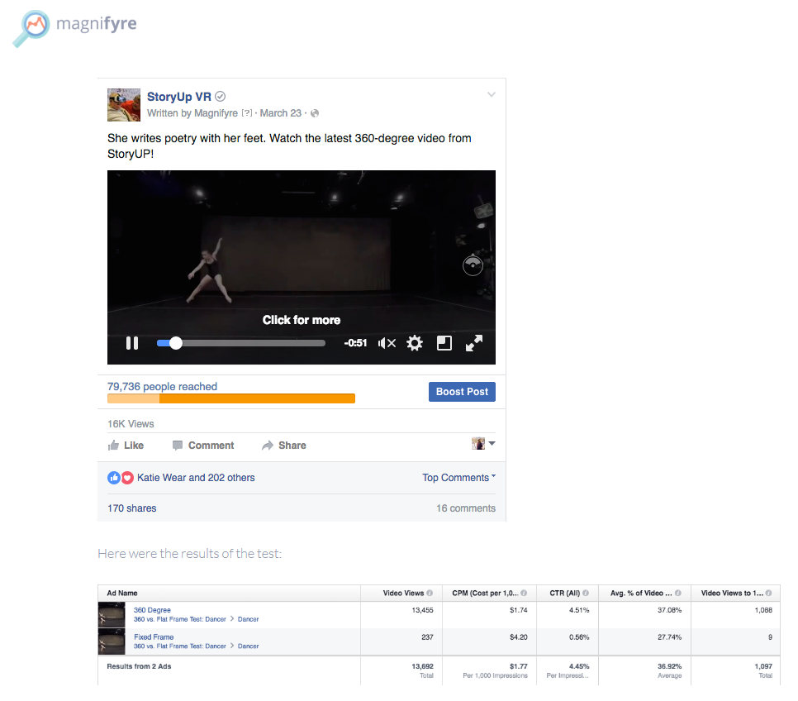
[Figure 6]

Sarah Hill, the CEO and Chief Storyteller for StoryUP VR wrote a guest post on Mediashift about the experiment and the findings it presented. The main finding was that “despite the same copy, ad spend and content, the average percentage viewed for the 360 video was 28.81 percent higher and double the viewers watched the video to 100 percent. 360 video also beat fixed frame video in terms of views, cost per impression (CMP) and click through rate (CTR)”. Hill stated that they found the figure very interesting for the 360 video especially, because its content is ‘likely to be consumed outside of a headset. This is because Facebook does not work with Google Carboard, only Samsung Gear VR. Facebook also does not give Magnifyre or StoryUP the ability to see where the viewers watched the video, whether it was in a GearVR or elsewhere, however as it likely that most people do not own a headset, it is safe to assume that the 360 video was intriguing, even without a headset. They do nonetheless know that 98 percent of the views on the ballerina video were on mobile. They will also be doing a test in the upcoming months featuring Youtube 360 vs Fixed Frame video. Hill goes on to talk about the aspect of 360 videos that sets it apart from flat frame video, in which you have a harder time portraying it. She states that ‘The killer metric for VR video is empathy. How does allowing someone to step inside your story enable them to better understand it?’. This goes back the question I am trying to answer, that not only is 360 video worth it, but what is it that makes it a completely different medium, more engaging and more immersive? Through science dating back to 2006 has shown that Virtual Reality not only aids memory recall, but it can also create false memories. Hill relates this back to what can 360 be useful for by saying, “for VR Journalists, false memories are likely not your goal. If you’re a marketer, creating a memory that does not otherwise exist could be a valuable tool.”
Although at the moment the numbers are all about likes, shares and CTRs, several VR analytics companies are working on “emotion metrics”. So, in addition to being able to see where in the 360 sphere the viewer is looking, through heat maps we will someday be able to know how our stories made the person feel. Hill states that “these increased data points could lead to what some marketers are calling a ‘datapoolooza’ with a hyper-personalization of immersive video products.” New software tools such as Liquid Cinema, which reorients the sphere on the cut line and gives VR storytellers the ability to target the viewers’ attention precisely and can then measure the actions they have taken at different gaze points.
In the final section of her article titled ‘Why Should Brands Care?’, Sarah Hill states that ‘the “internet” is no longer flat. Just as brands had to make their sites responsive for mobile, so too will they have to make them responsive for VR, because the “internet” is becoming a place you step into”. Even before VR headsets became increasingly popular in most markets, the immersive media that goes inside of them is increasing the time viewers spend on online stories. She goes on to say that, ‘immersive media could future-proof your stories by refusing ad spend per impression and increasing the time spent with your story. Jonnie Ross had it right when he recently told a packed VRLA conference room. “We’re about to turn a really big corner. It’s fast, and it’s gonna get weird”. We are still unknown as to what will happen in the future of VR and 360 video, however the evidence shows that people are currently very interested and invested in the software and many believe that it will change the way we view and interact with media in the near future.

360 Video vs Regular Video: Case Study
Think with Google also decided to partake in a 360 video case study to test whether 360 video advertising actually drives more engagement than standard video. Google partnered up with Columbia Sportswear to find out. Jim Habig in his July 2016 article titled ‘Is 360 Video worth it?’, he questions a number of important issue with the technology and what this could mean for the future of film production and storytelling. For example, ‘whether it [360 video] will revolutionise filmmaking, or whether it will end up as an historical footnote like Betamax’. Over the past few decades, there has been an abundance of ‘evolutionary advancements’ in film, such as HD, Dolby surround sound and 3D, but only a handful of revolutionary ones like sound and colour. 3D for example was said to be revolutionary after it became mainstream, however 3D televisions are no longer being made due to people either looking interest in the ‘fad’ or them not being up to the standard that are expected in cinema screens. The question is, will the same thing happen to 360 Video after the initial excitement of the new technology dies down? The questions continue as Habig goes on to ask, ‘what can 360 video really do for a brand? In the context of advertising, does it ensure higher viewer metrics?’. This is what google hoped to answer through the case study they carried out.
Google partnered up with Columbia Sportswear to create a video advertising campaign around two US Olympic skiers in Chile. As well as enlisting help from Columbia’s marketing team and in-house photographers, they also had assistance from 360 Labs, a firm that has been playing in 360 since the early days of street view, and a team of Chilean photographers. Much like the ballerina experiment [figure 7] by Magnifyre and StoryUP, they also created two similar campaigns (this time using Trueview, Youtube’s choice-based ad format), each featuring a 60 second spot for Columbia Sportswear, one was shot and presented in 360 video, the other a standard format video ad. ‘Both ads included CTAs in the lower- left corner that drove to an extended version, so that we could see if the 360 video ad was better than the standard ad at driving viewers to a full-length video.’ They looked at view through rate and view retention. For the 360 video they also considered a new engagement metric called interaction rate, which measures whether viewers engage with the functionality of 360 videos by dragging the viewfinder on a desktop screen or tilting a mobile phone [figure 8]. All of the videos remained unlisted throughout the experiment. This means that the only way to see any of the Columbia Sportswear videos was through their in-stream as campaigns or peer-to-peer sharing. The narrative of the ads was: a veteran skier, Hannah Kearney, and a rising star, Keaton McCargo, come together to train and learn from each other. Habig states, “we wanted the audience to feel like they were on the slopes with the skiers- sensing how Hannah and Keaton take on a mogul course, for instance, or hockey shop next to the camera rig.” The standard version of the ad (and the extended cut) was visually framed around the skiers, with aerial and wide-angle shots of their runs and the landscape. The 360 version of the ad (and again the extended version) planted the audience within the terrain, allowing viewers to explore independently. Both the standard and 360 video ads were narrated by Hannah and Keaton.
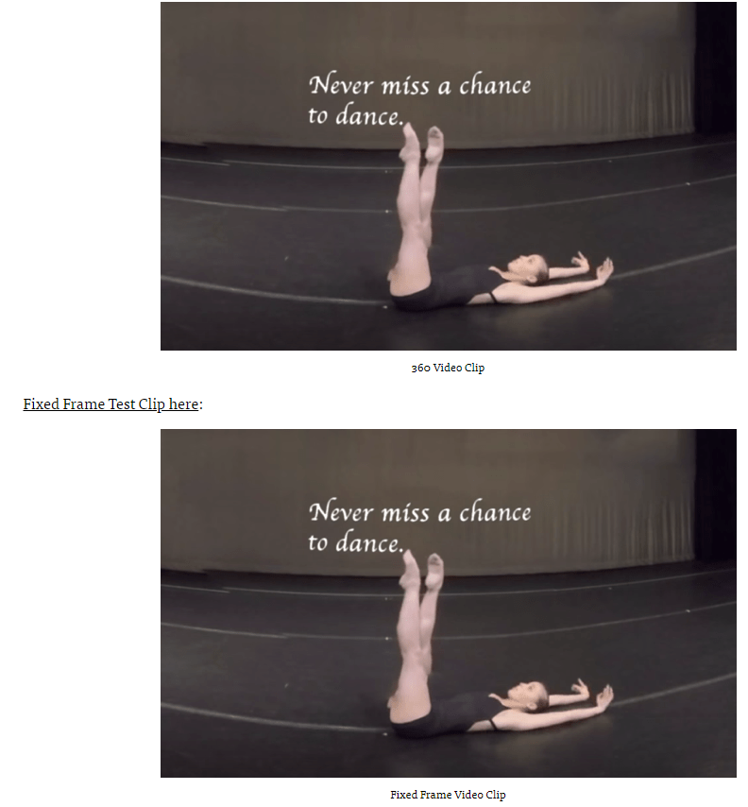

[Figure 7]
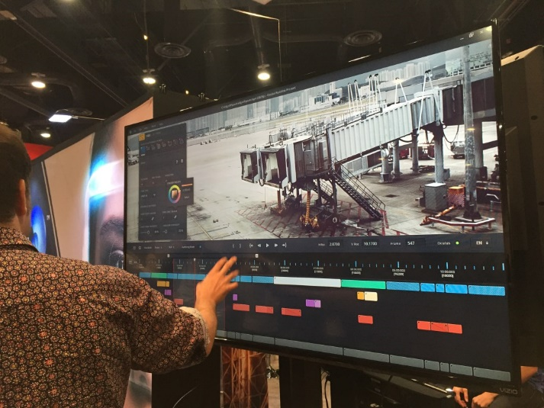
[Figure 8]
Jim Habig in his article said that, ‘we predicted that view-through rates and watch time for the immersive, 360 in-stream ads would be better than our standard video advertising campaign’. The results from the experiment however, were not quite as expected. The first surprise was that 360 video doesn’t overperform on traditional viewer metrics. They found that the 360 in-stream ad underperformed the standard ad on view-through rate, across mobile and desktop. This led them to conclude that viewers weren’t always in the mood for 360 video, if they’re mostly watching standard video, this was the exact opposite result that of the ballerina, where in that experiment the 360 video prevailed. Nonetheless 360 does have some strengths, such as, it motivates viewers to watch more and to interact with the story and technology. The 360 video had a lower retention rate than the standard ad, but the 360 video ad also had a higher click through rate. This means that the viewers were more interested in checking out the full-length version of the video. Viewers didn’t even need to watch the full cut to know they wanted more. The interaction rate, which measures how often viewers explored the 360 functionality by tilting or scrolling was higher than the view-through rates for the 60- second 360 ad, “this means that the 360 ad drove engagement via interactions, even if people didn’t watch 30 seconds or more. Lastly, 360 video drives viewers to share, subscribe and view other videos. “The 360 ad trounced the standard ad on all the earned action metrics, including views, shares and subscribes. In total, the 360 ad drove 41% more earned actions that the standard ad.” It also drove more engagement with Columbia’s YouTube channel than the standard ad. The most interesting part of the findings was that the only way for a viewer to get the longer version was to click from the ads, therefore it was expected that the views for the longer 360 piece to match with the shorter version but they didn’t. This means that the people who saw the longer 360 were copying the URL to share it directly with others. “in fact, we saw messaging apps like whatsApp and iOS messenger listed among the traffic sources of the 360 version- but not for the standard version.” The full length 360 video had a 46% higher view count at the end of the experiment than the standard full-length piece, making the 360 ad a more efficient buy because its cost-per-view was lower when organic and paid views were combined. At the end of his article, Jim Habig describes what this could all mean for the future of the technology using words like, “promising new ways, controlling their perspective, great news for brands, want to watch… want to share” and finishes by saying “As the technology continues to develop and more brands experiment with the format, its value will likely become stronger- for viewers and brands alike.”

360 Google Spotlight Stories: HELP
Before starting this ‘experiment’, I created a list of pros and cons for the 360 technology and how it works. When looking at different 360 examples, I will be comparing them against this list to see whether myself and others can eventually answer the question, Is 360 Video Worth it? The first category of 360 video I chose to look at was entertainment. This is probably the most popular use of the technology and is can be said to be less limited in what you can do with it, as many use animation and other components to make it more workable and exciting as a genre. Google Spotlight Stories made a 360 video titled ‘HELP’, that is based in Downtown Los Angeles and features a meteor shower and aliens through the use of 3D animation. [Figure 9] I chose this video in particular to analyse as it won four different awards in 2016 including, Cannes Lions Gold Lion Award Winner for “Virtual Reality” and “Technological Achievement” in Digital Craft and Webby Award Winner for Advertising & Media: Best use of Animation or Motion Graphics. As well as, Communication Arts Interactive Winner for “Tablet & Handheld Devices” and ADC Awards Winner for Branded Content & Entertainment”. This means that in its field, it is considered a great of the technology. It also gives us a great idea of how successful companies, such as Google are using the technology at a high standard.
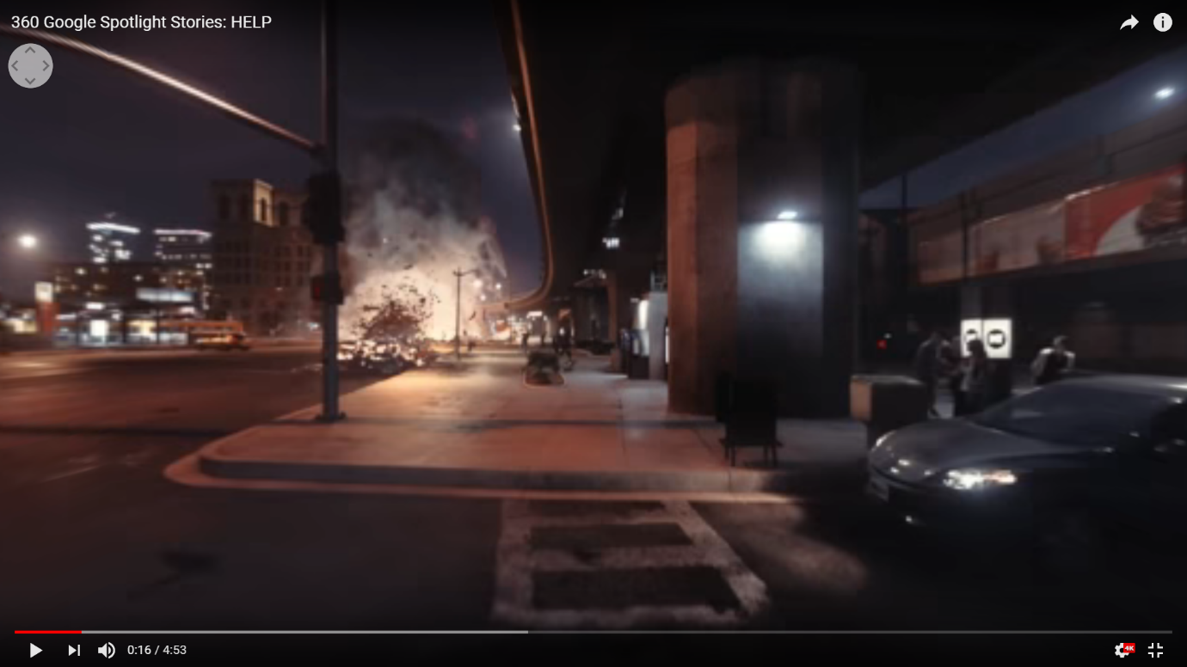
[Figure 9]
One of the most important things to remember, is that 360 video is a new medium and therefore there is no right or wrong, now is the time for experimenting to see what works and what doesn’t. In the video a commenter said that “If you think of 360 video as just a normal video with more range, then it’s a terrible idea, but it’s a new medium. It will take time to think of how best to use it or what content is best for it.” 360 Video is great for atmosphere and engaging with audiences in that setting. As mentioned previously, the video is set in Downtown Los Angeles, which has already given the film such a large scale to work with, making it already seem like an ambitious project for such a new technology, even though it is made by Google. The film starts with an establishing shot that pans down to the streets below. For some, 360 videos might seem like a restrictive medium, however this shot shows that this is not the case. You can look around while this is happening, making it appear as though you are falling, and with a pan of the camera it can make it so that you land in different position, whether that be sideways, backwards, head first etc. once landed, slow music starts to play, along with the sounds of a woman screaming, fire crackling and debris being moved revealing an animated creature. [Figure 10] The sound is also influenced by the direction you are facing; The object or subject becomes louder and everything else fades into the background. This not only helps to make the atmosphere even more immersive but helps to guide the consumer to where the action is. Also, by being able hear different sounds at different directions allows the audience to almost choose which aspect of the film they want to focus on.
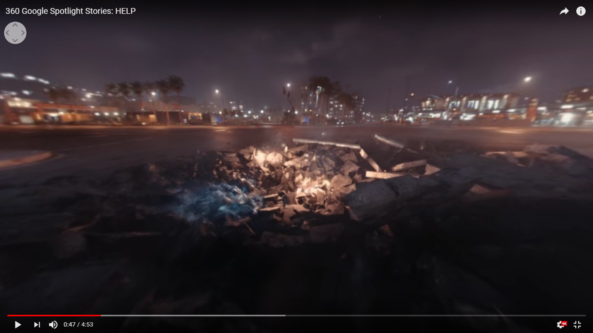
[Figure 10]

The sound is also non-diegetic music that plays throughout, that really adds suspense and emotion to the piece, much like in a regular film. For example, the people (police officer and woman character) or the aliens and the destruction they bring. The camera guides you on a pre-determined path, which I think is which I think is essential in terms of storytelling, as the order of events and what is in happening are all in the right order and therefore make sense, unlike they would in a VR Experience where you would be able to go whatever you please, however the ability to do this is also a great engagement tool. The camera shifts and gutters along with what is happening around you, chaos, destruction, loud noises. The camera also moves in a way that makes it appear as though you are on a kind of aircraft, this means that you are able to move from scene to scene quickly (keeping up with the fast pace action scenes) as well as giving off an almost ‘fly on the wall’ effect. There are a couple of disadvantages to 360 videos, for example the picture quality is generally not at the standard of regular video, and this has been a big issue since 360 videos became possible. In this film ‘HELP’ there are definitely some moments where you can see the blurry and pixelated footage [figure 11], however this has been something that companies have been working on, such as The GoPro Fusion which now films in 4K. The main issue with the pixelating issue is that it detracts from the story, which in term makes the technology feel more like a prototype than a finished product. Despite this, in time the technology will continue to improve (as we have already seen), I believe that through the early processes of 360, it was more about what the potential of what 360 could be or could do, rather than where it is currently, an in turn this is why in my opinion the video won so many awards because it was innovative and fresh.

[Figure 11]

Another downside to this video is that there is a lot of detail and content within it that can’t be appreciated as much as it deserves to be because everything is so far away, and you as a consumer are unable to zoom in and out. Nonetheless, it could be argued that this a 360 video not a VR experience. This means that we as a spectator do not have control over what we can and cannot control and as previously mentioned, it is more the case of we are just here for the ride that the creator has given to us and we are just along for the ride, similar to that of a regular film experience. In the video about the disadvantages of 360 an interesting point was brought up that ‘we don’t interpret things in 360 video’. It will be intriguing to see what people’s feedback is on this idea. 360 video can sometimes feel overwhelming as there is so much going on around you that it is difficult to keep up with it all or know where is the correct direction you should be looking. It could however be said that if you as a spectator where given less to focus on, then what would be the point of it being 360? It is also worth mentioning that this could actually be seen as a positive thing, that each time you watch it there are more things to observe. I also feel that it makes for a more believable and immersive environment if there are several scenarios at once, much like in a busy environment in the real world. Furthermore, in storytelling generally (especially in filmmaking) we tend to want to direct someone’s attention to something instead of getting distracted by less important things and making a video 360 could mean that you are focusing on entirely the wrong thing. Directorial decisions control what we are and are not shown; With 360 video that control is taken away, making following a particular story line challenging at times. Some may even argue that “there is not much point in 360 other than atmosphere.” Although the hype for 360 video has really blown up, with some even calling it the ‘future of filmmaking’, there are some that are more hesitant about investing in such a technology, as people tend to get excited about a new technology and the prospect of what that technology can do, but not necessarily how useful it is. It is very difficult to tell at the moment whether the interest and popularity will last, but as the technology gets better and better, the possibilities of what it could potentially be useful for in the future are limitless. Lastly, in the comments of the ‘disadvantages of 360 video’ a person commented saying “being able to look around is cool at first, but having to look around all the time can become annoying”. This could potentially link about to what I previously mentioned, (in terms of not being able to interpret things in 360), but not only that, it could be making us ask the question of, is 360 video an interesting enough concept that it can keep a person engaged for longer periods of time? An if its ‘only point is atmosphere’, then is looking at atmosphere alone enough to keep a person wanting to look around continuously? or is it just that in order for the 360 video to be successful it must have a reason to make to want to look around?
The feedback I received from my peers, I found that they found this film to be the most immersive and entertaining of the three films I chose to analyse. Generally, they found it to be more like a game, and therefore you knew exactly what was going on. One person in particular commented on the camera, saying that although you were following a pre-determined path, you still have control of what it is you are looking at, this means that it is more enjoyable because you don’t have to focus on people talking or reading words on the screen. They said that they felt it benefited from being 360 as a whole because it was like a game and it was more visual, but also the camera wasn’t static, so not only were you able to look around, but you were also able to move within the space, even if the journey is already mapped out. There is a lot going on, but not too much that you are unable to follow along. Generally, they felt that the graphics and animations made it more immersive because it shows that there doesn’t always have to be limitations within 360, and it also gives the feeling of “going on the journey with them”, as the characters in film act as your guide. Out of all the people I asked, they all said that they think in terms of this film, 360 video is definitely worth it, because it almost like a section between Virtual Reality and the pre-determined path of a regular film.

Refugees 360 Documentary by Scopic:
Going back to my previous argument that some people argue that the best use of 360 video technology is Observation Documentary, it made sense to look I more detail at a video from that genre. The film I chose to analyse is titled Refugees 360 VR Documentary by Scopic (2015). This film is also award winning, gaining the title of ‘Best Independent Film’ in 2016. The film follows the refugees on a journey to find sanctuary, making the viewer feel empathy towards them, even more so in 360, as you are placed in amongst the crowds of people, as though you are one of them. The film starts with text on a black screen that informs us that almost 3 million people have fled across the borders to escape the war, which is has become one of the largest forced migrations since World War Two. This is the only fact or statistic we are ever given. [Figure 12] Although I think they could have you more of this throughout if used sparingly to give the audience a greater understanding, nonetheless I think it is much more effective to focus more on the people we are being shown, as in many cases with observational documentary, the footage makes you feel and observe more than just words would ever allow. Accompanying this is sounds of crashing waves and a sound almost like radio interference, this is not as effective in making the spectator feel a certain emotion, such as using no lyric music that in popularly used to accompany on-screen text. I do however believe that the sounds used are more effective at already giving us a feel of the atmosphere that we are to be shown, harsh winds, cold. It also acts as a great transition into the footage we are shown shortly afterwards, an abandoned looking boat floating on rocky waters. This is then followed by scenes of refugees being helped off boats [figure 13], accompanied by the voiceover of section from a speech that Donald Trump made in 2016 about the Syrian migration as a Presidential Candidate for President of the United States. Where he uses phrases like ‘if I win, they are going back’, he then proceeds to repeat to repeat this several times ‘they’re going back, they’re going back’. I feel that even without knowing that Donald Trump would proceed to becoming the President of the United States, it is impactful to know that there are countries that are not willing to help refugees find shelter, because as a viewer we feel much more empathy towards then by knowing how helpless and lost the refugees must feel. The sound of the interference on a radio continues with a woman talking quietly in possibly Arabic.
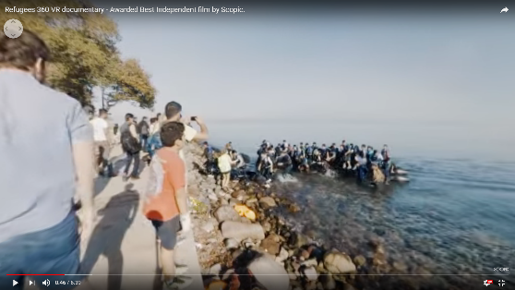
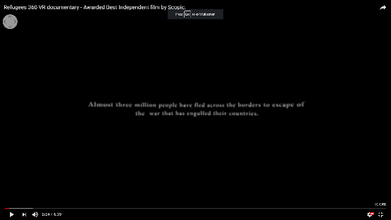
[Figure 12] [Figure 13]

Following more scenes of the chaos of people climbing of boats on strong waters, the footage turns to black and white and with it a voiceover from Geert Wilders, (2017) Candidate for Prime Minister of Netherland, who following Trumps example, talks about how these refugees could affect their country. What’s interesting though, is that the black and white footage only stays that for about 16 seconds before changing back to colour, there is no indication as to why this is the case. Wilder says, “this invasion is threatening our prosperity and our country”, which is then directly followed by two Syrian hugging, while one has his hand over his eyes as he cries. He then proceeds to use phrases like ‘fortune seekers’, and ‘of course we must provide shelter for actual refugees, but that must happen in the nearby region, not here”, the footage that accompanies this is a video of photographers taking photos of a refugee looking cold and frightened. [Figure 14] The scene ends by cutting to black. The image that fades in is of a beach, with what sounds like traditional Syrian music. By panning around you can see hundreds of life jackets piled up all over the shore. It has almost an eerie and lonely feel to it, because the people and the chaos have gone, leaving nothing but life jackets behind and the music reinforces this. The music continues as you follow refugees walking down a dusty path, carrying few possessions with them, and then guided on the buses.

[Figure 14]

We as an audience member are placed at the front of a car travelling up a hillside, where we follow the refugees on their journey walking miles and miles to an unknown destination. The traditional music continues, but this time without lyrics. Their journey continues as they are at a beach. The 360 is very successful here as you are able to see a large distance of the location, along with rows and rows of tents, calming music is playing along with sounds of birds, giving us an even better idea of the location; Refugees can also be seen queuing for bottles of water. As a spectator we are placed on the car again where we continue to follow hundreds of refugees continuing their journey, carrying their possessions with them. The last person we hear from is a refugee named Ahmed who is a 17 year old from Afghanistan who says “I’m tired of war and we don’t want such a life like this… I know it’s hard but we have no choices. We have to take risks” and while he says this we are shown refugees entering a large boat or ferry, where it sets off to another border. The film ends exactly how it started, a black background with words on the screen in white. ‘In memoriam, for all those heroes that lost their lives in Lesbos. The final image [figure 15] we are shown is the title ‘Refugees’, with a background of water crashing and a boat appearing from afar, a repetition from scenes shown in the film previously, as though they are trying to tell us that this is still happening and there will always be another boat reaching the shore. This continues as the credits roll. I feel that the film was extremely successful in both telling a story from the viewpoint of the refugees, while also putting it in to context with the rest of the world (with the voiceovers from Donald Trump and Geert Wilder). They managed to deal with a serious, political and relevant issue by presenting us with examples and showing us, rather than trying to force an opinion on us as an audience. We are merely observing what we are presented with and are free to make our own assumptions from them. With examples such as the life jacket scene and the scene that features the refugee’s tent camp, the 360 aspect of the film really enriched our experience, than what a regular video might have.
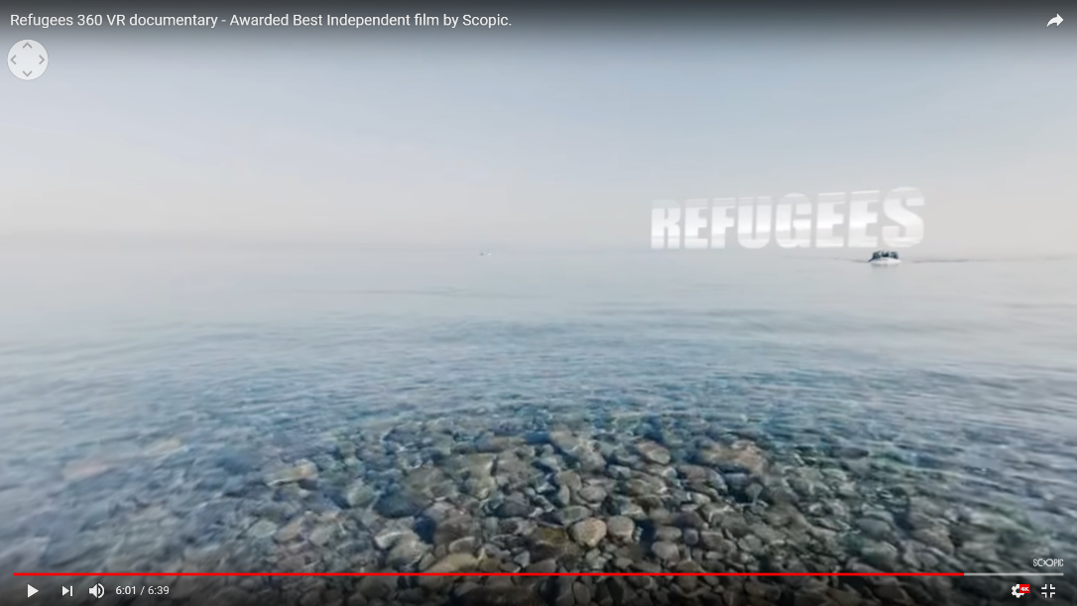
[Figure 15]
I was surprised to see that the feedback I received from this film in particular was almost completely negative, especially from a film that was so well received by audiences and won best independent film in 2016. They thought that the film didn’t really benefit from being 360 because they would rather be told the information than try and focus on moving around while also trying to take in the information shown through the text on screen and what is being said through a voiceover. They also thought that it would benefit from being a regular film much more because it’s too important a topic to follow so loosely. They stated that they would much rather just sit down and watch it, rather than spend time looking around. As a whole, they didn’t think the film was immersive because the camera is static and all you can really do is look around, creating a barrier between you and the content. Interestingly enough, in one of the feedback forms that I received a person said that they couldn’t enjoy it because they were focusing on too many senses at once. A number of people felt that it would have made a much bigger impact if they had made it in a standard video format, therefore 360 video was not worth it in this case.

Where’s Waldo 360:
Finally, I looked at a 360 game of Where’s Waldo. The game was created by Corridor on YouTube and was shot using five GoPros, all pointed at different directions on a 3D printed rig for high resolution [Figure 16]. To me this film is proof that a simple idea can actually work just as effectively in 360 video as more elaborate ones like HELP. It also proved that 360 video is not as restrictive as others might have us believe; instead of being ‘along for the ride with 360’ we are able to not only be immersed in a 360 environment, but we are able to interact with it, even if it is in a more passive way than VR. One of the main issues with 360 video is that you need a reason to pan around. In some cases most of what the creator of the 360 video shows you is directly in front of you, which begs the question, what is the point of it being 360? With ‘Where’s Waldo 360’, you are not just panning around to see the landscape or to follow sounds as a form of navigation, you are panning around for a purpose, to find Waldo.
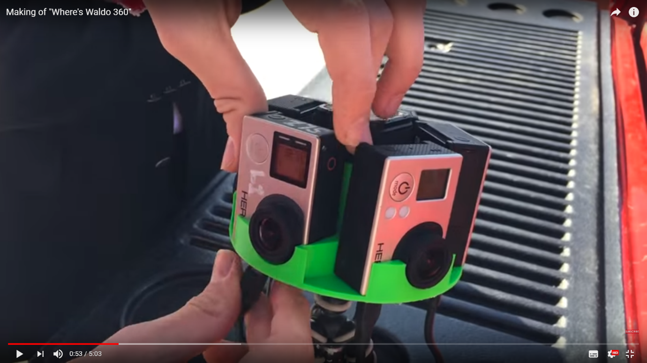
[Figure 16]

The film is 3 minutes 54 seconds in length which is significant as it may become tiresome to keep spinning after a longer period of time (as previously mentioned, was voiced in the comments of Disadvantages of 360 Video on YouTube). The first space we are brought to is an outdoor shopping or town centre, where we are only free to look around for about 40 seconds before moving on to the next scene. This gives it a fast pace, keeps the audience interested and invested, and more determined to spot Waldo if they haven’t already. There are also elements of ‘animation’ for example a man peers behind the stall at 0:32 [figure 17] and directly above that a person can be seen hanging head first out of a circular hole in the shop wall. There is also a man with his head poking through the wall 180 degrees from the last as well as a hooded man which seems to be glowing at times. It is scenarios like these that add to the environment of the ‘game’ and make the story more interesting, while also giving the audience a distraction so that they don’t necessarily spot Waldo wandering around, or at this part in the film, being chased. The creators used a equirectangular (taking the sphere and unmapping it out) to create the special effects. By using Skybox Studio they projected images on this equirectangular maps and then restored it so it fits perfectly into the spherical image that you’re seeing on the screen.
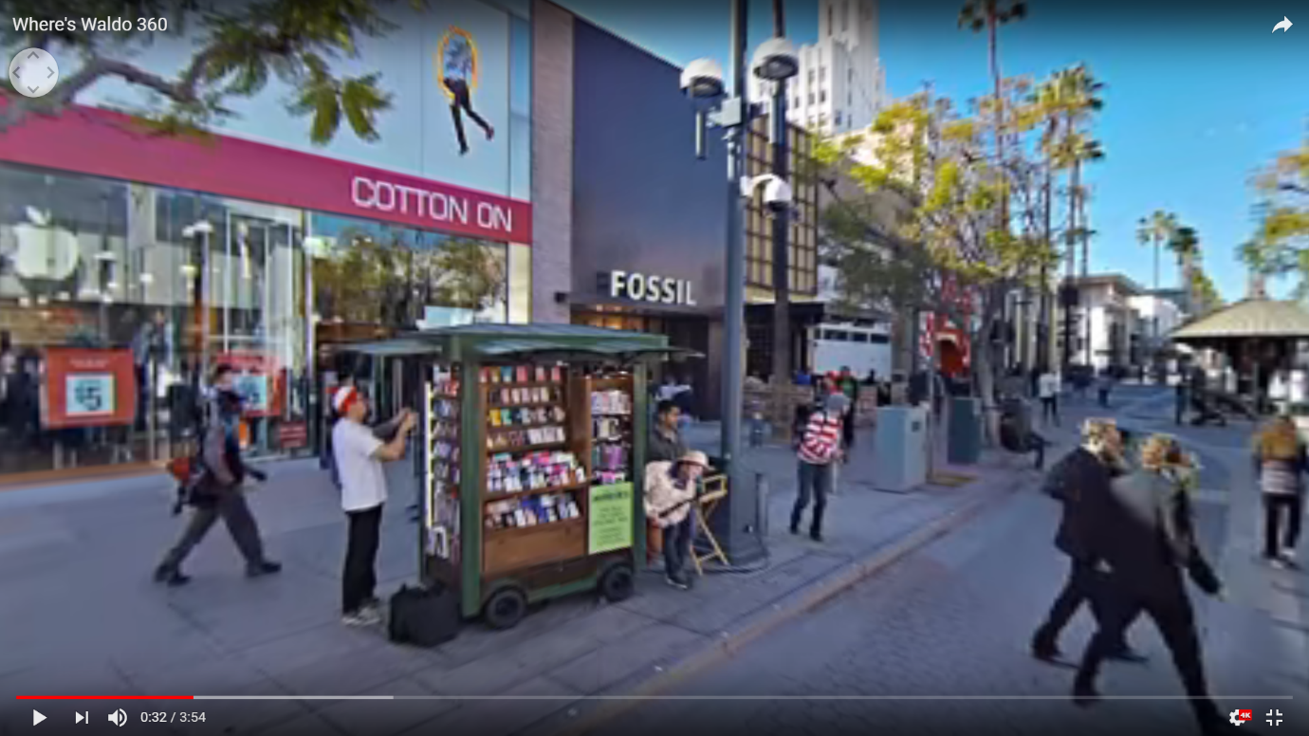
[Figure 17]
I have found that every time I watch the video I tend to notice something I hadn’t last time. I do however find the second scene (at the pier) far more successful as there are more first because there are far more people to try and search through, and the distraction of watching what people are doing and the other additional animations and people is even more appealing. [Figure 18] In some cases the distractions are so great that they make it difficult to remember what you are looking for in the first place on some occasions. A weakness I would say the film has is that it look a couple of watches to realise that you have to look all the way down to the ground to see the text written on a black background saying ‘can you find the rest?’ with a list of the other characters you have to find [figure 19]. This changes with every change in location (all locations were filmed in Santa Monica). I think that it is a positive that the text is not in the way of you as a spectator to see the atmosphere it is trying to show, however, you might not necessarily think to straightaway look at the ground, therefore you either have to restart the video if you notice it part way through, or you miss the list altogether. I think that is it almost a bit much to be trying to look for Waldo and trying to find all of them on the list in short amount of time we are given before the scene changes again. After the pier scene, the rest of the scenes that follow are much shorter than the first have much less going on within them.
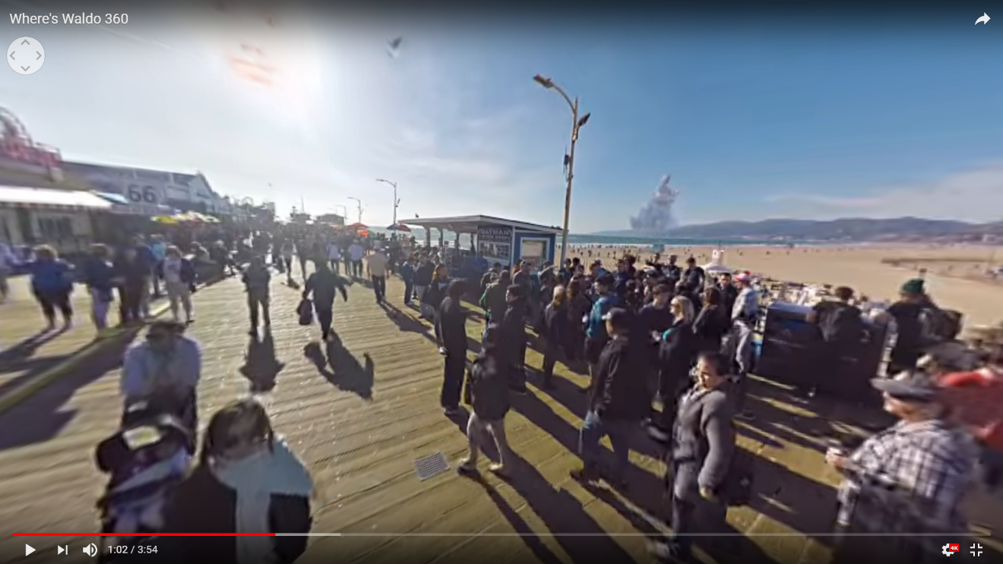
[Figure 18]
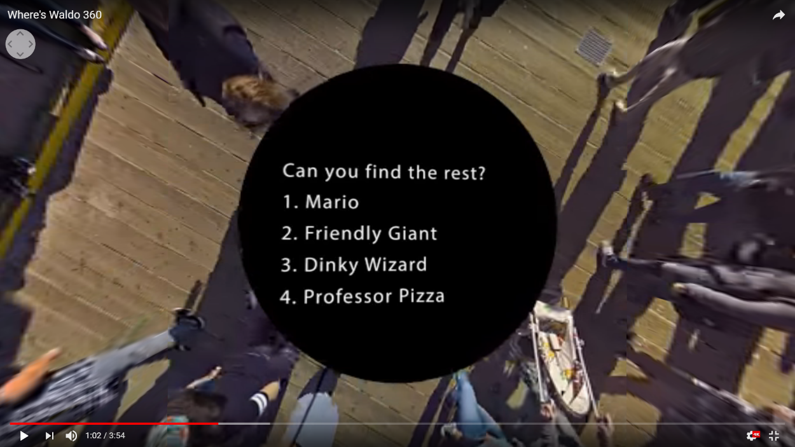
[Figure 19]
The one before the last scene(underneath the pier) for me is proven to be far more interesting, even with less characters because of the camera trick; as always the two ‘security guards’ chase after Waldo, who then disappears behind a pole. The security guards follow and one of the turns into Waldo and back again. This fast pace trick makes the scene far more immersive than the others. This I think is more of what I expected the whole film to be like; you follow, chase and search for Waldo. Although the list of other characters to find is not mandatory, it is still what one might expect from this video, especially as it is titled ‘Where’s Waldo 360’. In the YouTube video ‘The Making of Where’s Waldo 360’ they explain about a technique used to make sure Waldo could always be seen, which they called ‘Rule of Finger’, where they used put their index finger up to the camera and made sure that Waldo measured up to the size of it to be sure he was close enough. The final clip only lasts for 30 seconds in total and shows that when the security guards finally manage to catch him at a dead end he gets abducted by a stereotypical look spaceship [figure 20]. I think this is a fun and humorous way to conclude the film, as I think it needed a definitive ending instead of just ending abruptly. The creators of the film also mentioned that when editing the footage using AutoPano Pro by Kolor, they noticed that the GoPros don’t all record at exactly the same time, and therefore they didn’t stitch together properly. They discovered that to fix this issue, you have to spin the rig back and forth and the software automatically uses motion to synchronise the footage, then you can stitch it all together.
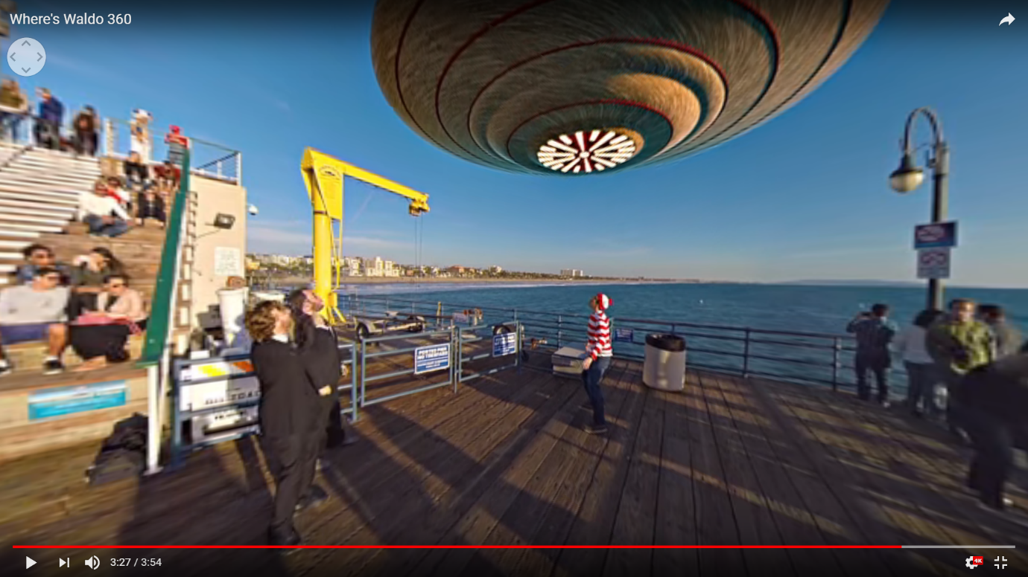
[Figure 20]
The feedback I received for this film was both positive and negative. Just like I did, they found that the concept benefited from the 360 format, because it gave them a reason to look around. However, some also stated that they didn’t like that it was a video, because it was too difficult to keep track. They thought that a 360 photo might have been a better choice in this case. Going into the video everyone knew what to expect and that made it more enjoyable. Even before watching the video they were already excited and intrigued by the idea of Where’s Waldo in 360. Overall, they found that the film was immersive, however the animation through out made it less immersive because there was no reason for them to be there. This is the complete opposite response to HELP. They found that Where’s Waldo 360 was easy to follow because you knew straight away what you were expected to do. The change of location also helped to navigate because it was pre-determined. In terms of finding the other characters, one person said that they liked seeing other characters when search for Waldo, but they didn’t want to go looking for them because it is not the purpose of the video. As a whole, they found the film or game enjoyable but also difficult, mostly because of how complicated they had made such a simple concept. Overall, they said that 360 video was worth it for this particular film because it you could search for yourself, but it was just too chaotic.
In conclusion, 360 video, though treated like an extension of other media formats, it is a new medium in its own right and therefore should be evaluated and critiqued like one. 360 video has gained so much popularity and intrigue, especially over the last few years because it is something new and exciting. Companies and regular people alike are still trying to figure out exactly what 360 videos capabilities are and how users or audiences can best benefit from it. To be able to make a conclusion as to whether 360 Video Is Worth It? We must remember that it is a new platform and therefore there is no checklist or expectation already in place. It can be argued that 360 video is a form of participatory culture because of its immersive and interactive nature. In New Media: A Critical Introduction (2003) by Martin Lister, Jon Dovey, Seth Giddings, Iain Grant and Kieran Kelly say when talking about Interactivity, that it is, “where ‘old’ media offer passive consumption; new media offers interactivity.” VR and 360 video are terms that are often used interchangeably, but do not mean the same thing. It is possible that people are generally more interested in VR as a platform because it allows an audience to interact with a space, allowing it to change and form around them. Even though I have previously stated that 360 video might not yet have found its best purpose, 360 video is already being used in a number of ways around the world from real estate to entertainment and has proven that some of which have very distinct benefits of being in 360. With 360 cameras and editing software becoming increasingly cheaper and better, 360 video not only is the quality of 360 videos increasing, but also the cost in which to produce and edit 360 videos to a profession standard is decreasing. Through looking at 360 video case studies, it was determined that audiences are interested in 360 video far more than regular videos, these figures and statistics help to justify the claim that 360 video is in fact worth it. The choice of analysing three short 360 videos, all with different purposes and all being very well received by audiences proved that there is not one set way of making 360 work well. The three were all very different in comparison, but collectively they are further evidence that 360 video as a platform is flexible and multipurpose, which could be the reason why people are questioning whether 360 video will continue to stay popular, because it doesn’t have one set purpose. There is so much that can be added to a 360, such as aminations, text, binaural sound, that the uses of 360 video seem endless. It is difficult to say whether this experiment was conclusive because there is still so much about 360 that we don’t yet know. From the feedback and others and my own analysis, it is clear that 360 can be worth it, but it is still very much the case of figuring out what makes it worth it, especially because some videos have gained far much more positive feedback than others, making us ask ourselves, what it that makes it successful. However, although the future of 360 video is unclear, 360 video as a platform is not only exciting, but is also worth it. In Participatory Culture in a Networked Era (2016) by Henry Jenkins, Mizuko Ito and Danah Boyd, Jenkins talks about the idea of fandoms and states that “fans were often early adapters of new media platforms and practices and experimenters with [modes] of mediamaking. If you weren’t fascinated, you wouldn’t engage as a fan”. I believe that 360 Video has become increasingly popular because we a fascinated by the technology and what its potential could be; it is because we are fascinated that we accept and adapt to new media platforms and that includes 360 video. Similarly, in The Medium Is The Message (1967) McLuhan and Fiore state that “print technology created the public. Electric technology created the mass.”. It is through our ability to share, especially these days with social media, that we are able to reach far larger audience and it is through the masses that we are able to adapt to new media and other new technologies.

https://youtu.be/OXhB5A_c7xE
McLuhan, M; Fiore, F (1967) The Medium is the Massage
Bolter, D; Grusin, R (1999) Remediation: Understanding New Media
https://youtu.be/nlB3Zsr-heE
https://en.wikipedia.org/wiki/Participatory_culture
Jenkins, H., Ito, M., Boyd, D. (2016) Participatory Culture in the Networked Era
Manovich, L (2002) The Language of New Media
https://vimeo.com/blog/post/virtual-reality-vs-360-degree-video
https://youtu.be/IDkbkvOFxng
Bolter, D; Grusin, R (1999) Remediation: Understanding New Media
McLuhan, M; Fiore, F (1967) The Medium is the Massage
Manovich, L (2002) The Language of New Media
https://www.youtube.com/watch?v=sPyAQQklc1s
Jenkins, H., Ito, M., Boyd, D. (2016) Participatory Culture in the Networked Era
https://ericadams321.com/blog/
http://magnifyre.com/360-degree-video-case-study/
http://magnifyre.com/360-degree-video-case-study/
http://magnifyre.com/360-degree-video-case-study/
http://magnifyre.com/360-degree-video-case-study/
http://mediashift.org/2016/05/360-video-vs-regular-video-our-case-study/
http://mediashift.org/2016/05/360-video-vs-regular-video-our-case-study/
http://mediashift.org/2016/05/360-video-vs-regular-video-our-case-study/
http://mediashift.org/2016/05/360-video-vs-regular-video-our-case-study/
http://mediashift.org/2016/05/360-video-vs-regular-video-our-case-study/
https://www.youtube.com/watch?v=SrYZlkyjWsg
https://www.youtube.com/watch?v=z9HEGHOk5hM
Lister, M; Dovey, J; Giddings, S; Grant, I; Kelly, K (2003) New Media: A critical Introduction
Jenkins, H., Ito, M., Boyd, D. (2016) Participatory Culture in the Networked Era
McLuhan, M; Fiore, F (1967) The Medium is the Massage Wordcount: 10,086

