

STUDENT NAME: ALINA PRECUP
ID STUDENT NUMBER:1816777
MODULE LCBB6000 A2
MODULE TITLE : DISERTATION
MODULE LECTURES: KONSTANTINA MARI

TOPIC DISERTATION : CRITICALLY EVALUATING THE IMPACT OF THE MANAGERS ON EMPLOYEE’S , MOTIVATION AND COMMITMENT AND HOW CAN ANY FALL OUT BE MANAGED

Executive summary

The chapter 1 sets the toe for the research study of evaluating the impact of managers’ impact on the employees’ performance and motivation and how the internal conflicts between them can be mitigated. Thus, the chapter 1 discusses the research background, research problem along with a rationale on the research topic. Following this, this section presents the research aim, research objectives along with the research questions. Lastly, the section describes the signific of this research study.
The chapter 2 critically evaluate the impact of managers on employee’ performance and motivations. Following this, this section discusses the impact of employee-manager relationship in the motivation of employees and productivity of organizations.
Table of Contents
Chapter 1: Introduction 3
1.1 Introduction 3
1.2 Research Background 3
1.3 Research Problem 3
1.4 Rationale 3
1.5 Research Aim 4
1.6 Research Objective 4
1.7 Research Questions 4
1.8 Dissertation structure 5
1.9 Research Significance 5
1.10 Summary 5
Chapter 2: Literature Review 6
2.1 Introduction 6
2.2 Impact of managers on employees’ motivation and performance 6
2.3 Evaluation of employee-manager relationship in the motivation of employees and productivity of an organization 8
2.4 Accessing the role of employees and managers in mitigating the internal conflicts. 10
2.5 Identifying the ways to make relation of managers and employees strong 11
2.6 Literature gap 11
2.7 Conceptual Framework 12
2.8 Summary 12
Chapter 3: Methodology 13
Introduction 13
Research Philosophy 13
Research Approach 13
Research design 14
Research validity and reliability 14
Data collection 14
References 15

Chapter 1: Introduction

1.1 Introduction
Maintaining a strong employee-manager relationship is very important as it helps organizations in enhancing productivity, and encouraging collaborative work among the employees. The research is aimed at discussing the impact of managers on employees’ motivation and performance. In addition, the research evaluates the role of managers and employees in mitigating internal conflicts. The research paper utilizes secondary data regarding the impact of managers on employees’ motivation and performance. However, internal conflicts between the employees and managers negatively impact the growth of an organization. Thus, this is a major concern for the organization. Therefore, the research emphasizes identifying the causes of internal conflicts and how the conflicts can be mitigated.

1.2 Research Background
A strong manager-employee relationship helps in fostering employees' engagement in a company. The employees are more willing to be engaged with the company due to the fulfilment of employee satisfaction (Onnis, 2019). Due to a strong employee-manager relationship, the productivity of an organization is significantly improved. Thus, the research tries to discuss the impact of managers on employees’ performance and motivation.

1.3 Research Problem
Due to lower productivity among employees, companies are not able to achieve their set goals and objectives. Therefore, the research aims to address the issue of lower productivity among employees by focusing on the employee-manager relationship.

1.4 Rationale
Low motivation among employees and poor performance of employees can severely impact the growth of a company. The performance and motivation of employees is a crucial factor for an organization’s success (Lim, 2021). Thus, any conflicts between the manager and employees would greatly reduce the motivation of employees which will be reflected in the performance of the employee and the financial performance of the organization. Therefore, organizations can fall short of achieving their goals and objectives due to lower productivity among employees. Thus, the research focuses on finding significant insights into the employee's motivation and performance.

1.5 Research Aim
The research is aimed at critically evaluating the impact of managers on employees’ motivation and commitment and the role of managers and employees in mitigating internal conflict.

1.6 Research Objective
- To assess the impact of managers on employees’ performance and motivation
- To evaluate the importance of the employee-manager relationship in the motivation of employees and productivity of an organization
- To assess the role of managers and employees in mitigating internal conflicts
- To identify ways to make the manager-employee relationship strong

1.7 Research Questions
- What are the ways to assess the impact of managers on employees’ performance and motivation?
- What are the ways to evaluate the importance of the employee-manager relationship in the motivation of employees and productivity of an organization?
- What are the ways to assess the role of managers and employees in mitigating internal conflicts?
- What are the ways to make the manager-employee relationship strong?

1.8 Dissertation structure
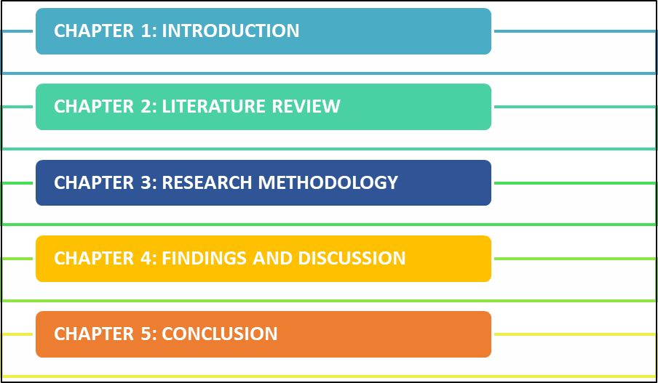
Figure 1.8: Dissertation Structure
(Source: Created by the Researcher)

1.9 Research Significance
The research is intended to identify the impact of managers on the employees' performance and motivation. In addition, the research will emphasize identifying the root causes of internal conflicts between managers and employees. The research will be performed with the help of secondary sources of data with the emphasis on utilizing several journals from credible sources for gathering qualitative data to support the research arguments.
The researcher will review several key pieces of literature for describing the factors regarding employees’ motivation and performance, the relationship between managers and employees and internal conflicts.

1.10 Summary
The section was focused on discussing the background of the research and taking the lead in the research. The crucial aspects of the research such as research aim, research objectives, research questions and research significance have been discussed. The Research significance has been presented in this section with a focus on the crucial aspects of this research paper.

Chapter 2: Literature Review

2.1 Introduction
The relationship between managers and employees is a very important aspect of the success of an organization. The effect of widening the gap between the manager and employees can be seen in the recognition and appraisal of employees. Along with the impact on recognition and appraisal, employees can suffer from the lack of presence of good learning of growth development (Fotiadis, Abdulrahman and Spyridou, 2019). Therefore, a poor relationship between the manager can negatively impact both the employees and the growth of the organization. This section tries to describe key pieces of literature from credible sources.

2.2 Impact of managers on employees’ motivation and performance
The relationship between manager-employee is a crucial factor for the employees’ performance and motivation. According to Paais and Pattiruhu (2020), A healthy relationship between managers and employees can positively impact the motivation and performance of employees. Due to a strong bonding, employees can acquire better learning and development opportunities which can help them obtain growth opportunities in future. Managers can also influence their employees by giving appraisals and recognition for their work. The work recognition and appraisal can enhance the engagement of the employees with their managers and job. Furthermore, the manager can influence their employees by giving them a clear plan of progression in professional life which can motivate their employees to work harder.
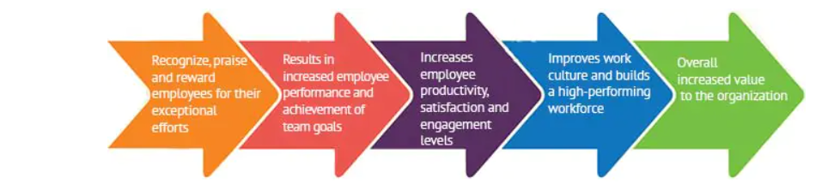
Figure 2.2.1: Impact of Managers’ recognitions on employees and organizations
(Source: Paais and Pattiruhu, 2020)
Whereas, the negative attitude of managers toward their employees can significantly reduce the motivation and performance of the employees. As stated by Al-Jedaia and Mehrez (2020), the bad attitude of managers toward their employees in workplaces can be reflected in the performance of employees. Firstly, unfair policies regarding salary and compensation can greatly impact the performance and motivation of employees. Following this, bad working conditions such as excessive workload and long working hours can also negatively impact the employees’ performance and motivation.
The signs of healthy relationships can reflect in job satisfaction, achievement, and recognition for the work of employees. Thus, managers play an important role in influencing employees towards working hard. As per the teachings of Herzberg’s motivation theory, there are two major factors: hygiene and motivational factors behind the motivation of an employee (Alrawahi et al., 2020). There are several hygiene factors that can cause dissatisfaction among employees. Among the hygiene factors, the relationship with peers, working conditions, company policies, security and supervision are the major ones that negatively impact the motivation of an employee. On the other hand, when it comes to motivation factors, achievement, recognition, work, and growth Opportunities are the major motivating factors that can enhance employees’ motivation and performance. Therefore, it can be understood that if company executives including managers work to eliminate hygiene factors and focus on motivating factors, the employees’ motivation and performance can be enhanced.
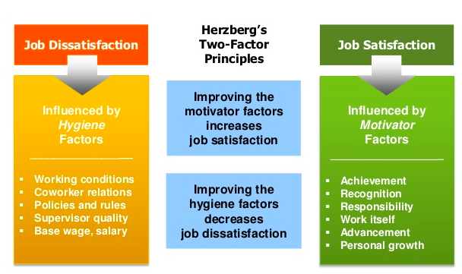
Figure 2.2.2: Herzberg’s two-factor principles
(Source: Alrawahi et al., 2020)

2.3 Evaluation of employee-manager relationship in the motivation of employees and productivity of an organization
The relationship between manager-employee impacts the productivity of organizations to a large extent because the fulfilment of an organization’s goals and objectives depends on both strong leaders and productive employees. As per the opinions of Hafeez et al (2019), in order to build a strong relationship between the managers and employees, a company's top management should look into the areas of employee-friendly policies, favorable working conditions, adequate pay and compensation, reasonable working hours, appraisal and recognition system. By providing employees adequate flexibility and favorable working conditions, managers can build strong relations with the employees. The effect of this strong relationship can be felt in the enhanced performance and motivation of the employees. Furthermore, companies should maintain fair policies in order to sustain their relations with the employees (MosakeNjomo, 2019). Due to the mutual understanding and trust between the managers and employees, companies can witness fewer obstacles in their internal workflows and can achieve their goals and objectives.
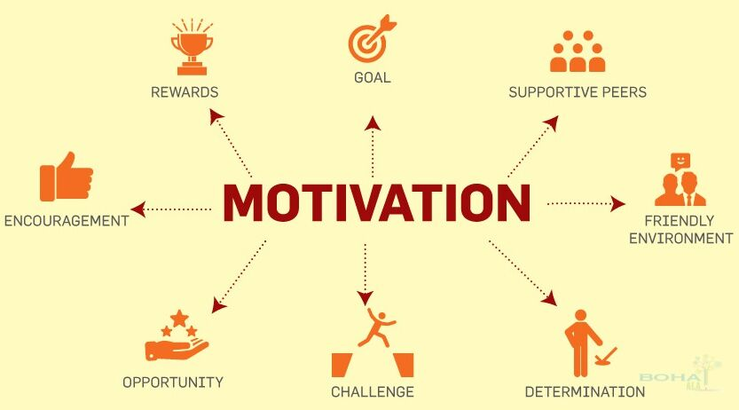
Figure 2.3.1: Impact of healthy employee-manager relationship on motivation
(Source: MosakeNjomo, 2019)
On the other hand, as stated by Atan and Mahmood (2019), organizations should priorities the work-life balance of employees as a critical factor in enhancing productivity. By having a suitable work-life balance, employees can eliminate the issue of burnout and stress. Along with the suitable work-life balance, managers should also emphasize providing adequate flexibility of measures. These 2 things can help managers strengthen their relationship with the employees which can be reflected in the enhanced productivity of the employees.
As per the concepts of Maslow’s hierarchy needs, there are 5 needs: physiological, safety, affiliation, esteem and self-actualization that need to be fulfilled in order to enhance employee productivity (Hale et al., 2019). The physiological needs refer to the basic human needs such as water and food. Therefore, companies should pay inadequate salaries to their employees that can help them fulfil their physiological needs. Following this, the safety needs refer to financial security, health and wellness and safety against accidents. Thus, companies should provide healthy working conditions along with medical benefits to their employees that can help them achieve their safety needs. Furthermore, social needs refer to the human interaction between co-workers. Therefore, the companies should promote and encourage collaborative work among the employees that can help them fulfil their social needs (Palumbo, 2021). In addition, the managers should also establish strong communication with the employees. Following this, esteem needs refer to the appraisal and recognition in workplaces. Thus, managers should offer five job appraisals and recognition for work to employees that can help them fulfil their esteem needs. Lastly, self-actualization needs to refer to the personal growth opportunities for the employees. Therefore, managers should provide a learning and development environment to the employees in the workplace that can help them acquire growth opportunities in the future.
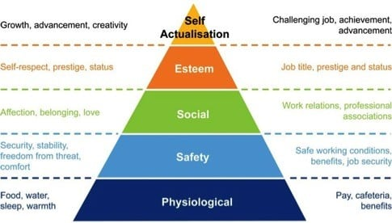
Figure 2.3.2: Maslow’s hierarchy of needs
(Source: Hale et al., 2019)

2.4 Accessing the role of employees and managers in mitigating the internal conflicts.
Internal conflicts are the type of conflicts that takes place in an organization when any employee or any character of an organization struggles with opposing desires of their own. These struggles can also include the struggle of their own beliefs. This internal conflict can affect the emotional and mental state of the main character (Khan, 2022). This struggle can include the fear of desire, height, desire for some powers, and also the fear of leaving upon someone's expectations. Internal conflict can be the worst thing for any business. This can cause great harm to the employees as well as the managers of the company. Both of them can be affected by this conflict which can be further resulted in a great loss for the company (Backman et al. 2020). That is why there is a need for both the employees as well as the customers to fight against this conflict and make it easy for the organization.
The manager can play an important role in managing this conflict in an organization. There is the most important role of managers in find the solution to this conflict. The employee of the organization just needs to support them. Both of them together can investigate the matter first from all the insiders. After that, both of them can listen to the involved parties of an organization for the conflict (Darkwa et al. 2020). They can hear all their problems and then help them to solve those problems. Further, they can ask the questions to all of them with the help of which they can easily get to know about the situation and also have the potential to solve that problem as well as conflict.

2.5 Identifying the ways to make relation of managers and employees strong
There is a need in every organization to have a great relationship between the managers and employees of the company. However, these days it is not possible to have a great relationship between them. Both of them are having a bad relationship these days because of which the company is also affected. Bad bonding between them can have an internal disbalance for the whole management. All the management can be affected by this bad relationship (Aboramadan et al. 2019). There is a need to better these relationships to have great management within the society. Great management within the organization can help the company to earn more profit and work more efficiently. There are five ways by which the relationship between the employee and managers could be stronger. These ways can be as follows:
- There is a need to check both of them on the regular basis and find their ongoing thoughts. This can help to find the beginning of a positive relationship between them
- There is also a need to add some feedback to the company. This way due to the fear of bad feedback all the employees as well as managers can work more honestly.
- The next needed process is about recognizing the great work and also coaching often.
- There is also a need to focus on the development of their career.
- Finally, the last way can be as focusing on a healthy balance of work-life.

2.6 Literature gap
Though the relation and development have a lot of significance in imparting skills to the employees to gain business sustainability, several research gaps have been found in the research. It has encountered a variance between the performance of the employees and their behavior. The organizations fall short of investing more in the development of their human resources. It has been found from a report that the policymakers are not served well by the analysts to make sure they can decide the intervention of the government in the relation markets (Park et al. 2022). The organizations should focus more on the impacts of the development of the relations between workers and employees. The motivation should come from the incentives and the related decisions of the firms that will, in turn, encourage much more investment in the training. The organizations should aim at stimulating the discussion and research on the related policy in the UK. 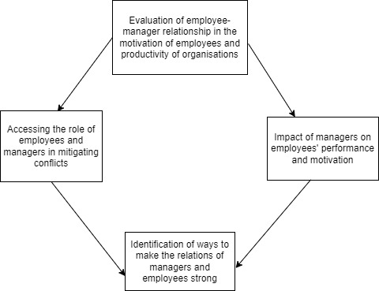

Figure 2.7: Conceptual Framework
(Source: Created by the Researcher)

2.8 Summary
The report summarizes the importance of relations between managers and employees to influence the sustainability of the business of organizations. The concept of the process ensures transparency among the employees to acquire as many skills as required that suit the organizational culture. There are many times when there is a rivalry between the managers and employees of the organization. These factors influence the reasons behind the employees leaving the organization. Employee retention has been a key issue in the context of business sustainability for the organization. This great relationship between the employees and managers can help to achieve great success in an organization. Hence, the significance of the relationship in the context of a sustainable business drives through excellence to retain employees and thereby meet the requirements of the customers.
Chapter 3: Methodology

Introduction
The process of collecting all the proper data for the research is helpful in the methodology chapter. This chapter is one of the most appropriate, systematic, and important reviews of the research. There is a focus on both primary as well as secondary data of the research in the methodology chapter. There are many key roles to identify the correct tools and technology, with the help of which the research can easily be conducted. According to Pandey and Pandey (2021), the research process is considered with maintaining the research problems, an extensive survey of the literature, and preparing the design of this research. The implementation of the research method shall help conduct the research based on solving certain issues of collecting the data and information from different sources.

Research Philosophy
This section of the methodology chapter deals with all the aspects of philosophy and also some various aspects in it. The use of this research is to gather all the information as well as data in the research. This collection of all the relevant data in this research is from then philosophically described in this chapter (Snyder, 2019). All the cultural criteria and context of the research are determined in fro analyzing the philosophy of the research. There are four-way by which this research philosophy works that is known as post-positivism, interpretive, pragmatism, and realism. With the help of research philosophy subjectivity of the research can also be analyzed. In this research, interpretive philosophy has been taken.

Research Approach
All the basic approaches of the research are identified in this section of the research methodology. There are three ways to proceed with the research approach and to find the proper approach for the research. These approaches are known as inductive, abdicative, and deductive. All these three approaches are equally important for any successful research (Mohajan, 2018). However, in this research, the inductive research approach has been taken. This is one of the most effective research approaches ever. This research approach helps to develop a great link between the objective and summary of the research.

Research design
The designing of research is one of the most important processes under the chapter on methodology. All the collected data and information on the topic is needed to be arranged well which is done under this research design. This helps to provide a proper structure on which all the collected information is designed. Two types of research design are very important for the design of the concept (Cr, 2020). The name of these two research designs is descriptive research design and the second is the explanatory research design. For this research, the explanatory research approach has been taken in this research. This research approach is very similar to the topic which is why this has been chosen for this research.

Research validity and reliability
This section of the research helps to evaluate the quality of the research. This section helps to find the best quality of information for the research and also helps to find the research quality. They also help to find the quality of the method that is being used in the research. Further, it also helps to find the technique that has been taken for describing the topic (Klemeš et al. 2018). Finally, it helps in testing the measures of the research. In this section, reliability is known as the consistency of all the measures of the research. Whereas validity is known as the accuracy of all the measures of the research.

Data collection
Data collection is the section of the methodology under which there is a collection of all the important data from the research. There is two ways to collect the data for the research. These two ways are known as the “primary data collection method and secondary data collection method”. In this research, the secondary data collection method has been taken (Mishra et al. 2022). This method is taken because this gives a great stage by which the data can be collected easily. The secondary data may not be as exciting as collecting the data primarily but the secondary data helps to build the existing research with extensive use of data collection tools and techniques.

References
Al-Habil, W., Aboramadan, M. and Zaqout, E., 2019. Leadership competencies of middle managers and employees' job performance: evidence from a Palestinian media channel. Middle East Journal of Management, 6(6), pp.671-694.
Al-Jedaia, Y. and Mehrez, A., 2020. The effect of performance appraisal on job performance in governmental sector: The mediating role of motivation. Management Science Letters, 10(9), pp.2077-2088.
Alrawahi, S., Sellgren, S.F., Altouby, S., Alwahaibi, N. and Brommels, M., 2020. The application of Herzberg's two-factor theory of motivation to job satisfaction in clinical laboratories in Omani hospitals. Heliyon, 6(9), p.e04829.
Amoah-Mensah, A. and Darkwa, P., 2020. LEADERSHIP STYLES OF OWNER-MANAGERS AND EMPLOYEES’PERFORMANCE: THE MODERATING ROLE OF AGE AND EXPERIENCE.
Atan, J.B. and Mahmood, N., 2019. The role of transformational leadership style in enhancing employees’ competency for organization performance. Management Science Letters, 9(13), pp.2191-2200.
Backman, M. and Karlsson, C., 2020. Age of managers and employees–Firm survival. The Journal of the Economics of Ageing, 15, p.100215.
Cr, K., 2020. Research methodology methods and techniques.
Fotiadis, A., Abdulrahman, K. and Spyridou, A., 2019. The mediating roles of psychological autonomy, competence and relatedness on work-life balance and well-being. Frontiers in psychology, 10, p.1267.
Hafeez, I., Yingjun, Z., Hafeez, S., Mansoor, R. and Rehman, K.U., 2019. Impact of workplace environment on employee performance: mediating role of employee health. Business, Management and Economics Engineering, 17(2), pp.173-193.
Hale, A.J., Ricotta, D.N., Freed, J., Smith, C.C. and Huang, G.C., 2019. Adapting Maslow's hierarchy of needs as a framework for resident wellness. Teaching and learning in medicine, 31(1), pp.109-118.
Khan, H., Abbas, J., Kumari, K. and Najam, H., 2022. Corporate level politics from managers and employees perspective and its impact on employees' job stress and job performance. Journal of Economic and Administrative Sciences, (ahead-of-print).
Klemeš, J.J., Varbanov, P.S., Walmsley, T.G. and Jia, X., 2018. New directions in the implementation of Pinch Methodology (PM). Renewable and Sustainable Energy Reviews, 98, pp.439-468.
Lim, S.Y., 2021. Factors affecting employee commitment to change in Malaysia service organizations: the moderating impact of organization culture. Studies of Applied Economics, 39(1).
Mishra, S.B. and Alok, S., 2022. Handbook of research methodology.
Mohajan, H.K., 2018. Qualitative research methodology in social sciences and related subjects. Journal of Economic Development, Environment and People, 7(1), pp.23-48.
MosakeNjomo, L., 2019. A Framework to Enhance-Employee Manager Relationship in South African Municipalities. The Case of the Nelson Mandela Bay Municipality in Port Elizabeth, South Africa. ITIHAS-The Journal of Indian Management, 9(2).
Onnis, L.A., 2019. Relationships: Social Exchanges, Community Ties and Employee-Manager Relationships. In HRM and Remote Health Workforce Sustainability (pp. 93-106). Springer, Singapore.
Paais, M. and Pattiruhu, J.R., 2020. Effect of motivation, leadership, and organizational culture on satisfaction and employee performance. The Journal of Asian Finance, Economics and Business, 7(8), pp.577-588.
Palumbo, R., 2021. Engaging to innovate: an investigation into the implications of engagement at work on innovative behaviors in healthcare organizations. Journal of Health Organization and Management.
Pandey, P. and Pandey, M.M., 2021. Research methodology tools and techniques. Bridge Center.
Park, H., Tangirala, S., Hussain, I. and Ekkirala, S., 2022. How and when managers reward employees’ voice: The role of proactivity attributions. Journal of Applied Psychology.
Snyder, H., 2019. Literature review as a research methodology: An overview and guidelines. Journal of business research, 104, pp.333-339.

