
Applied Computing

Wales Institute of Science and Art (WISA)

Networks and Cybersecurity Essentials (ACCA4024)

Lab 10: Hardening



n.kaliyamurthy@uwtsd.ac.uk 1

Objectives
Use security auditing tool to harden a Linux system.
Tasks
1. Use “Lynis” an open source security auditing tool with an automated set of scripts developed to test a Linux system.

Auditing a system for potential misconfigurations or unprotected services is an important aspect of system hardening.
Required Resources
- PC with Ubuntu 16.0.4 LTS installed in a VirtualBox or VMware virtual machine. (Alternatively, Any Linux Platform)
- Internet Connection to refer the outcomes o References:
- Lynis: https://cisofy.com/lynis/

Task 1
- Login as User Cisco.

- Go to Terminal and Type the following commands and examine

- Run The Lynis Tool by changing the directory to Downloads → Lynis

- At the command prompt, enter the following command and enter the password password when prompted:

cisco@ubuntu:~/Dowloads/lynis$ sudo ./lynis update info
This command verifies that this is the latest version and updates for the tool at the time of writing of this lab.
- Run the Tool: Type the following command in terminal and press Enter: cisco@ubuntu:~/Downloads/lynis$ sudo ./lynis --auditor cisco
The tool will begin auditing using the user cisco as the auditor. Note:
You will receive warnings.
- To continue with each stage of the audit press Enter.
- You will receive suggestions.
- You will receive a notification for any configuration that is weak
- You will receive detailed security enhancement suggestions as well as a final summary which provides the location where you can find the log file.
- Review Results
- Scroll up to the results section after the tool is finished running.
How many Warnings did you receive?
I received 2 warnings
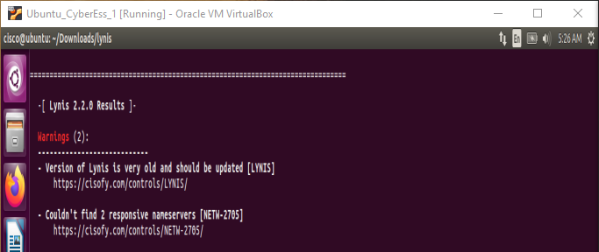

How many Suggestions did you receive?
I received 34 suggestions

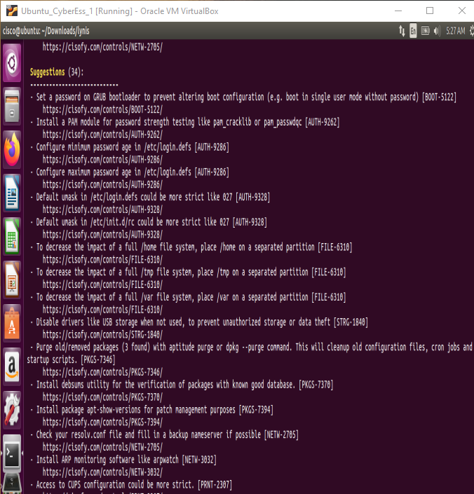

Scroll through the suggestions and select one. You will research a suggestion that you can implement to address the issue.
Which suggestion are you addressing?
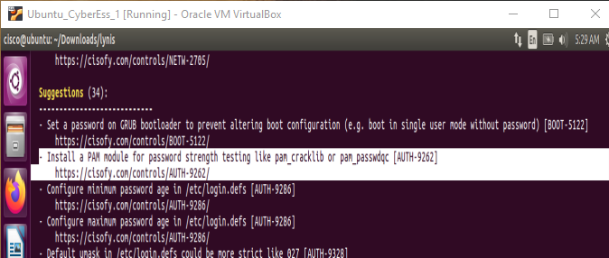

What is your suggested solution?
Install a module that will help test the strength of a password.

Learnings from tutorials so far:
Part 1 (Packet Tracer, Host Machines)
- Build a home Network
- Understand and configure IP Address
- Use Ping/ Trace route Utility to check the connection status
- Use ipconfig /all command to determine the MAC address of a Windows computer on an Ethernet network.
- Analyze a MAC address to determine the manufacturer.
- Analyze the Wired and Wireless Network connection.
- Analyze Address Resolution Protocol (ARP).
- Connect to a Wireless Router and configure the basic settings in a wireless router and add security features.
- Use nslookup command to understand the url to ip conversion.
- Configure basic connectivity settings in Intermediate devices (Switch/ Router).
- Work with SBA Packet Tracer Files/ environment
- Configure ftp, web, email, dns, ntp and aaa Servers Part 2
- Set up a virtual lab environment
- Troubleshooting the virtual lab environment
- Working with virtual machines
- Authentication, Authorization and Accounting
- Threats and Vulnerabilities – Using NMAP
- Hide and Seek – Use Steghide to hide a data file within an image file ✓ Password Cracking using John the Ripper ✓ Digital Signatures – Creating and Verifying.
- System Hardening

