

Student Name: Evelyn Belfon
Student ID: 1812690
Module name: Community Care and Development
Module Code: (BMHP6022_LON)
Lecturer Name: Bianca Sanfilippo
Date: 19/01/2022

Table of Contents
INTRODUCTION 3
DEMOGRAPHICS OF CAMDEN 4
Size/Area 4
Population 5
Life Expectancy 5
Cultural Diversity 5
Religion 5
Housing 6
Education 6
Employment 6
Pay and Income 7
Social Deprivation 7
Mental Health 7
Criminal Activity 7
CAMDEN’S AREAS OF CONCERN 8
Social Deprivation 8
Mental Health 8
PROJECT 1 8
CAMDEN’S MOBILE FOOD BANK 8
PROJECT 2 10
HEALTHY MINDS COMMUNITY PROGRAMME 10
THEORIES 11
DIGITAL MEDIA 11
POLICIES 12
CONCLUSION 12
REFERENCES 13

London Skyline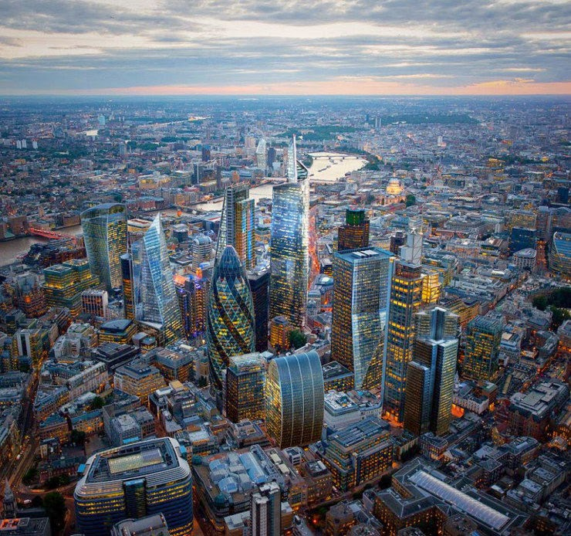

London is noted for being one of the most diverse cities in the world and according to the Greater London Authority, (2021), their official 2020 figures showed an increase of 45 per cent in the population raising it to just over 9 million people for the first time in its history. Known to be a tolerant city, London welcomes people from all over the globe and is considered to be an inclusive place for people to enjoy their different religions, cultures and belief systems. With diverse linguistics, London has over 250 distinct languages, making it an economic powerhouse for the global market and a prime place for migration and immigration, (Project Britain, 2013).

INTRODUCTION
This report focuses on one London borough to ascertain where the local council needs to place more resources to better support their residents within certain community groups. This paper will address two projects within the London borough of Camden which acknowledges areas of economic and social concerns. Situated in the centre of London, Camden is part of the 34 boroughs in the Greater London Authority, (London Councils, 2021), and shares similar issues seen in other London boroughs such as child poverty, (Child Poverty Action Group, CPAG 2019), and mental health issues, (London Assembly, 2014). In the event to tackle these issues and bring to the surface solutions, this paper will look at Camden’s demographics and explore two active projects that give consideration to the community it affects, (Camden Profile, 2021).
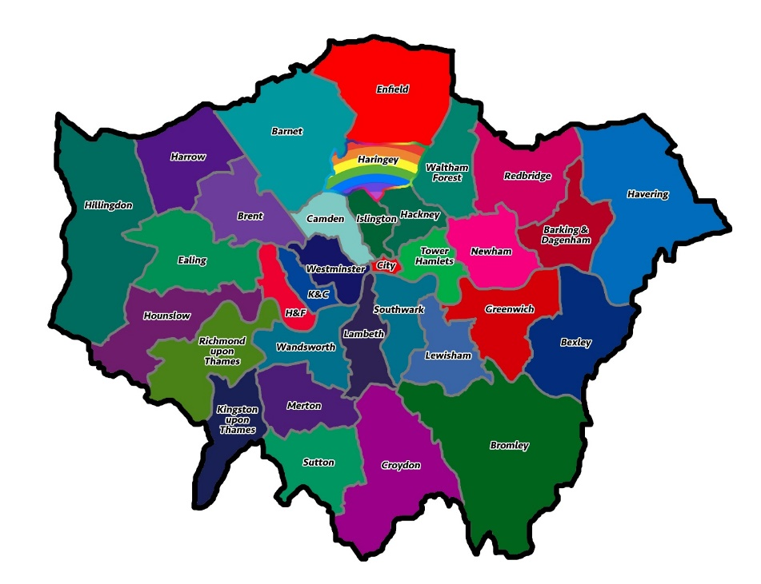
Londonist (2020), London Boroughs

DEMOGRAPHICS OF CAMDEN
The following information was taken mostly from the recently updated Camden Profile, (2021), which offers detailed data on the people of the area, however, this paper will cite a brief overview.

Size/Area
The area of Camden is 22 square kilometres and its immediate neighbours are the City of London, Westminster, Brent, Barnet, Haringey and Islington and the smallest borough is the City of London whereas the largest is Barnet. Famous for green spaces, Camden's parks include Regents Park, Hampstead Heath, Kenwood Parliament Hill and Primrose Hill. Over half the borough is designated as a conservation area and approximately 5,600 structures and buildings are of historical or architectural interest. With three mainline/international railway stations, several underground stations and many bus services. Camden has a rich history of famous singers, artists and musical groups making it a prime location for national and international tourism as well as the film industry, (Camden Profile, 2011).
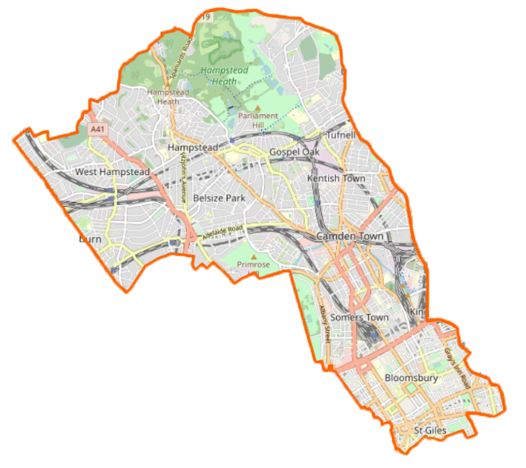

Population
Known as being the eighth smallest borough Camden boasts being the fifth highest in population density which according to Camden Profile’s 2020 figures the population stood at 279,500 with an expected increase of 15,100 between 2021 and 2031.
The same 2020 figures show both gender and age group data.
Gender |  |  | Age Groups
Males | 142,915 |  | 0-17 years | 54,100
Females | 136,601 |  | 18-64 years | 191,817
 |  |  | 65+ years | 33,599

Life Expectancy
Improvements in health and social care have led to the UK population living longer, (Office of National Statistics (ONS), (2018). It is noted that Camden's ageing population is expected to rise from 28,000 to 35,000 within the next 10 years, this meant, an older female who is 65 years old now can expect to live another 25 years and their male counterparts another 21 years. These figures are higher than the national average, (The Camden Commission, 2021).

Cultural Diversity
Camden Profile’s 2011 ethnically diverse figures show just how mixed the area is.
Ethnic Group 2011 Figure
White | 146,055
Asian | 35,446
Black African and Caribbean | 18,060
Mixed/Multiple | 12,322
Other Ethnic Group | 5,023
Arab | 3,432

Religion
Camden is a multi-faith community where people are free to practice the religion of their choosing. With over 60 churches, seven mosques, eight synagogues and over ten temples in and around Camden it gives people the confidence to respect each other’s religious spaces, (Camden Profile, 2011).
Faith
Christian | 74,821
No Religion | 56,113
Muslim | 26,643
Jewish | 9,823
Hindu | 3,141
Buddhist | 2,789
Other Religion | 1,267
Sikh | 465

Housing
A large majority of the dwellings in Camden are flats and accounts for 85 per cent of the accommodation in the area leaving 15 per cent for self-contained houses. Housing cost in the borough is amongst the highest in the country, the average house price according to Camden Profile’s 2021 figures is £796,442 making it 1.6 times the average price in the rest of London and 3.0 times the average price in England and Wales.

Education
There are eleven higher educational institutions in Camden and it has the largest population of students which stand at 27,600. 16 per cent of Camden residents have no or low-level qualifications putting them at a disadvantage within the workforce.
Percentage of NVQ Level 4 or Above Qualification
Camden | 66
London | 59
Great Britain | 43

Employment
When compared to London, England and Wales the employment rate in Camden is low, making it one of the lowest rates in London, however, this could be due to the high student percentage that is present within the borough, (Camden Profile, 2021). Camden has approximately 7,800 unemployed people according to the figure by (Nomis, 2021).
Rated second highest in London for businesses and the third highest within the Uk, Camden contributed £34.4 billion to the national economy in 2018, (Camden Profile, 2021).
Employment Percentage 2021
Camden | 71.2
Islington | 73.8
Westminster | 70.9
Kensington and Chelsea | 66.5
Central London | 74.7
Greater London | 73.8
Great Britain | 74.4

Pay and Income
Based on the median gross annual pay in comparison to other London boroughs and the UK. 19 per cent of households in Camden has an annual income of less than £20,000.
Annual Pay
Camden | £42,548
Central London | £43,309
Greater London | £38,592
United Kingdom | £31,461

Social Deprivation
The Child Poverty Action Group (CPAG), (2019), states that child poverty in London is the highest with approximately 700,000 children living in this situation. Shockingly this London figure is greater than both Wales and Scotland combined.
London Local Authority | Percentage of Child Poverty (2018)
Tower Hamlets | 53.40
Newham | 43.20
Hackney | 41.30
Westminster | 41.29
Islington | 40.40
Camden | 39.92
Enfield | 39.60
Barking and Dagenham | 37.80
Haringey | 37.18
Brent | 36.84

Child poverty has become a major issue all over the world, (Unicef, 2021), and although England is the twenty-fourth richest country, (World Atlas, 2021), it has 4.3 million children living in this unfortunate condition, (London Councils, 2021).
Poverty | Camden | London
Child Poverty | 24,118 (43.50%) | 819,058 (37.50%)
In-work Poverty | 34,000 (12.20%) | 875,000 (20.40%)

Mental Health
Camden is the third highest borough whose residents have been diagnosed with serious mental health and the seventh for depression, (Camden Executive Summary, 2019).
Mental Health | Camden | London | England
Serious Mental Illness | 4,263 (1.5%) | 1.1% | 1.0%
Depression | 21,758 (8.7%) | 7.6% | 10.7%

Criminal Activity
Camden has its share of criminal offences and data from Camden Profile, (2021) shows a breakdown. The impact of COVID-19 saw a decline in criminal activity.
Year | Annual Amount
2002-2003 | 53,000
2014-2015 | 28,400
2019-2020 | 39,543
2020-2021 | 25,424

CAMDEN’S AREAS OF CONCERN
An exploration from the data gathered in this report provides information that highlight areas that the London Borough of Camden need to address. This paper will look at social deprivation and mental health as it shows a high level of concern.

Social Deprivation
Social deprivation in London is high and this is measured by the level of children living in poverty (700,000), (CPAG, 2019) and the number of adults known to be part of the in-work poverty population which stands at approximately 1,050,000 whiles the overall poverty in London is 2.5 million, (Trust for London, 2020). Several factors contribute as to why families live in socially deprived conditions in London. The high costs of housing is a prime indicator as housing costs are soaring and many families cannot afford this rise in rent therefore they may become homeless and this is largely the case within the private sector where private landlords are free to demand higher rents and oftentimes the council will only pay a proportion of the costs. Another factor could be that people are being paid below the London living wage and hence creating in-work poverty, (CPAG, 2019). In this situation, the basic physiological and safety needs of Maslow’s Hierarchy of Needs have not been sufficiently met and therefore it would be hard for families in this position to feel a sense of connection particularly if they struggle to achieve food and employment requirements.

Mental Health
One of the most common mental health issues to affect approximately 280 million people worldwide is depression, (World Health Organisation, 2021). Within London, the Greater London Authority, (2014), states that depression affects 914,300 working-age adults and can impact the overall quality of life for the people affected. The reasons for high mental health rates in Camden can be shared with any borough facing the same issues. Depression presents itself as either mild, moderate or severe and the signs and symptoms evident in a person can vary, however, a person may feel low or lose the pleasure of doing activities they once enjoyed, outward signs that can be picked up by others could be if the person becomes tearful or irritable for no obvious reason. It can also leave a person with negative thoughts about themselves, (National Institute for Health and Care Excellence (NICE), (2011). Barriers to effective treatment could be because people lack financial resources or a lack of trained healthcare providers or due to social stigma around mental health disorders. Depression can be exacerbated due to poverty or unemployment and at its worse can lead to suicide, (World Health Organisation, WHO, 2021).

PROJECT 1

CAMDEN’S MOBILE FOOD BANK
The COVID-19 pandemic brought to light the desperate state of poverty within low income and unemployed families living in local communities, through Camden's Urban Community Projects they created the Camden's Mobile Food Bank to provide well-needed food supplies to the community. Families in dire need can self refer or be referred to receive weekly food donations, (Healthy Mind Community Programme, 2021).
Facebook @ https://www.facebook.com/Camdenmfb
Their Facebook page is not well publicised as they have 32 people following and 28 likes. However, there are regular activities on the page with multiple entries.

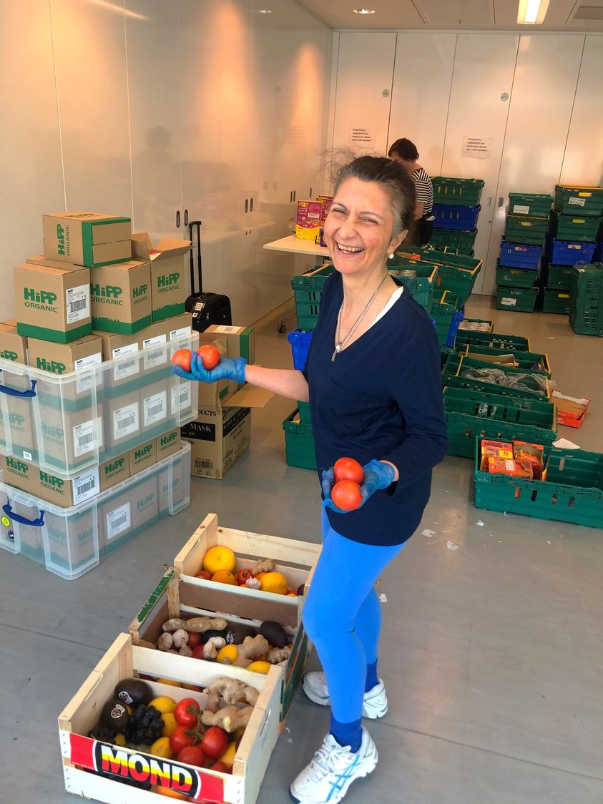
Camden’s Mobile Food Bank

Twitter @ https://twitter.com/Camdenmfb
Twitter is more of a success, they have 552 followers and has the same information as posted on their Facebook page.

Camden’s Mobile Food Bank
Instagram @ https://www.instagram.com/Camdenmfb/ has 104 followers and is inactive.
Email service @ info@urbancommunityprojects.org.uk; is available.
All four methods of communication are needed, however, there is not much activity in getting the information out to the wider community.

PROJECT 2

HEALTHY MINDS COMMUNITY PROGRAMME
The Healthy Minds Community Programme aims to support community users with a tailored programme of free activities that they can access to help with their mental health. The objective is to reduce the feelings of loneliness, social exclusion and isolation and to help them reconnect with their community.
Facebook @ https://www.facebook.com/mindincamden/ has 566 followers and 515 likes.

Healthy Minds Community Programme
Twitter @ https://twitter.com/mindincamden?lang=en has 256 followers.

Healthy Minds Community Programme
Email @ admin@mindincamden.org.uk is available.

Both projects 1 and 2 use digital media to promote their services using appropriate imagery to showcase how they can best support the community. The pictures used on Facebook and Twitter reflect the diversity of Camden which should give prospective users confidence that all people are welcome.

THEORIES
Maslow's Hierarchy of Needs cited by Mcleod, (2020), suggests to feel happy and contented people should have their basic needs met, therefore, everyone should have the right to food, water, shelter and security and if it is not met you are likely to struggle through life.
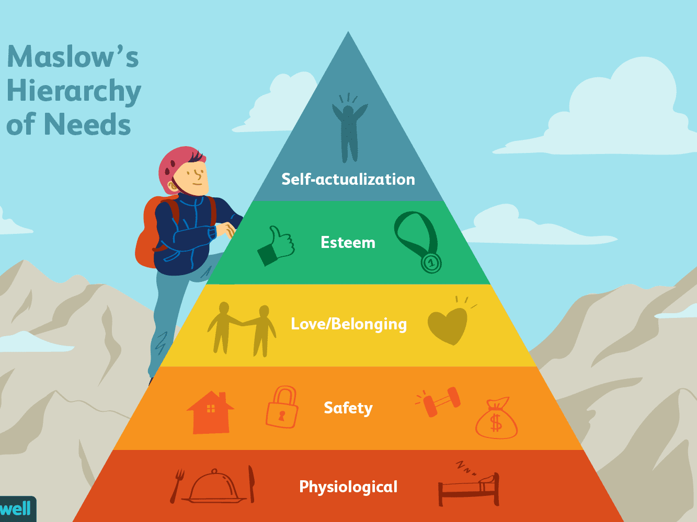

Similarly, Bronfenbrenner's Ecological System as cited by Guy-Evans, (2020), stresses that the quality and context of a person’s environment along with how they interact within the space is what helps to bring stability within their life.

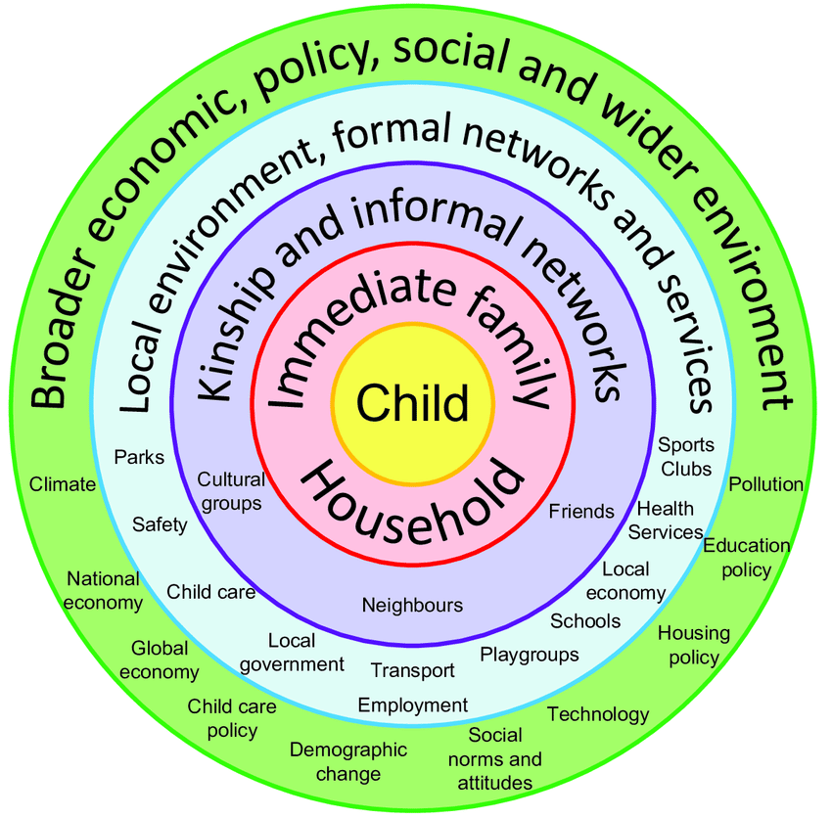
Both Maslow and Bronfenbrenner show the importance of an individual's relationship with family and the community they live in and fundamentally it is to have your needs met by utilising the people and services in that community space.

DIGITAL MEDIA
Technology is forever changing and how we communicate with others to deliver services has become quicker and more accessible, (Digital Technologies, 2021). The two projects use digital media to showcase their services and although when looking at the media profile there was no high traffic of users. Recommendations for them to expand their visibility would be to advertise their services on other community websites such as the local schools, libraries, churches or community centres, that way people accessing these other services will be able to see the projects.

POSITIVES | NEGATIVES
reaches more people | no-confidence using technology
information is immediate | no access to broadband
user can access information at their leisure | can be time-consuming if not familiar
long-term cost-effective | may not reach those with language barriers

POLICIES
Every borough should have in place suitable policies to protect the rights of the people in their community as this gives a sense of security.
- Equality Act 2010
Protects people from any form of discrimination
- Data Protection Act 2018
Protects how your personal information is used
- Human Rights Act 1998
Protects your legal rights
- Care Act 2014
Protects peoples wellbeing and independence
- Health and Safety Act 1974
Protection to a person’s safety and health
- Digital Economy Act 2017
Protect your rights to have a connection to broadband
- Sustainable Communities Act 20O7
Local authorities and community groups can foster change to the law, (UK Legislation, 2021).

CONCLUSION
In conclusion, this report cited the diverse demographics of the London Borough of Camden and through this data, it highlighted two main issues that affect this community and shows the steps the borough is taking to address them. Although they recognise the use of digital media is an important tool within the community, it gave an indication that the social media used for the community to access help was not wholly sufficient particularly in advertising their existence and although they are present on Twitter, Instagram and Facebook it may be more adaptive to display other languages that reflect the diverse area.

REFERENCES
Camden Executive Summary (2019) Camden and Islington PH Intelligence and Information Team. Available at: https://www.camdenexecutivesummary.gov.uk. (Accessed: 22 December 2021).
Camden Profile (2021) Camden Profile (latest) | Open Data Portal, London Borough of Camden. Available at: https://opendata.camden.gov.uk/People-Places/Camden-Profile-latest-/9m7e-5qyt (Accessed: 22 December 2021).
Child Poverty Action Group (2019) Child poverty in London facts, CPAG. Available at: https://cpag.org.uk/child-poverty-london-facts (Accessed: 24 December 2021).
Digital Technologies (2021) Changes in technology | Digital Technologies Hub. Available at: http://www.digitaltechnologieshub.edu.au/teachers/scope-and-sequence/f-2/digital-systems/changes-in-technology (Accessed: 31 December 2021).
Greater London Authority (2021) ‘London’s Population - London Datastore’. Available at: https://data.london.gov.uk/dataset/londons-population (Accessed: 23 December 2021).
Guy-Evans, O. (2020) ‘[Bronfenbrenner’s Ecological Systems Theory]’, https://www.simplypsychology.org/Bronfenbrenner.html [Preprint]. Available at: https://www.simplypsychology.org/Bronfenbrenner.html (Accessed: 31 December 2021).
Healthy Mind Community Programme (2021) ‘Healthy Minds’, Mind In Camden. Available at: https://www.mindincamden.org.uk/services/healthy-minds (Accessed: 30 December 2021).
London Assembly (2014) ‘Prevalence of Common Mental Health Problems, Borough - London Datastore’. Available at: https://data.london.gov.uk/dataset/prevalence-common-mental-health-problems-borough (Accessed: 24 December 2021).
London Councils (2021) Camden Demographics. Available at: https://directory.londoncouncils.gov.uk/demographics/camden/ (Accessed: 28 December 2021).
Mcleod, S. (2020) Maslow’s Hierarchy of Needs, Simply Psychology. Available at: https://www.simplypsychology.org/maslow.html (Accessed: 28 November 2021).
NICE (2011) Common mental health problems | Information for the public | Common mental health problems: identification and pathways to care | Guidance | NICE. NICE. Available at: https://www.nice.org.uk/guidance/cg123/ifp/chapter/common-mental-health-problems (Accessed: 18 August 2021).
Nomis (2021) Nomis - Official Labour Market Statistics. Available at: https://www.nomisweb.co.uk/reports/lmp/la/1946157246/printable.aspx (Accessed: 28 December 2021).
ONS (2018) Living longer - Office for National Statistics. Available at: https://www.ons.gov.uk/peoplepopulationandcommunity/birthsdeathsandmarriages/ageing/articles/livinglongerhowourpopulationischangingandwhyitmatters/2018-08-13 (Accessed: 28 December 2021).
Project Britain (2013) Languages Spoken in London. Available at: http://projectbritain.com/regions/languages.htm (Accessed: 24 December 2021).
The Camden Commission (2021) Older People. Available at: https://www.camden.gov.uk/documents/20142/20682755/Older+People.pdf/b7adf876-f1f9-a8d9-aa46-9fb567133cb8 (Accessed: 28 December 2021).
Trust for London (2020) London’s Poverty Profile 2020, Trust for London. Available at: https://www.trustforlondon.org.uk/publications/lpp2020/ (Accessed: 29 December 2021).
UK Legislation (2021) Legislation.gov.uk. Available at: https://www.legislation.gov.uk/ (Accessed: 31 December 2021).
Unicef (2021) Child poverty. Available at: https://www.unicef.org/social-policy/child-poverty (Accessed: 29 December 2021).
World Atlas (2021) The 15 Richest Countries In The World, WorldAtlas. Available at: https://www.worldatlas.com/articles/the-richest-countries-in-the-world.html (Accessed: 28 December 2021).
World Health Organisation (2021) Depression. Available at: https://www.who.int/news-room/fact-sheets/detail/depression (Accessed: 29 December 2021).

