 |  |  | E3 FORM – Sports Research Project
APPLICATION FOR ETHICAL APPROVAL – BA level

CAIS AM GYMERADWYAETH MOESEGOL – Lefel BA

Mae'r ffurflen hon i'w chwblhau gan bob BA myfyrwyr. Rhaid i bob ffurflen gael ei ystyried gan diwtor y modiwl.  Dylai un copi o'r ffurflen yn cael ei roi ar y ffeiliau Gyfadran ac un copi cadw ar y ffeil myfyrwyr. |  | This form is to be completed by all BA students conducting research, projects or productions. This form should be completed by the student. All forms must be considered by the Module tutor. A copy of the form must be kept centrally and on the student file.
ADRAN 1 – MANYLION MYFYRIWR |  | SECTION 1 - STUDENT DETAILS
Enw Llawn  Full Name | Jordan Gibbs
Ysgol/Cyfadran/  School/Faculty | UWTSD Swansea |  |  | Rhif Myfyriwr Student Number | 1603358
Cydlynydd prosiect / Tiwtor  Module Tutor/ Programme Co-ordinator | Andrew Thomas |  |  | Enw'r Gradd  Name of Degree | Sports Management
Teitl dangosol yr Traethawd Hir: |  |  |  | Indicative Title of Dissertation:
Participation in PE and Extra Curricular Activities Within Pontarddulais Comprehensive School

ADRAN 2 – MANYLION CYFRANOGWYR / CYNULLEIDFA |  |  | SECTION 2 - PARTICIPANT / AUDIENCE DETAILS
Pwy yw’r cyfranogwyr arfaethedig? |  | Who are the intended participants? |  |  | Ydw / Yes | Na / No
Myfyrwyr / staff Y Drindod Dewi Sant |  | Students / staff of Trinity Saint David |  |  |  | No
Oedolion (dros oed 16 ac yn gymwys i gydsynio) |  | Adults (over the age of 16 and competent to give consent) |  |  |  | No
Plant a phobl ifanc dan oed |  | Children / legal minors |  |  | Yes
Cleifion neu gleientiaid gweithwyr proffesiynol |  | Patients or clients of professionals |  |  |  | No
Rhywun sy’n cael ei gadw yn y ddalfa neu y mae’r llys wedi cymryd cyfrifoldeb amdano |  | Anyone in custodial care or for whom the court has assumed responsibility |  |  |  | No
Aelod o unrhyw sefydliad lle mae’n bosibl bod angen i unigolyn arall hefyd gydsynio. |  | A member of any organisation where another individual may also need to give consent. |  |  |  | No
Eraill: Nodwch: / Others: please identify:

Nifer, Oed a Ffynhonnell y Cyfranogwyr  Rhowch fanylion yr demograffeg y cyfranogwyr / gynulleidfa. |  |  |  | Participant / Audience Number and Age  Provide details of the demographics of the participants / audience.
Nifer o Gyfranogwyr / yn y Gynulleidfa | Participant/ Audience number |  |  | 300
Grŵp oedran y Cyfranogwyr/y Gynulleidfa | Participant/ Audience age group |  |  | 11-14

ADRAN 3 – GWEITHGAREDD YMCHWIL |  |  | SECTION 3 – RESEARCH ACTIVITY
1. | Ydy’r prosiect yn cynnwys: | Does the project include: |  | Ydy / Yes | Nac ydy/No
Defnyddio holiadur neu offeryn ymchwil tebyg |  | Use of questionnaire or similar research instrument |  | Yes
Defnyddio prawf ysgrifenedig neu gyfrifiadurol |  | Use of written or computerised test |  |  | No
Cyfweliad (cysylltwch gwestiynau posibl) |  | Interview (attach provisional questions) |  | Yes
Dyddiaduron |  | Diaries |  |  | No
Arsylwi ar gyfranogwyr a hwythau'n ymwybodol o hynny |  | Participant observation with their knowledge |  | Yes
Arsylwi ar gyfranogwyr a hwythau ddim yn ymwybodol o hynny |  | Participant observation without their knowledge |  |  | No
Recordio fideo neu sain |  | Video or audio-taping |  | Yes
Mynediad i wybodaeth bersonol neu gyfrinachol heb gydsyniad penodol y cyfranogwyr |  | Access to personal or confidential information without the participants specific consent |  |  | No
Defnyddio unrhyw gwestiynau, ysgogiadau prawf, cyflwyniad y gallai rhai cyfranogwyr eu profi fel rhywbeth sy'n achosi niwed / tramgwydd corfforol, meddyliol neu emosiynol |  | Administration of any questions, test stimuli, presentation that may be experienced as physically, mentally or emotionally harmful / offensive |  |  | No
Cyflawni unrhyw weithredoedd allai achosi embaras neu effeithio ar hunan-barch |  | Performance of any acts which may cause embarrassment or affect self-esteem |  |  | No
Ymchwilio i gyfranogwyr sy’n ymwneud â gweithgareddau anghyfreithlon |  | Investigation of participants involved in illegal activities |  |  | No
Gweithdrefnau lle defnyddir twyll |  | Procedures that involve deception |  |  | No
Gweini unrhyw sylwedd, cyfrwng neu blasebo |  | Administration of any substance, agent or placebo |  |  | No
Dull arall o gasglu data neu fformat cyflwyno (esboniwch) |  | Other method of data collection or presentation format (please explain) |  |  | No

2. | Restru eich dull o gasglu data | List your method of data collection:
I will collect data by handing questionnaires to pupils, these questionnaires will be approved by the head of PE department first. I will also observe lessons within the school. I will interview teachers to get their opinion on participation in sport within the school.

3. | Risg Posibl:  (corfforol, seicolegol, cyfreithiol, cymdeithasol neu economaidd) | Potential Risk:  (physical, psychological, legal, social or economic)
A oes unrhyw risg bosibl i: |  | Is there any potential risk to: | Ydw / Yes | Na / No
A | Cyfranogwyr? | Participants? |  | No
B | Ymchwilydd? | Researcher? |  | No
C | BrifYsgol/Cyfadran? | University? |  | no

4. | Rheoli Risg:  Os oes, beth yw'r risg a sut y bydd yn cael ei reoli? | Management of Risk:  If yes, what is the risk and how will it be managed?
There is no risk.

5. | Os ydych yn delio â phlant a / neu oedolion agored i niwed, rhaid i chi gyflwyno eich tystysgrif DBS i'ch tiwtor goruchwylio i'w cymeradwyo cyn i unrhyw gysylltiad â cyfranogwyr hyn. | If you are dealing with children and/ or vulnerable adults you must present your DBS certificate to your supervising tutor for approval before any contact with these participants.
 |  |  |  | Ydw / Yes | Na / No
A | Ydych chi wedi gwneud cais am dystysgrif DBS? |  | Have you applied for a DBS certificate? | Yes
B | A yw eich tiwtor weld a'i gadarnhau eich tystysgrif DBS? |  | Has your tutor seen and approved your DBS certificate? | Yes

6. | A fyddwch yn cael cydsyniad gwybodus ysgrifenedig gan eich cyfranogwyr? |  | Will you obtain written informed consent from your participants?
 |  |  |  |  |  | Ydw / Yes | Na / No
A | Os na fyddwch, pam hynny? |  |  | If no, why not?
B | Os byddwch, sut byddwch yn sicrhau cydsyniad gwybodus? |  |  | If yes, how will you secure informed consent? |  | Yes
Rhowch eglurhad / Please explain: I will have consent on behalf of the school.

Cynhwyswch gopi o’r ffurflen gydsynio os ydych yn defnyddio un. |  |  |  | Please include a copy of the consent form if you are using one.

ADRAN 4 |  | SECTION 4
CEFNOGWYD /APPROVED |  | NIS CEFNOGWYD/  NOT SUPPORTED
Datganiad  Mae'r wybodaeth a gynhwysir yma yn gywir, hyd eithaf fy ngwybodaeth a’m cred. Rwyf wedi ceisio dynodi unrhyw risgiau a phroblemau sy’n gysylltiedig â’r prosiect / ymchwil neu gynhyrchiad ac rwyf yn cydnabod f’ymrwymiadau innau a hawliau’r cyfranogwyr. |  |  | Declaration  The information contained herein is, to the best of my knowledge and belief, accurate. I have attempted to identify any risks and issues related to the project/research or production and acknowledge my obligations and the rights of the participants.
Llofnodau  Dylai'r ffurflen hon gael ei chwblhau a'i llofnodi gan y myfyriwr a'r Cydlynydd y prosiect /Twitor |  |  | Signatures  This form should be completed and signed by the student and the Module tutor/Programme Co-ordinator.

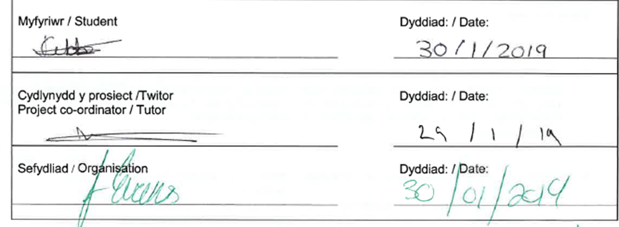


Cyfranogwr Rhif Adnabod:
Participant Identification Number:
CWESTIYNAU CYFWELIAD SAMPL | SAMPLE INTERVIEW QUESTIONS
TEITL Y PROSIECT: / PROJECT TITLE: Participation in PE and Extra Curricular Activities Within Pontarddulais Comprehensive School

1 | Could better facilities in the school improve the quality of PE delivered?
2 | Can you identify any trends in relation to participation in PE since you’ve started working in the school, has it increased/decreased?
3 | Would an increase in funding to the PE department improve the quality of PE?
4 | Do you feel there is enough PE on the children’s timetable each week? Should there be more/less?
5 | Do you feel PE is prioritised as highly as it should be?

ENW A CHYFEIRIAD YR YMCHWILYDD | NAME & ADDRESS OF RESEARCHER  Jordan Gibbs  7 Parc-Y-Delyn  Llangyfelach  Swansea

Cyfranogwr Rhif Adnabod:
Participant Identification Number:
CWESTIYNAU HOLIADUR SAMPL | SAMPLE QUESTIONNAIRE QUESTIONS
TEITL Y PROSIECT: / PROJECT TITLE: Participation in PE and Extra Curricular Activities Within Pontarddulais Comprehensive School

1 | Do you participate regularly in physical education lessons?
2 | Do you take part in any physical activity outside of school?
3 | Are you part of a sports club outside of school?
4 | How many times do you take part in PE/sport a week?
5 | Do you currently represent/have you previously represented the school in a sports team?
6 | Have you attended a taster session/training session with the Welsh Rugby Union development officer (Mr Humphreys)?
7 | Do you enjoy PE lessons?
8 | Are you confident in trying new activities/sport?
9 | Do you enjoy the sports offered during PE lessons?
10 | Do you feel your opinions are listened to regarding PE?

ENW A CHYFEIRIAD YR YMCHWILYDD | NAME & ADDRESS OF RESEARCHER  Jordan Gibbs  7 Parc-Y-Delyn  Llangyfelach  Swansea

Cyfranogwr Rhif Adnabod:
Participant Identification Number:
FFURFLEN GANIATÂD CYFRANOGIAD | PARTICIPATION CONSENT FORM
TEITL Y PROSIECT: / PROJECT TITLE: Participation in PE and Extra Curricular Activities Within Pontarddulais Comprehensive School

Name of Researcher:
Please initial box

1. I confirm that I have read and understand the information sheet dated XXXX for the above study. I have had the opportunity to consider the information, ask questions and have had these answered satisfactorily.

2. I understand that my participation is voluntary and that I am free to withdraw at any time, without giving any reason.

3. I understand that any information given by me may be used in future reports, articles or presentations by the research team.

4. I understand that my name will not appear in any reports, articles or presentations.

5. I agree to take part in the above study.

________________________ ________________ _____________________________
Name of Participant Date Signature

_________________________ ________________ _____________________________
Researcher Date Signature

You may decline to participate in this study. You may end your participation in this study at any time. If you decide to remain anonymous, maintaining your anonymity will be a priority and every practical precaution will be taken to disguise your identity. If you prefer anonymity, there will not be any identifying information on audiotapes or transcripts of this or any interview. No-one will hear any audiotapes or see any transcripts without your prior consent. All materials generated from this or any interview will remain confidential.

When completed, please return in the envelope provided (if applicable). One copy will be given to the participant and the original to be kept in the file of the research team at: PLACE:

ENW A CHYFEIRIAD YR YMCHWILYDD | NAME & ADDRESS OF RESEARCHER  Jordan Gibbs  7 Parc-Y-Delyn  Llangyfelach  Swansea

Cyfranogwr Rhif Adnabod:
Participant Identification Number:
TAFLEN WYBODAETH CYFRANOGWR | PARTICIPANT INFORMATION SHEET
TEITL Y PROSIECT: / PROJECT TITLE: Participation in PE and Extra Curricular Activities Within Pontarddulais Comprehensive School

Dear Participant:

My name is Jordan Gibbs and I am studying in the School of Sport, Health and Outdoor Education in the University of Wales Trinity St. David.

I would like to invite you to participate in my research project. This project will critically analyse the reasons why the participation in sport is low in Pontarddulais Comprehensive School, within years 7-9 and aims to provide research and recommendations for the future.

Through your participation in the interviews, students’ participation in questionnaires, and my lesson observations, I hope to ascertain information regarding participation in sports within the school.

All pupils’ questionnaires will be kept strictly confidential to the researchers involved and at NO time will individual questionnaires be released to the general public. This gives your pupils a chance to express their views on your programme in a confidential and anonymous forum. Findings from all observations will be kept strictly confidential also. Your schools participation in this study is completely voluntary so you can withdraw from the process at any stage.

The questionnaire for students should take about 10 minutes to complete, but there is no time constraint. Interviews with yourself and staff will take longer, but each interview should not take longer than 15 minutes. As this is a new project, your feedback is also important to me and I would be much obliged if you could also provide any feedback on my actions/attitudes during the process as and when you feel necessary or at the end of the project. I understand that your time is at a premium as a school but your opinions are very valuable to me.

After careful and precise analysis of the data obtained from the questionnaire, interview and observations, I will be happy to provide you with a copy of the findings at your request. The results of this questionnaire will hopefully enhance my understanding of participation in sport within the school. The results of the research will be fed back to yourself, and if you would like to share these findings with staff and/or pupils that is fine by me.

We thank you in advance for your time and participation. If any questions do arise, feel free to contact me at your convenience.
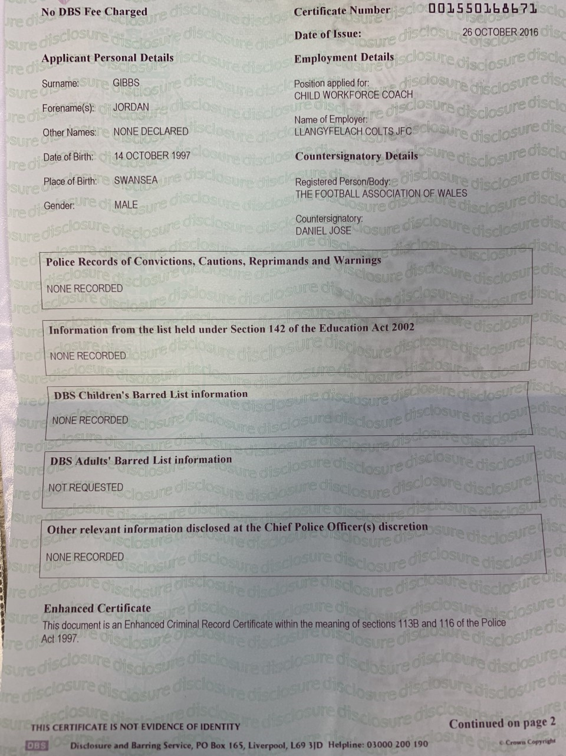0

