Emma Jane Vaughan
1703817
Artisans Meet the Mass Market
Word Count: 1306

Artisans Meet the Mass Production
An Artisan is described/ defined as "one skilled in any mechanical art, craftsman”(Harper, 2001). While Harper (2001) proposes that the term Artisan can be dated back to the 1530s, others have questioned this, arguing that it was first found in 1939 deriving from ‘Artisanal’ (Merriam-Webster Dictionaries, 2018) Archaeologists, however, have theorised that the concept dates back much further, to 10,000 BCE in Mesopotamia (Net,2000). Despite the discrepancy between the years of origination, the definition within contemporary terminology remains fairly consistent.
In the Renaissance, there was an abundance of goods available, due to the large number of artisans working in our towns. This lead to the “tide of new material objects” (Brotton and Jardine, n.d cited in Sennett, 2008:82), the everyday person now wanted items that were essential in everyday use in larger numbers, for example having several pots to cook with and different plates to eat off. This led to terms such as “an embarrassment of riches… [and the]… spoiling” of children (Schama, n.d cited in Sennett, 2008:82).
During the 18th century, there was a focus on improving designs of manufactured goods, so they could compete with other nations. Schools and Academies were opened to help improve and enhance drawing skills, also allowing the designer to have more control over the finished items. During the 1750s “Britain’s ability to produce competitive luxury goods was at its height” (Puetz,1999:217) this lead to an increase in production. This opened up a new market; for the first time copies of originals were being produced, enabling the masses to purchase these items at a fraction of the cost. Luxury goods became less about the quality of the materials used or the workmanship involved, but about how fashionable and desirable the item was (Puetz, 1999).
The Industrial Revolution which began in the 18th Century started in Britain, and filtered across to Europe, and by the late 18th century hit America. This had a major impact on the artisans at the time, instead of quality produced handmade items, things became mass produced. The industrial revolution led to “a decline of traditional skills and a replacement of the living, breathing, thinking craftsman by the inhuman machine” (Adamson, 2010:43). The machines were taking over, they not only dramatically reduced the production times, but also reduced the cost of material production. The need for manufactured goods was greater than the supply, hence the increased number of factories appearing (Anon., n.d.). This had a detrimental effect for artisans. Their numbers declined significantly as mass produced items gained in popularity. The “Industrial machines never tired, they did the same work hour after hour without complaining” (Sennett,2008:39). The Artisan were not capable of keeping up with the demand for goods, so the machinery which began as a friend ended up as becoming the enemy (Sennett,2008).
John Ruskin was against the “idea of a mechanical civilization… [and believed] that modern society as a whole should and could return to the preindustrial past” (Ruskin, n.d cited in Sennett, 2008:108). He was of the opinion that people’s lives were better before, and “capitalism led to a deterioration of living [and working] conditions for the working class” (Hartwell, 1971). Workhouses for example, were places filled with poor people including children who were made to work in the most unpleasant conditions without pay, in return for food and shelter (Archives, n.d.) Furthermore, he conceived the idea that there was a connection “between the problem solving and problem finding…machines break down when they lose control, whereas people make discoveries, stumble on happy accidents” (Sennett, 2008: 113). Myself working within the creative field, have happened upon ‘happy accidents’, these are what make us unique over the machines- thinking on our feet. If we just solely used to the mass production and machinery, everyone would look the same and have the same things, it would all become very boring.
Whereas John Ruskin was against the introduction of the machine, William Morris believed it was possible to work with the machine, “I would do some things with machinery which are now done by hand, and other things by hand which are now done by machinery; in short, we would be the masters of our machines and not their slaves” (Anon.,1996). Perhaps this is a more valid argument for the way forward; machinery while efficient, arguably cannot recreate the same individualised hand-made finish and quality of items made by hand.
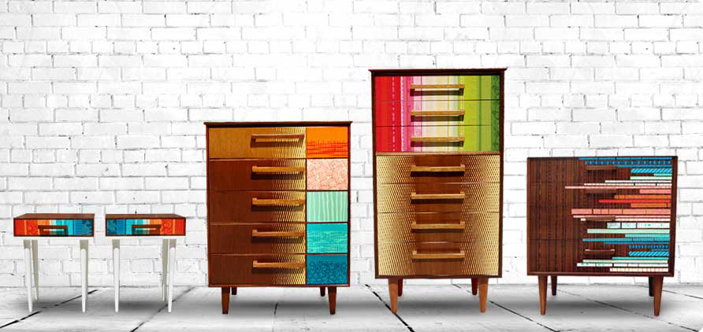
The artisans chosen for the exhibition are prime examples of this.

Figure 1. Zoe Murphy

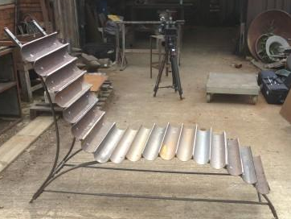
Zoe Murphy changes furniture predominantly 1950s style and places unique prints upon them; personalising them. No two pieces are the same, you would need a number of different machines to create theses prints, whereas, Murphy can place them were and on whatever she likes. Similarly to Murphy, Bex Simon is able to transform a range of metals, including reclaimed and recycled and reforms them into something else. In figure 2, Simon transformed cast iron down pipes and makes them into a truly exclusive one-of-a-kind-chair- a machine could not have done this.

Figure 2. Bex Simon

Even though these artisans can be expensive to work with, there is an increasing movement into wanting individualised items, not mass-produced copies.
The project started with research into how artisans could meet the mass produced, like those found in the pound shop. Having explored the history of Mesopotamia, Industrial Revolution and third-world countries, it became apparent that it is all about the money; people buy what they can afford. Artisan produce can be very expensive compared to the high street shops for example, so have they out priced themselves? There is no denying the exquisite piece of furniture or item they have produced is worth the money, but it just isn’t what the masses can afford. An example of this can be found within the markets of Nigeria, where there are importer’s selling miss-printed textiles; “it’s very cheap, if we buy first quality, we cannot market in this area. People prefer them, in fact, because it is what we can afford” (Adamson, 2010:273), there is a market for everything as long as the price is right. We have become a nation that deposes of everything, changing things because of the difference in seasons or fashion (becomes out of date very quick), these items mostly are in good working order, nothing wrong with them just being replaced for the newest or latest model, “being able so easily to dispose of things desensitise us to the actual objects we hold in hand” (Sennett, 2008), there is no appreciation. So instead of comparing the mass produced and artisan side by side, the concept of combing them became the focus of the exhibition.
The exhibition would consist of a small group of British artisans, all of which bring different techniques and knowledge fields; all relevant to my own practice. Choosing IKEA’s clearance section to stage the exhibition was made because all the artisans work within interior and exterior furniture and fittings. Recreating there studio spaces all together within an extended clearance section will enable the customer to see everything, from examples of the artisans own work, seeing their work practice and environment, as well as having the opportunity to speak to the artisan. The exhibition is not only about getting the individual to choose between a mass produced or a hand crafted item, it is about introducing the general public (working class) to artisans working within the local area. Many people might not have seen, heard or worked with artisans before so this will provide them with the opportunity. Artisans come with the stigma that they are very expensive to work with and that they only create very high end pieces which are normal purchased by the upper classes. I believe this exhibition could bring different social classes together by placing the artisans within a shop the masses use.

Bibliograhy
Websites
Anon., n.d. Man-Made to Machining - History of the Industrial Revolution. [Online] Available at: https://www.thomasnet.com/articles/custom-manufacturing-fabricating/history-of-the-industrial-revolution [Accessed 12 March 2018].
Anon., 1996. Socialist by design. [Online] Available at: http://pubs.socialistreviewindex.org.uk/sr196/nineham.htm [Accessed 13 April 2018].
Douglas Harper, 2001. Online Etymology Dictionary. [Online]. Available at: https://www.etymonline.com/word/artisan. [Accessed 12 March 2018].
Archives, T.N.,n.d. 1834 Poor Law.[Online] Available at:http://www.nationalarchives.gov.uk/education/resources/1834-poor-law/ [Accessed 20 April 2018]
Merriam-Webster Dictionaries, 2018. Artisanal. [Online] Available at: https://www.merriam-webster.com/dictionary/artisanal. [Accessed 20 April 2018].
Net, H.o.t., 2000.Mesopotamian Artisans and craft workers. [Online] Available at: https://www.historyonthenet.com/mesopotamian-artisans-and-craft-workers/ [Accessed 2 April 2018]
Books
Adamson, G., 2010. The Craft Reader. Oxford: Berg.
Hartwell, R.M., The Industrial Revolution and Economic Growth (London: Methuen and Co.. 1971).
Sennett, R., 2008. The Craftsman. London:Penguin Books.
Journals
Puetz, A., 1999. Design Instruction for Artisans in Eighteenth-Century Britain. Design History, 12(3), pp. 217-221.
Figures
Figure 1. Anon., 2012. Zoe Murphy. [Online] Available at: http://www.zoemurphy.com/ [Accessed 18 April 2018].
Figure 2. BBC One, 2017. Money for Nothing - Up-Cycle TV. [Online] Available at: https://www.bexsimon.com/money-for-nothing-up-cycle-tv/ [Accessed 13 April 2018].

