3/24/2025
University of Wales Trinity Saint David
London campus
E-Portfolio Link:
Module Name: Learning In the Digital Era
Module Code: ACCA 4025

Student Name: Courtney Smith
Student ID: 2532694
Group: 1

Lecturer’s Name: Koushik Modak

LDE Assignment 1
E-Portfolio
Table of Contents
Introduction 2
I decided to do this course to improve my knowledge with computer. To learn new skills that could help me in the future, to gain some kind of employment. In modern society everything is controlled or operated by computer, so I think it’s a good investment.
Main Body 2
Task 1: Essential Academic and Employment Skills for the future career Path 2

Task 1 (a): Report on Essential Academic and Employment Skills 2
Task 1 (b): Evaluation of Task 1 (a) based on Similarity report 2
Task 2: Collaborative Mind Map and Individual Poster 2
Mind Map (Collaborative) 2
Poster (Individual) 2
Task 3: Virtual Collaboration and RefWorks 2
Report on Virtual Collaboration 2
Step-by-step process of using RefWorks with visuals 2
Task 4: E-Portfolio Creation and Evaluation 2
Task 4 (a): E-Portfolio Creation 2
Task 4 (b): Illustrative Review of E-Portfolio tool Selection 2
Conclusion 2
References 2
Task 1 References: 2
Task 3 References: 2

Introduction
I decided to do this course to improve my knowledge with computer. To learn new skills that could help me in the future, to gain some kind of employment, if I decide to continue and progress. Achieving the best qualification possible to accomplishing to create a good academic background. In modern society everything is controlled or operated by computer, so I think it’s a good investment to further my knowledge and improve my ability.

Main Body

Task 1: Essential Academic and Employment Skills for the future career Path

Task 1 (a): Report on Essential Academic and Employment Skills
The world is control by computers, most of which is controlled by humans, some run and make decision by themselves. So, it’s essential to have some academic background develop skills to gain employment, now or in the future depending on what you want to do.
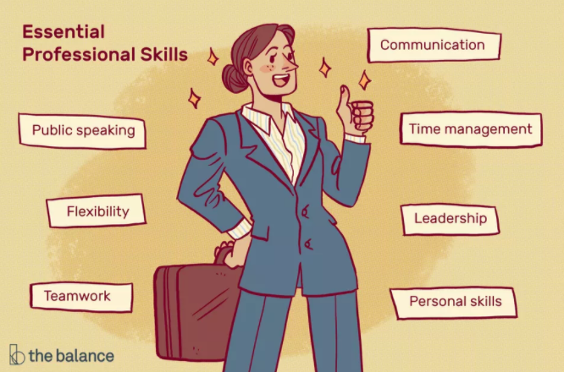 [1]
Figure 1: future of employment

Essential Skills

- Employability skills can be taught on the job. workers must be able to solve problems be reliable. Must have good social skills and be responsible.
- You must be creative and have a high standers and good work ethics, you must be discipline and deliver a good high-quality work
- Employee must have good integrity and professional behaviour they must be punctual
- Communicating effectively showing respect to colleagues, collaborating with others supporting teamwork to share goals.
- Staying focused on your job tackling difficult task, delivering a high level of output
- Individual must grow their reputation to achieve career growth and success

Academic Skills
- The basic skills that you need, is to be able to read and write and the ability to learn very quickly because the environment moves very fast.

Task 1 (b): Evaluation of Task 1 (a) based on Similarity report

Task 2: Collaborative Mind Map and Individual Poster

Mind Map (Collaborative)

Poster (Individual)

Task 3: Virtual Collaboration and RefWorks

Report on Virtual Collaboration
Put your Chosen topic here

Step-by-step process of using RefWorks with visuals

Task 4: E-Portfolio Creation and Evaluation

Task 4 (a): E-Portfolio Creation

Task 4 (b): Illustrative Review of E-Portfolio tool Selection

Conclusion

References

Task 1 References:

Task 3 References:

