Anna Curtis – 2311852 (Cohort 8)
CIPD membership number: 88280658
Professional behaviours and valuing people Assignment
Word count: 3570 inclusive of the + 10%

- With reference to typical activities and behaviours, appraise what it means to be a ‘people professional’. (AC 1.1)

The people professional (PP) role encompasses a variety of activities and behaviours including fostering positive relationships, supporting employee well-being, championing open communication, and inclusivity where everyone is encouraged to speak truth to power, to be a voice for employees of an organisation. Staff welfare is crucial to promote an engaged workforce and boost retention figures.
The role helps organisations seek to attract, develop, and retain talent, while ensuring legal compliance. The role can be broken down into: Human Resources (HR), talent acquisition, engagement, and employee relations for example. The overarching purpose is to support the organisation in driving their strategy, supporting stakeholders in achieving the business goals and objectives. Ulrich (1977) argues a disadvantage is, in some organisations PP’s may have limited involvement in strategic decisions, constraining their ability to contribute to long-term organisational success. HR need buy-in from key stakeholders within the business to succeed. Taylor & Woodhams (2022b) argue whilst all PP’s are expected to adhere to discrimination law at the very least, ideally, they would promote an environment of a diverse management team with a variety of cultural backgrounds, committed fully to the principles of inclusion.
The CIPD profession map (2022) outlines the core behaviours expected of a PP and identifies where these behaviours come from. Examples of these behaviours are: ethical practice, working inclusively, self-awareness, valuing people and a passion for learning. The profession map outlines three professional values:
- Principles led
- Evidence-based
- Outcomes driven
Fig. 1, CIPD
Waite et al (2021) argue that applying these values in one’s approach to the PP role, will contribute to better decision-making in all areas of professional practice, regardless of the complexity of the matter. In aid to interpret both our and others’ behaviour, we can recognise our own values and how these are at the core of personality, emotions, and beliefs. Being a PP demonstrates ethical and positive values in your behaviour daily. These behaviours may encompass elements of communication and various interpersonal skills, that aid the development of positive working relationships. It is paramount you have the right person in the role. Goleman (1995) argues dealing with the complexities of human behaviour can be challenging, requiring strong interpersonal skills and emotional intelligence. PP’s bring expertise, skill and dedication to their roles, contributing to the delivery of organisational goals. Furthermore, they drive collaboration, innovation and change management.

- Discuss how ethical values underpin the work of a people professional, including two examples of how ethical values might be applied in a people practice context. (AC 1.2)
Ethical values help guide not only decisions and actions of a PP, also interactions within the organisation. Waite et al (2021) claim one can promote a positive working environment by aligning ethical principles, with an organisation’s vision and values. Kew & Stredwick (2016) argue values underpin ethics, whereas values of an organisation underpin its business ethics. A values-driven company is prone to maintain consistency in its decision-making processes.
CIPD (2023a) claim PP’s can consider the 8 ethical lenses when making workplace decisions. For example, the ‘fairness lens’ implies that individuals at any level within an organisation should be able to reach a mutual decision irrespective of their position. This strengthens positive morale, culture, and inclusivity within an organisation. Waite et al (2021) state utilitarianism, an ethical perspective, prioritises maximising overall happiness and minimising suffering. Having a moral purpose, is one of the core elements of integrity and ethics, in terms of justice and fair outcomes. Understanding utilitarianism can guide PP’s to choose the outcome with the most positive effect.
An example of this in the workplace: HR may have to decide between employee training programs or offering higher salaries to employees. From a utilitarian perspective, HR would evaluate the potential outcomes and select the option that maximises overall happiness and well-being for the greatest number of employees. The training program could lead to increased skill levels, career progression opportunities and job satisfaction for a larger number of employees. Whereas increased salary would benefit individual employees, investing in training programs has the potential to benefit a greater number of employees with overall job security and employability.
Another ethical viewpoint is deontology, which centres on the principles of doing the right thing. Britannica (2023) suggests, deontological ethics place special emphasis on the relationship between duty and the morality of human actions. Individuals adhering to deontology evaluate whether an action conforms to universal moral principles and duties.
An example of this in the workplace: HR may discover an employee has breached a company policy by accessing confidential information without authorisation. From a deontological perspective, HR would prioritise following established rules and ethical guidelines, regardless of potential consequences. HR would conduct a thorough investigation, gather all evidence whilst assessing the breach. ‘Practitioners’ ability to recognise and resolve ethical dilemmas is fundamental to remaining effective when exercising professional judgement’ (CIPD, 2015). Incorrect decisions, or poorly executed decisions, can profoundly affect both people’s lives and the reputation of organisations. Serious risks can occur when an organisation’s culture is at odds with its ethical values (CIPD, 2023a).

- Consider the importance of people professionals being able to influence others and ensure that the ‘people practice voice’ is heard in an organisation, through informed, clear and confident communication. (AC 1.3)
The importance of PP’s being able to influence within an organisation is paramount for driving engagement, aligning HR strategies with company goals, change management, resolving conflict and fostering a positive work environment. CIPD (2023b) claim the best decisions are made for people within the organisation, when PPs effectively communicate and influence. PP’s serve as advocates for employees, demonstrating a good understanding of employment law and influencing on decisions that could be detrimental to the business. By using the ‘people practice voice’, and confidently communicating for employees, PPs help create a supportive and inclusive working environment. Knowledge within the field, helps the PP voice be heard.
An influencer is someone who has the power to affect the buy-in of others, because of their knowledge. A key behaviour of the PP is to gain trust and respect from stakeholders, demonstrating this through confidence, clear communication and results. If PP’s are seen as the face and delivery for solutions within an organisation, it is crucial their voice is heard through transparent communication. Waite et al (2021) argue non-verbal communication can be clear and strong when the following elements align: body language, facial expressions, and eye contact.
Experienced PP’s tailor their influencing style depending on which stakeholders they speak to. Influence often happens in tandem with courage (CIPD, 2023c). PP’s should address when something isn’t right and have the courage to do so, in an open forum. Waite et al (2021) suggest championing good people practice is a basic remit of a PP. It is essential to express views and speak openly to stakeholders, to demonstrate expertise and add value in business. Cultivating a culture of openness and accountability is paramount for organisational success. Simth & Johnson (2020) claim if PP’s fail to speak truth to power, organisations can lack transparency as a result. They may suffer from ineffective decision-making and potential ethical lapses. By not providing honest feedback or raising critical concerns to stakeholders, PP’s risk fostering a culture of complacency.
Ulrich (2018) argues it is not having the great ideas as a PP, but knowing how to influence and convey those ideas is more demanding. Turning those great ideas into impactful strategic values, requires the ability to influence. ‘Influence pivots theory to practice; data to delivery; using power for oneself to empowering others’ (Ulrich, 2018). Ulrich looks at influence shifting HR ideas, from agendas, to business essentials.

- For each of the situations below (a & b), provide an example of an issue that would cause you to raise the matter to a manager (or other authority) - and describe how you would do this.

- where you consider something to be unethical (whether or not it is illegal)

Raising ethical concerns to management demands a strategic approach, mitigating risks effectively. Ethics are at the heart of professionalism. CIPD (2023a) outlines the competitive edge of ethical practices, crucial for fostering trust and mitigating risks. Success depends on trustful relationships with employees, customers and suppliers. ‘Codes of conduct support and promote ethical practice’ (Waite et al, 2021).
Within Admiral Claims department, concerns arose regarding certain approved repairer networks approaching the Chief in-house engineer, offering gifts to remain approved, risking ethical breaches. These could be seen as unethical bribes to remain part of the network, for financial gain. After gathering evidence, I raised the issue calmly with my manager, emphasizing the breach's unethical nature and potential conflict of interest. I remained professional, questioned what I had seen, without being accusatory. I found this unethical, accepting a bribe can be seen as a violation of trust. Employees are expected to demonstrate integrity. Admiral responded by implementing a policy requiring declaration of gifts over £50 and offering regular anti-bribery training. Waite et al (2021) argue, upholding integrity and eliminating corruption are central to ethical organisational culture.

- where you believe something contravenes legislation. (AC 1.4)

Sexual harassment in the workplace is considered illegal. I have dealt with cases of sexual harassment including unwanted attention, physical touch and sexual comments. In most cases, sexual harassment is considered a form of discrimination based on sex and is prohibited by various laws and in breach of the Equality Act 2010. ACAS (2020) argues under equality & diversity, everyone deserves to be treated with dignity and respect and work in a non-hostile working environment.
I encountered a case where a female colleague faced unwanted advances from a male manager, creating discomfort and fear. Despite her polite refusals, the behaviour persisted in unwanted emails. The behaviour escalated to physical touch. The manager’s behaviour created a hostile working environment for her. The employee felt uncomfortable, intimidated and fearful for her job, as she denied the advances. As the behaviour continued, it interfered with her ability to perform her job effectively. Prompt and professional action is crucial. After a formal complaint, a thorough investigation including review of the email exchange, confirmed the gross-misconduct, resulting in disciplinary action. Employers are legally obligated to prevent discrimination (ACAS, 2020), highlighting the importance of addressing such behaviour decisively and swiftly.

- Discuss two theories or models relating to the human and business benefits of people at work feeling included, valued, and fairly treated, concluding your discussion with a summary of your own view of these benefits. (AC 2.1)

Maslow’s hierarchy of needs:
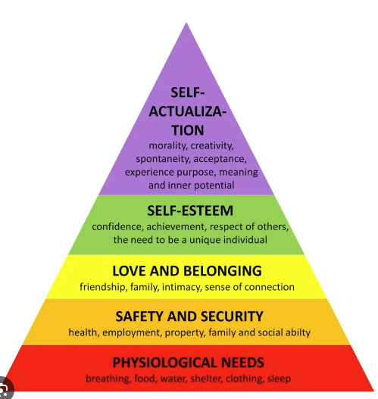
Fig. 2, Masterclass
A psychological theory that provides a framework for understanding human motivation and behaviour, suggesting humans are driven by a hierarchical progression of needs, from basic to higher-order psychological needs. Maslow (1947) argued individuals have a set of needs that can be arranged in a pyramid. Focusing on the higher-level needs of the pyramid, feeling included at work closely aligns with social belonging and self-esteem.
When employees feel included in work, they satisfy their need for social connection and acceptance. This behaviour is essential for fostering a sense of belonging within the organisation. Being part of a supportive, inclusive environment, increases confidence and employees feel valued for their contributions. Nishii (2013) suggests without inclusivity, employees can feel marginalised or undervalued, leading to decreased engagement. Inclusive workplaces have equality, diversity & inclusion policies, that promote fairness and transparency in every aspect of employment including hiring and promoting. CIPD (2024) claim people can break down barriers and become less defensive in psychologically safe working environments.
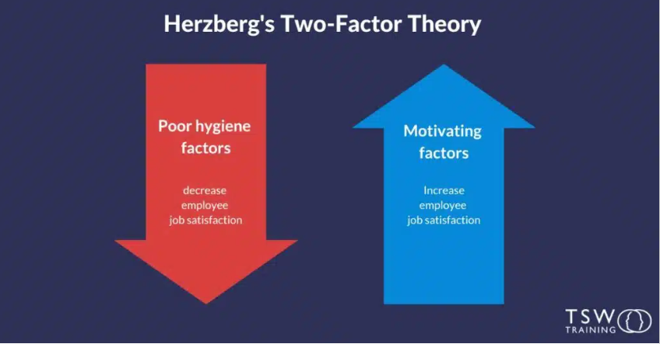
Fig. 3, TSW Training
‘Herzberg’s 2-factor theory suggests that job satisfaction and dissatisfaction are influenced by separate sets of factors: motivators and hygiene factors’ (Herzberg et al, 1959). Herzberg’s theory suggests inclusivity acts as a motivator, contributing to job satisfaction and employee well-being. Employees who experience inclusivity, appreciation, and treated fairly in the workplace, are more inclined to experience job satisfaction and motivation. Inclusive environments foster a sense of belonging, trust, respect and recognition, resulting in higher levels of engagement.
The absence of inclusivity can contribute to feelings of isolation dissatisfaction and disengagement among employees. Herzberg’s theory emphasizes the importance of creating inclusive workplaces that address employee’s psychological needs for recognition and respect, ultimately promoting job-satisfaction and well-being. CIPD (2017) suggest employee engagement is at the heart of having motivated and satisfied employees, engagement is crucial if we want to be more agile. An inclusive workplace creates the right atmosphere for employees to thrive.
In my opinion, employees are more likely to feel valued at work when their needs are looked at on an individual basis and not just as part of a team. The importance of hearing every voice is paramount for genuinely including people. To echo Maslow’s theory, the sense of belonging can enhance morale and job satisfaction. Raising employee satisfaction levels, results in an engaged team, meaning better delivery and output.

- Discuss two ways in which a people professional can build inclusivity into a people practice initiative at the design stage, and two ways of checking inclusivity after a people practice initiative is implemented. (AC 2.2)

PP’s can build inclusivity into recruitment practices at the design stage. PP’s can revise job descriptions to focus on skillsets necessary to the role, over subjective criteria that may inadvertently exclude certain groups. Using gender-neutral language and avoiding biased terminology helps attract a diverse pool of candidates. Taylor & Woodhams (2022a) recommend images of diverse groups in marketing and to avoid gender specific language such as, ‘decisive’, which may deter females. Using AI to carry out blind CV screening, which removes identifying personal data such as age and gender, mitigates unconscious bias. Diverse recruitment panels, ensures fair evaluation and decision-making. Taylor & Woodhams (2022b) claim direct discrimination can occur when an employer fails to recruit or promote a candidate based on the grounds of their protected characteristic. By pro-actively integrating these measures into the design stage, PP’s can foster a more diverse and inclusive workforce from the outset.
To assess the effectiveness of inclusive recruitment practices you could introduce diversity metrics. By tracking these metrics, including age, sex, gender, you can compare the protected characteristics of the overall workplace, to ensure the recruitment process is attracting candidates from underrepresented groups.
In aims to prevent bullying in the workplace, a new policy can be brought in by PP’s. Engage a diverse group of stakeholders, including employees from different levels, backgrounds and ethnicities, gathering insight and perspectives on bullying concerns. Having a diverse group of stakeholders, will naturally bring with it equality and inclusivity. The new policy should clearly outline what constitutes as bullying and explain the organisation has a zero tolerance to bullying, harassment and discrimination.
Demonstrate inclusivity by ensuring the policy is accessible to everyone and written in comprehensible language, to accommodate diverse learning needs. Training programs on the policy, should be compulsory for employees at all levels. The behaviour traits we would expect would include confidentiality and open communication, so that everyone feels included and able to speak up against bullying. By integrating inclusivity at the design stage, PP’s can demonstrate a culture of respect, equality and belonging. Branch et al (2007) argue without a clear anti-bullying policy in place, employees may feel unprotected, leading to stress, anxiety, and mental health issues.
Regular evaluations and feedback should be conducted to assess the effectiveness of the policy. Send out draft copies of the policy to stakeholders to critique. Have bullying claims reduced as a result? Review the data, how many people are coming forward, there may be an increase in people coming forward, but a decrease in the number of people being bullied. To demonstrate how many people this policy has helped, investigate both qualitative and quantitative data. By completing regular employee surveys, you’re able to gauge perceptions of workplace culture, inclusivity, and respect. Positive trends in survey results indicate the policy is effectively addressing concerns and improving employee perceptions at work. Taylor & Woodhams (2022) argue evidence-based decision making is paramount to good research being carried out and evaluating the credibility of evidence, is central to thoughtful HR practice. Evidence-based decision making can help to reduce errors based on ill-founded judgements.

Task 2

- Reflect on your own approach to working inclusively and building positive working relationships with others. (AC 2.3)

I am inclusive by ensuring everyone feels supported, treating everyone fairly and using open communication. I choose to be inclusive, I strongly believe in treat others as you wish to be treated. I value diversity as everyone is different, we all have different values, strengths, wants and needs. It is paramount to encourage numerous different people to raise a voice. Having a diverse workforce with people from different cultural backgrounds, allows for increased creativity and smarter decision-making. I engage with individuals from diverse backgrounds and cultures daily, with the notion that everyone is equal. As CIPD (2022) describe, the power of reflection helps learners be knowledgeable and skilful. Learning doesn’t stem solely from experience; we learn from reflecting on it.
I champion fostering positive relationships with colleagues by listening, one of the most important attributes of an influencer. My current role within HR is to influence my stakeholders. Listening supports an engaged team with greater delivery. My personality is extrovert, I am a people’s person and want to engage with the team to ensure a unified output where possible. It comes naturally to me to build strong relationships with colleagues and stakeholders. Admiral promotes an ethos of ‘leave your ego at the door’. This helps break down barriers with employees of different stature within the organisation. I choose to listen to their opinions and perspectives to gain trust, take time to get to know individuals personally and use clear lines of communication. To develop further continuing to foster positive working relationships, would be to have greater confidence connecting with senior leaders.

- Explore how the role of a people professional (specialist or generalist) is evolving and the implications this has for your CPD. (AC 3.1)

The role of PP is evolving rapidly as a result of changing workplace dynamics, technology, AI and shifting societal expectations. Admiral moved to operate in a Business Partner model six months ago, being seen as strategic partners in organisational success. It has become clear I need to develop in change management for my CPD. I have seen constant pockets of redundancies over the last six months, more so than before. I have supported a redundancy project for over twenty employees where we held a collective consultation, which led to me processing redundancy payments and settlement agreements. In today’s dynamic workplace, HR are expected to take on a more proactive, consultative approach to justify their role. With the rise of remote working, HR need to navigate new challenges of maintaining employee well-being and ensuring productivity targets are hit.
For my CPD, I also need to focus on skills such as business acumen and data analysis, as data is at the heart of all decisions. Being able to critically analyse data, identify trends and deliver key information to stakeholders across the business. The CIPD (2020) report on future trends in 2030 predicts, to thrive in 2030, PP’s should develop future-fit skills, including agility and autonomy enhancing expertise in areas such as organisational development, AI and change. I am currently studying for my CIPD level 5 diploma, to enhance my skillset as part of my CPD. I will be ensuring I stay updated on employment law, demonstrate I can drive change initiatives and continue horizon scanning to stay current and enhance my ability to align HR strategies, with organisational goals.

- With reference to your responses for Q1 & Q2, and feedback on your behaviours or performance obtained from (at least) one other person, assess your current strengths, weaknesses, and development needs. Your response should include an explanation of the feedback received and how it has informed your self- assessment. (AC 3.2)

The feedback below is from my annual 360 review, broken down by my colleagues and line manager (PS) and from the department stakeholders I supported as HR advisor (Non-PS). The latter feedback is more recently since our department re-structure, moving from a generalist HR role, into the Business partner model.
I have gained 7 years’ experience in HR and 6 years in people management prior, in the financial sector. I know my strengths and I am confident in my experience and knowledge as a generalist. The focus now is the shift to business partner, I want to be able to demonstrate my worth in that role. However, I would like to increase my confidence when dealing with senior stakeholders across the business. I am keen to take on feedback from colleagues to help identify my development needs. Waite et al (2021) argue, to be realistic about development needs and present our best selves when career opportunities arise, ensure the greater self-awareness we gain through CPD enables us to identify transferable skills.

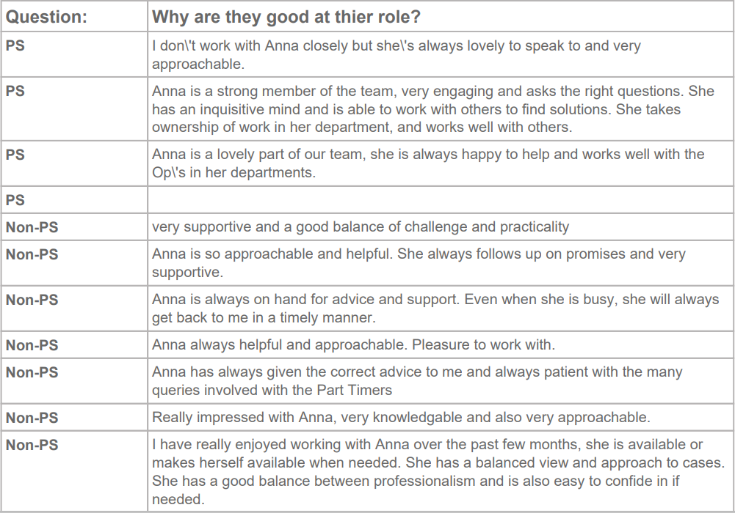
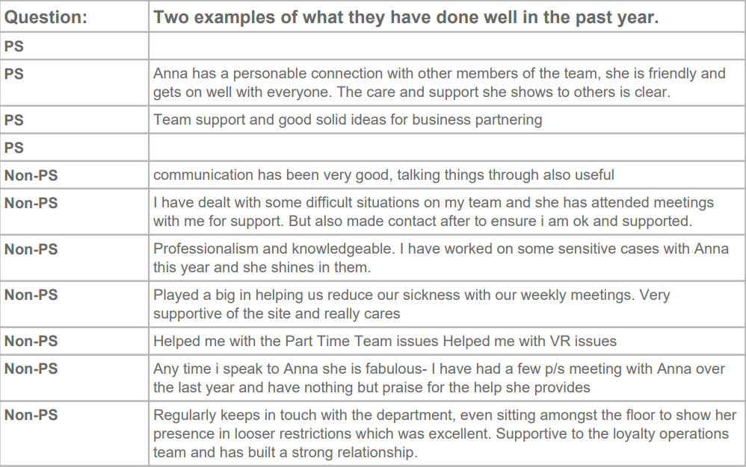
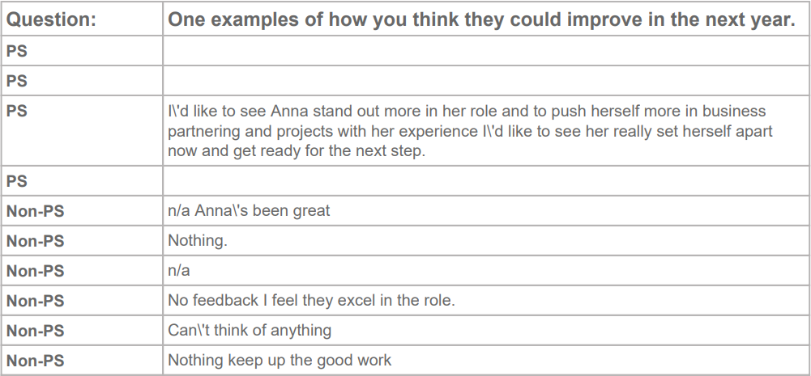
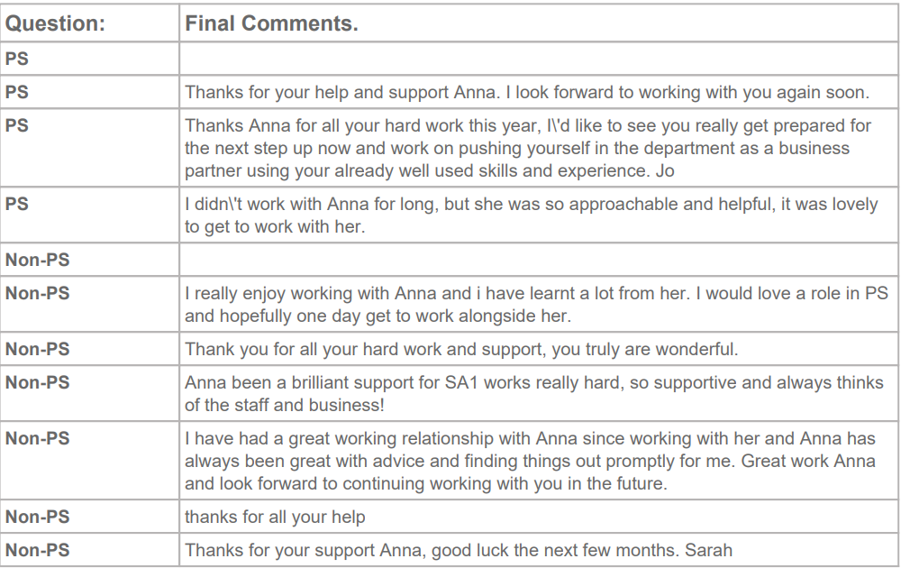
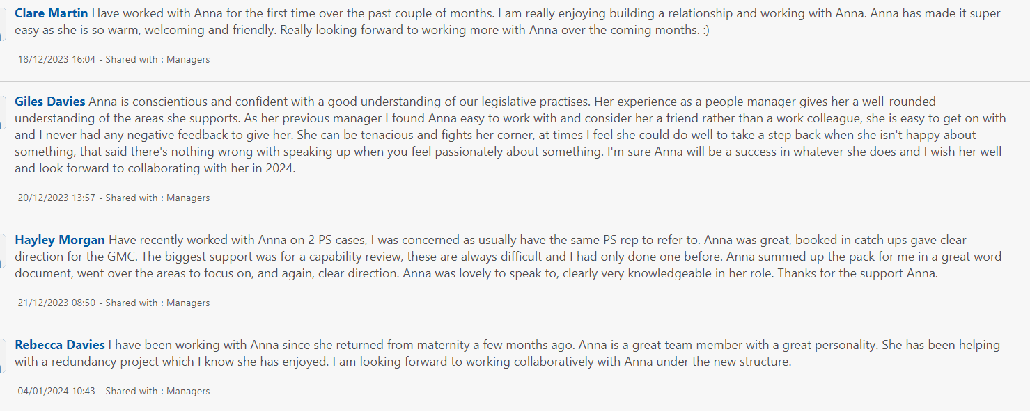
Fig. 4, 360 appraisal feedback

Taking what I know about myself and the combined feedback on-board, this has shaped my self-assessment. In conclusion, I have completed a SWOT analysis to review my strengths, weaknesses, development needs and threats.
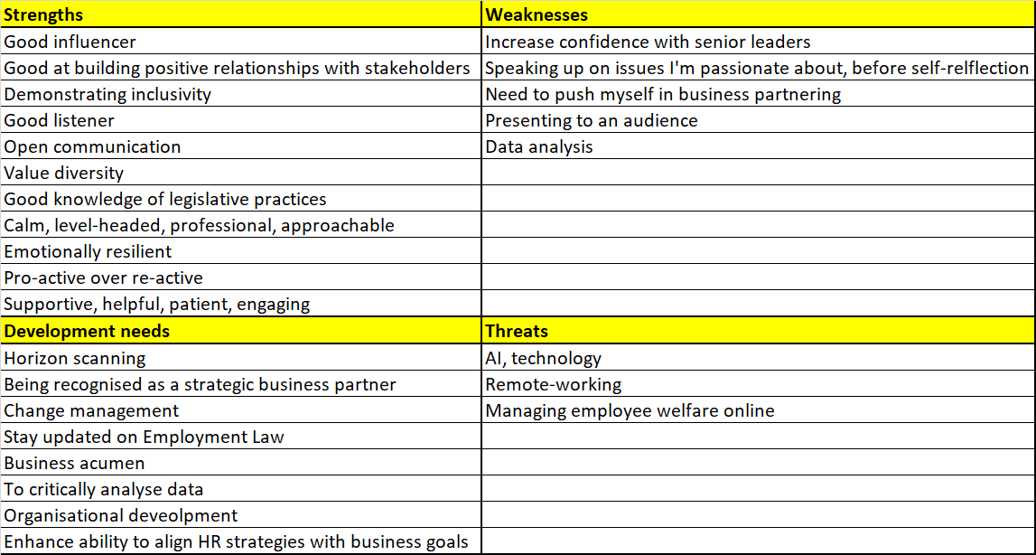
Fig. 5, SWOT Analysis (107 words)

- In follow-up to your self-assessment, identify a range of formal or informal development activities you will undertake to support your ongoing professional development. Your response should include a brief description of your chosen activities and your reasons for selecting them. (AC 3.3)

As a PP I would look to undertake both formal and informal development activities, to support my professional growth. I can ensure continous improvement to expand my skillset and stay current in the rapidly changing field of HR:
- Conference and events: Attending HR conferences, and networking events provides opportunities to gain insights from leaders in the profession, exchange ideas and stay informed about emerging trends and legislative practices.
- HR podcasts and books: e.g. Disruptive HR, Law breakfast, The culture code, Radical Candor. These platforms allow for self-paced learning tailored to specific skill gaps and your preferred learning interests. This type of learning compliments my auditory learning style. The more an auditory learner implements strategies specific to auditory learning in their daily work life, the more successful and productive they can be (Indeed, 2022).
- Redundancy and change management training with Admiral’s solicitors Geldards: Attending training specific to my job role and the direction of the Business partner in Admiral, will benefit me immensely.
- Professional certifications: I have chosen to do my CIPD level 5 diploma to evidence formal recognition, HR expertise and demonstrate commitment to my career progression.
- Personal progression: To increase confidence on speaking to an audience, I will volunteer to present to my team on a chosen topic. I would also continue to use self-reflection as part of my learning. As CIPD (2022) suggest, self-reflection is a really powerful tool when done correctly, reflective PP’s are amongst the most resilient, as they are able to reflect on their behaviours and search for a better approach.

- Reflect on the impact of three previous learning activities (i.e., not the activities planned at Q4 above) on your behaviour and performance. The selected activities may be any formal/planned or informal/unplanned activities undertaken in the last 12 months, which you consider to have impacted your behaviour and performance. (AC 3.4)

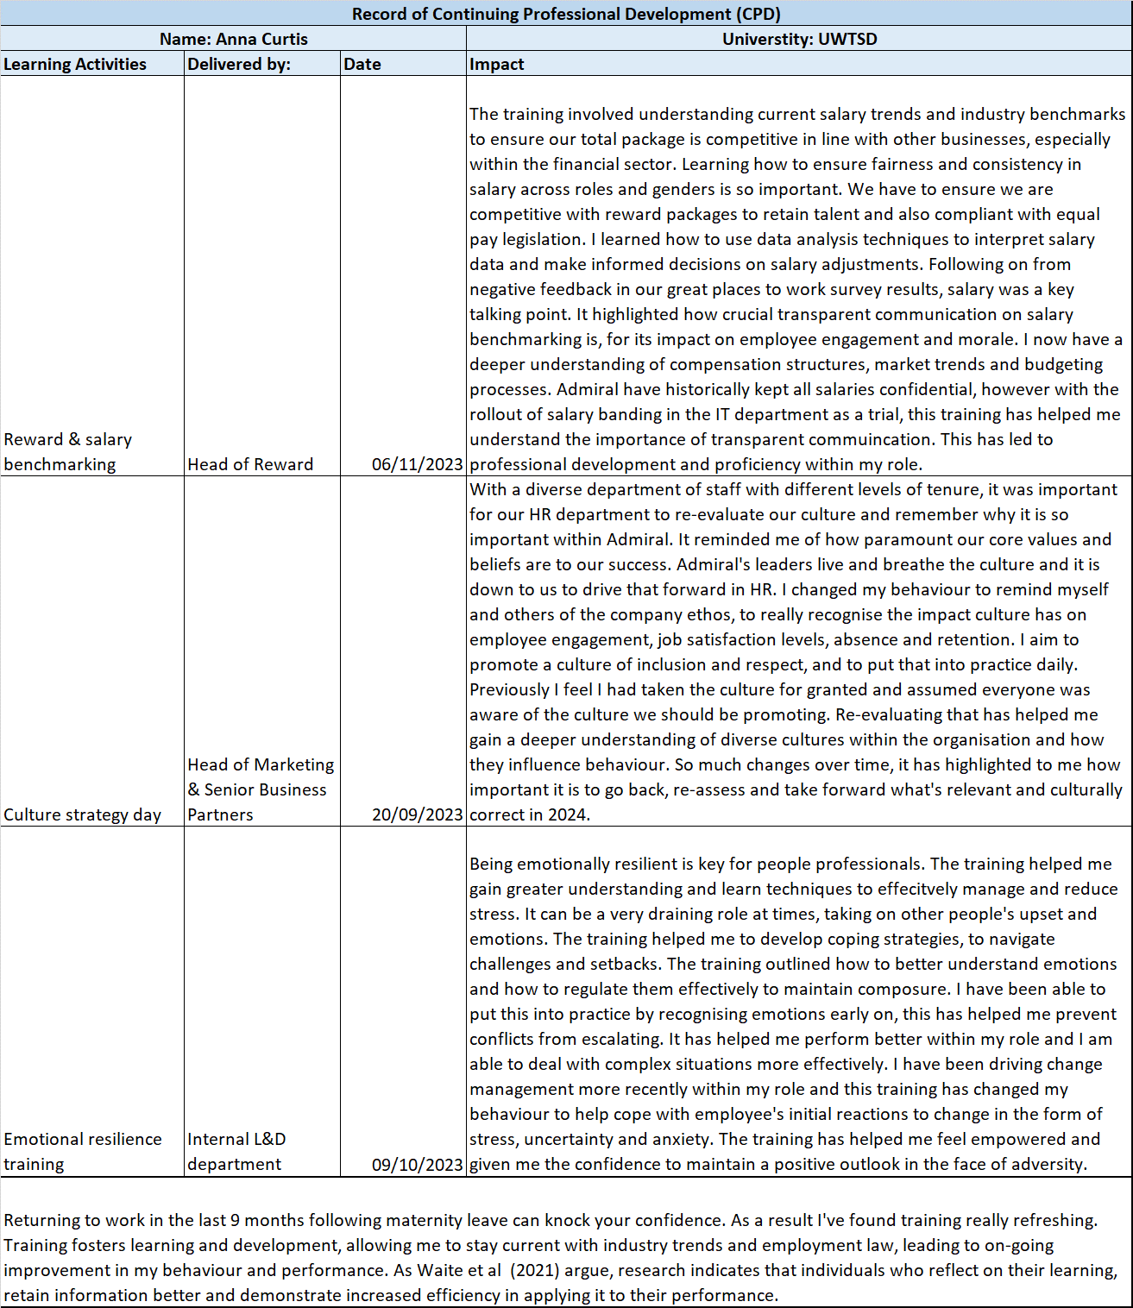
Fig. 6, My personal CPD

References
A guide to the 5 levels of Maslow’s hierarchy of needs - 2024 (2021) MasterClass. Available at: https://www.masterclass.com/articles/a-guide-to-the-5-levels-of-maslows-hierarchy-of-needs (Accessed: 21 February 2024).
About Us (2024) Admiral Group Plc. Available at: https://www.admiralgroup.co.uk/who-we-are/about-us (Accessed: 02 March 2024).

ACAS. (2023). Discrimination and the Equality Act 2010. [Online]. ACAS. Last Updated: 10th May 2023. Available at: https://www.acas.org.uk/discrimination-and-the-law [Accessed 22nd February 2024].
Branch, S. Ramsey, S. & Barket, M. (2007). Workplace bullying: A review of group-level processes within organisations. Journal of management.
Channell, M. (2021). Herzberg's Two-Factor Theory: How Leaders & Managers Can Motivate Their Team. [Online]. TSW Training. Last Updated: 30th September 2021. Available at: https://www.tsw.co.uk/blog/leadership-and-management/herzbergs-two-factor-theory/ [Accessed 19th February 2024].
CIPD. (2020). People Profession 2030 - A collective view of future trends. [Online]. CIPD. Last Updated: November 2020. Available at: https://www.cipd.org/globalassets/media/knowledge/knowledge-hub/reports/678people-profession-2030-fu [Accessed 2nd March 2024].
CIPD. (2023c). Professional courage and influence. [Online]. CIPD. Last Updated: 2023. Available at: https://www.cipd.org/uk/the-people-profession/the-profession-map/explore-the-profession-map/core-beh [Accessed 8th February 2024].
CIPD. (2023b). Professional Courage and Influence Introductory Programme. [Online]. CIPD. Last Updated: 2023. Available at: https://shop.cipd.org/product?catalog=Professional-Courage-and-Influence-Introductory-Programme#:~:t [Accessed 20 February 2024].
CIPD. (2022). The profession map. [Online]. CIPD. Last Updated: 2022. Available at: https://www.cipd.org/en/the-people-profession/the-profession-map/ [Accessed 10 February 2024].
CIPD. (2024). Trust and psychological safety: An evidence review. [Online]. CIPD. Last Updated: 7th February 2024. Available at: https://www.cipd.org/uk/knowledge/evidence-reviews/trust-psychological-safety/ [Accessed 1st March 2024].
Creating Ethical Workplaces (2019) CIPD. Available at: https://www.cipd.org/uk/knowledge/podcasts/ethical-workplaces/ (Accessed: 03 February 2024)
Deontological ethics (2023) Encyclopaedia Britannica. Available at: https://www.britannica.com/topic/deontological-ethics (Accessed: 12 February 2023)
Ethical decision making in the workplace: Reports (2015) CIPD. Available at: https://www.cipd.org/uk/knowledge/reports/workplace-decisions-report/ (Accessed: 02 November 2023).
Ethical Practice and the role of people professionals (2023a) CIPD. Available at: https://www.cipd.org/uk/knowledge/factsheets/ethics-role-hr-factsheet/ (Accessed: 11 February 2024).
Evidence-based L&D: The Power of Reflection (2022) CIPD. Available at: https://www.cipd.org/en/knowledge/podcasts/ld-reflective-practice/ (Accessed: 20 February 2024)
Goleman, D. (1995). Emotional Intelligence. Why it Can Matter More Than IQ. Batman Books.
Indeed Editorial Team. (2022). What is the auditory learning style? (With learning tips). [Online]. Indeed.com. Last Updated: 24 November 2022. Available at: What Is the Auditory Learning Style? (With Key Strategies) | Indeed.com [Accessed 05 March 2024].
Kew, J. and Stredwick, J. (2016). Human Resource Management in a business context. 3rd ed. London, United Kingdom: CIPD - Kogan Page.
Maslow, A.H. (1947) A theory of human motivation: A psychological research that helped change the field for good. New Delhi, India: General Press.
Nishii, L. H. (2013). The benefits of climate for inclusion for gender-diverse groups. Academy of management journal.
Page, N. (2022). Ten tips for successful influencing. [Online]. HR Magazine. Last Updated: 28th June 2022. Available at: https://www.hrmagazine.co.uk/content/insights/ten-tips-for-successful-influencing/ [Accessed 28th February 2024].
Smith, A. & Johnson, B. (2020). The role of HR in Organisational Leadership: A Comprehensive Review. Journal of Management Studies.
Taylor, S. and Woodhams, C. (2022) Studying Human Resource Management: A guide to the study, context and practice of hr. London, United Kingdom: CIPD. (P.83)
Taylor, S. and Woodhams, C. (2022). Human Resource Management: People and Organisations. 3rd ed. London, United Kingdom: CIPD - Kogan Page.
Ulrich, D. (1997). Human Resource Champions: The Next Agenda for Adding Value and Delivering Results. Harvard Business Press.
Ulrich, D. (2018). How do HR Pros Influence Others?. [Online]. Linkedin. Last Updated: 23rd October 2018. Available at: https://www.linkedin.com/pulse/how-do-hr-professionals-influence-others-dave-ulrich [Accessed 21st February 2024].
Waite, K. et al (2021) People practice: A complete guide. London, United Kingdom: Kogan Page. (P. 66, P.67, P.71, P.77, P.81)

