James Denton – 1702202
Synthesize a solution to a potential real life scenario
Computer Forensics
Dr Carlene Campbell

Table of Contents
- Research on Forensic Tools
  - Image Analysis Forensic Tools
    - SIFT – SANS Investigative Forensic Toolkit
    - CAINE – Computer Aided Investigative Environment
    - Kali Linux
    - Paladin Forensic Suite
    - DEFT – Digital Evidence and Forensics Toolkit
    - Helix3 2009R1
    - Helix3 Enterprise
    - bulk_extractor
    - The Sleuth Kit (and Autopsy)
    - FTK – Forensic Toolkit
    - EnCase Forensic
    - Linux ‘dd’
    - Last Activity View
    - USB Historian

  - Memory Dumping Forensics Tools
    - Volatility Framework

  - Network Analysis Tools
    - Xplico

  - Metadata Analysis Tools
    - ExifTool

  - Device Imaging Tools
    - FTK Imager

  - Hex Editor Tools
    - Free Hex Editor Neo
    - HxD

  - Security Tools
    - FireEye Redline

  - Email Analysis Tools
    - Paraben E3: EMX

- Forensic Case Study
  - Incident Handler or Forensics Investigator
  - Forensic Methodology
  - Report
  - Invoice – Original document included in zip file.

- Practical Application of Skills
  - Process of File Recovery
  - Recovering Files with no File Extension
  - Recovering Files with an Incorrect File Extension
  - Recovering Encrypted Files
  - Recovering Deleted Files

- Bibliography

- Research on Forensic Tools

  - Image Analysis Forensic Tools

    - SIFT Workstation – SANS Investigative Forensic Toolkit
The SIFT Workstation is an open-source, comprehensive software containing several free (libre and gratis) and open-source forensic tools for the purposes of Incident Response and Digital Forensics. It is currently one of the most popular Digital Forensics tools with over 100,000 downloads, only wavering to commercial solutions.
The software is available as a repository for Ubuntu 16.04 LTS, but is also available for Windows 10 and can be easily downloaded and installed via a Command Line tool on Ubuntu 16.04 LTS and via the SANS DFIR website on windows, featuring cross-compatibility between the 2 Operating Systems. [1]

    - CAINE – Computer Aided Investigative Environment
CAINE is an open-source Linux live-image that integrates a variety of existing open-source software tools such as Autopsy, Pasco, Photorec, The Sleuth Kit, etc. Into the OS as software modules along with a user-friendly graphical interface. [2] [3]
On top of this, CAINE also offers several tools for use within a Windows Operating System (these tools are also open-source). Referred to as the “Windows side”, this offers tools such as FTK Imager, USB Write Protector, QuickHash and Arsenal Image Mounter (just to name a few). [3]

    - Kali Linux
Kali Linux is a free (libre and gratis) and open-source Linux Live Image based upon Debian that includes over 600 free and open-source software utilities geared towards a number of different tasks such as auditing, digital forensics, reverse engineering, etc. It was first released on 13th March 2013, originally as a fork of Backtrack Linux [4]
The software includes support for ARMEL and ARMHF, [4] as ARM-based systems occupy a 46.2% market share (as of 2017), this is a very useful and necessary feature. [5] The software also supports many languages (though most penetration tools themselves are written in English). The software features GPG – GNU Privacy Guard (an encryption tool) [6] signed package and repositories. The software also features a modified kernel, patched with the latest fixes for improved security. [4]

    - Paladin Forensic Suite
Paladin Forensics Suite is a free (libre and gratis) live GNU/Linux distribution based upon Ubuntu and released by SUMURI. It is a collection of popular open-source tools such as Autopsy, SUMURI Remote Services (a support service), and over 100 other forensic tools for file carving, steganography, and many other purposes within the digital forensics umbrella. [7]

    - DEFT – Digital Evidence and Forensics Toolkit
DEFT is a free (libre and gratis) GNU/Linux distribution produced and maintained in Italy by Tesla Consulting srls. Designed for Incident Response and generalised Digital Forensics, [8] DEFT is a collection of 2 live-bootable operating systems. DEFT Zero, based upon Lubuntu Linux (a variant of Ubuntu utilising the LXDE Desktop Environment [9]) [10] and DEFT X va, based upon Ubuntu 18.04 Mate (a GNU/Linux operating system based on Debian that includes the Mate Desktop Environment [11]). [12]
DEFT Zero includes a multitude of tools for Hashing and Imaging such as Sha512deep, Md5deep, cyclone, ddrescue and several others. [10]
DEFT X va appears to include many additional packages relative to DEFT Zero, such as BitLocker (for mounting), network forensics tools such as Xplico and Wireshark. Several data recovery tools such as Photorec, Scalpel and Testdisk, as well as including several imaging and hashing tools such as Affcat and Guymager and Sha256sum and Ssdeep respectively. [12]

    - Helix3 2009R1
Helix3 is made up of a free (libre and gratis) GNU/Linux distribution based upon Ubuntu and a suite of (also free) windows software packages designed for forensic investigation and incident response. It is no longer maintained by its previous maintainer, e-fense, as it was discontinued in favour of offering a proprietary, in-house solution in the form of Helix3 Enterprise. [13]
Helix3 offers several tools for forensic investigation. On the GNU/Linux side, it offers The Sleuth Kit, dc3dd, and several others. On the Windows side, it offers FTK Imager, mdd, WFT, IRCR, and several others. [13]

    - Helix3 Enterprise
Helix3 Enterprise is the proprietary replacement for the free and open-source tool Helix3. It is sold to companies in batches of licenses and is aimed at monitoring systems in anticipation of an incident rather than after the fact, like most forensic tools. [14]
It offers monitoring of internet usage, perform screen capture and keylogging, and obtain files based on timestamp/date, keyword search or hash values, as well as obtaining forensic images of system RAM, processes and drives. [14]
The software then allows the investigator to formulate a report based on any audited information.
    - bulk_extractor
bulk_extractor is a forensics tool based in C++ used for scanning a file, disk image or directory to extract information. Crucially however, bulk_extractor differentiates itself from similar tools in that it does not parse file system structures in its extraction process and its speed in conducting this process. This means that the tool is still able to recover information from drives with a corrupt or incomplete file system by examining the raw data. [15]
The data is recovered by splitting the disk into 16MB pages, and assigning a page to each idle processor core, allowing the use of multiple processing cores to drastically speed up the data recovery process. [15]

    - The Sleuth Kit (and Autopsy)
The Sleuth Kit is a free (libre and gratis) and open-source library of command-line based tools for forensic analysis of disk images and file recovery. The file system tools allow examination of file systems non-invasively and view the layout of disks, their various partitions and any hidden and deleted files, directories and partitions. [16]
Autopsy is a free (libre and gratis) and open-source GUI (Graphical User Interface) for The Sleuth Kit to make the software less fatiguing to use. The software also provides management of extracted data into cases and maintains image integrity (to protect against accidental self-incrimination). [16]

    - FTK – Forensic Toolkit
FTK is a proprietary forensic tool that includes a multitude of different tools in one piece of software. It operates via a central case database, meaning that teams can work on the same data set, reducing complexity by eliminating the need for multiple data sets and allowing for the collaboration of investigators. This also means that no data is lost in the event of the client device (or software) crashing, as all data is stored externally. [17]
It features multi-core support, allowing the software to perform more efficiently on systems featuring multiple cores/threads. It allows investigators to crack passwords using dictionary attacks, and to decrypt via brute-force password hashing. Once the investigator has finished analysing the disk, FTK allows them to create a report of their findings, as well as to create a hash report on the disk before and after, allowing them to demonstrate that the image has not been altered. [17]

    - EnCase Forensic
EnCase Forensic is a proprietary Forensic Investigation tool produced by Opentext Corp. that allows a forensic investigator to recover data from computers, smartphones (such as Android devices, iOS devices and blackberry devices), tablets and Satellite Navigation Systems. [18]
EnCase Forensic also offers decryption and password cracking in the form of Tableau Password Recovery, an included software for password cracking. EnCase Forensic then allows an investigator to analyse and produce customised triage reports from audited data to best suit the data being recovered. [18]
    - Linux ‘dd’
‘dd’ (stands for data duplicator) is a free command line utility within Unix and Unix-like operating systems (such as Linux) used for the conversion and copying of data. It is a low-level utility (low level formatting – the process of marking the surface of disks with markets to indicate the start of a recording block [19]). It offers features such backup and restore of partitions and drives, backup of Master Boot Record (MBR). It requires superuser access to be used, due to potentially large loss of data if used improperly. [20]

    - Last Activity View
Last Activity View is a freeware (gratis, not libre) Windows-based software tool used for collecting data on user activity from a running system. E.g. if the user ran an executable, opened a jpeg image, installed software, etc. It will also collect information on system/application crashes (such as BSODs). [21]
Upon collecting this information, the investigator can export this information into a variety of file types such as CSV, XML or HTML or copied to the clipboard and used with a software of the investigators choosing. [21]

    - USB Historian
USB Historian is a free (libre and gratis) tool that allows an investigator to recover the log files and registry entries created by Windows when external storage devices are connected. The software also allows the investigator to recover USB ID’s and names of computers the device was used on. [22]

  - Memory Dumping Forensics Tools
    - Volatility Framework
The Volatility Framework is a free (libre and gratis) and open-source software first released by Black Hat DC in 2007. The software was created from the desire to expand digital forensics to collect data stored within volatile storage eg RAM, something that was not possible with the tools available at that time. Volatility Framework is designed to analyse the runtime state of a system by examining the data stored within volatile storage (eg RAM). [23]
This differs from prior digital forensics software which focused on obtaining evidence from images of non-volatile storage (e.g. Hard Disk Drives, Solid State Drives, Flash Drives etc.)
Development of this software is supported by The Volatility Foundation, a non-profit organisation established for the purpose of promoting the usage of Volatility Framework, to protect the project IP (Intellectual Property) and to encourage the continued contribution to memory analysis research. [23]

  - Network Analysis Tools
    - Xplico
Xplico is a Network Forensics Analysis Tool (NFAT) used to capture application data from captured internet traffic (such as that obtained via a packet sniffer such as Wireshark) licensed for use under the GNU GPL v2, meaning that it is free (libre and gratis) and open-source. It supports a variety of different protocols such as HTTP, IMAP, POP3, SMTP, TCP (e.g. reassembly of TCP data), UDP, etc. and supports real-time examination of traffic and custom dispatchers allowing the user to customise the organisation of output data to arrange it in the most suitable fashion. [24]
The software is modular (split up into independent components) which allows developers to create new components for the software to better suit their needs. [24]

  - Metadata Analysis Tools
    - ExifTool
ExifTool is a free (libre and gratis) and open-source, command-line software tool created in PERL for the purpose of modifying, writing and reading metadata from various image and music file formats such as EXIF, GPS, IPTC, XMP JFIF, MakerNotes, etc. It can read timed metadata from a variety of different video formats. [25]

  - Device Imaging Tools
    - FTK Imager
FTK Imager is a software bundled with FTK – Forensic Toolkit, however it is designed to be used alongside it, and is a separate program. It is an imaging tool used to obtain evidence from a source device without making changes to the original evidence, and in a manner than is appropriate for a forensic investigation. [26]
It allows you to create forensic images of external drives, CDs and DVDs, and even individual folders and files. It also allows mounting of a forensic image in a read-only capacity to preview the contents inside. This software, like FTK, will allow you to generate hash reports to prove the integrity of any recovered files and disk images. [26]

  - Hex Editor Tools
    - Free Hex Editor Neo
Free Hex Editor Neo is freeware software (proprietary, but gratis) and claims to be the fastest freeware binary file editor for Windows Operating Systems (it is compatible with Windows 7 and up, and Windows Server 2008 R2 and up). It allows you to edit and analyse the binary hex of individual files and hard disks and to verify checksums and hashes (such as SHA-256, SHA-512, MD5 and many others). [27]
It is distributed under a “freemium” model, which provides users with all basic functionality for free, with advanced features available in the form of Hex Editor Neo Standard/Professional/Ultimate. [28] [29]
    - HxD
HxD is a freeware (gratis, not libre) hex editor designed for Windows Operating Systems that allows editing and reading of raw disks, system memory and any files. HxD offers several features such as splitting of files and file shredding, along with basic find and replace functionality. The software also allows an investigator to generate checksums in popular formats (e.g. MD5, SHA-1, SHA-512, etc.) and to generate basic byte distribution graphs for analysis. [30]
The software is available as an installer or portable release and supports all versions of windows (including Win9x). [30]

  - Security Tools
    - FireEye Redline
FireEye Redline is a free (libre and gratis) investigative tool that examines volatile and non-volatile storage to search for malicious activity. After which, the software allows the investigator to create a threat assessment profile. Redline allows the investigator to perform an audit on memory, registry, browser history, running services, and file-system data, and to view and investigate collected data (and to sort recovered data by timestamp). [31]
The latest version of Redline (1.20.2) features support for Windows XP and above. [31]

  - Email Analysis Tools
    - Paraben E3: EMX
E3: EMX is a proprietary software produced by Paladin that is designed to examine local email archives and recover deleted emails. It is a subscription-based tool that works with a variety of different formats, such as PST & OST (Microsoft Outlook files), AOL, EML files, Mozilla Thunderbird, etc. The software also allows removal of duplicates, indexed searching and provides live support (included in the yearly fee) to answer any questions and provide training. [32]

- Forensic Case Study

  - Incident Handler or Forensics Investigator
The roles of the Incident Handler and Forensic Investigator are similar in that they typically use similar tools but are different in the goal that they are attempting to achieve. Incident response is focused on detecting and analysing a specific issue to provide a quick response to a problem and contain the incident. [33] The role of the Forensics Investigator is different, as it is focused primarily on the forensic collection of evidence. This investigation may involve corrupt drives, files, and may span across multiple devices such as mobile phones, computers, tablets, GPS devices, etc. and may span over a large time period (potentially over 1 year). Any evidence collected may be used for the purpose of prosecution. [34]
An incident Handler has the job of mitigating damages as much as possible. they are often part of a CIRT – Computer Incident Response Team and are responsible for handling an incident quickly by containing the issue, investigating the events that lead to said incident and recovering from it. The Incident Handler would be responsible for the containment of the incident and would assess any damages as a result of the issue. They would perform basic forensics, and then be responsible for fixing any issues in the task of recovery. [35]
The Forensic Investigator has the job of collecting all forensic data using various Digital Forensics tools and formulating the findings into an easy-to-understand report. Digital Forensics as a field incorporates many specialist terms, however it is the responsibility of the Forensics Investigator to ensure that any report produced is written in uncomplex language that could reasonably be understood by anyone. This is because one role of the Forensics Investigator is to provide their reports as evidence in a court of law, and to act as an expert witness for the court. As such, a requirement of this job is that the person obtains a security clearance before working on any cases. [36]
With that in mind, the type of personnel required for this case is a Forensics Investigator. This is due to the fact that the evidence is allegedly terrorism-related and was provided to the Forensic Investigator by a Police Investigator, who requested that it be investigated. As such, it is certainly possible that the court may require the Investigator to provide reports and to testify as an expert witness. As this is something that only a Forensic Investigator is able to do, they are required for this particular case.

  - Forensic Methodology
To allow him to investigate the case, John was provided with the evidence laptop, photographs of the crime scene and the fingerprints of the suspect. At this time John should prepare a chain-of-custody and single evidence form. This will detail the case number and evidence number, the date and time that the evidence was collected, who it was collected by and where it was collected from, as well as information on the evidence such as when it was first stored, the location of storage and the specifications of the device e.g. manufacturer, model, etc. Other information is required on the single evidence form that will be added throughout the investigation. It is important that John keeps the forms with the evidence at all times.
The computer was provided in a Stand By mode. John noticed that the Operating System of the computer was Windows XP Professional SP2. John took photographs of the computer screen throughout. While doing this, John should include a digital clock in all photographs to provide a second form of timestamp (aside from EXIF data). John should also wear gloves while handling the device to prevent contaminating the device with his fingerprints. [37]
To begin, John should utilise a Forensic tool that can obtain the contents of the volatile storage e.g. RAM from the system (as the system was provided in a stand-by state) as this may hold information that would be useful to the investigation. [37] The Volatility Framework and FireEye Redline were both designed for this purpose and would be effective tools for John to use in obtaining this data. This should be done first as if the computer were to shut down or lose power in any way, this data would be lost. [38]
Next, John should use a forensic tool capable of creating an image of the system’s hard drive. If John were to examine the original drive, there is a risk of destroying or altering the evidence. This would be classed as perverting the course of justice which could result in legal consequences for John. [39] One tool that can help to prevent this is FTK Imager. It is a free and open-source (libre and gratis) forensics tool produced by AccessData. This software allows a Forensic Investigator to create an Image file of a Hard Drive.
First, John should use this software to generate a SHA-1 and MD5 hash of the original hard drive. These 2 values should be added to the single evidence form. Then, John should use the software to create a disk image of the hard drive. Once John has obtained the image file, he should perform an integrity check by generating the SHA-1 and MD5 hash of the image file. If John did everything correctly, the 2 hash values will be the same as the original hard drive. This also needs to be added to the single evidence form, along with stating that a digital image was taken of the original hard drive and the date and time it was imaged, who it was imaged by, the filename and the size of the image. This will show that John did not alter the original hard drive in the process of creating the image file and will also ensure that the image file is a bit-for-bit copy of the original hard drive. [26] John should then store the evidence in a secure location until it is returned.
Next, John should use a forensics tool to analyse the image file he obtained. John could use multiple tools for generalised file recovery, but one good option is FTK – Forensic Toolkit. FTK is a proprietary forensic tool that is designed for forensic investigation of image files created in FTK Imager. [17]
Using FTK, John could recover emails, images, video files, documents, files in swap space, and many more via indexed search, using the correct keywords to find files e.g. OST and PST for Microsoft Outlook files, mp3, wav and rm for audio files, etc. John can also use FTK to identify files with bad extensions, encrypted files and deleted files. If any files with a bad extension are identified, FTK will list the current extension, and what its actual file type is, allowing John to correct the files to the correct extension, allowing them to be processed as evidence. If any encrypted files are identified, then John could utilise the included PRTK (Password Recovery Toolkit) to utilise a dictionary attack on the files in order to recover the password. [17] To recover deleted files, as well as any other files obtained, John can simply export the files to a directory and view them.
At this point, John should have recovered all the file types that he was asked to obtain, as FTK has a tab for emails, a tab for chat messages, and all other file types can be recovered via a search based on their file types.
As it is likely that John will be required to provide the report to the court and act as an expert witness, it is a good idea for John to analyse the recovered files and provide documentation of them. [40] This should mention the name, content and file extension of the file (if the file was recovered with an incorrect file extension, both the incorrect and correct file extension should be provided). This will be helpful for John to refer to if he is asked to act as an expert witness and is asked to explain the recovered files to the court. In doing this, John would simply have to extract the files to a directory and play them with a media player such as VLC.
At this point in the investigation, John should also return the evidence, at which point, he should use the single evidence form to document the date and time of handing over the evidence and the names and signatures of himself, the person receiving the evidence from him and of a witness. At which time, he should also add to the chain of custody document. His name, signature, the date and time and then state if the evidence was modified by him (it wasn’t). The person receiving the evidence will then also provide the date/time, and their name and signature. Next, John should prepare and submit a report of his findings and an invoice to the relevant party, stating the payment required for his services.

  - Report

To: Mr. Mark Wales
From: John
Re: Digital Forensic Investigation. Case #383
Introduction: [41]
On the 1st March 2019, the evidence (a laptop bag containing 1 Dell laptop, photographs of the crime scene and fingerprints of the suspect) was collected (as documented in the single evidence form). The laptop was received in a stand-by state, and as such, after first taking a photograph of the screen, the first task conducted on the device was to obtain the contents of the volatile storage, as this would be lost in the event that the system was powered down. Next, a digital image was taken of the original drive (as its ill advised to work on the original drive for fear of altering the evidence), integrity checks were performed on the original drive prior to taking the image and on the image to ensure that the image was a perfect copy of the original drive (as documented in the sample evidence form). The drive was then examined using forensic tools to obtain any image files, video files, documents, etc. from the image file, which were then documented on file name, file size, file extension, found state (e.g. if the file extension was incorrect or if the file was found in a deleted or encrypted state, etc.)
Findings:
While gathering evidence from the image file, multiple video files were obtained. These video files focused on 9/11 bombings, a video of terrorists practicing the killing of kidnapped hostages at a terror camp, several videos containing leaders of terrorist organisations giving motivational speeches, home videos of the suspect with his family, a video of Heathrow International airport in London and Mason International airport in Fiji, and videos localised to a hotel room of the suspects and 6 others.
These videos were accompanied by several images. There were a large number of photographs of both Heathrow International airport and Mason International airport. These photographs showed both airports in great detail and logos of another terrorist group.
There were also several documents relating to the subjects of bomb making, preparing for Jihad and a guide on Suicide Bombing, along with other similar materials. One noteworthy document was named “How to bomb Mason International airport” with instructions on spreading terror at Mason International airport.
A contacts list was recovered from the Microsoft Outlook of the accused. The names matched those in other documents that were found. Excel sheets containing bank details and flow of funds were also found. The laptop bag contained several documents and immigration VISAs.

Conclusion:
Considering all the evidence, such as the accused’s video files featuring radicalisation and terrorist attacks, the video detailing Heathrow International airport and Mason International airport, and the videos of the suspect and 6 other suspects, it is my belief that the suspect and the 6 other suspects, and the terrorist organisation to which they are allegedly associated, intended to commit an attack of some sort at Heathrow International airport and Mason International airport. The included home videos of the suspect with his family are irrelevant to the conclusion but were also recovered from the suspects computer.
This view point is further supported by logos of the allegedly associated terrorist organisation, and the detailed set of photographs taken of both airports and is, in my opinion, confirmed by one document recovered from the suspects computer, titled “How to bomb Mason International airport”, which contained instructions on causing terror at Mason International airport, which leads to the conclusion that the suspect intended to commit a terrorist attack at Heathrow International airport, and intended to follow it up with a subsequent attack at Mason International airport. The fact that the suspect was shot down while engaged in terrorist activities at Heathrow International airport makes this conclusion irrefutable.

  - Invoice – Original document included in zip file
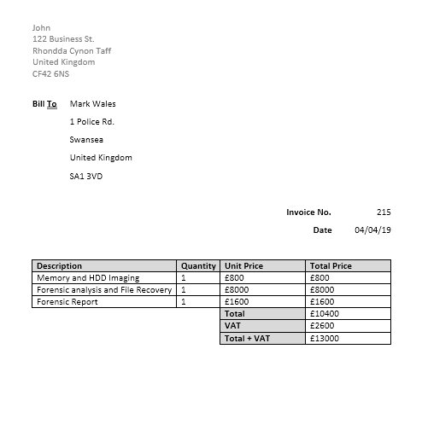

- Practical Application of Skills

  - Process of File Recovery
Prior to recovering the files, an integrity check should be performed to ensure that the image is a bit-for-bit copy.
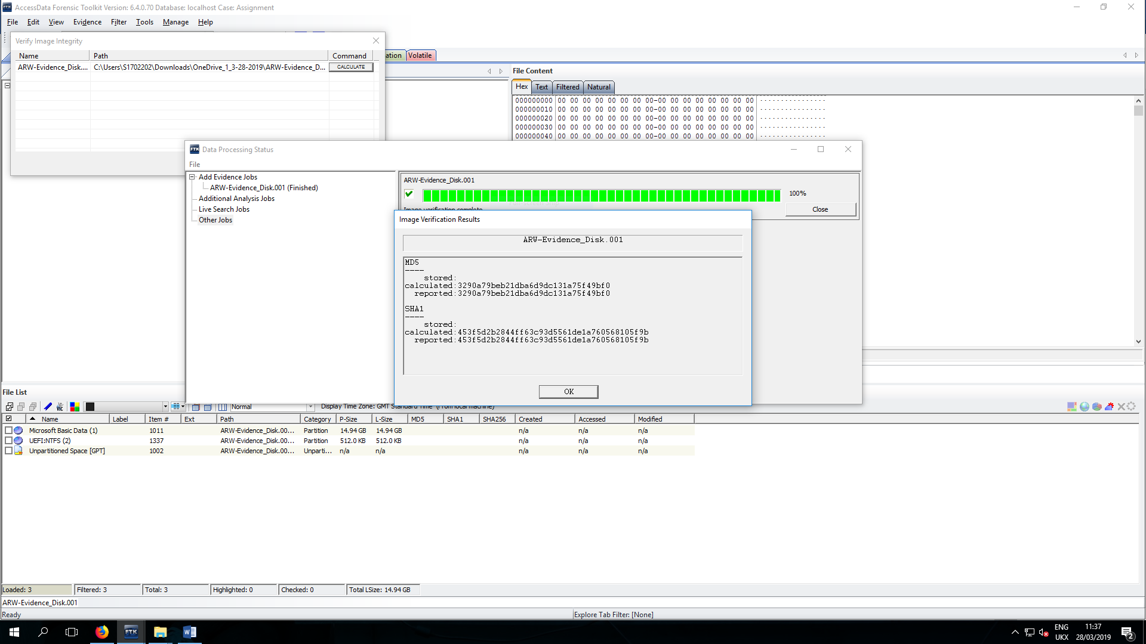

To recover the files, FTK – Forensic Toolkit was used. It allows an investigator to create a case, load a disk image produced in FTK Imager, and to examine the contents of the image and export the files contained within.
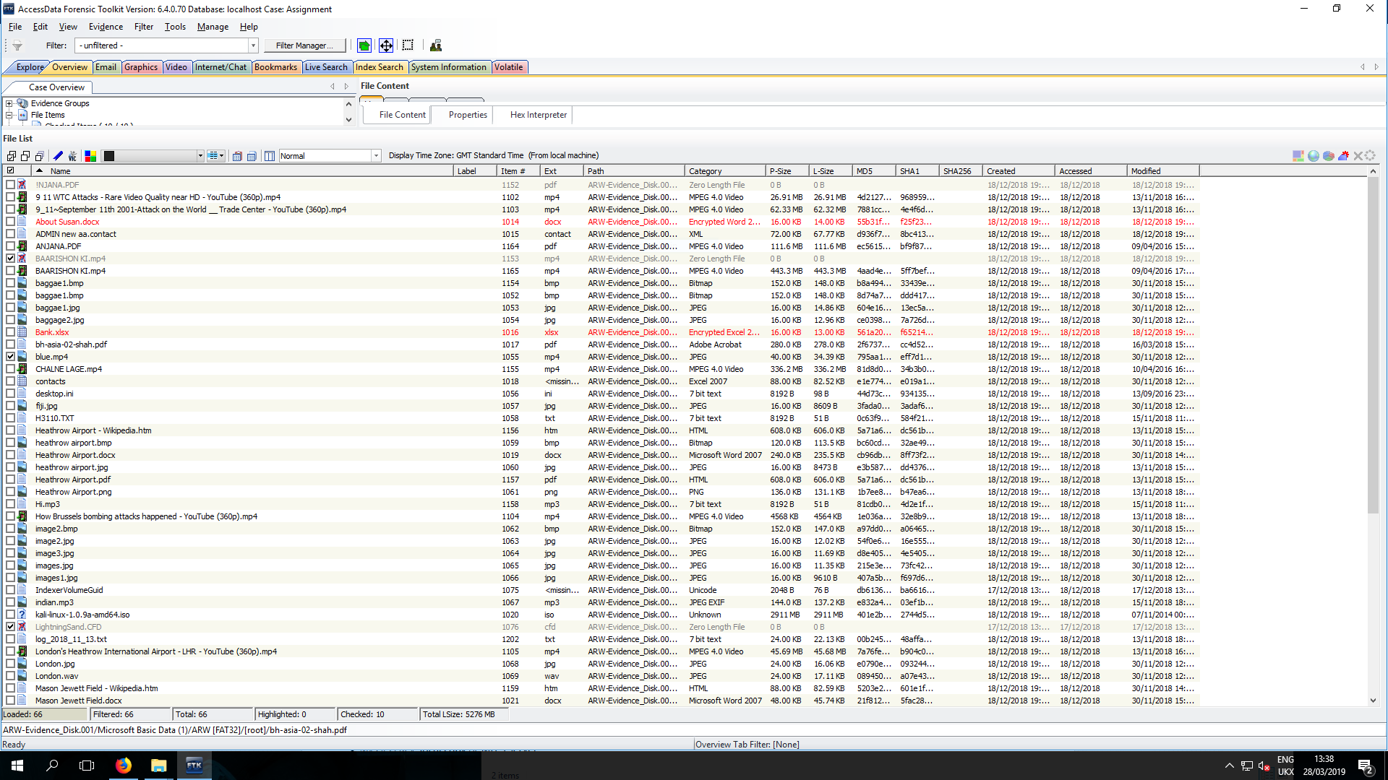
In order to sort this list into just the files required, the Index Search tab was used. A list of file extensions was used to list only the file types that are wanted, as can be seen in the image below.
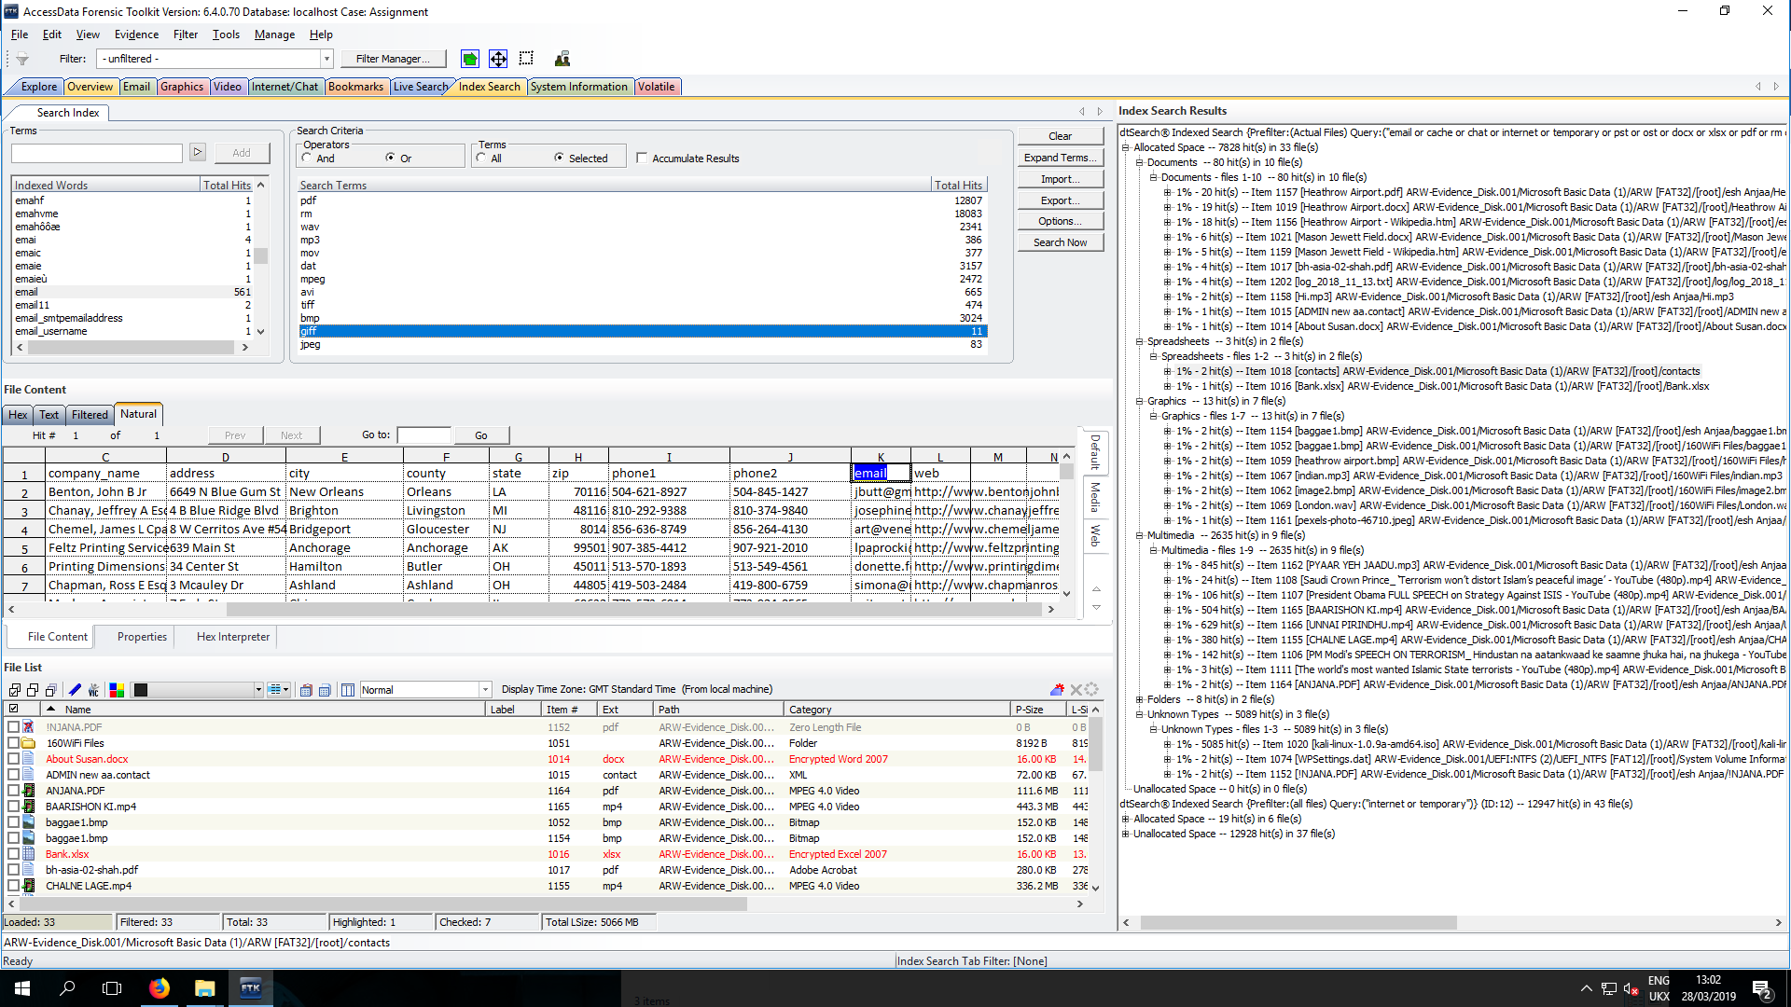

  - Recovering Files with no File Extension

Of the files recovered, the “contacts“ file has no file extension. In order to be opened, this needs to be fixed
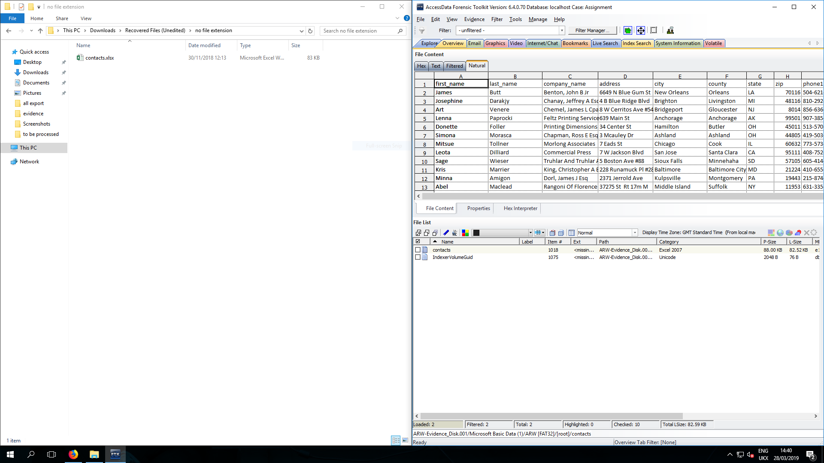

  - Recovering Files with an Incorrect File Extension
Several of the files recovered were unable to examined. This was due to incorrect file extensions. By utilising the “Category” column, the correct file type can be determined, and the file extension fixed (as can be seen in the image).
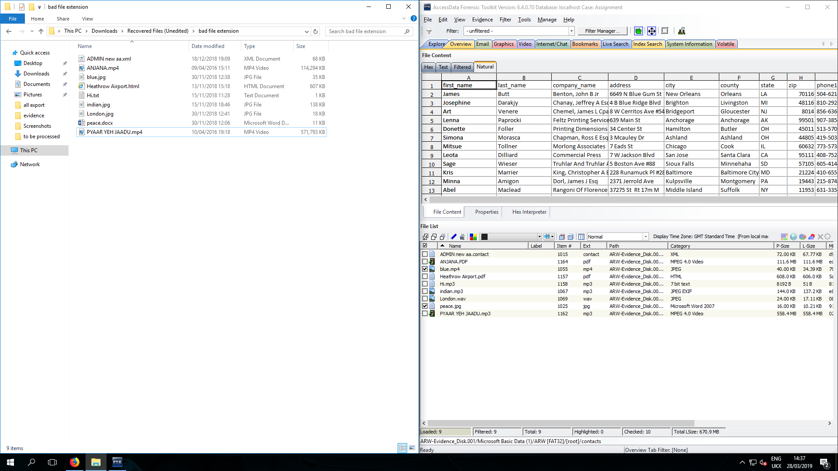
  - Recovering Encrypted Files
Two of the files recovered, “About Susan.docx” and “Bank.xlsx” were encrypted.
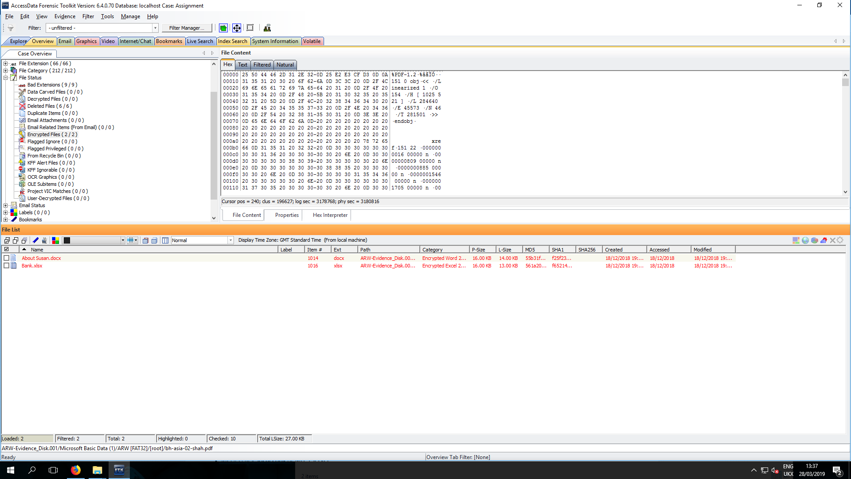
Fortunately, FTK includes Password Toolkit, which allows an Investigator to launch a Dictionary attack on the two files, allowing the passwords to be recovered.
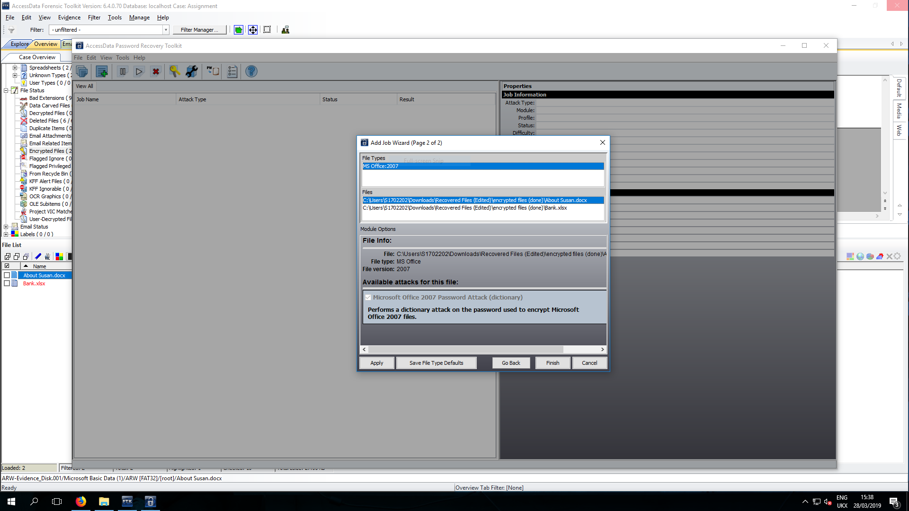

The passwords are “money” for “Bank.xlsx” and “plan” for “About Susan.xlsx”.
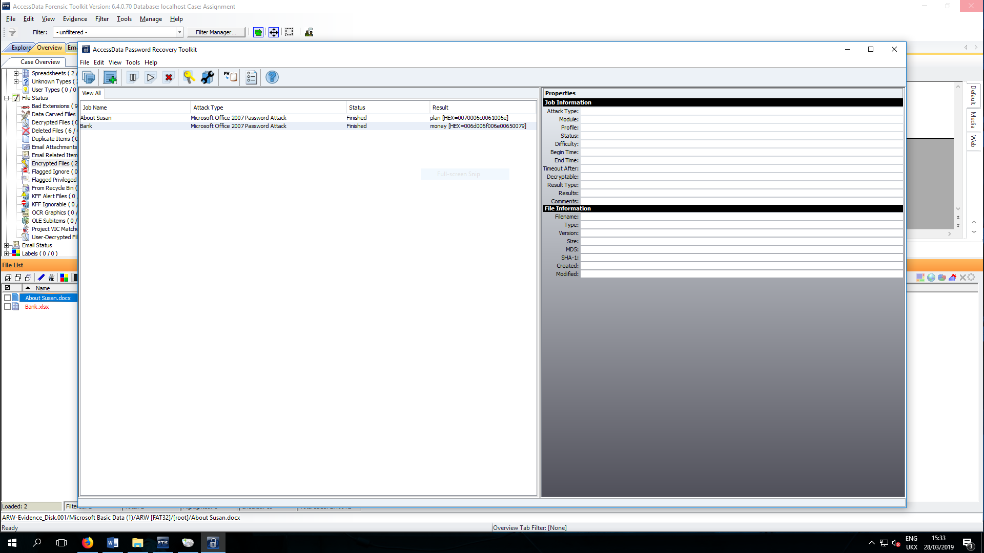

Bibliography

[1] | SANS DFIR, "Community: Downloads," SANS DFIR, [Online]. Available: https://digital-forensics.sans.org/community/downloads. [Accessed 21 February 2018].
[2] | CAINE, "Index," CAINE, 18 December 2018. [Online]. Available: https://www.caine-live.net/index.html. [Accessed 21 February 2019].
[3] | CAINE, "Tools and packages included in CAINE Live DVD," CAINE, 18 December 2018. [Online]. Available: https://www.caine-live.net/page11/page11.html. [Accessed 21 February 2019].
[4] | Offensive Security, "What is Kali Linux?," Offensive Security, [Online]. Available: https://docs.kali.org/introduction/what-is-kali-linux. [Accessed 21 February 2019].
[5] | D. Manners, "ARM market share slipping," Electronics Weekly, 14 May 2018. [Online]. Available: https://www.electronicsweekly.com/news/business/arm-market-share-slipping-2018-05/. [Accessed 02 April 2019].
[6] | Brian Balsamo, "Data Encryption: GNU Privacy Guard (GPG)," University of Illinois at Urbana-Champaign, 01 May 2018. [Online]. Available: https://guides.library.illinois.edu/data_encryption/gpg. [Accessed 02 April 2019].
[7] | SUMURI, "PALADIN - SUMURI," SUMURI, 2019. [Online]. Available: https://sumuri.com/software/paladin/. [Accessed 02 April 2019].
[8] | Tesla Consulting srls, "About - DEFT," Tesla Consulting srls, [Online]. Available: http://www.deftlinux.net/about/. [Accessed 02 April 2019].
[9] | lubuntu, "About - lubuntu," lubuntu, [Online]. Available: https://lubuntu.net/about/. [Accessed 02 April 2019].
[10] | Tesla Consulting srls, "DEFT Zero - DEFT," Tesla Consulting srls, [Online]. Available: http://www.deftlinux.net/package-list/deft-zero-2/. [Accessed 02 April 2019].
[11] | Ubuntu MATE Team, "What is Ubuntu MATE? | Ubuntu MATE," Canonical Ltd., 2019. [Online]. Available: https://ubuntu-mate.org/what-is-ubuntu-mate/. [Accessed 02 April 2019].
[12] | Tesla Consulting srls, "DEFT X va - DEFT," Tesla Consulting srls, [Online]. Available: http://www.deftlinux.net/package-list/deft-x-va/. [Accessed 02 April 2019].
[13] | ForensicsWiki, "Helix3 - Forensics Wiki," ForensicsWiki, 18 January 2014. [Online]. Available: https://forensicswiki.org/wiki/Helix3. [Accessed 02 April 2019].
[14] | e-fense, "e-fense, Inc. Store - Helix3 Enterprise," e-fense, 2009. [Online]. Available: https://www.e-fense.com/store/index.php?_a=viewProd&productId=5. [Accessed 02 April 2019].
[15] | B. A. Simson L. Garfinkel, "GitHub - Simsong / bulk_extractor," 19 June 2014. [Online]. Available: https://github.com/simsong/bulk_extractor/wiki. [Accessed 14 March 2019].
[16] | B. Carrier, "The Sleuth Kit - Overview," Sleuthkit, 2019. [Online]. Available: https://www.sleuthkit.org/sleuthkit/desc.php. [Accessed 21 February 2019].
[17] | ACCESSDATA, "Forensic Toolkit (FTK)," ACCESSDATA, 2019. [Online]. Available: https://accessdata.com/products-services/forensic-toolkit-ftk. [Accessed 28 February 2019].
[18] | OpenText Corp., "EnCase Forensic Software - Top Digital Forensics & Investigations Solution," OpenText Corp., 2018. [Online]. Available: https://www.guidancesoftware.com/encase-forensic. [Accessed 02 April 2019].
[19] | Jean, "Low Level Format Tool," EaseUS, 03 Dec 2018. [Online]. Available: https://www.easeus.com/partition-manager-software/low-level-format-tool.html. [Accessed 02 April 2019].
[20] | I. Ashraf, "12 Linux DD Command Examples," The Linux Juggernaut, 08 March 2016. [Online]. Available: https://www.linuxnix.com/what-you-should-know-about-linux-dd-command/. [Accessed 02 April 2019].
[21] | N. Sofer, "LastActivityView - View the latest computer activity in Windows operating system," NirSoft, 2018. [Online]. Available: http://www.nirsoft.net/utils/computer_activity_view.html. [Accessed 02 April 2019].
[22] | 4Discovery, "USB Historian - 4Discovery," 4Discovery, 2019. [Online]. Available: https://4discovery.com/usb-historian/. [Accessed 02 April 2019].
[23] | The Volatility Foundation, "About The Volatility Foundation," The Volatility Foundation, 2018. [Online]. Available: https://www.volatilityfoundation.org/about. [Accessed 21 February 2019].
[24] | A. D. F. Gianluca Costa, "Xplico - About," Xplico, [Online]. Available: https://www.xplico.org/about. [Accessed 21 February 2019].
[25] | P. Harvey, "ExifTool by Phil Harvey," 21 February 2019. [Online]. Available: http://owl.phy.queensu.ca/~phil/exiftool/#features. [Accessed 28 February 2019].
[26] | ACCESSDATA, "FTK Imager," ACCESSDATA, 2018. [Online]. Available: https://marketing.accessdata.com/ftkimager4.2.0. [Accessed 02 April 2019].
[27] | HHD Software Ltd., "Free Hex Editor Neo," HHD Software Ltd., 2019. [Online]. Available: https://freehexeditorneo.com/. [Accessed 02 April 2019].
[28] | "Free Hex Editor Neo: Fastest Binary File Editing Software for Windows OS," HHD Software Ltd., 2019. [Online]. Available: https://www.hhdsoftware.com/free-hex-editor. [Accessed 02 April 2019].
[29] | HDD Software Ltd., "Hex Edito Neo: Download Fastest Heaxadecimal Viewer/Editor Software App," HHD Software Ltd., 2019. [Online]. Available: https://www.hhdsoftware.com/hex-editor. [Accessed 02 April 2019].
[30] | M. Hörz, "HxD - Freeware Hex Editor and Disk Editor | mh-nexus," mh-nexus, 2019. [Online]. Available: https://mh-nexus.de/en/hxd/. [Accessed 02 April 2019].
[31] | FireEye, Inc., "Redline | Free Security Software | FireEye," FireEye, Inc., 08 June 2018. [Online]. Available: https://www.fireeye.com/services/freeware/redline.html. [Accessed 02 April 2019].
[32] | Paraben Corporation, "E3:EMX Email Forensics - Paraben Corporation," Paraben Corporation, [Online]. Available: https://paraben.com/email-forensics-emx/. [Accessed 02 April 2019].
[33] | P. Tavares, "Incident Response and Computer Forensics," INFOSEC RESOURCES, 2019. [Online]. Available: https://resources.infosecinstitute.com/category/computerforensics/introduction/areas-of-study/computer-forensics-investigations/incident-response-and-forensics/. [Accessed 03 April 2019].
[34] | INFOSEC RESOURCES, "Computer Forensics Investigator - Infosec Resources," INFOSEC RESOURCES, [Online]. Available: https://resources.infosecinstitute.com/job-titles/computer-forensics-investigator/. [Accessed 03 April 2019].
[35] | M. Borodkin, "Computer Incident Response Team," SANS Institute - Information Security Reading Room, 2001.
[36] | Infosec, Inc., "Incident Responder - Infosec," Infosec, Inc., 2019. [Online]. Available: https://www.infosecinstitute.com/career-profiles/incident-responder/. [Accessed 03 April 2019].
[37] | P. A. ENISA, "Electronic evidence - a basic guide for First Responders," European Union Agency for Network and Information Security.
[38] | A. Kariuki, "Difference between Volatile and Non-Volatile memory," COMPUTERSCIENCEMENTOR, 18 May 2017. [Online]. Available: http://computersciencementor.com/difference-between-volatile-and-non-volatile-memory/. [Accessed 03 April 2019].
[39] | L. Trevelyan, "Perverting the course of justice - InBrief.co.uk," In Brief.co.uk, [Online]. Available: https://www.inbrief.co.uk/offences/perverting-the-course-of-justice/. [Accessed 03 April 2019].
[40] | Y. Gabanov, "Retrieving Digital Evidence: Methods, Techniques and Issues," Belkasoft Ltd., 11 July 2012. [Online]. Available: https://articles.forensicfocus.com/2012/07/11/retrieving-digital-evidence-methods-techniques-and-issues/. [Accessed 03 April 2019].
[41] | SampleTemplates, "Formal Forensic Report Template," [Online]. Available: https://images.sampletemplates.com/wp-content/uploads/2016/08/26111251/Formal-Forensic-Report.zip. [Accessed 03 April 2019].
[42] | B. Carrier, "Autopsy," Sleuthkit, 2019. [Online]. Available: https://www.sleuthkit.org/autopsy/. [Accessed 21 February 2019].
[43] | Offensive Security, "Kali Tools - bulk-extractor," Offensive Security, 16 February 2014. [Online]. Available: https://tools.kali.org/forensics/bulk-extractor. [Accessed 28 February 2019].
[44] | "Bulk Extractor," ForensicsWiki, 10 June 2015. [Online]. Available: https://www.forensicswiki.org/wiki/Bulk_extractor. [Accessed 14 March 2019].

