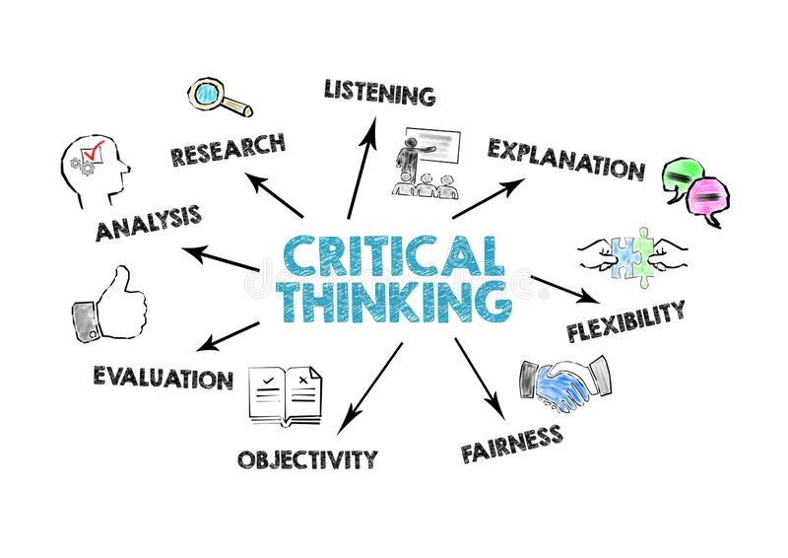

Module: Developing workplace critical thinking
Module code: BMSW5101
Student Name: Vasilica-Madalin Iliuta
Student ID: 2007277
Lecturer’s name: Zahra Mohammadnazari
Assessment title: Analysis of Lidl company.

Table of Contents

Introduction 3
1. Management theories. 4
1.1. Frederick W. Taylor's scientific management theory. 4
1.2. Theory of management implemented by Lidl. 5
1.3. Advantages and disadvantages of Frederick W. Taylor's theory of management. 6
2. Conflict resolution within the company. 7
Recommendation. 9
Conclusion. 9
References. 10

Introduction
The purpose of this report is to analyze different types of management theories, developing Taylor's scientific management theory. A detailed analysis of the theory, as well as its advantages and disadvantages, are presented. There is as well a description of how the chosen company implements its theory of management, which I considered being Taylor’s scientific management.
Frederick Taylor's scientific management theory, called the classical management theory, influences all organizations, as all of them are concerned with productivity and profitability, though organizational priorities and strategies differ (Cole and Kelly, 2020).
And as conflict exists in any type of organization, in the report, there is a part describing conflict resolution within the organization.

Management theories.
Management theories are a group of rules designed to manage an organization or business. These theories can set up the strategies used to accomplish organizational goals and techniques of motivating employees applied by managers (Cole and Kelly, 2020). In the workplace, managers are applying individual theory, or usually different theories at the same time, which make the workplace to be more innovative.
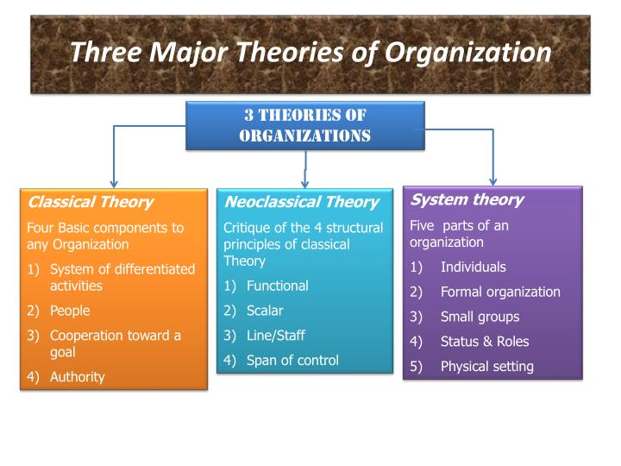
There are three most important theories of management:
Classical theory was initially concerned with organizational structure and activities (Cole and Kelly, 2020). Now is extremely focused on the mechanical and physiological components of management (Kitana, 2016; Nhema, 2015). The two greatest practicing managers of the classical theory are without any doubt Fayol and Taylor. Source: three-major-theories-of-organization-n.jpg (720×540) (slideserve.com)
Unlike the classical approach to management, Neoclassical theory is more people-oriented and highlights viewpoints, behavior, and employee needs (Kwok, 2014). It involves motivation as well.
System theory which is an approach to modern management theory views the organization as a structure of complementing sets of activities that allow inputs to be transformed into outputs (Cole and Kelly, 2020). It allows theorists to study the leading elements of an organization regarding their mutual interaction and external environment (Johnson et al., 1964).

Frederick W. Taylor's scientific management theory.
Frederick W. Taylor's scientific management theory is a technique that was developed to improve the efficiency and productivity of the method of work within an organization (Bahnisch, 2000). Frederick Winslow Taylor, known as the "father of scientific management" emphasized the need for empirical observation (examination of real phenomena), investigation, and experimentation, suggesting that the manager has the role of coming upon the best way to carry out the work under his guidance (Taksa, 2017).
Kulesza et al., (2011) observed that Taylor aimed to analyze each step because of the different components or movements that make up the physical work. Further to see if those components could be modified to achieve the best and fastest way to work, the emphasis being on efficiency. Taylor proposed that the work should be done simply as possible (Olum, 2004; Nhema, 2015).
Taylor lays out a series of principles of work as directing traditional experience, organizing in groups, and transforming into rules, and laws, to help employees in their daily activities; selecting and training the employee on scientific bases; collaborating with employees for the job to be performed according to the developed scientific concepts; accomplishing a division of work and equal responsibility between employees and managers, for them to carry out the activities for which they are best trained (Schachter, 2020).
Major wastes of time occur due to employees and the way they perceive their time and that of others. On the one hand, they are not constantly reminded of the purpose they have, and on the other hand, they find it useless to finish their work in a faster way, thinking that they will receive extra tasks (Schachter, 2020).

Theory of management implemented by Lidl.
Lidl is a German international food retailer that opened its first store in Great Britain in 1994, having now over 920 stores across the country, with more than 22.000 employees. Being an international company, Lidl has its principles of respecting the diversity of cultures and
The company’s mission is to provide its customers with the best quality products at the lowest prices and work in close collaboration with suppliers to make this idea possible. Lidl also aims to have products from local providers, where it is possible, and more than half of our products are sourced from British suppliers (Lidl GB, 2022).
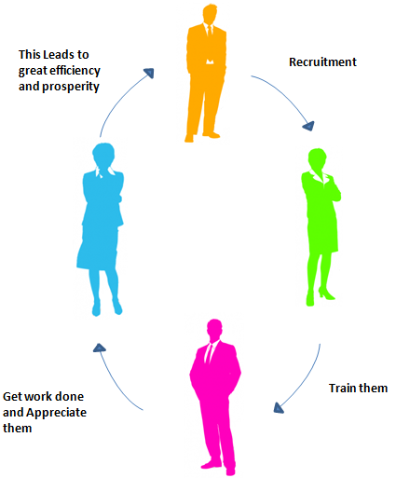
Taylor considered a similar hierarchy of three levels, with the most influential employees at the top. Each level is given exact responsibilities and detailed instructions particular to its role. They respect and bond with those above them and do only what is assigned to them (Olum, 2004). His philosophy of management is the best to suit Lidl. He described four basic norms:
- Developing a scientific management method to understand the best method for performing a task (Kitana, 2016).
Source: ting.png (425×513) (bp.blogspot.com)
2. Regular recruitment of employees for performing tasks who can be given responsibility for which they can best suit (Cole and Kelly, 2020).
3. Scientific education and growth of employees (Kitana, 2016).
4. A reciprocal cooperation between the manager and the employee to make these ideas a success (Cole and Kelly, 2020).
According to Taylor, rather than penalizing employees for every insignificant mistake, employers should reward workers for increasing productivity (Cole and Kelly, 2020).
Management theories have become a toolkit, used by talented managers who also have appropriate skills and abilities to help their organizations to implement and accomplish their goals (Kitana, 2016; Nhema, 2015). Hence, Lidl’s managers use Taylor's theory of management, which is mainly established on creating a structure through which both the employer and the employee have the opportunity to receive a significant number of benefits and profitability.
To realize this aspect, the management of Lidl should establish that the company’s employees have persistent and high-quality training to perform better at the workplace, leading to better results in overall performance.
In addition, Schachter (2020) stated that some of Taylor's disputes are mainly focused on the certitude that each employee’s skills should be adapted to the job for which he was recruited, and continuous training will allow them to become more skilled. Taylor’s most usual conception is that the employees' and employers' aims are often different. However, he states that this is not the case, since it is possible to control both groups to the same goal, which is high productivity and effectiveness (Taksa, 2017).

Advantages and disadvantages of Frederick W. Taylor's theory of management.
Though Frederick Taylor's theory of scientific management has its advantages and disadvantages, it cannot be disregarded by managers when implementing a management theory within an organization.
Advantages | Disadvantages
It is mainly focused on the human factor in the workplace, based on motivating employees, and their relationship with the leader (Taneja et al., 2011). | Taylor’s theory of management is not focused on the organization but only on the organizational functions (Schachter, 2020).
Managers measure the most effective way to do a certain task, then delegate partial tasks to employees with the appropriate skills and abilities (Schachter, 2020). | The basic tasks of the employees tend to be specific, fixed, and repetitive. Often, employees feel unimportant, performing the same tasks every day.
Taylor's theory of management states that each worker is important and  plays a crucial role in the success of the company (Kulesza et al., 2011). | Some employees dislike the idea of being watched and targeted and this led to strikes (Taneja et al., 2011).
By implementing this theory in the workplace, organizations became more successful and flexible, the productivity improves significantly (Ehiobuche and Tu, 2012). | A lot of times managers just apply the increased output part of the Taylor method and thus they don’t share the benefits of the increased output with the employees (Ehiobuche and Tu, 2012). Hence specialized jobs can be very boring, and employees begin to doubt Taylor’s management approach
Employees provide good work because they are financially motivated and according to their performance (Kulesza et al., 2011).

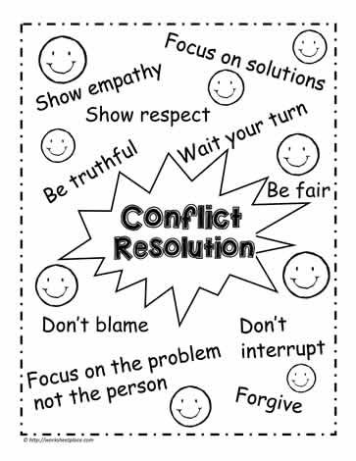
2. Conflict resolution within the company.
In any work environment, situations can be encountered when not everyone agrees on the way of carrying out the work or other aspects of a professional nature. In these cases, various organizational conflicts can arise, which each party involved should manage as well as possible.
The confrontation of ideas in organizations is a source of innovation and creativity, and even some leaders encourage these conflicts, to increase competitiveness and channel energy in a constructive direction (Wallensteen, 2018).
Source: 47dbd4435297bcecde5760bc99d4cd5c.jpg (363×470) (pinimg.com)
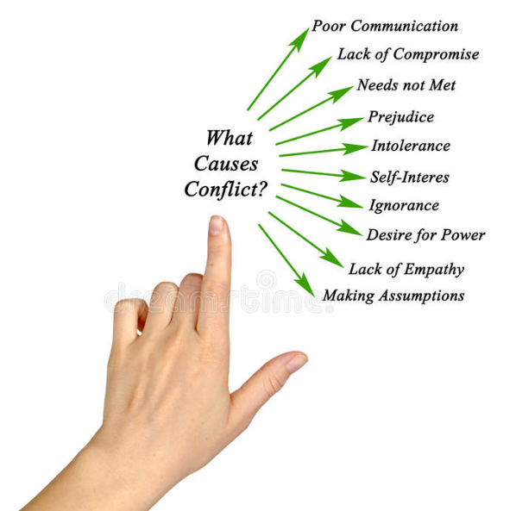
Conflicts in the workplace can have a negative influence not only on employees but also on the business itself. It can be caused by different factors. These factors can be without importance, such as an employee who has an always messy office desk, or majors, such as an employee who compromise the skills of colleagues.

Source: what-causes-conflict-diagram-85665903.jpg (800×809) (dreamstime.com)
According to studies, several factors lead to the onset of conflicts in the workplace: the vagueness of the tasks of each employee; favoritism; poor communication; unequal opportunities for professional affirmation; the salary system, or difficult personalities of the employees Humphreys, M. (2005).
Hence, good communication is a necessary factor that every employee should be aware of when there is a conflict to be solved in the workplace. Though it is easier to disregard the conflict and imagine that nothing is going on, we must be conscious that an unresolved conflict does not pass away but escalate (Burton, 1990).
Unfortunately, a lot of people are scared of conflict resolution, as they feel intimidated by the possibility of not getting what they want if the other side wins. How can a conflict be resolved so that no one feels like they have lost?
- Evaluate the importance and the seriousness of the conflict, and how urgent it is to be solved. Analyze if it requires a confrontation.
- Always consider the second part of a conflict. It is important to take into consideration his position in the organization as well as the relationship between the two of you.
- Stick to the ongoing conflict, without considering the problems from the past. It is counterproductive behavior, to behave like that.

Recommendation.
- Lidl organization managers that are implementing management theory properly, by taking advantage of their employees, and motivating them have the best chance to increase productivity and improve performance.
- As there are conflicts in all organizations, is it vital for a leader to have good strategies about how to behave in difficult workplace situations. Leaders should know how to act quickly to solve the problem effectively as possible.
- By choosing to implement the right management theory, managers learn how to power team leaders to work successfully together.
- Seek creativity while resolving a conflict, as it does not mean that one side of it should give up and the other side should win. Probably the best way to solve a conflict is to join forces creatively. Someone can generate a brilliant idea that would be a real gain for both you and the organization.

Conclusion.
Overall, effective management is essential in any modern organization. It is important to have an organized management structure easy to understand by everyone inside the organization. As Taylor’s management theory is the main one reviewed in the report, it is considered to be the most efficient in the Lidl and suggests that managers should reward financially those employees that benefit the most for increasing productivity. Implementing appropriate management theory is a benefit for both management and the employees as all the steps are followed in accomplishing a common goal.
After researching Taylor’s management theory, the advantages and disadvantages were depicted. In conclusion is more advantageous to implement, as it leads to customer satisfaction, higher productivity, and reduce costs, which is a very important factor for a business. Quick decision-making when a conflict appears, is as well significant.

References.
- Bahnisch, M. (2000) ‘Embodied work, divided labour: subjectivity and the scientific management of the body in Frederick W. Taylor’s 1907 ‘Lecture on Management’, Body and Society, 6(1), pp. 51–68.
- Burton, J.W. (1990) ‘Conflict Resolution’, Prevention. New York: St. Martin’s Press.
- Cole G.A. and Kelly P. (2020) Management theory and practice. Andover: Centage Learning.
- Ehiobuche, C. and Tu, H.W. (2012) ‘Towards the relevance of classical management theories and organizational behavior’, ASBBS Proceedings, 19(1), p.310.
- Humphreys, M. (2005) ‘Natural resources, conflict, and conflict resolution: Uncovering the mechanisms’, Journal of conflict resolution, 49(4), pp.508-537.
- Johnson, R.A., Kast, F.E. and Rosenzweig, J.E. (1964) ‘Systems theory and management’, Management Science, 10(2), pp.367-384.
- Kitana, A. (2016) ‘Overview of the managerial thoughts and theories from the history: Classical management theory to modern management theory’, Indian Journal of Management Science, 6(1), pp.16.
- Kulesza, G., Weaver, P.Q. and Friedman, S. (2011) ‘Frederick W. Taylor's presence in 21st Century management accounting systems and work process theories’, Journal of Business and Management, 17(1), pp. 105-119.
- Kwok, A.C. (2014) ‘The evolution of management theories: A literature review’, Nang Yan Business Journal, 3(1), pp.28-40.
- Lidl GB (2022) About Lidl GB. Available at: About Lidl GB - Lidl Great Britain (Accessed: 3rd October 2022).
- Lidl GB (2022) Vision and mission statement. Available at: Vision and Mission Statement - www.lidl.co.uk (Accessed: 3rd October 2022).
- Nhema, A.G. (2015) ‘Relevance of classical management theories to modern public administration: A review’, Journal of Public Administration and Governance, 5(3), pp.165-179.
- Olum, Y. (2004) ‘Modern management theories and practices’, Uganda: Makerere University, pp.1-24.
- Schachter, H.L. (2020) ‘The uses of Frederick Winslow Taylor: how management theorists have interpreted scientific management over the years and why’, Handbook of Research on Management and Organizational History. pp. 39-55.
- Taksa, L. (2017) 'Scientific Management', The Oxford Handbook of Management. Oxford Handbooks.
- Taneja, S., Pryor, M.G. and Toombs, L.A. (2011) ‘Frederick W. Taylor's Scientific Management Principles: Relevance and Validity’, Journal of Applied Management and Entrepreneurship, 16(3), pp. 60-78
- Three major theories of management [illus.] (ND) Available at: three-major-theories-of-organization-n.jpg (720×540) (slideserve.com) (Accessed: 22 October 2022).
- Wallensteen, P. (2018) Understanding conflict resolution. Sage.

