Anna Curtis – 2311852 (Cohort 8)
CIPD membership number: 88280658

Task 1
AC 1.1
Briner states evidence-based practice (EBP) is “getting the best available evidence from multiple based sources”. The concept of using EBP is to use multiple trustworthy and relevant sources of evidence, rather than relying on opinion or judgement, to make a less informed decision. The importance would demonstrate a much better understanding and knowledge of the subject matter to share with stakeholders. Waite et al (2021, P.47) states, “EBP promotes critical thinking, where the reader judges and appraises sources of evidence to determine their relevance to the matter in hand.” This helps eliminate bias and group think, which can result in poor quality decision-making. It is important to ask focused questions and challenge our own biases. EBP encourages effective communication and collaboration between HR professionals and stakeholders inside and outside of the organisation. As Waite et al state (2021, P.60), “consciously challenge stereotypical views that you may have”.
Its limitations include a time-consuming process and the wider the pool of evidence, the more diluted it could become. I.e. 100 people could be interviewed, however if these 100 people all work for the same department or are all of the same age bracket or ethnic origin, the data could be skewed a certain way. Therefore, it is highly important organisations apply critical thinking when gathering evidence.
One key element of EBP is collating evidence from different sources. The 6 steps to acquiring solid evidence:
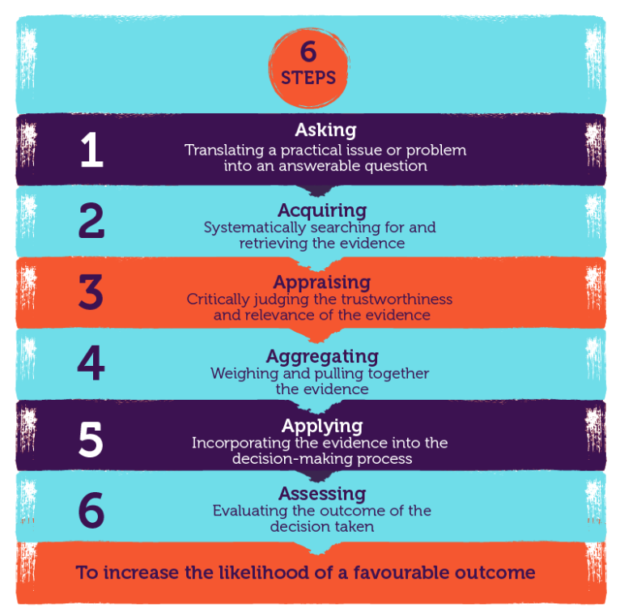
Figure 1. CIPD (2023a)
These 6 steps allow the organisation to make an informed judgement and increase the likelihood of a favourable outcome, CIPD (2023a). Practitioners should also question where the sources of evidence have come from, how trustworthy and reliable are they? Is it the best sufficient evidence? If yes, then organisations can optimise decisions. By taking a stepped and structured approach, this gives most trustworthy and substantial data. Briner states, ‘we’re not looking for quick wins here’. By critically appraising the evidence, the best possible decision can be made and the more buy in they will get from stakeholders. Ultimately being able to understand the organisation better and what makes it successful.
The 4 sources of evidence are: practitioner expertise, organisational data, scientific evidence and stakeholder perspectives. ‘EBP helps them make better, more effective decisions by choosing reliable, trustworthy solutions and being less reliant on outdated received wisdom, fads or superficial quick fixes’ CIPD (2023a). By following these approaches, it can help eradicate group bias and group polarisation. ‘We’re guided by what’s popular, instead of what’s best’ Gifford (2017). This is what practitioners need to move away from.
Organisations can be subject to authority bias, conformity bias and confirmation bias. ‘We have a tendency to cherry pick evidence that best suits our opinion’ CIPD (2023a). Daniel Levitin has said, ‘we’re assaulted with facts, pseudo facts, jibber-jabber, and rumour all posing as information’ CIPD (2023a). By adopting the 6 steps and 4 sources of EBP, an organisation can demonstrate sound decision-making, with evidence that is factual, trustworthy and has been critically evaluated and does not conform to biases.

AC 1.2
There are several analysis tools available to diagnose organisational issues, challenges and opportunities. The Pestle tool is an appropriate management framework analysis tool. When recognising strengths, it can be argued using this tool can give organisations a well-rounded view of their external environment, as it covers a comprehensive scope of factors including political, economic, sociological, technological, legal and environmental CIPD (2023b). By demonstrating a thorough understanding of these external factors, it creates valuable and informed decision-making.
Organisations that follow transformational HR will appreciate the strategic planning and decision-making this type of analysis allows. This pro-active approach is integral for long-term success. These strategies will help eliminate risk, supporting effective risk management.
Its limitations include the complexity and time-consuming task of analysing all 6 factors. ‘Some Pestle analysis users oversimplify the amount of data used for decisions, making it easy to use insufficient data’ CIPD (2023b). It can be argued Pestle analysis could become quickly outdated, due to the external environment changing rapidly. Therefore, this is more effective, when used in conjunction with other analysis tools. Pestle would not be key for horizon scanning and future forecasting, as it provides a snapshot of the current timeline.
There are several analysis methods to consider when gaining the best data, including people analytics and interviews. Qualitative data such as interviews allow for the collection of rich data. Interviewees can take dedicated time to seek out information they are looking for. The depth of this information can out-weigh what could be collected in survey. Waite et al (2021) argue ‘this approach is useful when you need to capture understanding of the views and perceptions of how people feel’. Interviewees can drill down into certain areas to get a deeper understanding of a threat or issue. Social cues and body language can often tell you more than a written account. The interviewee is able to offer a personal touch and this may be considered useful in exit interviews. The employee, when made to feel comfortable, may be open to letting their guard down to divulge certain issues. By seeking clarification, they can gain a contextual understanding. There are many diverse viewpoints within a workforce, interviews can help capture these.
Its limitations include how someone interprets the responses can be subjective and open still to opinion/bias. Both the interviewer and interviewee could lead questioning one way for their gain. Interviews can be time-consuming, and interviewees may become fatigued and not invest the same effort at each stage. Output can become distorted if the interviewee does not feel comfortable to disclose the constructive feedback. The findings may represent a small part of an organisation and should not be generalised to represent the masses. Interviews can be a powerful analysis method, as long as organisations are mindful this data can be subjective.

AC 1.3
The main principles of critical thinking encompass critiquing the ideas of others and how they construct those themselves, it’s about asking good questions, the ability to think well, think clearly and reach conclusions CIPD (2019). Being able to identify common errors, being persuasive, confident and competent, enables for objectively evaluating information. Collaborative decision-making allows for well-informed and reasoned decisions and can expose potential bias and weaknesses in arguments. By using EBP in an approach to critical thinking, it relies on evidence and logic. When reviewing ideas, seek supporting evidence and evaluate the quality of that. To assist objective and rationale debate, apply this approach to your own ideas by ensuring you have a solid foundation of evidence and encourage others to provide evidence for their views.
Thinking critically means, ‘analysing and assessing the work, in terms of what the author is trying to achieve, the approach they took, how they conducted the research and whether the outcomes were valid and acceptable’ CIPD (2016). There is so much fake news out there, it is important practitioners don’t fall foul of that and are able to recognise what they read is valid and unbiased. ‘If you’re going to base corporate change and your proposals to management on information from published sources, you can’t take everything you read at face value’ CIPD (2016). Whilst being critical, do not dismiss ideas altogether, but approach them with scepticism until efficient evidence is presented. Clearly articulating ideas and arguments from an open-minded perspective is crucial. Ambiguity can lead to misunderstandings and hinder objective debate.
Cambridge university delve into how biases are missed, overcoming bias and being aware of our own biases. By having certain biases based on stereotypes, we tend to dismiss information and ideas altogether, without giving it a second thought. ‘Note that having biases does not necessarily imply that we’re bad people. We all have biases. They come from our upbringing, from our culture and society, from our education and life experiences’ Shiroma (2022a). This hinders our ability to think critically. Confirmation bias is key and arguably the most famous. ‘This is the tendency to only look for or believe in information that supports our opinion or affirmation’ Shiroma, (2022b). The drawbacks of having biases, prejudice and even ignorance, can make you vulnerable to certain situations. You can become isolated in your opinions and disadvantaged. You can only fully troubleshoot solutions effectively, when you have considered removing biases. Use a test and learn approach. This allows a business to test with real customers and products, to recognise the impacts on personal experience.

AC 1.4
De Bono’s 6 thinking hats is one of the most effective, ethical decision-making models.
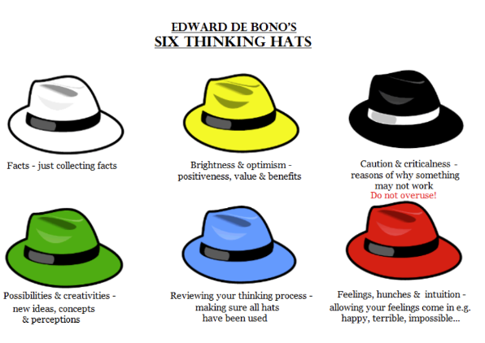
Figure 2. CMI (2022a)
It encourages parallel thinking, where individuals approach a problem from different perspectives at the same time. Each hat represents a different style of thinking, and participants are encouraged to put on and take off these metaphorical hats to explore various mindsets of a decision or issue, CMI (2022a).
The green hat focuses on creativity and innovative thinking. The theory behind wearing this hat is to generate new ideas, alternatives and positives, to find the good in something. It encourages outside of the box thinking and fosters creative solutions to problems. It is a valuable tool to use for decision-making in group settings. It encourages a balanced viewpoint. It promotes both critical and creative thinking, by considering various factors. However, its effectiveness does depend on how well it is implemented.
Another decision-making model is SWOT analysis. This strategic planning tool can be used to identify and evaluate organisations internal strengths and weaknesses, as well as identifying external opportunities and threats. To evaluate strengths, internal factors that give an advantage over others can be considered. Examples may include, a great culture and identity, an inclusive workforce, advanced technology, and efficient processes. Reviewing weaknesses would highlight the opposite including outdated technology, a weak identity, and no equality within the workforce. Opportunities review external factors that an organisation can capitalise on to achieve its objectives. Threats can identify competition and external factors that could harm performance. Using a SWOT analysis at the very start of a project provides organisations with a complete overview of the threats they face throughout their work, Indeed (2023). Ultimately, being aware of all the risks instantly, allows for dedicated time to resolve these issues and mitigate any potential threats.
It’s simplicity and versatility makes it a widely adopted tool for organisations. However, for best results, it’ll work better alongside other strategic planning approaches, for a more comprehensive understanding of the business.
A third model to consider is future-pacing. ‘The process of future-pacing decision-making entails thinking about the future effects of a choice before making it’ CIPD (2023c). Technology and AI is currently dominating the workplace, making this model crucial as we approach 2024. By taking time to use data and analytics to forecast future outcomes, organisations can make better informed decisions to help the business. For example, a business could be thinking of introducing a new product. This product is likely to affect its reputation and financial gains. By applying the future-pacing model, this strategy aids in ensuring that the choice is right, during the long term and short-term. ‘It takes into account the decision’s potential future impact, rather than just the decisions immediate ramifications’ Klein (2018) Massaad, (2019).
Its limitations include the future’s lack of certainty. ‘It’s difficult to forecast the future with absolute confidence, and there is always a chance that something unexpected will happen’ Groves (2019). Practitioners must consider accuracy in reporting. The quality and integrity of the data is key. ‘Understanding implications of your decision, including the impact on organisation objectives, will help you avoid costly mistakes and make decisions that add value to your business’ CMI (2022b). By considering the decision-making checklist below as outlined by CMI, organisations can ensure they plan to make the best suited decisions for their business:
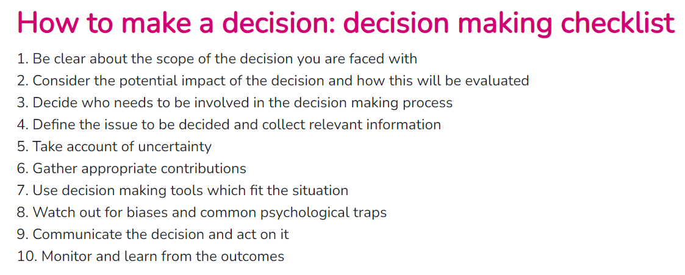
Figure 3. CMI (2022b)

AC 1.5
There are 8 ethical lenses:
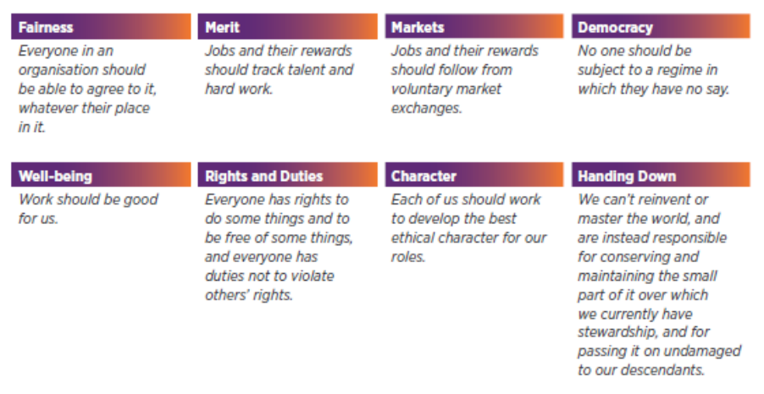
Figure 4. Core (2017)
‘Ethical practice is the application of ethical values in organisational behaviour’ CIPD (2022a). Using ethics is to be seen to do the right thing, when forming decisions. For example, ‘the ‘fairness’ lens considers that everyone should be able to agree to a decision regardless of their place in an organisation’ CIPD (2022a). This promotes good morale and inclusivity and better culture within an organisation.
Utilitarianism is one ethical perspective where its core idea is to maximise overall happiness and minimise suffering, Britannica (2023). It emphasises the consequences of actions, as the primary factor in determining their morality. Understanding utilitarianism can guide individuals to assess the potential outcomes of their actions. When faced with a decision, practitioners would consider the overall happiness or well-being that different choices may bring and strive to choose the option that has the most positive effect or outcome.
Another ethical perspective is deontology. Deontology is based on the concept of duty and moral rules. ‘Deontological ethics holds that at least some acts are morally obligatory regardless of their consequences for human welfare’ Britannica (2023). It informs decision-making by focusing on the moral quality of an action. Individuals guided by deontology consider whether an action aligns with universal morale principles and duties. This perspective helps in making decisions that are consistent with a sense of moral duty and integrity.
A third is altruism. ‘A theory of conduct that regards the good of others as the end of moral action’ Britannica (2023). Those who adhere to an altruistic ethical perspective believe in acting in ways that contribute positively to the welfare of others, promoting kindness, compassion, and empathy. A strength of this behaviour fosters positive social relationships and encourages individuals to support each other. However, critics may argue that all human actions are ultimately motivated by self-interest.
By considering these ethical perspectives, individuals can incorporate a more thoughtful approach to moral decision-making. To make well-informed and ethically sound decisions, integrate aspects of each ethical perspective. ‘Practitioners’ ability to recognise and resolve ethical dilemmas is fundamental to remaining effective when exercising professional judgement’ CIPD (2015).

AC 3.1
Organisations measure financial and non-financial performance. Financial measures focus on indicators that look into past performance, making them easier to analyse. Non-financial performance measures help add context.
Common examples of financial performance measurement are key performance indicators (KPIs) and return on investment (ROI). ‘Financial KPIs are metrics organisations use to track, measure, and analyse the financial health of the company’ Stobierski (2020). Organisations can use these goals and objectives to benchmark departments and tweak where necessary to continue to improve monthly results. ‘By having a deep understanding of these metrics, you can be better positioned to know how the business is performing from a financial perspective’ Stobierski (2020). Drilling down into the accuracy of department KPIs takes time, meaning KPIs don’t always give you actionable information in the short-term. Time is key to determine whether certain measures are effective and organisations in the public sector may need 6 months of data to assess a certain metric. Therefore, it’s important not to take action on results straight away.
Common examples of non-financial performance measurement are customer retention and a balanced scorecard (BSC). The scorecard can give a holistic approach to evaluate overall performance. One metric would be customer satisfaction score (CSS), which measures how satisfied customers are with a product or service. A high CSS indicates that an organisation is meeting customer expectations, which in turn would boost customer loyalty and renewal. The BSC allows organisations to consider various aspects of performance, beyond financial indicators, to ensure a comprehensive evaluation. A BSC can sometimes be seen as a quick fix rather than have longevity. ‘It requires strong leadership support to be successful. It’s important to remember that the BSC requires a total overhaul to the way you manage; it is not a project with a defined end date’ Jackson (2023).
Admiral insurance as part of the financial sector, focus heavily on their claims loss ratio as a key metric; a primary feature of their company performance. Over the last 12 months the loss ratio has increased by 19%, which is as a result of higher than usual levels of claims inflation. Road usage continues towards pre-pandemic levels, therefore an increase in claims frequency compared to the year before. To counteract the loss ratio, it's imperative the claims are reserved correctly, Admiral (2023).

AC 3.2
“The final step in making good evidence-based decisions is to be able to evaluate the extent to which people management issues add value to an organisation using business indicators” Taylor and Woodhams (2012, P.135). There are several areas where HR practices can add value in the form of talent acquisition, retention or employee engagement. With regards to employee engagement, investing the time and commitment into developing the employees, leads to increased skills, increased job satisfaction and engaged staff. ‘By taking a systematic critical approach to examining people data, practitioners can contribute to an organisation’s success by creating insights on what can and should be done to drive strategic change’ CIPD (2022b). When an organisation drill down into the data correctly, they can add significant value to their decision-making processes, staff retention and people initiatives.
Admiral is renowned for looking after the well-being and mental health of their staff, with a company mission statement of, ‘those who enjoy what they do, do it better’. Looked after staff can lead to improved overall productivity and innovation. This can boost an organisation’s reputation and make them more favourable to potential new employees, Admiral (2023).
Taylor and Woodhams (2012, P.7) argue that “HR management signified a new way of managing people that was clearly distinct from traditional personnel management: more strategic, less reactive and more firmly focused on achieving organisational objectives”. Being pro-active over re-active allows HR practices to really add value. For example, within learning and development, by prioritising training and development for the staff, this contributes to clear progression paths, enhances skills, increases confidence and allows for succession planning from within. A clever way of aligning individual development with organisational goals.
Employee satisfaction surveys can be used to measure the impact of people practices. Regularly conducting surveys can help gather feedback, implement change and boost morale, with consideration to survey fatigue. Survey results when used correctly, can provide great insight into the effectiveness of people practices. These surveys help organisations understand how well their practices align with employees’ needs and expectations.
Return on investment (ROI) is another key metric used to measure the impact of people practices. ‘ROI is a calculation of the benefits realised as a result of investing in an HR programme’ CIPD (2021a).
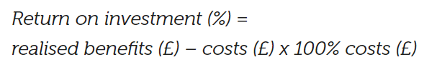
When it comes to measuring the impact of people practices, such as HR initiatives or talent management strategies, ROI can be applied to assess the value generated in relation to the resources invested. The insights gained from the ROI analysis can be used to inform future decision-making. If the ROI is negative, this allows stakeholders to assess what went wrong and make adjustments for improvement. It is important to note quantitative and qualitative measures are often used for a more thorough analysis. It’s not easy to measure the impact of people practices, especially when assessing a metric like culture or morale.

Task 2
AC 2.1 – 2.3
Qualitative and quantitative data are two types used in research and analysis. ‘A key point is that qualitative data is based around words and meanings, while quantitative data is based around numbers and statistics’ Taylor and Woodhams (2012, P.122). To be able to fully understand and interpret data, a combination of both approaches would give the better outcome, whilst remembering qualitative data alone can be subjective.
a)

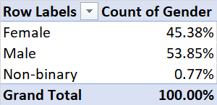

b)
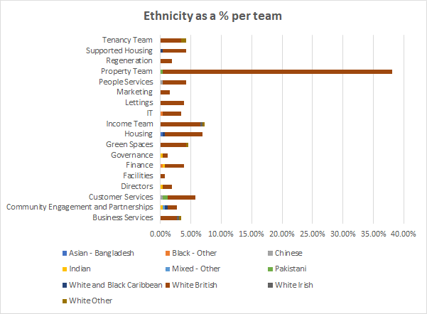
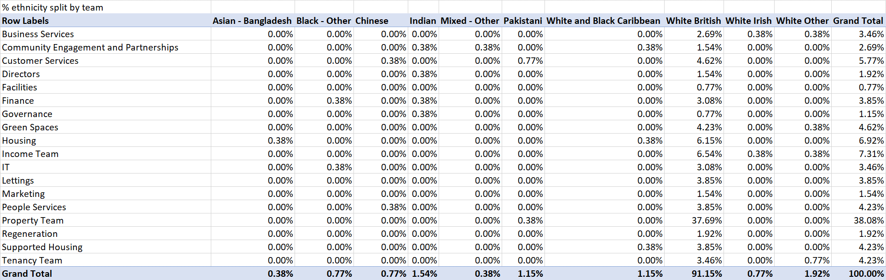

c)

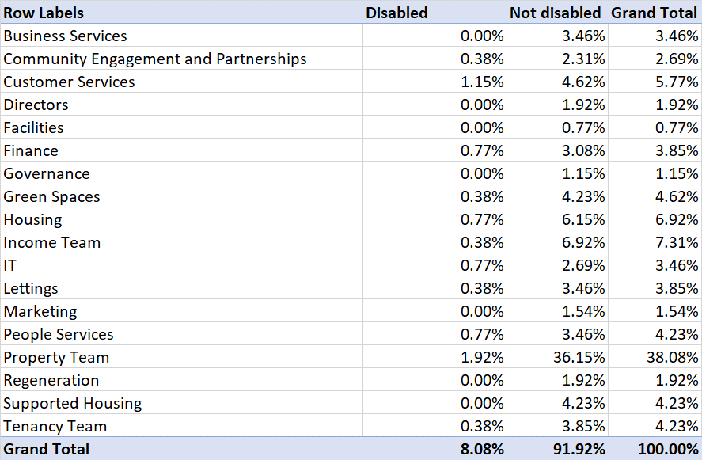

d)
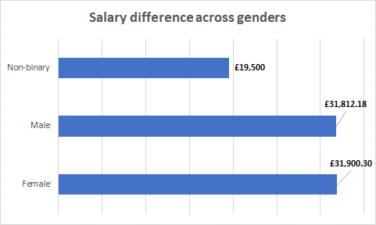
e)
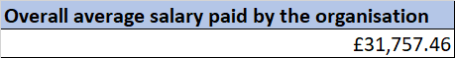
There is a slight difference between the total male and female staff members at 8.47% more males, and non-binary employees make up just 0.77%. White British ethnicity dominates the workforce at 91.15%, whilst the next two highest are white other at 1.92% and Indian at 1.54%. The team with most ethnic diversity is Community Engagement and Partnerships. Regeneration and Lettings teams only have white British employees.
The property team has the highest percentage of disabled staff. However, still low at 1.92% and they have the biggest team. A concern that the demographic isn’t showing inclusivity and diversity. Only 8.1% of staff have a disability.
Females get paid on average £88.12 more a year than males. The total average across all employees is £31,757.46, £31,812.18 for males and £31,900.30 for females. The average salary for non-binary employees is considerably lower by approximately £12,350. However, non-binary percentage of staff is much lower, not giving an accurate representation. They have two staff as Administrator and Trade Apprentice, roles associated with lower salaries. When reviewing the highest paid salary roles, male director of customer service and female director of finance, both have a salary of £98,500. Similarly, male and female cleaning staff are paid the same.
Interestingly, 85.7% of the IT roles are occupied by white British males. 93.4% of the trade operative staff are male. This is known as occupational segregation, where the distribution of staff is based upon certain characteristics, mainly gender. ‘Woman are more likely to be care workers, administrators and HR practitioners’, Close your pay gap (2022). Similarly in the above data, the director of People Services is female and on the second highest salary of £102,500. There is a prominent higher split of males in IT roles across organisations. Hence the Woman in Tech Excellence Awards championing woman within this field, promoting a diverse workplace.
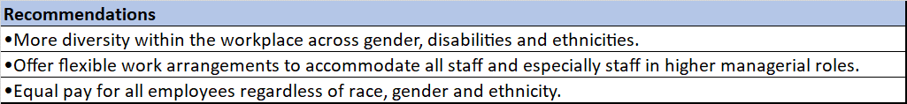
‘It’s no secret that diverse teams work better’ HR Metrics (2023). Creating a diverse workforce is a goal many organisations strive for. Leaders are there to influence staff to advocate for an inclusive culture, by providing an open and supportive environment where everyone feels valued. The workplace needs to be accessible to staff with disabilities and implement reasonable adjustments. This includes looking at roles to see if they can be done in different ways in terms of best practice, to ensure your organisation is as inclusive as possible. Occupational segregation also extends to race and ethnicity, as well as sexual orientation. Benefits include, to prevent any discrimination under the equality act 2010, to improve staff retention rates and to keep staff engaged and motivated. Some risks associated can be gender stereotypes, cultural misunderstandings and occupational segregation. Financial implications could include costs for reasonable adjustments, software packages to support additional learning needs and training to recognise inclusivity.
Offer flexible work arrangements to accommodate all staff and especially staff in higher managerial roles. This can include flexible hours, hybrid and remote working. ‘A lack of flexible working arrangements at senior levels is a factor affecting women’s progression opportunities’ CIPD (2023d). Benefits include, higher productivity, retention rate and offers more flexibility for parents. Risks include poor mental health from working in silo, lack of development from deskside learning and communication can be misconstrued if not face-to-face.
Equal pay regardless of race, gender and ethnicity is crucial to demonstrate fairness and inclusivity. ‘The gender pay gap is a measure of labour market or workplace disadvantage, expressed in terms of a comparison between men’s and women’s average hourly rates’ CIPD (2023d). Ways to demonstrate this can be through salary banding, ensuring all salaries are transparent and documented and having equal pay policies. Whilst the gender pay gap has been declining slowly over time, ‘In 2022 the gap among full time employees was 8.3%’ ONS (2022). The benefits include, all staff feeling more valued, in turn become more loyal and want to stay within the organisation.

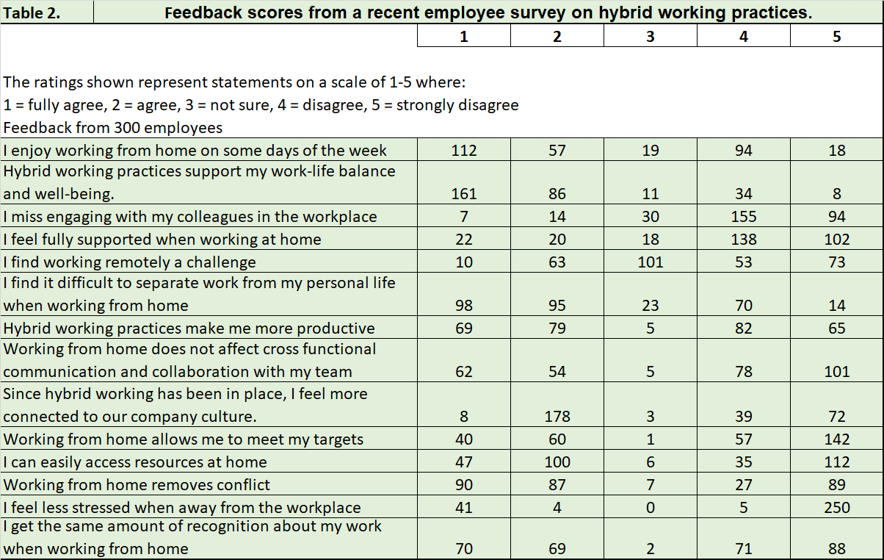

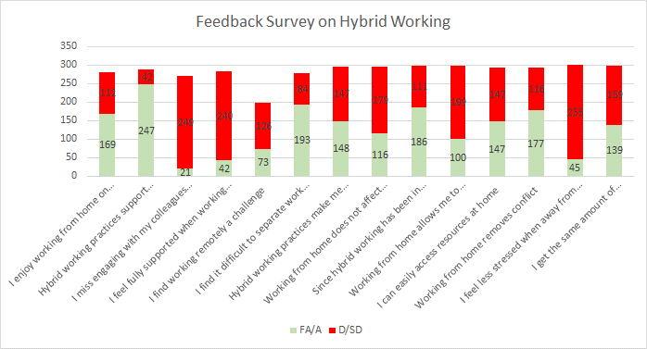
The above graph shows a breakdown of fully agree and agree answers combined Vs the strongly disagree and disagree answers. The combined scores are reflected below.
82.3% of staff members agree hybrid working supports work-life balance and well-being. This is great for mental health, morale, and balancing work-life. 83% of staff do not miss engaging with their colleagues in the workplace, it could be argued they experience the same level of camaraderie by hybrid working. However, when asked if they feel fully supported working from home (WFH), 80% disagree. 64% of staff find it difficult to separate work from personal life, which contradicts the earlier answer of most staff agreeing hybrid working supports their work-life balance. 66.3% of staff disagree WFH allows them to meet targets. Interestingly, 85% have said they disagree they feel less stressed when away from the workplace.
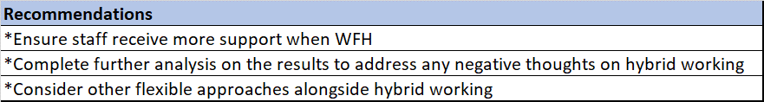

By staff receiving more support when WFH, they feel heard and are able to reach out for colleague/managerial support regardless of where they work. CIPD (2021b) suggest, ‘providing training to managers on how to manage hybrid teams effectively and support hybrid workers, including remote communication, collaboration and relationship building’.
Some of the survey needs further discussion or analysis with the employees, why are 64% finding it difficult to separate work from personal life? It can be argued there is difficulty to switch off from work when WFH. Start and finish times can blur when the laptop is within easy reach. If this is a concern for some employees, a recommendation would be to increase the days working in the office a week or to work more days on when needed. CIPD (2021b) suggest, ‘ensuring action is taken to address any negative or unintended outcomes of hybrid work’.
As 85% of staff disagree they feel less stressed when away from the workplace, I would suggest delving further into this. Are they stating they feel more stressed by WFH or are they stating they feel they can’t switch off from work regardless of where they are working? CIPD (2021b) suggest, ‘being mindful that hybrid working is just one form of flexible working: employees also desire time flexibility, and benefits can also be realised by providing this, for employees and the organisation itself’.

References
Briner, R. (2014) Rob Briner, professor of organisational psychology, Bath University, on evidence based HR practice, YouTube. Available at: https://www.youtube.com/watch?v=-cpvi8glLog (Accessed: 23 October 2023).
(2020) Close your pay gap briefing five women’s jobs, men’s jobs? job ... Available at: https://clicktime.symantec.com/15sMAxFhkRkpFLigdHPGh?h=fu4KcDM5NAQBuVSBMvRwrxHs5NkMylIchNmt8eAthDY=&u=https://www.closeyourpaygap.org.uk/files/briefing-5-segregation-what-means-2020.pdf (Accessed: 28 November 2023).
Critical thinking: Podcast (2019) CIPD. Available at: https://www.cipd.org/en/knowledge/podcasts/critical-thinking/ (Accessed: 02 November 2023).
Davies, J. (2017) Core – aggregating the world’s Open Access Research Papers. Available at: https://core.ac.uk/download/pdf/78074353.pdf (Accessed: 02 November 2023).
Decision making (2020b) CMI. Available at: https://www.managers.org.uk/knowledge-and-insights/resource/decision-making/ (Accessed: 04 November 2023).
Deontological ethics (2023) Encyclopaedia Britannica. Available at: https://www.britannica.com/topic/deontological-ethics (Accessed: 02 November 2023)
Effective hybrid working: Practical guidance (2021b) CIPD. Available at: https://clicktime.symantec.com/15sM1Hs8qCPdRT4qYAayT?h=xHAtn9SwXI6Cgg7VEUVnqHqRbQsvsQCQE0O7aImDxbo=&u=https://www.cipd.org/uk/knowledge/guides/effective-hybrid-working/ (Accessed: 29 November 2023).
Ethical decision making in the workplace: Reports (2015) CIPD. Available at: https://www.cipd.org/uk/knowledge/reports/workplace-decisions-report/ (Accessed: 02 November 2023).
Ethical Practice and the role of people professionals (2022a) CIPD. Available at: https://www.cipd.org/uk/knowledge/factsheets/ethics-role-hr-factsheet/ (Accessed: 16 November 2023).
Evidence-based practice for effective decision-making: Factsheets (2023a) CIPD. Available at: https://www.cipd.org/en/knowledge/factsheets/evidence-based-practice-factsheet/ (Accessed: 21 October 2023).
Future pacing decision-making CIPD: Future pacing NLP (2023c) CIPD Assignment Help. Available at: https://cipdassignmenthelp.co.uk/future-pacing-decision-making-cipd/ (Accessed: 15 November 2023).
Gender pay gap reporting guide (2023d) CIPD. Available at: https://clicktime.symantec.com/15sM684RHp5DqPtm5iz85?h=0Qbi0GtmHKbCOTOrGA6ICAFSI6TddSMWJacaVkTGzX8=&u=https://www.cipd.org/uk/knowledge/guides/gender-pay-gap-reporting-guide (Accessed: 29 November 2023).
Gifford, J. (2017) Evidence-based practice: An introduction, YouTube. Available at: https://www.youtube.com/watch?v=ikJ687g2tPo (Accessed: 29 October 2023).
Groves, D. G. et al. (2019). Robust decision making (RDM): application to water planning and climate policy. Decision making under deep uncertainty: From theory to practice, 135-163.
How to write A critical review (2016) CIPD. Available at: https://www.cipd.org/uk/learning/support-for-students/currently-studying/critical-review-writing/ (Accessed: 15 November 2023).
HR Metrics & Kpis that matter in 2023 (2023) HiBob. Available at: https://clicktime.symantec.com/15sMFnSzD3SQfHYcAqnRK?h=6y_FmsYSB12_a_GyV68ugwlTEARimiaEkZveT5HsHKo=&u=https://www.hibob.com/guides/metrics-that-matter/ (Accessed: 28 November 2023).
Jackson, T. (2023) A thorough list of balanced scorecard advantages & disadvantages: Clearpoint strategy, Brand. Available at: https://www.clearpointstrategy.com/blog/thorough-list-of-balanced-scorecard-advantages-disadvantages (Accessed: 16 November 2023).
Klein, G. (2018). “Future-Pacing Your Decision Making.” Harvard Business Review, vol. 96, no. 1, pp. 70-78.
ManagementDirect, W. by (2022a) Use these workflows for all of your decisions, CMI. Available at: https://www.managers.org.uk/knowledge-and-insights/article/use-these-workflows-for-all-of-your-decisions/ (Accessed: 20 October 2023).
Massaad, E. et al. (2019). Predictive analytics in spine oncology research: first steps, limitations, and future directions. Neurospine, 16(4), 669.
On this page (2022) CIPD. Available at: https://www.cipd.org/uk/knowledge/factsheets/ethics-role-hr-factsheet/ (Accessed: 14 November 2023).
People analytics: Factsheets (2022b) CIPD. Available at: https://cipd.org.uk/knowledge/factsheets/analytics-factsheet/ (Accessed: 29 October 2023)
People analytics: Guide for people professionals (2021a) CIPD. Available at https://www.cipd.org/uk/knowledge/guides/analytics-practitioner-guide/#how-is-hr-using-people-analytics (Accessed 21 November 2023)
Pestle analysis (2023b) CIPD. Available at: https://www.cipd.org/uk/knowledge/factsheets/pestle-analysis-factsheet/ (Accessed: 29 October 2023).
Shiroma, M. (2022) Critical thinking – the bias battle : Cambridge English, World of Better Learning | Cambridge University Press. Available at: https://www.cambridge.org/elt/blog/2022/09/07/deep-dive-into-critical-thinking-bias-battle/ (Accessed: 15 November 2023).
Stefan, Deborah and Mahjabeen (2023) Car, Multicar and multicover insurance quotes, Admiral. Available at: https://www.admiral.com/ (Accessed: 23 October 2023)
Stobierski, T. (2020) 13 financial performance measures managers should monitor: HBS Online, Business Insights Blog. Available at: https://online.hbs.edu/blog/post/financial-performance-measures (Accessed: 21 November 2023).
Taylor, S. and Woodhams, C. (2022) Studying human resource management: A guide to the study, context and practice of hr. London, United Kingdom: CIPD (P.7, P.122, P.135)
Tcc (2023) Women in tech excellence awards 2023 - home page, Women In Tech Excellence Awards 2023 - Home Page. Available at: https://clicktime.symantec.com/15sLvTfrNai31WEuzcBpq?h=INE8BKTa_2Ljo1I2P_jUvHBTCQyjpdN0R0ed_tUMD7s=&u=https://womenintechexcellence.co.uk/womenintechexcellenceawards2023/en/page/home (Accessed: 27 November 2023).
Waite, K. et al (2021) People practice: A complete guide. London, United Kingdom: Kogan Page. (P.47, P.60)
White, N.J. (2022) Gender pay gap in the UK: 2022, Gender pay gap in the UK - Office for National Statistics. Available at: https://clicktime.symantec.com/15sMLceGff815ENXiQBZw?h=6LDX0cJ9c--9vHyW10bPNVwr6-XpkHIqvF9X5rPaeu8=&u=https://www.ons.gov.uk/employmentandlabourmarket/peopleinwork/earningsandworkinghours/bulletins/genderpaygapintheuk/2022%23:~:text%3DImage%2520.csv%2520.xls-%2CThe%2520gender%2520pay%2520gap%2520has%2520been%2520declining%2520slowly%2520over%2520time%2Cup%2520from%25207.7%2525%2520in%25202021 (Accessed: 29 November 2023).
Why SWOT analysis is used by organisations (with definition). Available at: https://uk.indeed.com/career-advice/career-development/why-swot-analysis-is-used (Accessed: 16 November 2023).

Davies, J. (2017) Core – aggregating the world’s Open Access Research Papers. Available at: https://core.ac.uk/download/pdf/78074353.pdf (Accessed: 03 December 2023).

