DS 1 Template

My Screenshots/Photos
- Please add 4–6 screenshots or photos of your digital life.
- You can use your phone or laptop.
- For each screenshot, write one or two sentences explaining what it shows.

Screenshot/Photo 1
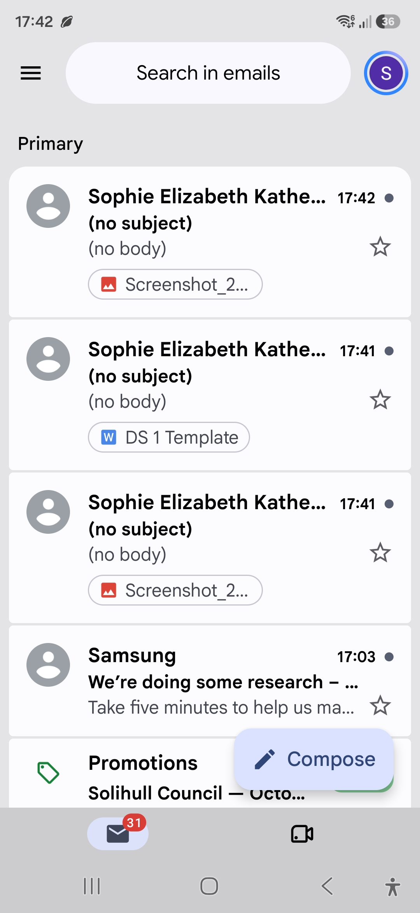
Emails – Here this shows that I can accurately use modern apps such as my emails to respond, manage and go about my day-to-day life.

Screenshot/Photo 2
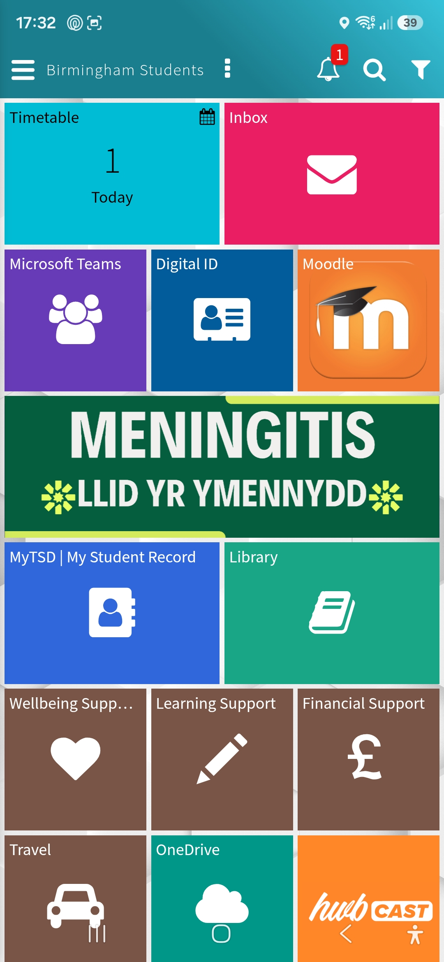
Moodle – Here this shows that I can manage all my university needs from one hub confidently no matter where I am.

Screenshot/Photo 3
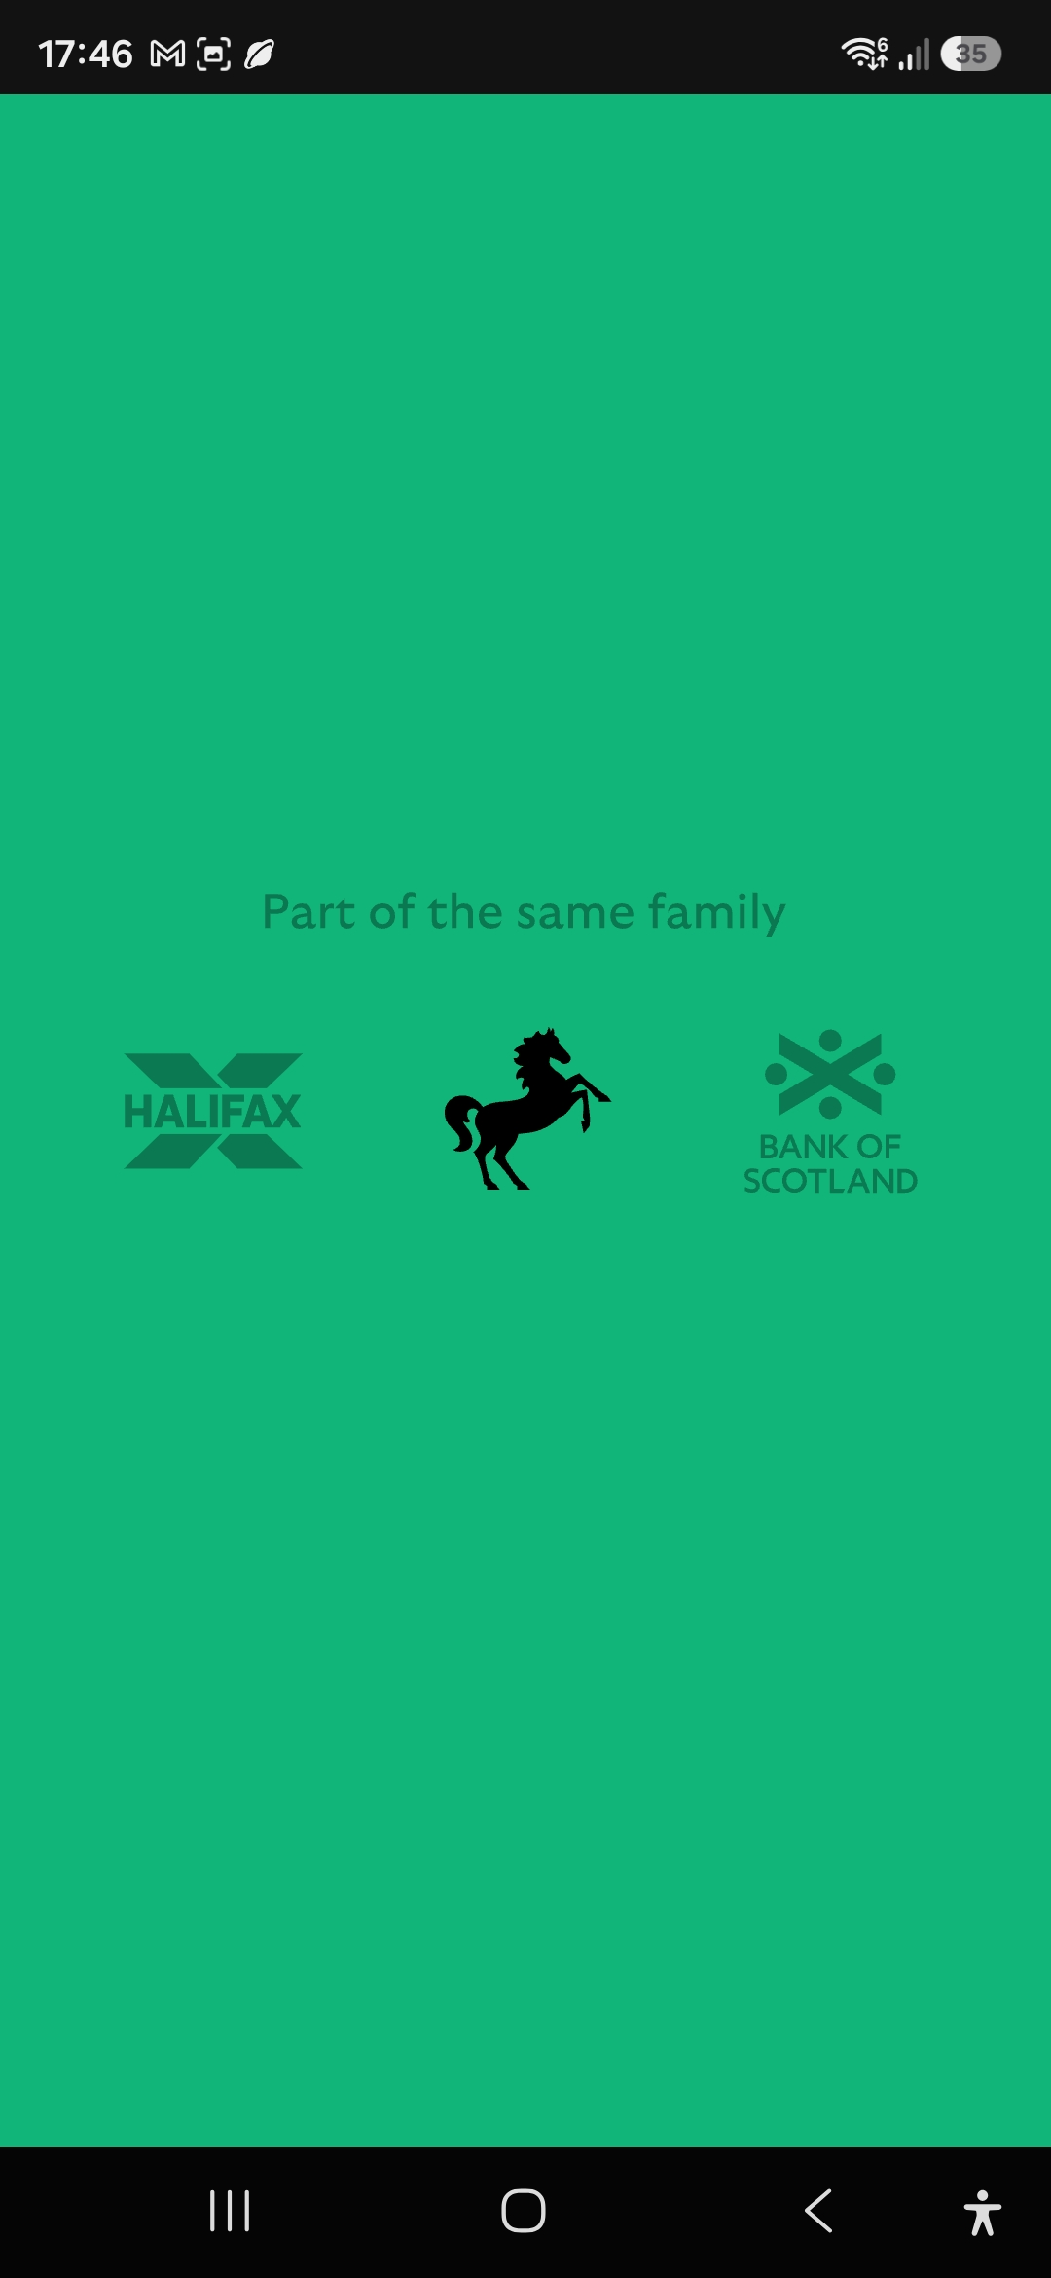
Internet Banking – Here this shows that I can confidently manage any financial requirements online.

Screenshot/Photo 4
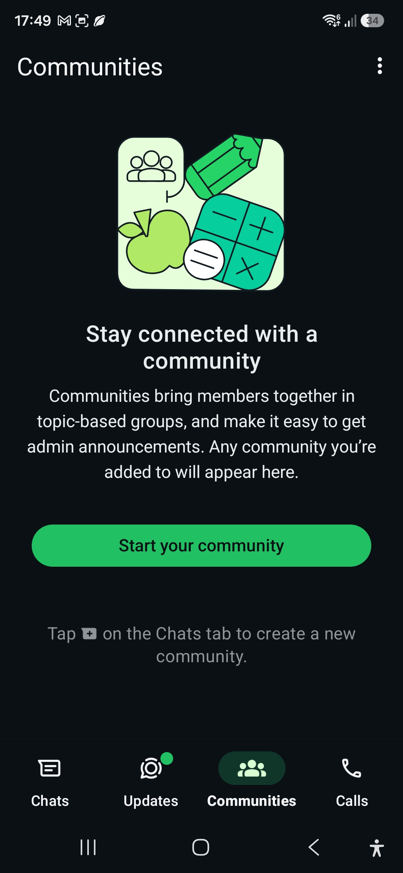
Whatsapp – Here this shows that I can easily communicate with people no matter where one person may be through either messaging, voice notes or calling.

Screenshot/Photo 5
[Insert Photo/Screenshot below]
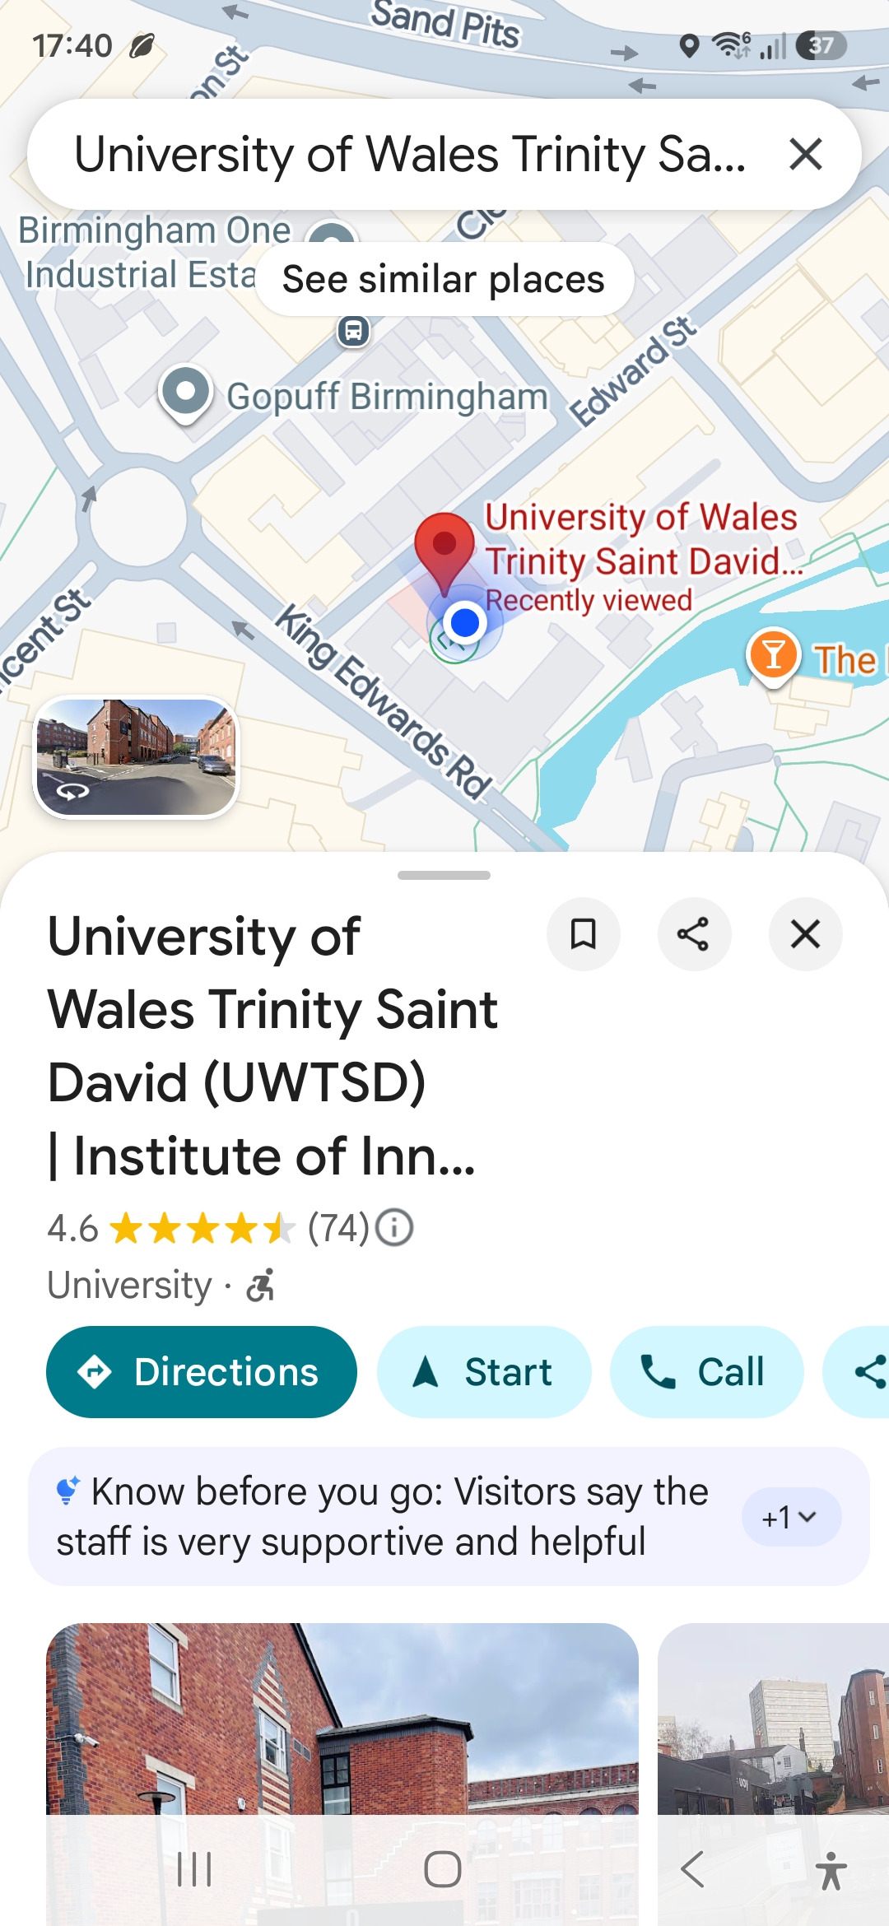
Google maps – Here this shows I can confidently travel to many locations without getting lost through the help of google maps as it can guide me to anywhere with ease.

Screenshot/Photo 6

Folders- Here shows clean organisation of documents and miscellaneous items.

My Short Reflection
- Write 5–8 simple sentences about your digital life.
- You can use the sentence starters below if helpful.
I use digital tools to navigate around my everyday life, handle any tasks whether they may be banking, communicating with people, checking my emails or navigating my area.
I feel confident when I use all these apps as I know how to find anything that I may need to get.
I want to improve my digital skills even further by using different apps and software to enhance my understanding and knowledge.
I often use these tools in everyday life to communicate with others and go about my daily life.
I sometimes feel nervous about using different software as some of it is confusing however once I am taught on how to use it, I can use it with ease.
I hope this module will allow me to better enhance my digital skills and teach me new things and allow me to progress further with the skills that I already know.
Digital skills are important for me because they affect nearly every part of modern life.

Sentence starters
- I use digital tools to …
- I feel confident when I …
- I want to improve …
- I often use these tools: …
- I sometimes feel nervous about …
- I hope this module will help me …
- Digital skills are important for me because …
You can write more if you want.

Submission Checklist
Before you submit, please check:
​​​ ☒ I added 4–6 screenshots ✅
☒ I wrote short sentences for each screenshot ✅
☒ I wrote my short reflection ✅
☒ My work is my own ✅
☒ My file opens correctly ✅

