Academic and
Employability Skills
ACE
Individual Presentation
Task 1
Tutor- Lloyd Beharry
Group 8

Viorel Grigorita

ID number: 2009055

Introduction

In this PowerPoint I will be talking about my planned career, my personal academic and employability skills and how they will help me get the job I want.

Getting right to the point realistically my planned/desired career would be to become a cabin crew member. A shorter way is crew member, and their role covers much more then serving tea and food to the passengers which I will be presenting in a short time.

Cabin Crew’s roles

They consist of serving passengers food and drinks

Providing basic medical support if needed unless there would be an assigned medical person onboard

Making announcements that are either given by the company or by the pilot on-board

Communication skills with other cabin crew members

Entry Requirements

Going by ‘gov.uk’ the right entry requirements to become a cabin crew are:

At least 2 GCSEs at grades 9-3 or a level 2 course specialized in cabin crew

Customer service skills are required

Knowledge of public safety and security

Being over 18 years of age

Passing a medical check

My plans for personal development

With the help of this course learning more about how to improve my academic skills will help me then pursue my dream

To be able to achieve that I need to make sure I always pay attention to my University classes

Get engaged in every day's teaching to acquire the correct information and show my full potential at the right time when training for cabin crew

Having to improve my patience skills for the job as a flight attendant

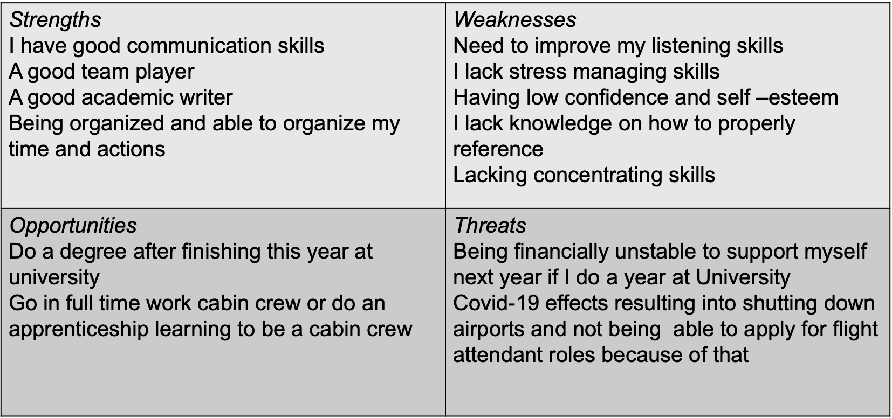

My Strongest Personal Skills

Employability Skills

Good communicator

A team worker

A motivated individual

Academic Skills

A good academic writer

Note making in class
- Able to use computer skills

These skills have been used and improved throughout my time at this university. Leadership skills I need to still improve on to be able to command passenger's safety throughout their journey.
My plan is to improve these skills and acquire new skills this year while studying at WUTSD that will help me be more employable and next year when things have cleared with Covid-19 I will be applying for cabin crew/flight attendant jobs.

Personal Development Plan (PDP)

Next Steps

Taking an example from an article I've read online about Taiwanese airlines EVA finally employing male flight attendants after 30 years showing that there now are more opportunities for me as male student.

Also, because EVA is known to be the cleanest airline in the world, I will be considering on applying to this airline after finishing this course and with the knowledge and skills perfected/improved this year at this university will increase the chances of me being accepted in such a high ranked airline.

Conclusion

Overall to be able to achieve the goal of becoming a flight attendant I need to make sure I follow the next steps:

Successfully complete my University course this year

Pass a medical check certification

Apply for different airlines

Hopefully, this time next year I will be working as a cabin crew for a successful airline using my employability skills

References

” What is a swot analysis” - https://www.mindtools.com/pages/article/newTMC_05.htm, Accessed 18th November 2020

“Cabin crew requirements” – https://nationalcareers.service.gov.uk/job-profiles/cabin-crew, Accessed 19th November 2020

“EVA air to employ male flight attendants for first time in its history” https://www.independent.co.uk/travel/news-and-advice/eva-air-taiwan-airline-cabin-crew-sexist-male-flight-attendants-female-a8971846.html, Accessed 25th November 2020

“Example of Personal Development Plan table” https://issuu.com/helencritchell/docs/120723102553-083f5cf4edf64970843a04328722bc69, Accessed 27th November 2020

” Air cabin crew skills required” https://www.ncfe.org.uk/training-providers/employability-qualifications, Accessed 28th November 2020

