Qualitative report – Thematic Analysis

Abstract
Motivation is the driving force to why someone does something or the force behind human actions. There are many previous studies that look at factors that influence motivation such as positive encouragement, social support, receiving feedback, and sense of belonging (Ryan and Deci, 2020). The study conducted looked at the factors that have an influence on university students’ motivation to apply for, and maintain engagement with, a university degree program? Four participants took part in a semi structured focus group to discuss their motivation. A transcript was created, and a thematic analysis was developed. Three themes were developed after becoming familiar with the transcript, Extrinsic motivation, self-improvement, and intrinsic motivation. The results from the study support previous literature in that a variety of intrinsic and extrinsic factors influence motivation, including the sense of belonging felt when engaging with educators. Further developments are discussed.

Introduction

Motivation is the driving force to why someone does something or the force behind human actions. Motivation is the process that initiates, guides, and maintains goal-oriented behavior. Motivation makes you act in a way that leads you closer to your goals, it is the “why” behind a behavior (Graham, 2012). There are two types of motivation, intrinsic and extrinsic. Intrinsic motivation is commonly defined as doing it purely for yourself. This involves doing a task because it’s fun, pleasurable, interesting, or enjoyable etc. Individuals completing a task with intrinsic motivation are often satisfied with just completing the task rather than meeting a tangible goal. Whereas extrinsic motivation refers to an influential goal. Things such as money, praise, holiday, and career advancement can be the cause of extrinsic motivation. This is when you complete a task to be praised or rewarded rather than doing it because it’s fun or interesting (Reiss, 2012).
According to Ryan and Deci’s (2000) self-determination theory (SDT) it is suggested that when extrinsic motivators, like money, are introduced people’s behavior changes and they stop wanting to do tasks spontaneously. Self-determination theory argues that there are three basic needs that influence our behavior autonomy, competence, and relatedness. Motivation can range from non-self-determined to self-determined, and the theory generally maintains that motivation that is intrinsic is far more beneficial than being influenced by external factors.
There are many factors that can influence motivation such as positive encouragement, social support, receiving feedback, and sense of belonging (Ryan & Deci, 2020). Positive encouragement from others can influence a person’s intrinsic motivation which leads to higher competence. O’Connor et al. (2007) conducted a study examining the relationship between teachers, children, and their achievements. The study found that higher quality relationships between teacher and child encourage achievement and behavior in class. Furthermore, having strong social support from teachers and friends has been shown to lead to greater motivation to learn. Furthermore, Tezci et al. (2015) concluded that there was a positive relationship between external or internal motivation and their motivation for their subject, with social support strengthening the relationship.
Receiving feedback is also another factor that can influence motivation. Garcia et al. (2019) concluded that individuals who received positive feedback had an increase in levels of competence and subject vitality, whereas those who received negative feedback, or no feedback did not experience the same increase. Pedler et al. (2022) support this with their finding that those with higher sense of belonging are more likely to have higher levels of motivation, achievement, academic self-confidence, and academic engagement levels.
As the literature has shown there are many elements that are related to motivation as well as the different influences it has on individuals, especially within an educational setting. Therefore, this study will be exploring what factors have an influence on university students’ motivation to apply for, and maintain engagement with, a university degree program?

Method

Participants
The study was comprised of four participants in total who were currently enrolled on university degree programs. Two male and two female, the male participants where aged 20 and 45 whereas the female participants where aged 32 and 22. Participants were selected to take part in the study based upon the provision of interest noted by a group of university applicants during their stage of application over the previous two years. Email communication was sent including a brief outline of the purpose of the study and the focus group was arranged. Of those who had responded and were interested in taking part in this study, the four participants outlined above were those that were able to attend on the date and time, and at the location of the focus group.

Date Collection
A semi-structured interview schedule was created by the researcher that aimed to explore motivation in university students. Ten open-ended questions were developed with some additional prompts included to elicit specific examples from participants. The interview schedule was used to conduct one 60-minute focus group with the four participants which was audio recorded. Following completion of the focus group, the researcher transcribed the information provided by participants verbatim to use for data analysis. Participants names were replaced with pseudonyms to maintain anonymity in the final report, and any identifying information within the final transcript was removed or replaced with another pseudonym to further ensure no participants could be identified from any quotes used. The final transcript was provided to students to analyse for the purpose of a second-year research report.

Date Analysis
Thematic analysis was chosen as the method to analyse the focus group conducted for this study to identify patterns/themes within the data. Braun and Clarke’s (2006) six-phase framework was followed to analyse the data. First, the transcript was read through multiple times to ensure familiarity with the data. Next, comments and initial codes were noted in the margin to reduce large excerpts of data to smaller, meaningful codes, followed by an attempt to search for patterns from the codes and notes developed to develop themes. Single statements were reviewed regarding their relevance, to critically review if it was only one person’s opinion or an opinion in general among/across the participants. The fourth stage involved reviewing and modifying the preliminary themes and memoing/cutting and pasting of data to support the themes was considered to decide whether the data really did support that theme. The fifth and final phase related to analysis involved defining themes and constructing a final list of themes and associated sub-themes.

Results

A thematic analysis was conducted on a focus group transcript. To identify key themes (see table 1) relating to factors that influence university students’ motivation that become evident with familiarity of the focus group transcript. Three themes have been interpreted within the data, however only two will be discussed.
Table 1.
Themes and Sub-Themes with Supporting Quotes
Theme | Sub theme | Quote
Extrinsic motivation | Family influence  Teacher  Social interactions | “for me it’s literally just my kids. They’re the reason I applied, they’re the main reason I turn up every day even when I really don’t want to” (Sarah, lines 474-475).  “Yeah, I guess my dad is probably the main reason I went to university” (Alex, line 565).  “so interesting…, but his passion for it made me really excited to go in each week” (Emily, lines 342-343).  “so the modules I’ve enjoyed the most are the bits that I’ve had to interact with people basically.” (Sarah, lines 231-232).  “it is sort of like you get all of us or you get none of us situation.” (Alex, lines 663-664).
Self-improvement | Career ambition  Self-development | “I feel like studying computing can help me get a better job.” (Alex, lines 56-57).  “the understanding that there are going to be more paths that I can go down with the degree that I don’t currently have.” (Emily, lines 771-773).  “I physically can’t do what I want to do anymore so I’ve sort of been pushed to do something else?” (Mark, lines 512-513).
Intrinsic Motivation | Self-motivation  Self-discovery | “realistically I’m here for me and I’m here to learn… I just need to know that I’m doing the best that I can do for me.” (Emily, lines 669-671).  “but I feel like I need to be back there doing something.” (Mark, 796-797).  “The pressure of social interactions sometimes just feels too much and I wanted to know why I’m like that…?” (Emily, lines 130-132).

Theme 1: Extrinsic motivation
Looking thought the data, one of the distinguishable themes was extrinsic motivation. Thought-out the transcript extrinsic motivation was mentioned a lot. This theme can further be divided into sub-themes of family influence, teacher support, and social interactions.

Sub-theme 1: Family Influence
The biggest motivation for Sarah is her kids, and she states they are her main reason for turning up every day “They’re the reason I applied, they’re the main reason turn up every day even when I really don’t want to” (Sarah, lines 474-475). It can be suggested that her kids are the reason why she’s more likely to maintain engagement with her degree program.
Family influence also plays a big part in Alex’s motivation to attend university and he says that “I guess my dad is probably the main reason I went to university” (Alex, line 565). His desire to make his dad proud and to learn from the push he got from his dad to attend will make him more likely to continue his studies.
Family influence is a factor that can influence a student’s motivation. As you can see it can also be a leading factor that influences students to apply and/or stay engaged with their degree program.
Sub-theme 2: Teacher
It is implied that lecturers have an impact in motivating the participants to engage in their studies, and Emily describes her personality lecturer as making a module “so interesting… but his passion for it made me really excited to go in each week” (Emily, lines 342-343). Alex and Sarah further support the influence of their educators in a similar way, indicating that the interaction and passion from lecturers can be a motivating factor for students in them feeling engaged.
Having a strong relationship with lectures can be seen as a motivation for students. By having this connection with a lecturer it’s seen to have a positive effect on students’ classroom participation and attitudes towards their degree program.

Sub-theme 3: Social Interactions
One aspect of motivation for Sarah is social interactions. She enjoys communicating with people and it has become an enjoyment for her “so the modules I’ve enjoyed the most are the bits that I’ve had to interact with people basically.” (Sarah, lines 231-232). It can be suggested that interacting with people can encourage motivation as Sarah has mentioned that she enjoys it the most.

It can be suggested here that Alex has had a positive social life to the point where he’s developed strong bonds with his peers. With Alex’s strong social life, it can be deemed that his motivation towards his engagement with his degree will also be strong as he states, “it is sort of like you get all of us or you get none of us situation.” (Alex, lines 663-664).
Having a positive social interaction with others can be seen as a factor that influences motivation in students which can lead to more engagement in lectures.

Theme 2: Intrinsic Motivation
The last theme to be considered is intrinsic motivation. Throughout the transcript it was clear to see that some of the participants were attending university for their own enjoyment/ pursuits. Not all the participants had pure external motivations to attend university. Two sub-themes were developed self-motivation and self-discovery.

Sub-theme 1: Self-motivation
Emily’s strong motivation to attend university is not affected by outside factors, she’s here for her own benefit. This suggests that there won’t be any outside influences that will affect her motivation which will lead her to maintain engagement with her degree. “realistically I’m here for me and I’m here to lean… I just need to know that I’m doing the best that I can do for me.” (Emily, lines 669-671).

Mark’s biggest motivation is his want to go back into the construction industry. “but I feel like I need to be back there doing something.” (Mark, lines 796-797). This suggests that his motivation to apply was his love for the construction industry. Furthermore, outside factors also won’t hinder his motivation to stay engaged.
Students who attend university though self-motivation are more likely to stay motivated and engaged with their degree with little outside interference as their engagement solely benefits them.

Sub-theme 2: self-discovery
Emily course choice (psychology) was chosen to help her understand herself and the way she behaves in social settings. Implying that her own curiosity on the course will allow her to be engaged. “ the pressure of social interactions sometimes just feels too much and I wanted to why I’m like that…?” (Emily, lines 130-132).
Self-discovery can be a motivation for students who attend university to helps them in their journey in understanding themselves or use a degree as a starting point to discover what they want in the future.

Discussion

The aim of the study was to identify factors that influence motivation in university students. After conducting a thematic analysis on the focus group transcript, it led to the identification of three themes but only two were discussed: Extrinsic motivation and intrinsic motivation. The finding from the study supports Ryan and Deci’s (2020) theory on self-determination which mentions that there are six types of motivation. From the result of the study, it has shown that Sarah shows signs of extrinsic motivation (external) as she is motivated by her kids, by being able to provide for her kids is like a reward which regulates her behavior. Mark and Alex show signs of extrinsic motivation (integrated) as they are connected and competent with their programs, however their behaviors are regulated by them wanting to live up to their own ideas. Whereas Emily shows signs of intrinsic motivation. Emily feels very connected to her studies, and she enjoys the degree she is studying for, which gives her a high form of competence.
The results of the study also support previous research by O’Connor et al. (2008) who examined relationships between teachers and children. The result of this study supports the findings in that the higher the quality of relationships between educator and students encouraged their engagement and achievements. This suggests that by having a high-quality relationship between teacher and student can have a positive influence over student participation and engagement. Another piece of supporting research was done by Tezci et at (2015) about social support. The results from the study also found that social support/ social interactions had a positive effect on motivation. This also suggests that having positive social support/ interactions can lead to active participation and the continuation of engagement within students’ degree programs.
However, it’s important to be aware of the fact this study was only conducted on one group of participants. Further, expanding the sample may benefit the research as it would provide more of an ecological valid view of the wider population as well as further confirming the results found.
To conclude, the participants in this study demonstrated that there are a range of internal and external factors that influence their motivation, with external factors having a more prominent influence on their motivation than internal factors.

References
Graham, S., & Weiner, B. (2012). Motivation: Past, present, and future. In K. R. Harris, S. Graham, T. Urdan, C. B. McCormick, G. M. Sinatra, & J. Sweller (Eds.), APA educational psychology handbook, Vol. 1. Theories, constructs, and critical issues (pp. 367–397). American Psychological Association. https://doi.org/10.1037/13273-013
Reiss, S. (2012). Intrinsic and extrinsic motivation. Teaching of Psychology, 39(2), 152-156. https://doi.org/10.1177/0098628312437704
Ryan, R. M., & Deci, E. L. (2000). Self-determination theory and the facilitation of intrinsic motivation, social development, and well-being. American Psychological Association, 55(1), 68-78. https://doi.org/10.1037//0003-066x.55.1.68
Ryan, R. M., & Deci, E. L. (2020). Intrinsic and extrinsic motivation from a self-determination theory perspective: Definitions, theory, practices, and future directions. Contemporary Educational Psychology, 61, 101860. https://doi.org/10.1016/j.cedpsych.2020.101860
O’Connor, E., & McCartney, K. (2007). Examining teacher-child relationships and achievement as part of an ecological model of development. American Educational Research Journal, 44(2). https://doi.org/10.3102/0002831207302172
Tezci, E., Sezer, F., Gurgan, U., & Aktan, S. (2015). A study on social support and motivation. The Anthropologist, 22(2), 284-292. https://doi.org/10.1080/09720073.2015.11891879
Garcia, J. A., Carcedo, R. J., & Castano, J. L. (2019). The influence of feedback on competence, motivation, vitality, and performance in a throwing task. Research Quarterly for Exercise and Sport, 90(2), 172-179. https://doi.org/10.1080/02701367.2019.1571677
Pedler, M. L., Willis, R., & Nieuwoudt, J. E. (2022). A sense of belonging at university: student retention, motivation, and enjoyment. Journal of Further and Higher Education, 46(3), 397-408. https://doi.org/10.1080/0309877X.2021.1955844
Appendices

Consent form:
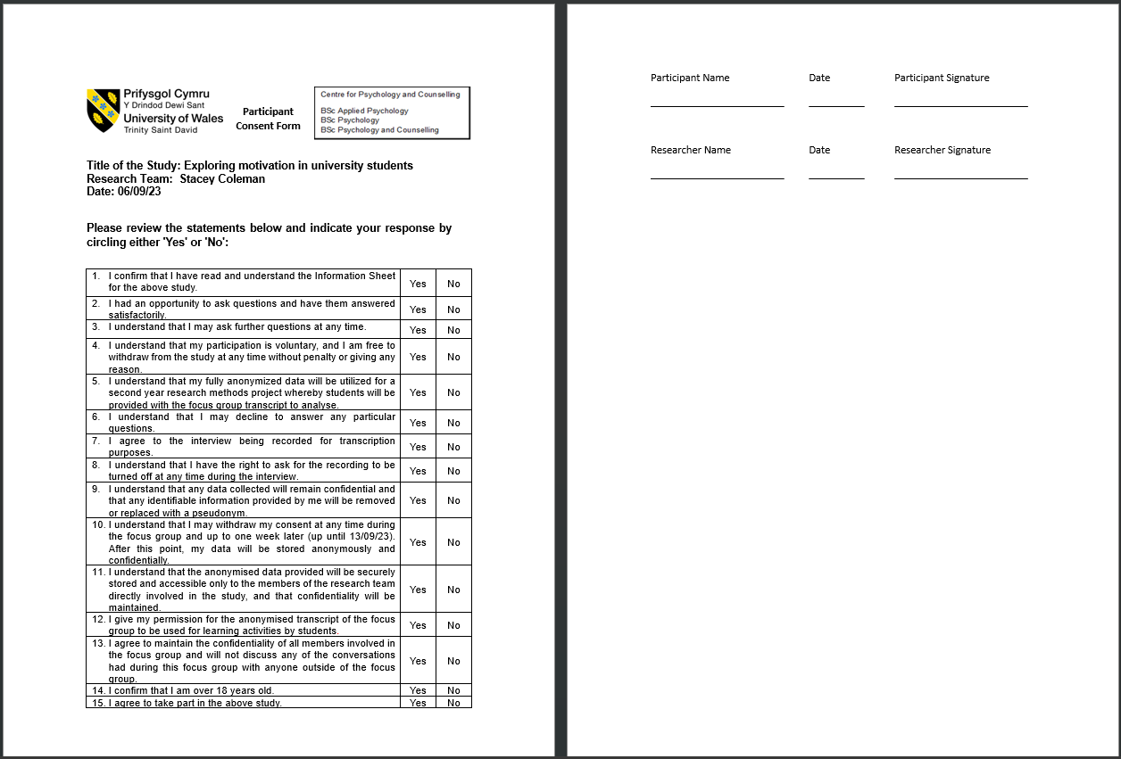

Debrief form:
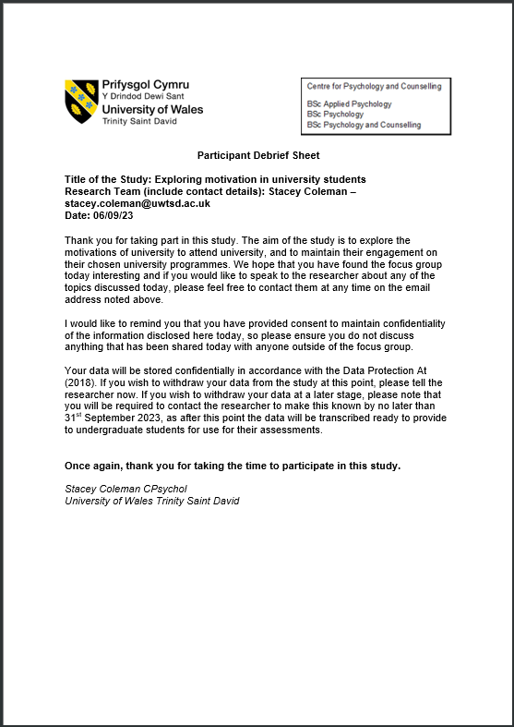

Interview schedule:
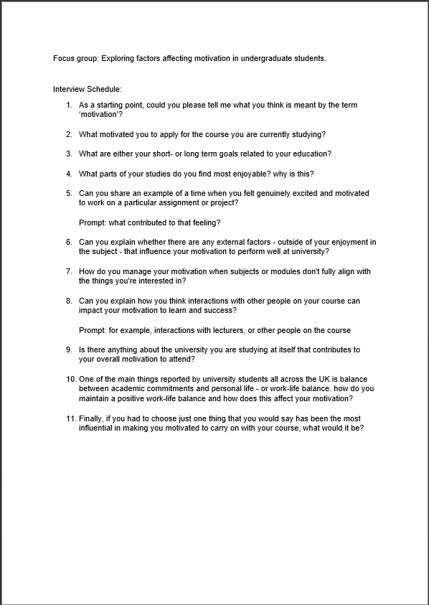
Theme table:
Theme | Sub theme | Quote
Extrinsic motivation | Family influence  Teacher  Social interactions | “for me it’s literally just my kids. They’re the reason I applied, they’re the main reason I turn up every day even when I really don’t want to” (Sarah, lines 474-475).  “Yeah, I guess my dad is probably the main reason I went to university” (Alex, line 565).  “so interesting…, but his passion for it made me really excited to go in each week” (Emily, lines 342-343).  “so the modules I’ve enjoyed the most are the bits that I’ve had to interact with people basically.” (Sarah, lines 231-232).  “it is sort of like you get all of us or you get none of us situation.” (Alex, lines 663-664).
Self-improvement | Career ambition  Self-development | “I feel like studying computing can help me get a better job.” (Alex, lines 56-57).  “the understanding that there are going to be more paths that I can go down with the degree that I don’t currently have.” (Emily, lines 771-773).  “I physically can’t do what I want to do anymore so I’ve sort of been pushed to do something else?” (Mark, lines 512-513).
Intrinsic Motivation | Self-motivation  Self-discovery | “realistically I’m here for me and I’m here to learn… I just need to know that I’m doing the best that I can do for me.” (Emily, lines 669-671).  “but I feel like I need to be back there doing something.” (Mark, 796-797).  “The pressure of social interactions sometimes just feels too much and I wanted to know why I’m like that…?” (Emily, lines 130-132).

