

Project Planning Resubmission

Sophie Reed – 2000492

ACHA5012
Word count - 2628
Table of Contents
Introduction 3
1.0 Roles and Responsibilities 4
1.1 Gantt Chart 5
2.0 Personal roles and responsibilities 7
3.0 Bills of materials 10
4.0 Significant milestones 12
Conclusion 13
References 14

Introduction
The group are completing the IMechE design project, a competition which entails creating an autonomous vehicle which travels from one point to another and returns to its original spot. ‘The Design Challenge gives first and second year undergraduates a taste of the ‘real world’ of engineering’ (Imeche.org, 2023). The aim of this competition is to have created the vehicle which is the most accurate on the target. There are four people in the group, and after the internal project has finished the goal is to advance to regionals (which would involve competing against students from other universities) and possibly to nationals if successful. ‘Planning is crucial to working together successfully’ (Experience Mcintire, 2022), and completing each task within the time is also important. A Gantt chart is crucial when trying to organise a group for a project.

1.0 Roles and Responsibilities
To be able to organise the jobs needed to complete this project, a table was made by the group, detailing each task which requires completing. Creating a table was the clearest way to display all of these responsibilities.
Task | What it involves | Group members working on | Group member leading
Prototype assembly and testing | Building the prototype from the parts provided | Everyone | N/A
Coding initial basic designs | Building code that does the job in a basic way | Sophie | Badrakh
Coding autonomous basics | Building code for the autonomous part of the vehicle | Badrakh | Sophie
Environment sensor selection | Finding/selecting a sensor that can sense its environment in an appropriate way | Munty | Evan
CAD | Designing all the CAD for the vehicle, outside appearance, and internal | Badrakh + Sophie | Badrakh
Transmission and motor selection | Finding/selecting a transmission and motor that is appropriate for the project | Evan | Munty
Battery selection | Finding/selecting a battery that gives the power but is the correct size for the build | Munty | Evan
Green Power | Identifying how to incorporate environmentally friendly aspects into the project within budget. | Badrakh | Sophie
PID work on speed control | Identifying ways to control the speed of the motor | Evan | Munty
General wiring | Complete general wiring for the vehicle, ensuring it runs correctly. | Sophie | Badrakh
Track Design | Building the track following the spec | Munty & Evan | Sophie
(Figure 1, 2023)
The table above clearly shows what each role is, what that role entails and who will be involved. There is an additional column to show who will lead on the task, to ensure that all work is completed and is equally distributed, as well as ensuring that it is done to a high standard as it will be checked. This table can then be put into a Gantt chart to identify the duration and deadlines of each task.
All group members will be involved in the prototype assembly and testing - this is to ensure that everyone’s ideas are included, and that if anything were to fail, the correct person will be there to fix it. Every role has been dedicated to the person who is most confident in that section. For example, Evan and Munty have strength in research so were assigned predominantly research-based allocations. Bigger projects have been split between two people (once again to prevent workload imbalances) - this can be seen in the CAD section where Badrakh and I are splitting the task. CAD is a huge part of the project, as it needs explain the way the vehicle is built in the presentations and will be used for overall design and development.

1.1 Gantt Chart
‘A Gantt chart is a project management tool that illustrates work completed over a period of time in relation to the time planned for the work’ (Atlassian, 2023). Having a Gantt chart gives the team a clearer vision of what needs to be done, when, and how long they have to do it. Each section of the project has been given its own time period. This Gantt chart allows for extra time if needed, as it shows the project over a 20 week period rather than the given time of twenty one weeks. Half term is also scheduled midway through this project, so the group should finish ahead of time. Below is a Gantt Chart made for the group project.
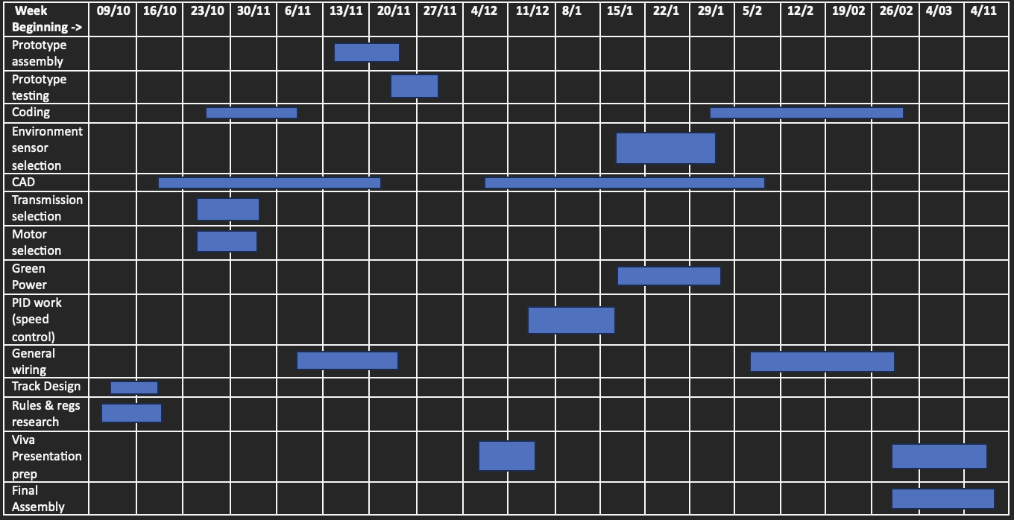
(Figure 2, 2023)
As shown in the chart above, the tasks that will take the longest are planning, research and design. This is because these are the key tasks needed to ensure that the vehicle is completed to the highest possible standard. Each week is based on around 10 hrs of work, which over the course of twenty weeks will achieve the target of at least 200 hrs. Around 4 of these hours will be spent in progression meetings. Using this Gantt Chart, the viva prep will require around 20 hours, which split between 4 people will equate to 5 hours each. This will allow for the presentation to be built well and laid out correctly. Every Monday there is an hour meeting scheduled, and the aim is to have another later in the week. This is to ensure that group members are working on their allocated tasks and that the correct amount of progress is being made. This Gantt chart will permit the group to progress quicker as it clearly demonstrates which task needs to be completed next, helping with organisiation. Within my role it is crucial that I stick to these 10 hours a week as a large part of the project relies on the coding of the vehicle. Therefore, I need to ensure that it is done to a high standard and on time.

2.0 Personal roles and responsibilities
According to Belbin’s Table of Roles there are eight key roles that are shown to be effective when it comes to team progress. ‘The types of behaviours in which people engage are infinite. But the range of useful behaviours, which make an effective contribution to team performance, is finite’ (Belbin. M, 2019). To help me identify where my strengths and weaknesses lay my responses to a set of questions relating to these roles were used. My results were then compared to an average. Below is a table displaying what my scores were for each role and how they compare to the average, this is made clearer using colour coding. These results are based off a questionnaire that was filled in a lecture.

Role | Average score | My score
Shaper | 11.6 | 8
Implementor | 10.00 | 10
Complete finisher | 5.5 | 7
Plant | 7.3 | 8
Evaluator | 8.2 | 8
Team-worker | 10.9 | 8
Resource investigator | 7.8 | 9
Co-Ordinator | 8.8 | 8

From this is it clear to see my two biggest strengths were ‘Resource Investigator’ and ‘Complete Finisher”. Resource Investigator is defined as someone who ‘uses their inquisitive nature to find ideas to bring back to the team’ (Belbin, 2018). This trait is useful for a multitude of reason, it displays my ability to be outgoing and enthusiastic. However, a counter part of this is my ability to get over excited initially and then lose my enthusiasm is a weakness.
Complete finisher is then defined as ‘most effectively used at the end of tasks to polish and scrutinise the work for errors, subjecting it to the high standards of quality control’ (Belbin, 2018). This is a trait I possess and have observed within past projects. I try to over-perfect things and this can cause issues if a disproportionate amount of time is dedicated to this aspect. A weakness within this trait is the reluctancy to delegate roles to other people, this is something that I am going to struggle with within this project. I like to do things myself so I know exactly how it has been done, however, having spoken to the group already we have discussed the roles and how we can work together with bigger things to stop anyone doing this.
My lowest score (as shown on the table) is Shaper, this is defined as someone who ‘provides the necessary drive to ensure that the team keeps moving and does not lose focus of momentum’ (Belbin, 2018). This is something that another member of the group will have to achieve. Another aspect of this trait is the ability to thrive under pressure, this is something I’m not good at, I don’t always react well to stress and hate leaving things to the last minute.
My personal role within the group is a mixture between timekeeper, notetaker and co-ordinator. The group have merged the first two roles as they are similar to each other. A timekeeper ‘ensures that everything in the meeting gets enough time to be discussed’ and ‘can also keep track of how long each task will take so the entire team project is completed in time’ (Chris Drew (PhD, 2022). I have been doing these tasks successfully by ensuring that all meetings have been planned and that notes have been taken, which ensures organisation and makes sure that the group stay on plan. A register for each meeting has also been taken to record which members have attended. The co-ordinator role is also an important part of the project, because they ‘bring people and information together to help them collaborate on common goals’ (Indeed.com, 2022). As previously discussed in relation to my relatively low ‘Shaper’ score, coordination isn’t my strongest suit, however my proficient result for ‘Resource Investigator’ will enable me to successfully bring innovative ideas to the table which will be important within my role. Although I believe will succeed in this, my confidence may hinder me slightly, however I hope that by taking on the role I will be able to improve this.
My main concern regarding my section of the project is the coding. This is not my strong suit and is something I struggle with. However, there are online tutorials and books that can be used to improve. Consulting with my lecturer is another way I can also improve on this. A second potential hinderance is my lack of ability to work well in a group. I have always found myself stronger within an independent task. Nonetheless, the Gantt chart will allow me to stay on my tasks as it gives clarity to the work I am supposed to be doing and what others should be completing themselves. Despite these weaknesses I’m confident I should be able to complete my roles well and deliver them to a high standard.

2.1 Personal SMART Objectives
‘Smart goals are Specific, Measurable, Achievable, Relevant, and Time-bound’ (MindTools, 2020). To help my organisation and having a clear achievable target it is crucial I use a Smart Objective. My personal Smart Objective is – to create a circuit board and code that allows the vehicle to move from one target to the next autonomously, I will do this in forms of small circuits and gradually putting them together. To achieve this I will use the facilities the University provide. This aligns with the teams goals and is one of the main parts of the project. Using the Gantt Chart I know this needs to be completed by the end of the week commencing 26th February 2024.

3.0 Bills of materials
The project has a total budget of £80, this includes all physical aspects, but will not extend to the software that will be used. The three softwares which are to be used in this project are SolidWorks, Arduino and MATLAB. SolidWorks will be used for the CAD part of the project, to allow us to visualise our ideas, and ensure that the components fit together properly. These designs can then be transferred to a laser cutter in order to build the chassis. Arduino will be used for the development of the coding, and MATLAB will be used for the final coding as the software enables better visualisation and has the capability to create graphs which will facilitate the comparison of data.
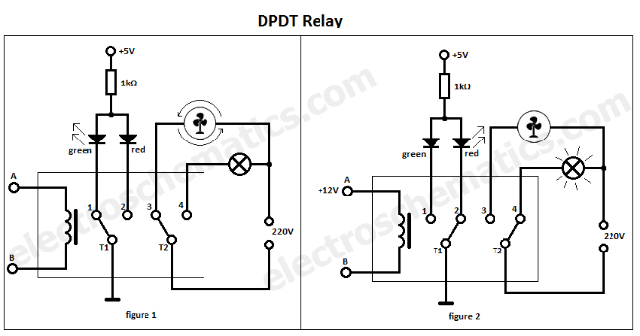
The main part that needs to be researched is how to get the vehicle to reverse directions, so from going forwards to back up the track. Obviously, being autonomous means that a remote control can’t be used as it needs to be able to change direction independently. Through group research we identified that the best way to achieve this would be to use a DPDT relay (double-pole double throw). This ‘controls two separate circuits with the actuator, which is generally designed for on-on or on-off-on function’ (MGI SpeedWare, 2020). The reason we decided to use this form of relay was because it is very useful for changing the direction a motor will turn. To ensure that the vehicle will stop on the correct spot, a timer will be used to calculate the length to the wall then when it returns it stops right where it started. The image on the right shows the way a DPDT switch works. This switch costs £3.14 from Switch Electronics, meaning there is still plenty of budget left.
(Figure 3, 2014)
The next important part of the vehicle is the motor. It needs to be strong enough to move at a decent pace, yet simultaneously small enough not to cause the vehicle to be too heavy. Due to the DPDT switch the motor needs to be reversible or it will not function correctly. A suitable motor that could be used costs £21.04 from RS online. This does consume a large portion of the budget however it is crucial for the vehicle.
The design is currently still being worked on but the current proposal is to use acrylic, which could then be cut on the laser cutter making the assembly easier. A thickness of 2mm would be the best to use as would prevent the from being too heavy - thicker acrylic could stop the motor from working as efficiently. Until the design is finalised the exact size required is unknown, however L – 1.2m and W – 0.6 should be plenty. This sheet costs £26 at B&Q. This is just over 25% of the budget although this will reduce when the final design is complete.
A breadboard and wires are needed to complete the circuit, this is the easiest way. A breadboard helps with the organisation of the circuit. A breadboard and wires can be purchased for £9.99 on Amazon. This also includes a battery clip and a power supply module, which will both be useful in the wiring of the vehicle.
There are many different types of wheels available that could be used for this project. However, a small wheel that is unable to change direction will be best, as this will help keep the vehicle moving in a straight line rather than diverting off to the side. For 4 wheels of 15mm diameter, the cost will be £6 on eBay. These will be sufficient as they are lightweight but can withstand weight.
Below is a small bill of materials that is based on the research that has been completed so far, after more development and research this will become more accurate.
Part | Price | Company
DPDT switch | £3.14 | Switch Electronics
Reversable motor | £21.04 | RS Online
Acrylic | £26 | B&Q
Breadboard and wires | £9.99 | Amazon
Wheel | £6 | eBay
Final Price | £66.17
Budget Remaining | £13.83

4.0 Significant milestones
There are significant milestones within the development of the project, however there are some internal dates that also need to be considered within the project. For example, there is a viva on the 14th December, by this time the group needs to have a significant amount of work done to allow for a good presentation. The next viva after that is on the 20th March 2024, this rounds off the end of the internal assessment, so the group needs to aim to have a finished product by then.
There are then deadlines regarding IMechE, however these dates are loosely based around previous years. They’re currently serving as an estimation, the submission deadline is towards the end of January. There are then competitions between March and October.
Below is a table that shows the significant milestones for the development of the project. This table will allow the group to identify the milestones when they are reached. It also makes the project less daunting as they can be used as mini targets that need to be achieved.
Phase | Milestone | Deliverables
Analysis | - Analysis of what is needed to comply by the rules and compete. | - Analysis document
Project planning and research | - Having initial research completed  - Knowing the parts that can be used.  - Having a Gantt chart to organise the project | - Gantt chart  - Project plan  - Research document
Design | - Having an initial design of the vehicle  - Having an initial design of the circuit board | - Physical initial working vehicle
Research | - Code/functionality compliance | - Data sheet
Development | - Improvement on system components  - Improvement on physical build of vehicle | - Working circuit  - CAD model
Installation | - Vehicle build | - Physical working vehicle
Testing | - Test in correct environment | - Test results
Table 1 (Reed. S, 2023)

Conclusion
The IMechE project should be a success based on the planning that has been done as long the group stay organized and on track. Some research has been carried out to ensure that the vehicle will function successfully, but further research will be needed to be in for a chance of the national finals. The roles each member of the team have been assigned have been thoroughly thought out and fit each person well with a slight push out of the comfort zone. This is seen for me as bringing new ideas and speaking up isn’t my strong suit. A factor that needs to be researched further is the finance side, as the group is close to the budget cap and it’s vital not to exceed it. Using the Gantt chart will help keep the group on track and it can be amended if required throughout the course of the project.

References
Atlassian (2023). Gantt Charts | Atlassian. [online] Atlassian. Available at: https://www.atlassian.com/agile/project-management/gantt-chart#:~:text=Summary%3A%20A%20Gantt%20chart%20is,tasks%2C%20assignees%2C%20and%20more [Accessed 6 Nov. 2023].
Belbin (2018). Belbin. [online] Belbin.com. Available at: https://www.belbin.com/about/belbin-team-roles [Accessed 8 Nov. 2023].
Belbin. M (2018). Belbin. [online] Belbin.com. Available at: https://www.belbin.com/about/belbin-team-roles [Accessed 8 Nov. 2023].
Chris Drew (PhD (2022). 21 Group Roles for Students (List of Examples). [online] Helpful Professor. Available at: https://helpfulprofessor.com/group-roles-for-students/ [Accessed 14 Nov. 2023].
Experience Mcintire. (2022). Tips to Make Group Work Successful. [online] Available at: https://experience.mcintire.virginia.edu/blogs/ms-commerce/tips-to-make-group-work-successful/#:~:text=Planning%20and%20Time%20Management,and%20integrate%20the%20final%20product. [Accessed 4 Nov. 2023].
‌Figure 1. Reed. S (2023) Roles and responsibilities table.
Figure 2. Reed. S (2023) Gantt Chart
Figure 3. Marian, P. (2014). DPDT Relay: Overview and Application | ElectroSchematics.com. [online] ElectroSchematics.com. Available at: https://www.electroschematics.com/dpdt-switch-relay/ [Accessed 15 Nov. 2023].
Imeche.org. (2023). Design Challenge. [online] Available at: https://www.imeche.org/events/challenges/design-challenge?resultsPage=2 [Accessed 4 Nov. 2023].
Indeed.com. (2022). What It Takes To Be a Successful Team with Derrick Coleman. [online] Available at: https://www.indeed.com/career-advice/career-development/group-roles [Accessed 14 Nov. 2023].
‌‌MGI SpeedWare. (2020). SPST to DPDT Explained - MGI SpeedWare. [online] Available at: https://mgispeedware.com/guides-documentation/what-is-spst/#:~:text=Double%2DPole%20Double%2DThrow%20DPDT,on%2Doff%2Don%20function. [Accessed 15 Nov. 2023].
MindTools (2020). SMART goals. [online] Available at: https://www.mindtools.com/a4wo118/smart-goals [Accessed 20 Mar. 2024]
‌

