Student Name: Mihaela Delia Ilie  Student ID: : 2119794  Module Title: Foreign Languages and Cultural Awareness  Module Code: BMIH5003  Lecturer: Heidi Prosser  Date: 05/02/2024 | 
ASSIGNMENT 1: PORTFOLIO

Component 1: Professional Reflection
The cultural miscommunication I observed during my Level 4 placement at the Grand Hyatt hotel was between a server and a Chinese visitor working at the hotel restaurant for a busy Saturday dinner service. The guest's arrival was in the backdrop of a large Chinese tourist group, and the waiter faced problems due to the language barrier while trying to clarify the menu options and noting the client’s order. The waiter and kitchen staff were exasperated and then agitated from the long time it took to make the order right and, therefore, served the other tables late ( Ting-Toomey & Dorjee, 2018).
As an outside authority, it was pretty evident that the primary reason behind the trouble was a lack of sufficient cross-cultural communication abilities. Both parties lacked reciprocity and did not see important non-verbal indications and body language during the challenging discussion. Research shows that linguistic differences are enormous problems that undermine effective cross-cultural communication. Nevertheless, it should be mentioned that awareness of differences in communicative styles, behaviours, attitudes, and techniques may also lead to misinterpretations (Xiao & Chen, 2009). Sriussadaporn-Charoenngam and Jablin (1999) suggested that attaining intercultural communication skills constitutes acknowledging and resolving the differences above with empathy, adaptation, and a receptive and understanding attitude.
From my perspective as a hospitality worker, I ascribe the underlying reasons to my lack of cultural sensitivity, language proficiency, and ability to adapt to servicing. As hotel workers, we often serve a very diverse clientele with vastly differing backgrounds. Inevitably, misunderstandings are unavoidable without a deep understanding of various cultural norms and communication styles, and subpar service and negative guest experiences will inevitably follow (Sizoo et al., 2005). Language limitations significantly reduce common understanding. Yet a rigid and uncompromising attitude can make problems worse and lead to taking offence (Xiao & Chen, 2009).
To improve and proactively prevent future misunderstandings, I must strengthen my cultural sensitivity related to major tourist groups, learn basic linguistic skills such as simple greetings and words in languages like Mandarin, and become familiar with culturally specific needs and preferences. However, knowledge acquisition alone is not enough. I must adapt my communication and behaviour in reaction to cues noticed during multicultural encounters. This means displaying competence in listening skills, decoding nonverbal cues to determine signs of miscomprehension and modifying both my verbal clarifications and nonverbal behaviours accordingly (Sriussadaporn-Charoenngam & Jablin, 1999). Instead of being resentful, I should exhibit a calm and tranquil attitude and adopt an accepting and forgiving attitude founded on the search for answers.
Inevitably, in the global hotel cultures, cultural misunderstandings will arise. Even so, by focusing on the progressive development of multicultural consciousness, communication skills, and flexible behaviours, I can help turn misbeliefs into good opportunities for mutual education. This guest experience has brought the above need for further emphasis, which would add to my proficiency as a communicator in cross-cultural situations. Through adopting a belief that is accommodating and accepting of the myriad of human experiences, I endeavour to turn challenges such as these into harmonious encounters for myself and others.

References:
Sriussadaporn-Charoenngam, N., & Jablin, F. M. (1999). [online] Google Books. Multilingual Matters. Available at: https://www.google.co.uk/books/edition/Journal_of_Asian_Pacific_Communication/2d9mAAAAMAAJ?hl=en&gbpv=1&bsq=Sriussadaporn-Charoenngam [Accessed 5 Feb. 2024].
Sizoo, S., Plank, R., Iskat, W., & Serrie, H. (2005). ntercultural Service Encounters: Cross-cultural Interactions and Service Quality. [online] Google Books. Springer. Available at: https://www.google.co.uk/books/edition/Intercultural_Service_Encounters/VHJgDwAAQBAJ?hl=en&gbpv=1&dq=Sizoo [Accessed 5 Feb. 2024].
Ting-Toomey, S., & Dorjee, T. (2018). Communicating Across Cultures, First Edition. [online] Google Books. Guilford Press. Available at: https://www.google.co.uk/books/edition/Communicating_Across_Cultures_First_Edit/ndZy_EWD0LUC?hl=en&gbpv=1&dq=Ting-Toomey [Accessed 5 Feb. 2024].
Xiao, X., & Chen, G. M. (2009). Intercultural Communication Competence: Conceptualization and its Development in Cultural Contexts and Interactions. [online] Google Books. Cambridge Scholars Publishing. Available at: https://www.google.co.uk/books/edition/Intercultural_Communication_Competence/SZ0xBwAAQBAJ?hl=en&gbpv=1&dq=Xiao [Accessed 5 Feb. 2024].

Component 2: Training Plan

Identified cultural misunderstanding :
A cultural miscommunication has been pinpointed, in particular a communication gap between hotel employees who are English-speaking and customers that speak Mandarin.
Training Plan Rationale
As international tourism is predicted to rise by thirty percent in the current year (VisitBritain, 2023), the Grand Hyatt will witness a geometric growth in the number of intercultural service contacts. To maintain our high branding and offer continuous great experience to our guests, despite their cultural background, culturally intelligent organisation is imperative. This is owing to the fact that we are a five-start resort that is recognized overseas and serves a clientele that has come from all over the world.
Based on research carried out by Zhang et al. (2011), hotels that are able to understand multicultural communication and adapt fast to new modes of delivering services stand to gain a competitive advantage. Such a benefit is obtained, as a result, from enhanced clients’ satisfaction and positive word-of-mouth reviews. Properties which cannot be able to maintain the momentum in this area suffer loss financially and reputationally as indicated by Guchait et al. (2014). This is because it has been shown that cultural misconceptions undermine the sensations which guests have.
No longer an option, but an absolutely essential responsibility, is to make available to all the departments that interact directly with the customer the multi-cultural understanding, communication techniques and flexible styles of communication. This hotel-wide strategy outlines, a training programme that will be rolled out in the entire hotel to acquire necessary cultural competencies.
Objectives of the Training
- Boost cultural knowledge of staff members regarding the best source markets, dimensions, and service requirements.
- Improve verbal and nonverbal communication skills between you and culturally diverse people.
- Encouraging dynamics that are variable and plastic while dealing with guests from all over the world.
- Acquire the power to overcome cultural misunderstandings using empathy and individual creativity
Training plan (Why/What//Who/Where/When):
Scope
Mandatory for all guest contact employees including:
- Front office concierge F&B housekeeping delivery format.
- Blended program combining:
- 3 Interactive Workshops
- Extensive manager-led coaching in e-Learning Course.
Self-Reflection Diaries
Module 1 of the Simulation Exercises with Peer Feedback Workshop 1 – Cultural Awareness
- Relevant facts, customs, values to the major source markets
- Hotel case study analyses
- Myth-busting stereotyping tendencies
- Delivery: Interactive presentations, small group discussions, self-evaluations
Workshop 2 – Communication Skills
- Analyzing cultural communication styles
- Language acquisition (basic Mandarin, Arabic)
- Decoding verbal / non- verbal cues.
- Delivery: Presentations, videotaped role plays, peer feedback
Workshop 3 – Adaptive Behaviors
- Cultural preference for adapting of service styles
- Identifying and mitigating personal biases
- The cultural sensitivity and creative problem-solving
Delivery: Adaptation models’ frameworks according to Hofstede, Hall etc. Video scenario analyses, role plays.
Measurement Strategy
- Pre-Post Cultural Intelligence Quizzes
- Service Observation Audits
- Mystery Guest Program
- Guest Satisfaction Metrics
Following Guchait et al. (2014), sustaining continuous learning is vital in dynamic global hospitality contexts, and this is achieved by creating a culturally adaptable workforce through ongoing experiential training. There would be a competitive advantage in training workers such that they understand intercultural service encounters.

References:
Hofstede Insights (2023) 'Compare countries', Hofstede Insights. Available at: https://www.hofstede-insights.com/product/compare-countries/ (Accessed: 1 February 2024).
Ting-Toomey, S. & Dorjee, T. (2019) Communicating across cultures (2nd ed.), The Guilford Press.
VisitBritain (2023) 'Inbound tourism forecast', VisitBritain. Available at: https://www.visitbritain.org/inbound-tourism-forecast (Accessed: 2 February 2024).
Zhang, X.A., Cao, Q. & Tjosvold, D. (2011) 'Linking transformational leadership and team performance: A conflict management approach', Journal of Management Studies, 48(7), pp. 1586-1611.

Component 3: Student Self-Reflection
For proper self-reflection, I will use Gibbs’ Reflective Cycle (1988) that provides a clear structure to reflect on my own growth in intercultural competence. This process eases through provoking questions that helps me draw deep insights into the development of my attitudes, knowledge and behaviours.
Description
Being a student of hospitality management, I effectively completed a 6-month industry placement at the Grand Hyatt 5-star hotel in London. Working alongside a multitude of colleagues and greeting guests from more than a hundred countries, I gained immense practical knowledge in handling intercultural interactions on a daily basis.
Feelings
Adapting to the international environment was, at first, a daunting task but one that was highly energizing. The biggest challenge I faced was in accommodating foreign people who were not in the habit of the UK workplace; conflicts were common. There was a sense of inadequacy to face cross-cultural conflicts, much more I wanted to have other advice on how to cope with the situations.
Evaluation
Looking from the objective side, several areas where developments should be made are established. First of all, I lacked precise practical information about some core visitor cultures that should guide my actions. My poor responses also indicated my poor understanding of essential cultural theories that are critical in understanding the complexities in intercultural service encounters (Sizoo et al., 2005).
The most evident one was a tendency to ethnocentrism: I would judge foreign behaviours by my standards, without making an attempt to understand varied communication methods and underlying intentions behind guest responses (Barna, 1994). The frustration I felt only increased the tensions; it did not reduce them.

Analysis
Comprehensive analysis allowed me to realize two crucial weaknesses that only damage my cultural proficiency. First my high level of self-confidence did not allow me to see my weaknesses until they revealed themselves through unpleasant events. All in all, I have finally realized that humbleness and teachability are the cornerstones of life-long intercultural learning (Barna, 1994).
Additionally, lacking holistic frameworks for the analysis and adaptation to various cultures, I found challenges in moving beyond surface-level generalisations and understanding guests’ cultural backgrounds and preferences in service better. Not until I learned Hofstede’s Cultural Dimensions framework in my academic quest I gained a more systematic set of skills to interpret cultures (Hofstede Insights, 2023).
Conclusion
In conclusion, my field visits revealed major cultural ill-preparation in me for hotel management, which greatly humbled me. However, my constant learning has allowed me to develop finer cultural constructs which guide acceptable cross-cultural interventions. This, then calls for a constant widening of one’s cultural knowledge during reflective practice to eliminate unconscious biases.
Intercultural learning shall be involved in all facets of hotel operations with the use of staff training interventions target at the crucial areas like communication etiquette, flexibility skills, and unconscious stereotyping. The culture greatly determines the experience of guests. Thus, investments in cultural intelligence to be spread across the organisation can prove to be very effective in increasing the service levels.
Action Plan
Propose the introduction of intercultural competency interdepartmental training to foster improved intercultural competency.
Conduct research to improve the internal cultural repository
Enrich the content of the induction programme for foreign personnel to understand the organisational culture in a wider sense(Hofstede Insights, 2023).

References:
Barna, L.M. (1994) 'Stumbling blocks in intercultural communication', in Samovar, L.A. & Porter, R.E. (eds.) Intercultural Communication: A Reader. 6th edn. Wadsworth, pp. 337-346.
Gibbs, G. (1988) Learning by Doing: A Guide to Teaching and Learning Methods. Oxford Brookes University.
Hofstede Insights (2023) 'National culture', Hofstede Insights. Available at: https://hi.hofstede-insights.com/national-culture (Accessed: 1 February 2024).
Sizoo, S., Plank, R., Iskat, W., & Serrie, H. (2005) 'The effect of intercultural sensitivity on employee performance in cross-cultural service encounters', Journal of Services Marketing, 19(4), pp. 245-255.

Component 4: Training Presentation

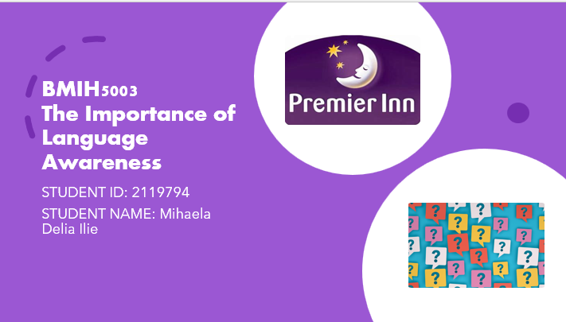
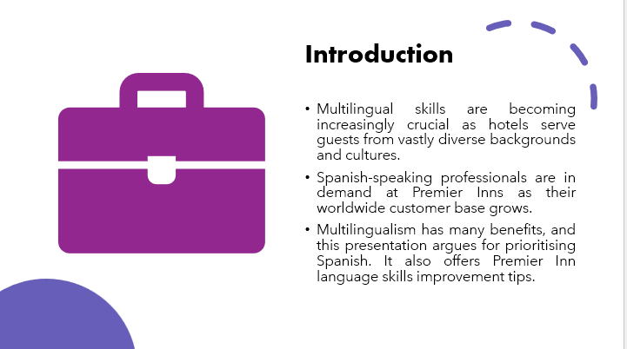
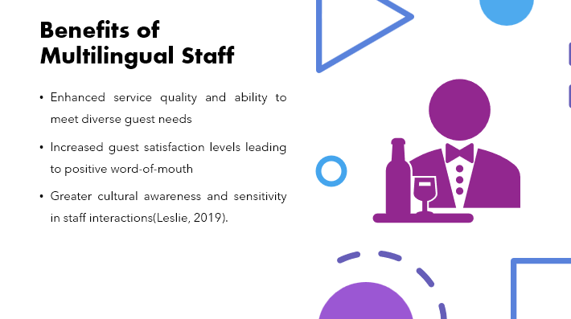

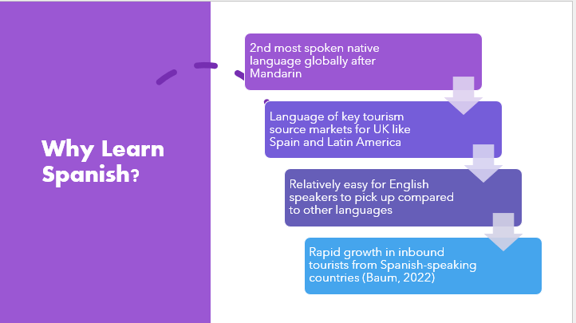

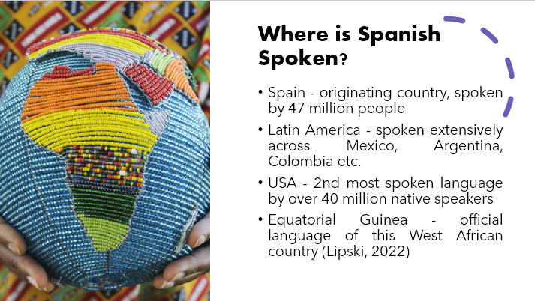
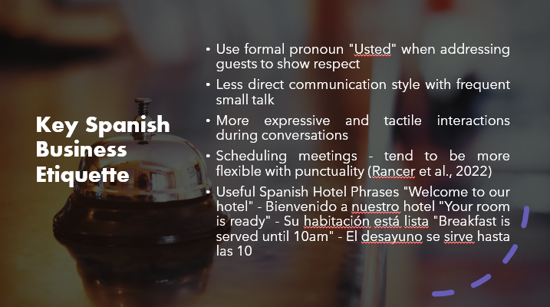
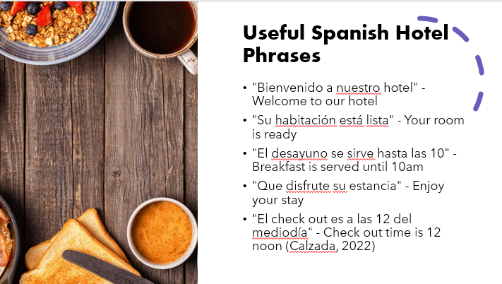
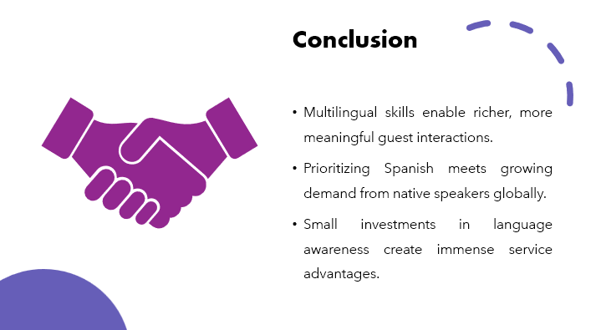
References (no screenshots):
Baum, T. (2022). Has COVID-19 influenced the pattern of future travels. Journal of Tourism Futures.
Leslie, D. (2019). Servicing hospitality and tourism labour markets: National and transnational dynamics. In New Directions in Understanding Immigration in Tourism for Policy and Planning (pp. 27-44). Emerald Publishing Limited.
Lipski, J. M. (2022). A history of Afro-Hispanic language: five centuries, five continents. Cambridge University Press.
Osman, H., Johns, N., Lugosi, P., & Yang, E. C. L. (2022). Hospitality employees’ transferrable skill sets, career success and career patterns after the COVID-19 pandemic. International Journal of Hospitality Management, 102, 103131.
Rancer, A. S., Al-Momani, M., Lamschtein, S., Avtgis, T., Zhang, C., & Moreno, D. (2022). Testing an argument ethic model in Jordan: Arguments, verbal aggressiveness, time orientation, and religio-cultural communication ethics expectations. Communication Research Reports, 1-10.

