
Global Business Environment
Environmental Analysis of an industry
(Assessment 2)
Student Name: Cristina Caraman
Student ID: 2125666
Lecturer: Alfred Mensah

Table of Contents
1. Introduction 3
2. Analysis of the impact of the pandemic on the automobile industry 3
3. Analysis of the impact of the pandemic on the chosen company 4
4. Evaluation of the survival and success factors of the industry through Porter’s diamond model 7
5. Analysis of the megatrends of the industry through external environmental analysis 9
6. Suggestive measures regarding the survival and success factors for the industry 11
7. Conclusion 11
8. References 13

1. Introduction
The following individual assignment is based on the analysis of assignment 1 and its key findings on the global business environment in the context of the automobile industry of the UK such as Ford motor. Concerning this, the researcher will discuss the impact of the pandemic on both the automobile industry as well as the organisation. Additionally, an evaluation of the survival and success factors of the industry as well as the organisation will be done through the analysis of Porter’s diamond model. Moreover, the researcher will analyse the megatrend followed by the industry through the previous external business factor analysis and lastly, the suggestive measures regarding the survival and success factors will have been discussed, which would make the study more comprehensive.

2. Analysis of the impact of the pandemic on the automobile industry
According to the report of Hawes (2021), the impact of the pandemic has put a significant impact on the automobile industry of the UK. Due to Covid-19, the car production rate of the UK has been diminished by -29.3% regarding 920,928 units. Additionally, the production rate of the UK, as well as the overseas market, has declined by -30.4% and -29.1% respectively, which has shown a huge negative impact on the automobile industry outlet.
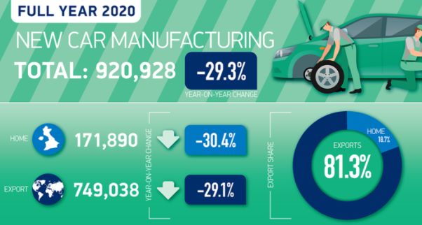
Figure 1: Impact of Covid-19 on the automobile industry in the UK
(Source: Hawes, 2021)
Further Business Today (2021) reported that British car production has slumped by an annual declination of 18.2% in the October of 2021, which signifies the impact of the pandemic and lockdown on the car industry. The report has further depicted the occurrence of the factors that are triggered by the outcome of Covid-19 on the automobile industry of the UK such as Brexit and shifting into electrified vehicles due to environmental sustainability practices.
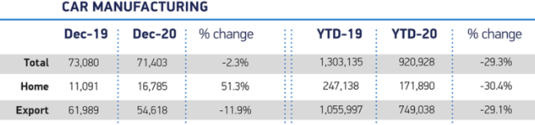
Figure 2: Diminished car manufacturing rate of automobile industries in the UK
(Source: Hawes, 2021)
Moreover, Gössling, Scott and Hall (2021) stated that due to the onset of the pandemic, the concern for the environment and climate change has been significantly enhanced among UK citizens, which has an indirect effect on the automobile industries of the UK respectively. The report of Hawes (2021) depicted that with the decline in the production rate of the UK's automobile industries, the total output of car manufacturing has been decreasing up to -2.3%. The main reason behind it can be the border closure due to lockdown or significant supply chain issues owing to the pandemic.
However, the report of Jolly (2021) opined that the automobile industries of the UK have continued to overcome the challenges due to the pandemic and slowly rising their revenue as well. The majority of automobile industries are focusing on electric vehicle production as the sale of EV-driven cars has been doubled from the previous years by 10.7% respectively, which can be the survival and success key factors for the automobile industries of the UK.

3. Analysis of the impact of the pandemic on the chosen company
Mcelroy (2020) stated that the global Covid-19 pandemic not only logjam the public movement but also shut down organisational performances. The economy of the Ford organisation minimises and they decided to the provision to combat the critical situation in the future. As Ford is a huge automobile company hence, it needed proper support to continue its business and improve organisational performance. Xu et al. (2020) opined that during the Covid-19 pandemic, many organisations such as Ford decided to shut their supply chain, and hence it faced a huge economic loss for that reason Ford decided to provision the losses to safeguard the company’s future.
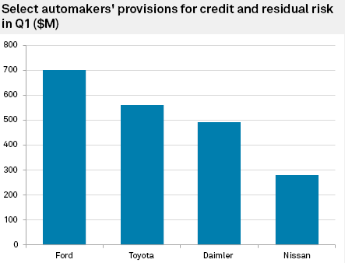
Figure 3: Impact of Covid-19 on Ford and other Companies
(Source: Mcelroy, 2020)
Mcelroy (2020) deduced that Ford is the only company, which provisioned much rather than the other companies such as Toyota, Daimler, and Nissan. Ford’s provisions amounted to $700 Million for the risk maintenance and it protects the organisational capacity (Statista, 2021). The organisation further suffered from a low supply chain and poor network among the suppliers and it reduced Ford’s internal capacity for the continuation of the operation. Kim (2020) mentioned that consumers of Ford are the main sufferers and they were the main ingredients for the organisational development. During the Covid-19 pandemic, Ford had not generated their sales with effective internal control but after the pandemic, they raised their sales, and at the end of the year 2020, they generated revenue of around $136 Billion with a $17.9 Billion net income (Statista, 2021).

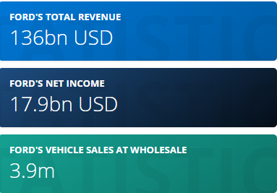
Figure 4: Net Income of Ford in 2020
(Source: Statista, 2021)
As per the data of Statista (2021), Ford is highly influential in the UK market, but in other countries, the operation is not satisfactory. Hence, it can be said that the global business strategy of Ford should require value addition techniques and sustainable function planning for long-term growth with short-term risk. The selling units of Ford highlighted the improvement in sales during the Covid-19 pandemic but as per the rank of Fortune 500, they hold 21st rank, which is not satisfactory for the organisational context (Fortune, 2021).
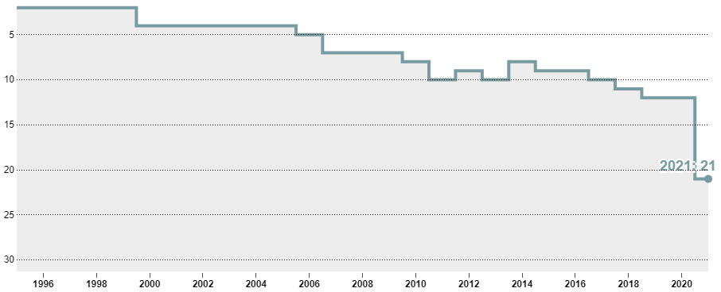
Figure 5: Global Rank of Ford Motor in 2021
(Source: Fortune, 2021)

4. Evaluation of the survival and success factors of the industry through Porter’s diamond model
As per opined by James (2022), the porter's diamond model has mainly preferred the core theory related to the competitive advantage, which is possessed by the nation or particular group for identifying certain core factors such as the role of the Government in improving the country's economic position for achieving global competitive advantage. Further opined by De Bruin (2018), the model has mainly depicted the theories, which would help the businesses to reshape their strategy with proper investing and operating in different global markets. Concerning this study, the impact of the pandemic has diminished the growth of automobile industries in the UK and adopting an innovation strategy, an organisation such as Ford is trying to move towards electrical vehicle production to survive this uncertain economic condition as well achieve success factors regarding this.
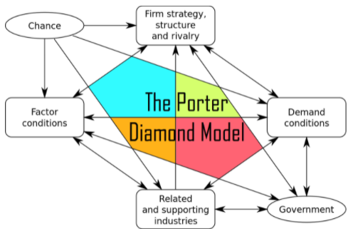
Figure 6: Porter’s Diamond Model
(Source: Claessens, 2016)
Claessens (2016) stated that porter's diamond model is mainly composed of four core elements a firm's strategy, structure and rivalry, supporting industries, demand conditions in the market and factor conditions. The secondary elements of the model are comprised of the support from the Government and chances of the survival and success factor in the target market respectively. Considering the aspect of automobile industries, the survival and success factor of the industry such as Ford can be analysed.
As opined by Clark (2022), the pandemic has put a significant impact on the economy of the UK and the GDP of the country has become 2.2trillion respectively. In this aspect, the implementation of EV vehicles by organisations such as Ford can enhance the economy of the country by attracting a large number of consumers regarding this. The report of BBC (2020) opined that Government has a significant role in the law formation regarding the rules and regulation of the car manufacturing industry. Hence, the help of the UK Gov. in EV vehicle implementation would beneficiary regarding the company.
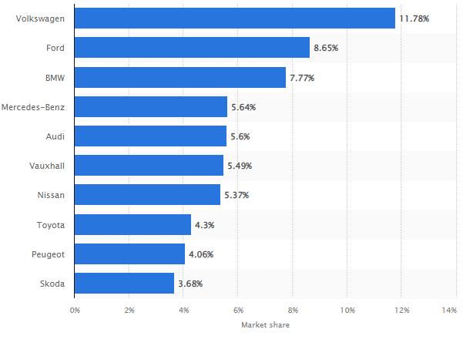
Figure 7: Competitors of Ford in the UK market
(Source: Statista, 2022)
Further reported by Statista (2022), the competition in the UK regarding Ford is comparatively high due to the presence of various competitors such as Volkswagen, Audi, BMW, Mercedes-Benz, and Toyota and so on. Thus, the implementation of EV vehicle can enhance their market share by targeting a large number of consumers and thereby, enhances competitive advantage in the UK. Additionally, the report of Statista (2022) stated that consumers from the UK prefer innovative practices in the automotive industry.
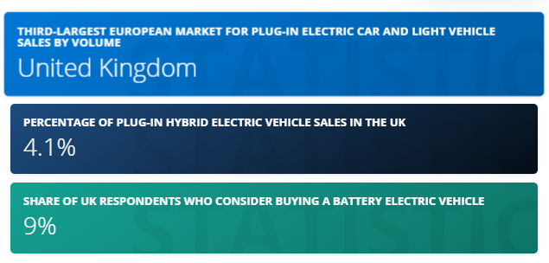
Figure 8: Market demand for EV in the UK
(Source: Wagner, 2021)
It has been further reported that EV requirement in the UK region has been increased and the country has become the largest EV market in Europe in 2020. As per opined by Wagner (2021), the plug-in EV sale has been climbed by 140% owing to the pandemic. The report has further depicted that the demand for EV sales in the UK market is roughly 40% and registration of EVs has been done by 10% of citizens. Additionally, the market share of plug-in hybrid EVs in the UK market is approximately 4.1% while the market share of battery EVs has been 9% respectively. This high demanding market regarding the EV would enable the industry to survive from the previous loss and achieve their desired success effectively.
Furthermore, due to the technical advancement in the UK sectors, the growth of supporting industries such as automotive car manufacturing industries and auto-parts making industries has been found (Giampieri, Ling-Chin and Ma, 2020). Concerning this, Ford can collaborate with these supporting industries for implementing better innovation in their product and further can develop AI-based EVs for gaining a high competitive advantage respectively.

5. Analysis of the megatrends of the industry through external environmental analysis
Components | Analysis | Justification
E-commerce | The E-commerce approach is very crucial for the present day and it highly motivates organisations for future sustainability especially for downgrading automobile industries (Kawasaki, Wakashima and Shibasaki, 2022). | - Ford is highly popular in the UK and it operated through effective internal control, but lack of Government support facing various problems and majorly affected much owing to the Covid-19 pandemic, which logjam the global supply chain enormously and affected the automobile industry (Belhadi et al., 2021).  - E-commerce facilities can uplift the industry value with a critical analysis of marketing development and its effective implementation.
Effective Business reforms | Business reforms can be done by the government of a country and revive the organisational capacity through providing subsidies and benefits (Hassan and Basit, 2018). | - As Ford is facing dynamic challenges from the Government of the UK and policies of BREXIT hence, easy business reforms can improve the automobile industry situation and enable the GDP growth of the country.  - Giving an easy business license can improve the organisational condition and protect the automobile industry, which was once called the sunrise industry (Qazi et al., 2021).
Digitalisation | Digitalisation helps in the promotion of operations and minimises the time for the production and supply chain movement through Blockchain technology (Xu et al., 2022). | - As UK and USA, both are technical giants in the world hence, in the automobile industry, Ford has implemented their technical software for the promotion of digital operations in the UK and USA (Ford about - us, 2022).  - As the Ford Company installed digital functions, it attracted a large number of people with better profitability.
Sustainability Practices | Eco-friendly activities are very crucial after Covid-19 and it improves the operational management very effectively within an organisation for the future growth of the automobile industry. | - As the UK and USA, both countries are suffering from huge carbon emissions and global warming; hence, the EV can reduce the emission level very effectively and protect the sustainability of the automobile industry such as Ford (Luna et al., 2020).  - After Covid-19 sustainability and green operations and management is highly motivated and encouraged by the people. Hence, to attract customers to buy automobiles, Ford must follow sustainable and green operational strategies (Qiao et al., 2019).
Table 1: Analysis of the Megatrends of the Automobile Industry

6. Suggestive measures regarding the survival and success factors for the industry
Phiri (2020) opined that the digital marketing process helps the automobile industry in the future and enhances the capability of organisations such as Ford. Digital marketing tools such as Facebook, Instagram, Twitter, and LinkedIn provided much information regarding digital marketing and it helps to build the nation’s economy for a sustainable future. Digital marketing further reduces the cost of the organisation and Ford can operate maximum revenue with minimum cost. Hallikainen and Laukkanen (2018) opined that organisational trust depends on the quality of the product, it influences the automobile industry very effectively, and this will create dominance in the leading automobile company Ford. The productive analysis of the operations and their effectiveness in the industrial culture development is highly benefitted through digital implementation and this ensures customers for a better-innovated brand. The automobile industries are suffering from various issues and they need to revive the economy of the UK and the USA with the help of analytics and tools.
Mokhtar et al. (2020) opined that the importance of industry 4.0 could generate different results with respect to the Covid-19 pandemic. As the pandemic reduced the effectiveness of the automobile industry, hence it is required to install technical innovation tools and manage the operations with sustainable practices. The covid-19 has given a vast crisis in the automobile industries and it further evaluated the carbon emission statistics, which is very crucial for the upcoming years (Jiang, Zhou and Liu, 2019). Henceforth, it can be said that digitalisation, innovation, and creativity can protect and give success to the automobile industries such as Ford.

7. Conclusion
The above discussion placed many fundamental factors for the analysis of the impact of Covid-19 on the automobile industry. The leading automobile company namely Ford has suffered various issues, which it created owing to the Covid-19 pandemic. Covid-19 highly affected the automobile industry in the UK and the USA, hence they tried to survive and get success over barriers. Many instances of survival and success of the automobile industry are discussed with due care and analyse the opportunities for future operations in the automobile industry. At last, the topic highlighted the future trends or megatrends of the automobile industry such as Ford, which needs to rebuild internal operational management for global business continuation.

8. References
BBC (2020) Brexit: What you need to know about the UK leaving the EU, BBC News. Available at: https://www.bbc.com/news/uk-politics-32810887 (Accessed: 29 March 2022).
Belhadi, A., Kamble, S., Jabbour, C.J.C., Gunasekaran, A., Ndubisi, N.O. and Venkatesh, M., (2021). Manufacturing and service supply chain resilience to the COVID-19 outbreak: Lessons learned from the automobile and airline industries. Technological Forecasting and Social Change, 163, p.120447, DOI: 10.1016/j.techfore.2020.120447.
Business Today (2021) COVID-19 impact: UK's car output slumps 18% in October, Business Today. Available at: https://www.businesstoday.in/auto/story/covid-19-impact-uk-car-output-slumps-18-in-october-279783-2020-11-26 (Accessed: 29 March 2022).
Claessens, M. (2016) The Porter Diamond Model - National Competitiveness, Marketing-Insider. Available at: https://marketing-insider.eu/porter-diamond-model/ (Accessed: 29 March 2022).
Clark, D. (2022) Topic: The UK economy, Statista. Available at: https://www.statista.com/topics/6500/the-british-economy/#topicHeader__wrapper (Accessed: 29 March 2022).
De Bruin, L. (2018) Porter's Diamond Model Explained with Examples | B2U, B2U - Business-to-you.com. Available at: https://www.business-to-you.com/porter-diamond-model/ (Accessed: 29 March 2022).
Ford about - us (2022) Ford, corporate.ford.com. Available at: https://corporate.ford.com/about.html (Accessed: 29 March 2022).
Fortune (2021) Ford Motor | 2021 Fortune 500, Fortune. Available at: https://fortune.com/company/ford-motor/fortune500/ (Accessed: 29 March 2022).
Giampieri, A., Ling-Chin, J. and Ma, Z. (2020) A review of the current automotive manufacturing practice from an energy perspective, Sciencedirect. Available at: https://www.sciencedirect.com/science/article/pii/S0306261919317611 (Accessed: 29 March 2022).
Gössling, S., Scott, D. and Hall, C.M., (2020). Pandemics, tourism and global change: a rapid assessment of COVID-19. Journal of sustainable tourism, 29(1), pp.1-20.
Hallikainen, H. and Laukkanen, T., (2018). National culture and consumer trust in e-commerce. International Journal of Information Management, 38(1), pp.97-106, DOI: 10.1016/j.ijinfomgt.2017.07.002.
Hassan, Z. and Basit, A., (2018). Ease of doing business and its impact on inward FDI. Hossain, MT, Hassan, Z., Shafiq, S., & Basit, A.(2018). Ease of Doing Business and Its Impact on Inward FDI. Indonesian Journal of Management and Business Economics, 1(1), pp.52-65, https://papers.ssrn.com/sol3/papers.cfm?abstract_id=3219641.
Hawes, M. (2021) UK car production down -29.3% as coronavirus slams brakes on sector - SMMT, SMMT. Available at: https://www.smmt.co.uk/2021/01/uk-car-production-down-29-3-as-coronavirus-slams-brakes-on-sector/ (Accessed: 29 March 2022).
James, M. (2022) What Is the Porter Diamond?, Investopedia. Available at: https://www.investopedia.com/terms/p/porter-diamond.asp#:~:text=The%20Porter%20Diamond%2C%20properly%20referred,catalysts%20to%20improve%20a%20country's (Accessed: 29 March 2022).
Jiang, Y., Zhou, Z. and Liu, C., (2019). The impact of public transportation on carbon emissions: a panel quantile analysis based on Chinese provincial data. Environmental Science and Pollution Research, 26(4), pp.4000-4012, https://link.springer.com/article/10.1007/s11356-018-3921-y.
Jolly, J. (2021) UK car industry continues weak recovery from Covid in June, The Guardian. Available at: https://www.theguardian.com/business/2021/jul/05/uk-car-industry-continues-weak-recovery-from-covid-in-june (Accessed: 29 March 2022).
Kawasaki, T., Wakashima, H. and Shibasaki, R., (2022). The use of e-commerce and the COVID-19 outbreak: A panel data analysis in Japan. Transport Policy, 115, pp.88-100, DOI: 10.1016/j.tranpol.2021.10.023.
Kim, R.Y., (2020). The impact of COVID-19 on consumers: Preparing for digital sales. IEEE Engineering Management Review, 48(3), pp.212-218, DOI: 10.1109/EMR.2020.2990115.
Luna, T.F., Uriona-Maldonado, M., Silva, M.E. and Vaz, C.R., (2020). The influence of e-carsharing schemes on electric vehicle adoption and carbon emissions: An emerging economy study. Transportation Research Part D: Transport and Environment, 79, p.102226, DOI: 10.1016/j.trd.2020.102226.
Mcelroy, C. (2020) Global automakers' finance arms brace for impact from coronavirus crisis, Spglobal.com. Available at: https://www.spglobal.com/marketintelligence/en/news-insights/latest-news-headlines/global-automakers-finance-arms-brace-for-impact-from-coronavirus-crisis-58785497 (Accessed: 29 March 2022).
Mokhtar, S.S.S., Mahomed, A.S.B., Aziz, Y.A. and Rahman, S.A., (2020). Industry 4.0: the importance of innovation in adopting cloud computing among SMEs in Malaysia. Polish Journal of Management Studies, 22, DOI: 10.17512/pjms.2020.22.1.20.
Phiri, M., (2020). Exploring digital marketing resources, capabilities and market performance of small to medium agro-processors. A conceptual model. Journal of Business and Retail Management Research, 14(2), https://www.jbrmr.com/cdn/issue_file/2020-05-03-13-39-59-PM.pdf#page=8.
Qazi, T.F., Niazi, A.A.K., Asghar, W. and Basit, A., (2021). Ease of doing business: analysis of trade facilitations of one hundred twenty-seven countries of the world. Journal of Accounting and Finance in Emerging Economies, 7(1), pp.65-75, DOI: 10.26710/jafee.v7i1.1531.
Qiao, Q., Zhao, F., Liu, Z. and Hao, H., (2019). Electric vehicle recycling in China: Economic and environmental benefits. Resources, Conservation and Recycling, 140, pp.45-53, DOI: 10.1016/j.resconrec.2018.09.003.
Statista (2021) Topic: Ford, Statista. Available at: https://www.statista.com/topics/1886/ford/#dossierKeyfigures (Accessed: 29 March 2022).
Statista (2022) Car brands' UK market share by month 2020 | Statista, Statista. Available at: https://www.statista.com/statistics/300467/leading-car-companies-market-share-in-the-united-kingdom/ (Accessed: 29 March 2022).
Statista (2022) Willingness to pay for innovative automotive technologies in 2016 | Statista, Statista. Available at: https://www.statista.com/statistics/788626/willingness-to-pay-innovative-automotive-technologies-in-the-united-kingdom/ (Accessed: 29 March 2022).
Wagner, I. (2021) Topic: Electric vehicle market in the United Kingdom, Statista. Available at: https://www.statista.com/topics/2298/the-uk-electric-vehicle-industry/#topicHeader__wrapper (Accessed: 29 March 2022).
Xu, X., Tatge, L., Xu, X. and Liu, Y., (2022). Blockchain applications in the supply chain management in German automotive industry. Production Planning & Control, pp.1-15, DOI: 10.1080/09537287.2022.2044073.
Xu, Z., Elomri, A., Kerbache, L. and El Omri, A., (2020). Impacts of COVID-19 on global supply chains: facts and perspectives. IEEE Engineering Management Review, 48(3), pp.153-166, DOI: 10.1109/EMR.2020.3018420.

