Mihai-Catalin Badici
2009202
Data Analysis and Visualization
Anupam Mazumdar

Contents
List of figures 2
Introduction 3
Description of Dataset 4
Hypothesis for the analysis 5
Appropriate Technique for Analysis 6
Selection and justification for the techniques used 7
Application of Hypothesis techniques 7
Results of the Analysis 7
Visualization of both the data 10
Results 11
Conclusion 12
References 13

List of figures

Figure 1 Dataset 4
Figure 2 Regression statistics 5
Figure 3 F-test 6
Figure 4 t-test for p=0.10 8
Figure 5 t-test for p=0.01 9
Figure 6 t-test for p=0.02 10
Figure 7 Visualization 10

Introduction
The BBC news of London has identified that the infection rate of covid-19 in between BAME and white people is varying, this report consist of the finding and satisfying the news produced by BBC news. This report consists of description of the data set and the testing result of data including the null and alternative hypothesis made on it.

Description of Dataset
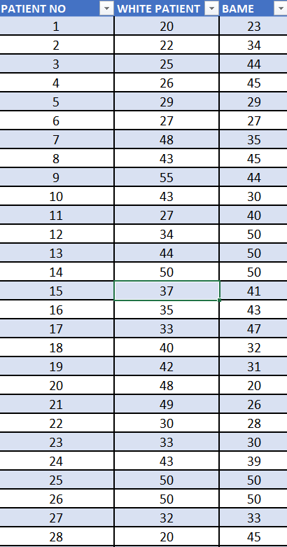
Figure 1 Dataset
The dataset consists of the value of ages of BAME patient and White patients of UK, the BBC news of UK identified that the infection rate of Covid-19 is different in both BAME and White patients. There is 50 people in the dataset selected from both of the communities.
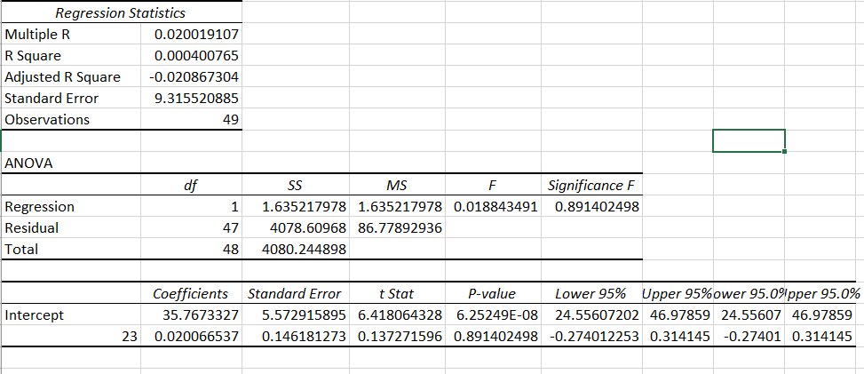
Figure 2 Regression statistics
This is the regression statistics of the data. The p value here is so small.

Hypothesis for the analysis
F-Test Two-Sample for Variances
This test is used to identify the variances of the data of BAME and White patients, so to know which condition is to be used to test the data. There is two kind of testing which is for equal variances and another one is for unequal variances. It also tests the Null hypothesis if the value of F is larger than the value of F critical then the null hypothesis can be rejected otherwise cannot be rejected (Solver n.d.).
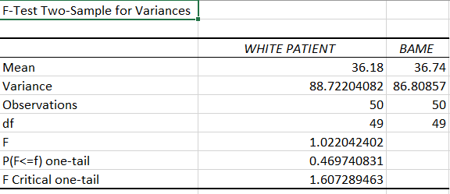
Figure 3 F-test
From the above result of f-test it can be seen that the value of variances of both the patients are different and so the testing must be preferred for the unequal variances and the hypothesis will be rejected according to that.

Appropriate Technique for Analysis
Null Hypothesis:
Null hypothesis is used to identify whether the population parameter and hypothesized value are equal. It is used as the initial claim before starting any analysis. According to this:
Mean1-mean2 =0
Alternative Hypothesis:
It is the opposite of the Null Hypothesis, it states that the population parameter is not equal to hypothesized parameter and is greater, smaller or different from that.
Two-sided hypothesis:
It is type of alternative hypothesis in which a observer wants to detect whether the condition is greater than or smaller than the hypothesized value, it is calculated in that case.
One-sided hypothesis:
It is used to determine whether the population parameter differs from the hypothesized value in a specific direction. In that case this type of hypothesis is calculated (Minitab n.d.).

Selection and justification for the techniques used
The techniques used to determine the truthfulness of the findings of the UK news and to determine whether the infection rate for both of them are different of not. First of all, from the f-test the variances are calculated and then for the unequal variances, t test for unequal variances is chosen. The reason behind selecting this technique is because it tests both for null and alternate hypothesis by giving the value of t-stat and t-two tail, also the values of the probability is calculated in order to identify whether there is any chance to reject the null hypothesis, if the null hypothesis is not proved to be rejected then the testing of alternate hypothesis is not favored. The null hypothesis tells the initial condition which was assumed is true and there is no mistake in the assumption and it is true. The techniques are best to analyze the data in case of hypothesis (Solver n.d.).

Application of Hypothesis techniques
1) Hypothesis techniques can help companies by making the false perception and analyzing whether the data is different or not. The companies can control on their production system.
2) The hypothesis testing is used after the other statistics methods fails to demonstrate any findings.
3) This is used to know whether the assumption is true or not, so that accuracy of the system can be checked (Syafriandi et al. 2020).

Results of the Analysis
1) p = 0.10
The test for the significance level 0.10 tells that:
- If the value of t-stat is less than the value of t critical two-tail, then the null hypothesis cannot be rejected. Here the value of t-stat is -0.298 which is clearly less than the t critical value which is 1.66, so the null hypothesis cannot be rejected.
- If the value of p two tail is greater than the significance value then the null hypothesis cannot be rejected. Here the value of p two tail is 0.765, which is greater than the 0.10 so the null hypothesis cannot be rejected.
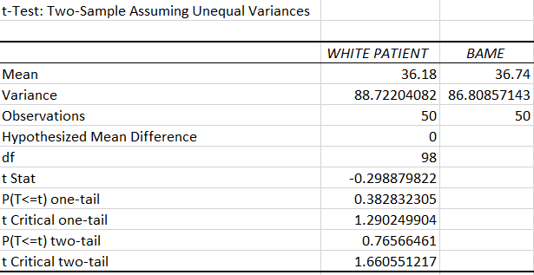
Figure 4 t-test for p=0.10
(Solver n.d.)
2) p = 0.01
For the significance level of 0.01, the hypothesis is tested by means of t-test for unequal variances.
From the test it can be analyzed that:
- If the value of t-stat is smaller than the t-critical two tail, then the null hypothesis cannot be rejected, the two tail is considered because the infection rate is varying and it is to be find whether the hypothesis is true or not. So here the value of t-stat is -0.298 and value of t critical two-tail is 2.62 so the null hypothesis cannot be rejected.
- Second method is to check whether the value of p two-tail is greater than the significance value then the Null hypothesis cannot be rejected. Here the value of p two tail is 0.765 which is clearly greater than the significance value 0.01.
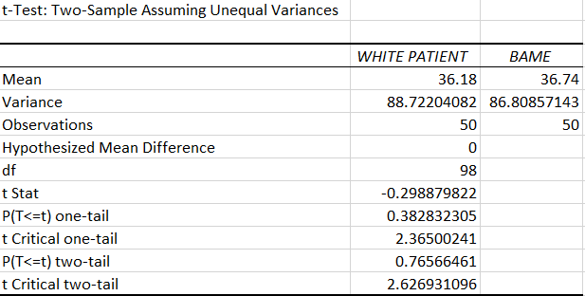
Figure 5 t-test for p=0.01
(Solver n.d.)
3) p = 0.02
For the value of significance level 0.02, the result value can be analyzed as:
- If the value of t-stat is smaller than the t critical two stat, the null hypothesis cannot be rejected, here the value of t-stat is -0.298 which is clearly smaller than the t critical two tail value which is 2.365, which tells that the null hypothesis cannot be rejected.
- It states that if the p two tail value is greater than the significance value then the null hypothesis cannot be rejected. Here the value of p two tail is 0.765 which is greater than 0.02, so the result is null hypothesis cannot be rejected.
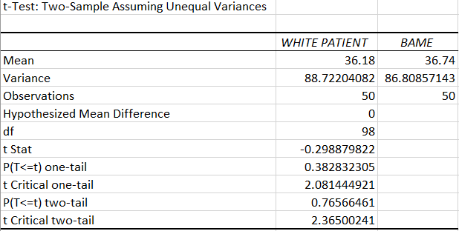
Figure 6 t-test for p=0.02
(Solver n.d.)

Visualization of both the data

Figure 7 Visualization
(Gu et al. 2017)
This shows the age visualization of both of the community in which the idea of different ages from BAME and White can be seen.

Results
The t test for unequal variances is followed for various significance value like 0.01, 0.10, 0.02 to test whether the hypothesis is true or not, from the observation it is found that the null hypothesis cannot be rejected that means the assumption which was taken cannot be rejected as in every significance level the test doesn’t allow the alternate hypothesis, which means the assumption which was taken is true, the cases in both the community BAME and White patient is varying.

Conclusion
For the news produces by the BBC channel, the covid-19 rate is varying in the BAME and White people, the data is analyzed by using excel. The data was tested by using t-test for unequal variance and the result was found. To check the assumptions whether the news is true or not the operations was made and found that the null hypothesis was hard to reject in all the cases where value of p is 0.01, 0.10, 0.02 and found that the null hypothesis cannot be rejected and the rate of covid-19 is actually varying in the BAME and White people.

References
Syafriandi, S., Fauzan, A., Lufri, L. and Armiati, A., 2020. Designing hypothetical learning trajectory for learning the importance of hypothesis testing. In Journal of Physics: Conference Series (Vol. 1554, p. 012045).
Minitab. N.d. About the null and alternative hypothesis. Minitab, [online], Available at: https://support.minitab.com/en-us/minitab/18/help-and-how-to/statistics/basic-statistics/supporting-topics/basics/null-and-alternative-hypotheses/. [Accessed on 3 December 2020]
Solver. N.d. t-test: two sample assuming unequal variances. Solver, [online], Available at: https://www.solver.com/t-test-two-sample-assuming-unequal-variances. [Accessed on 3 December 2020]
Solver. N.d. f-test two- sample for variances. Solver. [online], Available at: https://www.solver.com/f-test-two-sample-variances#:~:text=The%20F%2DTest%20Two%2DSample,and%20their%20scores%20were%20recorded.. [Accessed on 3 December 2020]
Gu, W. and Li, S., 2017. EXCEL Advanced Tips and Tricks: Filter, Data Sort, Pivot Table, and Graphics.

