DS 1 Template
Student ID: 2618327

My Screenshots/Photos
- Please add 4–6 screenshots or photos of your digital life.
- You can use your phone or laptop.
- For each screenshot, write one or two sentences explaining what it shows.

Screenshot/Photo 1
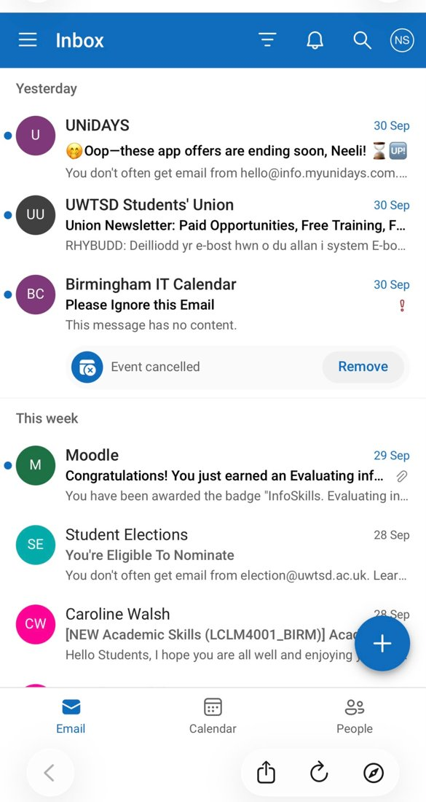
This screen presents my university email inbox in the Outlook app on my phone. I regularly use this for messages from my tutors, the Students’ Union and Moodle, such as the badge I earned for demonstrating skills in evaluating information.

Screenshot/Photo 2
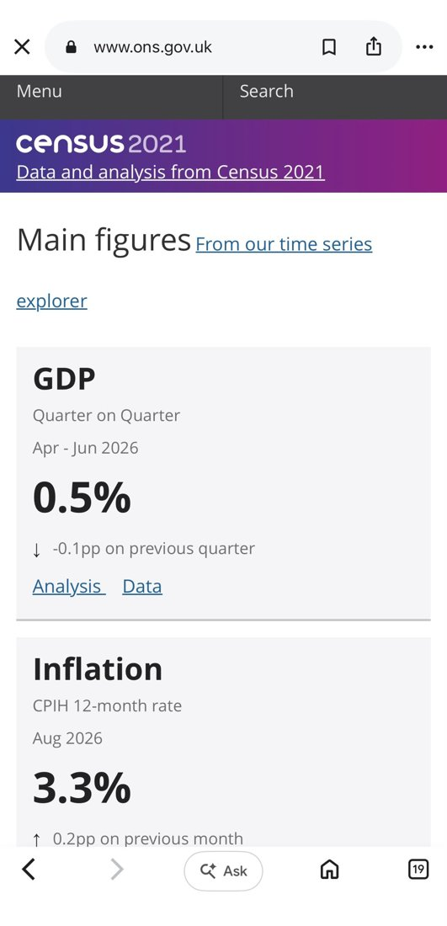
This is the Office for National Statistics (ONS) website accessed through a web browser on my mobile phone. I use it to find reliable, up-to-date data such as GDP (0.5%) and inflation (3.3%), which helps me practise judging information in a business context.

Screenshot/Photo 3
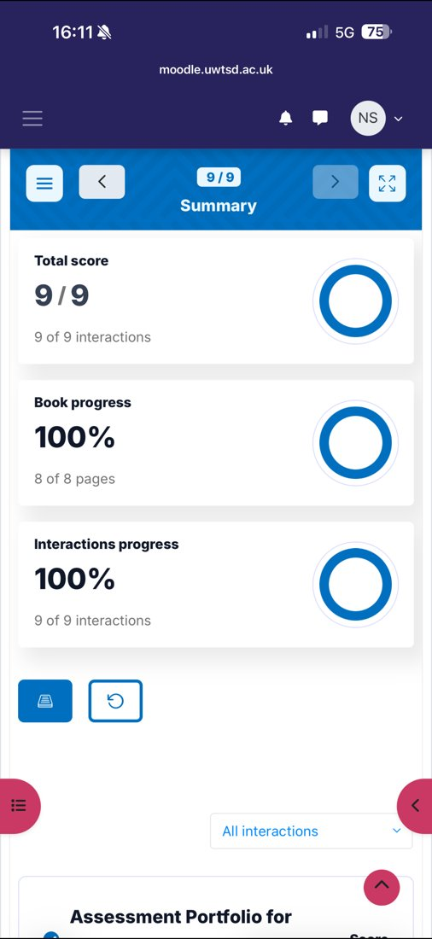
This screenshot shows the result for an online InfoSkills lesson on Moodle in which I've achieved a score of 9/9 and 100% progress. This demonstrates my ability to engage effectively with interactive online learning and independently monitor my academic progress using digital technology.

Screenshot/Photo 4
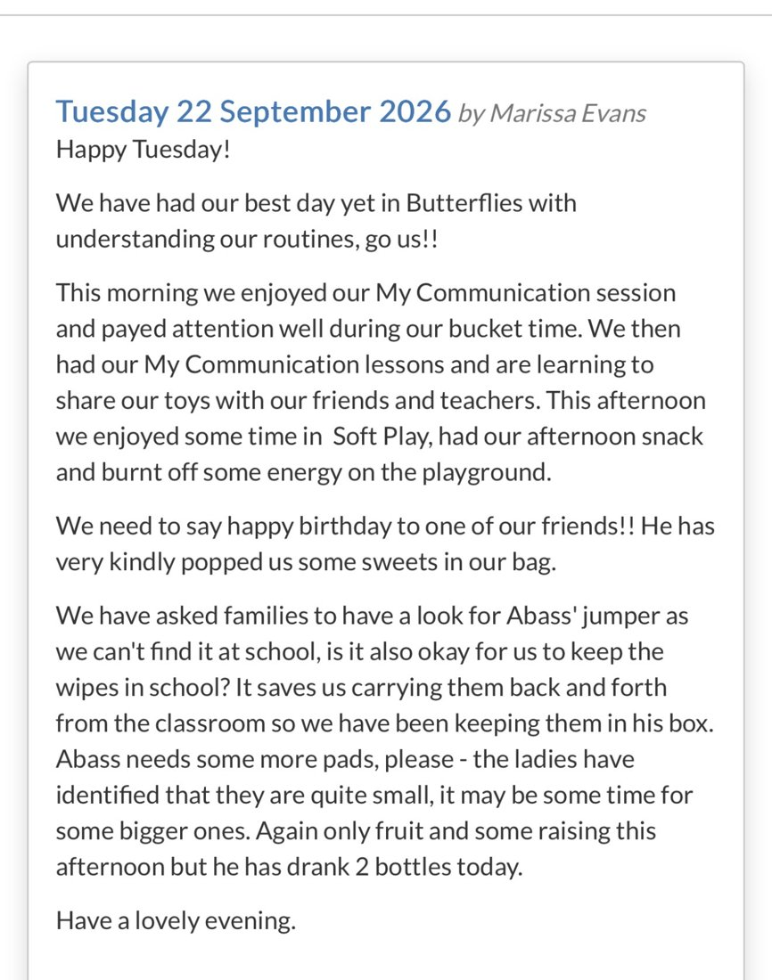
This is a daily update shared through an online communication platform that my family’s school/nursery uses. It provides important information about daily activities and demonstrates my ability to use digital tools effectively to stay informed and communicate in my personal life.

Screenshot/Photo 5
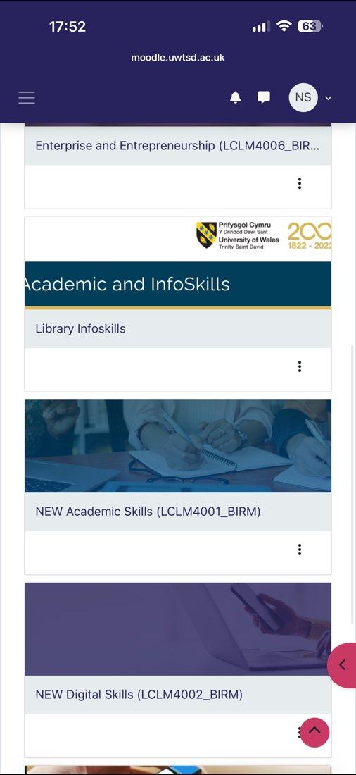
This is my Moodle course page accessed through my phone. It displays my university modules, including Academic Skills, Digital Skills and Library InfoSkills, so I can access and manage my study resources wherever I am.

My Short Reflection
- Write 5–8 simple sentences about your digital life.
- You can use the sentence starters below if helpful.
I use a range of digital tools to support my studies, to find reliable information and to stay in touch with university and family. I frequently use these tools: Moodle, Outlook email, my phone web browser and online messaging platforms.
I feel confident using Moodle on my phone, checking my emails and completing online lessons, for example, my InfoSkills lesson where I scored 9/9, which has increased my confidence in using digital learning resources.
I also feel confident when I look for reliable and relevant data on websites like the ONS, and I check the source to ensure that the data is credible and appropriate for my studies.
I want to improve how I organise my files and notes effectively on my laptop and how I use Microsoft Teams, OneDrive and PowerPoint.
Although I sometimes feel nervous about using new technology or lengthy online tasks, I know the tutors and the HWB team will support me when necessary.
I hope this module will help me to build my digital skills and increase my confidence step by step.
Digital skills are important for me because they are essential for my studies, my family life and my future business career.

Sentence starters
- I use digital tools to …
- I feel confident when I …
- I want to improve …
- I often use these tools: …
- I sometimes feel nervous about …
- I hope this module will help me …
- Digital skills are important for me because …
You can write more if you want.

Submission Checklist
Before you submit, please check:
​​​ ☒ I added 4–6 screenshots
☒ I wrote short sentences for each screenshot
☒ I wrote my short reflection
☒ My work is my own
☒ My file opens correctly
​​☒ My file opens correctly

