Student Name: Anoshia Zaheer
Student Number:2128010
Module Code: LCHS4005
Module Name: Professional Development within Health and Social Care
Lecture Name: Farah Islam

Contents
1. Task 1 - CV 3
2. Task 2 – Cover Letter 5
3. Task 3 - SWOT Analysis 7
Personal development plan 8
4. Task 4 - Personal statement 9
5. Task 5 - Reflection 11

Task 1 - CV

ANOSHIA ZAHEER
Mobile Number :07734630172
Email: anmalik2021@hotmail.com
Adress: 11 Grantham Road
Sparkhill
B11 1LU
Birmingham

OBJECTIVES
It is my goal to obtain a position that will allow me to utilize my education, knowledge, and ability to work with people in order to gain valuable experience.

EDUCATIONAL BACKGROUND

- Graduation B.A
- Intermediate F.A
- Matric

PROFESIONAL EXPERIENCE
- One year experience in Holiday clubs.
- One year experience in Nursery.

LANGUAGE

- Urdu, Punjabi, English

PERSONAL INFORMATION

- “Father’s Name” Zaheer Ahmed
- “Date of Birth” 12-11-1987
- “Marital status” Married
- “Gender” Female
- “Religion” Islam
- “Nationality” England
INTEREST
- Working with kids
REFERENCE
Naheem Malik
Mubial Number +44 7735 336427

POST APPLIED FOR YOUTH WORKER

Dear Sir/Madam,
It is requested that; I am applying for the above-mentioned post in your organisation.
I have known about the responsibilities of youth worker.
I Have much experience in the relevant field.
If you give me a chance in your institute, I will prove myself an asset for your institute.

ABOUT THE ROLE
- The youth worker will be supporting young people with special educational needs on a one-to-one basis.
- Building a strong rapport with the student to encourage them to attend and thrive in school health and safety and rules of conduct are followed.
- To build a rapport with young people and listen to their concerns.
- To facilitate and participate in games, activities and discussions with young people.

Task 2 – Cover Letter
Dear Hiring Manager,
I am writing to express my keen interest in the Youth Worker position advertised in your organisation. With one year of experience in both Holiday Clubs and Nursery, I am confident in my ability to support young people with special educational needs, build strong rapport and facilitate engaging activities that encourage their growth and development. In my previous experience working in Holiday Clubs, I was responsible for creating and implementing exciting and engaging activities for children aged 5-11. My duties included creating and organising lesson plans, supervising group activities and ensuring the safety of the children in my care. This experience has allowed me to develop excellent communication skills and a deep understanding of how to support young people in different environments.
Similarly, in my experience working in Nursery, I was responsible for providing a nurturing and stimulating environment for children aged six months to 4 years old. My responsibilities included planning and leading age-appropriate activities that fostered learning and development, ensuring a clean and organised environment, and communicating effectively with parents and colleagues. Furthermore, pursuing a Level 4 Diploma in Health and Social Care has equipped me with knowledge and skills relevant to the role of Youth Worker. I have developed a deeper understanding of mental health and well-being, and I believe that this knowledge will be invaluable in supporting young people with special educational needs.
As someone who has always had a passion for working with children, I am confident that my combination of experience and education will allow me to excel in the role of Youth Worker. I am eager to support young people on a one-to-one basis, build strong rapport and facilitate engaging activities that encourage their growth and development. I am committed to upholding health and safety protocols and ensuring that all rules of conduct are followed.

In the end, I would like to express my sincere interest in the Youth Worker position advertised in your organisation. I am excited about the opportunity to bring my skills, experience, and passion for working with children to your organisation. Thank you for considering my application, and I look forward to hearing from you soon.
Sincerely,
“Name”

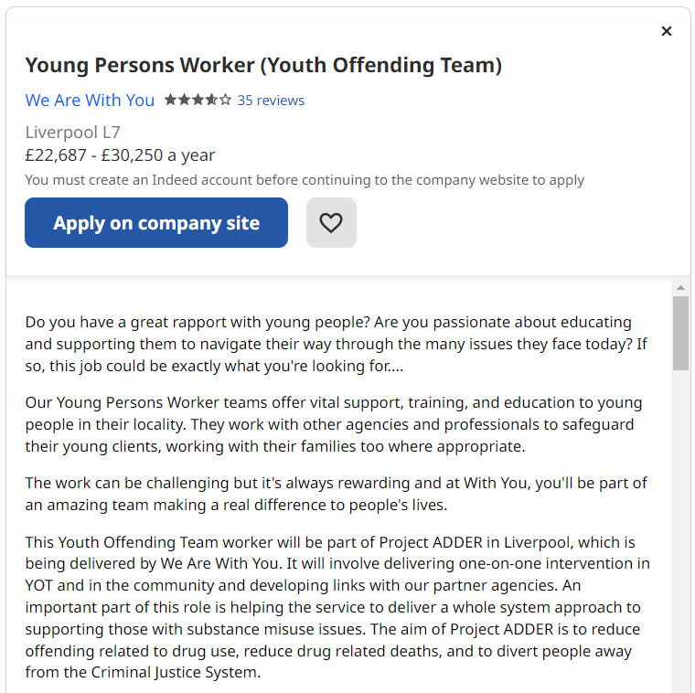

Indeed.com

3.Task 3 - SWOT Analysis
SWOT stands for Strengths, Weaknesses, Opportunities, and Threats. A SWOT analysis is a framework to help assess and understand the internal and external forces that may create opportunities or risks for an organization.

Strengths | Weaknesses
- Experience in working with children through one year of holiday club and one year of nursery experience.  - Strong communication skills and ability to build rapport with children and families.  - Passion for working with children and promoting positive mental health and well-being.  - Pursuing a Level 4 Diploma in Health and Social Care to further develop knowledge and skills. | - Limited experience in working with children with special educational needs.  - May struggle with time management when balancing work and studies.  - Lack of experience in management roles or leading teams.
Opportunities | Threats
- Opportunities to gain further experience in working with children with special educational needs to develop a more diverse skill set.  - Opportunities to learn from experienced professionals in the field and attend relevant training and conferences.  - Possibility of pursuing a higher level of education, such as a degree or postgraduate qualification, to further enhance knowledge and skills. | - Competition in the job market for educational and social care roles.  - Economic and political factors could affect funding and resources available for education and social care.  - Changing regulations and policies may affect the delivery of care and support for children and families.

Personal development plan
A professional development plan is an ever-changing document that assesses your current skill set, helps you set career goals, create strategies, and uncover resources that will help you reach them. Read on for examples of professional development goals and plans and discover tools to help track your progress. (2022)

Target | How will I achieve this? | Why will this target benefit me? | What will change when I achieve this? | When do I want to meet this target by?
Develop expertise in working with children with special educational needs | Enroll in a course or training program that focuses on special education and working with children with special educational needs.  Volunteer or work in a setting that specializes in supporting children with special educational needs. | It will help me develop the knowledge and skills necessary to provide effective support for children with special educational needs.  It will increase my employability and make me a more attractive candidate for roles that require expertise in this area. | I will have a deeper understanding of the unique needs and challenges faced by children with special educational needs.  I will be better equipped to develop and implement effective strategies for supporting these children and promoting their development. | I want to develop expertise in working with children with special educational needs within the next 16 months.
Develop management and leadership skills | Seek out opportunities for leadership roles within my current organization or through volunteering.  Enroll in a management or leadership course or training program. | It will increase my ability to manage and lead teams effectively, making me a more valuable employee and enhancing my career prospects.  It will enhance my ability to communicate and collaborate effectively with colleagues, families, and other professionals. | I will be better equipped to manage and lead teams effectively, improving outcomes for the children and families I serve.  I will be able to communicate more effectively with colleagues, families, and other professionals, improving collaboration and coordination. | I want to develop management and leadership skills within the next 24 months.

Task 4 - Personal statement

As a passionate and committed individual, I am writing to express my interest in the position of Youth Worker. With one year of experience working in holiday clubs and one year of experience in a nursery, I have gained valuable skills and knowledge that I believe would be a valuable asset to your team. Additionally, I am pursuing a Level 4 Diploma in Health and Social Care, which has further enhanced my ability to effectively support individuals with varying needs. I have developed a strong passion for working with children and young people throughout my career. My experience in holiday clubs and nurseries has given me the opportunity to work with a wide range of children from diverse backgrounds and with varying needs. This has helped me develop a deep understanding of the importance of building strong relationships with children and their families in order to provide effective and tailored support. As a result, I have become skilled in building rapport with children and young people and ensuring that they feel valued and heard.
In addition to my experience working with children, I have also developed a range of professional skills that I believe would be of value to an employer. Firstly, I am a highly organised individual who is able to manage multiple tasks and responsibilities simultaneously. This is essential when working in a fast-paced environment such as a youth centre, where there are often multiple demands on my time. Additionally, I have excellent communication skills, which enable me to effectively engage with children, colleagues, and external professionals such as social workers and teachers. One of my greatest strengths is my ability to work effectively with children with special educational needs (SEN). Through my experience working in holiday clubs, I have developed an understanding of how to support children with a range of needs, including those with autism, ADHD and other behavioural and developmental conditions. I have also learned how to create an inclusive environment that is welcoming to all children, regardless of their abilities.

As a person, I am highly empathetic and caring. I take great pride in supporting children to develop their social and emotional skills, helping them to become confident and resilient individuals. I understand the importance of creating a safe and nurturing environment where children feel comfortable sharing their feelings and experiences. This is essential in building trust and developing positive relationships with the children and their families. My main career aim is to continue developing my skills and knowledge in the field of education and social care, with a particular focus on supporting young people with special educational needs. I am committed to positively impacting the lives of the children and young people I work with by providing tailored and effective support that meets their individual needs. I am passionate about working in a role that enables me to make a real difference by empowering young people to reach their full potential.
I believe that my skills, experience and personal qualities make me an ideal candidate for the position of Youth Worker. My passion for working with children and my professional skills and educational background make me confident in my ability to contribute positively to your team. I am eager to use my skills and knowledge to support the development of the children and young people that you work with, and I am excited about the prospect of working with your organisation to achieve this goal. Thank you for considering my application.

Task 5 - Reflection
Throughout the process of completing the various tasks, including my CV, cover letter, swot analysis, personal development plan, and personal statement, I have learned a great deal about myself and my professional goals. The feedback provided by my lecturer has been invaluable in helping me to identify areas for improvement and to refine my approach to these tasks. In terms of my CV, I feel that I have been able to effectively showcase my education, experience, and skills. However, my lecturer pointed out that I could benefit from highlighting more specific achievements within my roles rather than simply listing my duties. I plan to revise my CV accordingly to better demonstrate my value as a candidate.
Similarly, in my cover letter, I have described my passion for working with young people and highlighted my relevant experience. My lecturer advised me to be more specific about why I am interested in this particular position. This feedback will be incorporated into my cover letter to demonstrate my fit for the job. Identifying my strengths and areas for improvement has been made easier by my SWOT analysis. Having worked in holiday camps and nurseries and pursuing a Level 4 Diploma in Health and Social Care, I was pleased to see that my experience was recognized. However, I also identified a weakness in my lack of experience working with children with special educational needs. I plan to seek out opportunities to gain experience in this area to improve my skill set.
My personal development plan provided a clear pathway for achieving my goals. Developing my leadership skills and working with children with special education needs are my priorities. I believe these goals will help me become a more well-rounded and effective youth worker. In my personal statement, I explained my passion for working with young people and my relevant skills and experience. In my lecturer's opinion, I should be more specific about why I am interested in this particular role and how my previous experience and education will be beneficial.

To better demonstrate my fit for the job, I will revise my personal statement. These tasks have helped me assess my strengths and areas for improvement and formulate a plan for reaching my professional objectives. The feedback from my lecturer has been very helpful and I hope to continue to grow and develop.

Refence
https://asana.com/resources/professional-development-plan
https://corporatefinanceinstitute.com/resources/management/swot-analysis/

