
WIZZ AIR


Name: simona COTOFAN (2313525)
name: management Accounting for Managers
Code name: LCBB5010

Table of Contents
1.) Introduction 2
2.) Content 3
2.1) Cost Analysis and Business Model of Wizz Air 3
2.2) Financial planning and budgeting at Wizz Air 5
2.3) Performance Measurement and Decision-Making 7
2.4) Sustainability and Ethical Considerations 9
3.0 Conclusion 11
Bibliography 12

Wizz Air Holdings Plc’s Financial Decision-Making and Management Accounting Tools


1.) Introduction
Wizz Air was founded in 2003 by József Váradi, and its first flight took place on 19 May 2004 from Katowice International Airport (KTW) to London Luton Airport (LTN) (Lomas , 2023).
The London Stock Exchange lists Wizz Air Holdings plc, a European ultra-low-cost carrier, under the ticker WIZZ. The airline uses a low-cost model based on intensive aircraft utilisation, point-to-point routes, a distinctive aircraft family strategy, and robust ancillary income generation to operate primarily in Europe, Central and Eastern Europe, and a few foreign markets. With a fleet of Airbus A320 and A321 aircraft and over 63.4 million passengers transported in fiscal year 2025, Wizz Air established itself as one of Europe's top low-cost airlines. Because the airline business is so cost-sensitive, managerial accounting is crucial to Wizz Air (London Stock Exchange, 2025).
Profitability may be greatly impacted by a few factors, including fuel prices, airport fees, maintenance expenses, aircraft leasing, staff costs, currency exchange rates, and passenger demand. As a result, managers may make well-informed financial choices with the use of management accounting tools including cost analysis, budgeting, variance analysis, KPI monitoring, route profitability analysis, and performance assessment. These techniques are crucial for Wizz Air's cost control, fare setting, capacity planning, aircraft utilisation management, and reaction to external pressures, including inflation, geopolitical upheavals, and engine issues (Kheraj, 2025).

2.) Content

2.1) Cost Analysis and Business Model of Wizz Air

The ultra-low-cost carrier strategy is the foundation of Wizz Air's business plan. In other words, the corporation wants to offer low base rates and earn additional revenue from auxiliary services. Passenger ticket revenue and ancillary income are the two primary components of its business model. While ancillary revenue comes from various services like priority boarding, seat selection, baggage fees, onboard sales, scheduling flexibility, and other travel-related items, passenger ticket revenue is derived from the sale of airline seats. Wizz Air recorded passenger ticket sales of €799.1 million and ancillary revenue of €629.1 million in Q1 F26, demonstrating the importance of ancillary revenue in the company's business strategy (Yahoo!Finance, 2026) (Wizz Air Holdings PLC , n.d.).
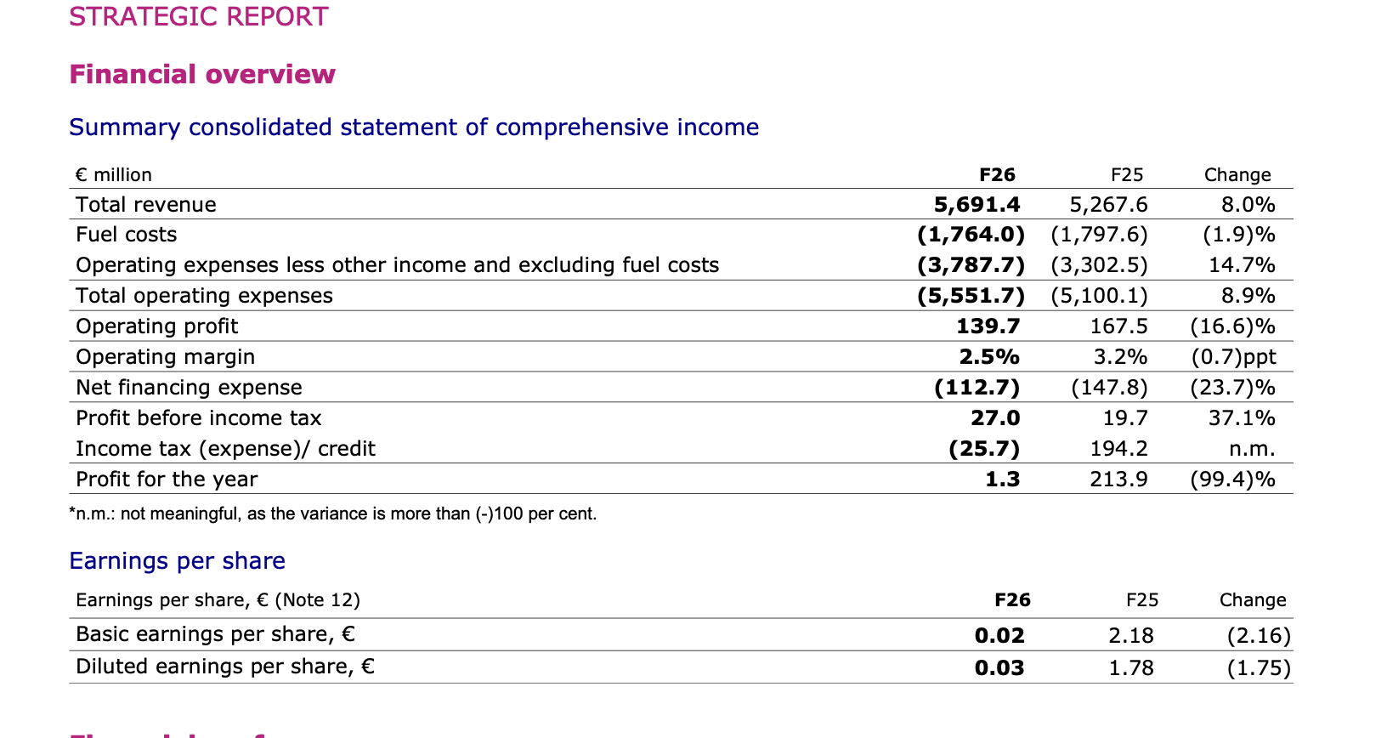
Source: https://www.wizzair.com/cms/api/docs/default-source/downloadable-documents/corporate-website-transfer-documents/annual-reports/wizz-air-holdings-plc---annual-report-and-accounts-f26.pdf

From the standpoint of management accounting, this revenue structure is crucial since it enables Wizz Air to maintain cheap advertised tickets while raising average income per passenger through add-on services. Wizz Air has a divided pricing strategy, whereby basic consumers pay for the seat and customers that need more convenience or flexibility pay more, rather than depending only on ticket costs. This helps the business strike a balance between affordability and profitability and promotes yield management.
Fixed and variable expenses are two of Wizz Air's primary cost structures. Aircraft ownership or lease-related expenses, depreciation, administrative expenditures, technological systems, training, head office expenses, and some workforce costs are examples of fixed costs. In the near term, these expenses are not directly affected by the number of passengers carried. For instance, even if the aircraft is not completely occupied, depreciation and aircraft leasing payments must be made. Strong load factors and high aircraft utilisation are therefore crucial since they distribute fixed expenses over a larger number of passengers (Canvas Business Model, 2026).
Fuel, airport fees, handling charges, maintenance, distribution expenses, marketing, and operating costs associated with passengers are examples of variable costs. Fuel is one of the most variable expenditures for airlines as it fluctuates according to both global oil prices and flight activity. Wizz Air's fuel expenses in Q1 F26 were €438.1 million, up from €459.9 million in the same period last year. Additionally, airport, handling, and end route fees went up to €383.7 million from €321.8 million. This demonstrates that because variable costs can fluctuate rapidly owing to factors including volume, inflation, route mix, and external market circumstances, management must continuously monitor them (London Stock Exchange, 2025).
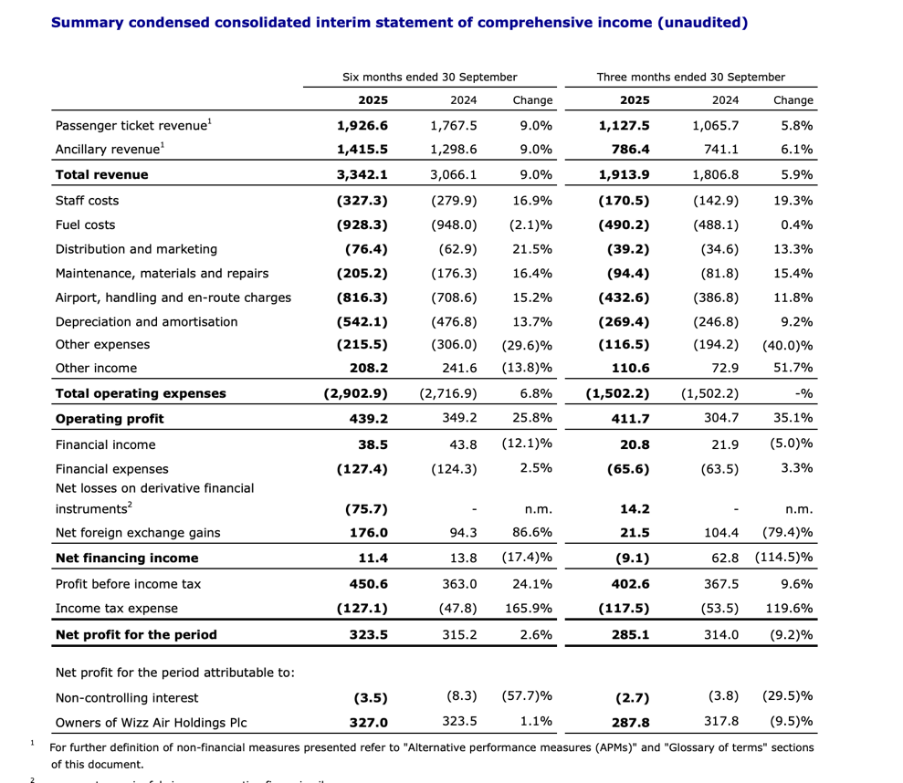
Source: https://www.londonstockexchange.com/news-article/WIZZ/half-year-results/17324698

2.2) Financial planning and budgeting at Wizz Air
A budget is a financial plan that projects earnings and outlays for a given time frame, usually a month or a year. It displays projected income and how to allocate it among investing, saving, and spending. Budgets help people, companies, and governments monitor expenditures, set priorities, and prevent overspending (GANTI , 2025).
As airlines need to plan capacity, aircraft deployment, staffing, fuel risk coverage, maintenance programs, route development and liquidity, budgeting is essential to Wizz Air’s operations. A budget connects strategic objectives to quantifiable financial targets and serves as both a financial and operational planning tool. Budgeting helps Wizz Air’s management determine how many aircraft to fly, which routes to prioritise, how much capacity to allocate to markets and how to control expenses.
Capacity planning is crucial. ASKs, or available seat kilometres, form the basis of Wizz Air’s capacity calculations. Wizz Air increased ASKs to 67,062 million in the first half of 2026, an increase of 8.9% compared to the previous year. Passenger numbers increased by 9.8% to 36.5 million, while the load factor remained at 92.4%. This shows that Wizz Air has increased capacity while maintaining a high level of seat occupancy. Higher load factors improve cost absorption and can boost profitability (Wizz Air Holdings PLC, 2026).
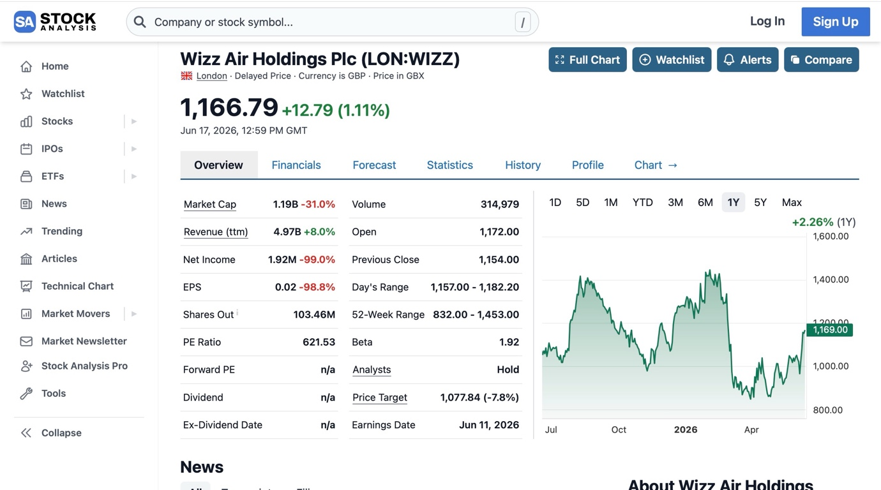
Source: https://stockanalysis.com/quote/lon/WIZZ/
A study of the current year-over-year change in operational expenditures is requested in the assessment brief. According to Google Finance (2026) Google Finance provided Wizz Air's most recent quarterly operating expenditure data, which showed total operating expenses of approximately €1.06 billion, €1.40 billion, €1.50 billion, and €1.42 billion in the previous quarters. Additionally, Yahoo Finance released annual data for the most recent year, showing total revenue of €5.54 billion, cost of revenue of €5.10 billion, and operating expenses of €157.4 million. These numbers show that Wizz Air's cost base remains substantial and highly sensitive to operational conditions (Craig, 2026).
Variations in operational expenditures were impacted by a few internal and external variables. Wizz Air has been responsible for internal fleet renewal, aircraft utilisation, route network decisions, and cost-cutting measures. Inflation in maintenance and airport-related expenses, geopolitical unrest, foreign currency fluctuations, and aircraft groundings associated with Pratt & Whitney GTF engine inspections have all posed external challenges for the corporation.
According to Wizz Air, 41 aircraft were grounded in Q1 F26 due to GTF engine-related inspections, compared with 46 in the same period last year. Because the airline may lose capacity, must pay more for maintenance, and even need to utilise wet leasing or operational changes to safeguard its schedule, grounded aircraft put pressure on expenses (Craig, 2026).
Because Wizz Air's budget is dynamic, management uses variance analysis to regulate performance when fuel prices, demand, aircraft availability, or operating expenditures fluctuate.
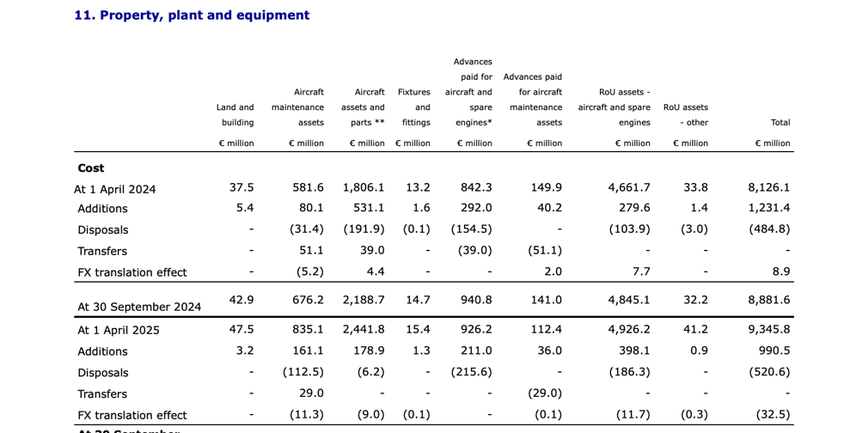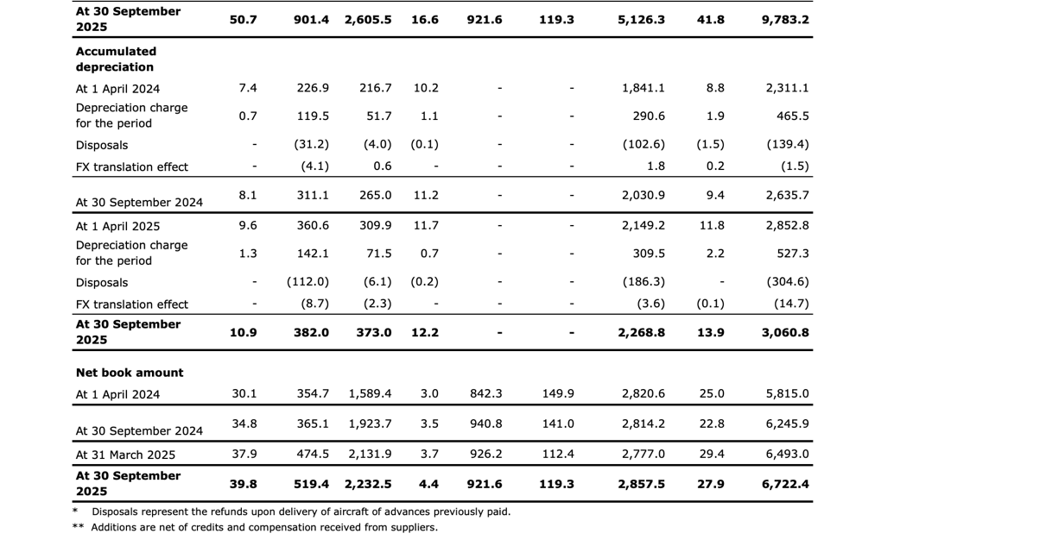
Accessed at: https://www.londonstockexchange.com/news-article/WIZZ/half-year-results/17324698

2.3) Performance Measurement and Decision-Making

KPI tracking is crucial since both accounting results and operational effectiveness are critical to Wizz Air's financial performance. Passenger volume, load factor, total revenue, CASK, and CO2 emissions per passenger-kilometre are five important metrics that measure its performance.
Market reach and demand are revealed by passenger numbers.
In H1 F26, Wizz Air handled 36.5 million passengers, a 9.8% year-over-year increase, helping management determine whether capacity growth is in line with actual demand.
The load factor shows how well aeroplane seats are occupied. Filling more seats every flight immediately increases profitability, which is why the high percentage of 92.4% in H1 F26 is significant. Airlines have high fixed expenses.
A key financial indicator, total revenue, increased 9.0% to €3,342.1 million in H1 F26, enabling management to assess pricing strategy, route planning, and ancillary income performance.
Cost efficiency is measured by CASK. Although ex-fuel CASK increased 2.7%, overall CASK decreased 1.8% due to a 10.4% decline in fuel CASK, indicating that non-fuel expenses still need management attention.
Lastly, sustainability is measured by CO2 emissions per passenger-kilometre. In terms of regulation, investor trust, and brand reputation, this decreased to 51.7 grams (rolling 12-month, Q1 F26), a 1.3% improvement (Wizz Air PLC, 2026) (Investing.com, 2025).
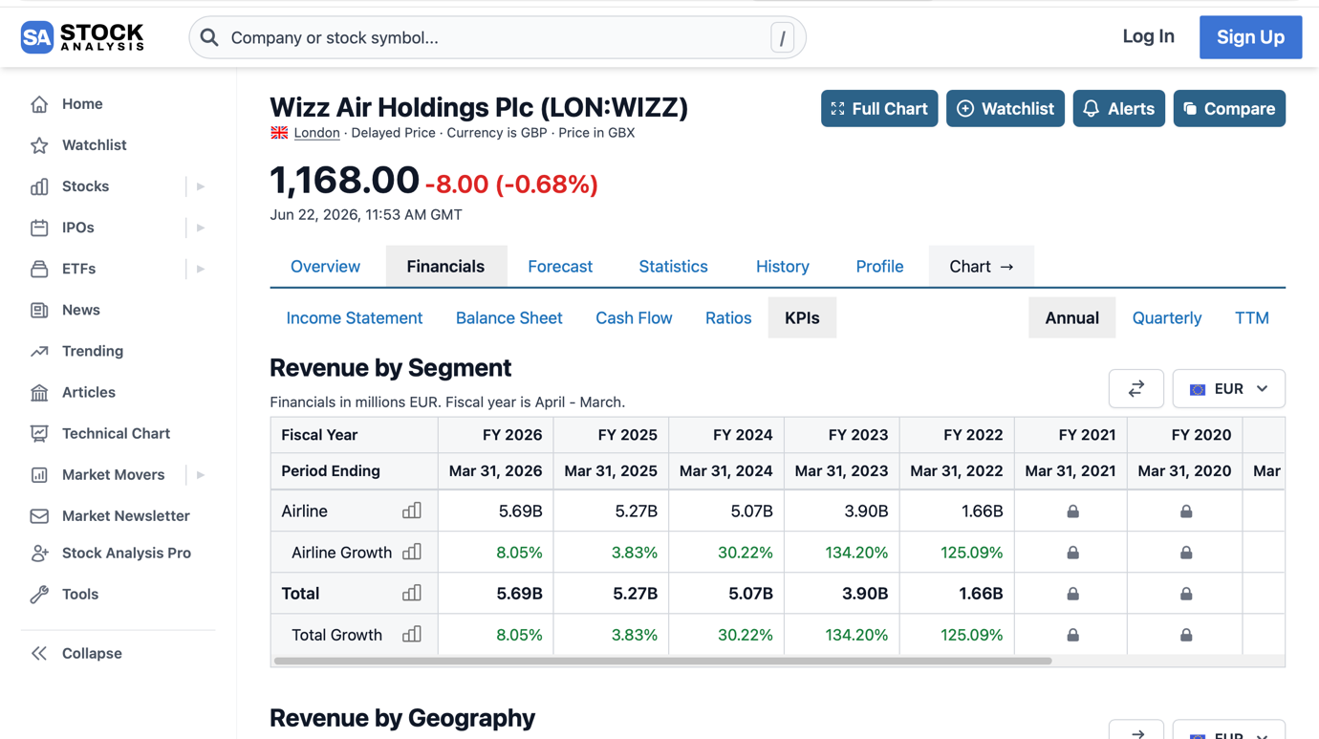
Source: https://stockanalysis.com/quote/lon/WIZZ/financials/metrics/
Both financial and non-financial data inform Wizz Air's strategic decisions. One example of fleet renewal is the company's ongoing investment in Airbus A321neo aircraft, which have more seats and are more fuel-efficient. As of Q1 F26, the average fleet age was 4.5 years, and 69.5% of the aircraft were modern "neo" technology, which supports reduced unit costs and better environmental results.
Another crucial choice is network reconfiguration. Wizz Air halted its operations in Abu Dhabi and refocused on its main markets in Q1 F26. This suggests that, to determine whether markets generated sufficient profits, management relied on operational and financial data. Management accounting data supports lowering exposure and rerouting aircraft to better-performing markets when a route or base falls short of profitability or strategic objectives.
Financial data is also used by Wizz Air to determine price and capacity. Low-cost airlines employ dynamic pricing, meaning that demand, booking time, route popularity, and available capacity all affect ticket prices. By examining revenue per passenger, ancillary revenue, route profitability, and load factor, management accounting facilitates analysis of these metrics. Prices may rise during periods of high demand; during periods of low demand, load factor and cash flow may be safeguarded by using promotional rates (Wizz Air PLC, 2026) (Muharremi, 2026).

2.4) Sustainability and Ethical Considerations

Wizz Air has an ambitious fleet renewal plan to directly link its financial decisions to sustainability. The firm has made significant investments in Airbus A321neo aircraft, which, owing to the combination of new-generation engines and Airbus's Sharklet wing-tip devices, reduce fuel consumption by up to 20% when compared to earlier versions. This decision has financial and environmental implications because lower gasoline prices give low-cost airlines a clear competitive edge. Rather than being a distinct "corporate responsibility" expenditure, efficiency investment is part of the company's core financial model (ClimatePartner, 2025) (Mitchell , 2022).
Regarding fuel, Wizz Air has pledged $6.7 million to acquire 525,000 tonnes of sustainable aviation fuel by 2028, but it freely admits the moral conundrum this initiative raises: the cost of sustainable fuel is four to five times higher than that of conventional fossil jet fuel, and the infrastructure for its production is not evenly distributed throughout Europe. The corporation acknowledges that it must strike a balance between technological investment and profitability, as neglecting to adopt certain technologies could ultimately impair its competitiveness. This is where the true conflict between ethics and cost management emerges (Sweet, 2025).
Wizz Air's pricing approach remains debatable from an ethical perspective. The company's ultra-low-cost approach relies on optimising load factors, and it defines this business strategy in terms of the environment, claiming that distributing the expense of a trip across a larger number of passengers reduces the carbon footprint per passenger-kilometre. Operational efficiency is used as both a commercial and an environmental rationale, which raises valid concerns about how much of this is genuine transparency and how much is corporate image-building. It's a brilliant but contentious argument (Peters, 2026).
Although this model is prevalent in the business and lawful, it must be clear so that buyers are aware of the entire cost before making a purchase. Wizz Air has already been subject to regulatory investigation, including a punishment from the Hungarian competition commission for deceiving customers about self-check-in and directing them toward more costly packages (Wilson, 2024).

3.0 Conclusion

In summary, Wizz Air's financial decision-making heavily relies on management accounting. The firm works in an expensive, fiercely competitive, and unstable sector where pricing, fuel management, aircraft utilisation, load factor, cost control, and route performance all affect profitability. To inform strategic decisions, Wizz Air employs management accounting techniques, including budgeting, cost analysis, KPI monitoring, CASK analysis, and performance assessment. Strong passenger and revenue growth is evident in recent data, but there is also pressure from non-fuel expenses, aircraft groundings, and maintenance-related issues.
There are three suggestions. To guarantee that aircraft are assigned to areas with the highest financial returns, Wizz Air should first improve route-level profitability assessments. Second, the business should continue investing in fuel-efficient aircraft while closely monitoring the financial risks associated with engine-related disruptions. Third, to preserve consumer confidence and reduce regulatory risk, Wizz Air should enhance pricing transparency and ethical communication regarding ancillary fees.

Bibliography
AIR SERVICE ONE, 2026. Wizz Air sees growth opportunity amid industry headwinds. [Online]
Available at: https://www.google.com/?client=safari&channel=iphone_bm
[Accessed 15 06 2026].
Anon., n.d. [Online].
Canvas Business Model, 2026. How Does Wizz Air Operate?. [Online]
Available at: https://businessmodelcanvastemplate.com/blogs/how-it-works/wizz-air-how-it-works
[Accessed 15 06 2026].
ClimatePartner, 2025. Wizz Air: Taking climate data to new heights. [Online]
Available at: https://www.climatepartner.com/en/node/4752
[Accessed 24 06 2026].
Craig, F., 2026. Wizz Air Expands Network and Passenger Numbers as Higher Costs Erode Profitability. [Online]
Available at: https://uk.finance.yahoo.com/news/wizz-air-expands-network-passenger-072910373.html
[Accessed 17 06 2026].
GANTI , A., 2025. What Is a Budget? Plus 11 Budgeting Myths Holding You Back. [Online]
Available at: https://www.investopedia.com/terms/b/budget.asp
[Accessed 17 06 2026].
Google Finance , 2026. Wizz Air Holdings. [Online]
Available at: https://www.google.com/search?q=Google+Finance+showed+recent+quarterly+operating+expense+figures+for+Wizz+Air%2C+including+total+operating+expenses+of+approximately+€1.06+billion%2C+€1.40+billion%2C+€1.50+billion+and+€1.42+billion+across+recent+quarters.+
[Accessed 15 06 2026].
Investing.com, 2025. Earnings call transcript: Wizz Air Q2 2025 highlights growth and challenges. [Online]
Available at: https://uk.investing.com/news/transcripts/earnings-call-transcript-wizz-air-q2-2025-highlights-growth-and-challenges-93CH-4367966
[Accessed 22 06 2026].
Kheraj, S. A., 2025. Wizz Air: My Personal Journey Through the Skies of Lean Operations Management. [Online]
Available at: https://medium.com/digital-global-traveler/wizz-air-my-personal-journey-through-the-skies-of-lean-operations-management-436fd90b5b78
[Accessed 05 06 2026].
Lomas , C., 2023. Wizz Air at 20 – a short history of Europe’s Ultra Low Cost Carrier. [Online]
Available at: https://www.flightradar24.com/blog/aviation-news/airline-news/airline-stories/history-of-wizz-air/
[Accessed 05 06 2026].
London Stock Exchange, 2025. Amended Airbus delivery agreement. [Online]
Available at: https://www.londonstockexchange.com/news-article/WIZZ/amended-airbus-delivery-agreement/17316028
[Accessed 05 06 2026].
London Stock Exchange, 2025. HALF YEAR RESULTS. [Online]
Available at: https://www.londonstockexchange.com/news-article/WIZZ/half-year-results/17324698
[Accessed 15 06 2026].
Mitchell , A., 2022. Another On The Shelf: Wizz Air Wins Yet Another Sustainability Award. [Online]
Available at: https://simpleflying.com/another-on-the-shelf-wizz-air-wins-yet-another-sustainability-award/
[Accessed 24 06 2026].
Muharremi, L., 2026. Wizz Air Earnings: Growth Returns, but Productivity and Yield Recovery Lag. [Online]
Available at: https://global.morningstar.com/en-gb/stocks/wizz-air-earnings-growth-returns-productivity-yield-recovery-lag
[Accessed 22 06 2026].
Peters, L., 2026. From seat covers to SAF: how Wizz Air is pursuing its sustainability goals in 2026. [Online]
Available at: https://aerospaceglobalnews.com/news/wizz-air-sustainability-goals-2026/
[Accessed 25 06 2026].
Sweet, G., 2025. How is Wizz Air Planning to Decarbonise Aviation?. [Online]
Available at: https://sustainabilitymag.com/news/how-is-wizz-air-planning-to-decarbonise-aviation
[Accessed 24 06 2026].
Wilson, C., 2024. Wizz Air fined by Hungarian Competition Authority. [Online]
Available at: https://aviationnews-online.com/public/index.php/article/wizz-air-fined-by-hungarian-competition-authority
[Accessed 25 06 2026].
Wizz Air Holdings PLC , n.d. Annual Report And Accunts F26. [Online].
Wizz Air Holdings PLC , n.d. Annual Report and Accounts F25. [Online].
Wizz Air Holdings PLC, 2026. Annual Report and Accounts F26. [Online]
Available at: https://www.wizzair.com/cms/api/docs/default-source/downloadable-documents/corporate-website-transfer-documents/annual-reports/wizz-air-holdings-plc---annual-report-and-accounts-f26.pdf
[Accessed 17 06 2026].
Wizz Air PLC, 2026. F26 - RETURNING TO GROWTH IN CEE AND RECOVERING PRODUCTIVITY FROM FEWER ENGINE INSPECTIONS. [Online]
Available at: https://www.wizzair.com/cms/api/docs/default-source/downloadable-documents/corporate-website-transfer-documents/results-and-presentations/wizz-air-holdings-plc---stock-market-report-f26-ye_vf.pdf
[Accessed 22 06 2026].
Yahoo!Finance, 2026. Wizz Air Holdings PLC (WZZAF) Full Year 2026 Earnings Call Highlights: Strong Financial Growth .... [Online]
Available at: https://www.wizzair.com/cms/api/docs/default-source/downloadable-documents/corporate-website-transfer-documents/annual-reports/wizz-air-holdings-plc---annual-report-and-accounts-f26.pdf
[Accessed 15 06 2026].

