
APPENDIX GA36d

LEVEL 7 ASSESSMENT SPECIFICATION

Student name: | LUI KA MAN | Student ID number: | 2133986
Programme: | MBA
Module: | Human Resources Management
Module code: | HKBM7007 | Contribution to Overall Module Assessment (%): | 50%
Lecturer: | Dr Leo Ho | Internal Verifier: | Dr Terence Li
Assignment Title: | Assignment 2 | Word count (or equivalent): | 2500 words Essay
Submission deadline: | 12 Dec 2022 (Report) | Return date of provisional marks & written feedback: | 20 working days after submission
Submission method: | All written assessments, where practical and possible, must be submitted via Turnitin unless otherwise instructed by the Lecturer. (Please DO NOT put this assessment specification into Turnitin or it will match many similarities with other students’ submissions.)  Alternative submission method (if applicable):  Late submission of the assessment will result in a late penalty mark. Penalties for late submission: Up to one week late, maximum mark of 50%. Over one week late, 0%. Only the Extenuating Circumstances Panel may approve a change to submission dates.
Academic honesty / referencing: | Academic honesty is required. In the main body of your submission you must give credit to authors on whose research and ideas your work is based. Append to your submission a reference list that indicates the books, articles, etc. that you have used, cited or quoted in order to complete this assessment.

Table of Contents
1. Background 2
1.1 Introduction 2
1.2 Company Background 2
2. HR Challenges of International Expansion 3
2.1 IHRM Challenges 3
2.2 Concluding Summary 4
3. Impacts to IHRM and potential improvement areas 5
3.1 Impacts to IHRM 5
3.2 Improvement Areas 6
4. Recommendation 7
4.1 Recommendation and Action Plan to HR managers 7
4.2 Pre-implementation evaluation 8
5. Conclusion 9
6. Reference 9

Background
The purpose of this essay is to identify human resource (HR) challenges of the two selected companies related to international expansion, analyze the challenges, the root cause of the challenges and the proposal to both companies with action plan.

Introduction
International human resource management (IHRM) concerns with HR problems of multinational companies in foreign subsidiaries (Schuler, Jackson and Tarique, 2011). It crosses national boundaries other than the home country headquarters and concerns with foreign environment. When a corporate grows well in the home country, it usually has more desire the expand overseas. However, some corporates may not operate well by adopting the same HRM model overseas so IHRM issues may arise. This essay is going to focus on the two selected companies, which are Luk Fook Holdings (International) Limited (Hong Kong) and Pandora (Denmark), and study about their IHRM issues and provide recommendations.

Company Background
Luk Fook Holdings (International) Ltd (SEHK:590) is a Hong Kong jewellery retailer and was founded in 1991. It engages in sourcing, designing, wholesaling, trademark licensing and retailing of gold, platinum jewellery and gem-set jewellery products. It has 2800 points of sale in 10 countries and regions. For its expansion in mainland China, Luk Fook has 77 self-operated shops and 2569 licensed shops. Despite the sound pandemic control, the mainland China market increase retail revenue by 47.9% (Annual Report, 2022) and it is expected to expand further in mainland market.

Pandora (PNDORA) is a Danish jewellery manufacturer and retailer and founded in 1982 (Annual Report, 2021). It provides customized bracelets, rings, earrings and necklaces. It operates in more than 40 countries across 6 continents and has a strong international presence. Mainland China is one of the seven key markets which accounts for 5% of sales revenue in 2021. Pandora sees China as high potential for growth and the network footprint is underpenetrated so it is also expected to expand its presence in China market.

HR Challenges of International Expansion
During globalization expand, there is a need for workforce planning about international employees. As a company usually with a strong vision and mission, and core values, the employees from different countries should align well so that it can sustain the brand image and reputation. Training and development of talents is very important in IHRM (Podgorodnichenko, Edgar and McAndrew, 2020).

IHRM Challenges
Training and development (T&D) in international expansion may require HR department to manage a large pool of talents (Farndale, 2019). It needs to integrate the HR systems, fulfil the skill gaps and provide trainings accordingly. Learning management system should be well operate to meet the needs. It is very important to retain and sustain the best talent in the international market (Wood et al. 2018).

First of all, there is challenge of maintaining good quality of T&D in mainland China that is aligning with global business strategy.

Luk Fook has a sales representative training to understand the jewellery knowledge and selling skills (Table 2.1). It also provides support to the certificate of Gemological Institute of America (Wenweipo, 2008). For new joiners, they can join the training in Pangyu factory and “Luk Fook Academy” to understand the standard of Luk Fook’s customer service. Although Luk Fook tries to provide a lot of trainings to the staff in China so as to align with the global strategy of providing high value customer service, there are problems of the training needs of individuals and training quality. The platform and ways of training should be considered to fully meet the local staff’s need. Pandora is relatively doing better than Luk Fook in terms of quality of training. It can provide a customized trainings to each individual by their levels, functions and development needs (Sina, 2021). “SPARK Program” is provided to teach their front-line staff about customer service and “Panzone” is the 360 internal learning platform for their staff to learn at their own pace at any time depending on their needs. “Panzone” consists of interactive multimedia training, video-conferencing, E-Learning and face-to-face coaching. It is founded that 50% of the staff in Pandora works in the company for more than 3 years which means the T&D in China can really retain and sustain the talents (Cedu Media, 2022).

Secondly, there is challenge in designing and delivering global leadership development program.

Luk Fook has established a well-defined Store Manager Manual for progression and promotion in mainland China (Baidu, 2022) (Table 2.1). It standardized the promotional ladder and provides a competency set for employees to track their development progress. Luk Fook also requires the existing store managers to share the working diary for internal exchange so that the junior level employee can better understand the job description and what does it expect. Although it standardized the requirement of store manager and develop the employees in structured approach, it may overlook the importance of develop high potential employees with individual development plan and insufficient follow up with the leadership development plan (Caligiuri et al. 2020). In contrast, Pandora has done better in this aspect. Pandora has a well-known “Global Graduate Program” (Pandora, 2022) for the fresh graduates to have an on-the-job experience so that they can have job rotation in global office, absorbing knowledge from coaching and action learning. It developed a lot of high-quality employees to continue the personal growth in Pandora. There are also ongoing global leadership programs for existing employees to have global exposure and become a future manager. It assists them to the next milestone and tailored to their ambitions with the company’s strategic needs.

Table 2.1: IHRM Challenge of Luk Fook and Pandora
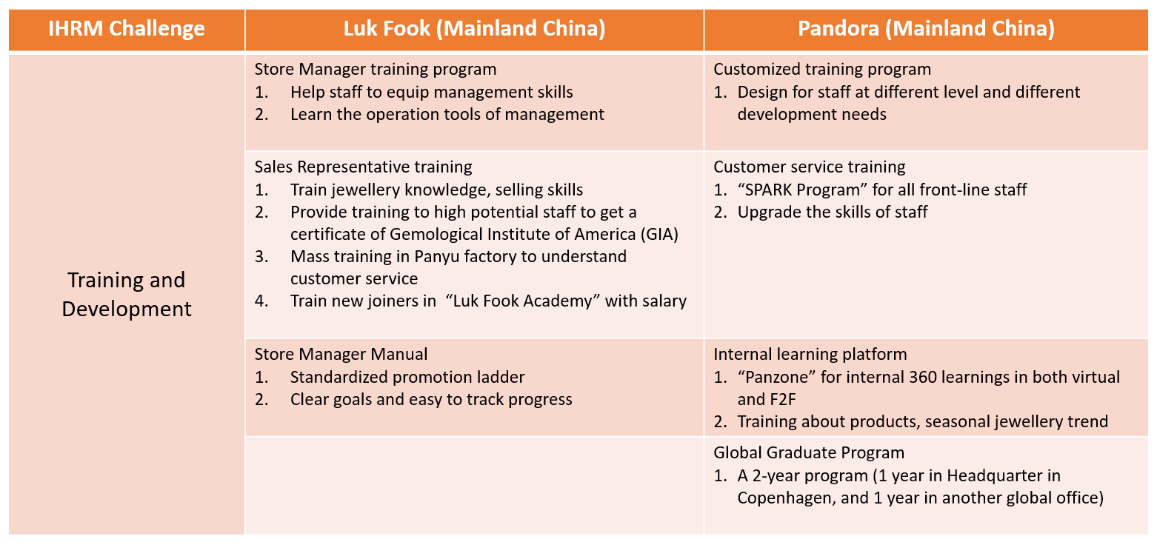
Source: Constructed by author

Concluding Summary
In global expansion to mainland China, companies like Luk Fook and Pandora faced the T&D challenges. T&D is crucial to increase the company’s productivity and the competitiveness in the market. It is the key to sustain the business growth and success in China market.

Luk Fook seems to have sufficient trainings to boost up the knowledge of the employees, such as sales training and “Luk Fook Academy”, and meet the criteria of the customer service. However, there are doubts in ensuring the training quality and fulfilling the training needs of individuals. For the global leadership development program, Luk Fook has low level of support to tailor-made the development plan and follow-ups and this will be hard to retain the high potential talents.

Pandora is relatively better in the T&D in China market. It provides personalized trainings based on each individual needs and provides training programs such as “SPARK Program” and “Panzone” to fill the skills gaps efficiently. For the global leadership development, Pandora has its own “Global Graduate Program” and leadership programs to develop employee which align with global business strategy.

Managing and developing Chinese employees requires knowledge upgrade and education which are highly valued in the market. It can boost the morale and reduce the turnover rate. HR needs to address the cultural difference, proper communication and the quality of the T&D. It is also important to provide the opportunity for Chinese managers to fill the top positions of the Company other than sending expatriates from headquarter offices overseas. Succession and career planning should be comprehensive for the Chinese employees so that it can retain and sustain the talents (Warner and Goodall, 2010).

Impacts to IHRM and potential improvement areas
T&D in China market has several challenges and HR managers of Luk Fook and Pandora have to solve the issues. The current practice has both positive and negative impacts. Below is the analysis of the challenge and the potential improvement areas.

Impacts to IHRM
Luk Fook’s T&D in China can help its employees to have a good understanding of the work of managers (Table 3.1). It also provides a structured approach about T&D plan for the employees so that it is easier to follow and increase the work incentive and fill the skills gaps efficiently. A standardized competency set can help the employees to develop accordingly. However, it has negative impacts such as lack of individualized development and lack of follow-up with high potential employees. There are also insufficient tools to establish high potential development plan. Therefore, there is risk of high turnover rate because of the low motivation from work.

Pandora’s T&D in China is more comprehensive and well-developed (Table 3.1). It can enhance the work motivation by providing good follow-up with the high potential, such as the “Panzone” implementation. Pandora’s leadership development plan is very personalized and select the high potential employees to learn from leadership program, such as job rotation in headquarter office. It has a strong sense of attention to high potential leaders so that the retention rate can be high and benefit to the company’s business growth.

Table 3.1: Positive and negative impact of IHRM
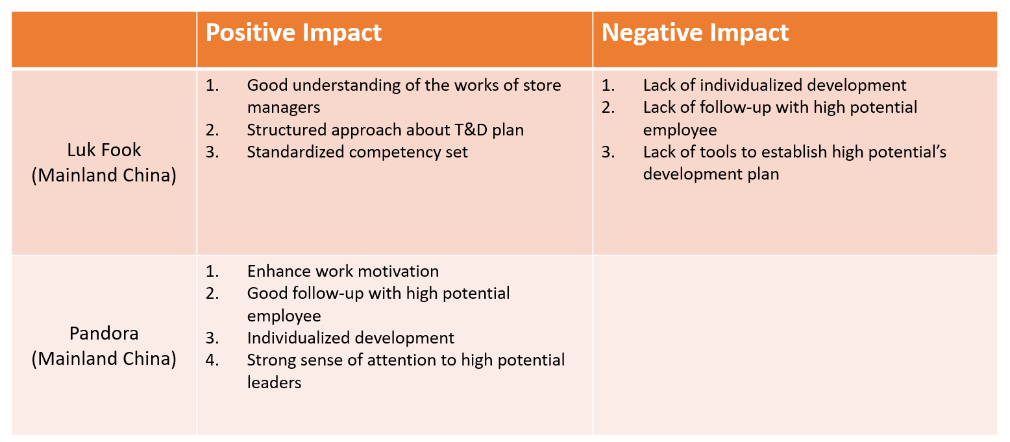
Source: Constructed by author

Improvement Areas
Luk Fook has room for improvement while Pandora should sustain the good practice in IHRM of T&D.

Individual learning plan (ILP) should be considered in the international expansion of China market. Luk Fook can utilize integrated approach to leadership development. It can create its Lominger high potential (Hi-Pot) identification and develop a future leader pool. For performance management, potential and performance potential matrix can be used to identify top rating employees. Looking into the learning and development, Luk Fook can utilize the existing competency development trainings together with E-Learnings. There is also non-training type of development plan such as meet with executives, organize regular group sessions lead by Hi-Pot and executives. Luk Fook can provide coaching, mentor scheme and stretch assignment to have job enrichment and overseas exposure. The learning plan has to align with the Learning need analysis and the company strategic goals. For the result assessment, it can be done quarterly so that a good follow up with the Hi-Pot and determine the status and competency level.

Pandora’s T&D has well-developed in China. It has a personalized development plan for its employees and the training tools are tailer-made to each employee so it makes Pandora get a high retention rate and develop talents. E-Learning tools is the great trend so Pandora can continue to embrace digital tools to efficiently manage the employees.

Recommendation
The action plan is to adopt the integrated approach of development plan. Individual Learning Plan (ILP) will provide the high potential employees to develop as a future manager by filling the skills or knowledge gaps according to different individual’s need.

Recommendation and Action Plan to HR managers
In short run, company can first develop their own analytic tools to find out the future talent pool (Figure 4.1). After identification, a ILP can be conducted to the talent pool employees and find out the skills gap. Later, E-Learning platform can be adopted so that employees can upskill themselves any time and any place with their own pace. It is also suggested to arrange coaching, mentor scheme and short-term stretch assignments to enrich the experience of the talents and gain global exposure (Zhu, 2019).

In long run, it is suggested to adopt high technology in order to save time in the HR process and get an efficient T&D system (Figure 4.1). For a large corporate like Luk Fook and Pandora are worth to invest in the T&D system so that it can reduce the workload of HR and produce high quality and customized trainings and development plan to employees and the managers to follow up.

The required resources will be a ILP system. The in-house ILP system will be developed based on the Company Learning Management by HR so that the ILP can align with the global strategic goals and develop the talents accordingly. HR and managers need to know how to use this ILP system so that they can select the talent pool every year and check the competency and training progress.

The potential outcome is to increase the retention rate, decrease the turnover rate, lower the skills gaps of employees, increase the sense of belonging and work motivation of employees. In business aspect, it can boost the business productivity and growth (Ererdi et al. 2022).

The involved stakeholders will be the executive, HR department, managers and all employees. Executive expects a good productivity and good business driving employees in the company; HR department expects a good quality and easy-to-manage T&D process and meet the HR goals; managers expect to retain the talents and helpful employees in the team and drive the business success for them; general employees expect a work stability and satisfaction where they can work longer with a bright career development plan. The recommendation can fulfil the stakeholders’ expectation and drive mutual success in business operation.

Figure 4.1: Short-term and Long-term action plan
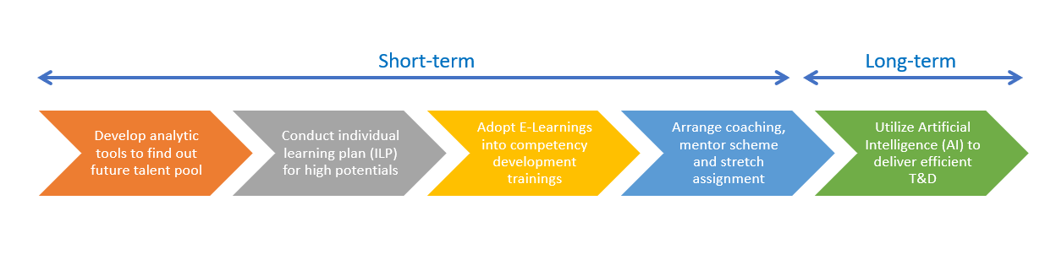
Source: Constructed by author

Pre-implementation evaluation
For the adoption of ILP, there are a lot of advantage to the company (Figure 4.2). It can help to develop high potentials with a more personalized development plan and better way of using company resources so that it will not waste the time and money in unnecessary trainings. Thus, it can enhance employee’s satisfaction and increase their career competencies. With skilled employees and future talents, it can boost company’s productivity.

On the other hand, the ILP may also have some challenges (Figure 4.2). It can cost time and money in the ILP development and the process of working with the talent pool. Extra time will be required from the employees for the T&D so it can increase work burden and stress to them. Sometime, the training session can be complicated and time-consuming so HR has to be extra careful to avoid the T&D affects the original duties of the employees. ILP requires executive and HR to take time in the initial phase of the project but it is worth to invest time and money as this will eventually beneficial to the company’s productivity and competitiveness. The advantages of ILP outweigh its disadvantages.

Figure 4.2: Pros and Cons of the recommendation
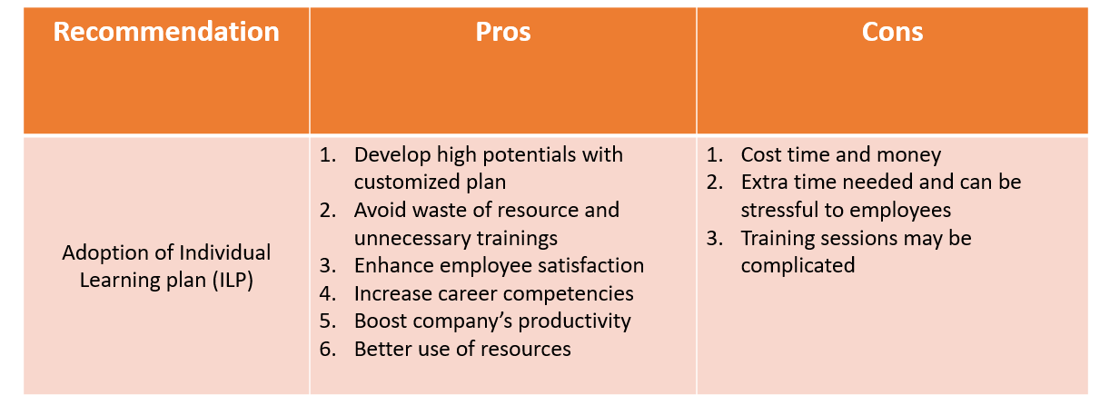
Source: Constructed by author

Conclusion
International business environment can cause a lot of challenges to HR. For company who want to expand its business overseas, HR need to be careful to tackle the international T&D.

In Luk Fook and Pandora, they face the T&D challenge in entering mainland China market and deal with the issues differently. Luk Fook has utilized a very standardized approach to the trainings and develop future store managers while Pandora has adopted a personalized approach and organized job rotations to help employees gain overseas exposure so it results in a better retention rate. China workplace usually take company’s training as high priority when talking about employee development and Chinese employees treasure the opportunities and see it as an important element when choosing their preferred job. Therefore, it is necessary for HR leaders to adopt a good ways of international T&D in China market.

Individual Learning Plan with the integrated approach can custom-made the trainings and development plan to fit better the employee’s need. It can avoid the waste of resources and time and money. It clearly defines the high potential employee, their competencies, and develop according to the skills gap. This model in long run can merge with some high technology like Artificial Intelligence (AI) in order to make the process more time-efficient and reduce the work burden of HR and managers.

T&D in China is challenging but HR leaders can overcome the obstacles by upgrading the IHRM by assessing what the stakeholders need and what the global business strategy is. A successful IHRM can eventually drive higher productivity and business success.

Reference
Annual Report (2021) Pandora Annual Report 2021. Available at: https://www.pandoragroup.com/staticcontent?url=http://pandoragroup.gcs-web.com/static-files/f298ed02-3a4b-4bae-b1bf-c0598e03b450&format=pdf&title=Annual%20Report%202021 (Accessed: 11 Dec 2022).

Annual Report (2022) Luk Fook Holdings (International) Limited Annual Report 2022. Available at: https://www1.hkexnews.hk/listedco/listconews/sehk/2022/0718/2022071800524.pdf (Accessed: 11 Dec 2022).

Baidu (2022) 六福珠宝店长的管理方法和六福珠宝店长职责与管理. Available at:
https://baijiahao.baidu.com/s?id=1750708618769493407&wfr=spider&for=pc (Accessed: 1 Dec 2022).

Caligiuri, P. et al. (2020) International HRM insights for navigating the COVID-19 pandemic: Implications for future research and practice. Journal of international business studies, 51(5), pp. 697-713.

Cedu Media (2022) 全媒体总裁专访 | 潘多拉大中华区零售副总裁Rosa Tao：让数字化学习平台成为赋能企业发展的重要抓手. Available at: http://www.cedumedia.com/i/37688.html (Accessed: 1 Dec 2022).

Cegos (2015) Learning and development function globalization and challenges. A European Survey by the Cegos Group. Available at:
https://www.equiposytalento.com/contenido/download/estudios/learning-and-development.pdf (Accessed: 1 Dec 2022).

Ererdi, C. et al. (2022) International HRM in the context of uncertainty and crisis: A systematic review of literature (2000–2018). The International Journal of Human Resource Management, 33(12), pp. 2503-2540.

Farndale, E. et al. (2019) Facing complexity, crisis, and risk: Opportunities and challenges in international human resource management. Thunderbird International Business Review, 61(3), pp. 465-470.

Schuler, R. S., Jackson, S. E. and Tarique, I. (2011) Global talent management and global talent challenges: Strategic opportunities for IHRM. Journal of world business, 46(4), pp.506-516.

Sina (2021) 潘多拉珠宝中国蝉联中国杰出雇主2021. Available at:
http://vr.sina.com.cn/news/hz/2021-01-26/doc-ikftssap0983056.shtml (Accessed: 1 Dec 2022).

Warner, M. and Goodall, K. (2010) Management training and development in China. London and New York, NY: Routledge.

Wenweipo (2008) 五大策略 有助發展品牌. Available at:
http://paper.wenweipo.com/2008/08/22/zt0808220006.htm (Accessed: 1 Dec 2022).

Wood, G. et al. (2018) International Journal of Human Resource Management (IJHRM) Special Issue on: International human resource management in contexts of high uncertainties.

Pandora (2022) Development and training in Pandora, Global Graduate Program. Available at: https://pandoragroup.com/careers/working-at-pandora/development-and-training (Accessed: 1 Dec 2022).

Podgorodnichenko, N., Edgar, F. and McAndrew, I. (2020) The role of HRM in developing sustainable organizations: Contemporary challenges and contradictions. Human Resource Management Review, 30(3).

Zhu, J. S. (2019) Chinese multinationals’ approach to international human resource management: A longitudinal study. The International Journal of Human Resource Management, 30(14), pp. 2166-2185.

