Student name: Florentina Alistar
Student number:1918688

Table of Contents
Introduction 3
Background 3
Aims and objectives 5
Methods 5
Results 6
Discussion 13
Conclusion 14
References 16
Appendix 18

Introduction
A virtual learning environment is being widely used in the education sector. This has assisted in delivering instruction materials in the education sector. With the help of virtual learning environment, higher level of communication between the students and teachers has been enabled. However, the introduction of virtual learning environment has created positive as well as negative influence on the students learning ability. The analysis of positive as well as negative influence of virtual learning environment on the learning ability of students is important. This helps the teachers as well as universities in using the technology of virtual learning environment in an effective manner for the students. The main intention of this assignment is to develop a report analyzing the influence of virtual learning environment on learning experience of students studying at the University of Wales Trinity Saint David London Campus. For this purpose, survey has been conducted among 20 students studying in at the University of Wales Trinity Saint David London Campus.

Background
Historical background on the use and development of VLEs
It has been stated by García-Álvarez, Novo-Corti and Varela-Candamio, (2018) that the computer has been utilized for gaining knowledge and learning purposes since 1970. Therefore, it is quite difficult for people to provide a definite time period from which the utilization of VLEs has occurred. It has also been stated that the UK’s Open University has been utilizing the computers for providing information and knowledge since 1970. However, in 2000, the patent for commercial computer based VLE ‘Blackboard’ was introduced. Ina recent survey, it has been found out that a total of 3700 institutions from more than 60 countries have been using the Blackboard software until 2010. However, one of the most popular VLE known as “Moodle” was introduced for the sake of providing knowledge. In the opinion of Straková and Cimermanová, (2018), the main intention behind this renowned VLE was to provide online courses to provide a better platform for the educators and develop new contents with the help of collaboration as well. It was further notice that by the end of 2011, there were around about of 49,365 active sites in more than 75 languages. Moreover, the user base of Moodle had expanded up to 212 countries throughout the globe. In addition, UK had witnessed a gradual increase within the post compulsory sector in the year 2008 -09.
General positive impacts of VLEs
It has been stated by Huggins-Manley et al., (2015), that the positive effects of the utilization of VLEs on the student learning are majorly edited by study held in West Virginia, USA. It was later observed that the students as well as teachers used to collaborate with the help of a software time to communicate online in order to level up their analytical as well as understanding skills. Moreover, the software collaboration was majorly used by upper grade elementary students that help them to perform better on standardized test in reading language and vocabulary. Later on, it was considered that the students were able to encourage progressive thought as well as implement independent thinking with the help of VLEs. Furthermore, it has also been stated that the students who had access to more than one of the resources such as integrated learning system, simulation software, design and programming technologies, and computer assisted instructions were able to achieve better results on standardized tests, national tests as well as researcher constructed tests. According to a recent survey, it was later found out that the graduate students variable to access that cause from home in an easy manner. In the opinion of Hamutoglu et al., (2020) the non-graduated students were found to be more enthusiastic regarding the utilization of technology for learning purposes. The study also concluded that the satisfaction level of the students were quite higher as they were dependent upon exposure, access as well as utility of VLEs.
General negative impacts of VLEs
According to a recent study, it was observed that due to the introduction of web-based instruction, there was a lack of emotional and social interaction among each other in the traditional classrooms. In the opinion of Al-Azawei and Al-Masoudy, (2020), Later on, it was found out that there were no such differences in the learning performances of the students that were placed between two classroom environments. However, it was further concluded that the students were engaged in the web based well satisfied with the learning process as well as the lack the benefits and opportunities regarding the traditional classroom environment.
Impact of VLEs on Independent Learning and Students’ Motivation to learn
According to a recent study, it was found out that a sum total of 55% of the total respondents where happily agreeing that there is a hike in the motivation level of students. Moreover, it was also observed that there was higher level of engagement of the students while taking part in the course with the help of collaborative tools. In the opinion of Annansingh, (2019), a roundabout of 65% of the students also concluded that online courses are more convenient as well as more fun as compared to the traditional classroom approach.

Aims and objectives
The main intention of this assignment is to develop a report analyzing the influence of virtual learning environment on learning experience of students studying at the University of Wales Trinity Saint David London Campus. The objectives of the research are as follows:
- To analyze the influence of virtual learning environment
- To evaluate the impact of virtual learning environment on learning experience of students studying at the University of Wales Trinity Saint David London Campus
- To analyse General negative impacts of VLEs on students studying at the University of Wales Trinity Saint David London Campus
- To analyse General positive impacts of VLEs on students studying at the University of Wales Trinity Saint David London Campus

Methods
The research in the study has been carried out with the help of mixed approach of data collection. In the resrech, primary as well as secondary method of data collection has been adopted. In the primary collection, surevy has been conducted among 20 students studying at the University of Wales Trinity Saint David London Campus. For secondary research, the articles and journals related to the topic of research has been selected. The selected articles and journals have been studied in a detailed manner. For carrying out survey, Survey Monkey has been used.

Results
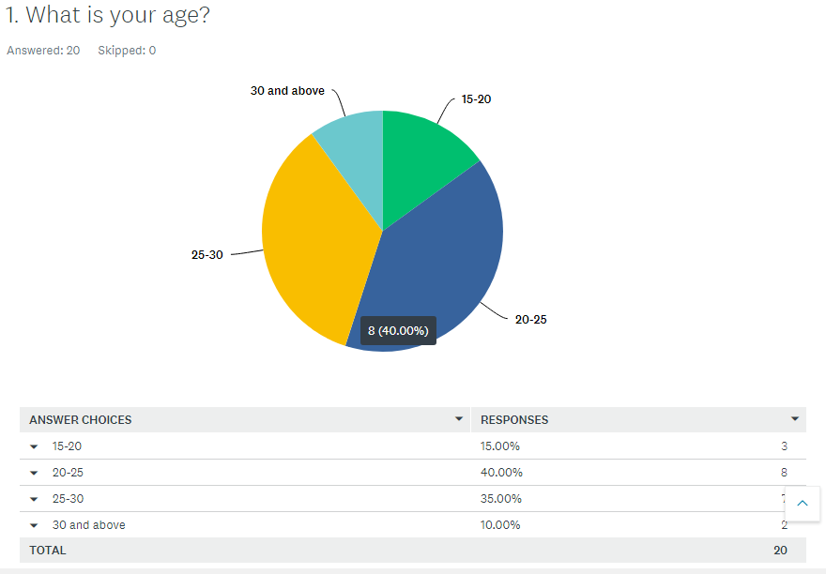
The above graphical representation reflects that most of the participants who participated in the survey were aged between 20 to 25 years.
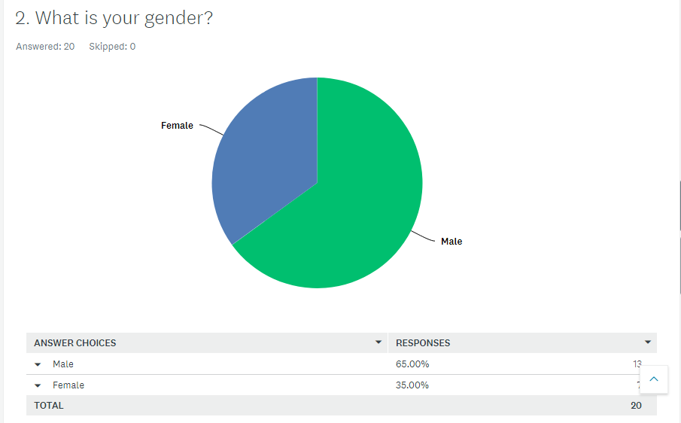
The above graphical representation reflects that most of the participants who participated in the survey were male.
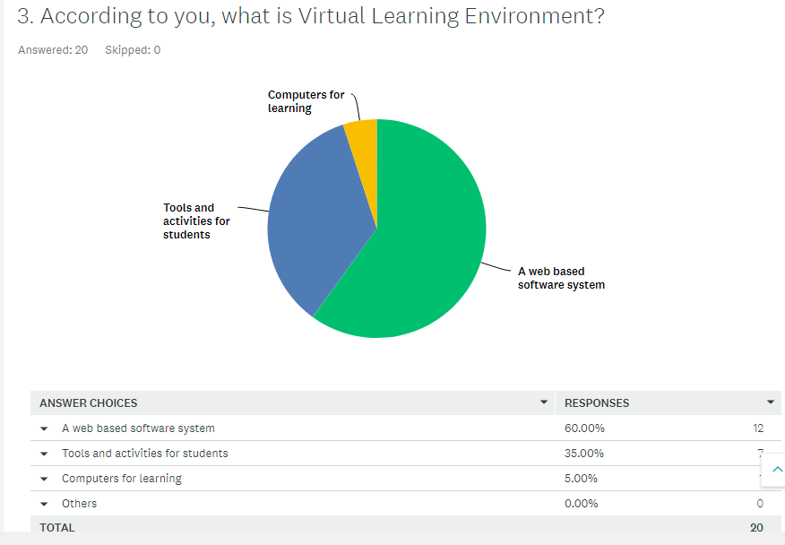
In the above graphical representation, it has been identified that according to most of the respondents, virtual learning environment is a web-based software system.
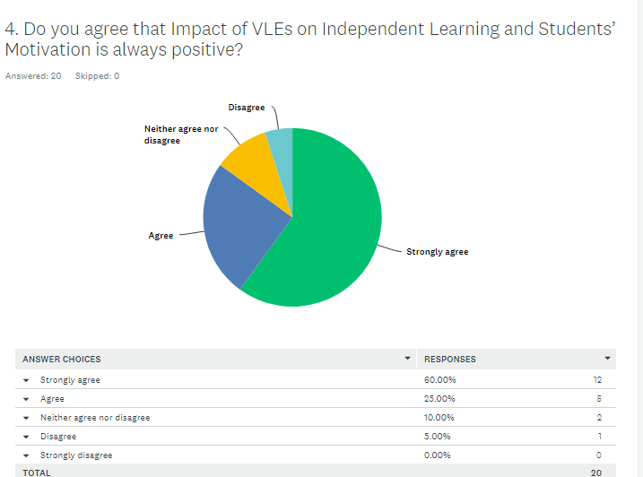
In the above graphical representation, it has been observed that most of the participants strongly agreed that VLE has created a positive impact on Independent learning as well as students.
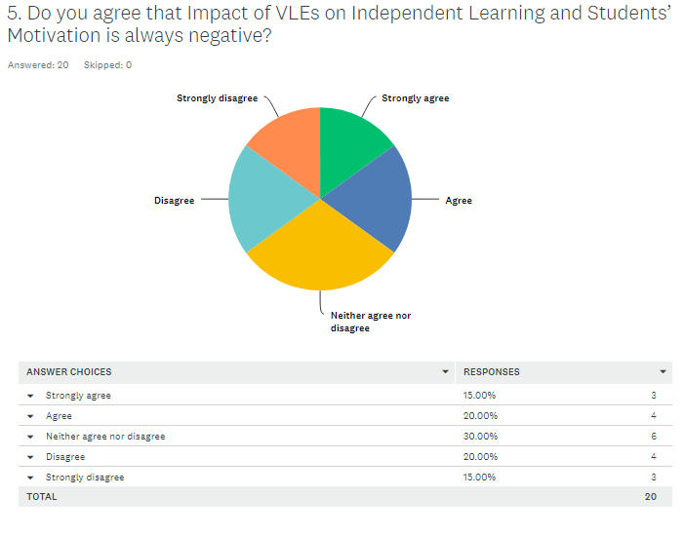
The above graphical representation reflex that most of the respondents neither agreed nor disagreed that VLE has created a negative impact on Independent learning as well as students.
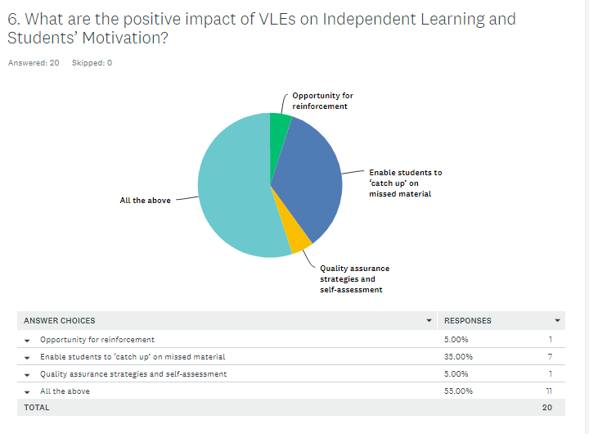
In the above graphical representation, it has been found that according to most of the respondents VLE has enabled the students in catching up the missed lectures and discussions.
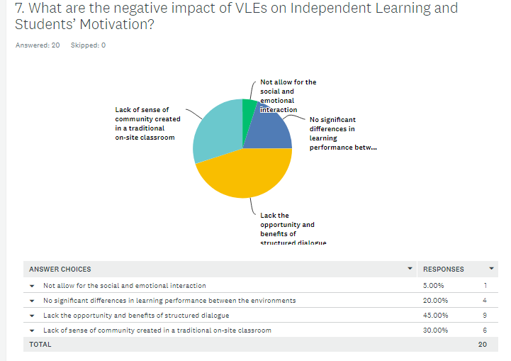
In the above graphical representation, it has been observed that according to most of the respondents, due to VLE, lack of benefit as well as opportunity in respect of structure dialogue is being faced by the students.
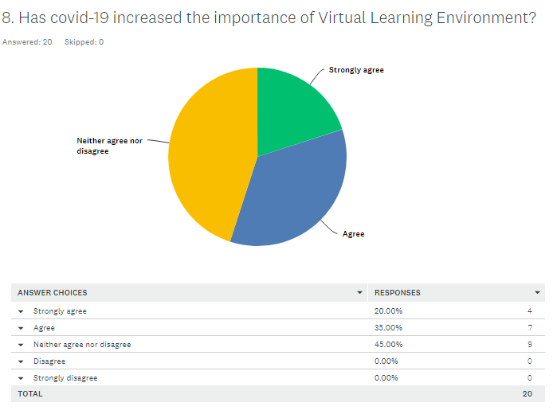
In the above graphical representation, it has been found that most of the participants neither agree nor disagree that the spread of covid-19 has influenced the importance of virtual learning environment among students.

Discussion
From the survey of students, it has been identified that there are negative as well as positive influence of virtual learning environment. However, spread of corona virus has increased to the importance of virtual learning environment among the students of the university. The students are capable to attend the missed lectures or discussion. This is creating a positive influence on the academic performance of the students studying in the university. However, there are certain disadvantages of using virtual learning environment. The level of distraction for the students has increased due to the use of internet for online classes.
With the introduction of VLEs, the students were fully responsible for the accomplishment of the tasks and activities they wish to engage in (Ryan and Poole, 2019). In addition, with the usage of email chat as well as forums for discussion and feedback purposes, there was a hike in the communication level among the students and the teachers (Ouherrou et al., 2018). Furthermore, the introduction of VLEs gradually increases the opportunities regarding the feedback as well as the assessments that will eventually lead to achievement or retention. it was considered that the students were able to encourage progressive thought as well as implement independent thinking with the help of VLEs. Furthermore, it has also been stated that the students who had access to more than one of the resources such as integrated learning system, simulation software, design and programming
There was a research conducted that help the researchers to find out the change in the habits of the learners with the excessive use of internet for retrieving any kind of information with the incorporation of tools and technologies (Lacka and Wong, 2019). Additionally, the report concluded that a specific amount of respondents declared the discussion boards as one of the least used technologies. It was further concluded that VLEs could be further used for passive reading instead of active learning. It was further observed that a roundabout of 92% of the total educational institutions had a virtual learning environment as compared to the year 2003-04 where the total sum was around 58 percentile. According to Omar and Geer, (2018), the strategy adopted by UK government known as the harnessing technology-transforming learning and children's services has helped several institutions as well as learning providers to make the full and effective utilization of technology. According to the reports that were published between the year September 2005 and December 2007, it was found out that more than half of the schools that have been surveyed had a major influence of VLEs on the student's learning ability in a positive manner. It was also found out that the level of interaction between the teacher and the student has been gradually increased. Due to this reason, the students experienced a gradual increase in the motivation and independence level.

Conclusion
VLE has enabled the students in catching up the missed lectures and discussions. a roundabout of 65% of the students also concluded that online courses are more convenient as well as more fun as compared to the traditional classroom approach. it was found out that there were no such differences in the learning performances of the students that were placed between two classroom environments. However, it was further concluded that the students were engaged in the web based well satisfied. it has also been stated that the students who had access to more than one of the resources such as integrated learning system, simulation software, design and programming technologies, and computer assisted instructions were able to achieve better results on standardized tests. the strategy adopted by UK government known as the harnessing technology-transforming learning and children's services has helped several institutions as well as learning providers to make the full and effective utilization of technology. the patent for commercial computer based VLE ‘Blackboard’ was introduced. Ina recent survey, it has been found out that a total of 3700 institutions from more than 60 countries have been using the Blackboard software until 2010.

References
Al-Azawei, A. and Al-Masoudy, M., 2020. Predicting Learners' Performance in Virtual Learning Environment (VLE) based on Demographic, Behavioral and Engagement Antecedents. International Journal of Emerging Technologies in Learning (iJET), 15(9), pp.60-75.
Annansingh, F., 2019. Mind the gap: Cognitive active learning in virtual learning environment perception of instructors and students. Education and Information Technologies, 24(6), pp.3669-3688.
García-Álvarez, M.T., Novo-Corti, I. and Varela-Candamio, L., 2018. The effects of social networks on the assessment of virtual learning environments: A study for social sciences degrees. Telematics and Informatics, 35(4), pp.1005-1017.
Hamutoglu, N.B., Gemikonakli, O., Duman, I., Kirksekiz, A. and Kiyici, M., 2020. Evaluating students experiences using a virtual learning environment: satisfaction and preferences. Educational Technology Research and Development, 68(1), pp.437-462.
Huggins-Manley, A.C., Beal, C.R., D’Mello, S.K., Leite, W.L., Cetin-Berber, D.D., Kim, D. and McNamara, D.S., 2019. A commentary on construct validity when using operational virtual learning environment data in effectiveness studies. Journal of Research on Educational Effectiveness, 12(4), pp.750-759.
Lacka, E. and Wong, T.C., 2019. Examining the impact of digital technologies on students’ higher education outcomes: the case of the virtual learning environment and social media. Studies in Higher Education, pp.1-14.
Omar, N. and Geer, R., 2018, June. virtual learning environment (VLE): Its Impact on primary school children's learning. In EdMedia+ Innovate Learning (pp. 1916-1922). Association for the Advancement of Computing in Education (AACE).
Ouherrou, N., Elhammoumi, O., Benmarrakchi, F. and El Kafi, J., 2019. Comparative study on emotions analysis from facial expressions in children with and without learning disabilities in virtual learning environment. Education and Information Technologies, 24(2), pp.1777-1792.
Ryan, E. and Poole, C., 2019. Impact of Virtual Learning Environment on Students’ Satisfaction, Engagement, Recall, and Retention. Journal of medical imaging and radiation sciences, 50(3), pp.408-415.
Straková, Z. and Cimermanová, I., 2018. Developing Reflective Skills of Student Teachers in the Virtual Learning Environment. Electronic Journal of e-Learning, 16(2), pp.107-121.

Appendix
Question for survey
1. What is your age?
- 15-20
- 20-25
- 25-30
30 and above
2. What is your gender?
- Male
- Female
3. According to you, what is Virtual Learning Environment?
- A web based software system
- Tools and activities for students
- Computers for learning
Others
4. Do you agree that Impact of VLEs on Independent Learning and Students’ Motivation is always positive?
- Agree
- Strongly agree
- Neither agree nor disagree
- Disagree
- Strongly disagree
5. Do you agree that Impact of VLEs on Independent Learning and Students’ Motivation is always negative?
- Agree
- Strongly agree
- Neither agree nor disagree
- Disagree
- Strongly disagree
6. What are the positive impact of VLEs on Independent Learning and Students’ Motivation?
- Opportunity for reinforcement
- Enable students to ‘catch up’ on missed material
- Quality assurance strategies and self-assessment
- All the above
7. What are the negative impact of VLEs on Independent Learning and Students’ Motivation?
- Not allow for the social and emotional interaction
- No significant differences in learning performance between the environments
- Lack the opportunity and benefits of structured dialogue
- Lack of sense of community created in a traditional on-site classroom
8. Has covid-19 increased the importance of Virtual Learning Environment?
- Agree
- Strongly agree
- Neither agree nor disagree
- Disagree
- Strongly disagree

