Software Development

(ACCA4017)

Jack Rout

1802047

Table of contents
Introduction – Page 3
Task 1 – Page(s) 3, 4, 5
Task 2 – Page(s) 5, 6, 7, 8
Task 3 – Page(s) 9, 10, 11, 12
Conclusion – Page 12

Introduction:
The task that has been given is to complete all the tasks in the assignment brief whilst listing all the problems from easiest to hardest. The document will have photographs of notes made before developing the code so that way it outlines the though process on how to tackle each problem. There will be screenshots of the code in development for each task to give a general idea as to the thought process behind it and screenshots of the code in action and showing if the code works or it does not work.
Task1:
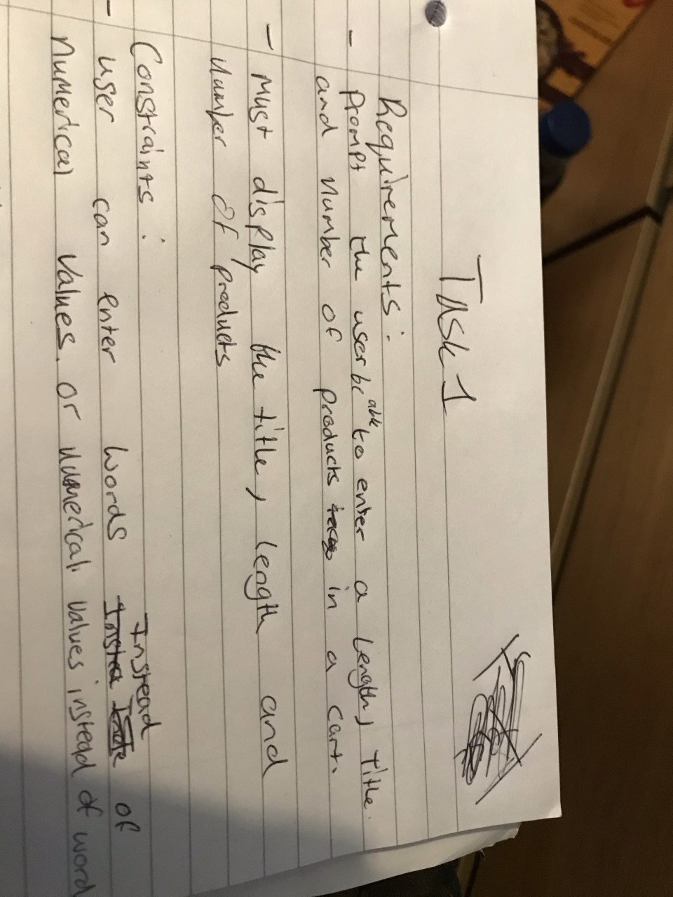
Below are 2 images of the thought processing before making the code outlining the requirements, constraints and solving the problem and arriving to a conclusion of how to solve this task which in this case was to read into the console then display what the user entered at the end of the code

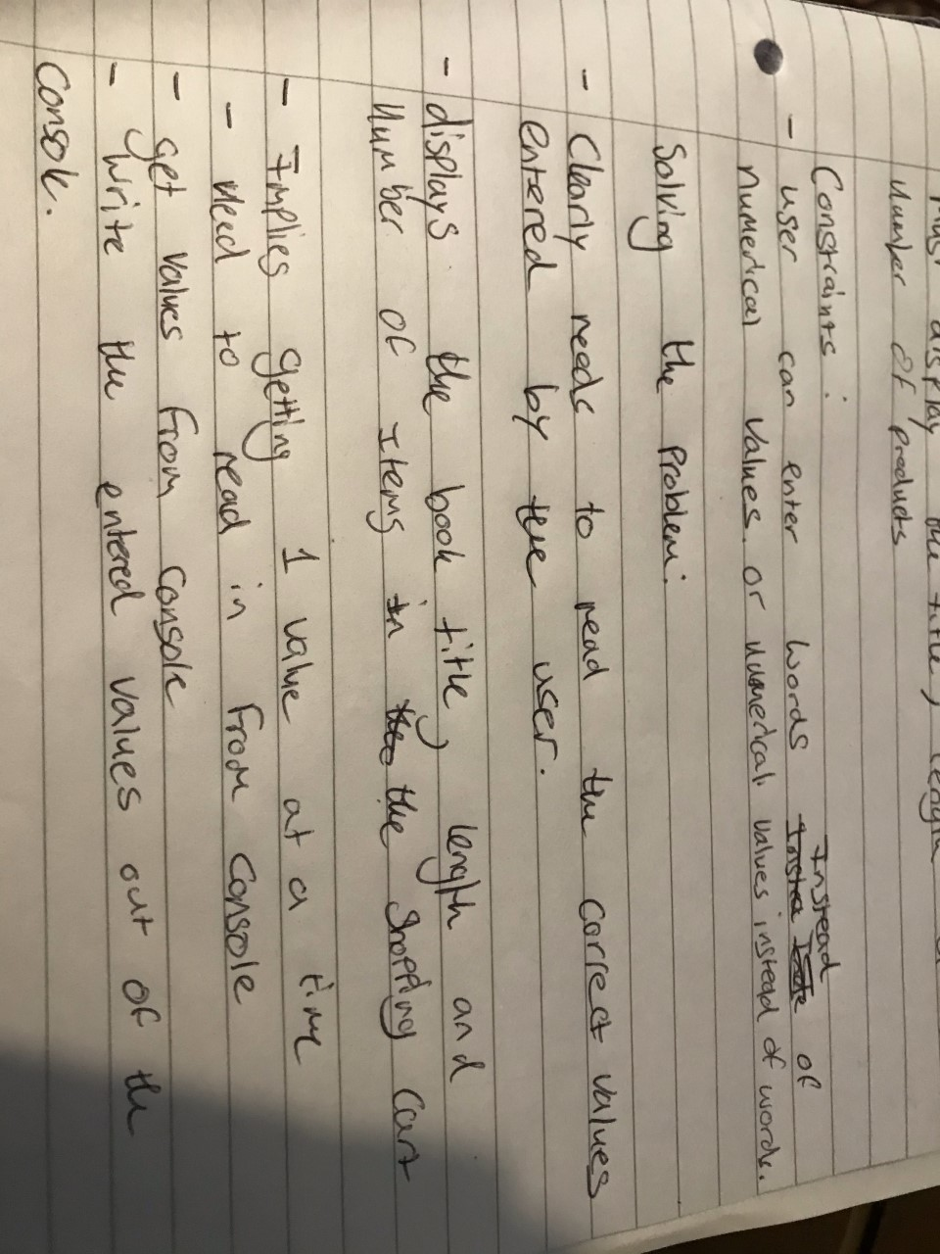

Below are going to be screenshots of the code in development and the code running to give a general idea of what should be happening in the code.
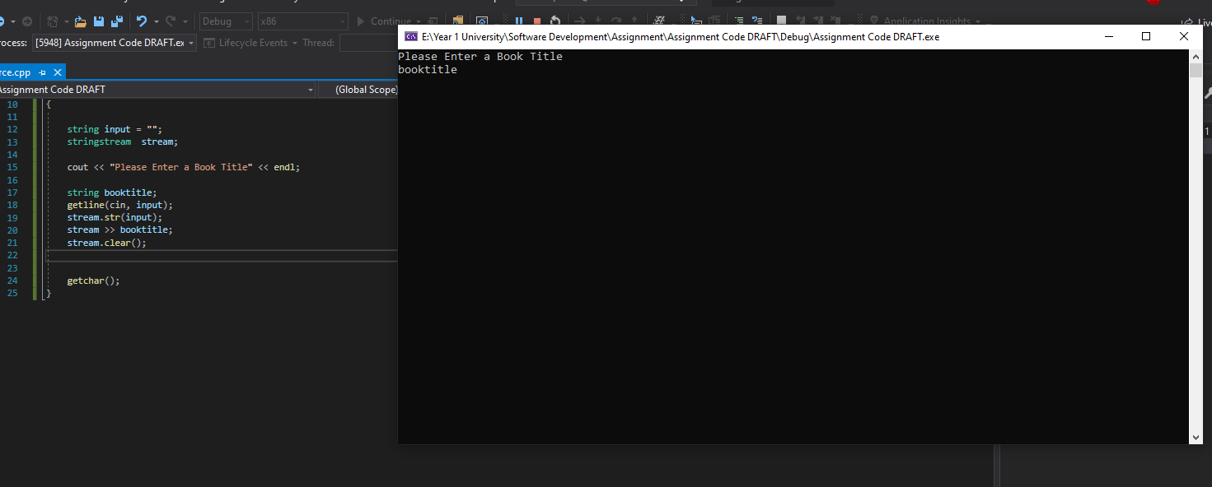

The code is prompting the user to enter a book title by seeing into the console and when coded it will correctly display what the user entered in the console.
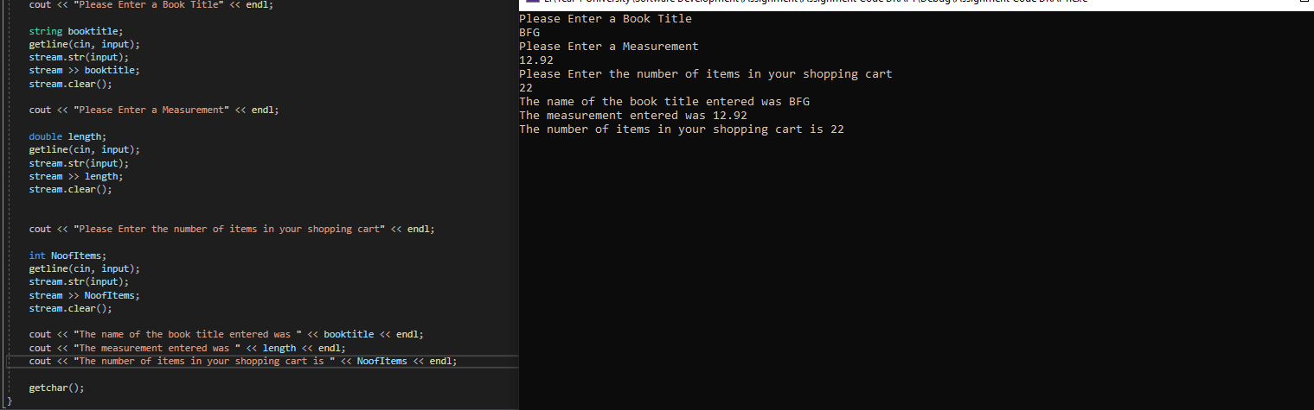
Above is a screenshot of the finished code for task 1 and as shown in the screenshot it is doing what was intended which was to get values from the user and then display them at the end. There are probably bugs with the code such as if a user was to enter a numerical value for the string it would likely break the code, but this was also shown as a constraint in an earlier screenshot.
Task 2:
Below are 2 images that show the requirements of what the code is going to do, the constraints that could potentially be a problem in the code and the solution as to how to solve the problem.
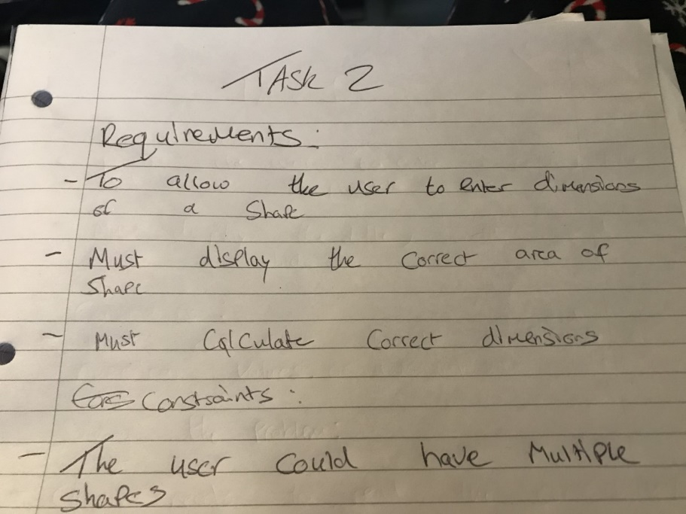

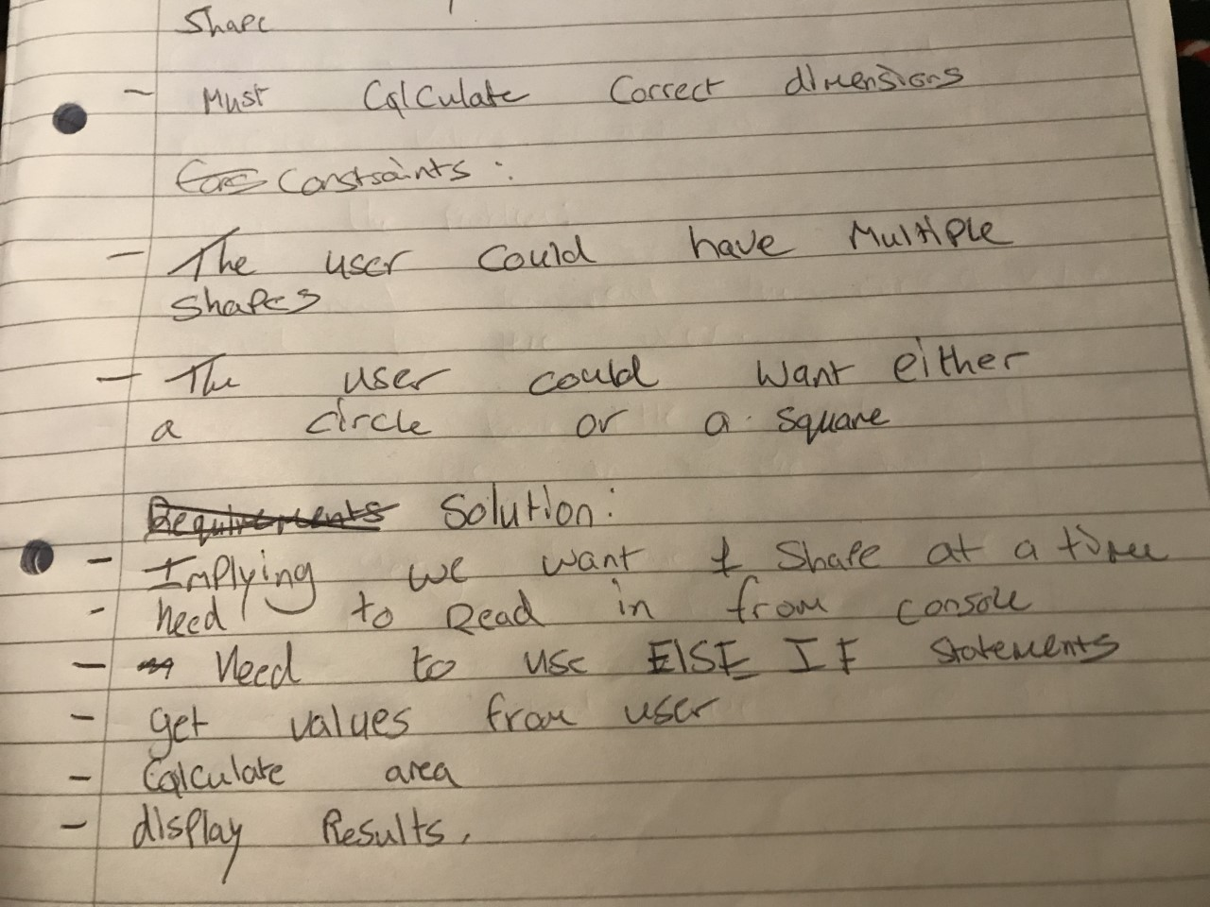

Below is are 2 screenshots of a flowchart that was made for further documentation and to show how to tackle the problem further.
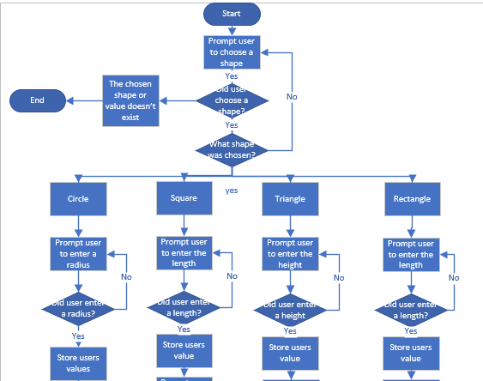

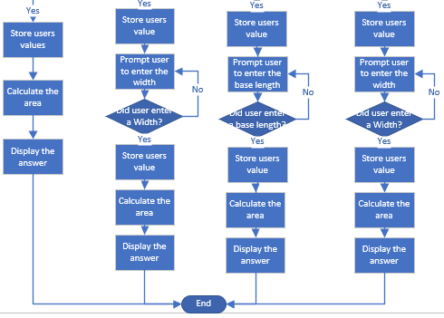

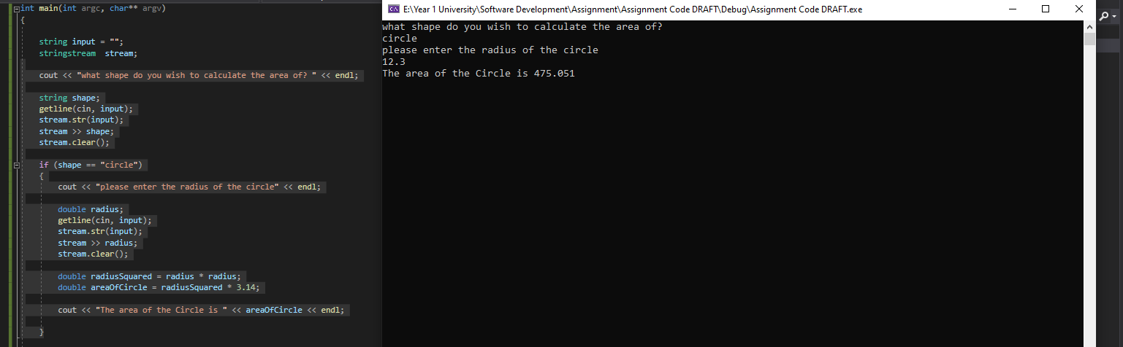
Below are going to be multiple screenshots of task 2 and the creation of the code and showing the code working, there will be bugs with the code as it was early in development and the code was always changing since the code gave multiple choices as to what shapes the user could have chosen or the user might enter a value that the code won’t recognise. After reading the brief incorrectly the screenshots below aren’t much proof of the code working and found it to be too difficult to go back and fix and figure out how to create a shape into code and then work out how to make it display those shapes inside of the block.

This is just an example of what the code is doing when a user is looking for a specific shape.

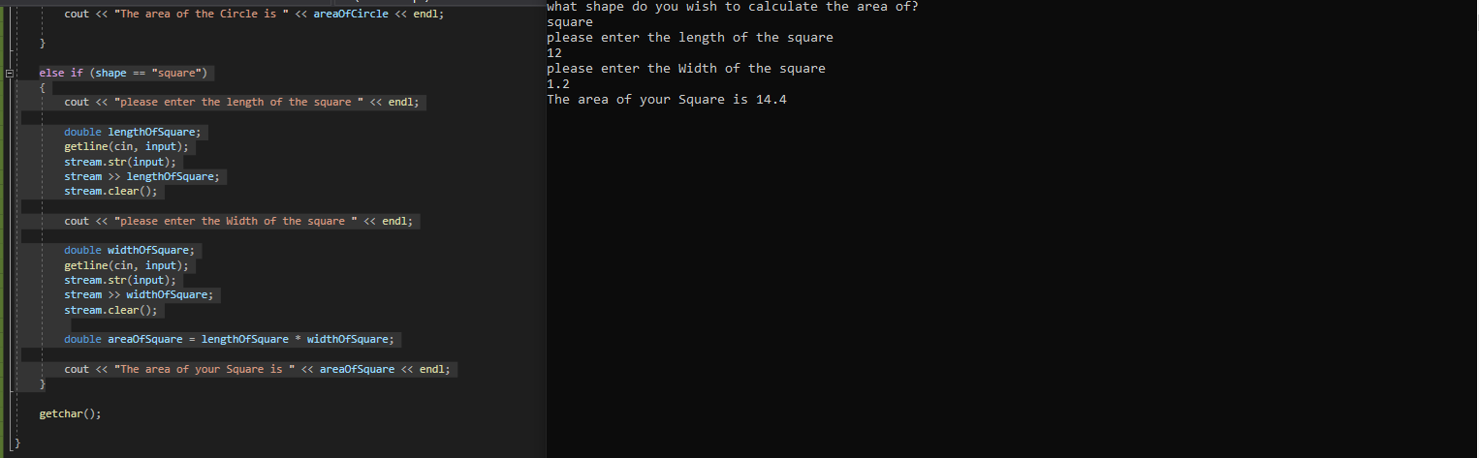
As mentioned before the code was designed for multiple choice between shapes and it does it very well and give correct values.
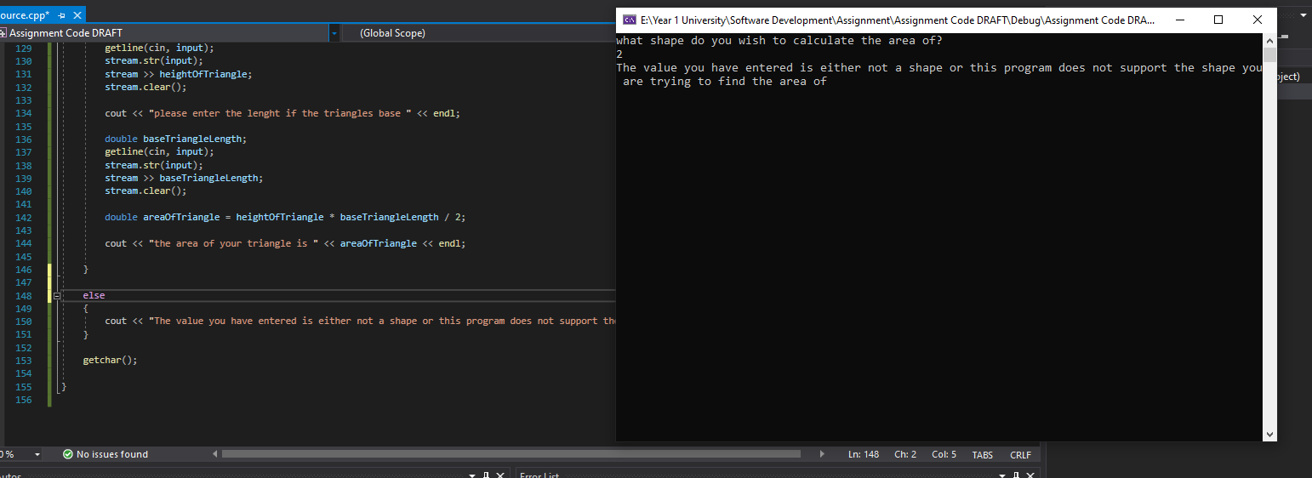

During creating the code there was something that was looked over when planning out how to tackle the problem of the user entering incorrect values and during testing there was the ability to use Else to make sure a user enters a correct value in order for them to use the program.

Task 3:
Below is going to be 3 screenshots of the written requirements, constraints and solution to solving task 3s problem, with each picture taken of the notes made on tackling the problem there were some problems such as it mentions use of an IF statement when in fact all that was simply needed was a FOR loop.

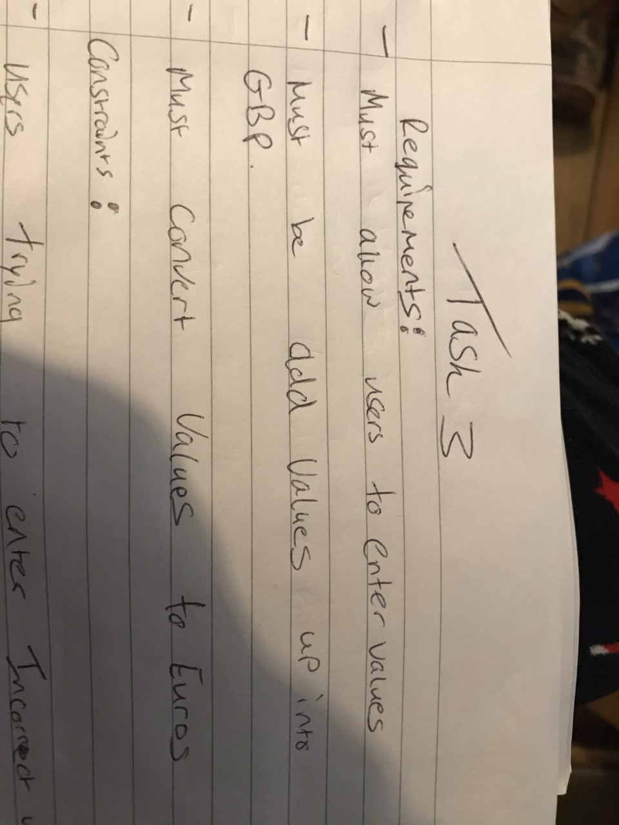
Above shows the requirements for converting Pounds into Euros and what must happen for code to work.
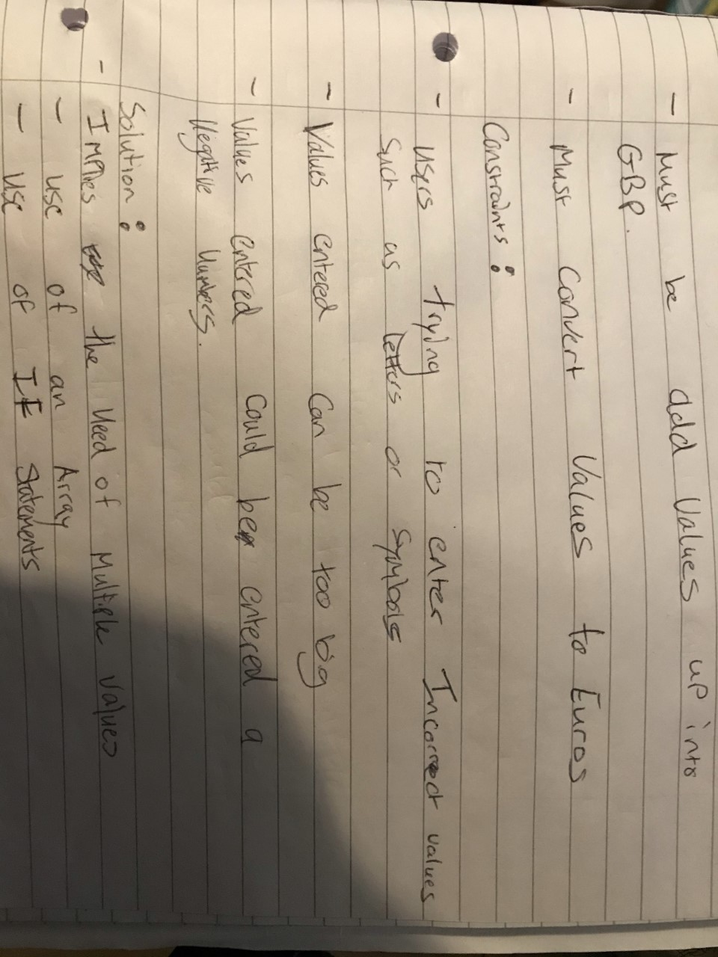
Above are the constraints and the issues that could occur during development of the code outlining that values being negative and not working with the code or the value simply being too large for the code or the user enters an alphabetical value.
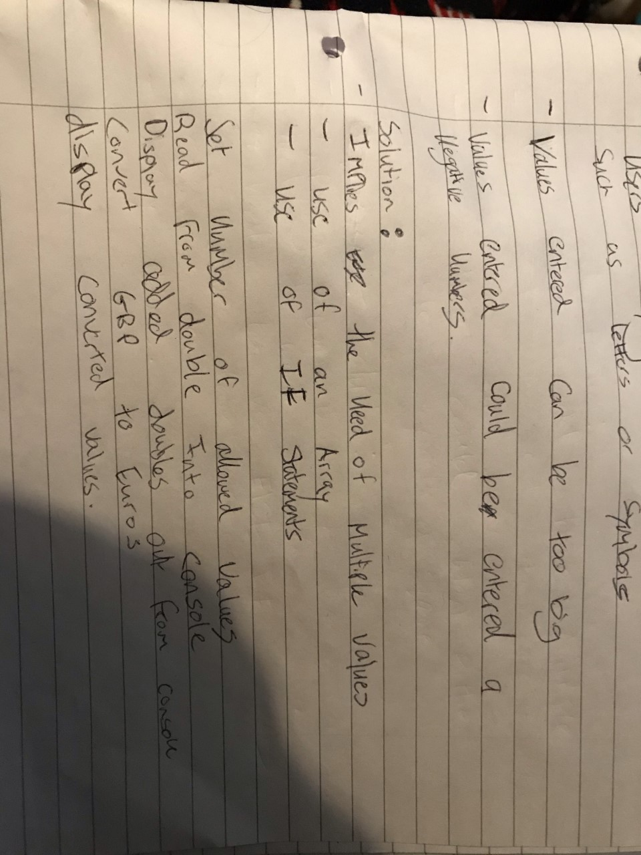

Then finally the solution as to fixing the problem but as mentioned there where no IF statements used and instead a FOR loop to make the user enter multiple values.

The next few screenshots are screenshots of the code in development and the finished code for that specific task.
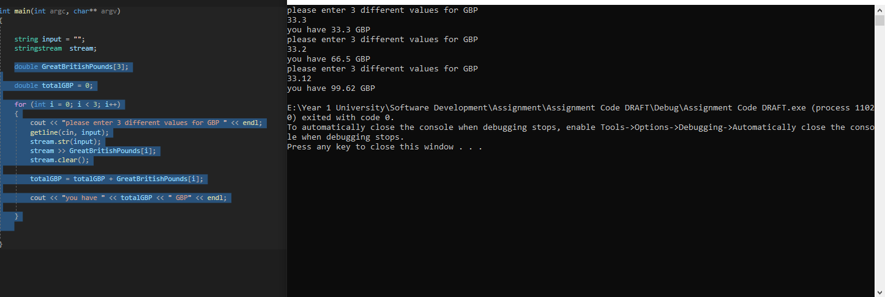

As shown above that is the code that was developed for getting 3 values from the user and taking those values as GBP (Great British Pounds) and then adding all the values together using a for loop.
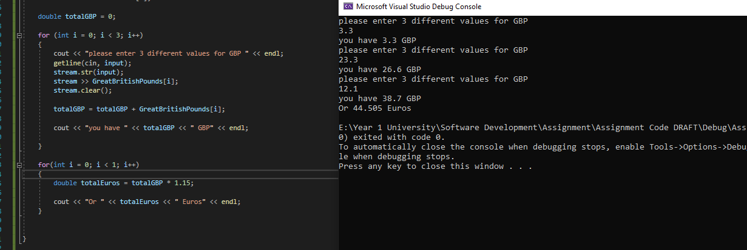
Above is showing the conversion rate of Pounds to Euros before creating the code the sensible thing to do was to look at todays conversion rate and it was 1.15 Euros to 1 Pound and in the code when it was created it correctly displayed the values but when double checking from google, google was rounding the values and giving different answers to the code but when doing the conversion in a calculator the conversion in the code was the same as the calculator.

Conclusion:
In conclusion there are a lot of things that I could have done differently for example given tasks 4 and 5 a try but after reading the brief there I had an epiphany and I recognised that doing them was beyond my level of knowledge and understanding and doing them would have just caused a lot of strain. As for the tasks I did task 1 I could have done better but I just made it simplistic and didn’t devote much time to it at all and just did some basic notes and coded it, as for task 2 there was a lot I didn’t understand and don’t know if it was done correctly so I did what I thought was right and did some basic notes and created a flowchart of what the code should have looked like and then went from there. Task 3 on the other hand was like task 1 not much effort devoted to it and did some basic notes which turned out to be a little wrong and just outlined what the code should have looked like and then made a pounds to euros converter. As for what I could have done differently it would have been to give tasks 4 and 5 a shot and do some research on both of them as to how the problem would have been solved and devote more time to tasks 1 and 3 and provide better documentation as to how the problems could have been solved.

