An English philanthropist and tycoon in the name of Sir Richard Branson from England and is the owner of Virgin Group. To date this group has had in excess of 400 companies under its umbrella. Branson is known as a serial entrepreneur who has had an extraordinary life of ups and downs. Branson has embraced the moments of success and struggle, with his indefatigable spirit, thus turning his failures to the steppingstone for success.
Branson always had the knack of making money through his entrepreneurial streak in him. Branson could eye an opportunity where there would not have been, in turn making it into a successful business. His first venture was the iconic Virgin Records. Its humble beginning as a small record shop in Oxfordshire, England. Branson’s musical efforts eventually led him to establish virgin Atlantic thus bringing his companies under the virgin group. Even in today’s era Branson continues growing strong in expanding his fifty plus year old legacy.
Richard Charles Nicholas Branson was born in 1950 in Surrey. His farther is Edward James Branson and mother is Eve Branson. Branson did not fair well in school as a child. Branson was always struggling to keep up in school due to his dyslexia. At the mere age of 16, Branson decided to leave school. This led him to establish a magazine for the youth students. His first issue came out om 1966 which sold £8000 in advertising also 50000 copies were released for free.
Mike Oldfield was the first artist signed by virgin records in 1973. Oldfield’s song “Tubuler Bells” had topped the UK charts for a staggering 247 weeks. This initial success showed that Branson had a great knack in spotting talent. The success then led to huge deals with iconic artists such as Sex pistols and the rolling stones. These bands then went onto catapult virgin records to be one of the top record companies in the world.
However virgin records was only able to sustain success for so long and in 1992 the company was financially struggling to stay afloat. The following year Branson sold virgin records for $1 billion to THORN EMI. However, prior to this setback Branson acquired two travel companies virgin Atlantic and the Voyager Group. Eventually the first store in oxford street multiplied to a number of virgin megastores.
The selling or virgin media was not at all easy for Richard Branson, there were reports of him crying during the signing of the contract. But this loss did not stop him but in turn made him stronger. In the same year he opened virgin radio, along with V2 his second record company three years later, signing Hugh superstars like Sit Tom Jones and Powder Finger.
Branson also suffered from other business losses such as virgin cola and virgin cosmetics. Virgin cola was his worst venture, only capturing 0.5% of the US market share. In 2012 the company stopped producing the drink. Although all these businesses shut down, this made Branson stronger, he never went into his shell rather he learned from all his failures and used these for future success as a steppingstone.

What is leadership
Leadership is the ability to inspire a team to achieve a certain goal. It’s usually discussed in the context of business, but leadership is also how you, as an individual, choose to lead your life. The true leadership definition is to influence, inspire and help others become their best selves, building their skills, and achieving goals along the way. You don’t have to be a CEO, manager or even a team lead to be a leader. Leadership is a set of skills – and a certain psychology – that anyone can master. (What is Leadership? Definition, Importance & More | Tony Robbins, 2021)
Transformational leadership is a leadership style that can inspire positive changes in those who follow. Transformational leaders are generally energetic, enthusiastic, and passionate. Not only are these leaders concerned and involved in the process; they are also focused on helping every member of the group succeed as well. (Cherry, 2020)
Richard Branson Was never a normal leader, his vison from the first day was to shake thigs up. Richard Branson’s philosophy fits exactly as a transforaminal leader. Richard Branson wants his employees to come to him with new ideas directly to him without any fear of being shot down. The employees of Richard Branson are treated like humans, this allows the creative juices to flow, it will not matter in what part of a business they are working in. how exiting is it to know that you can directly go to the CEO at the top of an organisation and give your opinion without the fear of any repercussion. Richard Branson is quoted as saying “staff first, customers second, and shareholder third”. This is such a simple concept, but this makes a lot of sense as, employees who are happy will give a better service and will be more driven to do what is correct thus leading to happy customers which in turn will lead to greater profit for virgin.
Branson always sets lofty goals for his employees. Everything to fall into place the very first time is not expected from Branson instead manager, employees are trained to become more effective and better people. Rewards are given to people for excelling, he also encourages people to turn mistakes into opportunities. Praise of employees is given publicly, thus, to motivate others.

But there can also be disadvantage in transformational leadership.
The influence can backfire, if plans do not come to fruition then the employees will be blamed as they are the ones who gave the recommendation.
Employee burnout
Although subordinates feel a part of the team people may be asked to work longer hours and may even be asked to go beyond their task to achieve the goals of the organisation.
A charismatic leader has specific effects on followers in their own unique ways. Going outside the box in thinking would best describe Richard Branson.
Another trait of Richard Branson is being there for the employees in difficult times of pain and stress where the employees will look to the follower to get them out of tough times. Another characteristic or Branson is pushing employees to their fullest potential.

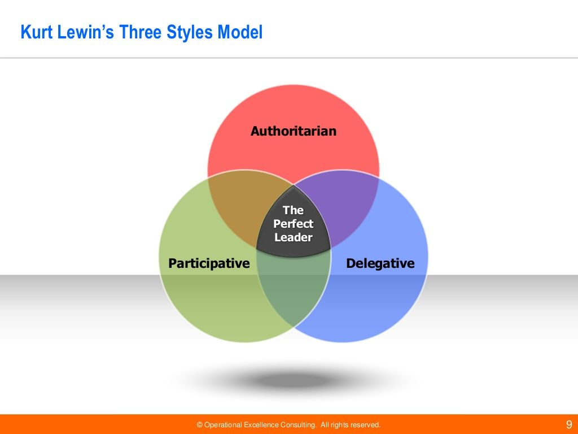
Kurt Lewin was a psychologist and in 1939 he led a group of psychologists in identifying different leaderships styles. More distinctive types of leaderships have now been identified but In the early studies this was very influential which established three leadership styles.
Authoritarian leadership (autocratic)
These leaders say what needs to be done and when it needs to be done. This style focuses on controlling the followers with the command of the leader. Decisions are made independently with no input from employees.
The advantage of an autocratic leader is when rapid decision making is needed then the leader is seen as the most knowledgeable person to give instructions.
The disadvantage is leader is seen as bossy controlling. It will create hostile and dysfunctional environments leading to followers being against the leader.
2 democratic leader
The study found that this leadership style is the most effective, these leaders offer guidance to followers but allow input from the followers in the decision making. Although the final decision is made by the leader.
Advantages here are
This works best when trying to solve complex concerns – as they say two brains is better than one.
It encourages creativity, the relationship of a team is strengthened, it will improve job satisfaction with stronger commitment levels.
Some disadvantages would be.
Negative emotions could be created, as team members with strong creative skills will be highlighted and implemented, making other team members feel their opinions are not valued. This could stop that person from participating. Unless these negative emotions are dealt with, this will reduce productivity rather than enhancing it.
Team members could be made to question the capabilities of the leader. Some members may feel that they are doing all the work for the leader, this is true if the best ideas are always coming from the members. The members feel the leader is compensated more for the members ideas. This could lead to low morale and less productivity, leading to in severe cases employees quitting r refuse to participate.
3 laissez-faire
This is where the decision making is left to the followers. This is seen as the least effective method as more demands are made to the leader, little cooperation was showed, and they were unable to work independently. As no guidance is given to members and decision making is left to be made by the members.
While this style will be effective when high qualified group members are involved but it can often lead to lack of motivation and roles being poorly defined.

It can be said that Richard Branson has different leadership styles depending on the situation. Trying to follow in the footsteps of Branson would exhaust many entrepreneurs. His energy makes him one of the most exiting entrepreneurs in the world. His styles may not be able to be replicated but lessons can be learned from his approach
Sometimes Branson could be classed as a Laissez-Faire leader. This is because he believes lessons need to learn from mistakes. While goals are set by Richard Branson, the expectation is employees need to do the work to get to the goal. Branson shares his ideas but understands the from action employees learn the best.
From the success of virgin Atlantic to the failure of virgin cola, a team of experts have been embraced by Branson, to run the show as they see fit. This sometimes will mean letting employees to fail in reaching the goal.
However, this came to bite back during the balloon trip where Branson and Per Lindstrand had to jump out of the hot air balloon to save themselves.
Some of the characteristics that define his leadership are
People moving forward through his motivation.
For managers and employees to reach higher goals through encouragement.
Taking action against mistakes and learning.
Gaining insights and share ideas by communication with team members.
Without excessive oversight letting executives and managers in pursuing interest.
Bring fun to life by balancing work and family life.
You can say Branson is a visionary leader he has many visions. Although Branson does not have all the skills to make his visions come true, for example he has no experience in making an aeroplane, but his charismatic personality gets other people excited about his vison and his ideas. In ways Branson maybe seen as too flexible to be a visionary leader, he has very high expectations while he punches better than most visionary leaders.

Branson can also be said to be a situational leader as backed up by (Hersey and Blanchard 1984)
This model suggest that no single leadership style is better from one another. Instead of focusing on the factors in the workplace, this model suggests the leader (Branson) adjusts their style depending on the ability of the employees.
As you can see with Branson encourages employees to learn from mistakes as he will help them but where his knowledge is not needed Branson will stay away and let the team get on with it.
According to the model a successful leadership is relationship relevant and task relevant again agreeing to Branson’s personality.
Branson takes on board individual or team factors that might impact the work environment before choosing the way to lead the particular team to unsure targets are met.
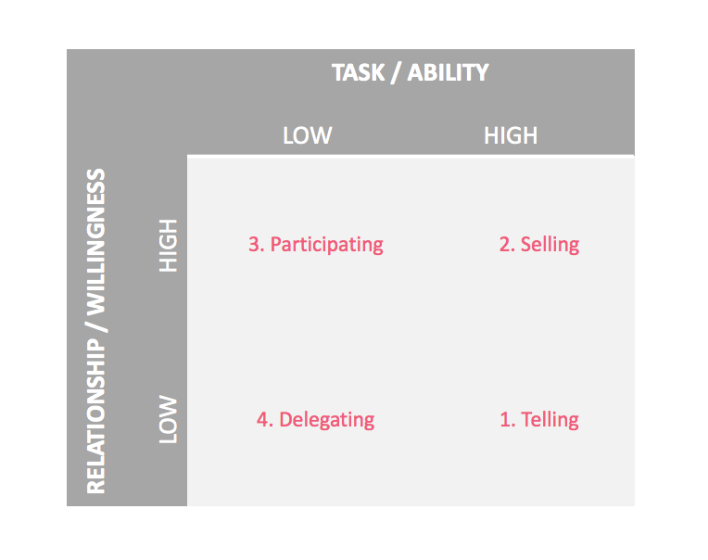

The diagram above shows Hersey & Blanchard's Situational Leadership® Model.

An advantage using this model to Branson will be. He uses his own discretion at any one time. A leader who is seen to adapt to shifts in the workplace is seen as a desirable trait by the employees. This style is simple and easy to use. This means Branson can easily evaluate a situation and make the decision they see fit. For example, after his failures at virgin cola, he brought in experts in that field so they can have input into decision making in future business.
The downside here would be, too much pressure maybe put onto Branson, whose decision maybe flawed, also this model does not apply to all work culture, this model prioritises task and relationships, and may forget the companies long term goal.

Vrooms expectancy theory.
Canadian professor of psychology Victor Vroom developed an expectancy theory in 1964. In this theory Vroom studied people’s motivation and concluded it depends on the factors. Vrooms theory is related to motivating within a working environment. Vroom argues that when an employee is able to make a choice in work, they will choose what motivates them the most.
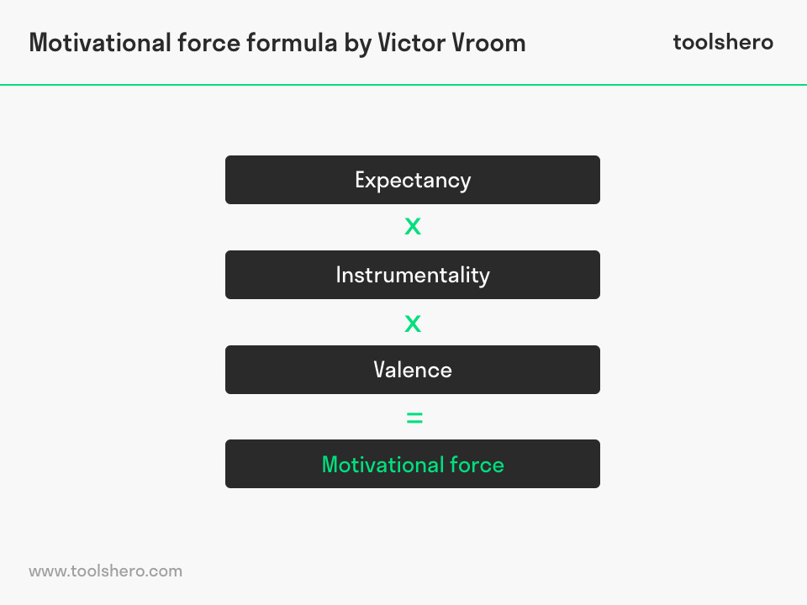
The above images show Vrooms formula.
Expectancy. To get a relation to good performance through the employees own efforts. An organisation can then determine and respond to what factors are needed for the employee to deliver the best performance possible.
Instrumentally.
Each employee is a cog in the machine and an instrument that contributes to the business results. (What is Vroom's Expectancy Theory? Definition, application | toolshero, 2021)
To grasp instrumentally is not difficult from the above perspective. By making a promise on reward such as a bonus can be stimulated by the organisation. The employee will then believe that a better performance will lead to appreciation being shown due to the results.
Valence.
The final result that employees achieve is valued differently by each individual. This value is based on their own basic needs. As such, it’s a good idea for an organisation to find out what an individual employee values and what his personal needs are. One might value money, while another values more days off. (What is Vroom's Expectancy Theory? Definition, application | toolshero, 2021)

Richard Branson relates to this theory greatly. Branson believes that when a reward value has a personal value that employee will then increase the work effort to reach their target and get rewarded. That employee in turn is made aware of the relationship between results due to greater effort. In this case Branson and his employees are aware that, work performance is improved through increased efforts. Bigger rewards are led from increased performance. Employees then appreciate the reward offered.
Branson is aware that if these conditions are not met, the motivation of employees will be difficult. Together with its employees Branson concludes which reward is valued by the employee. Branson sees that financial rewards often lead to employees performing better at reaching the lofty goals set by Branson himself. Even though vrooms theory suggests that this alone is not the defining factor. Thus, Branson always sets a balance in offering financial rewards and setting up a performance standard which is clear. And is individually tailored to that employee.
An advantage of Vrooms theory is. Incentives are likely to boost the expectation of employees. A motivational process can be triggered which will improve performances. Managers or employees can understand which reward best suites each individual employee. Thus, when gaps appear training can be given a commit to a reward being delivered.
A weakness of this theory would be. Without participation from the managers this theory will not work. The theory suggests that employers already know the components but in reality leaders need to be aware of what the employee values as a reward.
Another disadvantage would be. Some rewards given by the employer might not be of value to certain employees. If rewards are not chosen relevantly, employees may lose concentration and motivation.

To conclude. It can be said that Sir Richard Branson has many different leaderships qualities and styles, but he is seen to be mainly of a democratic leaderships styles where he considers employees advice in reaching his final decision.
Even though recent controversies of Branson which has arisen during the covid pandemic of asking staff to take eight weeks of unpaid leave to safeguard the company. He still remains an attractive person to work for as his decorative history will tell you.
Branson believes that a greater team is always behind a great leader. Branson believes in working as a team which shares the same beliefs and values as himself.
Branson is genuinely interested in all his employees and recognises the value of that employee.
“Having a personality of caring about people is important. You can’t be a good leader unless you generally like people. That is how you bring out the best in them.” – Richard Branson
Praising and rewarding employees will mean them working more harder than ever, whether Branson is physically there or not these employees will continue to work hard in achieving these goals.
A sign of a great leader is to create a project which is run effetely without the presence of the leader.
Every business idea will not work but it is an idea worth fighting for. Every step of the way may not be smooth but with adversity the wish for success is strengthen.
Another famous Branson quote “Do not be embarrassed by your failures, learn from them and start again.” – Richard Branson
Branson believes a company should be like a family. Bonds should be connected across the board. Delegation is the art mustard by Branson. He allows employees to flourish in the correct circumstances albeit from a little guidance which strengthens the bond the more you work together.
Employees want to work for Richard Branson because, he puts employees ahead of customers and this works.
Employees feel valued in turn they repay him with a superior service to customers and loyalty.
While many managers are scared to put employees first Branson is living proof that his theory works.
To his employees Richard Branson is nothing short of inspirational. Branson not only inspires people within his organisation, but he also inspires people who ae not in his organisation which tell you the magnitude of power Richard Branson has.

Task4
My leadership qualities.
I see me self as a transformational leader as I work in the food industry we need the help of emplyees to fulfil custromer satisfacrion.
I am passionate about my role as a leader as I have been in this trade for about 20, although Richard branson is not in the food trade I like the way he interaxts with employees and I want to see my self as a fun loving chariector where everyone wants to work with. I want to help every member of my group to succeed.
Although I have been in this trade for many of years there is always something new that can be learnt from others creativity skills. This does not make you a bad leader but adds to your know;ledge and customer satisfanction. My staff cam come to me directly with new innovative ideas without having to come through middle people as I work there myself. All my staff are treated like family as we sometimes spend more time together then our own family, I believe this goes a long way as if you treat your staff with respect then they will work hard to deliver the end goas as I believe “happy staff happy customers happy leader”
Rewards are always given when staff excel them selves and when targets are met they are rewared by bonuses this could range from money to vouvhers etc.
But sometimes if I take the advice of a particular employees and it was to backfire I would think twice about taking that persons advice again.
But by taking thoer adcive I want them to feel a aprt of the family in orde for them to perform better.
Sometimes in this trade an autocratic style is needed. For example when a customer complains of bad service I would diredctly speak to that customer first and try sort the problem and then I would relay it back to the staff to make them aware and make them better.
This style may not always be good for the long run as 2 brains are always better then one but in certain situations, time is limited and a desciosn needs to be made instalty.
As its my own business financial decisions are made by myself only.
Sometimes I have used the laizze-faiire style as if I go away on hilidays I will need to leave someone in charge to make the decisions while I am away, as how the see fits best. They are fully trained well before these holdiays are taken.
The macgregor x-y theory is one that I follow a lot.
Theory x is where some team members may dislike the work or have little motivation, I am very hands on with this arrpoach as this I micromsnage peoles work to ensure it is done properly in certain situations.
Some people may not like their work, they may need conatant direction, sometimes staff have to be forced to do their work, may need to be supervised all the time. May not have the incective to work and may need to be enticed by a reward to achive this goal.
To be honest I am not a big fan of these emppoyees as I want them to enjoy work and not be there for just having to be there.
The Y theory is where staff take joy and pride in teir work and see it as a challange. With this I take a more pastipative style of management. I trust the staff to do their work effectively by themselves as I cannot be at sll places at any one time.
Theory Y would best suit my thinking as.
Workers are happy to work with teir own initiatives. Employees are more involved in the decision making, staff need to be self motivated in order to complete tasks. Staff should take ownershiod of their work. Sometimes in a fast busy environment staff sometimes need to accept responsabiti with little direcrtion.
The questionnnre which was completed backs up my theory of me being a democratic leader followed by authouratarian and last by laizze-ffair.
The questionnaire also suggest that I am of process emphaisi leadership style. I also believe this is correct and a true reflecrtion. I like to think I create condition for others to succeed. I like to guide, nurture and support my staff in order for my business to grow.
While working I like to see me self as a part of them employees and not the boss. But if I need to step In I will.

Task 5
I now see myself as a situatinal leader as any adversity can arise at any time and we need to be prepared to deal with this adversity weather it be autocratic or democratic.
This covid pandemic has thrown a lot of difficult situations so I have had to change things as we go when the gonvenment gives guildlins we have to adhere to these guidline. For example we have had to social distance staff and customers alike and when lockdown measures were given we needed to come up with solutions to keep the buciness flowing and to keep customers happy. Weather it be a democtraic style or autocratic style decisions needed to be taken to try and run things as smooth as possible.

