Carmarthen Wellbeing | - An investigation into the need to develop a community-based Online Directory of Support services to combat Loneliness and Wellbeing Problems within Carmarthen Town
What Is Wellbeing?  World Health Organisation describes it as "a state of complete physical, mental and social wellbeing and not merely the absence of disease or infirmity" (WHO, 1948).  Maslow's Hierarchy Of Needs:  Is it possible to develop an online community directory that specifically targets helping people achieve self-actualization by giving them the sense of love and belongingness they need to self-actualize?  Digital Wellbeing:  Excessive use of mobile technology can lead to people feeling a lack of balance because technology has begun to dominate their life. Digital well-being is a brand-new concept opposite to this feeling. Therefore pursuing "digital well-being" is urgent  Carmarthenshire Rural Areas:  60% of the County's residents live in rural communities opens a window into the reality that nearly two-thirds of the population could suffer loneliness.  Support Groups:  Self-help groups are formed by people who share similar interests and want to share their knowledge hence why an online directory would be beneficial to signpost support groups such as self-help groups.  Is there a demand for a Wellbeing Director?  Do you value the idea of an Online Well-being Directory? 96% of the respondents answered "Yes" or "Maybe". . Therefore, the evidence shows that there is very likely to be solid demand for an online directory to signpost people to the most appropriate services to meet their needs, | 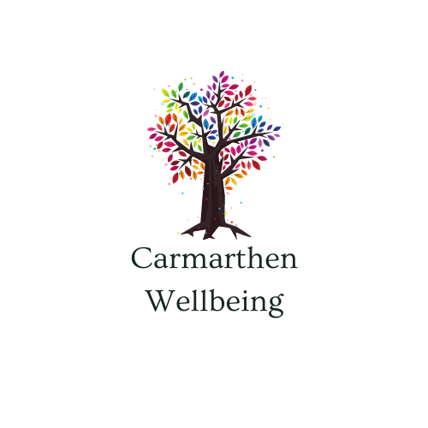  The Research:  Key Findings:  63.7% of respondents reported having concerns about their well-being throughout the week, whether it was more than once a day or more than once a week.  Does this mean there is a demand for an online directory?  More evidence shows that there is likely to be demand for an online directory to signpost people to the most appropriate services to meet their needs.  66% of participants believed the internet and social media could be helpful. A majority of respondents (65%) live in rural areas and are at risk of being socially isolated as a result.  By Samuel Rossiter  University Of Wales Trinity Saint David

