NATESHA NATOYA LEWIS
2134545
Marketing Skills BMIH4005
Dale Clarke
A comparison of the marketing methods of two multinational hotel brands
Six Sense and Holiday Inn
Introduction
In this essay I will be comparing marketing methods between two hotel brands. The Six Sense and Holiday Inn. Both hotels are different in many ways, from customers, quality of service and different marketing strategies. They are both apart of the Intercontinental Hotel Group PLC, which makes them a branded hotel. A hotel with a brand name gets a similarity between a class of other hotels with a brand name that’s put them in the eyes of the customer. This generates marketing skills in the form of a purpose that exists behind an action, fact or object. No two hotels are the same, but all hotels have an aim to have an excellent marketing skill that leads to more customer and more business. Marketing is a very important part of any business; this is where you advertise your business so that it is known to the public about the services you offer and the reason why your service is better than your latest competitor. Below I will explain all the marketing strategy for “The Six Sense” and “Holiday Inn” along with the difference in the way they market themselves.
Main Body
Holiday Inn is an American hotel that was founded in 1952 by Kemmons Wilson, since then it has been spread across six continents throughout the world. Holiday Inn also has resorts under its name along with club vacations. The services they offer are hotel rooms, food service and function room. In their function room they host weddings, parties, meetings and other events that would require the size and location they have on offer. Marketing organises course of action that is well built, will increase the flow of customers and spread the awareness of the brand. This comes in the form of, logos, adverts from Tv to billboards and promotions. According to Alex Samuely, “Holiday Inn promotes travel planning with mobile destination guide contest. He states that, holiday Inn the hotel brand group has teamed up with
The 5cs of marketing are, company, customers, competitors, collaborators and climate. These has a real effect on hotels with a brand name and how they approach the 5cs. Holiday Inn collaborates with franchises such as booking.com, hotel.com, expedia and much more. These are a few of their supply chains to get more consumer to their business. These franchises mostly do Tv advert and to what we have learnt, visual always gets more attention, along with the discounts that comes with using these franchises.
The Six Sense hotel story began in 1995, their mission is to make the world a better place by creating an environment that is suitable for customers and the planet. Their aim is to be different from other hotel brands by inventing recyclable materials along with creating their own water to have that extra special feeling for their consumers. Unlike the holiday inn, the six sense uses the 5cs, where climate is of importance for their resources, for example, their ski resorts that all depends on the weather conditions. The six sense swot analysis states that they provide an extraordinary experience for their customers. They offer different activities that is suitable for families. These activities ranges from, learning about food in a class setting, outdoor cooking events that comes with a one to one hired help. Lawn meals are also available in various destination that has views no one has ever seen in any other hotel. Six sense has been granted a high level award for their great effort in being a hotel with a brand name that provides healthy habits. The Holiday swot analysis has stated due to the hotel being so great with how it markets itself and the franchises it poses around the world, a upper hand has gain in this situation. Their weak point is, not being able to match their competitor’s strategy. They are face with some huge competitors such as “The Six Sense hotel”. This is where each hotel has different ways of marketing.
The Bowmans Strategy clock explain the different levels located on the chart, where each company is position in the marketing world. See in the appendix below the chart where I place Six Sense hotel at “5” this called focused differentiation. Holiday inn I placed at “3” this is called hybrid. I choose these levels based on their performance as a brand hotel.
The Pestle Analysis is the politics, social, legal, economics, technological and environment aspect of marketing. The holiday inn is not an environmental based company because they are not a recyclable brand as the Six Sense, where they do recycle, and their aim is to make the world a better place. Holiday inn is a government-based company as they rely on their policies to carry out taxable information concerning their employees. They operate all over the world so that makes them sociable. The Six Sense Hotel has a different social background, even though they are environmentally friendly not everyone is for saving the planet, so holiday inn will be more social able. The six sense uses less technology as they use nature as a way of saving the planet, from recycle to sun light and reusing the coral reefs.
“The marketing mix refers to the tactics (or marketing activities) that we have to satisfy the customers needs.” A. Allen Oxford College of marketing. This known as the 7Ps of marketing, which consist of the product, price, promotion, place, people, packaging and process, see appendix below for table example. The 7ps are an important part of marking. The product is the first P that is needed of the 7. Without a product, you have nothing to market. With the Six Sense Hotel their product is their wellness and sustainability for customer interested in saving the planet. Their prices also varies, and they have provided the opportunity for discount if booking is done early. They are widely spread across Europe and Asia. Their facilities can accommodate any weather as they have location around the globe even areas with severe weather condition. The people they accommodate are interested in saving our planet and recycling, although everyone is welcome, their main targets are families. The Holiday inn speaks differently, they have been around longer than the Six Sense hotel and they have far more location and is more well know to lot more consumer in the hotel industry. Holiday Inn product is their large conference rooms and events that they are known to have, that is their product, what they market. The people they target, are businesspeople who uses their rooms and conference room so it’s a double sale in the way they package each deal.
Conclusion
In conclusion, both hotel market their establishment for the same reason to make money. They do it differently as they have different customers and different ways of doing thing. We have learnt that Six Sense Hotel aims to save the planet, they obey the rules of the land, but their biodegradable plans do minimise the politics influence. The holiday is government based, where political influence is adhered due to their financial structure and how they deal with taxes. I have learnt that they are struggled to deal with their competitors and has the world gets more advance they try to keep up but it still results in some of their branches being sold.
Appendix

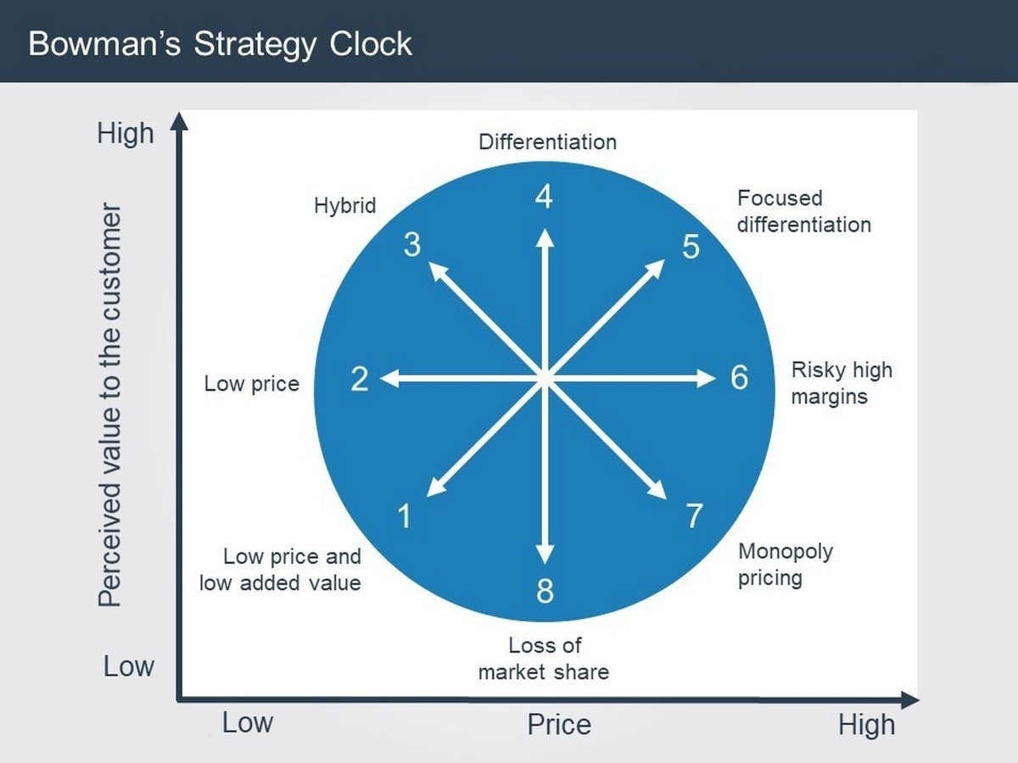

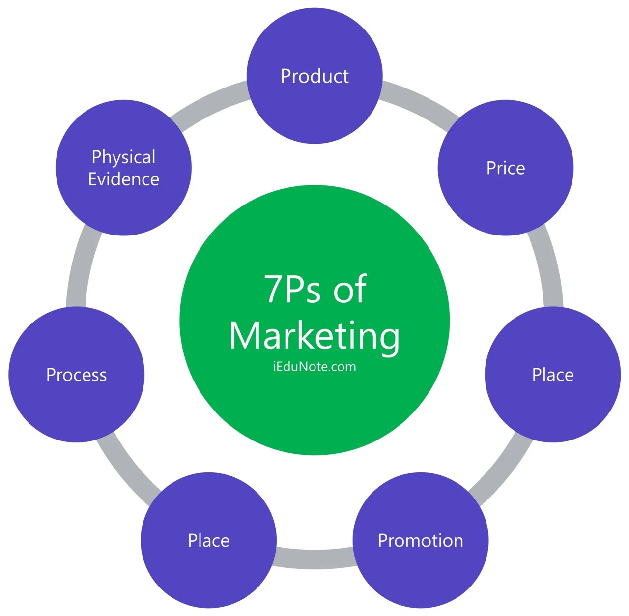

Reference
A. Allen, Oxford College of Marketing
Understanding the 7ps of marketing
The 7Ps of The Marketing Mix | Oxford College Of Marketing (08/10/2020)

