4/28/2026
Assessment
Software Application for Business

MODULE NAME: SOFTWARE APPLICATION FOR BUSINESS
MODULE CODE: ACCA 406
LECTURER: AMITAVE BANIK
TRINITY SANT DAVID UNIVERSITY OF WALES (LONDON CAMPUS)

STUDENT NAME: MARYAM ALI ZODA
STUDENT ID NUMBER 2531289

Table of Contents
Task 1: E-Commerce Website Builders/Software Solutions 3
1. Shopify 3
2. WooCommerce 3
3. Conclusion 4
Task 2. Mind-Map of Contemporary Software Applications 4
a. Mind Mapping and Its Benefits in Business Operations 4
b. Mind Map of Contemporary Software Applications 6
Task 3. Office Applications for Creating, Storing, Presenting, And Analysing Information/Data 7
a. Office Software Solutions for Business Operations 7
b. Practical Application of Excel Features 11
Task 4. Communication And Collaboration Applications 13
a. Analysis of Communication and Collaboration Tools 13
b. Practical Application of Features 15
Reference List 17

Task 1: E-Commerce Website Builders/Software Solutions
E-commerce website builders are Internet-based platforms that help businesses create and run their e-shops, regardless of whether they have programming skills. They provide a range of services, including product listings, transaction processes, customer support, and order tracking. Examples of well-known e-commerce sites include Shopify and WooCommerce [1].

1. Shopify
Overview
Shopify is a fully hosted, cloud-based e-commerce platform that operates on a subscription model for building and running online shops. It offers a one-stop solution in which hosting, security, and software updates are handled by the platform [2].
Key Features
- Drag-and-drop interface that is user-friendly.
- Website design using customizable templates and themes.
- Combined payment gateways, e.g. PayPal and credit card.
- Inventory and order management system.
- Responsive design to enhance user experience.
- In-house promotional features, such as email messages and discounts.
- Extension functionality app store.
Benefits for Business
The advantage of Shopify is that it is simple to use, as it only takes a few steps to create an online store, making it suitable for novices and small businesses. It helps save time as one does not have to worry about getting their own hosting services. Additionally, it enables a growth company to grow, which can increase its traffic.

Example Usage
As an illustration, an online clothing company can showcase products, manage stock, and accept payments worldwide with Shopify, operating smoothly online.

2. WooCommerce
Overview
WooCommerce is an open-source e-commerce platform that extends WordPress. The functionality enables users to turn their site into a real online store. Unlike Shopify, WooCommerce is a self-hosted e-commerce platform, so users can manage their data themselves.
Key Features
- Free and extremely customizable [3].
- Wholehearted compatibility with WordPress.
- Various other themes and plug-ins.
- Authors: The Product and Inventory Management tools.
- Safe payments and shipping facilities.
- Friendly search engine optimisation.
- The capability to edit code to do sophisticated functionality.
Benefits for Business
Besides, WooCommerce is inexpensive because there are no initial fees charged during installation; the only charges will be incurred from hosting. Moreover, WooCommerce is highly flexible, enabling the customisation of business websites to individual preferences through its open-source nature and the variety of extensions it offers [4]. Moreover, WooCommerce allows total control over data and design, as businesses retain ownership of the content on their web pages.
Example Usage
An example of such is a small handmade products business which can utilise WooCommerce to build an online store with a personalised design and functionality.

3. Conclusion
Shopify and WooCommerce are two popular platforms that help businesses grow in e-commerce. If you want everything convenient and put all your eggs in one basket, then the first application is best for you. However, if you require something flexible and customisable, then the second one may suit you better.

Task 2. Mind-Map of Contemporary Software Applications

Mind Mapping and Its Benefits in Business Operations
This entails representing information about each other visually, depending on how they relate to one another. Mind maps help people or teams of people organise ideas easily by using a flexible approach to organising them. The mind map generally starts with a topic or subject in the centre and arranges the major subjects and the information associated with them in a hierarchical, interconnected manner[1]
Mind mapping is crucial in business due to the efficiency and effective decision-making it enables. Two of the greatest advantages include clarity and organisation. Mind maps enable managers within the organisation to see how business processes are connected through a visual representation. Mind maps make it easier to plan and prevent any confusion when handling complex matters.

Another major benefit is the opportunity to use creativity and brainstorm. With the use of mind maps, you will be able to come up with new ideas easily. This will prove useful when developing products, planning marketing techniques, and solving problems. Research shows that mind mapping helps people think creatively and efficiently develop various ideas.
Mind mapping promotes better retention of information. This form of presentation enables individuals to remember things better compared to traditional written notes. Research shows that mind mapping facilitates understanding and memorisation of facts by making connections with known information[2]
In addition, mind mapping encourages teamwork an
d collaboration among organisations. For instance, when planning projects or conducting meetings, members can use the mind map to brainstorm, ensuring each party knows their role and the purpose. The result is improved collaboration and no misunderstandings.
Lastly, mind mapping would help achieve higher productivity and efficiency levels. Since there is an organised, simplified graphical representation of data, workers can complete their duties more quickly and make sound judgments. Corporations that adopt mind-mapping techniques have shown improved workflows and productivity.
Overall, mind mapping is a useful tool in today’s business world, applied to planning, innovation, collaboration, and decision-making[3]

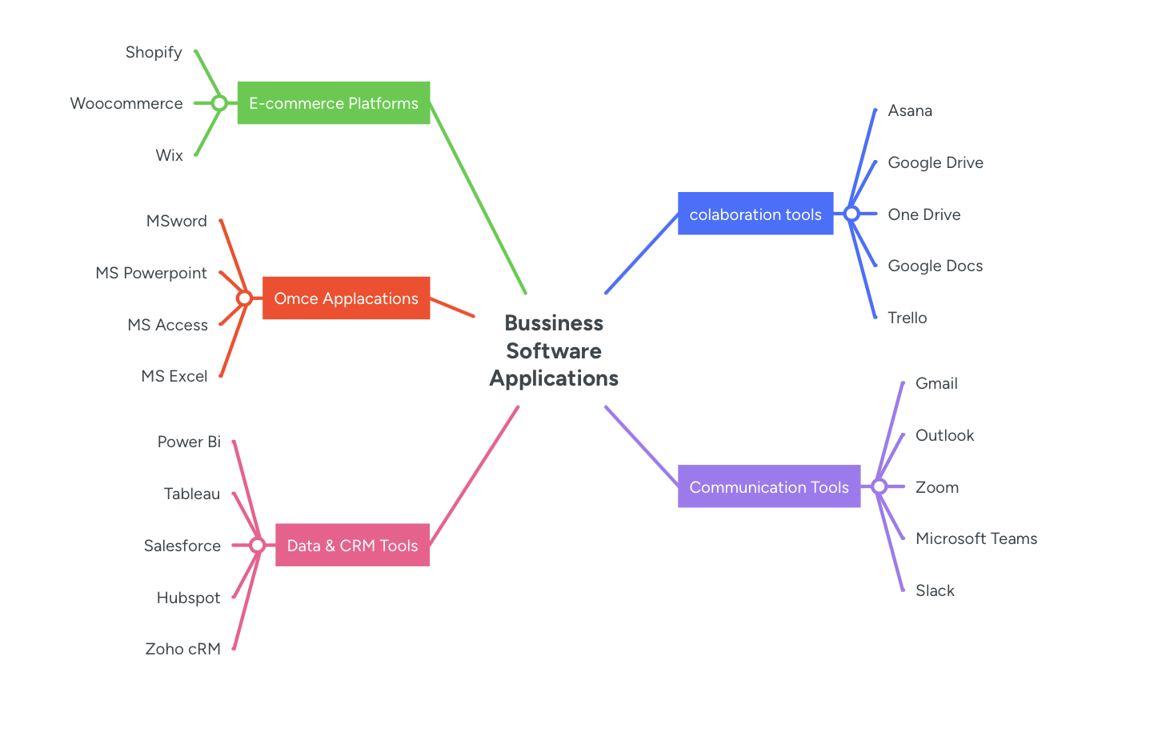
Source: Made it by myself
Link of mind map:
https://mm.tt/map/3952545937?t=gSC7G3DUL3
Figure 1: Mind Map

b. Mind Map of Contemporary Software Applications
The following is an organised form of a mind map of the current software applications for running a business:
Central Topic: Contemporary Software Applications in Business
1. Office Applications
- Microsoft Word (document creation)
- Microsoft Excel (data analysis)
- Microsoft PowerPoint (presentations)
- Microsoft Access (database management)
2. Communication Tools
- Email (Outlook, Gmail)
- Instant Messaging (Slack, Microsoft Teams)
- Video Conferencing (Zoom, Google Meet)
3. Collaboration Tools
- Google Workspace
- Microsoft 365
- Trello / Asana (project management)
4. E-commerce Platforms
- Shopify
- WooCommerce
- Magento
5. Customer Relationship Management (CRM)
- Salesforce
- HubSpot
6. Cloud Computing Services
- Google Drive
- Dropbox
- OneDrive
7. Data Analytics Tools
- Power BI
- Tableau
These mind maps have shown how various software applications are linked and serve different functions in business communication, data management, sales, and decision-making. It is a good reflection of the benefits of technology in improving organisational efficiency and productivity.

Task 3. Office Applications for Creating, Storing, Presenting, And Analysing Information/Data

a. Office Software Solutions for Business Operations
Introduction
The software applications for the office perform a critical function in the creation, management, review, and analysis of business data. Microsoft Word, Microsoft PowerPoint, Microsoft Excel, and Microsoft Access are examples of office software applications. All the above software applications are part of the Microsoft Office package, commonly known as Microsoft 365. Microsoft 365 is a package that enables efficiency, coordination, and decision-making in the current business environment . Applications have a specific use; applications are designed according to different aspects of a
1. Microsoft Word
Overview
Microsoft Word is a word-processing software used to create, edit, and format documents, such as reports, letters, and business proposals.
Key Features
- Text structure (equipment, style, alignment)
- Spell check and grammar correction.
- Professional template documents.
- Bulk communication: mail merge.
- Embarkation of images, tables and charts.
- On-the-fly teamwork and cloud integration.
Benefits in Business
Microsoft Word is widely used in businesses to produce high-quality documents quickly, using templates that ensure uniform formatting[4]. Microsoft Word facilitates collaboration by allowing several users to edit documents at once. Microsoft Word integrates well with OneDrive, which allows you to access documents from any location.
Limitations
Microsoft Word has certain limitations, even though it is useful. It is not appropriate for handling a large dataset or performing advanced data analysis. Moreover, it is sometimes difficult to access advanced formatting features, especially for beginners. Excessive use of templates can also lead to a lack of originality in document design.
2. Microsoft PowerPoint
Overview
Microsoft PowerPoint is a presentation package used for visual slide shows in meetings, training, and company presentations [8]. [5]
Key Features
- Creation of slides using text, graphics and multimedia.
- Ready-made templates and themes.
- Transition effects and animation.
- Charts, SmartArt graphics.
- Slideshow and presenter view tools.
- A combination of audio and video content.
Benefits in Business
PowerPoint is an important part of business communication as it gives organisations an opportunity to demonstrate the ideas both logically and graphically. It aids the delivery of information in a well-organised form, making it easier for the audience to learn complex notions.
Visual elements like charts and images are used to increase audience engagement and retention. PowerPoint is used by businesses to present to clients, deliver employee training, and support strategic planning. It also facilitates collaboration, enabling teams to work in real time when preparing presentations.
Limitations
PowerPoint can, however, be limited. Excessive animations and text-filled slides may decrease their effectiveness and make the presentation boring. It can also generalise complex information, which can be misinterpreted [13]. In addition, a good presentation cannot be done without designing skills, which not all users have.
3. Microsoft Excel
Overview
Microsoft Excel is a spreadsheet application used for data organisation, analysis, and reporting. It is another potent instrument of numerical management of data in business[6]
Key Features
- Row and column data entry.
- Functions and formulas (e.g., SUM, IF, VLOOKUP).
- Schemes and data visualisation.
- Data analysis using pivot tables.
- Conditional formatting
- Filtering and sorting of data.
Benefits in Business
Excel is widely used in financial analysis, budgeting, forecasting, and performance tracking. It enables businesses to make complicated calculations and analyse big data effectively. Charts and graphs can be used to visualise data, enabling decision-makers to interpret trends and patterns more easily.
Excel further facilitates scenario analysis and forecasting, thus helping organisations to make informed decisions and predict the future. Microsoft suggests that Excel is especially effective for data analysis and report creation, but it may be more efficient when combined with other tools.
Limitations
Excel is not without shortcomings, even with all its benefits. It is also complicated in dealing with very large volumes of information and thus, poor performance. Flaws in formulae may trigger incorrect data analysis. Also, Excel lacks sophisticated database administration and cannot be used to manage structured relational information or perform database administration.
b. Test any two features from the following: Mail merge, IF Function, VLOOKUP, Pivot Table, Goal Seek in MS Excel and document several screenshots with accompanying descriptions to provide evidence of practical use. Note: This task is based on your own practical activities.

4. Microsoft Access
Overview
Microsoft Access is a database management system (DBMS) used to store, organise, and manage large amounts of structured data.
Key Features
- Figure and Table Construction of Databases.
- Data retrieval query tools.
- Data entry forms.
- Report generation
- Indexing and the relationship between data.
- Intertwining with other applications of Microsoft.
Benefits in Business
Microsoft Access is tremendously beneficial for managing structured data, including client, inventory, and personnel data. It enables businesses to store massive amounts of information in a well-structured format and access it in response to queries quickly[7]
Its ability to serve many users while maintaining data consistency is one of its greatest benefits. Its accessibility is also more effective for controlling relational data than Excel, and it also provides enhanced data integrity . It also enables businesses to develop tailored applications without extensive programming knowledge.
Limitations
Nevertheless, Access has a limitation in scalability. It does not scale well for very large enterprise-level databases, as with other systems such as SQL Server. It is also not the easiest to use for beginners, and it might require technical expertise to create complex databases. Also, Access primarily supports Windows and is not cross-platform.
Conclusion
Finally, Microsoft Word, PowerPoint, Excel, and Access are needed, as they are office applications that facilitate various business processes. Word is the best fit for creating documents; PowerPoint facilitates communication through presentations; Excel supports data analysis and decision-making; and Access provides effective data management [16]. Combining these tools enhances productivity, collaboration and organisational efficiency.
Nevertheless, both applications have limitations, and companies have to choose a tool based on their needs. The integration of these applications within the Microsoft 365 ecosystem further enhances their effectiveness by enabling real-time collaboration, cloud access, and seamless workflow management. All in all, office software solutions are very important in business in the contemporary world to facilitate effective and informed decision making.

b. Practical Application of Excel Features

First, we open the Excel
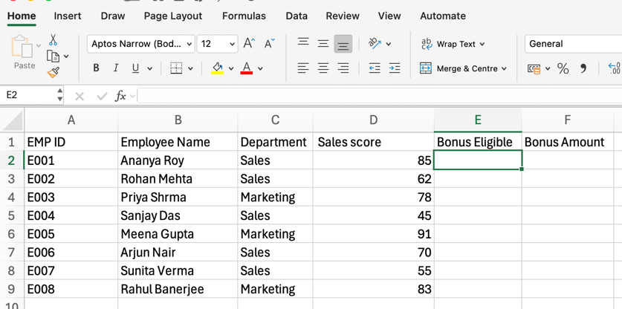
We write all the employee details
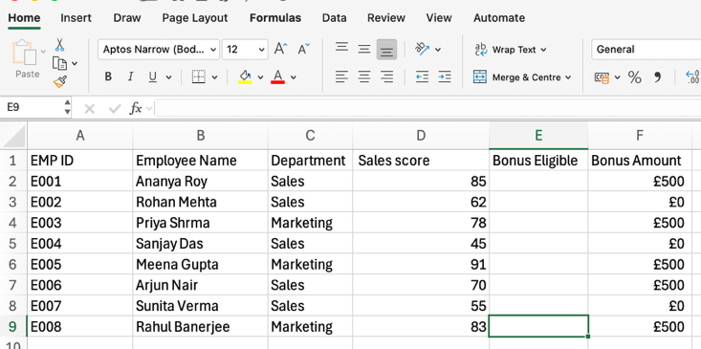
We must check the eligibility
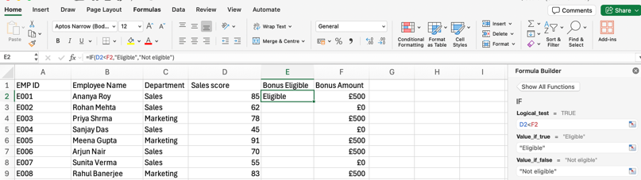
We use the formula to check eligibility and apply the same process to all employees.
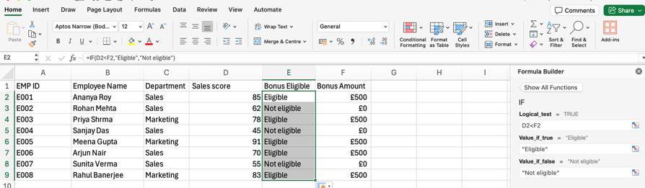
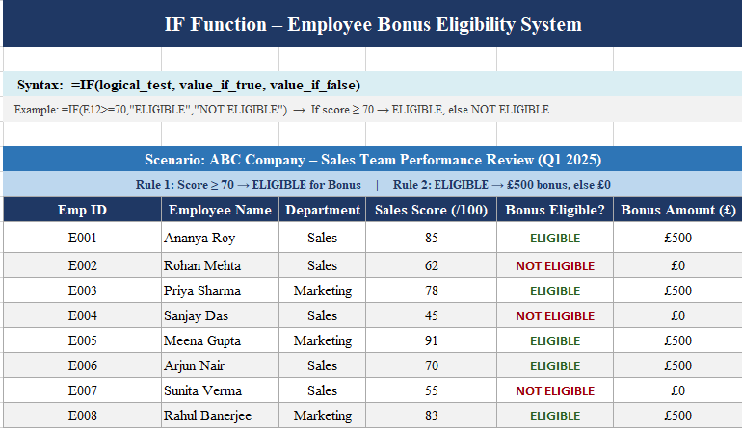

Fig 2: IF Function – Employee Bonus Eligibility System
Figure 1 shows an Excel-based employee bonus eligibility system, where we will use the IF function to determine the impact of employee performance [4]. The data sample will consist of employee data, including ID, department, and sales score. A condition is set that employees who score 70 or higher will be labelled ELIGIBLE to receive a bonus, and those who do not will be labelled NOT ELIGIBLE. Another thing is that qualified employees would be offered a £500 bonus, while those whose services are not valuable would receive nothing. This shows the role of the IF in automating decision-making processes within a business by applying logical conditions, enhancing efficiency, minimising errors in a manual system, and facilitating the rapid review of employee performance data. Moreover, this system can be further expanded by using multiple conditions in nested IF statements, enabling the business to classify employee performance into categories such as excellent, average, and poor. This provides a more comprehensive analysis than an "eligible" or "not eligible" response. Such automation saves time and promotes uniformity in decisions made by various departments. It also facilitates openness in reward systems, which can enhance both employee motivation and overall organisational performance.
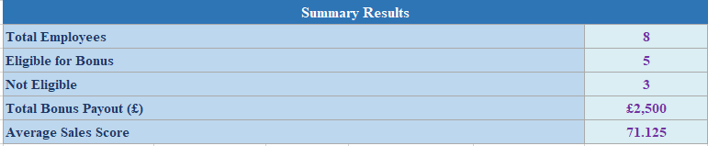
Fig 3: Summary Results
Figure 2 illustrates a summary of the analysed employee performance data. It provides essential information such as the total number of employees, the number of staff members who qualify for bonuses, and those who do not. It also shows the overall bonus payout and the average sales rating. It is also reasonable to suppose that this summary was created with the help of Excel functions, including COUNT, AVERAGE, and SUM. The figure underscores Excel's power to turn raw data into meaningful information accessible to management. This type of summary is crucial in business management because it assists in decision-making, performance analysis, and financial projection by rendering available information in a clear and informative manner. In addition, this type of summary report can be used to reveal both historical performance trends and interdepartmental performance. Managers can easily assess the performance of individual teams and identify underperformers. These summaries may be in the form of charts or dashboards as well in order to create an improved understanding of them. Automated calculations help significantly in eliminating the risk of human error. This ultimately aids strategic planning, budgeting, and resource allocation, helping organisations work more efficiently and make evidence-based decisions.
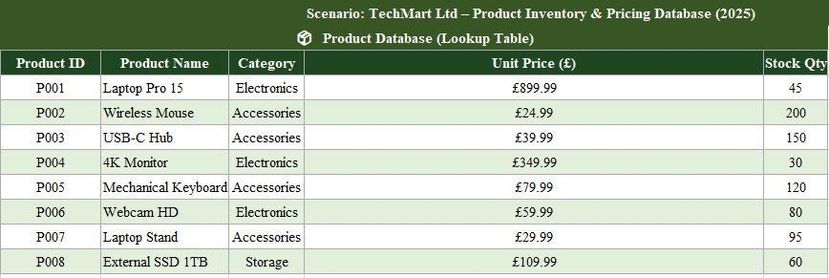
Fig 4: Product Database (Lookup Table)
Figure 3 provides a structured product database for use in Excel for lookups. It contains information such as product ID, product name, product type, unit price, and stock quantity. The table is used as reference data to search for desired information using functions such as VLOOKUP. Storing the data as rows and columns makes it competent and convenient to access. These databases are commonly used in business operations for inventory management, pricing, and stock tracking. The figure shows why maintaining a well-organised dataset is crucial for accurate data retrieval and successful decision-making. Moreover, a well-organised product database will ensure that data remains consistent and minimises duplication errors in the system. It also enables businesses to easily update product information (e.g., price or stock changes) without compromising the overall dataset structure. An organised database enhances the efficiency of various departments, such as sales, inventory, and procurement. It also allows scalability, i.e., the addition of new products without interrupting old records. This helps improve inventory management, operations, and customer service delivery.
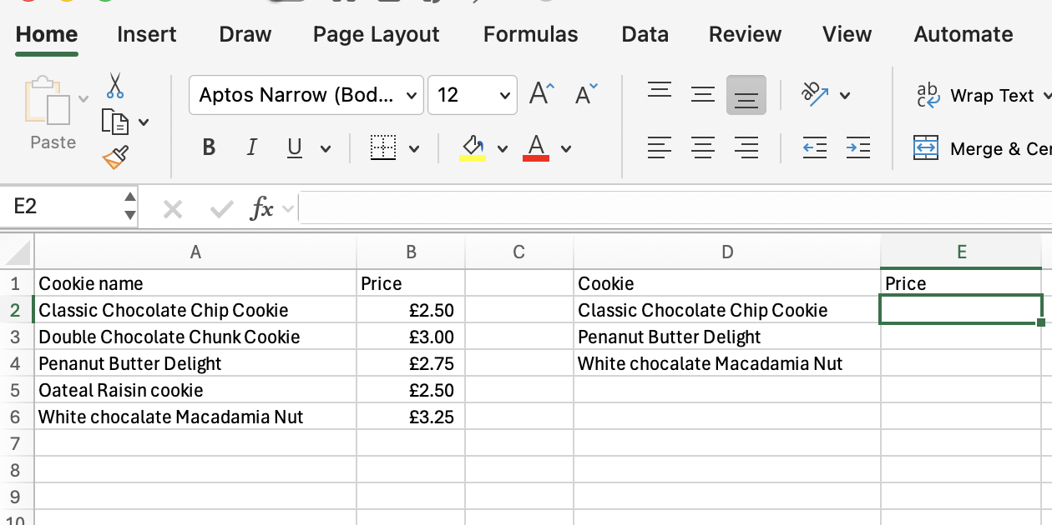
First, we have to write all the products
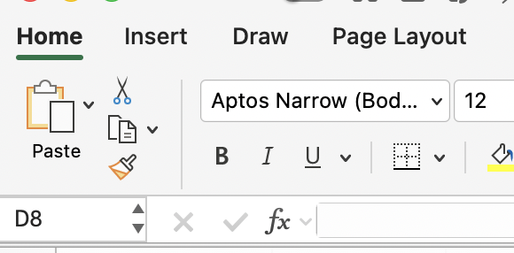
After we must click on fx to type our formula.

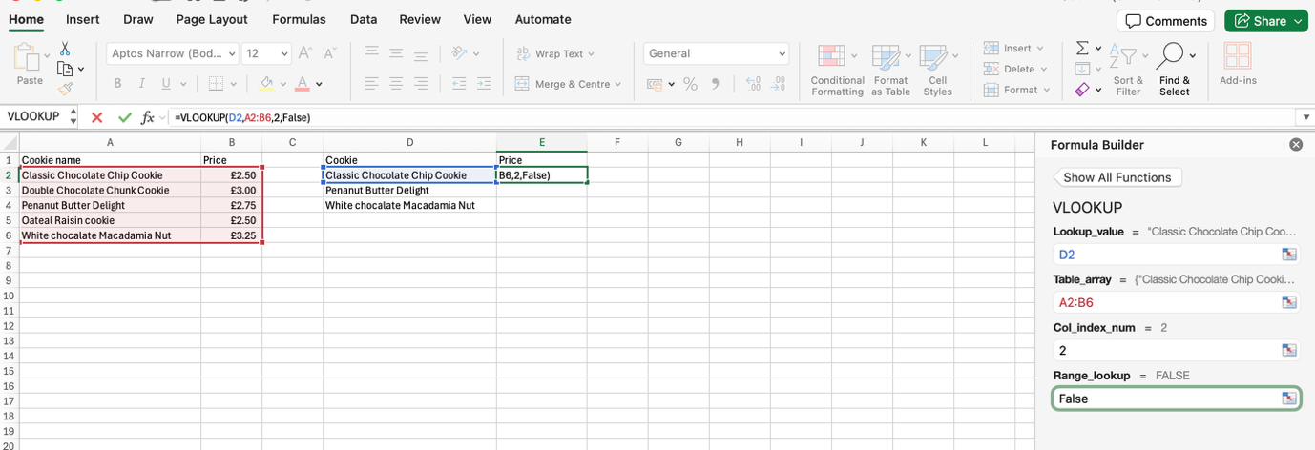

Fig 5: VLOOKUP Query System
Figure 4 shows how the VLOOKUP function would be used to find information in the product database. By entering a product ID, the system provides information about the product, such as its name, type, price, and stock quantity. This operation is used to find a value in the first column of a table and to access the other columns with related data [6]. It also makes data search easier and minimises manual searching. VLOOKUP is mainly used in inventory management, sales tracking, and database queries in business environments, as it increases efficiency, speed, and accuracy when managing large datasets. Moreover, VLOOKUP can be combined with other Excel functions to build more sophisticated data access systems, enhancing functionality. It is especially advantageous for large volumes of data when searching them manually would be time-consuming and unproductive. The role of accuracy as an input value is directly related to the input data. This increases productivity and reduces operational delays. Also, it facilitates real-time updates, so any change in the database is automatically reflected in the lookup results, ensuring accurate, up-to-date information for decision-making.

Task 4. Communication And Collaboration Applications

a. Analysis of Communication and Collaboration Tools
1. Communication Tool: Microsoft Teams
Microsoft Teams is among the most widely used communication tools in the contemporary business world. It belongs to the Microsoft 365 platform and offers messaging, video conferencing, file sharing, and collaboration in the same platform. Microsoft Teams is used by businesses to enhance internal communication, especially in remote and hybrid work settings[8]
Key Features
- Group chat and instant messaging.
- Video and audio conferencing.
- Sharing of the screen and recording of meetings.
- File sharing and real-time document collaboration.
- Microsoft Office app (Word, Excel, SharePoint) integration.
- Channel-based communication structure
Microsoft Teams is a central system of communication on which employees can interact in real time. It enables users to form channels of individual teams or projects, which is useful in organising the conversations. Research explains that such tools as Microsoft Teams integrate messaging, video calls, and sharing files into a single platform, eliminating communication barriers and increasing the efficiency of the workflow.
Benefits in Business
Microsoft Teams also maximizes work output through decreasing the use of numerous communication devices. Employees do not need to change platforms to send messages, attend meetings and share files. It also facilitates remote working by allowing real time communication at various sites . Also, its compatibility with Microsoft Office products enables easy collaboration in documents and enhances efficiency.
The other benefit is enhanced transparency. Channels store conversations and shared files, which team members can easily access. This assists organisations to achieve improved communication history and lessens miscommunication.
Limitations
Microsoft Teams cannot be used without limitations, although it has certain benefits. New users may find it hard to use because it has a broad spectrum of features. In large companies, these notifications may be overwhelming. It also needs a stable internet connection to perform without any difficulties, which is not always the case.
2. Collaboration Tool: Google Workspace
Google Workspace is an online work-collaboration service that contains a set of tools: Google Docs, Google Sheets, Google Slides, Google Drive, Gmail, and Google Meet. Organisations use it extensively as a real-time collaborative tool and for document management [12].
Key Features
- Live editing of the documents ( Docs, Sheets, Slides ).
- Google drive cloud storage.
- Google Meet video conferencing.
- Sharing schedules to manage.
- Simple access and sharing of files.
- Cross-device accessibility
Google Workspace is very practical for teamwork, as it allows multiple users to work on the same document. It enables teamwork in the cloud, allowing users to access files from anywhere. As industry observers note, Google Workspace offers seamless real-time collaboration and easy sharing, making it well-suited to the contemporary business environment.
Benefits in Business
Google Workspace enables real-time collaboration, and this capability is one of its biggest advantages. Documents can be updated jointly, with comments and changes tracked in real time by team members. This saves time and enhances the productivity at work.
Another advantage is accessibility. It is cloud-based, hence it can be accessed by users on any device, and it is applicable in remote and global groups. It also enhances communication, as email, chat, and video conferencing tools are combined into a single system.
Google Workspace also promotes cost-efficiency, with many of its capabilities being lower to subscribe to than traditional software. It eliminates any possibility of physical storage and manual handling of files.
Limitations
Nevertheless, Google Workspace has its limitations. It relies heavily on the internet connectivity, which can impact productivity if the connection is slow. Its interface is not as familiar to some users as Microsoft Office tools. Also, there is a threat of data security issues should there be no appropriate access controls.
Comparison and Analysis
Both Google Workspace and Microsoft Teams are effective tools used in contemporary businesses, but they are applied slightly differently.
- Microsoft Teams is more about interacting and communicating with the team, messaging with the team, and collaborating on a single platform.
- Google Workspace is a cloud-based productivity and document collaboration solution that allows real-time editing and sharing files.
In practice, many organisations use both tools in synergy to maximise efficiency. Tools such as Teams and Google Workspace ensure effective interaction and collaboration, respectively. They are also now widely used in workplaces, particularly through the spread of remote and hybrid work environments.

b. Practical Application of Features
1. Communication Tool Feature: Microsoft Teams – Video Meeting
To show practice, a video conferencing functionality on Microsoft Teams was experimented.
Firstly, the application was opened and meeting time was created through the calendar option. The respondents were approached by filling in their email addresses. Once the meeting started, features such as video calling, screen sharing, and chat were used.
The screen sharing was also tested during the meeting where a document was shown to the rest of the participants. This enabled instant discussion and feedback. Illegitimate forms of sending messages to break the interlocutor were also used, the chat.
Outcome: The aspect illustrated how Teams can facilitate real-time communication and teamwork. It enhanced communication among the participants and facilitation of information sharing. This will mostly come in handy during business meetings, training classes and a discussion about a project.
2. Collaboration Tool Feature: Google Docs – Real-Time Editing
As a part of Google Workspace, a real-time editing option of Google Docs was tested.
A document was made and it was shared with various users through the share option. There were permissions to enable editing. The document was then edited by several users and text, comments and suggestions were added.
Feedback was offered in the form of the comment feature and the changes could be tracked in the form of the suggestion mode. Any changes that occurred were seen immediately, which showed real-time collaboration.
Outcome: This feature has demonstrated how Google Docs enables teamwork, allowing several individuals to work on the same document simultaneously. It does not require submitting several copies of files and minimises confusion. This is very useful in the business world, where collaboration and document exchange are essential.
Conclusion
To sum up, communication and collaboration tools are essential in present-day business operations. Microsoft Teams supports communication, enabling messaging, meetings, and file sharing in a single platform. Conversely, Google Workspace promotes teamwork with regard to real-time document editing and cloud-based collaboration.
Both tools enhance productivity, collaboration and efficiency, thus becoming a necessity to organisations in the modern digital world. Although they are somewhat constrained, their advantages supersede the difficulties. The real-life testing of the functions of video meetings and real-time editing can prove the application of these tools in real business data to improve communication and collaboration.

Reference List

[1] | “Woocommerce overview,” Automattic Inc, April 2024. [Online]. Available: https://woocommerce.com. [Accessed 2026].
[2] | K. C. L. a. C. G. Traver, Electronic Commerce 2018: A Managerial and Social Networks Perspective, Harlow, U.K.: Pearson, 2018.
[3] | K. C. L. a. C. G. Traver, E-commerce 2020: Business, Technology and Society, Harlow, U.K.: Pearson, 2020.

References
[1] | “Woocommerce overview,” Automattic Inc, April 2024. [Online]. Available: https://woocommerce.com. [Accessed 2026].
[2] | K. C. L. a. C. G. Traver, Electronic Commerce 2018: A Managerial and Social Networks Perspective, Harlow, U.K.: Pearson, 2018.
[3] | K. C. L. a. C. G. Traver, E-commerce 2020: Business, Technology and Society, Harlow, U.K.: Pearson, 2020.
[4] V. Opara, S. Spangsdorf and M. K. Ryan, "Reflecting on the use of Google Docs for online interviews: Innovation in qualitative data collection," vol. 23, no. 3, pp.561–578, 2023,
[5] R. Melati, "Analysis of the advantages of Microsoft Teams as a corporate communication tool in supporting employee performance," vol. 5, no. 3, pp.2893–2899, 2025,
[6] M. Moraru, V. Ţapcov and V. Căpăţînă, "Data security and access management in microsoft tools: excel, power query and power bi", Technological innovations in digital security, pp. 175–183.
[7] M. L. Khobir and E. Masnawati, "Pengaruh penggunaan media visual Microsoft PowerPoint terhadap hasil belajar pada mata pelajaran Pendidikan Agama Islam," vol. 1, no. 1, pp.15–24, 2025,
[8] L. Andiani and U. Prajogo, "Excel Optimization for Financial Resilience in Pre-Order SMEs: A Case Study of Digital Accounting Adaptation in Indonesia," vol. 4, no. 1, pp.61–68, 2026,
[9] M. Paulden, "A Modern Approach for Constructing Decision Analytic Models in Microsoft Excel: M. Paulden," Pharmacoeconomics. pp.1–20, 2026,
[10] K. Pírková, Microsoft Word 2010, Computer Press, 2013.
[11] N. M. Bocken, P. Rana and S. W. Short, "Value mapping for sustainable business thinking," vol. 32, no. 1, pp.67–81, 2015,
[12] M. J. Somers, K. Passerini, A. Parhankangas and J. Casal, "Using mind maps to study how business school students and faculty organize and apply general business knowledge," vol. 12, no. 1, pp.1–13, 2014,
[13] T. Buzan and C. Griffiths,Mind Maps for Business: Using the ultimate thinking tool to revolutionise how you work, Pearson UK, 2013.

