Spies, Transparency and Havens. Exploring the homes of dystopian literature.
“Life begins well, it begins enclosed, protected, all warm in the bosom of the house.”
The house is a sacred space, a space where there should be no worries, where one should feel calm and at peace with the world. One should get home from work, kick off the shoes that have carried your tired body all day, make a nice dinner, relax, safe from the outside. In an ideal world, this would be so, but in the totalitarian worlds of We by Yevgeny Zamyatin and 1984 by George Orwell, or in the ultra-violent world of A Clockwork Orange by Anthony Burgess, such relaxation and security isn’t attainable.
The classic idea of a home is that of four walls, a roof over the head, comfortable furniture and safety. However, throughout the thousands of books encompassed by the dystopian genre, that idea of a house changes to suit the needs of the government. In 1984, the government put seemingly no care into the state of the houses of the citizens, as a lot of them are in disrepair, with terrible furniture, and a generally dreary atmosphere.
The book is set in the year 1984, and so we can infer that the houses were built in the late nineteenth, to the early twentieth century.
“Were there always these vistas of rotting nineteenth-century houses, their sides shored up with baulks of timber, their windows patched with cardboard and their roofs with corrugated iron, their crazy garden walls sagging in all directions?”
From this quote, we can infer that the government do not care about the houses, and that the only renovation that has been done is the fitting of the all-seeing eye: the telescreens. A device that allows the Party to listen in on and see the citizens of Airstrip One.
Professor Lawrence Phillips suggests that the emergence of Winston’s rebelling against the ministry and the government are not governed by the “towering ministry buildings” but instead by the “evidence of an earlier society represented by ‘rotting nineteenth-century houses’ and his own Victory Mansions ‘built in the 1930s or thereabouts’ and ‘falling apart’, as well as the evidence of the Party’s inability to provide even basic housing for some of its citizens evident from the wooden shacks that have grown up in the larger bomb sites.” To some extent, I agree with this statement. Every day, Winston looks up across the city and sees the four buildings of the Party, the ministries of Truth, Peace, Love and Plenty. Each building an “enormous pyramidal structure of glistening white concrete”, standing out like a sore thumb against the war-struck buildings. Looking at such lavish buildings while living in a rundown apartment would surely make one a little jealous. Perhaps though, that’s the aim of the Party, to make everyone a little bit jealous, to make them want to go to work in the nice buildings. However, I don’t agree that this is the first time that we do see the emergence of Winston’s true feelings. I believe that his true feelings lie in support of the Proles.
The Proletariats are a class of people that are outside of the Inner and Outer Party. Winston states that they live like “cattle turned loose on the plains of Argentina”. Winston firmly believe that “If there is hope … it lies with the Proles”. This is because in his eyes, they are free to do as they like. Regarding the home, the Proles are much safer, and arguably have a better homelife than Winston and the members of the Party. They do not have telescreens, have modest furniture and are outside of the Party’s control. The constant presence of the telescreens means that the members of the Inner and Outer Party are forever at attention in their house. They must maintain a facial expression that looks like they’re all okay, they must never say anything that could be construed as going against the Party. The Proles do not have this almost instinctual level of behaviour because they do not have the telescreens watching them, allowing them to truly relax.
As we proceed through 1984, Winston’s safe space becomes the room he buys above Mr Charrington’s shop with Julia. This room becomes his haven from the world, where he and Julia are safe and can hide from the prying eyes of the thought police and Big Brother. The safety of their home is represented by the paperweight that Mr. Charrington sells Winston.
“The paperweight was the room he was in, and the coral was Julia’s life and his own, fixed in a sort of eternity at the heart of the crystal”
The panopticon is a trope that appears throughout all dystopian literature. It was originally proposed by philosopher Jeremy Bentham in the 18th century as a social control mechanism for a new type of prison: A tower with a guard in the middle surrounded by the cells of the prisoners. In 1984, and many other dystopian novels, such as We, this is represented by the all-seeing eye of the government. In 1984, the Telescreens serve as the panopticon, and in We, it is the glass buildings. Regarding the home, the Telescreen serves as a way of making sure that no citizen is thinking outside of the allowed norms and is not planning on going against Big Brother and the government. Thus, not allowing for the home to ever feel like a safe space.
“On such days the whole universe seems to be moulded of the same eternal glass, like the Green Wall, and like all our buildings”
In We the panopticon returns, but in this universe, The Benefactor, ruler of One State, and the boss of the Board of Guardians constructs all floors, walls and ceilings out of glass. This enables the Bureau of Guardians (One State’s secret police) to see what everyone is doing, regardless of their location. Of course, the Bureau cannot see into the minds of the people, as D-503 realises: “human heads are opaque, and there are only two very small windows that lead inside, the eyes.” The idea of a safe space in the home does exist, but only to the citizens of One State. They feel safe in their homes, because of the Bureau. The citizens, and the main character D-503 are used to the Bureau and know that anyone who fails to remain part of the singularity, will get killed. There is another level of home that can be found in the world of One State, and that is in the city itself, for The Benefactor constructed the city with a large wall that is impenetrable around the whole city. For the citizens, this means that they are safe, and they can see the whole city as their home and their safe space.
Although the citizens feel safe in their glass houses, the Ancient House becomes a home and a meeting point for the Mephi, who wish to connect the outside world with One State. For one reason or another, the government have allowed this building to stand, an ancient monument to the past world of opaqueness and secrets. To the people of One State however, it serves as a reminder of how great One State is now that everything is part of the singularity.
It can be argued that the concept of safety does not exist in A Clockwork Orange, and if people do feel safe in their homes then they had better have a good security system. In Chapter 4 of A Clockwork Orange, after attacking another gang, and drinking heavy doses of “moloko with knives”, Alex and his gang of droogs make their way out of town and to a quiet little village on the outskirts of the city. Here they come across a group of cottages and decide to break into one of them. Anthony Burgess’ choice of accommodation here, a cottage, conjures thoughts of a cosy little place, where a couple might become a family, and where they might live in peace. The cottage is called “Home” to which Alex responds “A gloopy sort of a name”. From this, it can be inferred that Alex does not believe in the sanctuary of the home, or maybe even that a Home does not exist, just a house.
Once inside the house, we meet Frank Alexander and his wife. This is the first time in the book that the belief of safety is tested and for the Alexanders, the idea of safety has never been twisted more than now. Readers of the book will recall the horrific events that take place in the house, which ultimately end up killing Alexander’s wife. Alex proceeds to push the limits of people’s belief in safety once more in the book when he breaks into Cat Lady’s house in chapter 6. The fact that Alex and his gang see breaking and entering as a joke and just something to pass the time, and to get money from tells us that they are not afraid of the consequences. In fact, it is only once Alex murders Cat Lady, that the police intervene. Who knows how many times the police have failed to catch Alex and his gang.
One need only look at Alex’s house and homelife to understand a lot about him and the way he sees the world. We can also learn something about the government. For example, when we first go to Alex’s house in chapter 3, the first thing that we as readers see is “one young [girl] sprawling and [screaming] and moaning in the gutter, all cut about and lovely, and … in the lamplight also streaks of blood here and there like signatures of the nights [playing]” This shows us that there is more gangs than the ones belonging to Alex and Billyboy. Alex’s reaction to the violence on his doorstep tells us that for him, the home isn’t a space cut off from the outside world, but a space where his violent fantasies and life continues.
Alex lives in “Municipal Flatblock 18A” Which tells the reader that there are more flatblocks, that are, or have been at some point in the past organised by the government. We can infer from this that the government did at one time care about the houses that people lived in, but from the lack of care that has been put into them in recent years, the disrepair of the area outside and the unimaginative title of the block, we can also infer that this is a lower class area.
We can tell that Alex is a child, because he still lives at home with his parents, and when he is late for school, his mum reminds him with “It’s gone eight, son. You don’t want to be late again,”. When he gets home, Alex’s mother has put out a dinner for him, which suggests at first glance that she is a kind mother, who cares for her son. Later we learn that “Pee and em in their bedroom next door had learnt now not to knock on the wall with complaints of what they called noise” If Alex has such a seemingly normal homelife, then why does he feel the need to torture his parents? Perhaps he is just a psychopath, who believes that he can do whatever he wants because that’s the world he’s been bought up in, or perhaps he is just a child.
For Alex, the home is most definitely a safe space, and he has carved out his own little den in his room where he can be happy and relaxed. However, once Alex returns from the treatment, his safe space, his home, has been taken away from him. He has been replaced with a better-behaved son, and his friends have abandoned him, and taken into the folds of the government. This shows the start of the dystopian government, one that is beginning to control the world around them. They are eradicating the gangs, repairing the houses, and reforming criminals.
In Stanley Kubrick’s adaptation of A Clockwork Orange, the idea of a haven is further explored and there is an idea that the home can represent the outside world.
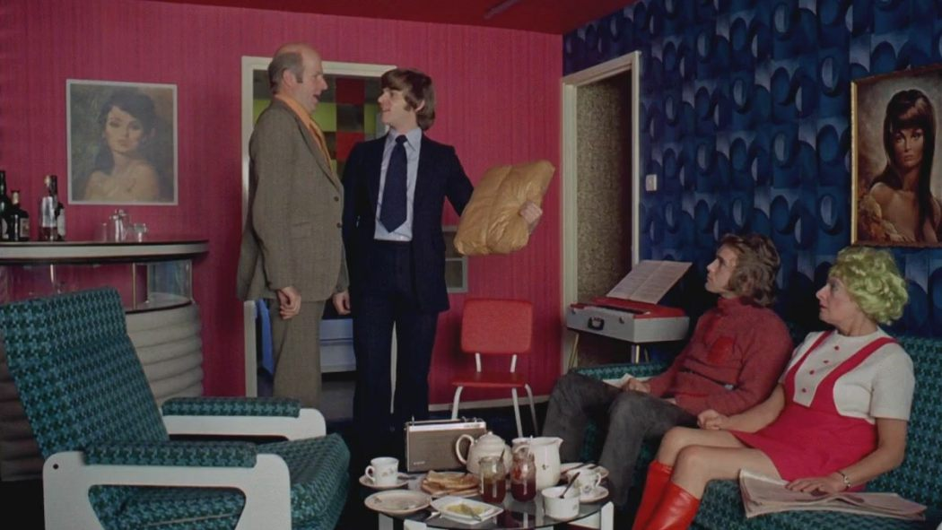
Figure 1 shows the interior of Alex’s apartment from Kubrick’s adaptation. The whole apartment building is a demonstration of brutalist architecture, “characterised by simple, block-like forms and raw concrete construction”. The interior can also represent the government towards the end of the book and film: an overwhelming presence.
Figure 1 - Interior of Alex's Apartment
In the book, Alex’s room is described as an “overwhelming and cluttered presence”. There are speakers placed all over the room and school banners and flags hung on the walls, the room sounds more akin to the living room as shown in Figure 1. However, as media theorist Vivian Sobchack notices “Kubrick has placed that equipment more modestly within a room which is both aesthetically-pleasing and rather ascetically furnished in comparison with the other rooms in the family's apartment.” This change is due to the fact that Alex does not describe much in detail. What he does describe is what he is feeling, and what he is looking at, but he does not give much information about the rooms. Perhaps this is what the government hope for, the youths not paying attention to the surroundings, so that they focus more on themselves and the fact that they want more, urging them to commit more crimes.

Gaston Bachelard and others, The Poetics Of Space (New York: Penguin Books, 2014).
George Orwell, Nineteen Eighty-Four (London: Penguin Classics, 2004), p. 5.
Phillips Page 76
Orwell, p. 6.
Ibid, p. 82.
Orwell, p. 80.
Ibid, p. 169.
"Internalized Authority And The Prison Of The Mind: Bentham And Foucault's Panopticon", Brown.Edu, 2009 <https://www.brown.edu/Departments/Joukowsky_Institute/courses/13things/7121.html> [Accessed 3 November 2018].
Evgeniĭ Zamyatin, We (New York: E.P. Dutton, 1959), p. 5.
Ibid, p. 27
Milk that has been enhanced with drugs.
Anthony Burgess, A Clockwork Orange (London: Penguin Books, 2013), p. 25.
Ibid, p. 37
Ibid, p. 37.
Ibid, p. 41.
Ibid, p. 39.
Interior Of Alex's Apartment In A Clockwork Orange (1971), 2016 <https://s3.birthmoviesdeath.com/images/made/clockwork_orange_family_1050_591_81_s_c1.jpg> [Accessed 4 November 2018].
"Brutalism – Art Term | Tate", Tate, 2017 <https://www.tate.org.uk/art/art-terms/b/brutalism> [Accessed 4 November 2018].
Vivian Sobchack, "Decor As Theme: A Clockwork Orange", Literature/Film Quarterly; Salisbury, 9.2 (1981), 92-102.
Ibid.

