

Student name: HAKIM SENOGA

Student ID: 2430688

Module name: INTRODUCTION TO PHYSIOLOGY

Module code: BMHP5023

Lecturer name: DR SOBAN SADIQ

Assessment: 1

Introduction.
Diabetes is a medical disorder in which the body is unable to control blood sugar levels.. Blood sugar, also called glucose, gives energy to our body from the food we eat. Insulin, a hormone made the pancreas, helps glucose enter the cells. When insulin does not work well or is not produced, glucose stays in the blood, causing high blood sugar. This can harm the eyes, kidneys, nerves, heart, and blood vessels if not treated (World Health Organization, 2024).
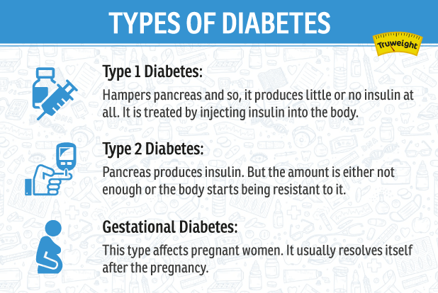
There are types of diabetes.
Type 1 diabetes is characterized by the body's failure to produce insulin due to the immune system's attack on insulin-producing cells. People with type 1 must take insulin daily.
Type 2 diabetes is the most common type, where the body cannot use insulin properly or does not make enough of it. It can happen at any age, and around 90% of people with diabetes have type 2. Gestational diabetes can develop It happens during pregnancy and usually disappears after the baby is born, but it can raise the chance of developing type 2 diabetes later in life. Other types include Maturity Onset Diabetes of the Young (MODY), neonatal diabetes, and rare syndromes (Diabetes UK, 2023).
Figure 1: types of Diabates
Risk factors for diabetes vary by type. Type 1 diabetes is genetic and not preventable. Type 2 diabetes has risk factors, such as being overweight, not exercising, eating poorly, aging, and family history. Ethnicity also plays a role, with higher risks for South Asian, African, and Caribbean groups. Gestational diabetes risk increases with older maternal age, obesity, and a family history of diabetes (National Institute of Diabetes and Digestive and Kidney Diseases, 2024). Prediabetes, The risk of type 2 diabetes in the future is increased when blood sugar levels are elevated but not within the diabetic range. Healthy lifestyle modifications, such as consistent exercise, eating a balanced food, and keeping a healthy weight, can lower risk (WHO, 2024).

2. Blood Sugar Regulation.

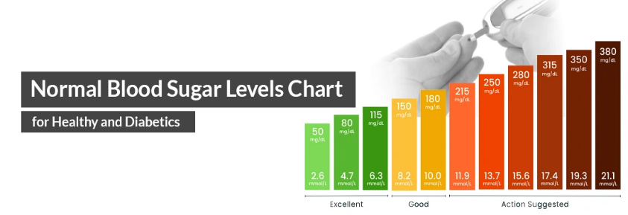
The body's cells use blood sugar, also known as blood glucose, as their primary energy source. Maintaining it at a safe and effective level is critical for health, as too much or too little glucose can cause serious complications, including diabetes, fatigue, and organ damage (Care Learning, 2026). The body uses a combination of hormones, organs, and cellular mechanisms to balance glucose levels, a process called blood glucose homeostasis.
Figure 2: blood sugar regulation

A key component is the pancreas, an abdominal gland. It contains beta cells, which produce insulin, and alpha cells, which produce glucagon. Insulin lowers blood sugar by Notifying the muscles, fat cells, and liver to take up glucose and store excess amounts as glycogen, a long-term energy reserve (Study mind, 2026).

When we eat foods rich in carbohydrates, blood glucose rises, triggering beta cells to release insulin. Muscle cells use glucose immediately for energy, and fat cells store any surplus. The liver also converts some glucose into glycogen, preventing dangerously high blood sugar levels (My Tutor, 2026).

Alpha cells release glucagon when blood sugar falls, for example, during exercise or in between meals. Glucagon instructs the liver to release glucose back into the circulation from stored glycogen. (Diabetes Teaching Centre, 2026).

This guarantees that glucose is accessible for essential functions, especially for the brain, which greatly depends on a consistent supply of glucose for energy. In addition to glycogen breakdown, glucagon aids in Gluconeogenesis are the process of making glucose from non-carbohydrate substances, such as glycerol or amino acids. supporting blood sugar during fasting or energy demanding situations (University of Guelph, 2026).

Additional organs also play a role. Whereas adipose tissue stores energy as triglycerides, skeletal muscles store glucose as glycogen for their own energy requirements. Insulin stimulates glucose uptake into these tissues, coordinating energy storage and usage. Besides hormonal control, lifestyle elements include stress reduction, exercise, and nutrition also influence glucose levels. A balanced diet with slow-releasing carbohydrates, regular physical activity, and adequate rest enhances insulin sensitivity and glucose uptake, helping maintain stable blood sugar (Open Access Journals, 2026).

Imbalances in this regulation can lead to hyperglycaemia, where excessive glucose damages blood vessels and nerves, and hypoglycaemia, where insufficient glucose reduces energy availability and can cause dizziness or seizures (Seneca Learning, 2026).

Healthy lifestyle choices and routine monitoring, particularly for diabetics, keep blood sugar levels within the normal range of around 4–7 mmol/L while fasting. (Care Learning, 2026).

To sum up, maintaining blood glucose at safe and effective levels involves a coordinated system where insulin and glucagon from the pancreas control glucose absorption, storage, and release. The liver, muscles, and fat cells perform crucial roles in storing and mobilizing energy. Combined with a balanced diet, regular exercise, and stress management, this system ensures that the body always has the energy it needs for proper functioning and overall health.

3. Cellular Metabolism.
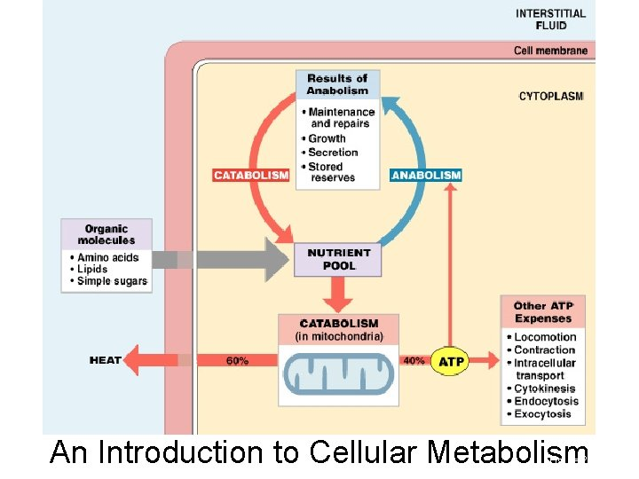
Cells need energy to perform all life processes, and this energy comes from the breakdown of glucose with the help of oxygen in a process called cellular respiration (Osmosis, 2022). Glucose, a sugar obtained from food, provides the chemical energy, while oxygen, taken from the air we breathe, acts as the final electron acceptor in the energy-producing reactions (Khan Academy, 2022).
Figure 3: Cellular metabolism
The first stage of cellular respiration is Glycolysis is a cytoplasmic process. Here, two molecules of pyruvate (three carbon atoms) are created from one glucose molecule (six carbon atoms). producing a small amount of energy contained in two ATP molecules (Monash University, 2022). This process does not require oxygen.
Next, pyruvate enters the mitochondria, where it undergoes pyruvate decarboxylation to form acetyl-CoA, releasing NADH and carbon dioxide. Acetyl-CoA is produced during the Krebs cycle, also called the citric acid cycle. subsequently enters the mitochondrial matrix. Through a series of chemical reactions, the Krebs cycle completes the breakdown of glucose, producing additional energy carriers NADH, FADH₂, and a few ATP molecules and carbon dioxide as waste (Biology Dictionary, 2016).
The inner mitochondrial membrane is where the electron transport chain (ETC), the last phase, takes place. At the conclusion of the cycle, oxygen takes up the high-energy electrons that NADH and FADH₂ have contributed, creating water. protons are pumped across the membrane by the energy generated during this electron transfer, creating a gradient that drives ATP synthase to produce the majority of the ATP, usually 30–32 ATP per glucose molecule. (Science notes, 2022). Without oxygen, this stage cannot occur efficiently, and cells produce much less energy.
Overall, glucose and oxygen are essential for creating ATP, the main energy currency that powers cellular activities, from repairing structures to muscle contraction. Carbon dioxide and water are generated as waste, which the cell or organism excretes (National Geographic Society, 2023).

4. Recording and tracking blood sugar levels for type 2 diabetes
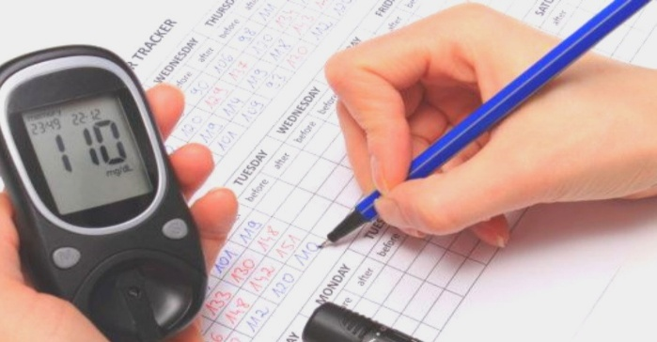
For persons with Type 2 diabetes to safely manage their condition, blood sugar levels must be recorded and tracked. Blood glucose monitoring allows individuals to understand how their body responds to food, exercise, stress, and medication, helping them make informed decisions about their daily lifestyle and treatment (Diabetes Australia, 2023).
Figure 4: recording and tracking diabates
By consistently checking their glucose levels, people can identify patterns, such as spikes after meals or dips during physical activity, which helps them maintain blood sugar within recommended ranges. Monitoring is particularly important for those on insulin or medications that may cause hypoglycaemia, as it allows early detection of dangerously low blood glucose levels. Without regular tracking, individuals risk uncontrolled high or low blood sugars, which can lead to serious complications such as nerve damage, vision problems, kidney disease, and heart conditions (Know Diabetes, 2023).
moreover, accurate records provide healthcare professionals with crucial information to adjust medication doses and make personalized recommendations, improving overall diabetes management. Modern tools, including glucometers, mobile apps, and continuous glucose monitoring (CGM) devices, make it easier to log and interpret blood sugar readings (Diabetes Guide, 2023). Automated tracking systems especially help individuals on insulin therapy by showing trends over time and alerting them to rapid changes in glucose levels. Those who do not record their levels may miss early signs of complications and struggle to achieve optimal control, which increases the likelihood of hospital admissions and long-term health risks.
To sum up, People with Type 2 diabetes can better control their condition by monitoring and documenting their blood sugar levels. make informed lifestyle decisions and avoid serious complications. It also strengthens the partnership between patients and healthcare providers for tailored diabetes care. Failure to monitor glucose could result in poor disease management and increased health risks.

5. Recommendations.
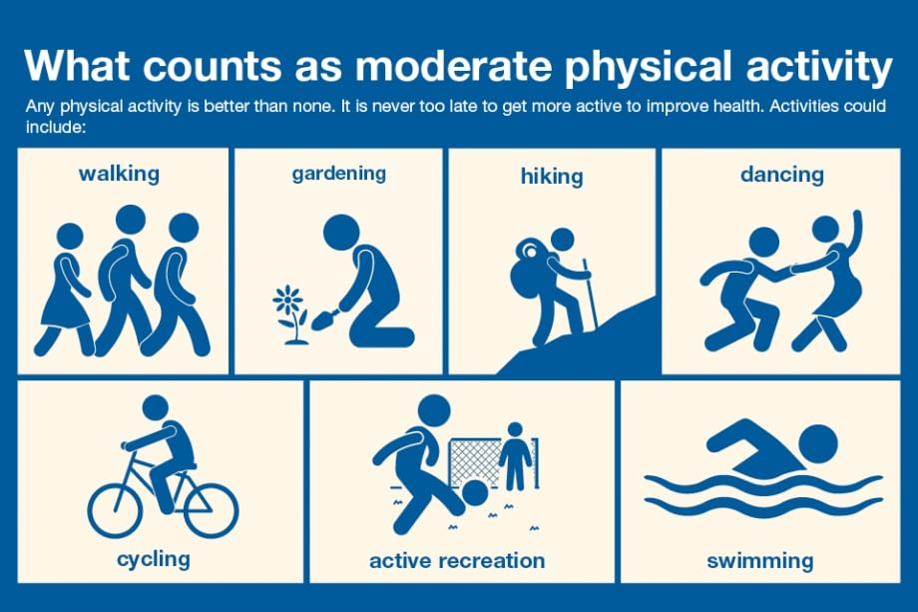
To improve the overall health and well-being of a person with diabetes, evidence-based strategies focus on both health and social care interventions. Health promotion plays a key role by encouraging lifestyle changes that manage blood sugar and reduce complications.
Figure 5: recommendations
Regular physical activity, such as walking or swimming for at least 30 minutes a day, helps to improve insulin sensitivity and maintain a healthy weight. A well-balanced diet low in processed carbohydrates and high in lean meats, veggies, and whole grains can stabilize glucose levels and prevent cardiovascular problems. Monitoring blood sugar regularly and adhering to prescribed medication ensures timely intervention if levels become uncontrolled (NICE, 2023).
Health and social care support can include structured diabetes education programs, social support networks, and access to community services to help manage day-to-day challenges. Psychological support and counselling can reduce stress, which positively affects glucose control. Social care professionals can assist with tailored care plans, ensuring the person's preferences and individual needs are considered, enhancing adherence and quality of life (WHO, 1998).
By combining lifestyle modifications such as increased physical activity, healthy eating, weight management, and stress reduction with evidence based medical care and social support, individuals can effectively manage diabetes, reduce complications, and improve overall wellbeing. Health promotion empowers the person to take active control over their health outcomes.
Conclusion.
Observation about these very dangerous chronic disease Diabates which termed as a health condition in which the body is unable to appropriately regulate blood sugar. Blood sugar, also called glucose, gives energy to our body from the food we eat. Insulin, a hormone made the pancreas, helps glucose enter the cells. And there 3 types of diabetes as described briefly can make an aware of how diabetes catch. And we get to comprehend how the body controls blood sugar as is the main source of energy for the body’s cells. Maintaining it at a safe and effective level is critical for health, as too much or too little glucose can cause serious complications, including diabetes, fatigue, and organ damage, The body uses a combination of hormones, organs, and cellular mechanisms to balance glucose levels, a process called blood glucose homeostasis. Briefly explain about cellular metabolism as Cells need energy to perform all life processes, and this energy comes from the breakdown of glucose with the help of oxygen in a process called cellular respiration. After that, monitoring and recording type 2 diabetes blood sugar levels aids in the safe management of their illness. Blood monitoring of glucose allows individuals to understand how their body responds to food, exercise, stress, and medication, helping them make informed decisions about their daily lifestyle and treatment. At the end recommendation is very crucial on how you’re going to sacrifice yourself to improve the overall health and well-being of a person with diabetes, evidence-based strategies focus on both health and social care interventions. Health promotion plays a key role by encouraging lifestyle changes that manage blood sugar and reduce complications.
References.
Biology Insights. (2026) Glucoregulation: How Your Body Manages Blood Sugar Levels. Available at: https://biologyinsights.com/glucoregulation-how-your-body-manages-blood-sugar-levels/ (Accessed: 7 March 2026).
Care Learning. (2026) Explain the regulation of blood sugar. Available at: https://carelearning.org.uk/qualifications/level-3-extended-hsc/hsccmo2-biochemistry/4-1-explain-the-regulation-of-blood-sugar/ (Accessed: 7 March 2026).
Diabetes UK (2023) Types of Diabetes. Available at: https://www.diabetes.org.uk/about-diabetes/types-of-diabetes (Accessed: 7 March 2026).
Diabetes Teaching Center. (2026) Blood Glucose Regulation in the Body. Available at: https://diabetesteachingcenter.ucsf.edu/content/blood-glucose-regulation-in-the-body (Accessed: 7 March 2026).
Osmosis (2022) Cellular Respiration: Steps, Process, and Stages. Available at: https://www.osmosis.org/answers/cellular-respiration (Accessed: 7 March 2026).
Khan Academy (2022) An introduction to cellular respiration. Available at: https://www.khanacademy.org/science/hs-bio/x230b3ff252126bb6:energy-and-matter-in-biological-systems/x230b3ff252126bb6:cellular-respiration/a/cellular-respiration-overview (Accessed: 7 March 2026).
Know Diabetes, 2023. Blood Glucose Monitoring. Available at: https://www.knowdiabetes.org.uk/resources/internal/blood-glucose-monitoring/ [Accessed 7 March 2026].
My Tutor. (2026) Explain how the human body maintains blood glucose levels. Available at: https://www.mytutor.co.uk/answers/9988/GCSE/Biology/Explain-how-the-human-body-maintains-blood-glucose-levels-within-a-narrow-range/ (Accessed: 7 March 2026).
National Institute of Diabetes and Digestive and Kidney Diseases (2024) What Is Diabetes? Available at: https://www.niddk.nih.gov/health-information/diabetes/overview/what-is-diabetes (Accessed: 7 March 2026).
NICE, 2023. Diabetes (type 1 and type 2) in adults: management. National Institute for Health and Care Excellence. Available at: https://www.nice.org.uk/guidance/ng17 [Accessed 7 March 2026].
Study mind. (2026) Control of Blood Glucose Concentration - Blood Glucose Homeostasis. Available at: https://studymind.co.uk/notes/blood-glucose-homeostasis/ (Accessed: 7 March 2026).
Science notes (2022) Aerobic Respiration Definition, Diagram, and Steps. Available at: https://sciencenotes.org/aerobic-respiration-definition-diagram-and-steps/ (Accessed: 7 March 2026).

World Health Organization (2024) Diabetes. Available at: https://www.who.int/news-room/fact- sheets/detail/diabetes (Accessed: 7 March 2026).

