
STUDENT NUMBER: 2407682
STUDENT NAME: SAIMA KAUSAR
MODULE: BMH5014
LECTURER’S NAME: PARESE AHMED
COMPONENT 1 P0RTFOLIO

Task 1 – Concept Map
HEALTH AND SOCIAL CARE
CREATIVITY
.
VALUE CREATION
C
. Creativity, value creation, and improvement are closely connected within health and social care. Creativity refers to the ability to think differently and develop new ideas, solutions, or ways of working. In a care setting, this might include designing
Value creation directly contributes to health and social care improvement. Improvements can be seen in safer practices, better health outcomes, and more person-centered care. For instance, introducing a creative digital system for patient records can reduce errors and improve coordination between professionals, leading to better care delivery.
Value creation means improving the quality and effectiveness of services while making the best use of available resources. For example, a creative approach to scheduling staff may reduce waiting times and improve patient satisfaction. This adds value by enhancing both service efficiency and patient experience.

REFERENCE:
National Centre for Creative Health (2023) Creative health in social care. Available at: https://ncch.org.uk/uploads/page/Creative-Health-in-Social-Care.pdf (Accessed: 24 March 2026).

Task 2 - Self-Reflection of Group Activity
Complete a self-Reflection on the Convergent/Divergent paperclip class activity using a reflective model (250 words, 1 source)
The convergent and divergent paperclip thinking activity helped me understand different ways of thinking in problem-solving. According to Graham Gibbs (1988), reflection involves reviewing experiences to improve future practice.
During the activity, I was asked to think of as many uses for a paperclip as possible. This was the divergent thinking stage, where I generated many ideas without judging them. I found this part enjoyable but slightly challenging at first because I am used to focusing on one correct answer. However, as I continued, my ideas became more creative.
In the convergent thinking stage, I had to select the most practical and realistic ideas. This helped me to evaluate and focus on quality rather than quantity. I realised that both types of thinking are important. Divergent thinking encourages creativity, while convergent thinking helps in decision-making.
I felt more confident as the activity progressed. It showed me that I can think creatively when given the opportunity. However, I also noticed that I sometimes limit my ideas too quickly, which can reduce creativity.
From this experience, I have learned that I need to allow myself more time to explore ideas before judging them. In the future, I will try to apply both thinking styles in my studies and work, especially in health and social care, where problem-solving and creativity are important.

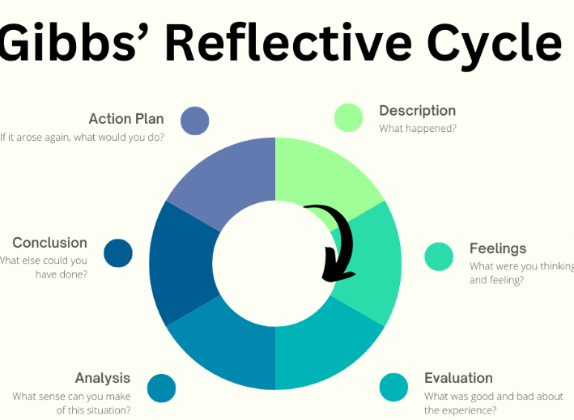
Gibbs, 1988

REFERENCE:
https://www.ed.ac.uk/reflection/reflectors-toolkit/reflecting-on-experience/gibbs-reflective-cycle
Gibbs, G. (1988) Learning by doing: A guide to teaching and learning methods. Oxford: Oxford Polytechnic

Task 3 - Case Study of a UK innovation
Write a concise case study analysis of an innovative project or initiative within the NHS or UK social care. Focus on how creativity was used to drive change and the value it created for patients or service users (400 words, 2 sources).

AI creativity to drive change
UK government has introduced the AI Diagnostic Fund to support NHS Trusts in adopting advanced artificial intelligence technologies aimed at improving the speed and accuracy of medical diagnoses. This initiative is designed to accelerate the use of innovative AI imaging and decision-support tools, particularly for serious conditions such as cancer, stroke, and cardiovascular diseases. The overall aim is to enable earlier detection so that patients can receive timely treatment and experience improved health outcomes (UK Government, 2023).
The Health and Social Care Secretary, Steve Barclay, highlighted that artificial intelligence is already transforming healthcare delivery within the NHS. AI technologies are helping clinicians diagnose conditions at earlier stages, which is essential for improving survival rates and ensuring patients receive appropriate care without delay.
A major focus of the fund is the use of AI tools to analyse chest X-rays, which are commonly used to detect lung cancer. As lung cancer is the leading cause of cancer-related deaths in the UK, improving diagnostic efficiency in this area is particularly important. In England, over 600,000 chest X-rays are conducted each month. The introduction of AI into this process can support clinicians by identifying abnormalities more quickly and accurately, leading to earlier diagnoses and better patient outcomes (UK Government, 2023).
The £21 million fund will be open to NHS Trusts wishing to implement AI diagnostic tools, provided these technologies demonstrate value for money. Trusts must ensure that their chosen solutions are both effective and cost-efficient before receiving funding approval.
This initiative builds on the government’s previous investment of £123 million in 86 AI technologies, which are already being used to support stroke diagnosis, screening programmes, cardiovascular monitoring, and the management of conditions at home. Additionally, the introduction of the AI and Digital Regulation Service provides guidance to NHS staff on safely deploying AI technologies. It also helps developers better understand regulatory requirements, reducing delays in bringing new innovations into practice (UK Government, 2023).

UK Government (2023) £21 million to speed up diagnosis using artificial intelligence. Available at: https://www.gov.uk (Accessed: 21 March 2026).

Task 4 - Research Task.
Identify a current issue in health and social care (e.g. e.g., mental health stigma, access to care for vulnerable populations). Find two pieces of academic research (journal articles) that explain the reason for this problem. Paraphrase the findings of each article (300 words, 2 sources).
FOOD AND NUTRITION
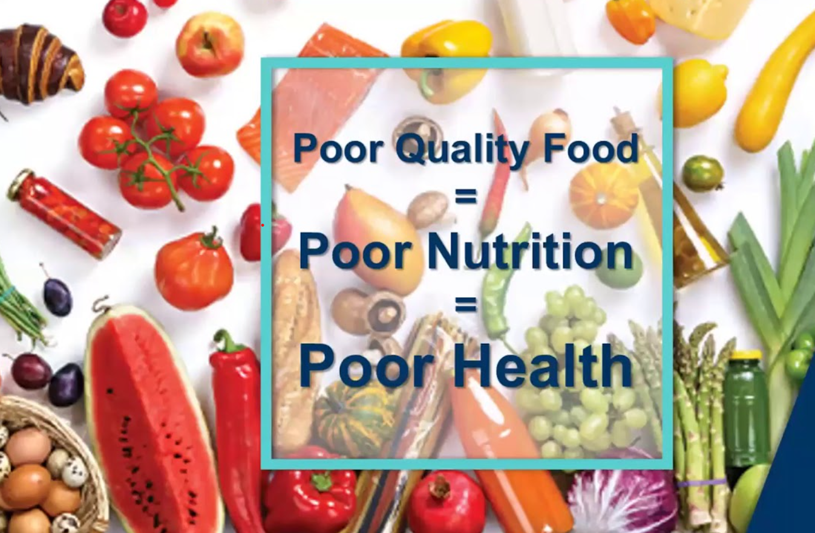
A major issue in health and social care is poor diet and unequal access to healthy food. Many people, especially those with low income, cannot afford nutritious food. This can lead to health problems such as obesity, diabetes, and heart disease.
A study by Drewnowski and Specter explains that unhealthy foods are often cheaper than healthy ones. The research shows that foods high in fat and sugar provide more energy at a lower cost, while healthier foods like fruits and vegetables cost more. Because of this, people with less money are more likely to choose cheaper, unhealthy food options. This increases the risk of obesity and other long-term health conditions.
Another study by Darmon and Drewnowski found that healthier diets are usually more expensive, which creates inequality in diet quality. The research explains that people with lower incomes often choose foods that are lower in nutrients because they are more affordable. As a result, there is a clear link between low income, poor diet, and worse health outcomes.
In conclusion, these studies show that poor nutrition is not only about personal choice. It is strongly influenced by food prices and income levels. To improve public health, it is important to make healthy food more affordable and accessible for everyone.

References:
Darmon, N. and Drewnowski, A. (2015) Contribution of food prices and diet cost to socioeconomic disparities in diet quality and health: a systematic review, Nutrition Reviews, 73(10), pp. 643–660.
Drewnowski, A. and Specter, S.E. (2004) Poverty and obesity: the role of energy density and energy costs, American Journal of Clinical Nutrition, 79(1), pp. 6–16.
Ytimg.com. (2026). Available at: https://i.ytimg.com/vi/1pUpxrZ0yDI/maxresdefault.jpg [Accessed 22 Mar. 2026].
‌

.

Task 5 - Podcast
.

Reference:
British Menopause Society (no date) British Menopause Society. Available at: https://thebms.org.uk/ (Accessed: 24 March 2026).

Task 6 - NHS Leadership Framework Analysis
The NHS Leadership Framework is a tool that helps people working in health and social care to build strong leadership skills at all levels. Its main aim is to support leaders in providing high-quality care, using resources wisely, and motivating their teams to achieve better outcomes for patients. The framework is made up of nine important areas, which are organised into three main groups: personal qualities, setting direction, and delivering services.
The first group, personal qualities, focuses on understanding yourself, managing your behaviour, and developing your skills. It encourages leaders to think about their strengths and areas where they can improve. The second group, setting direction, is about creating a shared goal, leading with compassion, understanding information, and working well with others to plan effectively. The third group, delivering services, focuses on working with teams, improving the quality of services, and managing resources in the best way to get good results. Each part of the framework includes examples of behaviours to help leaders use these skills in real-life situations.
In general, the NHS Leadership Framework gives a clear structure for developing leadership abilities that are important in health and social care. It supports teamwork, fair decision-making, and ongoing learning. These are all important for maintaining high standards and improving patient care across the NHS.

The component Inspiring Shared Purpose encourages leaders to communicate a clear vision and motivate teams to work toward common goals. In the NHS, this can be used to encourage creativity and improve care by involving staff in decision-making and innovative problem-solving. For example, a ward manager might organise regular team meetings where staff can propose ideas for improving patient nutrition or streamlining care processes. By acknowledging and implementing practical suggestions, the leader demonstrates that everyone’s input matters, fostering a culture of innovation.
This approach not only motivates staff but also improves patient outcomes, as creative solutions can enhance efficiency and the quality of care. Leaders using this component also build trust and engagement, encouraging teams to take initiative and adopt new approaches safely. Overall, inspiring shared purpose supports a positive environment that combines staff creativity with patient-centred care (NHS Leadership Academy, 2013; West et al., 2015).

References:
NHS Leadership Academy (2013) The NHS Leadership Framework. London: NHS Leadership Academy.
West, M., Eckert, R., Collins, B. and Chowla, R. (2015) Caring to change: How compassionate leadership can stimulate innovation in health care. London: The King’s Fund.

Task 7 - Self-Reflection Journal Entry
Write a short journal entry about what you learned in this module. Focus on how your understanding of creativity and value creation withing H&SC has changed and how it has informed your professional practice (200 words).
. During this module, I have gained a much better understanding of creativity and value creation in health and social care. I learned that creativity is not just about art or ideas but is essential in problem-solving, improving services, and enhancing patient care. For example, using creative approaches can help develop new ways to support patients’ nutrition, manage time more effectively, or make care environments more welcoming and inclusive.
I also learned that value creation in health and social care is about making a real difference to patients, families, and the organisation. It involves improving quality, efficiency, and outcomes while ensuring care is person-centred. I now understand that combining creativity with leadership and teamwork can help generate ideas that are both practical and beneficial for patients.
This knowledge has informed my professional practice by making me more aware of opportunities to think differently and suggest improvements. I feel more confident in contributing ideas and collaborating with colleagues to enhance care. Overall, the module has helped me appreciate that creativity and value creation are key skills for any health and social care professional and are essential for delivering high-quality, patient-focused services.

