Soup Project
Natalie Beard
1807949

Live Event Portfolio

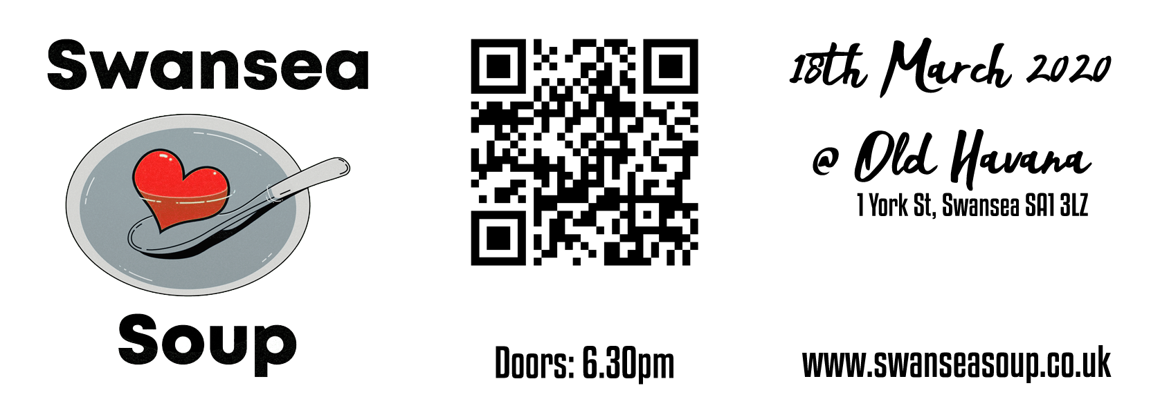

Table of Contents
1. 2
1.1 Executive Summary 2
1.2 Event Introduction 2
1.2 Event Information 2
1.3. Aims and Objectives 3
1.4 Planning 3
1.4 Staffing 3
1.5. Division of work 4
1.6. Suppliers, Stakeholders and Resources Required 4
1.7. Finance 4
2. 4
2.1 Marketing Plan 4
2.2 SWOT Analysis 4
2.3 Marketing Mix 5
2.4. Segmentation 5
3. 5
3.1. Risk 5
3.2. Insurance and Licensing 5
3.3. Contingency Planning 6
3.4. Evaluation strategy 6
4. Reference List 7
5. Appendix 0

1.

Executive Summary
This document will introduce a Swansea Soup event idea and analyse how it will be planned, marketed and evaluated.

1.2 Event Introduction

As the ‘conferences and meetings’ and ‘exhibitions and trade fairs’ events sectors are currently the highest-grossing event sectors (An Introduction To The UK Event Industry | Eventbrite UK, n.d.), it was concluded that organising an enterprise-related event would be a profitable sector to focus on as there is currently a demand for these types of events.

Inspired by projects such as Detroit Soup (About, 2015), the concept of the Soup event is an audience funded micro-granting project whereby local causes are invited to pitch their project ideas and the audience can vote for their favourite project to receive the prize pot which is made up of their entrance fees. Although other Soup projects are happening in other parts of the UK (Ruz, 2015), primary and secondary research showed that there were no Soup projects currently happening in the local area and so it was decided that would be a good concept to pursue as there would be very little direct competition. As Soup events are known for being community-based and creating a social impact (Wylie, 2016) the event needed to be designed in a way that makes the audience feel a part of a community. According to (Berridge, 2007), the design of an event is fundamental is it can influence how the audience perceives the event, creating an alternative reality to how they might see the venue otherwise, for this reason, it was decided that the venue chosen should have minimalistic decorations as this would give us a blank space to create a ‘grassroots’ type environment which would fit in with the community and social impact ideology as expected in these types of events. See (Appendix 14) for venue correspondence and (Appendix 18) for event brief sent to the venues.

Event Information

The event is to be held at Old Havana on the 18th March 2020 at 6.30pm. The feasibility research concluded that most networking events for businesses would normally be run on weekday evenings to give those who have day-jobs the chance to attend the event (Appendix 1). The event will be scheduled at a time that would allow those with 9-5 jobs to attend after work and leave at a reasonable time should they be scheduled to work early the next day (Appendix 2).
According to (Getz, 2007) “Financial problems are the main source of business and event failure.”, and so it is important to keep on top of financial issues. The venue was chosen as the most suited venue as the venue is willing to provide soup at cost price which would help to keep overheads low, this was arranged to be paid on the night of the event so that any variable costs would not need to be paid in advance, according to (Lock, 2007) variable costs are the quickest and easiest costs to make savings on. The venue management team were also very enthusiastic about promoting the event, as they were already currently hosting business events at their venue it was concluded that this venue had a good understanding of our target audience and would be able to help to reach them through their advertising networks, according to (Shone and Parry, 2004) it is important to understand the types of people that will attend your event as this factor could ensure its success.

1.3. Aims and Objectives

The aim and objectives of the event are as of follows:

Aim: Raise awareness for local social projects within the Swansea area
Objectives:
- Have at least 30 people attend the event
- Raise at least £100 for a local cause
- Select 3 local projects to pitch at the event so they can share their message with everyone and get more widely recognised for the work they do.
The reason for choosing these objectives was so the impact of the event could be measured in terms of monetary and reputational value to assess whether it would be beneficial to continue to run these events on a regular basis. An event can have a long or short term positive or negative effect on a local area which from a social impact point of view could create tighter social networks (Taks, Chalip and Green, 2015), this could allow for the social projects involved to better achieve their goals as having a wider support network could perhaps help them to attract more feedback, funding or volunteers.

1.4 Planning

The event feasibility testing determined that the event would be feasible and so it would be ok to go ahead with the planning stage of this event. The EMBOK model (EMBOK Model, n.d.) was used to identify different aspects of the event that should be considered, this enabled the event planning process to be broken down into multiple areas and tasks so to be better managed by the team. Using this model it was concluded that the key aspects of organising the event would be in relation to Administration, Design, Marketing, Operations and Risk and so the team has been organised into sub-teams who will contribute to different aspects of these factors dependant on their strengths in each of the areas, according to an article written for the Harvard Business Review matching the right talent with the skills required, is an efficient way to create an effective workforce (Chamorro-Premuzic and Kirschner, 2020), and so by matching team with the skills they feel most comfortable with, they are more likely to feel a valuable part of the team and continue to work in a manner which is a valuable asset to the organisation.

1.4 Staffing

In order to keep staffing costs low, the planning process will be organised by the Swansea Soup team and specialist jobs that could not be done within the internal departments will be outsourced to specialists. As none of the team currently have food hygiene certificates or personal licences it was established that any food and drink-related jobs would need to be outsourced in order to cut costs associated with training and licencing. As the team has members with expertise in administration, marketing, design, audio technical skills, website design and entertainment, these roles which would normally be of an extra cost to Event organisers, could be covered by the team. Please refer to (Appendix 3) for meeting minutes with details of the roles the staff have acquired during the planning process of this event.

1.5. Division of work

A Gantt chart (Appendix 4) will be used in order to give team members a visual reference of the tasks that need doing and the time-scale of which they should be completed. A Work Breakdown Structure (Appendix 5) will also be used in order to separate tasks into the areas of which the team has allocated roles (Appendix 10). As the team is small, it was decided that the team members should have the flexibility of crossing over to sectors outside of their allocated roles to help with incomplete tasks as and when needed. The team also decided to use a task tracking website (Trello, 2020), allowing them to keep track of completed tasks, enabling to take on more tasks or ask for help completing tasks as and when needed.

1.6. Suppliers, Stakeholders and Resources Required

Having spoken to the venue about their facilities it was established that most of the resources needed could be provided by them. As the management team of Old Havana are one of the main stakeholders in this event it was concluded that sourcing resources from them would be a reliable way to ensure that resources would remain available to use (Getz, 2007). Any other resources required such as posters, tickets and voting slips will be designed and provided by the team and sourced using materials available in local shops in order to support the local economy (O'Connell, 2013).

1.7. Finance
A predicted budget has been drawn up (Apendix 6) in relation to the current expenditure and profits, it should be noted that the feasibility research suggests that most Soup events seem to collect entry fees on the door as opposed to in advance, this would suggest that this is the preferred method of ticket buying for the target audience. Although the profits from tickets are currently low, feedback received in meetings and social media insights suggest that on the day ticket sales may be significantly higher.

2.

2.1 Marketing Plan
The marketing plan (Appendix 11) was designed to be flexible so that marketing methods could be tested on week one to see which had the most impact and then the marketing team could focus more on the most effective forms of advertising (Appendix 17) as shown by insights on the website and social media pages. Creating a website (Appendix 12) gave the infrastructure to be able to track page views, interactions and link clicks so that other forms of advertising could be used to focus more on aspects of the event that the audience is most interested in. A website also enabled the embedding of the application forms and contact forms so that everything is easily accessible (Appendix 15). Blogs were also added to the website as a form of information sharing and engagement with the audience (Appendix 13). Business mentor Amy Rees Anderson suggests that people chose to do business with people they like (Rees Anderson, 2013), and so by creating a personal feel within the team pages and blogs, it is hoped that a rapport can be built with the audience which makes them feel connected to the people organising the event and more likely to attend.

2.2 SWOT Analysis
The SWOT Analysis showed a fairly even mixture of strengths, weaknesses, threats and opportunities (Appendix 7).

2.3 Marketing Mix

Product: The product in the case of this event would be the event experience, taking into consideration the different reasons for attending events, it was concluded that the event would be most likely to appeal to those who seek socialisation and being part of a community (Getz, 2007).
Price: Feasibility research concluded that tickets should be priced at around £5 to make it accessible for people of all backgrounds as it is aimed at small enterprises and community projects, research by TUC suggests that around half (49%) of those who are self-employed within the UK earnt less than the national minimum wage in the tax year of 2016/17 (Two million self-employed adults earn less than the minimum wage, 2018), and so it is important that the event is priced low enough for self-employed people to attend as they are included in our target audience.
Place: It was decided that the event will be held within a venue in the city centre as the city centre has good transport links, making the event more accessible to attend.

Promotion: The event will be promoted through word of mouth, online and local press (Appendix 16) as these are the most cost-effective methods of advertising on a low budget. As social media is currently a trending form of advertising it is suggested that this might be the most used method, although the marketing plan will be adapted accordingly with how the target audience responds.

2.4. Segmentation

Through the marketing mix and feasibility research, it was concluded that the target audience of this event should be living, working or studying within the Swansea area. The target audience would be likely to have a low income and so tickets should be priced accordingly and would be likely to value community, social impact and non-for-profit.

3.

3.1. Risk

According to Health & Safety Executive, liaising with others is an effective way of managing event risk and if an event is considered to be a high risk, the event organiser could consider involving a Safety Advisory Group (Event Safety - Getting Started, 2020), however, it was decided that a SAG would not be necessary in this case as the team and the venue managers are able to manage the risks between them.
The main risks identified on the risk assessment (Appendix 8) were in relation to hot foods and drinks and the hygiene issues surrounding these, as the team are not providing the food themselves, some of the risks would be passed on to the provider of the food and drink, which in this case is the venue management team, although it is still important that the event manager ensures that those taking on the risks have the correct procedures and documentation in place.

3.2. Insurance and Licensing

In order to run an event, the correct insurance and licences should be in place prior to the event taking place. The documents which will be needed for this event include those in relation to fire safety, public liability, PPL, PRS and a personal licence for selling alcohol (Alcohol licensing, 2018), having spoken to the venue about these it was concluded that the correct insurances and licences are already in place. Although it is not currently a legal requirement in the UK that food handlers should obtain a Food Hygiene Certificate (Food hygiene for your business, n.d.) it is a legal requirement that food handlers are given the correct training and supervision, so this is something that should also be considered in relation to the chefs preparing the soup. Other legal documents to consider in relation to an event from an events organiser’s point of view are event insurance and public liability insurance in order to provide the correct cover for such as the sound technician who will need their own public liability insurance, this insurance can be obtained on a monthly basis from insurance companies such as Insure4Music (Quick Quote, 2020).

3.3. Contingency Planning

The highest risks identified in the contingency plan (Appendix 9) were the lack of ticket sales and the possibility of an Act of God. Considering the recent effects of current issues surrounding Coronavirus (Sudworth, 2020), the possibility of an Act of God affecting the event was raised from low to medium, as the virus is now starting to affect such as travel restrictions, this is something that should be monitored as a possible factor which may affect the event but is not currently being considered to be high risk as the events that it had been effecting are significantly larger than the planned soup event (France bans large indoor events to battle virus, 2020). It was concluded through market research within focus groups attended, that ticket sales would more than likely increase on the day of the event as quite a few of the networking meeting attendees at various business events attended by members of the team, suggested that they would be arriving with friends and buying a ticket on the door. It is also expected that the pitchers would be likely to attract supporters of their organisations.

3.4. Evaluation strategy

In order to evaluate the event a feedback survey will be conducted (Appendix) to evaluate the event from the audience, pitchers and staff’s point of view and assess how it could be improved for future events, the event budget will also be re-assessed to see if the monetary goals were met. The event will be continually assessed at all future events using a Control Cycle (Tum, Norton and Wright, 2006).

4. Reference List

BBC News. 2020. France Bans Large Indoor Events To Battle Virus. [online] Available at: <https://www.bbc.co.uk/news/world-europe-51690657> [Accessed 26 March 2020].

Chamorro-Premuzic, T. and Kirschner, J., 2020. How The Best Managers Identify And Develop Talent. [online] Harvard Business Review. Available at: <https://hbr.org/2020/01/how-the-best-managers-identify-and-develop-talent> [Accessed 26 March 2020].

Detroit SOUP. 2015. About. [online] Available at: <https://detroitsoup.com/about/> [Accessed 26 March 2020].

Embok.org. n.d. EMBOK Model. [online] Available at: <https://www.embok.org/index.php/embok-model> [Accessed 26 March 2020].
Eventbrite UK. n.d. An Introduction To The UK Event Industry | Eventbrite UK. [online] Available at: <https://www.eventbrite.co.uk/blog/academy/uk-event-industry-in-numbers-ds00/> [Accessed 26 March 2020].
Food Standards Agency. n.d. Food Hygiene For Your Business. [online] Available at: <https://www.food.gov.uk/business-guidance/food-hygiene-for-your-business> [Accessed 26 March 2020].

Getz, D., 2007. Event Studies. Oxford: Elsevier, pp.282-284.

Getz, D., 2007. Event Studies. Oxford: Elsevier, pp.284-285.

Getz, D., 2007. Event Studies. Oxford: Elsevier, pp.190-196.

GOV.UK. 2018. Alcohol Licensing. [online] Available at: <https://www.gov.uk/guidance/alcohol-licensing> [Accessed 26 March 2020].
hse.gov.uk. 2020. Event Safety - Getting Started. [online] Available at: <https://www.hse.gov.uk/event-safety/getting-started.htm> [Accessed 26 March 2020].

Insure4music.co.uk. 2020. Quick Quote. [online] Available at: <https://www.insure4music.co.uk/options> [Accessed 26 March 2020].

Lock, D., 2007. Project Management. 9th ed. Aldershot: Gower, pp.430-433.

O'Connell, J., 2013. Seven Reasons To Shop Locally. [online] the Guardian. Available at: <https://www.theguardian.com/money/2013/dec/06/shop-locally-small-business-saturday-seven-reasons> [Accessed 26 March 2020].

Rees Anderson, A., 2013. People Do Business With People They Like. [online] Forbes. Available at: <https://www.forbes.com/sites/amyanderson/2013/06/28/people-do-business-with-people-they-like/#77108863309f> [Accessed 26 March 2020].

Ruz, C., 2015. How The Soup Project Is Changing The UK. [online] BBC News. Available at: <https://www.bbc.co.uk/news/magazine-34346226> [Accessed 26 March 2020].

Shone, A. and Parry, B. (2004). Successful Event Management. 2nd ed. Hampshire: Pat Bond, pp.149-163.
Sudworth, J., 2020. China And The Virus That Threatens Everything. [online] BBC News. Available at: <https://www.bbc.co.uk/news/world-asia-china-51449675> [Accessed 26 March 2020].
Taks, M., Chalip, L. and Green, B., 2015. Impacts and strategic outcomes from non-mega sport events for local communities. European Sport Management Quarterly, 15(1), pp.1-6.

Trello.com. 2020. Trello. [online] Available at: <https://trello.com/home> [Accessed 26 March 2020].
Tum, J., Norton, P. and Wright, J. (2006). Management of Event Operations. 1st ed. Oxford: Butterworth-Heinemen, pp.241-245.

Wylie, I., 2016. The Soup Revolution: Changing Cities Over Dinner, From Detroit To Liverpool. [online] the Guardian. Available at: <https://www.theguardian.com/cities/2016/aug/01/soup-revolution-changing-cities-over-dinner-detroit-liverpool> [Accessed 26 March 2020].

5. Appendix

Feasibility Studies
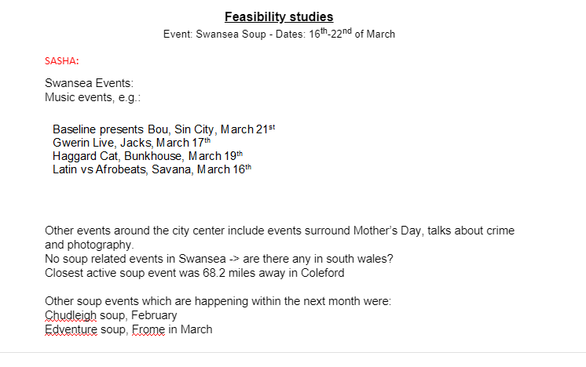

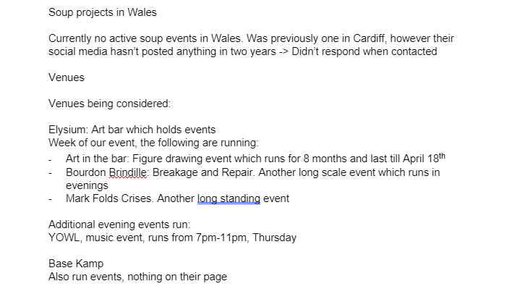

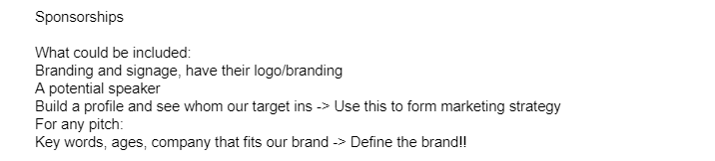

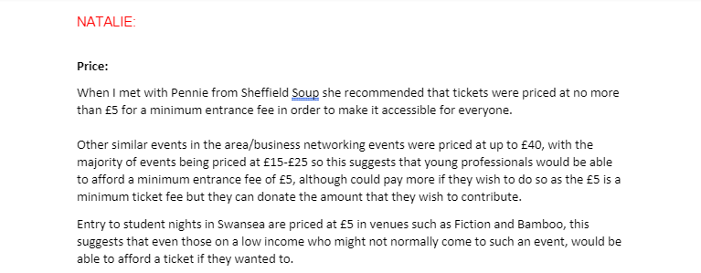

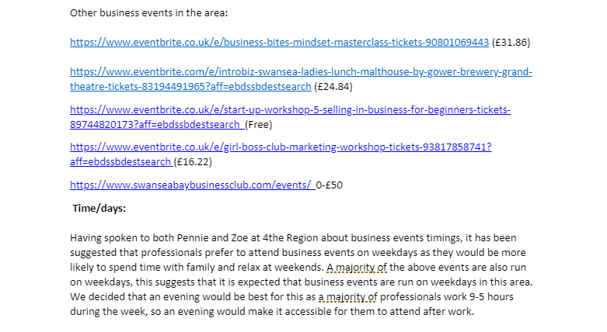

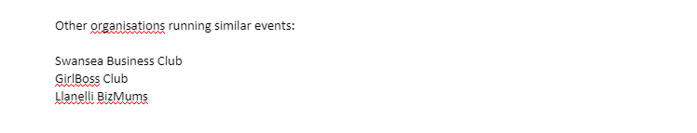

Running Order Schedule
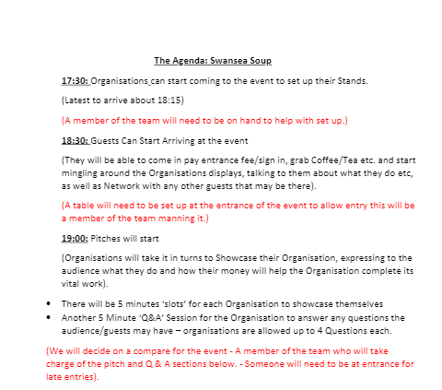

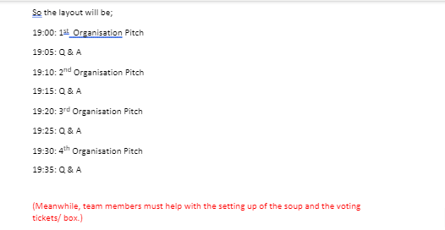

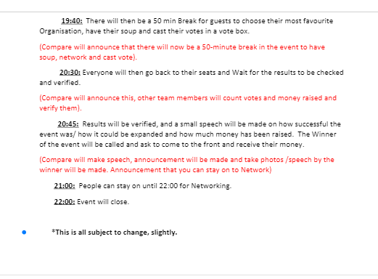

Meeting Minutes

Collection of Meeting Minutes Swansea Soup Event

_______________________________________________________________

Meeting One: 12th February 2020

4TheRegion

Attending: Start Time: 9:35

Isobel End Time: 10:00

Natalie

Sasha

Zoe (4TheRegion)

(Billy sends apologies, unable to attend)

Discussions:
- This meeting is about the possible split of the group and us creating our own event with the help of 4TheRegion.-

Possible Events we could do:

Climate Emergency Week? Links to Swansea and Gower College Running such events. - 5 days of different Activities

Workshop on Work Experience: Interview Skills , Placement Module?

City Centre Conference: Entertainment

Project Soup: Good Contender/Best Idea.

-Swansea SOUP

-Complete a Feasibility Study

-4TheRegion potential Venue?

Zoe to contact Social Business Wales

Today: Event Brief- Have one by next week

Contact the rest of the group discussing SPLIT.

Nat: Contact Penny

Next Week: Could set up a meeting with a guy from Business Wales. Check Brief in class and then Send Brief to Zoe 1st!!!

Possible venues:

Base Camp Coffee

4TheRegion

Elysium

Similar: 3 talks? Competition

RSA- Cinema and Co. ----- They don't get money/ or ideas go any further.

Our MAIN Aim and Objectives:

Aim: Raise Awareness for local Charities/Social Enterprises in Swansea.

Objective: Obtain £100 for potential participants.

Objective: Have an audience in attendance of at least 30 people from all different backgrounds to share the message.

Objective: Invite 5 small unknown local Charities to the event so they can share their message with everyone and get more widely recognised for the work they do.

____________________________________________________________________

Meeting Two: 17th February 2020

Attending: Start Time: 14:15

Billy End Time: 16:15

Natalie

Isobel

Sasha

Discussions/Tasks to be completed in the meeting today:

Discussion with Rachel about what we have done do far – NEXT WEEK make sure that we bring with us/show what we have done.

Finish off Brief

Go over agenda

E-mail it to Zoe – Ask about meeting with Business Wales/ Put us in touch with Venue

Divide Tasks between all of us.

End of meeting Results:

Finished off and amended Brief all together as a team.

Went over and made alterations to the agenda

E-mailed Zoe the brief and agenda as well as if we could maybe have a meeting with Business Wales and put us in contact with Base Kamp Coffee as she has dealt with them before.

Divided following tasks between us; UPDATED ON TRELLO TOO!

To do:

Send Event Brief _ Isobel

Finish Website_ Billy and Natalie

Create an Application form Sasha

Set Up Eventbrite Page Sasha

Logo (Create)_Billy

Marketing Plan_ PESTLE/SWOT_ Billy/Natalie

Forwarding Penny’s Application _Natalie

Type up todays Minutes Isobel

Social Media??

______________________________________________________________________

Meeting Three 24th February 2020:

Attending: Start Time: 15:00

End Time: 16:00

Natalie

Isobel

Sasha

Discussions:

Gantt Chart

Website (put it live)

Questions for the venue

The Equipment for the event;

-Posters

-Banners

-Land Yards/T-shirts

Social Media; Plan (Date)

Budget: Venue 1st Potential

Tickets

Posters Print

Potential Stamps

Design poll cards logo on the back

Questionnaires – Announcements/ the event

Map/Parking on Website

Reg Desk Entry

EP: Natalie

Contingency Plan

Individual Tasks this week (To-do): (Trello)

______________________________________________________________________

Meeting Four: 28th February 2020

Attending: Start Time: 12:30

End Time: 14:30

Natalie

Isobel

Sasha

Discussions:

Set up an e-mail on our Gmail accounts (Isobel is through Swansea Soups Main one)- isobel@swanseasoup.co.uk

Looked at form for attendees at the event to fill in.

Upload this through SurveyMonkey

Upload SurveyMonkey to website

Sasha to send Isobel List of jobs this week to do.

Typed up last week's e-mails

Isobel completed website profile.

To Do list this week:

Isobel: Gantt Chart

Rough Budget

- merchandise

- Equipment

Sasha: Calendar

Meeting

Rough Map/ Parking

Natalie: Emerging Procedure

Social Media

Contingency Plan

Marketing Plan

Website

Billy: Marketing Plan (Nat)

Social Media (Nat)

HIRE LAPTOP!!!

____________________________________________________________________

Meeting Five: 2nd March 2020 (DIDN’T HAPPEN)

Isobel and Natalie away, Sasha took over the running of the event. During this time she met with Business Wales who gave her ideas on how we could improve our event as well as starting contacting a wide range of businesses that may want to attend the event and replying to various e-mails.

______________________________________________________________________

Meeting Six: 9th March 2020

Attending: Start Time: 12:30

End Time: 14:30

Natalie

Isobel

Sasha

Discussions:

Final finishing of the event, looking at our event Gantt chart and seeing the final tasks that need to be completed.

Having a final push for marketing the event – Facebook, LinkedIn- Uploading posts and videos.

Attending the meetings at 4theRegion to encourage an audience of similar mind set to the event.

Attend a meeting at Volcano Theatre to see what they could offer in advice for a similar event they produced to us.

Be in constant contact with Rachel about our event.

______________________________________________________________________

VIDEO Meeting Six: 14th March 2020

Attending: Start Time: 18:30

End Time: 19:30

Natalie

Isobel

Sasha

Discussions:

Ring Old Havana on Monday to confirm the event

Check e-mails from Rachel

Ask her the following questions;

-Risk Assessments

-Fire

-Public Liability

Isobel to print off posters

Isobel Create ballot box

Isobel needs to message Patti (lady at the 4theRegion event) who has an idea about a business.

_____________________________________________________________________

Meeting Seven: 16th March 2020

Attending: Start Time: 14:30

End Time: 16:30

Natalie

Isobel

Sasha

Discussions:

Shut down of the event needs to be now processed due to its cancellation by the University and the fears over the Coronavirus.

The meeting was conduct at home by the above attendees.

SHUTDOWN

The Shutdown of the event was completed in the following way during this meeting;

- Messaged Andy, he said we can do the event at a later date.

- Could do another idea; David (4theRegion) suggested - questioning it.

Figured out how to refund people on Eventbrite

Messaged Patti to let her know that the event is no longer taking place – she asked to be invited to the next event.

Send David and Beth money back on Eventbrite – Natalie and Sasha has messaged them to ask if they would like a refund or would like to move the ticket to the next event --- waiting to hear.

E-mail Zoe and Dawn about the event.

Create a video announcing the event cancellation for Facebook – Sasha and Natalie.

Swansea Soup statement to be put on Eventbrite/ Facebook.

To keep the idea/momentum going we could create a Slack, this would be a forum where people could discuss, have conversations and support one another in setting up businesses successfully.

Messaged group chat for Tourism to announce the cancellation of the event

Announce the event is postponed on Eventbrite/ sold all tickets so no more can be purchased.

______________________________________________________________________

EVENT FINISHED/SHUTDOWN

Gantt Chart

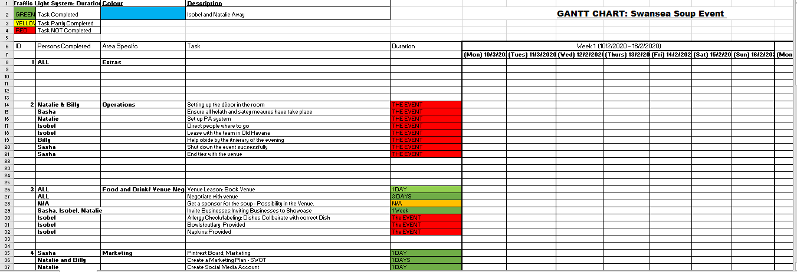
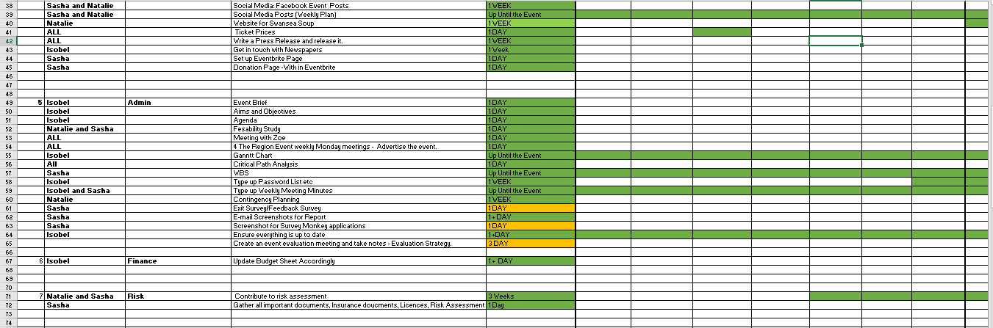

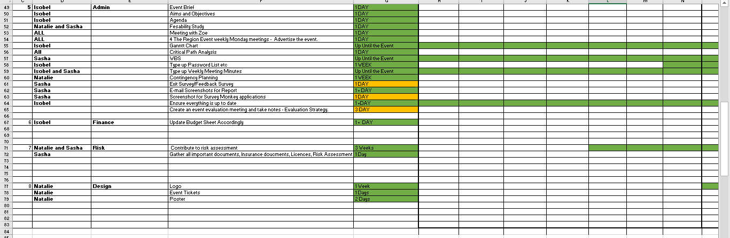

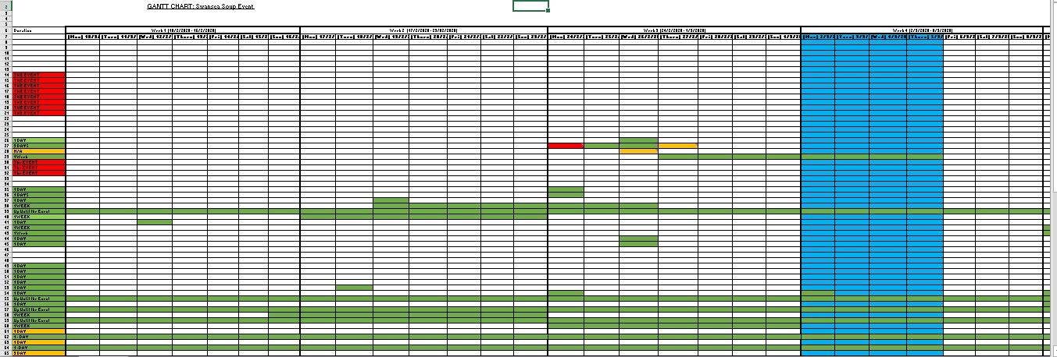

WBS

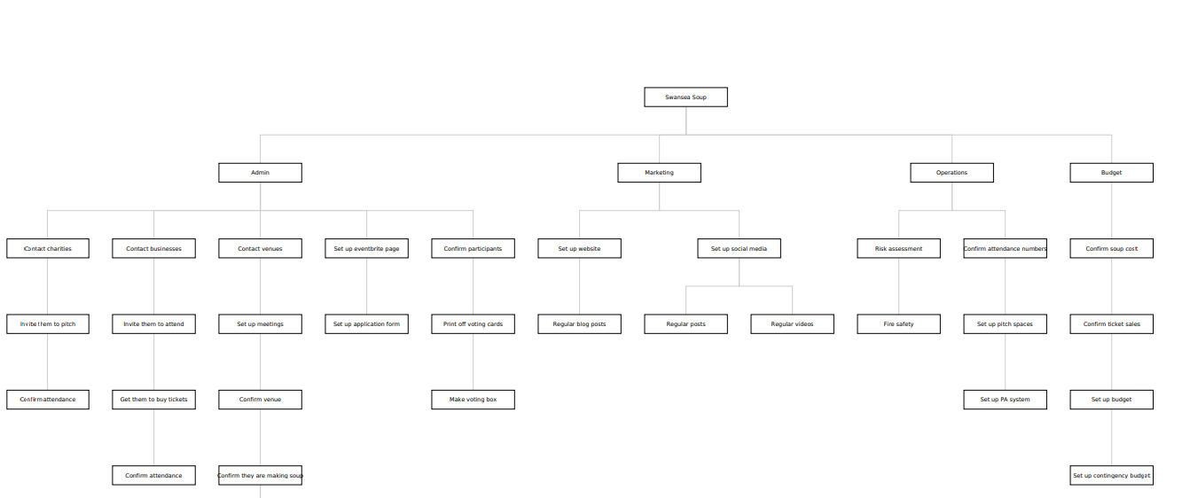

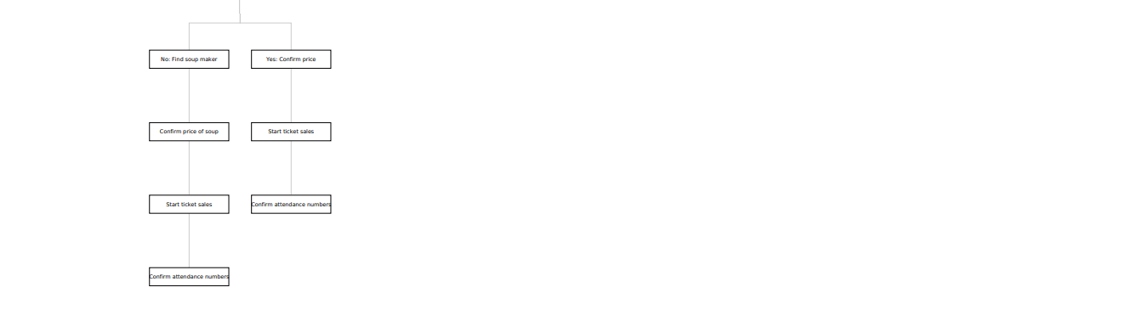

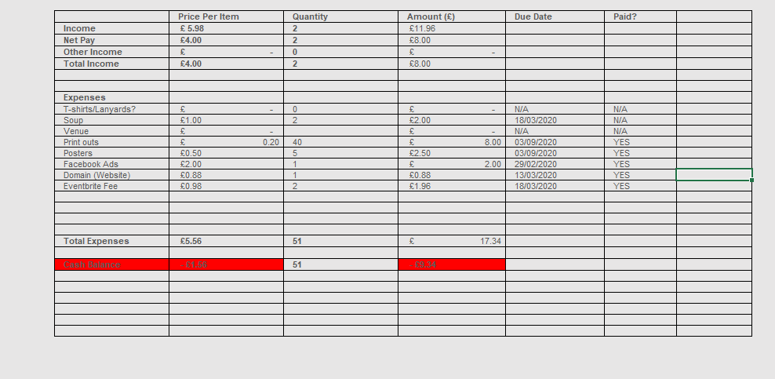
Budget

Swot Analysis
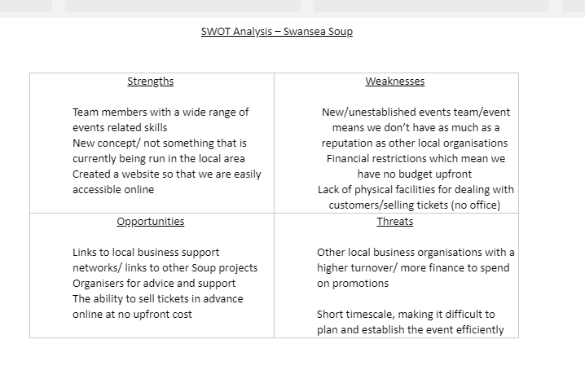
- Risk Assessment
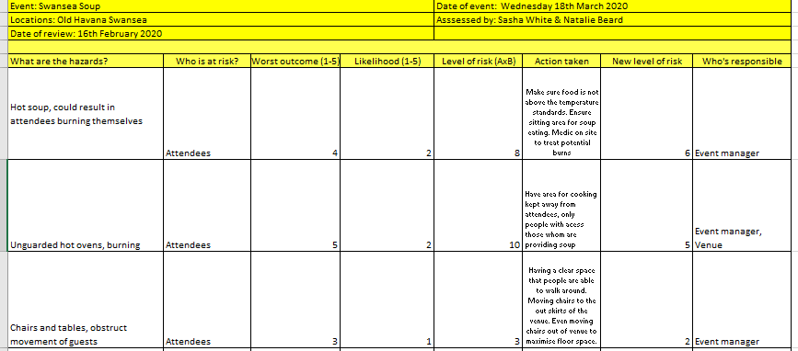

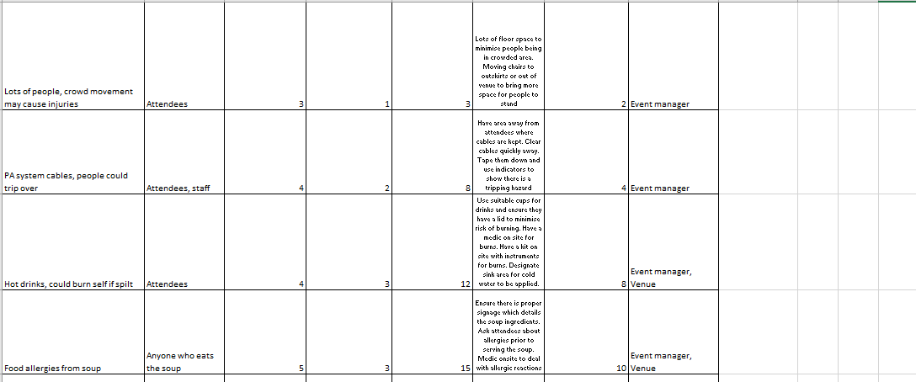
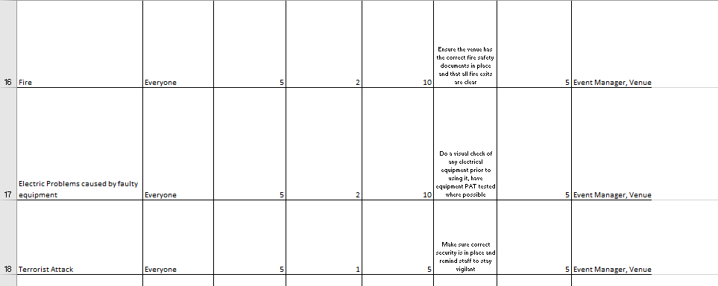
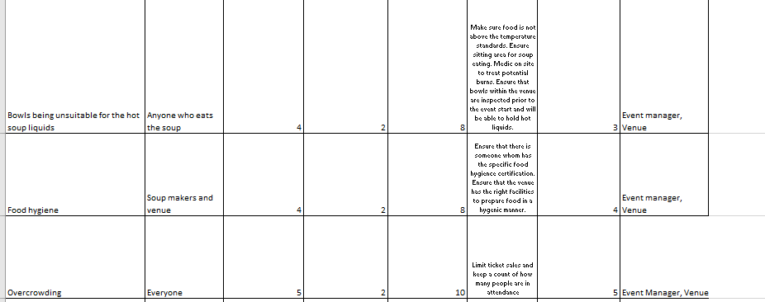

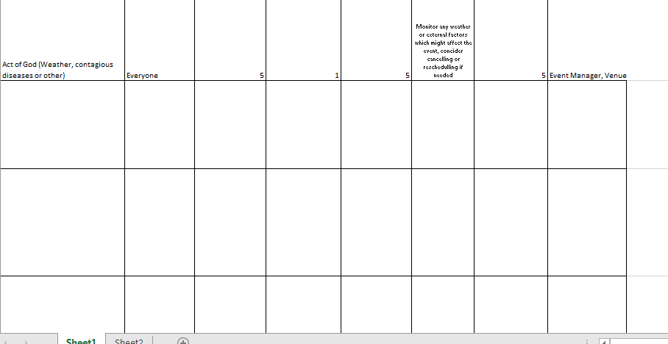

Contingency Plan
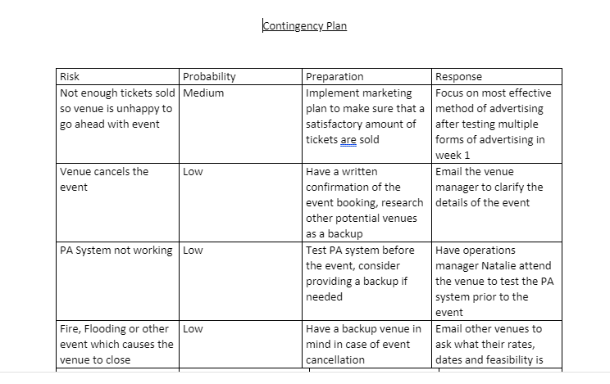
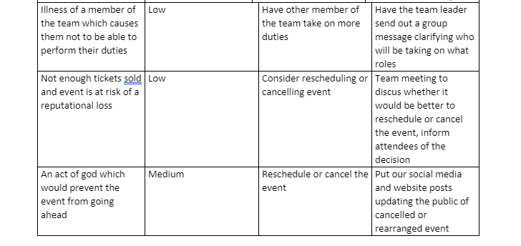

Team Roles
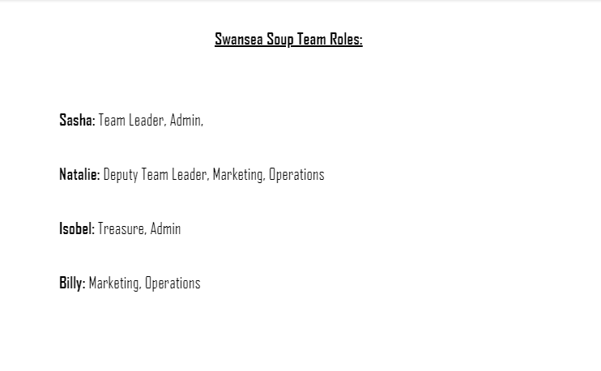

Marketing Plan
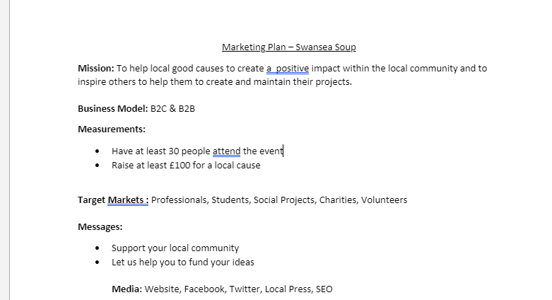

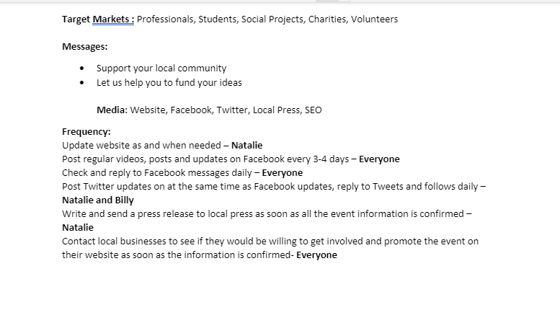

Website

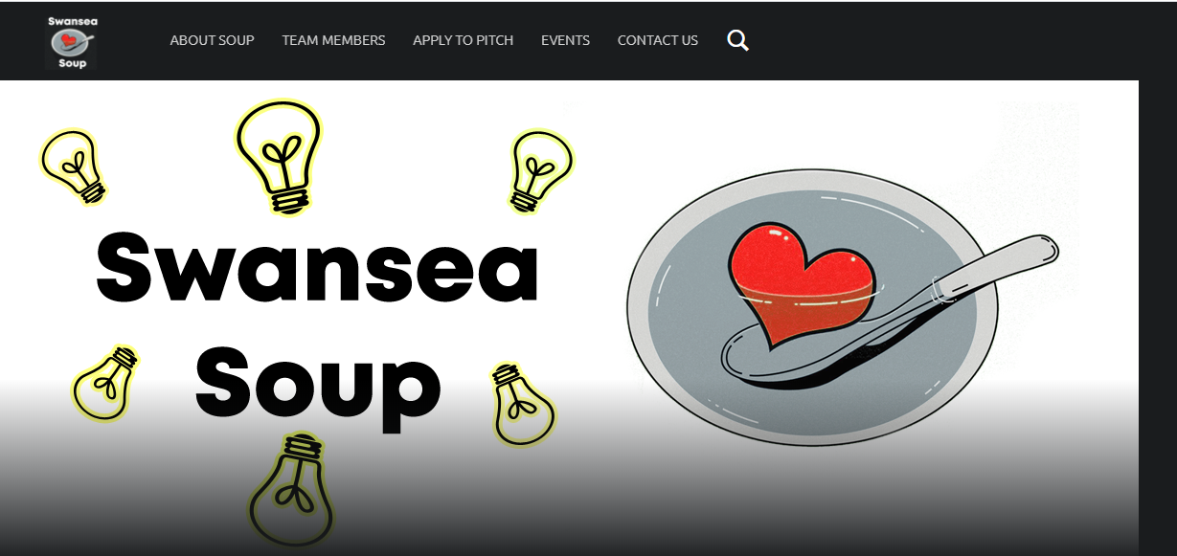

Blogs
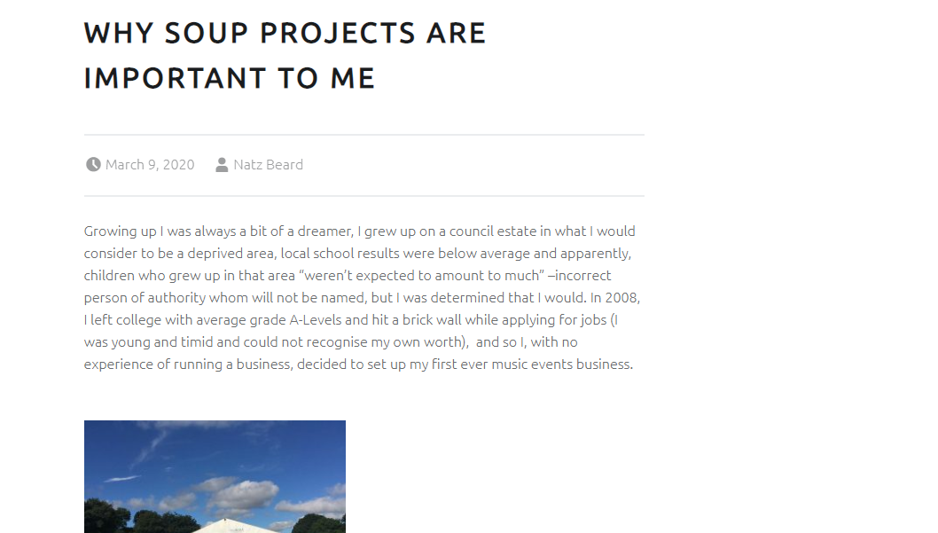

Venue Correspondence

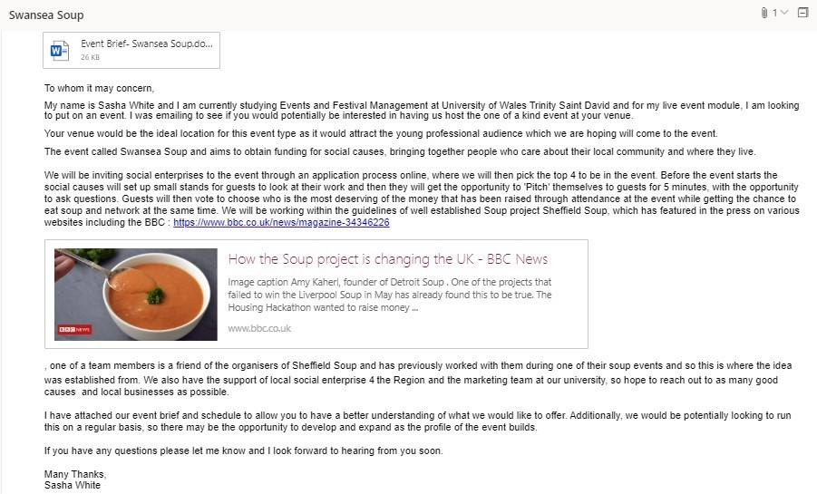
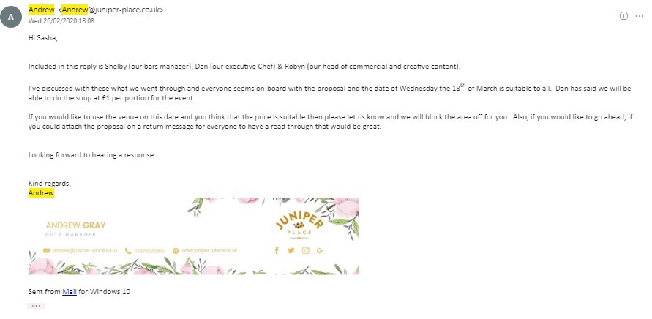
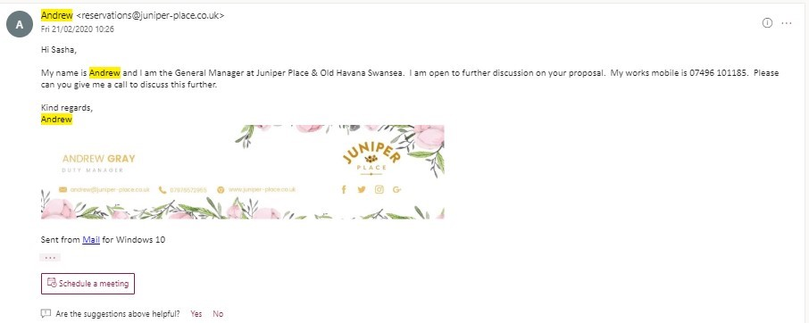

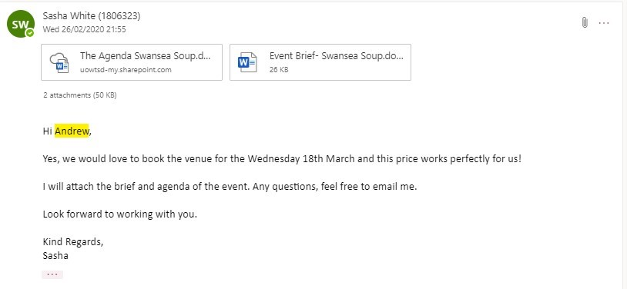

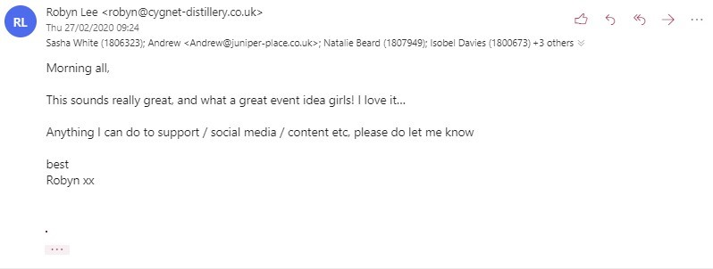 Elysium
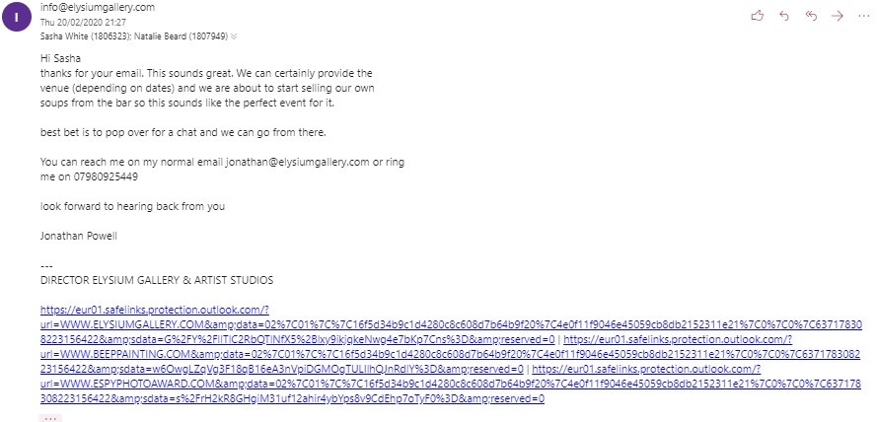
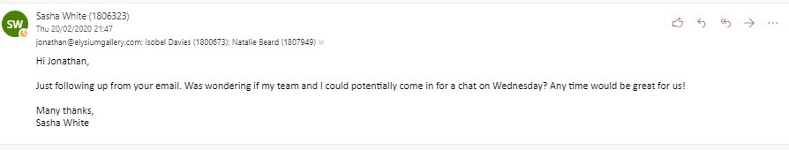
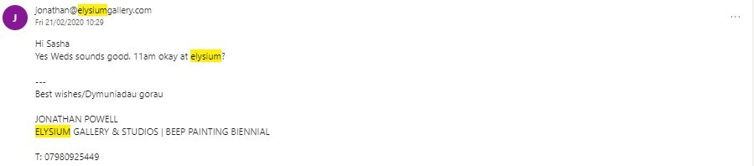
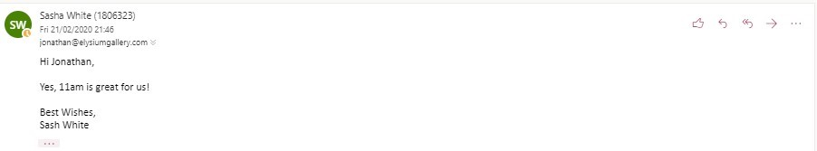
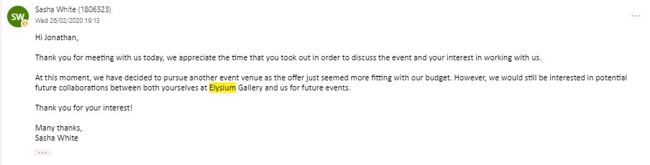

Hyst
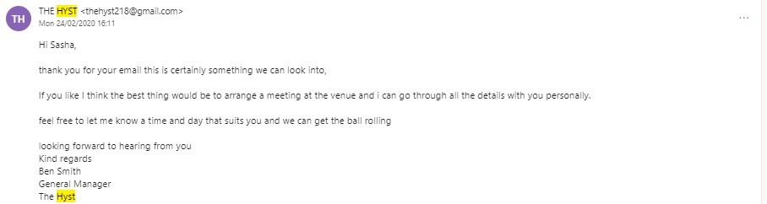
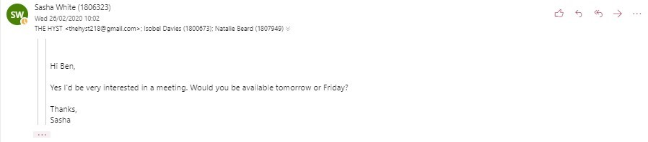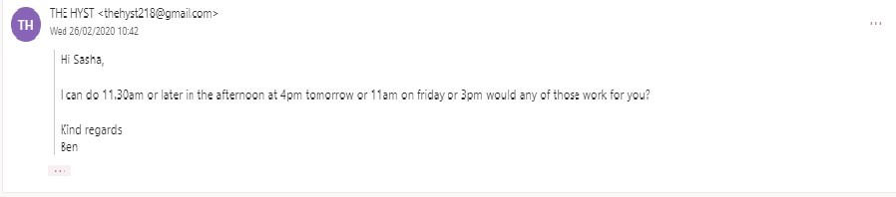
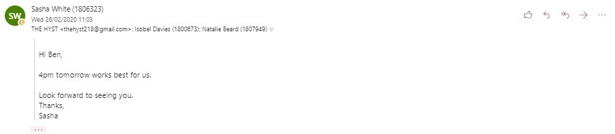
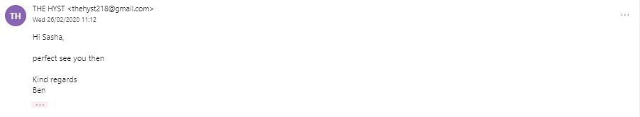
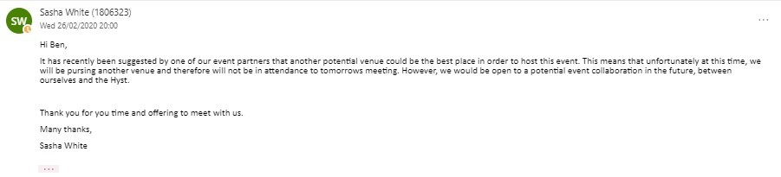
Perch
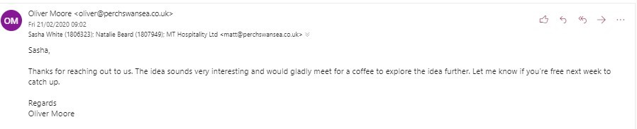
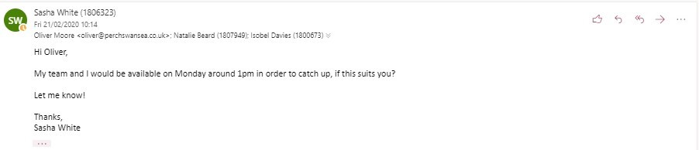
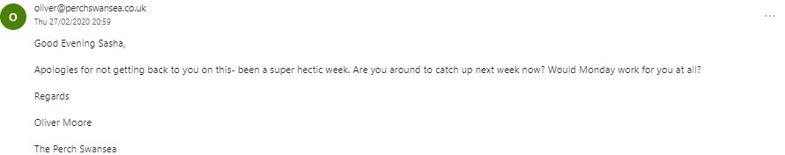

Volcano Theatre
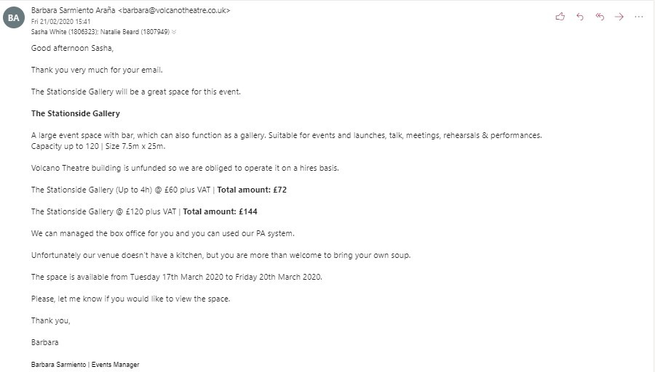
Cinema and Co response
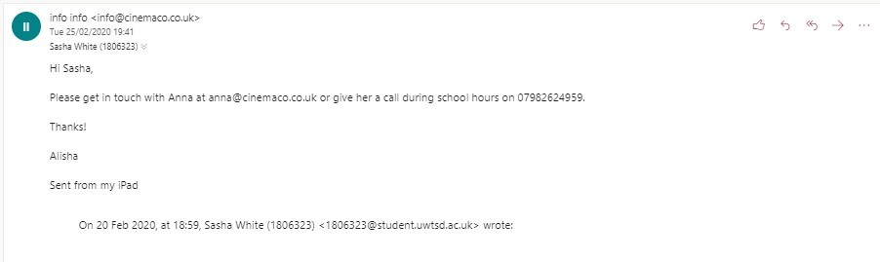
The email sent to everyone was: the first one sent to Old Havana
There was also a generic rejection: the rejection that was sent to the Hyst
Emails to charities

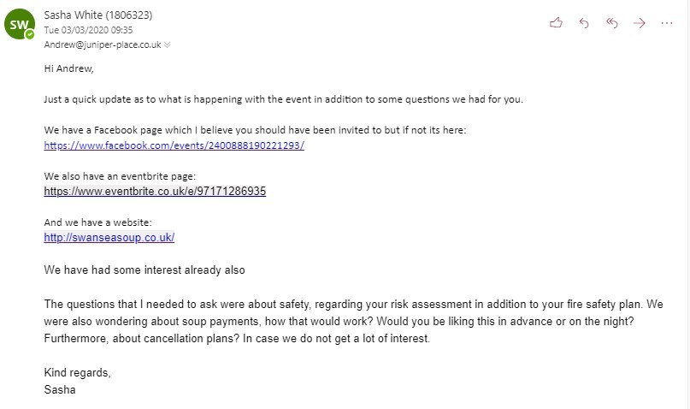
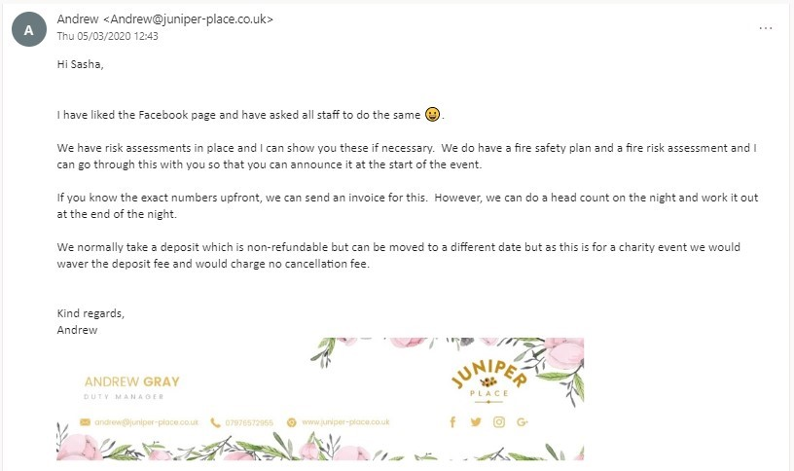
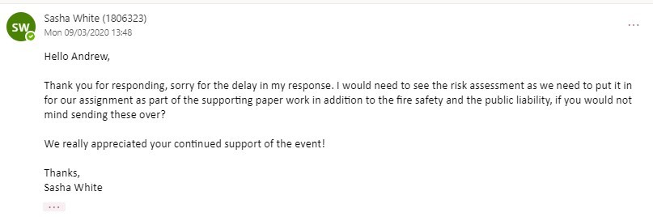
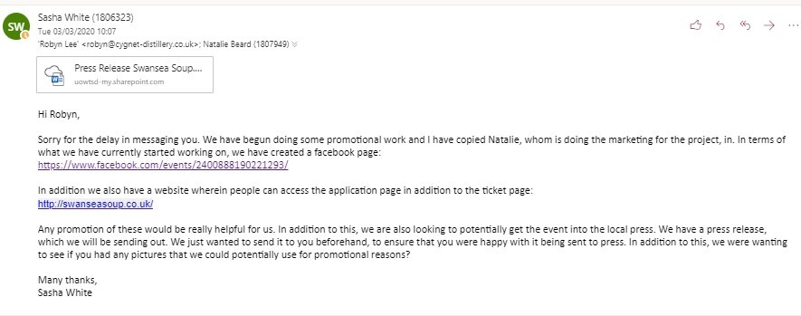
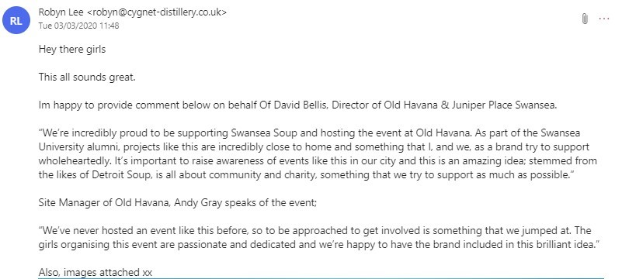

Website- Embedded Forms

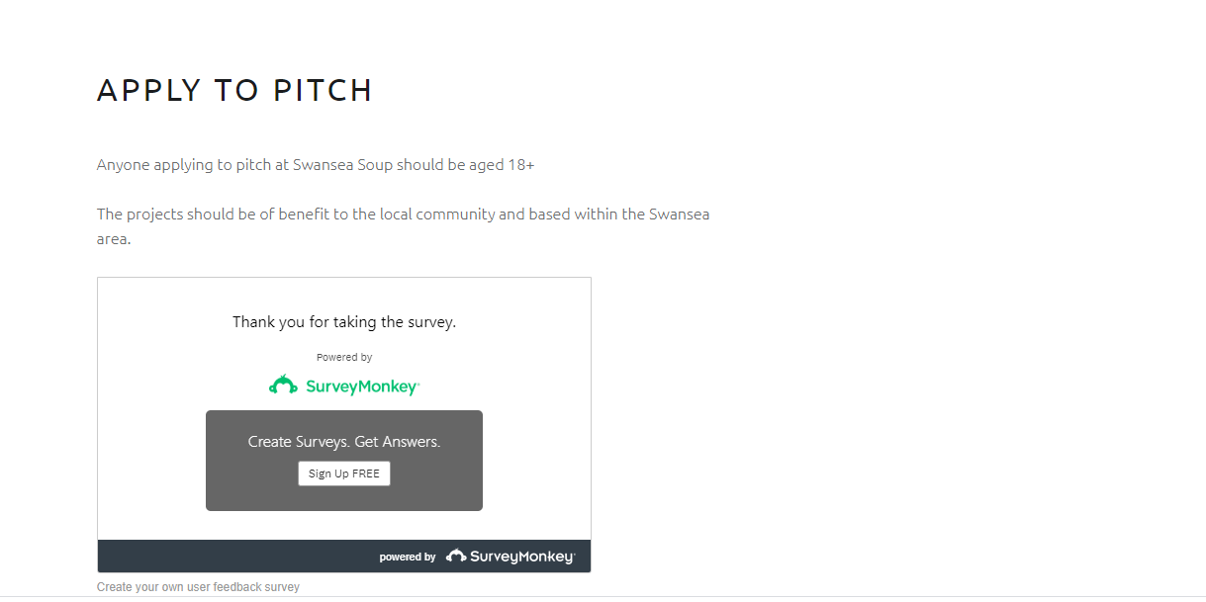
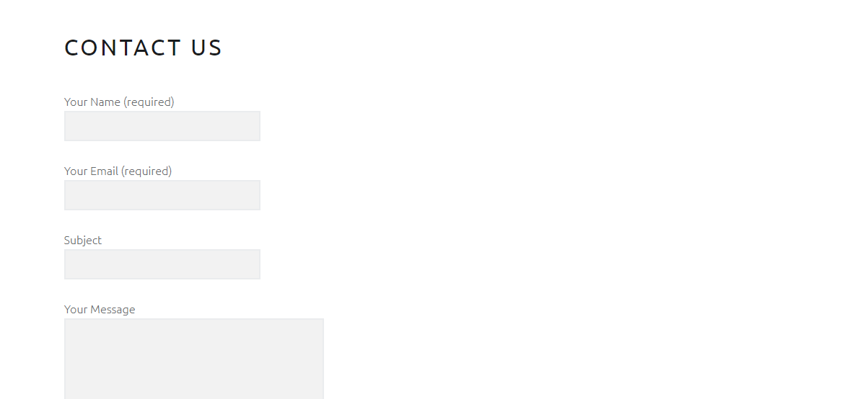

Press Release
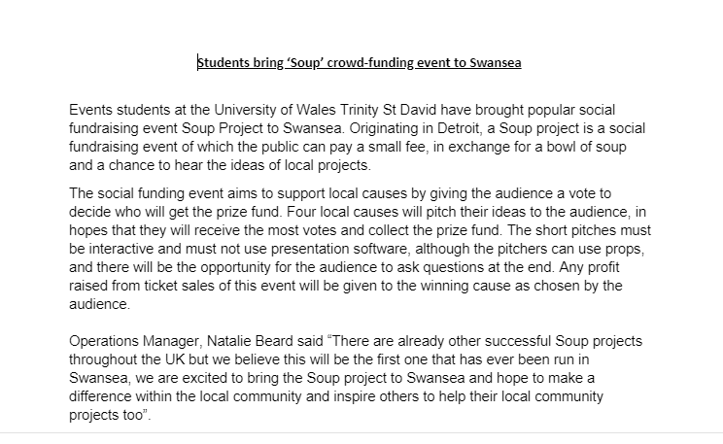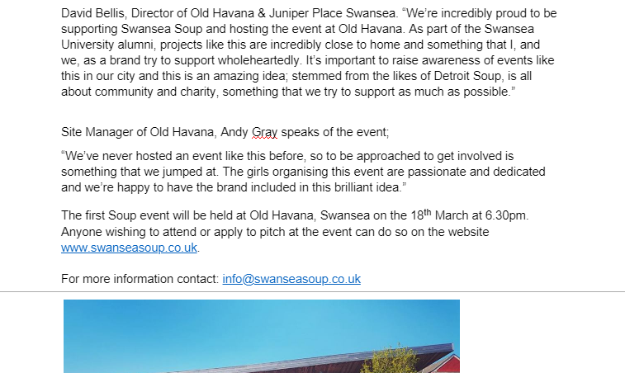

Advertising Methods

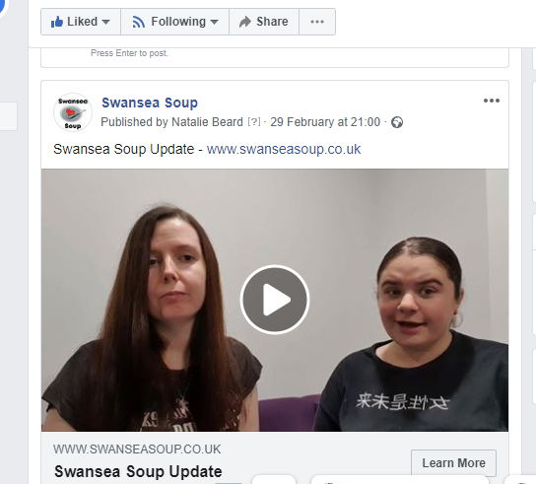

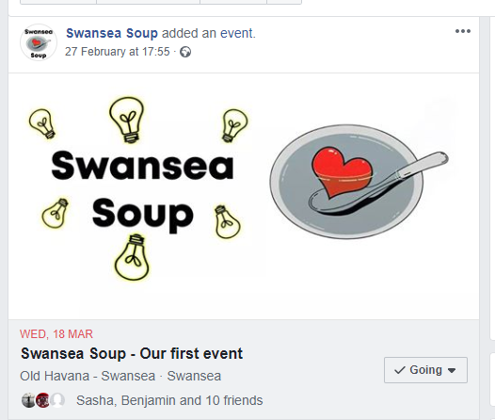

Video Event Page
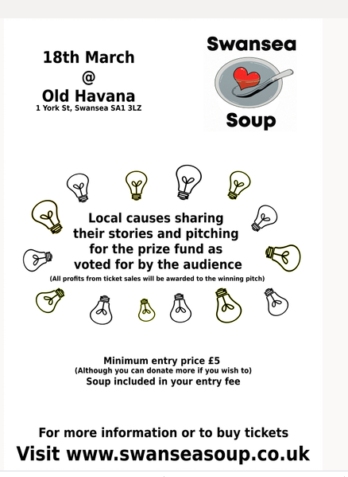
Poster

Event Brief


