

BSc Health and Social Care
Changemakers: Creativity & Value Creation
BMHP5014

Student Name: Misba Mahmood
Student Number: 2413669
Lecturer Name: Raheela Shaikh
Assignment Title: Component 1: Online Portfolio of Set Exercise
Submission Date: Wednesday 25th March 2026

Task 1 – Concept Map
Create a concept map that outlines the relationship between creativity, value creation, and health and social care improvement. Within the concept map explain how these concepts interact in a health and social care context (250 words).
Concept map

Creativity
Value creation
Health and Social Care Improvement

A multi-faceted cognitive process involving the generation of new and valuable ideas, influenced by motivation, wellbeing, and the working environment
The process of turning labour and resources into services that meet needs by achieving the best outcomes while using resources efficiently
Improving the quality, effectiveness, and outcomes of health and social care services to support wellbeing

Secondary idea
Secondary idea
Example
Example
Example
Secondary idea

Motivation and well-being support creative thinking and problem-solving
Health and social care professionals use creative thinking to adapt services and meet service users
Efficient use of resources improves service quality and reduces waste while maintaining person-centred care.
Value includes allocative, technical, and personalised value, focusing on quality, effectiveness, equity, and person-centred care
Improved services lead to better access, improved wellbeing, and positive health outcomes
Improvement includes patient-centred care, preventive care technology and innovation, community engagement, and population health management

C

Creativity plays an important role in improving health and social care services by encouraging new ways of thinking and problem solving (Abraham, 2015). When professionals are internally motivated, they are more likely to contribute creative ideas that improve practice (Ryan and Deci, 2000). This can help services make better use of resources, improve person-centred care, and achieve better outcomes for service users. Creative approaches can also support innovation and wellbeing, particularly in mental health care (Coulton et al., 2015; Mental Health Foundation, 2020), helping to promote continuous improvement in care delivery.

Task 2 - Self-Reflection of Group Activity
Complete a self-Reflection on the Convergent/Divergent paperclip thinking class activity using a reflective model (250 words, 1 source)

This reflection is based on Gibbs’ Reflective Cycle (1988) and explores my experience of the convergent and divergent paperclip thinking activity completed in Week 2.
Description:
Our group began the activity by sharing our ideas with the class. We first used divergent thinking to suggest as many different uses for a paperclip as possible and recorded what we did and how many ideas we came up with on post it notes. Everyone in the group was engaged; however, I played a key role in helping the group get started with sharing our ideas to the class. I also contributed most of the identified risks. As a group, we tested selected ideas by shaping the paperclips and created a heart bracelet, a key ring, and a zip-up replacement. We then used convergent thinking to narrow the ideas down by focusing on practicality and safety.
Feelings:
At the beginning, I felt hesitant about speaking in front of the class. However, once I started sharing ideas and supporting my group, I began to feel more confident. Taking responsibility for explaining ideas and highlighting risks helped increase my confidence and sense of involvement.
Evaluation:
The activity worked well because everyone participated and respected each other’s ideas. Using post-op notes helped organise our thinking, and physically making the paperclip items made the task more engaging. Identifying risks such as injury, choking hazards, and damage to clothing or bags encouraged critical thinking. A limitation was that some creative ideas were dismissed quickly due to safety concerns.

Analysis:
This activity showed me how divergent thinking encourages creativity, while convergent thinking helps refine ideas into realistic solutions (Gibbs, 1988).
Conclusion and Action Plan:
Overall, the activity improved my confidence in group discussions. In future activities, I will continue to take initiative and support group communication.

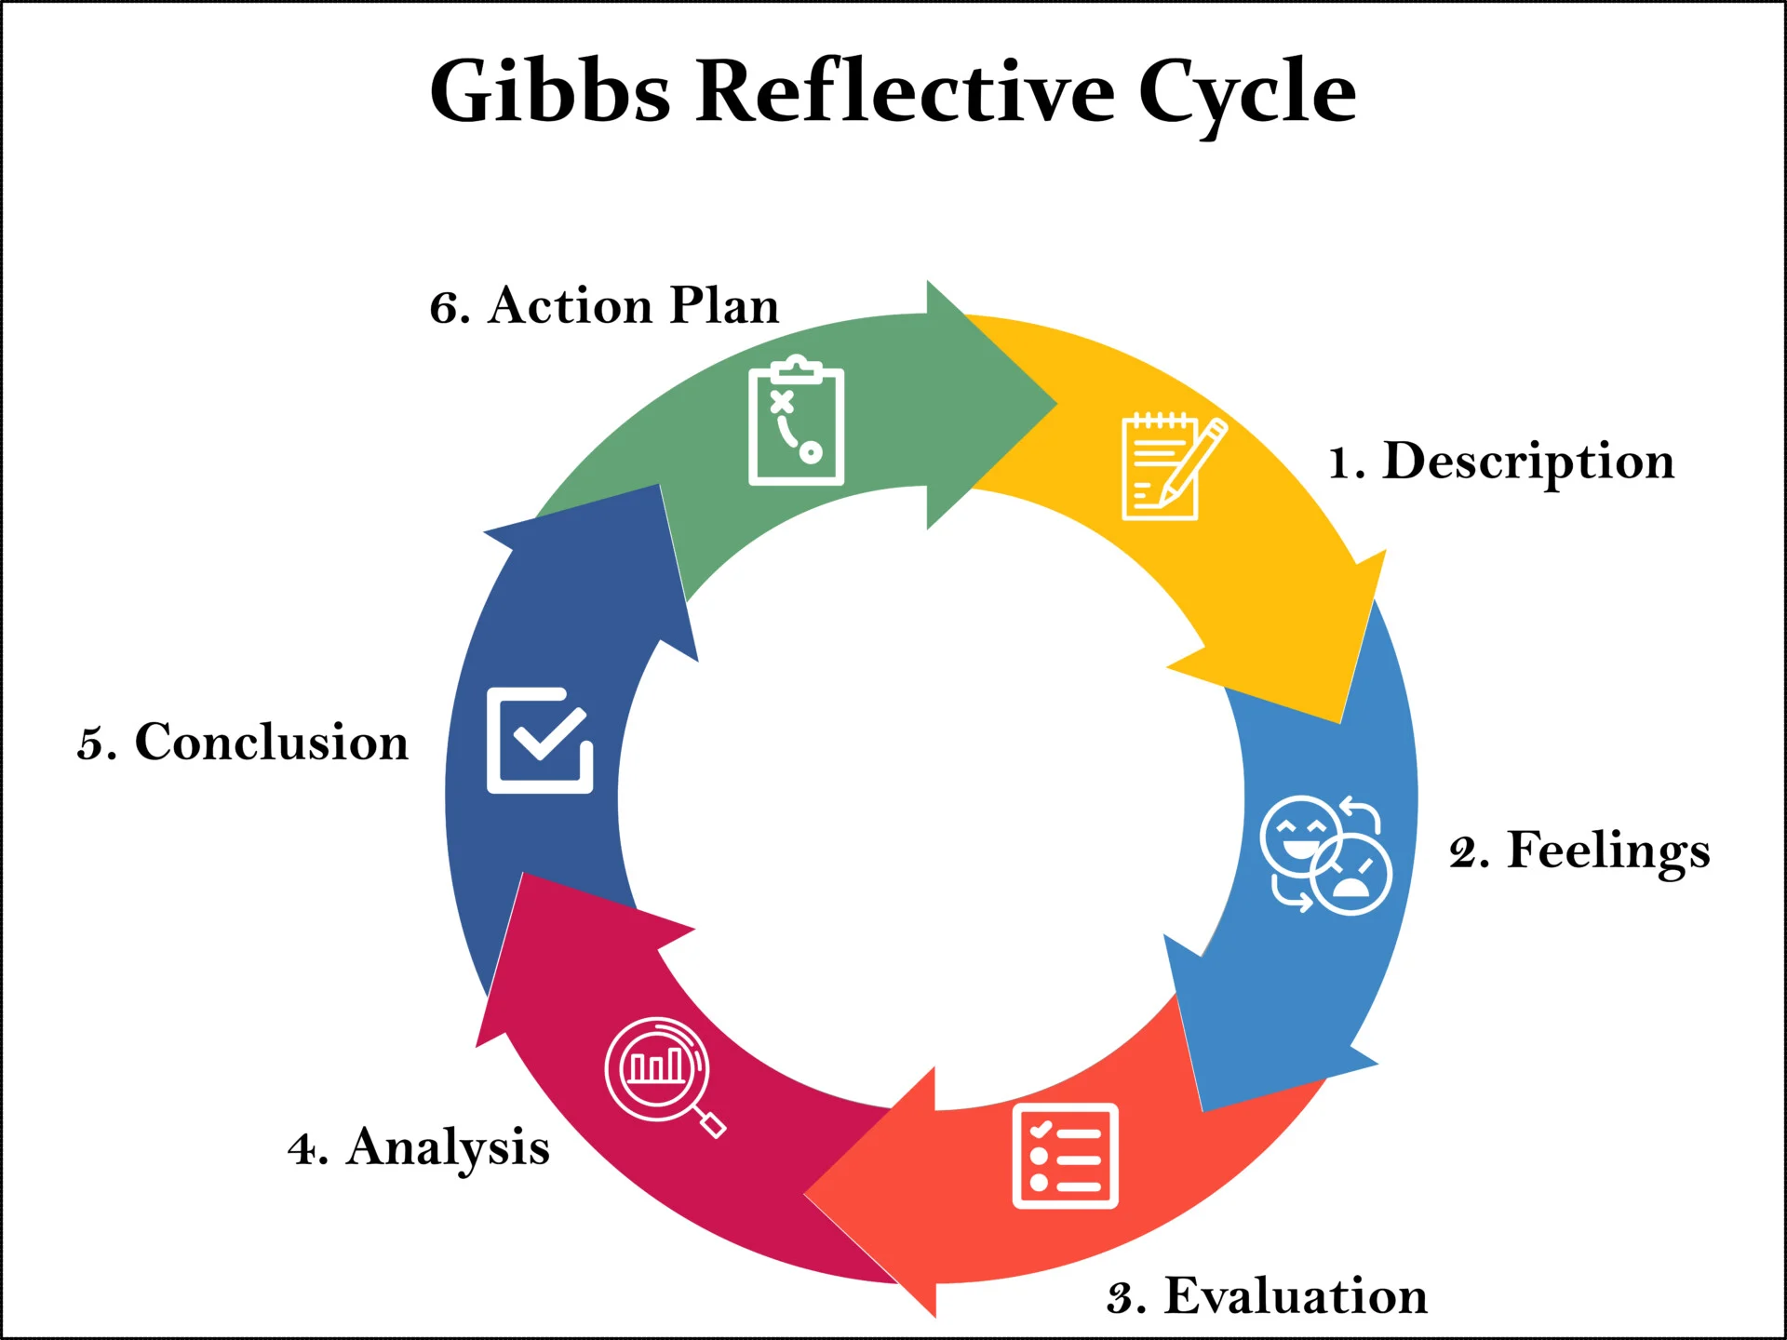

Task 3 - Case Study of a UK innovation
Write a concise case study analysis of an innovative project or initiative within the NHS or UK social care. Focus on how creativity was used to drive change and the value it created for patients or service users (400 words, 2 sources).

Case Study: NHS at Home Initiative
Introduction
The NHS at Home initiative was developed in response to increasing pressure on hospital services caused by rising admissions linked to long-term conditions such as cardiovascular disease, diabetes, and respiratory illness (NHS England, 2022). The initiative aimed to creatively redesign care delivery by shifting aspects of monitoring and management from hospital settings into patients’ homes (NHS England, 2022). By embedding digital technology into routine care, the NHS sought to improve patient outcomes while reducing avoidable hospital admissions and strain on healthcare resources (NHS England, 2022).

Creativity and Innovation
Creativity within the NHS at Home initiative was demonstrated through the innovative use of digital health technologies to transform traditional models of care (NHS England, 2023). A key strategy involved providing service users with wearable devices to monitor vital signs such as heart rate, blood pressure, and glucose levels at home (NHS England, 2023). This reimagined hospital-based monitoring into a more flexible and patient-centred approach, allowing care to be delivered beyond clinical settings (NHS England, 2023).
For individuals with more complex health needs, home-based monitoring equipment, including portable ECG machines and spirometers, was introduced (Care Quality Commission, 2021). These devices enabled service users to conduct advanced health checks remotely, with data securely transmitted to healthcare professionals (Care Quality Commission, 2021). This creative approach reduced the need for frequent face-to-face appointments and helped overcome barriers such as limited hospital capacity and workforce pressures (Care Quality Commission, 2021).
The initiative also incorporated artificial intelligence (AI) and predictive analytics to analyse patient data in real time (NHS England, 2023). These tools supported early identification of deterioration, allowing clinicians to intervene before conditions worsened (NHS England, 2023). This marked a shift from reactive care towards proactive and preventative practice, improving continuity of care and reducing emergency admissions (NHS England, 2023).
Patient education was a further innovative element of the initiative (Care Quality Commission, 2021). Service users were supported to understand and interpret their health data, enabling informed decision-making and greater involvement in managing their conditions (Care Quality Commission, 2021). This focus on empowerment encouraged active participation in care and improved long-term self-management.

Impact and Value Creation
The NHS at Home initiative created significant value for both service users and the healthcare system (NHS England, 2022). Patients benefited from improved health outcomes, increased independence, and enhanced quality of life through continuous monitoring and early intervention (NHS England, 2022). From a service perspective, the initiative contributed to reduced hospital admissions and more efficient use of NHS resources (NHS England, 2022). However, challenges such as digital exclusion highlight the need for inclusive implementation and ongoing support to ensure equitable access to technology (Care Quality Commission, 2021).

Task 4 - Research Task
Identify a current issue in health and social care (e.g. e.g., mental health stigma, access to care for vulnerable populations). Find two pieces of academic research (journal articles) that explain the reason for this problem. Paraphrase the findings of each article (300 words, 2 sources).

Mental Health Stigma in Young People
Rickwood, Deane and Wilson et al. (2007) investigated why young people may avoid seeking help for mental health problems. The study used survey data from young people aged 12–25 to examine attitudes towards mental health support. The findings showed that stigma was a major barrier preventing young people from accessing professional help. Many participants reported concerns about embarrassment and fear of negative reactions from others if they disclosed their mental health difficulties. The research also found that some young people preferred to rely on friends rather than professionals because they feared being labelled or misunderstood. In addition, lack of knowledge about available services was identified as another reason why support was not always accessed. The study concluded that stigma, fear of judgement and limited awareness of services all contribute to delays in help-seeking among young people.

Hermann, Durbeej and Karlsson et al. (2022) explored how adolescents understand mental health problems and stigma. They interviewed 32 young people aged 15–18. Many participants described mental health difficulties as common among their generation. Despite this, stigma was still present. Young people reported that fear of judgement from peers, school pressure and gender expectations influenced how mental health problems were viewed. For example, boys may feel pressure to hide emotions. Participants also explained that when people lack knowledge or personal experience of mental illness, they may respond negatively or without understanding.
Overall, both studies show that mental health stigma continues because of fear of negative judgement, limited understanding of mental health and social pressures. These factors can prevent young people from openly discussing their mental health and may delay access to proper support
Task 5 - Podcast
Record a two-minute Podcast introducing your idea for component 2 using https://www.rev.com/onlinevoicerecorder The MP3 audio must be downloaded and embedded as a file (see guidance video on how to do this here: https://www.youtube.com/watch?v=D21isId0agw) or an accessible OneDrive link if using a Chromebook (make accessibility – anybody) before inserting into your portfolio. Check the accessibility of the link before submitting.

Task 6 - NHS Leadership Framework Analysis
Write a short summary (200 words) explaining the key components of the NHS Leadership Framework. Then, choose one component and describe (150 words) how a leader might use it to encourage creativity and improve care in the NHS (2 sources).

NHS Leadership Framework Summary
The NHS Leadership Framework outlines the knowledge, skills and behaviours required for effective leadership across health and social care (NHS Leadership Academy, 2011). It is designed to support the delivery of safe, high-quality and person-centred care (NHS Leadership Academy, 2011). The framework is structured around seven core domains: demonstrating personal qualities, working with others, managing services, improving services, setting direction, creating the vision, and delivering the strategy (NHS Leadership Academy, 2011).
The first domain emphasises self-awareness, integrity and commitment to personal development (NHS Leadership Academy, 2011). Working with others focuses on collaboration, communication and relationship-building (NHS Leadership Academy, 2011). Managing services involves planning, organising resources and ensuring accountability (NHS Leadership Academy, 2011). Improving services highlights the importance of evaluation, patient safety and innovation (NHS Leadership Academy, 2011). Setting direction requires leaders to understand the wider healthcare environment and make evidence-based decisions (NHS Leadership Academy, 2011). Creating the vision centres on inspiring shared goals and organisational values (NHS Leadership Academy, 2011). Finally, delivering the strategy ensures that plans are translated into effective action (NHS Leadership Academy, 2011).
Overall, the framework promotes consistent leadership standards and recognises that leadership is a shared responsibility at all levels of the NHS (NHS Leadership Academy, 2011). Strong leadership is linked to improved staff engagement, better teamwork and enhanced patient outcomes (West et al., 2014)

Component: Improving Services
The “Improving Services” domain encourages leaders to focus on quality improvement, patient safety and innovation (NHS Leadership Academy, 2011). A leader can use this component to promote creativity by encouraging staff to question current practices and suggest new approaches (NHS Leadership Academy, 2011). For example, leaders might support regular reflective meetings where teams review patient feedback, analyse outcomes and identify areas for change (NHS Leadership Academy, 2011).
By creating a supportive environment, leaders enable staff to test new ideas safely and learn from experience (NHS Leadership Academy, 2011). Transformational leadership theory highlights the importance of intellectual stimulation, where leaders encourage critical thinking and problem-solving (Bass, Avolio and Atwater, 1996). When staff feel empowered to contribute ideas, they are more likely to develop innovative solutions that enhance service delivery (Bass, Avolio and Atwater, 1996).
Using this approach, leaders can improve care quality while maintaining safety and accountability, ensuring that improvements are meaningful and sustainable (NHS Leadership Academy, 2011; West et al., 2014).

Task 7 - Self-Reflection Journal Entry
Write a short journal entry about what you learned in this module. Focus on how your understanding of creativity and value creation withing H&SC has changed and how it has informed your professional practice (200 words).

Self-Reflection Journal Entry
Throughout this module, my understanding of creativity and innovation in health and social care has developed significantly. At first, I associated creativity with major inventions or large organisational change. I now recognise that creativity is also shown through everyday problem-solving, adapting communication styles and finding better ways to meet service users’ needs. Creative leadership involves using imagination to guide teams through complex challenges and encouraging staff to think differently (Buller, 2015). This has helped me understand that innovation often grows from small, practical improvements within teams.
My view of value creation has also expanded. Previously, I focused mainly on efficiency and managing resources. I now appreciate that value in health and social care includes improving patient safety, enhancing experiences and supporting staff wellbeing. Developing a creative mindset supports ongoing improvement and sustainable services, particularly in times of pressure (Amer, 2017).
Learning about reflective practice has strengthened my professional development. Applying Gibbs’ reflective cycle has encouraged me to think more critically about my experiences and plan meaningful improvements (Gibbs, 1988). Overall, this module has increased my confidence in contributing ideas, embracing innovation and supporting positive change within health and social care settings.

Reference List
Abraham, A.G. (2015) ‘Gender and creativity: An overview of psychological and neuroscientific literature’, Brain Imaging and Behaviour, 10, pp. 609–618.
Amer, W. (2017) ‘The art of creative leadership’, Strategic Finance.
Bass, B.M., Avolio, B.J. and Atwater, L. (1996) ‘The transformational and transactional leadership of men and women’, Applied Psychology: An International Review, 45(1), pp. 5–34.
Buller, J.L. (2015) Change leadership in higher education. San Francisco: John Wiley & Sons.
Care Quality Commission (2021) Enabling innovation and adoption in health and social care: Developing a shared view. Available at: https://www.cqc.org.uk/sites/default/files/20210208_InnovationPrinciples_report.pdf (Accessed: 30 January 2026).
Coulton, S., Clift, S., Skingley, A. and Rodriguez, J. (2015) ‘Effectiveness and cost-effectiveness of community singing on mental health-related quality of life of older people: Randomised controlled trial’, British Journal of Psychiatry, 207(3), pp. 250–256.
Gibbs, G. (1988) Learning by doing: A guide to teaching and learning methods. Oxford: Oxford Polytechnic.
Hermann, V., Durbeej, N., Karlsson, A-C. et al. (2022) ‘Feeling mentally unwell is the “new normal”: A qualitative study on adolescents’ views of mental health problems and related stigma’, Children and Youth Services Review, 137.
Mental Health Foundation (2020) Creativity and innovation: Findings from the Mental Health Fellowships. Available at: https://www.mentalhealth.org.uk/sites/default/files/2022-06/MHF-Winston-Churchill-Memorial-Trust-Creativity-Innovation-findings.pdf (Accessed: 4 January 2025).
NHS Digital (2023) Mental health of children and young people in England 2023. Leeds: NHS Digital. Available at: https://digital.nhs.uk (Accessed: 21 February 2026).
NHS England (2022) Delivering a digital-first primary care system. Available at: https://www.england.nhs.uk/publication/delivering-a-digital-first-primary-care-system/ (Accessed: 30 January 2026).
NHS England (2023) Virtual wards and remote monitoring. Available at: https://www.england.nhs.uk/virtual-wards/ (Accessed: 30 January 2026).
NHS Leadership Academy (2011) NHS leadership framework. Leeds: NHS Leadership Academy.
Rickwood, D., Deane, F.P., Wilson, C.J. and Ciarrochi, J. (2005) ‘Young people’s help-seeking for mental health problems’, Australian e-Journal for the Advancement of Mental Health, 4(3), pp. 218–231.
Ryan, R.M. and Deci, E.L. (2000) ‘Intrinsic and extrinsic motivations: Classic definitions and new directions’, Contemporary Educational Psychology, 25(1), pp. 54–67.
Sawyer, S.M., Afifi, R.A., Bearinger, L.H., Blakemore, S-J., Dick, B., Ezeh, A.C. and Patton, G.C. (2012) ‘Adolescence: A foundation for future health’, The Lancet, 379(9826), pp. 1630–1640.
West, M., Armit, K., Loewenthal, L., Eckert, R., West, T. and Lee, A. (2014) Leadership and leadership development in health care: The evidence base. London: The King’s Fund.

