dissertation


Date | The importance of Human Resource Management for UK organizations  How to retain the best human capital during times of external crisis


Master’s Degrees by Examination and Dissertation
Declaration Form.
1. This work has not previously been accepted in substance for any degree and is not being concurrently submitted in candidature for any degree.
Signed…….… Raluca Nemes
Date ………………25.06.2021

2. This dissertation is being submitted in partial fulfilment of the requirements for the degree of Master in Business Administration.
Signed Raluca Nemes
Date 25.06.2021
3. This dissertation is the result of my own independent work/investigation, except where otherwise stated.
Other sources are acknowledged by footnotes giving explicit references.
A bibliography is appended.
Signed candidate: Raluca Nemes
Date: 25.06.2021
4. I hereby give consent for my dissertation, if accepted, to be available for photocopying, inter- library loan, and for deposit in the University’s digital repository
Signed (candidate) Raluca Nemes
Date: 25.06.2021
Supervisor’s Declaration.
I am satisfied that this work is the result of the student’s own efforts.
Signed:
Date: 25.06.2021

University of Wales: Trinity Saint David

E-Thesis Deposit Agreement

Details of the Work
I would like to deposit the following item in the digital repository maintained by the University, and/or in any other repository authorized for use by the University:
Title ” The importance of Human Resource Management for UK organizations
How to retain the best human capital during times of external crisis “
This item is a product of my own research endeavours and is covered by the agreement below in which the item is referred to as “the Work”. It is identical in content to that deposited in the Learning Resources Centre, subject to point 4 below.
I agree that the University of Wales: Trinity Saint David may electronically store, copy or translate the Work to any approved medium or format for the purpose of future preservation and accessibility. The University is not under any obligation to reproduce or display the Work in the same formats or resolutions in which it was originally deposited.

UW: TSD Digital Repository

I understand that work deposited in the digital repository will be accessible to a wide variety of people and institutions, including automated agents and search engines via the World Wide Web.
I understand that once the Work is deposited, the item and its metadata may be incorporated into public access catalogues or services, such as national databases of electronic theses.

I agree as follows:
- That I am the author or have the authority of the author/s to make this agreement and do hereby give the University of Wales: Trinity Saint David the right to make available the Work in the way described above.
- That the electronic copy of the Work deposited in the digital repository and covered by this agreement, is identical in content to the paper copy of the Work.
- That I have exercised reasonable care to ensure that the Work is original, and to the best of my knowledge, does not breach any laws including those relating to defamation, libel and copyright.
- That I have, in instances where the intellectual property of other authors or copyright holders is included in the Work, gained explicit permission for the inclusion of that material in the Work, and in the electronic form of the Work as accessed through the open access digital repository, or that I have identified and removed that material for which adequate permission has not been obtained and which will be inaccessible via the digital repository
- That University of Wales: Trinity Saint David does not hold any obligation to take legal action on behalf of the Depositor, or other rights holders, in the event of a breach of intellectual property rights, or any other right, in the material deposited.
- That I undertake to indemnify the University of Wales: Trinity Saint David against all actions, suits, proceedings, claims, demands and costs occasioned by the University in consequence of any breach of this agreement

Signature. Raluca Nemes

Date 25.06.2021

Acknowledgement
I would like to thank my family and friends who helped me a lot in getting ideas to make the study more relevant and accurate. Most importantly I would like to show gratitude to the participants who took out time from their busy schedule and cooperated with me till the end of this research work. Without the efforts of these people the study would have stayed incomplete today also.

ABSTRACT
Purpose and background: The following chapter of the introduction has been laid down in order to highlight all the different points that are concerned with the aims and objective and the issues that are faced by human resource management of a company in the retention of the best human capital. Along with the research objectives, the problem statement regarding the particular topic of consideration has been discussed and also the research question and the significance of the research has been analysed. Finally, a conclusive section has been put forward in order to wrap up the entire chapter.
Literature review: The literature review chapter had helped in gaining huge information about the importance and basic idea of the human resource management practices along with providing detailed information about the importance of retention of human capitals during the external crisis. It has also provided deep knowledge about the different methods by which organizations of the UK make sustenance and retention of the best employees.
Research methodldogy: In this study primary quantitative data is collected through survey of 50 employees. Primary qualitative data is collcetd from interview of human resource mansgers. Random probablity sampling techniqies is applied for data collection. Data is analysed through Statistical Package for the Social Sciences (SPSS) software.
Findings and Anysis: It is anlsyed from the data collected from primary and secondary sources that HRM is importrant for an orgnzatsion. It helps in improving productivity and efficincy of the workplace by resolving conlfict amd increasing employee benefits.
Conclusion and recommendation: In this study a comendation is done in order to give a brief idea regarding the imporvement required in recent time. The trending strategies are often identified with loopholes thus, to mitigate those some recommendations have been made. The company can adopt those and enhance their productivity by retaing the right employees.

Table of Contents
Chapter 1: Introduction 7
1.1 Background of study 7
1.2 Research aim 9
1.3 Research Objectives 9
1.4 Problem statement 9
1.5 Research Question 10
1.6 Rationale 11
1.7 Significance of the Research 12
1.8 Structure of the Dissertation 12
1.9 Summary 14
Chapter 2: Literature review 15
2.1 Introduction 15
2.2 Concept and significance of HRM practices 15
2.3 Importance of retaining human capitals during the external crisis 18
2.4 Ways by which UK organisations retain the best human capitals during the crisis 20
2.5 HRM retention and management theories and frameworks 23
2.6 Emerging trends of human capital retention in different UK industry 26
2.7 Impact of HR managers’ roles and responsibilities on human capital retention 30
2.8 Challenges of retaining best human capital during the external crisis 33
2.9 Literature gap 36
2.10 Summary 36
Chapter 3: Research Philosophy 37
3.1 Introduction 37
3.2 Research philosophy 37
3.3 Research approach 39
3.4 Research design 39
3.5 Data collection method 40
3.6 Sampling size and Sampling technique 40
3.7 Data analysis method 41
3.8 Research timeline 41
3.9 Ethical consideration 42
3.10 Research limitation 42
3.11 Summary 42
Chapter 4: Findings and Analysis 43
4.1 Introduction 43
4.2 Analysis of primary findings 43
4.2.1 Qualitative 43
4.2.2 Quantitative 45
4.3 Analysis of secondary findings 53
4.4 Discussion 54
4.5 Summary 56
Chapter 5: Conclusion and Recommendation 57
5.1 Conclusion 57
5.2 Linking with objectives 58
5.3 Recommendations 60
5.4 Future scope 61
Reference List 62
Appendices: 70
Appendix 1:Interview Questions 70
Appendix 2: Survey questionnaire 72

Chapter 1: Introduction

1.1 Background of study
According to Kenton (2020), human resources are one of the most important divisions of a business that operates within the charge of funding, screening, recruiting and training all the job applicants along with management of the administrative activities within the realms of the company. In a fast-changing business and a flexible market environment, it is the role and responsibility of the human resource management of a company to fulfil the great demand of the customers and their employees by providing them high-quality services so that the company can earn customer satisfaction along with proper employee satisfaction.
It is also a duty of Human resource management to strategize the entire operative functions of the company. By the studies of Javed et al. (2017), in the present digital age when the economy is rapidly fluctuating in the market and the organisations are facing various challenges, the human resource management department of the company should respond to the environment and come up with new ideas of flexibility and capability in order to gain a competitive advantage in the market and interested annual turnover.
Javedet al. (2017) also claims that implementation of creative and innovative strategies on the employees who have entrepreneurial and innovative behaviour can prove to be one of the most important strategies designed by the department of human resource management in a company. HRM lies at the heart of the business strategies and it is the responsibility of the managers and the CEO of the company the fact that the human resource management department of the companies are acting properly in order to increase their profit margin and to gain a competitive advantage in the ever-changing marketing standards.
Presently, companies across the world are using a new strategy of Human resource management which is known as flexible Human resource management. As per the claims of Javedet al. (2017), flexible human resource management can be considered to be one of the most important aspects that a commercial form can adopt in order to shape the attributes of the employees that includes behavioural skills, attributes and abilities.
By correct implementation of flexible Human resource management, it is possible to maximize the productivity quotient of the company which is a positive response to the retention of pest human resource capital during times of external crisis. Another form of Human resource management that can prove to be playing an important role in developing organisational performance and employee well-being is through the implementation of strategic Human resource management. The overall integration of strategic management in a company and the human resource management practices has been highlighted by Showkatet al. (2019). Strategic Human resource management is intimately related to the well-being of the employees. Employee well-being is related to the maximization of the productivity of the company and which is indirectly related to the returns that are produced on the response of the retention of the human capital in times of external crisis.
Flexible human resource management is an important component of strategic Human resource management and it is directly related to the internal capability of the form to react and respond affirmatively to a crisis or to an external crisis which can be used to gain a sustained competitive advantage.
By the claims of Chenet al. (2015), flexible Human resource management has the potential of investigating the extent up to which the corporate sector all on the world effectively adjust itself to a rapid and tremendous environmental change. The rapid environmental change can be regarded as the fluctuation of the economy in the global world trade scenario and flexible human resource management has the potential to overcome these environmental changes. There are some key differences between traditional HRM and flexible HRM, and the flexible item has the potential of retaining human capital in times of external crisis.
According to Anbuoliet al. (2016), human resource management departments in UK commercial organisation a number of challenges that affects the global business scenario. These challenges include globalisation, diversity at the workplace, technological advancements and dynamic changes in the legal and political environment, along with the implementation of information technology. All these factors play a significant role in the global organisational scenario that acts as external challenges and poses threats to the existence of the companies.

1.2 Research aim
The aim of this following dissertation is to develop an understanding of the importance of the human resource management department for UK organizations and what challenges are facing nationally or internationally.

1.3 Research Objectives
The following are the research objectives of this particular that is conducted:-
- To develop an understanding of the importance of human resource management
- To identify the challenges faced by HR Managers in UK organization
- To analyse the qualities required to become an HR Manager
- To question issues of UK organizations

1.4 Problem statement
One of the most important challenges in human capital retention and organisation is the designation of the organisation. Human capital retention means that the human resource management of the company must act effectively in order to maintain a high level of employee satisfaction in the company so that the profit margin of the company can maximize along with the annual turnover. One of the most important characteristics that act effectively in retention of Human resource capital is the benefits and salary provided by the company which will also act as a motivational factor and during times of external crisis, this acts to be one of the most important and influential problems in the present organisational scenario.
During the times of the external crisis, that is, when the company is going through an economic crisis and problems, salary dissatisfaction becomes one of the most important problems that are related to retention of employees. In times of external crisis, according to Davidescu et al. (2020), job opportunities become high for the labour or the employees. Therefore, it becomes very difficult for the companies to retain their employees and thus, the entire performance of the company degrades.
Whenever there are any problems regarding the negotiation in the retention of human capital, it is the responsibility of the human resource management of a company to sit with the employees and discuss face-to-face the various issues that he might face in times of the external crisis. When there is an economic crisis going on in the company, it has been often observed that salary cuts occur within the company. This demotivates the employees of the company and often problems occur in the retention of human capital.
In the global competition of the companies in the market, Human capital management becomes one of the most important tasks of the human resource management of a company to maximize its productivity and to also increase the profit margin of the company. Human capital management is intimately related to employee engagement and this becomes a critical problem when an external environmental crisis is considered in the global organisational scenario.
By the studies of Hassan (2016), human capital is one of the most important assets that a company has which are not shown on the balance sheet. In the global competition, companies are fighting hard to get solid ground and this will be possible only if the company retains its Human capital. In times of the external crisis, it is not always possible to develop a positive work culture and this sometimes becomes a problem for human resource management to retain human capital. Employees of a company required a sustainable and global environment in order to prioritise their tasks and this becomes one of the grave issues when there is an external crisis going on in the organisational scenario.

1.5 Research Question
The research question of the following study can be stated as follows:-
- Why is it important to develop a fundamental understanding of the importance of human resource development?
- What are the different challenges that are faced by the human resource management organisation of various corporate sectors of the UK?
- What are the different qualities that are required to be a human resource manager of a company?
- What are the various issues that are faced by the human resource management department of various corporate sectors of the UK?

1.6 Rationale
The issue that is present in the present situation is the retention of human capital in the midst of an external crisis and particularly the crisis that is going on in the present world, that is the coronavirus pandemic. Employee retention which is synonymous with the retention of human capital is one of the key ideas that are related to this particular issue. Whenever there is an external issue going on in the market or in the environment, corporate organisations of the UK are supposed to face an economic crisis in the context of the global trade scenario. This is one of the reasons why the employees get demotivated when the company fails to fulfil the demands of the employees. This causes job dissatisfaction and the overall productivity quotient of the company's hampered along with the profit margin.
One of the most important external drivers that affect the retention of best human capital in various organisations of the UK is the economic growth in the particular country and in the particular organisation along with the growth of job seekers. By the studies of Lewiset al. (2016), a rise in the growth of job seekers becomes one of the most important factors that affect the overall job retention in a particular industry. Issues related to employee retention also occur due to the psychological feeling of the laws of company royalty in the minds of the employees. According to Lewis et al. (2016), there are various internal issues that highlight the importance of human capital retention within the realms of the company.
The issue also arises when the human resource management of the company lacks the potential of recognising the deeds of the employees and also fails in reward and recognition of the employees of the company. Furthermore, during an external crisis, such as the coronavirus pandemic, it becomes very difficult for companies to invest entirely in training and management purposes. This becomes one of the key postulates where employee management becomes one of the most important issues and often results in failure of employee retention.
The issue regarding employee retention is still relevant due to the coronavirus pandemic that is spread across the world and is now affecting every company by reducing the profit margin and the annual turnover. Furthermore, the coronavirus pandemic has increased the issues related to employee retention. The entire research sheds light on the various ways by which employee retention can be performed perfectly and effectively in order to positively develop prospects of employee retention and employee satisfaction within the boundaries of the company. The research is a mere portrayal of the various factors that have been affecting the overall performance of the company by means of employee retention in the external crisis. Additionally, the research also analyses the various ways in which companies across the world are using new strategies to find the external crisis of coronavirus pandemic and to influence employee retention in this particular context. The following research points out how effective strategic management can result in the development of employee retention by means of which the productivity of the company can be maximized and also the annual turnover and the profit margin of the company can be amplified.

1.7 Significance of the Research
There are various factors that affect the overall rate of employee retention in the company. By increasing the flexibility with the schedule of the employees, the Human resource management of a particular company can provide an affirmative impact on retaining the best human capital. Recognition of the tasks performed by the employees that are the human capital is one of the key strategies it is important for employee retention or best human capital retention in times of external crisis. If there are salary cuts in the global organisational scenario then it is very important to employees on their tasks so that we feel important to the company. Providing high-quality training and clearing paths full of barriers can prove to be one of the most important strategies of employee retention. Training is one of the most important parts in the careers of an individual employee and therefore it is very important to supervise the fact that the employees have perfect training and research is a step towards its discovery.

1.8 Structure of the Dissertation
- Chapter 1: Introduction
This chapter aims in developing the aims and objectives of the research along with the rationale of the present topic.
- Chapter 2: Literature review
Literature review trolls light on the empirical studies based on famous newspapers and journals in the present topic of consideration.
- Chapter 3: Methodology
This chapter highlights the main processes and techniques that have been used for conducting the research. Research methodology also deals with primary research philosophy and paradigm under the light of data collection.
- Chapter 4: Data Findings and Discussion
The chapter on data analysis deals with the analysis that has been obtained for the particular research.In the chapter of results and discussion, all the information that have adopted from data collection and data analysis are evaluated and with respect to this particular topic, various results have been discussed along with explanations that have been supported from different journals. Through this topic, divider knowledge of the overall concept has been developed.
- Chapter 5: Conclusions and recommendations
Based on the data collected and the literature review, this chapter is the conclusive section that precisely refers to the wrapping up of the entire report. Based on the conclusions some recommendations are provided so that further research can be conducted on the present topic of consideration.

1.9 Summary
The following chapter of the particular dissertation has dealt with the aims and objectives with reference to the particular topic of consideration. Several strategies have been analysed that are used by the companies in order to widen the profit margin and also to retain their employees or the best human capital. All the claims that have been provided in this particular chapter have been supported with credible sources and differences has been provided at the end of the chapter. The various issues that are related to the concept of employee retention or the retention of the base human capital have been discussed and therefore, a rationale has been laid with respect to those discussions.

Chapter 2: Literature review

2.1 Introduction
Human resource management is the skill that is required within any organization to make the organization utilize the best resources around. The organization needs support from diverse human beings and their capability to fulfil different responsibilities within the organization. The organization is a collective effort and hence, it is not possible to gain all the benefits of teamwork from either technological advancements or by engaging only a few people in the organization. This chapter visits the application and several other issues related to human resource management for organizations operating in the business atmosphere of the UK. The section will visit the importance, methods and trends of human resource management. The employed retention strategies, impact and different frameworks will be discussed as well. The discussion will be based on published literature that concerns the employment of external crisis as well. Finally, the literature gap with the dissertation topic will be discussed as well.

2.2 Concept and significance of HRM practices
Human beings are the unit of any system that is running with the collective practice and the presence of diverse capabilities. Human resources are one of the most important and valuable resources that can be utilized for organizational benefit and management. An organization requires the management of different departments that in all cases would not even be directly linked with the different functions of the organization (Björkman et al., 2014). Human resource management is responsible for finding the right kind of people for the right job and to get the maximum benefit out of them without creating a situation that would drive the people to either quit the job or not provide the organization with their best performance.
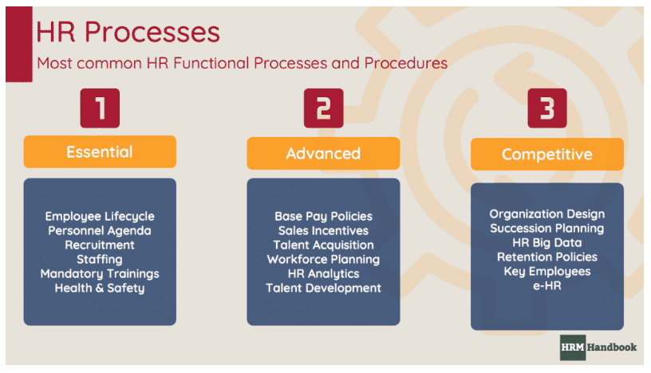
Figure 2.1: Human resource management
(Source: Hrmhandbook, 2021)
Human resource management involves the hunt for finding talents for the organization, identifying the potential of the people involved in the organization and channelizing them in the right departments, retention of the employees within the organization and taking steps that would enhance or retain the best performance of the individual people within the organization. According to Kianto et al. (2017), knowledge-based human resource management is the best tactic in the whole scenario to get the maximum benefit. The person appointed within the organization is also subject to evaluation. The organization must know whether the selection responsibility is given to the right person or not. The accumulation of more knowledge about the person to be appointed helps the human resource managers to guess and put them in the place where they will be performing best. Knowledge is the primary requirement that the human resource manager requires to get the right kind of allocation. The management of the issues is sometimes cannot be predicted as it has been. The prediction, however, is required but that needs to be as close to reality as possible.
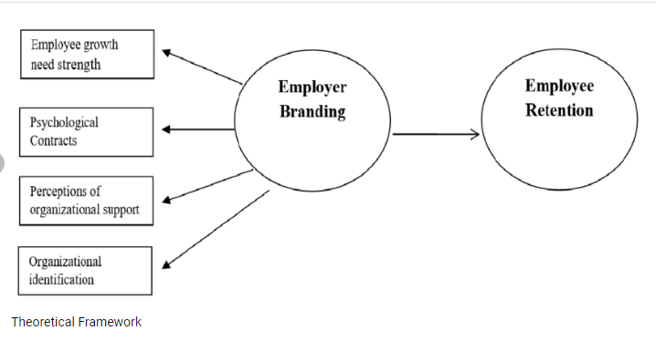
Figure 2.2: Theoretical framework for employee management
(Source: Thalgaspitiya, 2020)
Taamnah et al.(2018), has proposed that organizational performance has a huge impact on the management of the HRM department of the same. The research contains surveying 230 employees from the different sections and branches of the bank. The results indicate that the better the human resources have been managed within the organization the better the organization is going to perform. That is because when the person who knows her trade-in involved in doing the same trade it is much more likely that the results will be way effective.
The operation requires maximum success. The person who is not best equipped with the task requirement has less likelihood of arriving at success. On the other hand, Huo et al. (2015), has proposed that the high involvement comes with the practice of the skills that already present in the personals. The supply chain integration has the power to engage all the organizational peers and stakeholders within the same umbrella. The supply chain involves parties belonging from both internal organization and external organization. The organizational capability is determined by how well the management is taking care of the external and internal connection. A supply contains resources and connections from external sources and receiving them in the internal management. The level of connectivity could be found from the performance. Practising the same thing within the same paradigm with no interest of talents from the people who are doing the job most likely would not create a performance (Huselid, M.A., 2018).
Interpersonal trust makes the rest of the work done if the right people have been appointed for the right purpose (Vanhala and Ritala, 2016). Organisation innovation is only possible when the existing system is going good. The management of the already successful frameworks would be incorporated in the new strategy building. The positive effects of the previous Human Resource management practices will be effective in getting the maximum benefit from the management. The dependency of the human resource management will be effective only when the previous structure has been effective.

2.3 Importance of retaining human capitals during the external crisis
The retention of human resources is exceptionally important at the time of the crisis. The team that is present at the desk is responsible for maintaining the organizational benefit. The time of crisis requires the organization to perform better than it has been doing at normal times. The organization has a requirement to keep the balance between the external business atmosphere as well as the internal organizational capability (Theriou and Chatzoglou, 2014). The organization survives and balances the existence with the external atmosphere. The organization is a manmade creation that is not dependent on the external atmosphere. It needs to consciously adjust itself to suit the atmosphere to survive. The atmosphere can be beneficial or not. The benefits and the non-benefits are dependent on the framework that is been applied during the times of normalcy.
Vardarlıer, (2016) has proposed the requirement to bring strategic changes in the organization to manage the crisis. The situation of crisis has been determined as a situation when the financial capital, market demand, availability of human resources, product demand and competition or any other parameters are harming the business to run the way it was running previously. Some barriers are most likely making the continuous flow of the business to be harmed. The human resources already present in the organization have the requirement to stay together.
According to Sánchez-Zamora et al. (2014), the financial crisis in the rural areas has the maximum crisis arrive as the financial crisis. The availability of financial capital in the hands of the possible customers makes the product relevant that has prices decided previously. An economic crisis will bring the whole financial capital and the demand of the market to be completely hampered. The product prices at this time of crisis need to be readjusted to match the requirement of the customers. The product availability and the demand for the product are also most likely to be changed. In other words, the whole system is required to be reconstructed to get the organisation to suit the new business atmosphere (Zouaghi et al., 2018).
The time of crisis will be time for the organisation to truly incorporate innovation in the business. In other times the innovation is implemented to get the additional benefit from the market. The time of crisis makes it necessary to implement innovation in the organisation just for the sake of surviving. This could not be done without the people within the organisation performing to the best of their abilities. The best performance comes from the right person doing the right job and being passionate about it (Helliwell et al., 2014).
Human resource management determines how well each department within the organisation will be performing. The strength of the organisation is dependent on the strength of every employee. The employees have the responsibility to keep their identity and their task decided by the skill set they have. According to Vardarlıer (2016), the people who are most interested in their task get the personal initiative to manage their performance. The performance will be determining the strength the organisation will have in times of crisis. That makes it a compulsion for the people to do be doing exactly the thing they are best at. The time of crisis has less amount of tolerance towards missing out on any possibilities of growth. The organisation is functioning in a much risky and stressful atmosphere. One step out of the line can cause great issues for the sustenance of the organisation.
The organisation at this time needs expertise from everyone. The expertise is possible for only those who know what to do in different stressful situations primarily because they have been practising the whole thing at times when this was not necessary. The Covid-19 financial management has been managed by the best financial managers. The excellence of the management comes with experience but also requires the interested person to be incorporated in the first place Ugalde-Binda et al., (2014). The organisational employee motivation plays a huge role as well such as making the employees work in the organisation even without strong reward systems and making the team give their best in time of crisis as well.
The employees need to understand the fact that they are part of the organisational unit. The wellbeing or survival of the organisation will create possible benefit for them as well. The organisation has the responsibility to make sure that the employees find themselves safe and their job also means something to them other than just doing it for the sake of money.
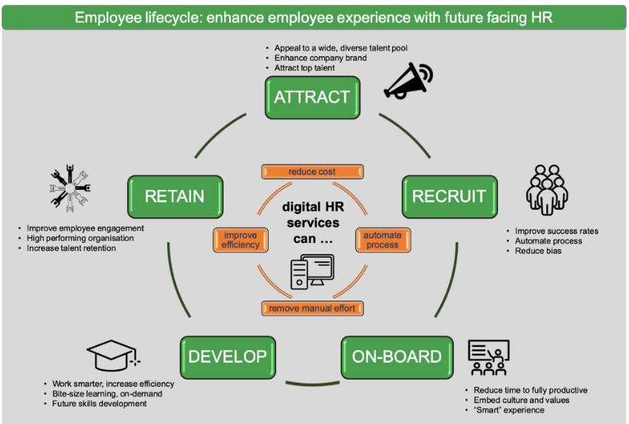
Figure 2.3: Employee life cycle
(Source: Performgreen, 2021)

2.4 Ways by which UK organisations retain the best human capitals during the crisis
The crisis has always put the organisations at a great risk regarding the management of the employees in the same organization that they are working in. The crisis is something that brings tension for both the company and the employees. A crisis is a time when employees and the company has the least tolerance for any kind of misdeeds (Bach and Stroleny, 2014). The UK has experienced a major crisis for business management several times. The recent crisis of covid-19 has pushed several companies to close down the business. The employees in the organization have been rapidly cut down and no HRM management could handle the crisis.
Although, the situation at this recent crisis was quite opposite to the situation when the employee retention strategies were required to be applied. In this case, the employees were majorly fired because most of the organisations could not afford to pay them for their contribution to the organization. The post-covid-19 situation has brought certain new strategies to make sure that the new employees are retained. According to Dirani et al. (2020), the employees will be put under the new and effective leadership so that they can understand the value of their work and they can also understand the greater good that the organization will be doing to the overall economy.
The retention strategies overall have to be something that makes sure that the employees are comforted. The employees would give their maximum to the organization only when they have developed the belief or have come to the conclusion that some kind of responsibility the organization also holds for the wellbeing of the employees. Moreover, the employees are generally putting a lot of effort into the task that they have been assigned. That sometimes might not be related to the success that particular endeavour was supposed to be bringing however, UK companies are taking the initiative of praising and rewarding the efforts of that particular employee or team as the method of retention (Kilpatrick and De Witte, 2014).
The flexible working atmosphere is the new trend in the working for almost all over the globe. The UK not being an exception has adopted this trend for retaining the employees in the workplace for longer times. This retention policy has not been a direct result of pandemic though, it has just made the retention policy much more popular (Lampel et al., 2014). The reduced workdays in the week is also another important step that organisations are taking to retain employees. The Saturday shifts are either been converted to first-hour work from home only or some organisations are taking it to be a complete holiday. According to a survey, the working hours exceeding 50 in a week has shown a considerable decline in performance (Munduate et al., 2014).
UK organisations are quite far in deciding the type of treatment they will giving to their employees. The organizations are employing plans altering working responsibilities to make the boredom and burden that comes from the repetitive task that has been allotted to the employee perhaps twenty years ago. The organisations are undertaking increased research among the employees for performance up-gradation and skill management. According to Kilpatrick and De Witte (2014), skill management can be done only when the human resource managers are well aware of the current status of the skill sets that each employee has. The employees will be benefitted if they are put in the right kind of task that is allotted to them. The organization has the responsibility to look after the employees even if they are not providing the best results.
The UK organisations are taking the conscious decision of engaging in CSR programs. The moment of crisis is not the moment when huge revenue could be made. The organisations are thus engaging in various forms of corporate social responsibility to gain trust and retain their relevancy in the outer atmosphere (Munduate et al., 2014). Setting such an example is helpful for the employees to trust in the organisation they are working in. This strategy is been taken as a form of employee retention strategy as well.
One of the most important strategies that a company must use in order to maximize human capital retention is to develop salary and benefits that is competitive in nature and through the application of which the highest amount of employee satisfaction can be obtained. It can be stated that on the basis of several theories and frameworks that have been described below salary and benefits turns out to be one of the most essential and crucial ways of obtaining the highest amount of employee satisfaction and hence human capital retention. Apart from this, avail refine recruitment and selection process which ensures the The selection of the right candidate into the organisation turns out to be another crucial way of developing strategies that might help to ensure the organisation in the retention of human capital. Furthermore, the selection of right candidate will also help in the talent management issues that the company might have been facing if they had not employed the right candidate.
Reduction of work pressure and employee pain will also help the company to retain the human capitals as individuals will be much interested in their work if the overall work pressure on them is quite low and therefore, the productivity of the company will also be maximized. Implementation and application of the correct form of leadership and management style and also help to gain employee satisfaction and thus, retention of human capital can be achieved. Various leadership models such as democratic form of leadership, transformational type of leadership and management and transactional type of leadership encourages employee satisfaction and therefore it helps to enhance the overall productivity of the company and also this helps the managers to retain the most efficient human capital in the company and hence also results in effective talent management systems. Systematic evaluation and following the various models and frameworks that have been described below will help to gain employee satisfaction and therefore the retention of human capital will be hence possible. Offering effective training and development campaigns and courses to the employees may also help in retention of human capital.

2.5 HRM retention and management theories and frameworks
The employee retention frameworks are hugely influenced by the company vision the atmosphere and size of the organization. The organization will be looking at certain positive and negative factors that can alter the presence and performance of the organization Ugalde-Binda et al., (2014). The major idea behind all the theories and frameworks is that the employee needs to be valued in different ways. The recognition of the true contribution of the employee within the organization creates the possibility of maximum retention. Certain frameworks capture the major idea of the retention theory. However, the application of the theories completely depends on the type of retention policy cultural presence and management vision of the organization.
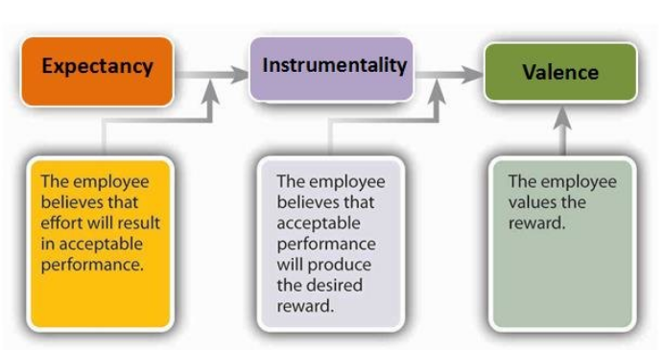
Figure 2.4: Vroom’s expectancy theory
(source: Melwin Joy, 2018)
Victor Vroom’s expectancy theory: This theory aligns the goals of the organization with that of the employee. The two goals need to match with each other (Narayanan et al., 2019). In other words, the employee needs to find out that not only the company find him to relevant but also he should find the company to be relevant for himself to create a sustainable relationship with the management.
Embedded to the job: The employees stay in the organization for quite some time and in that period they develop multiple relationships within the workplace that might be connected to the work they have been assigned to or might not be connected to the work they have been assigned to. The employees mighty stay in the organization if these relationships are maintained and good for them. He needs to value the relationship (Al-Emadi et al., 2015). Also, the work should be following the skill and interest set of the particular employee or he might not stay.
Maslow’s hierarchy needs: The Company is taking a sufficient amount of time from the life of the employees. Hence, they need certain care and protection from the company itself. The theory suggests that the caring of basic requirements of the employee like the salary, health, job security and mental health contributes hugely for the employees to stay (Lampel et al., 2014). The organization will be covering certain insurance-based policies that would look after the basic needs of the employee. This creates trust and raises the possibility of retention in the company.
Herzberg’s Theory: This is an interesting theory that makes the employee’s connection with the organization much more clearly defined. The theory suggests motivators that lead to employee satisfaction. These include achievement, reward, recognition and hygiene refer to supervision, salary, work conditions, company policies and many more (Kilpatrick et al., 2014). The application of the theory in the given scenario will give rise to an understanding of the factors that are potential to harm the employment relationship or the growth of it.
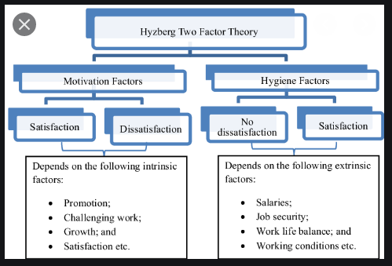
Figure 2.5: Herzbergs’s two factors
(Source: Gyarteng-Mensah et al., 2021)
Covella et al. (2017), has observed that the role of leadership to be one of the most important issues in terms of getting the attention of the employee in the organization. The application of models and framework helps the company to get access to the insights of the relationship of the employee with the organization. Anitha (2016), has explored the possibility of role reversals of employees to keep their attention intact in terms of the organizational benefit. The organization will be benefitted from the benefit of the employee itself. The retention process is just the other side of the creation of trust and loyalty from the employee. The employees need to find the organization relevant to them and their goals. Only then they are going to be retained in the organization for good. The retention process of employees is not much complicated as it seems but it might require certain calculations to fulfil the image that is present in the mind of the employee. The reason for the employee to arrive at the doors steps of the company is so required to be explored by the company before putting any responsibility on the shoulder of the employee. The employees generally do not bring their heart to work, at least for any specific organization. The organization has to ensure that the passion and the attention that the employee has for his job is utilized and left to grow on its own.

2.6 Emerging trends of human capital retention in different UK industry
Human resource is one of the vital management activities that are needed to be performed by every industry of the UK and other countries as well. It has been analyzed by Collins (2021), that there is a rising trend of enhancing retention of the human capital in the industries of England by enhancing meeting and fulfillment of the issues and grievances of the employees that are working in this sector. The retention of employees is being done by different UK industries on the basis of an evaluation of the talents, dedication, and working experience of those employees. This is because no organization would want to retain employees who have a bad performance, less knowledge, and lower productivity. The emerging trends in the retention process of human capital are the providing of better working facilities, generating a good working atmosphere, meeting all the requirements and demands of employees, and understanding of the suitability and comfort zone of employees.
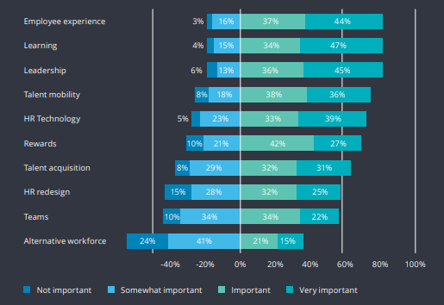
Figure 2.6: Top UK trends by importance
(Source: deloitte, 2019)
On the other hand, the biggest emerging trend of enhancing retention of human capital is providing complete diversification in the workforce so that employees of different backgrounds could come together and work with full enthusiasm and brotherhood mentality. This will further help in creating a secular culture in the companies of different UK industries. However, it has been noticed that the current condition of economic downfall and depression in the whole of the UK due to the latest pandemic situation and exit from Brexit has given a huge setback to the retention of employees in the organization of different sectors of industries. Moreover, it has been found that the majority of the industries of the UK had a chunk of talented and experienced employees that are being hired through outsourcing from other countries (Haque and Oino, 2019). However, retaining these outsourced employees had become very tough due to the current government's decision to get out of Brexit.
Thus, there has been a dramatic rise in the necessity of retaining those employees so that productivity does not get negatively affected. For this factor, different industries of the UK are taking different retention policies and programs so their daily business and management operations do not get affected (deloitte, 2019). In the retail industry, the organizations are adopting new methods of retention of human capital by enhancing new training programs to the employees for making them learn new direct selling processes to customers along with providing them ethical grooming about how to behave and deal with visiting customers in the store or shop along with pursuing them to buy the products.
On the other hand, in the food and beverages industry, the emerging trend of employee retention is the enhancement of better manufacturing devices and machines and making the employees understand the process by which they should be operated. This will make the employees feel at ease while working in the retail companies as the utilisation of new production machines and devices will reduce their workload and pressure (Collins, 2021). Moreover, employees also feel that the company is providing them all sorts of working facilities l, thereby generating retention of these employees in the food and beverage industry. On the other hand, the majority of the UK industry had been applying the new trend of generating cordial relations between the managers and employees so that no cases of mental or physical harassment could take place in the organizations.
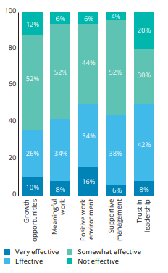
Figure 2.6: Effectiveness of organizations at engaging employees in the workplace
(Source: deloitte, 2019)
However, if any of the employees face sexual harassment or work pressure and intimidation, then the HR managers and their departmental body perform all legal forms of duties for taking strict actions against offenders of these serious crimes within the organization. This has created a ray of hope and motivation among the suppressed and oppressed employees of the organizations of UK industry in the sense that they started to have positive feelings that the company's HR department takes special care about any sort of personal or professional issues that are being faced by them. Another emerging trend in the UK industries about retention of human capital is generating performance appraisal and promotion of dedicated and talented employees in higher designated posts.
Moreover, the companies of UK industries also look after making increments in the salary of the employees. In the IT industry, the retention of human capital is being done by HR managers through making direct meetings with the employees and tech specialists to understand their views about the innovation and advancement in the production of new software applications. This is more relevant from the fact that management departments and team leaders of IT companies make regular meetings and group discussions with employees and technology specialists to make final decisions on the new technology software that is to be developed. This provides the employee's scope to express their innovative ideas and technical knowledge and skills, thereby enhancing value in the eyes of team leaders and managers (Haque and Oino, 2019). Thus, it can be said that democratic leadership style helps them in gaining opportunities to show their talents and expertise in digital and information technology fields. This makes the employees feel that the IT companies provide opportunities to show their skills and improve their quality in activities of managing software, online services, and improvement of the outsourcing of business processes. Thus, it can be said that the UK industries are making effective use of the new trends of managing and retaining human capital.
Moreover, it has also been identified by Zibarras and Coan (2015), that the biggest causes behind the emergence of new trends in retention of human capital are the increasing desires for transparency in the business companies of UK industries and government bodies, and increase in the dispersal of power at a national level and lack of huge distance between developing and developed countries in national power. On the other hand, increments in the capitalism of the state and instability of sovereign funds have also led to creation of new trends in the retention of human capital in different industries of the UK. Thus, the overall changes in the national wealth money and increasing connectivity of masses, societies, and countries had led to the hiring of talented and skilled workers, thereby applying new methods to retain those employees.

2.7 Impact of HR managers’ roles and responsibilities on human capital retention
The HR managers play a very crucial role and responsibilities in generating retention of the human capital or employees in the organization. It has been identified that the HR manager is the first person who makes deep intervention during any case of resignation of employees to find out the reason behind it. They are the ones who directly consult and talk with the employees to know about how much they like the organization and its working culture (Deakin, 2016). Moreover, the HR managers play a crucial role in making identification of any sort of private or professional issues that are being faced by the employees. Hence, it can be said that HR managers act as a first line of a body for retaining the talented and experienced employees in the organization. They are the ones who give the frustrated employees hope about remaining in the company for a long tenure by accommodating other employees and managers of their department or segment.
On the other hand, the HR managers play a crucial role in providing solutions to the employees in reducing any sort of issues related to work or other problems. Moreover, the duty of an HR manager, like creating friendly bonding with the employees, helps them in sharing their views regarding management, production, team coordination, behavior of team leaders and managers, and other aspects without any type of hesitation. On the other hand, it is the HR manager's efforts of providing the employees a chance to improve their performance and productivity through training and new skill development that tends to retain employees for a long tenure in a business organization (Pandita and Ray, 2018). Hence, it can be said that the responsibilities and roles of HR managers have a very positive impact on human capital retention.
As per Deakin, (2016), during the time of hiring, recruitment, and final selection of the employees, the HR managers are required to make detailed scrutiny and countercheck of the candidates' education qualification mark sheets, validation of experience letters of candidates in their former companies and others. This will assist the HR managers in ensuring that they are making recruitments of the right person for the designated post who will justify with the given position and thereby, retaining in the company for a long tenure. For this purpose, the HR managers and their respective departments are required to make adoption and use of new technologies and applications that will help them in noting and tracking down the personal and professional background of the candidates along with investigating their performance and behaviour in the previous company.
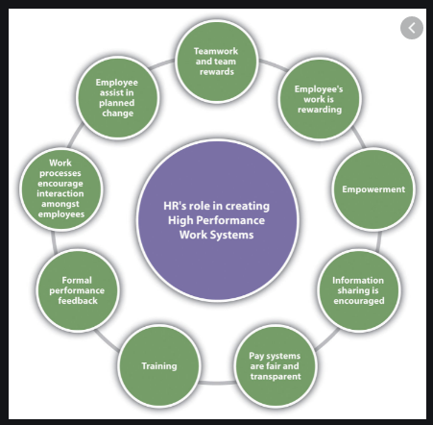
Figure 2.7: HR components of HPWS
(Source: Collins, 2021)
The management team of the HR department is needed to make adoption and practice of encouraging and appraisal actions at the workplace. This will further motivate the employees in giving more time and dedication to the work along with generating improvement in their performance and efficiency. It will make the employees have a sense of attachment with the organization where they are presently working. On the other hand, the responsibility of HR managers in enhancing the launching of different schemes of incentives for additional working hours will also boost the morale and concentration of the top performers in giving their best and thereby securing and sustaining their position in the company for long years (Kalitanyi and Goldman, 2021). In this way, they would be able to create attraction and reduction of detachment among employees for the organizations.
Moreover, another big responsibility of HR managers like reviewing the performance of individual employees and investigating and monitoring the productivity of the team members along with their leaders will help in ensuring how much the employees are enjoying their work. Thus, performance review will help the HR managers to make the employees understand their mistakes in the way of performing their assigned job. This will further help the employees and workers in rectifying their mistakes and understanding the regions where the improvements are necessary to be made within a short time (Pandita and Ray, 2018). This self-analysis of performance by employees will help them in retaining their position and job in the organization for a large duration.
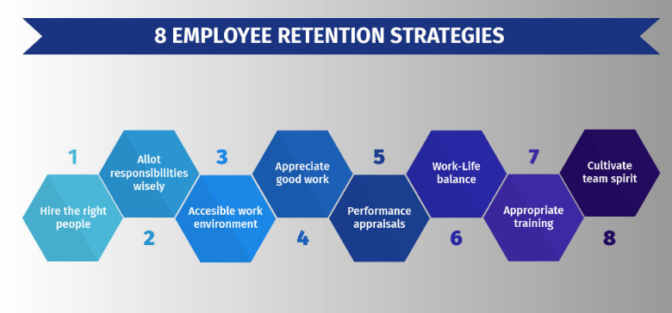
Figure 2.8: Employee retention strategies
(Source: deloitte, 2019)
On the other hand, it has also been recognized by Suseno and Pinnington (2017), the role of HR managers to conduct a special session with each employee directly will help them to gain information about any type of sexual violence or forceful intimidation that are being faced by them. Moreover, face-to-face interaction only provides the employees, especially females, to be open about any sort of physical harassment that is being faced by them. Thus, the overwhelming legal steps and assistance that are being provided to the employees helped them in sustaining a safe working atmosphere, thereby retaining the human capital. On the other hand, the HR managers are also required to make amendments in the employment laws so that all workers abide by the legal obligations and rules of the organization. This will prevent the organization from generating any kind of unlawful and illegal practices in the company.
Moreover, the employees will also be forced by these laws from indulging in any sort of unethical practices and behaviours, thereby protecting their goodwill image in the organization and sustaining their job for a long duration. In this way, the duties and roles of HR managers like creation of new staffs and board of members of the HR department and its management will help the business organization in setting modernized way of monitoring the performance and enthusiasm of the workers and employees who are giving their hundred per cent for making the business organization able to achieve their goals (Wassem et al., 2019). Thus, it can be said that there must be a proper selection of board members so that conduction of employee well-being programs could be generated by them for making employees able to retain their job in the business organization for many years. Hence, in this process, the responsibilities and roles of HR managers impact the retention of human capital.

2.8 Challenges of retaining best human capital during the external crisis
This external crisis of global pandemic and its related economic downfall and depression has negatively affected the business of the big, small, and medium-sized companies equally throughout the world. Due to this pandemic situation all the international business activity had completely stopped due to strict lockdown and flight restrictions that had been put by the central government of every nation. Thus, the big organizations have been continuously facing revenue losses due to lack of sales operations and global impact of economic downfall. This lack of revenue generation has made it impossible for the business companies to feed their large number of global employees as the entire capital reserve is getting vacated due to their obligation to pay monthly salaries and wages to every staff, workers, and employees (Narayanan et al., 2019).
For this factor, many companies are facing serious monetary deficits and thereby, unwillingly sacking many dedicated, talented, and experienced employees without any proper justification. In this way, it is becoming impossible for a big organization to enhance retention of their best employees. Thus, it can be said that the lack of funding has generated a huge threat in retaining their best human capital during this external crisis of pandemic. The HR managers can face huge problems and challenges in making recruitment of talented employees during this pandemic situation as there are hardly any employees that would work from home due to many issues. The best human capital has a large number of big demands and desires that sometimes become difficult for the company to fulfill.
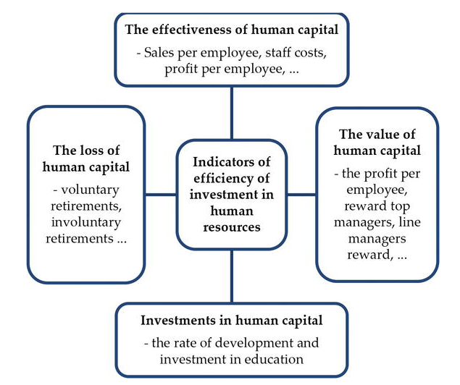
Figure 2.9: Indicators of efficiency of investment in human resources
(Source: Javorčíková, 2017)
On the other hand, it has also been noticed that many productive employees have big career ambitions that they might not be able to fulfill by staying in the present organization. The HR manager of that company will not be able to convince them to remain in the company easily for long tenures. Hence, it can be observed that the conflict of interests will serve as the biggest hurdle in the way of sustenance of best and productive human capital during any type of external crisis. As it has been identified that the majority of the big business companies tend to hire employees through outsourcing, hence, during political and military conflict between the host nation and enemy country from where the majority of the foreign employees belong, it will become impossible and challenging for the HR departments and its managers in retaining their employees (Johennesse and Chou, 2017).
The HR managers may also face threats and risks while complying with the governmental rules and regulations if it affects their international trade relation with another country from where a majority of foreign labourers and skilled employees come, thereby affecting the retention of the staff in the organization. On the other hand, if a particular employee takes voluntary or involuntary retirement that might have been very productive and dedicated, then it will serve as a big challenge for the HR managers in retaining them in the business company (Narayanan et al., 2019). For retaining the best employees and staff during this current pandemic situation, the HR managers and owners of business organizations are required to provide all sorts of medical help and comfortable work from home facilities so that they could work for the office along with maintaining all the social distancing guidelines and rules.
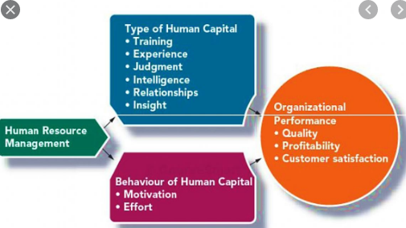
Figure 2.10: Impact of HRM
(Source: Javorčíková, 2017)
However, if the company fails to do it, then it will become very tough for the HR managers to convince the best and productive employees to stay in the company. This is because even during this pandemic situation there are many companies that are hiring employees and new candidates through conducting telephonic interviews and other recruitment processes. Hence, it will not be a big issue for the employees to leave the job of a particular company who has been unable to provide them with well-being and growth scopes in future. As the companies of different countries are facing a shortage of funds for providing salaries of the employees and continuing manufacturing activities, hence, it is becoming impossible for them to fulfill the payment of desired salary and increment in it (Carnevale and Hatak, 2020). Thus, many employees and workers are getting angry about it and not accommodating properly in the production works and planning to leave the company. Hence, it is becoming impossible for them to retain talented and experienced employees in the organization for the long term.

2.9 Literature gap
The above literature has provided large valuable information about the challenges that are being faced by the HR managers while retaining the employees. It has also reflected deep knowledge and information about the level of impact that the roles and duties of employees have on the retention of human capital along with emerging trends to retain employees. However, the literature chapter failed to provide information about the different solutions that are available and can be used by the HR managers in mitigating those challenges. It also failed in depicting information about how the UK organizations have failed to make utilisation of new trends of retaining employees during this external crisis of pandemic.

2.10 Summary
The above chapter had helped in gaining huge information about the importance and basic idea of the human resource management practices along with providing detailed information about the importance of retention of human capitals during the external crisis. It has also provided deep knowledge about the different methods by which organizations of the UK make sustenance and retention of the best employees. The chapter had also depicted information about various frameworks and theories of HRM retention along with depicting deep information about the emerging trend of retention of human capital in different industries of the UK. On the other hand, the chapter also provided information about the various challenges that are being faced by HR managers while retaining employees along with the literature gap that depicts the points that have not been discussed in detail.

Chapter 3: Research Philosophy

3.1 Introduction
In this chapter, the various elements of the research methodology are discussed in detail. The overall research philosophy considered to conduct the research is discussed along with the research approaches. Furthermore, research design and data collection methods are discussed effectively. Apart from this, a research timeline is provided along with data analysis used for the study. Primary qualitative data is collected from a survey of 50 employees in the organization. Primary qualitative data is gathered through an interview with a Human resource manager. Secondary data is collected through websites, journal articles and books available on the internet.

3.2 Research philosophy
Research philosophy is centred on how the data is collected for conducting research. It deals with the nature and source of knowledge gained for explaining a hypothesis or understanding its phenomenon. The research questions are focused while gathering data for the creation of new knowledge. Further, research philosophy is segregated into different types based on the nature of data to be collected and assumptions. As mentioned by Clarkeand Visser (2019), there are four major research philosophies such as pragmatic, positivism, realism and interpretivism. The choice of research philosophy is influenced by the practical implications. Further, each of the research philosophies has certain advantages for conducting research. Pragmatism is among the popular research philosophies that are considered by researchers. It is used for mixed structure or multiple structures as required by researchers. Besides, quantitative and qualitative data can be gathered effectively using pragmatism research philosophy.
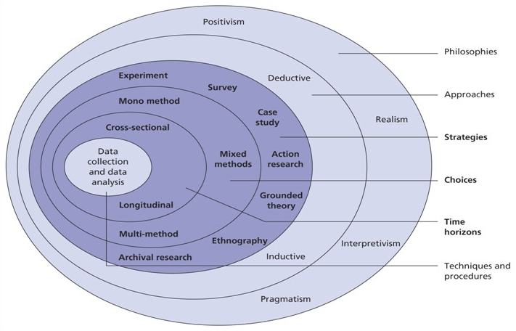
Figure 3.1: Research Onion
(Source: Saunders et al. 2015)
On the other hand, positivism philosophy is beneficial in quantitative as well as qualitative data collection. It is highly structured and a large sample can be effectively analysed using positivism philosophy. As stated by Cuervo (2017), realism philosophy is selected on the basis of subject matter to be analysed. It can be used either quantitative or qualitative based on the requirement of the study. Apart from this, interpretivism philosophy is applicable for the small sample and in-depth analysis of the data collected from multiple sources, it is used for qualitative data and investigation that are not based on quantitative data. In the study, the flexibility of positivism philosophy in terms of structure and sample size is focused and effectively utilized.
Justification
It can be observed that the understanding of Human resources management is considered in the study along with various aspects including challenges and issues faced by HR managers. As mentioned by Daniel (2018), the advantages of positivism philosophy help in gathering data in order to achieve the objectives of the study. Positivism philosophy is applicable for large samples and 50 employees are surveyed in the study. Moreover, qualitative as well as quantitative data is collected effectively in the study for which positivism philosophy is highly applicable.

3.3 Research approach
The research approach is based on the relevance of hypotheses applied in the study. It is observed that three major research approaches can be applied to a study as Deductive, Inductive and Abductive research approach. According to Ragaband Arisha (2018), the deductive approach is focused on testing the validity of theories, hypotheses or assumptions. On the other hand, the inductive approach is centred on the development of new theories. Apart from this, the abductive approach is directed at the explanation of surprising facts considered in a study. In a deductive research approach, the data collected in a study is used for the evaluation of propositions that are related to existing theory. Moreover, it can be effectively generalized from general to specific aspects in a study. On the other hand, an inductive research approach is used for the exploration of phenomena and the identification of themes in the collected data. Moreover, an inductive approach helps in generalizing from specific to general aspects in a study. In this study, a deductive research approach is used for analysing the importance of HRM.
Justification
The study is centred on the collection of data for analysing the role of HRM and relevant challenges faced by UK organizations. According to Abutabenjehand Jaradat (2018), deductive research philosophy is useful in analysing the importance of the study and understanding issues related to retention and crises such as Covid-19.

3.4 Research design
Research design is the overall strategy selected for the integration of different components in a study. It provides the blueprint for the development and collection and measurement of the data to be analysed effectively. As mentioned by Attiaand Edge (2017), it is observed that data can be collected in the study through different methods. Several methods of research design are descriptive, correlation, experimental and causal-comparative research. In descriptive research design, population, phenomenon and situation aims and accurately are described. Descriptive research design uses a variety of research methods for identifying and investigating one or more variables. Descriptive research design is applied in the study effectively.
Justification
The study is focused on identifying the factors for improving retention strategy effectively in the HRM. Descriptive research design helps in analysing the data effectively and outlining the impact of existing strategies applied by the organization. As mentioned by Ngozwana (2018), the descriptive research design is beneficial in highlighting the issues among employees and resolving them through effective data collection and analysis. The quantitative and qualitative data collected in the study can be effectively assessed with the help of a descriptive research design.

3.5 Data collection method
Data can be collected through two different sources as primary and secondary. According to Zangirolami (2018), Primary data is collected with the help of questionnaire from survey and interviews. On the other hand, secondary data is accessed from research conducted on similar topics previously and available on the internet for analysis. Journal articles, books and information present on websites of organizations and the government authorities are considered secondary data. Furthermore, primary data can be effectively categorised into qualitative and quantitative. Primary qualitative data is collected from interviews, whereas primary quantitative data is accessed with the help of surveys (Mohajan, 2018).
Justification
In this study, primary qualitative data is collected effectively from the interview of the Human resource manager of the organization. Further, surveys of 50 employees in the organization are conducted to collect primary quantitative data. Apart from this, secondary data is collected from journal articles and websites along with books. Google Scholar is used for accessing journal articles and books related to Human Resource Management and its challenges.

3.6 Sampling size and Sampling technique
It is observed that the 50 employees of the organization are surveyed using closed-ended questionnaires in the study. Hence, the sample size of the study is 50 for primary quantitative data collection. Further, it is observed that the sample size of the interview is 1 as only one human resource manager is interviewed. In order to collect data for the survey, consent forms were sent to the population size of 75 employees, in which only 50 employees provided their consent to participate in the data collection process. According to Snyder (2019), random probability sampling techniques are applied for the selection of employees for the data collection process.

3.7 Data analysis method
The data collected from primary quantitative sources are analysed using advanced software such as Statistical Package for the Social Sciences (SPSS). Furthermore, Google form is used for creating closed-ended questions and distributing them to participants. Furthermore, data collected from surveys is converted into raw data using Microsoft Excel. Apart from this, qualitative data is interpreted effectively through critical reasoning aligned with the aims and objectives of the study.

3.8 Research timeline
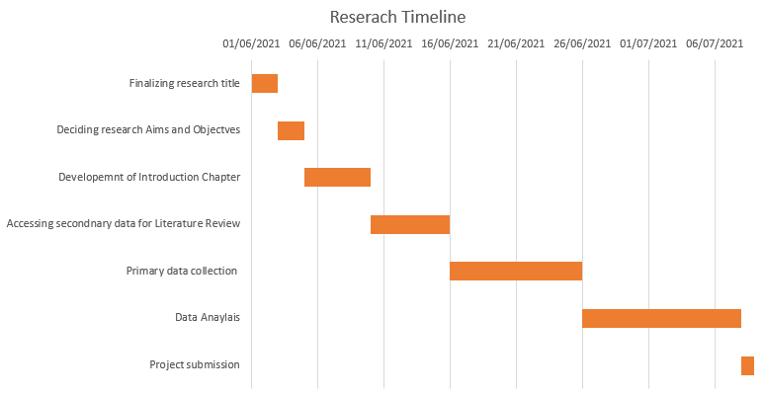
Figure 3.2: Research Timeline
(Source: Created by learner)

3.9 Ethical consideration
In order to collect primary and secondary data, ethical considerations are accounted for by the learner. The anonymity of participants who took part in the data collection of processes is prioritised in the study along with confidentiality. Further, none of the participants in the data collection process was harmed physically or forced to provide their views (Ngozwana,2018). In addition to this, the responses of the participant were stored securely in a password-protected file. Besides this, consent forms were sent randomly to 75 employees in the organization, out of which 50 employees responded positively. Those Employees who provided their consent to take part in the data collection process were sent a survey questionnaire online. Apart from this, the secondary data accessed in this study are effectively referenced where applicable. Authentic sources such as Google Scholar are used for accessing books and journal articles.

3.10 Research limitation
Time constrained and resource constraint is two major limitations that are observed in data collection processes. Further, in the era of the Covid-19 pandemic, door-to-door data collection is not possible. Moreover, face to face interview in the pandemic was not possible as observed in the study. Apart from this, it is identified that more information could be collected to enhance the quality of study; however, lack of time and resources are considered major limitations of the study.

3.11 Summary
In this chapter, the research philosophy along with the data collection process is detailed effectively. Moreover, it outlines how the data is collected and analysed for obtaining the objectives of the study. Random probability sampling techniques are applied for gathering quantitative data by applying essential ethical considerations.

Chapter 4: Findings and Analysis

4.1 Introduction
This chapter will be covering the findings and analysis segment of the study. This portion will help in understanding the requirement of the human resources in the business and how much it is important to retain them for present and future purposes. The Human Resource Management department plays the main role in this part. They select, recruit and train the best candidates out of the applied numbers. In this chapter, both primary and secondary findings have been done. In primary findings, both qualitative and quantitative methods have been used. In qualitative findings, an HR manager has been interviewed so that the proper information regarding the HR practices within the organisation could be collected. On the other hand, 50 employees of the organisation are surveyed in order to collect their experiences and ideas on the concept of Human Resources.
In these primary qualitative and quantitative findings the main aim was to measure how far Human Resource Management is important for an employee. Moreover, to what extent the employees agree that the HR department of the company plays the biggest role in understanding their work-related as well as personal issues and take necessary actions to solve those as early as possible. In workplaces conflicts among employees are a very common issue and in what ways or how the HRM solves it could also be measured by this method. By the support of the qualitative method the strategies that are adopted by the HRM in order to retain the employees are identified (DANIEL., 2021). The loopholes in the retention strategies are also measured which resist the companies to perform seamlessly. Some recommendations regarding new retaining strategies are also collected while interviewing the HR manager.

4.2 Analysis of primary findings

4.2.1 Qualitative
The present research incorporates an interview of an HR Manager of a UK-based organisation. Here, the interview has been discussed briefly to get a clear view of the research issue.
Q1. Do you think that retaining the best human capital is essential during crisis management?
As per the managers' statement, Human Capital plays a great role in managing crisis within an organisation. The organisation should have the power to select efficient employees who can turn out to be protective against the issues that may arise in the organisation and can negatively affect its performing capability. The employees with the best knowledge and experience can deal with the most challenging situations can also adapt to the changing environment very fast and efficiently.
Q2. What types of employee retention strategies are currently followed by UK organisations?
In the recent phase, the UK organisations are adopting some innovative strategies in order to retain the potential employees in their organisation. The manager said that the organisations are following hybrid working mode, along with better recruitment process and better pay provided to the employees. The employees are even provided with various benefits so that their interest could be retained towards the organisation and trust will also grow among them. Moreover, the organisations are stressing on the part of progression within the organisation. The companies are now trying to build up a strong and healthy workplace culture for the employees where there will be no much influence of office politics on the employees that will affect them negatively and lower their potentiality.
Q3. Do you think all the employee retention strategies are effective for crisis management?
According to the manager, the employee retention strategies may not be always positive they can affect negatively as well. The positive part is that choosing of correct staff can deal with the issues instantly. The more effective strategies would be adopted the employees' retention could be successful and effective in the organisation.
Q4. What are the loopholes of current retention strategies affecting the performance of the companies?
In the current retention strategies, there are certain loopholes that exist. These affect the performance level of the companies. According to the HR manager, the most prominent loopholes that exist in the retention strategies are non-performing employees are retained often instead of the potential performers. Moreover, proper compensation is not provided to deserving and experienced employees. This makes them feel less valued and become demotivated often which directly affects their performing abilities.
Q5. According to you, what sort of modifications are required in the existing retention strategies especially during a crisis?
As per the words of the manager, it is important for the companies to listen to their employees carefully and understand their requirements so that they can perform best and complete their jobs perfectly. It is better to take the pandemic situation into consideration where the home-based job facility has been started. The employees proved that nothing is impossible the tasks can be performed seamlessly from anywhere if there is proper dedication and knowledge present. Thus, from this part, the companies realised that there should be a change and the employees can be provided with the facility of hybrid working mode.

4.2.2 Quantitative
The quantitative data is collected from a Survey for 50 employees regarding the importance of human resources management for UK organizations. As mentioned by Snyder (2019), data is analysed effectively by SPSS software in order to identify the opinion of the participants. Data is analysed regarding HRM, its effectiveness in facing challenges and developing a strategy for crises.
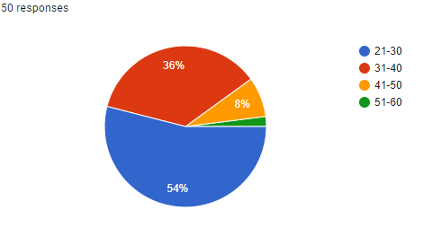
Figure 4.1: Age of Respondents
(Source: Created by the learner)
From the above figure, it can be observed that the majority of employees in the organization who took part in the online survey belonged to the age group of 21 to 30 years. Further, employees belonging to the age group of 31 to 40 years comprised 36 per cent in the data collection procedure.
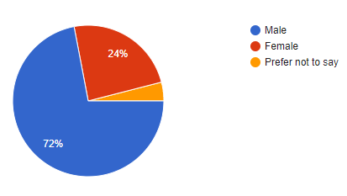
Figure 4.2: Gender of Respondents
(Source: Created by the learner)
Figure 4.2 indicates that 72 per cent of the respondents in the online survey were male. Besides, 24 per cent of respondent were female and the remaining declined to state their gender for participating in the quantitative data collection process.
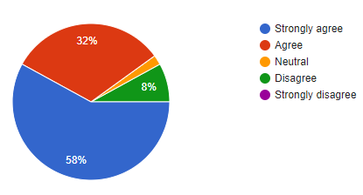
Figure 4.3: Effectiveness of HR department in understanding the employee's issues
(Source: Created by the learner)
Approximately 58 per cent of employees strongly agreed that the HR department in the organization understood the issues of employees. On the other hand, 32 per cent of employees in the survey indicated that the HR department was effective and understood the issues that originated in the workplace among employees (Zangirolamiet al.2018). However, 8 per cent disagreed that the HR department was effective in analysing issues of the employees.
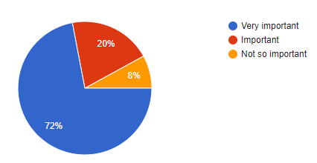
Figure 4.4: Importance of Human Resources Development for employees
(Source: Created by the learner)
From the above figure, it can be analysed that72per cent considered Human resources development essential, however, 8 per cent did not consider it much important. On the other hand, 20 per cent of respondent considered that HR development is an important aspect of employee productivity and growth.
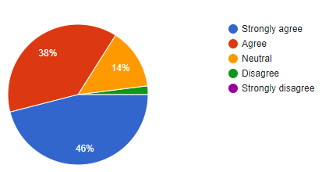
Figure 4.5: Role of HRM increasing retention rate
(Source: Created by the learner)
It is assessed from the pie-chart above that HRM has an effective role in increasing retention rate by understanding issues of employees (Kalitanyiand Goldman, 2021). Approximately 46 per cent of employees who took part in the survey strongly agreed that HRM can increase retention rate: however, 14 per cent remained neutral regarding this. On the other hand, it is observed that 2 per cent of employees disagreed about the fact that HRM was effective in increasing the rate of retention.
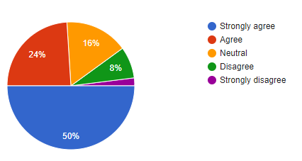
Figure 4.6: Role of HRM in providing in training and development
(Source: Created by the learner)
It is observed that 50 per cent of respondents considered that HRM has an important role in providing training and development. Further, it is 16 per cent remained neutral and 8 per cent disagreed that HRM had an effective role in training and development.
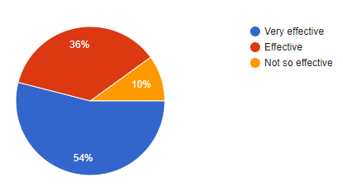
Figure 4.7: Effectiveness of HRM in resolving employee conflict
(Source: Created by the learner)
Around 54 per cent of employees responded that HRM in the organization is very effective in resolving issues that originate in the workplace between employees. Further 10 per cent of survey respondents indicated HRM was not effective in identifying and resolving issues.
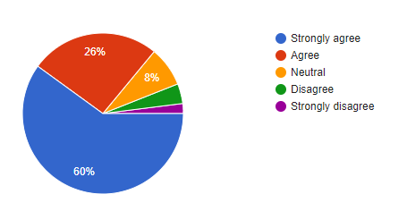
Figure 4.8: Enhancement of employee relation by HRM
(Source: Created by the learner)
According to Haqueand Oino (2019), employee relations need to be improved by the HRM in order to increase efficiency and productivity. Hence, 60 per cent of employees in the survey strongly agreed that HRM is capable of enhancing employee relations. Further, 8 per cent remained neutral about the employee's relation enhancement by HRM.
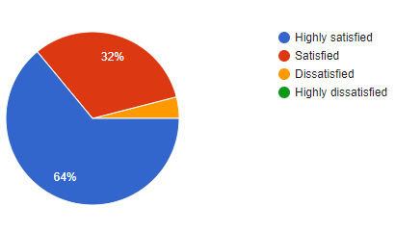
Figure 4.9: Satisfaction of employees from the HR department
(Source: Created by the learner)
The above figure indicates that 64 per cent of respondents are satisfied with the steps undertaken by the HR department. On the other hand, 4 per cent of employees are dissatisfied with initiatives undertaken by HRM towards employee benefits and relations.
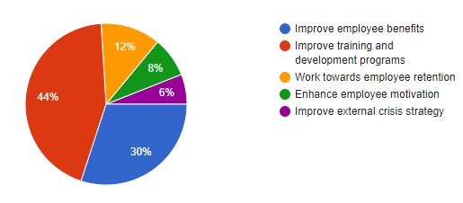
Figure 4.10: Suggestion for HRM department
(Source: Created by the learner)
Around 44 per cent of participants indicated HRM department needs to improve training and development programs. On the other hand, 30 per cent indicated that employee benefit needs to be paid attention by employees.
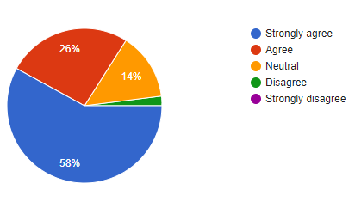
Figure 4.11: Effectiveness of HRM in developing strategies for crises
(Source: Created by the learner)
It is observed from survey results that HRM has an effective role in creating strategies directed at overcoming challenges in crises (Florentine, 2021). 14 per cent remained neutral and 2 per disagreed about the fact that HRM was effective in creating better strategies in responding to emergency scenarios.
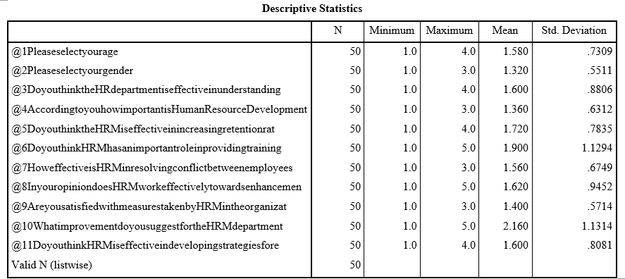
Figure 4.12: Descriptive Statistics from SPSS
(Source: Created by the learner)
The descriptive statistics obtained from SPSS indicated that the minimum value for the responses in the survey is one. On the other hand, it is observed that the maximum value for each survey question varied. The maximum value for question 11 is 4 and the mean is 1.600. The standard deviation for question 11 or variable number 11 is 0.8081. The value for standard deviation is less than 1. Further, the lowest value for standard deviation obtained is 0.5511 for variable number 2.

4.3 Analysis of secondary findings
Human Resource Management is essential for any organisation. The diverse capability of human beings can help in fulfilling the various responsibilities within the organisation. The importance of HRM practices has been identified well from this study. The right kind of people for the organisation can only be obtained by the Human Resource Management of the company. The HRM can bring out the maximum benefits from the employees by retaining their morale and value so that they can efficiently contribute to the operation of the organisation. The HRM practices are all about seeking to grab talents from the organisation. The knowledge-based HRM is the most beneficial one as it maximises profit (Kianto et al., 2017).
There is a huge significance of retaining human capital to the organisation as it plays a great role in supporting the organisation whenever there is a crisis taking place in the business. The employees need to perform more steadily than other normal days during the crisis period. It is said that there needs to proper coordination between the external and the internal atmosphere of the organisation (Theriou and Chatzoglou, 2014). The organisation is a manmade thing thus it does not depend on the external atmosphere much. The only relation with the atmosphere is to get adjusted to it and work efficiently and survive long. As per the statement of Vardarlıer, (2016) the organisation crises are the situations where the human capital, financial capital, product demand, or other parameters get disrupted and fail to run the way they were before. These are barriers that resist the business to run efficiently.
The financial crisis hampers the whole economic balance of the organisation. The financial crisis holds the capability to change the entire operating system of the organisation. The positivity that exists in the potential employees can reduce the stresses from the organisation and can hold up morale. According to Kossivi and Kalgora (2016), the positivity in the workplace atmosphere enhances the business productivity along with the performing capability of the employees. The organisation requires experts to handle tough situations. The more the employees will be efficient they can handle the worst situation even greatly. Here, the COVID- 19 pandemic situation has been taken into consideration where the financial segment of the organisation has been managed by the best financial managers. This became a mandatory thing as the financial condition was very complicated and huge losses were faced by the companies.
An employee can only enhance themselves if they stay motivated. This employee can become a future leader if guided properly. It is the responsibility of the organisation to keep the employees motivated. The best way is to recognise them for their best efforts and provide them with rewards for the same. It is essential to make the employees realize that the most valuable part of the organisation. This can create a great difference in the performance level of the employees. However, there are several ways present by the help of which UK organisations retain potential employees. The essential requirements of the employees need to be understood and the changes should take place as quickly as possible. According to Saifullah (2014), healthy and peaceful workplace culture is expected by all the employees especially those who try to avoid complications and stress mostly on the task part. The office politics should be resisted by the leaders as this can highly hamper the productivity ability of the employees.
The other strategy is to provide flexible working hours, and most importantly with the salaries added benefits such as health and safety facilities should be provided to them. The reduction in the workload can also play a great role in retaining potential employees. Some of the retention and management frameworks have been stated to support the issue more accurately. Some of the relevant theories in this part are Victor's Vroom's expectancy theory, Maslow's hierarchy needs, Herzberg's Theory, and many more (Narayanan et al., 2019). Moreover, it has been also identified that here are some of the emerging trends of human capital retention are used by organisations. Retention is nowadays mainly done based on work experience, talents, dedication. Basically, the knowledge is checked the most. Complete diversification in the workforce is the trending strategy so that there lays less presence of cultural differences which results in conflicts (deloitte, 2019).
In the recent pandemic phase, the challenges that are faced in retention are monetary issues. This forced the companies to sack a huge number of employees unwillingly. According to Carnevale and Hatak, (2020), the other challenge is there are hardly any people who have the facility to work from home seamlessly. Thus, the retention part got disrupt because of these issues.

4.4 Discussion
The primary and secondary data helps in analysing the importance of HRM in the organization of the UK. The survey of employees helps in understanding the role of HRM in an organization. The employee benefits and other related initiatives need to be improved in order to retain the talented individuals in an organization. It is observed that employee retention is a major challenge in the time of crises such as Covid-19 pandemic. As mentioned by Rodríguez (2020), HR department in an organization needs to identify the issues existing among employees and take effective measures in resolving them. The HR department needs to understand the issues and factors causing the issues through effective communication and coordination. Employees in the primary data collection process indicate that HRM has an important role in enhancing growth and productivity in the workspace through better identification of issues and requirements in emergencies such as the Covid-19 pandemic.
Apart from this, it is identified that training and development is an important issue that must be effectively prioritised by HRM. As stated by Susenoand Pinnington (2017), changing market demand and skill requirements for meeting the objectives of an organization needs to be effectively prioritized by HR departments. Training and development in utilising advanced software in the workplace are important. The HRM is responsible for outlining the requirements of employees and providing effective skill training directed at enhancing overall productivity and efficiency. On the other hand, it is observed for the primary that HRM is important for employees working in the UK organization. According to Narayanan (2019), human resource development is effective in identifying the talent required for fulfilling the objectives of an organization. Hiring talented individuals and retaining them through proper employee benefits is essential. Apart from this, it is observed that proper compensation is required for retaining talented individuals in the time of crises such as Covid-19 pandemic.
Furthermore, HRM is responsible for enhancing the overall retention rate by resolving conflicts, identifying issues and providing better compensation. Further, training and development at the time of crisis are important to overcome challenges. As stated by Kuzminovet al.(2019), the application of modern technology in completing jobs from remote locations can be effectively identified by HRM. HRM has an important role in providing a better platform to employees in order to overcome challenges. The secondary data help in understanding the ways that are beneficial for increasing efficiency as well as retention of employees. Enhancement of salary and employee benefits are essential for increasing the retention rate. On the other hand, the selection process such as the hiring of talented individuals needs to be improved in order to attract more talent to the organization.
Besides that, work pressure is an important factor that influences employees towards the fulfilment of organizational mission and vision. It is observed that HRM has a critical role in enhancing employee satisfaction level through effective measures and leadership style. As mentioned by Kalitanyiand Goldman (2021), HRM needs to identify the emerging trends in human capital retention. It is observed that a better working facility and work environment is essential in enhancing the productivity and efficiency of employees. HRM needs to understand the issues of employees in different time zones and provide effective solutions for better coordination and communication directed at increasing efficiency.

4.5 Summary
HRM is an important part of an organization that helps in improving efficiency and productivity of the workplace through better facilities and employee benefits. The HRM is responsible for providing better training and development programs and taking effective measure for retaining human resource capital. Furthermore, HRM needs to improve strategies for overcoming external crises such as Covid -19 pandemic.

Chapter 5: Conclusion and Recommendation

5.1 Conclusion
The study is based on Human Resource Management. It is very clear from the above discussions that human resources are the backbone of any business and they need to be retained properly for the benefits of the organisation. The more efficient a person will be the more positive he can contribute to the business. Here the importance of HRM practice has been identified where it could be said that the HRM is the crucial part to enhance the productivity of the employees. The HRM is the one who selects, recruits, and trains the best candidates out of the applied ones. The right people are identified by them and are placed in the right position of the organisation. They are basically selected based on their talents, knowledge.
It is said that human nature is quite uncertain so no one knows what will happen just after the next hour the employees may lose interest in the operation of the business and wish to quit the job and go for some alternatives. By this means, many companies lose their potential employees and this highly affects the business operation and profitability. Here, the strategies that the HRM department of an organisation chooses to retain the employees have been identified. The HR managers try to create a positive workplace culture for the employees where they could openly share their opinion thoughts with the managers. The issue of office politics could be resisted by the leaders as this can be very much harmful to the employees especially for those who do not want to involve them in any conflicts.
The employees are also provided with flexible working hours so that they do not get stressed out. The salaries are paid fair enough and along with that other benefits such as health and safety facilities are also provided. These are the ways adopted by UK organisations to retain employees during tough times especially. With the benefits there exist certain challenges as well with the current HRM practices. Here, often inefficient non-performing employees get appointed. The selection becomes wrong and later on when the work process starts the managers and the leaders realise that there still exist dome gaps in their recruitment procedures. Moreover, on the other hand, the most prominent loophole is because of such a scenario the deserving candidates get less paid as all the employees are paid equally. The experienced and the efficient ones do not get the chance to enjoy deserving benefits.
There are more challenges that have been identified in this study are in the recent phase because of COVID-19 the remote working mode is a problem for many employees. All of them do not have proper facilities to work from home efficiently. This has been a very tough thing to overcome. The companies are facing huge loss and thus, unwillingly they had to sack many employees. The companies are suffering hard as they had to lose some potential employees. To deal with this situation the companies have started deciding to carry on with hybrid working mode so that no one faces huge problems to work efficiently and this would also enhance the business productivity as before. In this manner, the potential employees could also be retained. Here, some of the impacts of HR managers' roles and responsibilities are identified and discussed in this study. They are the one who directly deals with the employees whenever they face any issue regarding their job. They provide the employees with mental support whenever they feel down or frustrated. HR managers ensure them about their jobs and their retention in the company.

5.2 Linking with objectives
Human resources management has been an utmost priority in the management of organisations. Human resources are one of the most important and valuable resources that have an immense contribution to the benefits of the organisation. It is responsible for finding the right kind of people who are appropriate for specific job roles. It is under the duty of the human resource professionals to carry out the process of recruitment and hiring and it is one of the most crucial responsibilities because the employees are the driving factors for the success of the organisations. Recruiting appropriate candidates can result in improvement of organisational performance and similarly, it can impact negatively if not carried out properly. For the purpose of carrying out the process related to human resource management, it is very important to gather a brief knowledge about the current trends and techniques in human resource management functions (Björkman et al., 2014). Human resource management also has to assess the needs and demands of the employees and need to participate in better employee engagement that can help to build a comfortable and positive organisational culture. Organisational culture helps to deliver a positive brand image and contributes towards sustainability and maintaining ethics in the workplace.
Human resource managers have faced many problems due to issues that have arisen due to the pandemic scenario in the UK. The major problem they have faced in initiating strategies is a scarcity of financial resources. This has caused the fall of the economy of the country because all the operations were closed (Davidescu et al., 2020), Due to the lack of fund, the departments ailed to participate in effective human resource management. This has affected all companies even the big companies could not pay salaries to their employees. Many companies have faced difficulties in fulfilling the needs and demands of the employees that have resulted in job dissatisfaction and many other similar problems within the employees. On the other hand, the job seekers are also searching for jobs and it has become a potential issue for the human resources department.
A good human resource manager must consider all aspects and problems within the human resources department in UK organisations to assess the need for better human resource management technique. The crisis has put the organisations at great risks economically and can be a potential threat to both employees and the organisations. The work pressure within the employees was at a significant rise and there was no system of recognition and rewards within the employees. As the human resource departments were facing a major economical crisis they were bound to fire many employees to counter the problems. Though this strategy has been mostly used in the time of the lockdown and the post covid period the organisations have come with several other strategies. The most basic strategy that has been used was focusing on employee retention. The retention strategies that have been used by the organisations were focused to bring comfort and satisfaction back to the employees. The companies were focused to the initiate new strategies that can contribute to providing a comfortable working culture and satisfaction to the employees. The companies also take part in better employee engagement and making efforts in assessing the needs and demands of the employees and fulfilling them. Several trends have been adopted such as providing flexible working culture, reduced working days in a week, converting the Saturday shifts to first-hour work from home and many others (Zouaghi et al., 2018). Another important strategy that has been used by the companies is to maximise human capital retention by developing salary and benefits of the employees along with reduction of work pressure.
UK organisations have faced several problems due to the crisis of the human capitals in the country for which better and effective human resource management is needed. Employee retention is the key issue of the problem and in the case of any external problem, the UK faces a potential economic crisis in the context of the global trade scenario (Narayanan et al., 2019). In the present scenario due to the outbreak of the Coronavirus the economy of the country has been affected. Another issue that has occurred during this time within the human resource department was that the department in the different industries has failed to recognise the efforts of the employees which has reduced the chances of rewards and recognition within the employees.

5.3 Recommendations
It can be recommended that the HRM department of a company should scrutinize and check the documentation of the employees several times. Moreover, the companies could use some new technologies in this part by which there will be less chance of getting wrong and selecting inefficient employees for some serious posts. This policy can even resist companies from paying inexperienced, non-performing candidates an equal amount of salaries and benefits like the deserving ones. The values and morale of the deserving employees could also be retained by way. According to Anderson, (2021), the company should be transparent to their employees regarding all their business works. This transparency can make them feel valued.
The employees will stay engaged in the business decision-making processes and will share their ideas with the managers and that will be beneficial in enhancing the business performances. The company will make the employees stay for long in the organisation as they will make the employees feel that they are the backbone of the business and without their cooperation, it would be impossible for them to run the business efficiently. On the other hand, companies should upgrade their technologies at least once a year. Human nature is all about accepting change and people seek new things on a regular basis thus, it is important to bring change in the working style. The employees should be given sufficient training and education to develop the skills required to handle the new technologies.
The employees often face safety issues. The issue that arises is the loss of their personal data that might get misused. Whenever such scenarios take place the out of fear the employees leave their existing jobs and try to switch to some other options. The company needs to be very much care in this part the details of the employees must be kept safe and secret. The use of AI will be one of the good solutions as the information can be kept safe. Though there is a high chance of getting hacked by the hacker it should be regularly checked by the company so that there remains no risk of any cybercrime. It is very obvious that one or the other day the employees may move to a better option in this case the company will be losing some potential candidates (Kappel, 2021). Despite this, the company should try to retain them from the very beginning only at least to hold them for a long period of time.

5.4 Future scope
The study will be very much beneficial for every organisation. From this study, the readers could get an idea about who the companies deal with their employees in order to retain their potentiality along with consistency in the organisation's performance. The study can further help many researchers who are planning to do research on the same topic or relatable topics. The researchers could get the basic knowledge about the issue and they will try to find out the gaps even which are lying in this study. After identifying they could include those portions in their research and make them more appropriate. On the other hand, The HR managers or the leaders of the different organisations can be benefitted from this study as well.
The companies who are still not aware of the recent trends by which the employees of the companies are retained and the organisations get the best out of them will get to know about the strategies from this study. Those companies can also start with such strategies and can retain potential employees in the organisation. The more the company will be successful in retaining them the more they will gain profits. On the other hand, the employees can be also very much benefit from the study. They will get to know that the organisations really work hard for their betterment. Along with the company's benefit, there is also personal of the employees. The training that is provided to them is very helpful as they can acquire relevant skills and can apply them in the future as well even if they switch to some other companies. This study has many future scopes and will be very much useful for people in different aspects.

Reference List
Abutabenjeh, S. and Jaradat, R., 2018. Clarification of research design, research methods, and research methodology: A guide for public administration researchers and practitioners. Teaching Public Administration, 36(3), pp.237-258.
Al-Emadi, A.A.Q., Schwabenland, C. and Wei, Q., 2015. The vital role of employee retention in human resource management: A literature review. IUP Journal of Organizational Behavior, 14(3), p.7.
Anbuoli, D., Thenpandian, D. and Sakthivel, D., 2016. HR challenges and opportunites -2020. [online] Available at: <http://ierj.in/journal/index.php/ierj/article/view/428#:~:text=HR%20managers%20are%20facing%20many,environment%20change%20in%20information%20technology>. [Accessed 29 April 2021].
Anderson, B. 2021. Council Post: It's Time To Focus On Your Employee Retention Strategies. [Online] Available at: <https://www.forbes.com/sites/forbescommunicationscouncil/2018/11/14/its-time-to-focus-on-your-employee-retention-strategies/?sh=6c43ac66ba41> [Accessed 23 June 2021].
Anitha, J., 2016. Role of Organisational Culture and Employee Commitment in Employee Retention. ASBM Journal of Management, 9(1).
Attia, M. and Edge, J., 2017. Be (com) ing a reflexive researcher: a developmental approach to research methodology. Open Review of Educational Research, 4(1), pp.33-45.
Bach, S. and Stroleny, A., 2014. Restructuring UK local government employment relations: Pay determination and employee participation in tough times. Transfer: European Review of Labour and Research, 20(3), pp.343-356.
Bilan, Y., Mishchuk, H., Roshchyk, I. and Joshi, O., 2020. Hiring and retaining skilled employees in SMEs: problems in human resource practices and links with organizational success. Business: Theory and Practice, 21(2), pp.780-791.
Björkman, I., Ehrnrooth, M., Mäkelä, K., Smale, A. and Sumelius, J., 2014. From HRM practices to the practice of HRM: Setting a research agenda. Journal of Organizational Effectiveness: People and Performance.
Carnevale, J.B. and Hatak, I., 2020. Employee adjustment and well-being in the era of COVID-19: Implications for human resource management. Journal of Business Research, 116, pp.183-187.
Chen, J. and Li, W., 2015, March. The relationship between flexible human resource management and enterprise innovation performance: a study from organizational learning capability perspective. In International Conference on Informatics and Semiotics in Organisations (pp. 204-213). Springer, Cham.
Chen, M., 2014, January. The effect of training on employee retention. In 2014 International Conference on Global Economy, Commerce and Service Science (GECSS-14) (pp. 356-359). Atlantis Press.
Clarke, E. and Visser, J., 2019. Pragmatic research methodology in education: possibilities and pitfalls. International Journal of Research & Method in Education, 42(5), pp.455-469.
Collins, C.J., 2021. Expanding the resource based view model of strategic human resource management. The International Journal of Human Resource Management, 32(2), pp.331-358.
Covella, G., McCarthy, V., Kaifi, B. and Cocoran, D., 2017. Leadership’s role in employee retention. Business Management Dynamics, 7(5), pp.1-15.
Cuervo‐Cazurra, A., Mudambi, R., Pedersen, T. and Piscitello, L., 2017. Research methodology in global strategy research. Global Strategy Journal, 7(3), pp.233-240.
Daniel, B.K., 2018. Reimaging research methodology as data science. Big Data and Cognitive Computing, 2(1), p.4.
Davidescu, A.A., Apostu, S.A., Paul, A. and Casuneanu, I., 2020. Work Flexibility, Job Satisfaction, and Job Performance among Romanian Employees—Implications for Sustainable Human Resource Management. Sustainability, 12(15), p.6086.
Deakin, R., 2016. HRM practices and mediation: Lessons learnt from the UK. In Advancing workplace mediation through integration of theory and practice (pp. 111-125). Springer, Cham.
deloitte, 2019. Global Human Capital Trends 2019. [Online] Available at: https://www2.deloitte.com/content/dam/Deloitte/uk/Documents/human-capital/deloitte-uk-human-capital-trends-2019-updated-latest.pdf [Accessed on 21 May 2021]
Dirani, K.M., Abadi, M., Alizadeh, A., Barhate, B., Garza, R.C., Gunasekara, N., Ibrahim, G. and Majzun, Z., 2020. Leadership competencies and the essential role of human resource development in times of crisis: a response to Covid-19 pandemic. Human Resource Development International, 23(4), pp.380-394.
E. DANIEL., 2021. The Usefulness of Qualitative and Quantitative Approaches and Methods in Researching Problem-Solving Ability in Science Education Curriculum. Available at: <https://files.eric.ed.gov/fulltext/EJ1103224.pdf> [Accessed 22 June 2021].
Florentine, S., 2021. Employee retention: 8 strategies for retaining top talent. [online] Available at: <https://www.cio.com/article/2868419/how-to-improve-employee-retention.html> [Accessed 29 April 2021].
Gyarteng-Mensah, H., Owusu-Manu, D.G., Edwards, D., Baidoo, I. and El-Gohary, H., 2021. An assessment of students’ job preference using a discrete choice experiment: a postgraduate case study. Journal of Humanities and Applied Social Sciences.
Haque, A.U. and Oino, I., 2019. Managerial challenges for software houses related to work, worker and workplace: Stress reduction and sustenance of human capital. Polish Journal of Management Studies, 19.
Hassan, R., 2016. The role of human capital management in enhancing engagement and retention among top talent in organization: A critical literature review. Journal of Emerging Economies and Islamic Research, 4(4), pp.1-14.
Helliwell, J.F., Huang, H. and Wang, S., 2014. Social capital and well-being in times of crisis. Journal of Happiness Studies, 15(1), pp.145-162.
Hrmhandbook, 2021. Modern HR Processes - HRM Handbook [online] Available at: <https://hrmhandbook.com/hrp/> [Accessed 21 May 2021].
Huo, B., Han, Z., Chen, H. and Zhao, X., 2015. The effect of high-involvement human resource management practices on supply chain integration. International Journal of Physical Distribution & Logistics Management.
Huselid, M.A., 2018. The science and practice of workforce analytics: Introduction to the HRM special issue.
Javed, A., Anas, M., Abbas, M. and Khan, A.I., 2017. Flexible human resource management and firm innovativeness: The mediating role of innovative work behavior. Journal of human resource management, 20(1), pp.31-41.
Johennesse, L.A.C. and Chou, T.K., 2017. Employee Perceptions of Talent Management Effectiveness on Retention. Global Business & Management Research, 9(3).
Kalitanyi, V. and Goldman, G.A., 2021. Human capital management in the fourth industrial revolution. In Research Anthology on Cross-Industry Challenges of Industry 4.0 (pp. 1592-1612). IGI Global.
Kappel, M. 2021. 5 Ways To Reduce Employee Turnover. [Online] Available at: <https://www.forbes.com/sites/mikekappel/2017/08/09/5-ways-to-reduce-employee-turnover/?sh=1681e19c5001> [Accessed 23 June 2021].
Kenton, W., 2020. Human Resources (HR). [online] Available at: <https://www.investopedia.com/terms/h/humanresources.asp> [Accessed 29 April 2021].
Kianto, A., Sáenz, J. and Aramburu, N., 2017. Knowledge-based human resource management p
Kilpatrick, C. and De Witte, B., 2014. Social rights in times of crisis in the Eurozone: The role of fundamental rights’ challenges. EUI Department of Law Research Paper, (2014/05).
Kossivi, B., Xu, M. and Kalgora, B., 2016. Study on determining factors of employee retention. Open Journal of Social Sciences, 4(05), p.261.
Kuzminov, Y., Sorokin, P. and Froumin, I., 2019. Generic and specific skills as components of human capital: New challenges for education theory and practice. Форсайт, 13(2 (eng)).
Lampel, J., Bhalla, A. and Jha, P.P., 2014. Does governance confer organisational resilience? Evidence from UK employee owned businesses. European Management Journal, 32(1), pp.66-72.
Lewis, A. and Sequeira, A.H., 2016. Effectiveness of employee retention strategies in industry. Available at SSRN 2733517.
Melwin Joy, M., 2018. Organisational Behaviour - T1 MBA - KTU Syllabus. [online] researchgate. Available at: <https://www.researchgate.net/figure/Vrooms-Expectancy-Theory-Expectancy-Expectancy-is-the-belief-ones-effort-E-will_fig53_323695129> [Accessed 21 May 2021].
Mohajan, H.K., 2018. Qualitative research methodology in social sciences and related subjects. Journal of Economic Development, Environment and People, 7(1), pp.23-48.
Munduate, L., Di Marco, D., Martínez-Corts, I., Arenas, A. and Gamero, N., 2014. Rebuilding the social dialogue and promoting inclusive organizations. A tool for social innovation in times of crisis. Papeles del Psicólogo, 2(35), pp.122-129.
Narayanan, A., Rajithakumar, S. and Menon, M., 2019. Talent management and employee retention: An integrative research framework. Human Resource Development Review, 18(2), pp.228-247.
Narayanan, A., Rajithakumar, S. and Menon, M., 2019. Talent management and employee retention: An integrative research framework. Human Resource Development Review, 18(2), pp.228-247.
Ngozwana, N., 2018. Ethical Dilemmas in Qualitative Research Methodology: Researcher's Reflections. International Journal of Educational Methodology, 4(1), pp.19-28.
Pandita, D. and Ray, S., 2018. Talent management and employee engagement–a meta-analysis of their impact on talent retention. Industrial and Commercial Training.
Performgreen, 2021 .Future Facing HR [online] Available at: <https://www.performgreen.co.uk/future-facing-hr-2/> [Accessed 21 May 2021].
Ragab, M.A. and Arisha, A., 2018. Research methodology in business: A starter’s guide. Management and Organizational Studies, 5(1), pp.1-14.
Rodríguez-Sánchez, J.L., González-Torres, T., Montero-Navarro, A. and Gallego-Losada, R., 2020. Investing time and resources for work–life balance: the effect on talent retention. International journal of environmental research and public health, 17(6), p.1920.
Saifullah, A., 2014. Strategies to Retain Employees in Organizations: How Textile & Telecoms Deal with Their Workforce. International Journal of Innovative Research Development, 3 (5): 727, 732.
Sánchez-Zamora, P., Gallardo-Cobos, R. and Ceña-Delgado, F., 2014. Rural areas face the economic crisis: Analyzing the determinants of successful territorial dynamics. Journal of Rural Studies, 35, pp.11-25.
Saunders, M.N., Lewis, P., Thornhill, A. and Bristow, A., 2015. Understanding research philosophy and approaches to theory development.
SHOWKAT, S., SHAJAN, K. and PATHAK, V.K., 2019. Strategic human resource management and organizational performance: mediating role of employee well-being in the indian it industry. Journal of Critical Reviews, 6(6), pp.75-83.
Snyder, H., 2019. Literature review as a research methodology: An overview and guidelines. Journal of Business Research, 104, pp.333-339.
Suseno, Y. and Pinnington, A.H., 2017. The war for talent: Human capital challenges for professional service firms. Asia Pacific Business Review, 23(2), pp.205-229.
Taamneh, A., Alsaad, A.K. and Elrehail, H., 2018. HRM practices and the multifaceted nature of organization performance. EuroMed Journal of Business. ractices, intellectual capital and innovation. Journal of Business Research, 81, pp.11-20.
Thalgaspitiya, U., 2020. Employer Branding as a Predictor of Employee Retention. [online] researchgate. Available at: <https://www.researchgate.net/figure/Theoretical-Framework_fig1_342314996> [Accessed 21 May 2021].
Theriou, G.N. and Chatzoglou, P., 2014. The impact of best HRM practices on performance–identifying enabling factors. Employee Relations.
Ugalde-Binda, N., Balbastre-Benavent, F., Canet-Giner, M.T. and Escribá-Carda, N., 2014. The role of intellectual capital and entrepreneurial characteristics as innovation drivers. Innovar, 24(53), pp.41-60.
Vanhala, M. and Ritala, P., 2016. HRM practices, impersonal trust and organizational innovativeness. Journal of Managerial Psychology.
Vardarlıer, P., 2016. Strategic approach to human resources management during crisis. Procedia-Social and Behavioral Sciences, 235, pp.463-472.
Wassem, M., Baig, S.A., Abrar, M., Hashim, M., Zia-Ur-Rehman, M., Awan, U., Amjad, F. and Nawab, Y., 2019. Impact of capacity building and managerial support on employees’ performance: The moderating role of employees’ retention. SAGE Open, 9(3), p.2158244019859957.
Zangirolami-Raimundo, J., Echeimberg, J.D.O. and Leone, C., 2018. Research methodology topics: Cross-sectional studies. Journal of Human Growth and Development, 28(3), pp.356-360.
Zibarras, L.D. and Coan, P., 2015. HRM practices used to promote pro-environmental behavior: a UK survey. The International Journal of Human Resource Management, 26(16), pp.2121-2142.
Zouaghi, F., Sánchez, M. and Martínez, M.G., 2018. Did the global financial crisis impact firms' innovation performance? The role of internal and external knowledge capabilities in high and low tech industries. Technological Forecasting and Social Change, 132, pp.92-104.

Appendices:

Appendix 1:Interview Questions

- Do you think that retaining best human capitals is essential during crisis management?
Yes is very important and essencial, as companies need to make sure they have the best knowledge and experience dealing with challenging situations and adapting quickly to various environments.

- What types of employee retention strategies are currently followed by the UK organisations?

- Progression within the company
- Hybrid working
- Better pay
- Better recruitment process
- Building a strong company culture – a healthy work environment
- Benefits for employees

- Do you think all the employee retention startegies are effective for crisis management?
I think they are important bceause the company needs to make sure they have the correct staff to deal with issues instantly, making sure that the compnay will fulfill targets and strategies for growth and progress. However, this can also be negative as:

- What are the loopholes of current rention strategies affecting the performance of the companies?

- Non performing employees are retained
- Experience employees – not compensated properly

- According to you, what sort of modifications are required in the existing retention strategies especially during crisis?

- I think is very important for the company to listen to their employees and see what they need to make sure their job is done correctly in the best of their abilities, taking into consideration what happen last year with the Covid pandemic.
- One of the biggest changes has been to work from home and employees have demonstrated that it can be done, meaning that the company had realised that they need to change and provide employees with hybrid working.

Appendix 2: Survey questionnaire
1. Please select your age
- 21-30
- 31-40
- 41-50
- 51-60
2. Please select your gender
- Male
- Female
- Prefer not to say
3. Do you think the HR department is effective in understanding employee issues?
- Strongly agree
- Agree
- Neutral
- Disagree
- Strongly disagree
4. According to you, how important is Human Resource Development for employees?
- Very important
- Important
- Not so important
5. Do you think HRM is effective in increasing the retention rate in an organization?
- Strongly agree
- Agree
- Neutral
- Disagree
- Strongly disagree
6. Do you think HRM has an important role in providing training and development to employees?
7. How effective is HRM in resolving conflict between employees?
- Very effective
- Effective
- Not so effective
8. In your opinion, does HRM work effectively towards the enhancement of relation with employees?
- Strongly agree
- Agree
- Neutral
- Disagree
- Strongly disagree
9. Are you satisfied with measures taken by HRM in the organizations
- Highly satisfied
- Satisfied
- Dissatisfied
- Highly dissatisfied
10. What improvement do you suggest for the HRM department?
- Improve employee benefits
- Improve training and development programs
- Work towards employee retention
- Enhance employee motivation
- Improve external crisis strategy
11. Do you think HRM is effective in developing strategies for external crises such as Covid-19?
- Strongly agree
- Agree
- Neutral
- Disagree
- Strongly disagree

