Component 2 - Research Report

BMSW4003 Digital Skills and Research Methods

Student Name: Alexandra-Luiza Tuta
Student Number: 2118375
Lecturer Name: Seyed Nasirpourosgoei

Abstract
This report signifies the scenario with an overview of digitalization of skills and researching techniques. It includes the exceptional engagement plan that provides an extensive range of relevance and incredible literatures. This defines the evaluation of suitable usage for the contemporary technologies which enhances to improve the workplace very effectively and with its operational employability. Identification of the effectiveness that evaluates the scale of provided raw facts and figures with the data sources. As well as it showcases the competence that describes in the workplace for data handling and management. Technologies and research methods to collaborate the UWTSD. Using the technology, It makes the sounds easy, when purposefully it has to make the school purposes that implements the projects or home works then requires a specified knowledge. This research report determines the data collection method which includes primary and secondary techniques with the importance of training programs.

Table of Contents
Abstract 2
Introduction 4
Research Design 5
Research Question 5
Methods used in the research 6
Interviews 6
Questionnaire’s 6
Observations 6
Need of the training Program on which the participants were recruited 6
1. It enhances the quality of education 7
2. It increases the motivation among the students 7
3. It focuses on the collaborative work 7
4. Improves the standards of learning 7
5. It involves the usage of technology in the work culture 7
Collaboration of Technology 8
1. It increases the standards of education 8
2. It signifies the availability of education for each and every student in the classroom 8
3. It enhances the effectiveness of training 8
4. Making the analysis of schooling more interesting and fun 8
5. Better performance growth of students and teachers 8
Ethical Considerations 8
Results 9
Discussions 14
Hypothesis: 15
Conclusion 16
References 17
Appendix 19

Introduction
The digital skills that comprises of the ability and learning knowledge regarding of a person for determining the information, which get the pre-requisites from the digital technology sources. It refers to the ability of a single person to find out, for utilizing, evaluating and creating to share the content for applying the information technologies. With these considerations, the primary and secondary methods are also considered as the main type of research techniques. It includes the information which is collected via first-one hand search. The main goal of this report is to increase the development of an individual within the workplace. This report covers the topics of summary/abstract, designing of research analysis in which one question must be chosen according to the topic, also with the methodology that is implemented along with any ethical considerations that were made. The results will be marked according to the questionnaire with usage of charts, graphs and tables to summarize the results. Discussions were made in respect to the outcomes section that what are those prospects which are included in the report. This document signifies the collaboration of technology with the considerations of ethical concepts.

Research Design
Online and digital lectures are referred to the circumstances that there might be some pre-requisites for the provided lectures that are to be delivered on time which is either from home or away from premises. The one main point is that the students get accessibility that has been scheduled to the sessions in computer lab virtually, if somehow one may not attend in the campus. The focus area is to provide the options in the experiences of learning stages and that is still maintained with the access to UWTSD resources which includes the software specialists via a medium of remote workstations and built-in connection by giving the enhancement of flexibility in undefined times (Sousa et. al., 2022). The usage of technologies sounds very easy of access, but when one have to apply it for the purpose of school, and using it in the multiple projects or home works then there is a need of knowledge.
For as per the students at UWTSD, it provides the best prospects for emerging the digital abilities for the allotted time at university and if there was a section of curricular teachings or if there is individual learning beyond the main functionality or program. Well, asking to the students is very necessary for the future long run project works for finding out that why they think for using the different methods and asking for the alternative questions. Unfortunately, the school management is unable to generate any change that is associated with the timetable (Jansen & Warren, 2020). Firstly, there is a need by asking the students to find the depth which applies different methods and putting multiple questions. It defines that when one student is studying at the UK University as the abroad international fellow, by that it seems with a great difference while studying at home. The online lectures are there for the huge group of students that can be the everyone which is in the equal level of year or everyone that are studying the same module on a course of degree (Paul et. al., 2018). There is a problem based learning which refers to a process which is designed for the experiments that utilizes the learners in the procedural line of inquiry which converts into the complex challenges of significance and their relativity with subsists and learning.

Research Question
Q1. How among the best can individual have knowledge that collaborates activities and practices with advancing digitalization to undertaken the course at UWTSD?
Q2. What will be the individual acquired with the sufficient training and the competence to undertake the studies such as independent learning, with the online studies and their competence in using the various digital applications?

Methods used in the research: In this report, the primary methodology is used for recruiting more participants in the training program. Some of the sections are mentioned below:
Interviews: It refers to the processes which are specially used for the collection of raw facts and figures that are also known as data from lthe very small group of streams on a wide range of topics. Both structured and non-structured type of interviews can be applied here. These interviews are in comparison to the questionnaires with the equal level of questions which are mentioned in the same order for particular subject with the multiple choice question / answer functionality (Newman, Guta & Black, 2021).
Questionnaire’s: These refer to the process of surveys which makes the instruments that are fulfilled by the multiple streams and subjects. It can consists the short closed ended questions or wide range of inquiries. This refers to the concept of collecting the data from a huge group of streams on the particular topic. As of now many of the questionnaires are being developed and get administered digitally.
Observations: This method refers to the process of data collection that specially involves by nearsighted the people in a positive set or specified time or place in a day. Basically, the researcher’s examines the study of behaviors including the individuals or group by which the surroundings get more data analyzing. It can be particularly organized, impulsive or applicant based research (Zheng, Zhang & Gyasi, 2019).
Need of the training Program on which the participants were recruited: Generally, the training of students takes place after the session of orientation or induction gets over. It refers to the process of increasing the abilities, skill development and learning with knowledge of lecturers for executing a particular kind of task/ activity. This leads to the quality performance and continuation of work which is never stops in nature (Abrar & Sidik, 2019).
- It enhances the quality of education: By considering the economic growth and process of globalization, this involves a particular debate that brews on how to expand the quality of higher education with completion of training programs. The qualification programs maintain the focus area on making bets achievements for students.

- It increases the motivation among the students: The training program helps to inspire and motivate the students and lecturers. This process will always supports the users which are involved in the development of their personal skills, individual efforts and best utilization for successful growth in academic planners.

- It focuses on the collaborative work: This concept is very essential in the program of training. Collaborative work is the task which is allotted to every individual and by making of good team spirit the work gets divided among the single person and at the time of completing the task with submission reports, it will brings the goal that marks on the collaborative sheets of assigned works.

- Improves the standards of learning: Regular training programs helps the students to develop and for improving the learning standards in the community or an organization. With this the lecturer and students get benefited with the given course of time that enhances the support and assistance of knowledge and learning standards.

- It involves the usage of technology in the work culture: The training and development have been always in the modes of structured or unstructured formulas that are using the age-old formatting methods. The social learning’s are not only for building the community which exist in the workplace, but it also permits the learners to implement the development of skills, by sharing the experiences and discussion of challenges and issues.
The importance of the training programs are very useful in the universities because they play as vital role for developing and helping the students & teachers by various aspects. Mainly, for the students, it helps in the increment of motivations which also leads to the generation of collaborative development with the other students for better learning. Meanwhile for the aspects of teachers, it supports to teach and learn the guidelines of policies with the standard of qualification education to teach the students that how it will implement the new technologies especially in the learning process.
Collaboration of Technology: Nowadays, the forward-thinking lecturers are implementing the particular technologies for encouraging the teamwork and collaborative activities, by connecting out with their students for classrooms across the nation. However, for building the students combined skills is very hard in the traditional rooms of class, in which a lecturer stands at the position of frontline in the students rows that is inaccessible by the desks (Bondar et. al., 2021).
- It increases the standards of education.
- It signifies the availability of education for each and every student in the classroom.
- It enhances the effectiveness of training.
- Making the analysis of schooling more interesting and fun.
- Better performance growth of students and teachers.
Ethical Considerations: It refers to the policies standards that defines responsibilities at the individual level also comes up with the institutional level that must guide the work probabilities in which it is involved at the funded research data collection, the storage and maintenance for ensuring that the collection of data which is to ensure by staff and students that this will be managed to the highest standards of research practices (Bhandari, 2021).
It secures the rights of participants of the provided research.
Enhances the quality of research work.
This procedure maintains the integrity of scientific data that includes raw facts and figures.
There must be the differentiation between the acceptable and non-acceptable behaviors and deals.
The main factors that are to be considered in this ethical consideration are very voluntary participation, maintenance of confidentially, none of the potential harm to the researchers, communication results, etc.
The reasons that in the training should be provided and how it can improve their own practices to achieve the sustainable outcomes in both the students and lecturer’s in which get the digital skills that are proposed at the University of Wales Trinity St. David (UWTSD).

Results
- Is there a use of MS Teams for collaborating with others at UWTSD?
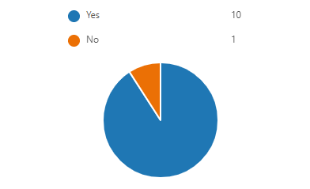
- Would you like to have some training on how to use MS Teams to collaborate with others?
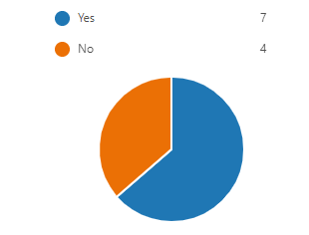
- Would you like to have training on how to use the OneDrive to collaborate with others?

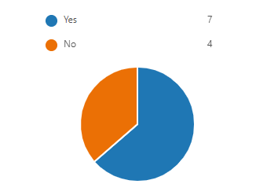
- If you were asked to work online with others to create a single PowerPoint presentation, would you know how to achieve this?
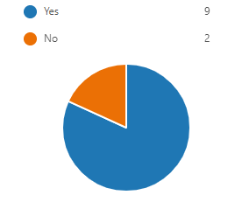
- If you were asked to work online with others to create a single MS Word document, would you know how to achieve this?
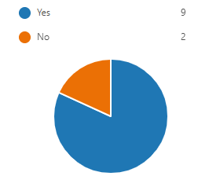
- Rank these applications in order according to which you would like to have training on how to use.
0% of respondents (0 of 11) answered this question correctly.
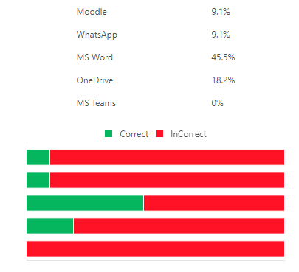
- Rank these applications according to how competent you are in using them to collaborate with others on the OneDrive (Most competent at the top)
0% of respondents (0 of 11) answered this question correctly.
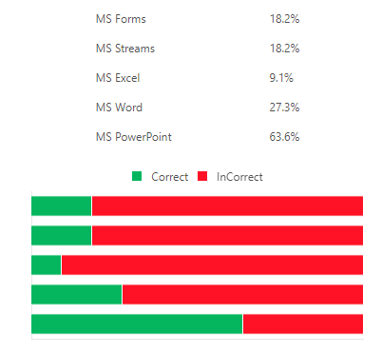
- Please select ONE response to the questions below:
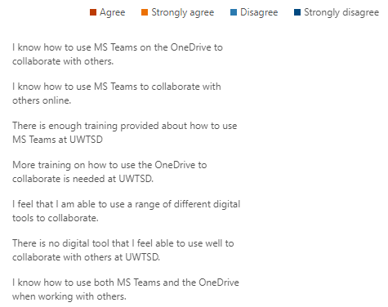
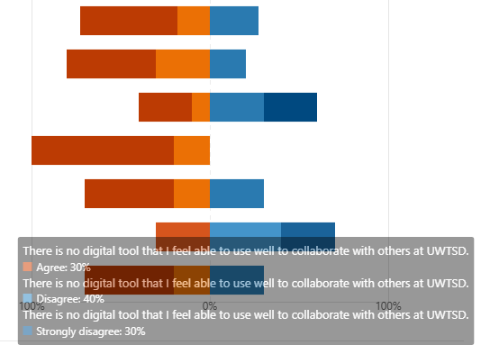

Discussions
It defines the methodology in which there is a description of questions and responses that has been described in this research report. This course will describe with ongoing mixture of digital libraries and online deliver. The face to face methods and theories include the description of sessions which had gone practical. The timeline on which the report has to be delivered of division within 5 weeks. On 1st – the research plan needs to follow on the basis of training program that is running at UWTSD. On 2nd, there must be the analysis of the report by which it can be explained thoroughly that how the planning structure has to be implemented. The 3rd week mentions about the writing part in which all of the above sections were inserted that follows the structural rule. The 4th one signifies the reanalysis of the training program that determines if once the work has been to be submitted it must be gone through twice and checking it out if any mistakes were there.

Finally on the day of fifth week, the absolute presentation has been developed which initializes the goal which is achieved by implementing the training programs assisting with students and lecturers. On the basis of above mentioned results, there are total 8 questionnaire’s that performs the scenario to discuss i.e What does it represents while getting the accessibility to use the MS teams for collaborating with others fragments at UWTSD, So in this 10 persons and 91% of the associated members and 1 of 9% are involved in this section. It is asked that would there be some likings for conducting the training program for how to execute the MS teams for collaborating with others. With that there are 64% of 7 members are included with the option of “YES” and other 4 of 36% chose “NO” for this question.

It has been asked that if someone wants to use the OneDrive to collaborate with other, with this regard there are again the 7 members of 64% needs the implementation of this software and 4 of 36% opted for “NO” that they does not wanted for the any usage of third party applications. One scenario is given that if someone is asked for working online with other to create a single PowerPoint presentation, so how to achieve, while this indicates that 9 of 82% of the dedicated students and lecturers did participation by doing “YES” and other 2 of 18% said “NO” in this situation. If there demand for working online with others to create a single MS word document, then how would it get achieve, sessions in the training program 82% of the 9 members told “YES” for participation and 18% of 2 persons denied with the graph of documentation. There is a ranking system of these applications in order for how to use the training system. Some platforms are Moodle-9.1%, whatsapp- 9.1%, MS word- 45.5%, OneDrive- 18.2% and the MS teams with 0%.

Conclusion
With the summarization of all the topics the report describes that what type of training provides to the students and why it is so important. The best way to learn that how the technology is used for collaboration with the UWTSD is to achieve best optimization of scheduled training programs with a development of digital skills. It determines that how the data is being collected with various sources such as interviews, observations, and questionnaires with surveys. The recommendations are that this report requires the need of training program which particularly enhances the quality of education, improves the standards of learning and maintains the focus on collaborative work. Also it consists of ethical considerations that secures the right path of participants given in the research and maintains the integrity of scientific facts and figures.

References
- Bhandari, P. (2021) Ethical Considerations in Research | Types & Examples. [online] Scribbr. Available at: https://www.scribbr.com/methodology/research-ethics/#:~:text=considerations%20in%20research%3F-,Ethical%20considerations%20in%20research%20are%20a%20set%20of%20principles%20that,for%20harm%2C%20and%20results%20communication. [Accessed on: 30 March 2022].
- Bondar, I., Komarnitskyi, I., Rusavska, V & Batchenko, L. (2021). Formation and development of digital skills in university education: a systematic approach. Internaational Journal, 7(1), pp.47-56. DOI:10.24115/S2446-622020217Extra-B882p.47-56
- Jansen, D. & Warren, K. (2020). What (Exactly) Is Research Methodology? A Plain-Language Explanation & Definition (With Examples). [online] Grad Coach. Available at: https://gradcoach.com/what-is-research-methodology/ [Accessed on: 30 March 2022].
- Newman, P. A., Guta, A & Black, T. (2021). Ethical Considerations for Qualitative Research Methods During the COVID-19 Pandemic and Other Emergency Situations: Navigating the Virtual Field. International Journal of Qualitative Methods, pp. 1-20. DOI: https://doi.org/10.1177%2F16094069211047823
- Paul, P. K, Bhuimali, A., Tiwary, K & Aithal, S. (2018). Digital Education and Learning: The Growing Trend in Academic and Business Spaces—An International Overview. Information Technology and Science. 6(5), pp. 11-18. DOI:10.5281/zenodo.1292856
- Sousa, M. J., Maroco, A. L., Goncalves, S. P & Machado, A. D. B. (2022). Digital Learning Is an Educational Format towards Sustainable Education. MDPI, 14(1140), pp. 1-16. DOI: https://doi.org/10.3390/su14031140
- Zheng, L., Zhang, X & Gyasi, J. (2019). A literature review of features and trends of technology-supported collaborative learning in informal learning settings from 2007 to 2018. Journal of Computers in Education, 6(4), pp. 529-561. DOI:10.1007/s40692-019-00148-2
Abrar, M & Sidik, E. J. 2019. Analyzing ethical considerations and research methods in children research, Journal of Education and Learning (EduLearn), 13(2), 184-193. DOI:10.11591/edulearn.v13i2.6516

Appendix A
- Is there a use of MS Teams for collaborating with others at UWTSD?

- Would you like to have some training on how to use MS Teams to collaborate with others?

- Would you like to have training on how to use the OneDrive to collaborate with others?

- If you were asked to work online with others to create a single PowerPoint presentation, would you know how to achieve this?

- If you were asked to work online with others to create a single MS Word document, would you know how to achieve this?

- Rank these applications in order according to which you would like to have training on how to use.
0% of respondents (0 of 11) answered this question correctly.

- Rank these applications according to how competent you are in using them to collaborate with others on the OneDrive (Most competent at the top)
0% of respondents (0 of 11) answered this question correctly.

- Please select ONE response to the questions below:
I know how to use MS Teams on the OneDrive to collaborate with others.
I know how to use MS Teams to collaborate with others online.
There is enough training provided about how to use MS Teams at UWTSD
More training on how to use the OneDrive to collaborate is needed at UWTSD.
I feel that I am able to use a range of different digital tools to collaborate.
There is no digital tool that I feel able to use well to collaborate with others at UWTSD.
I know how to use both MS Teams and the OneDrive when working with others.

