Electronic Ignition and Fuel Injection Systems Report
Vauxhall LE3 2.0 litre and
Vauxhall 1.5 Motronic 2.0 litre

1801879
James Smith
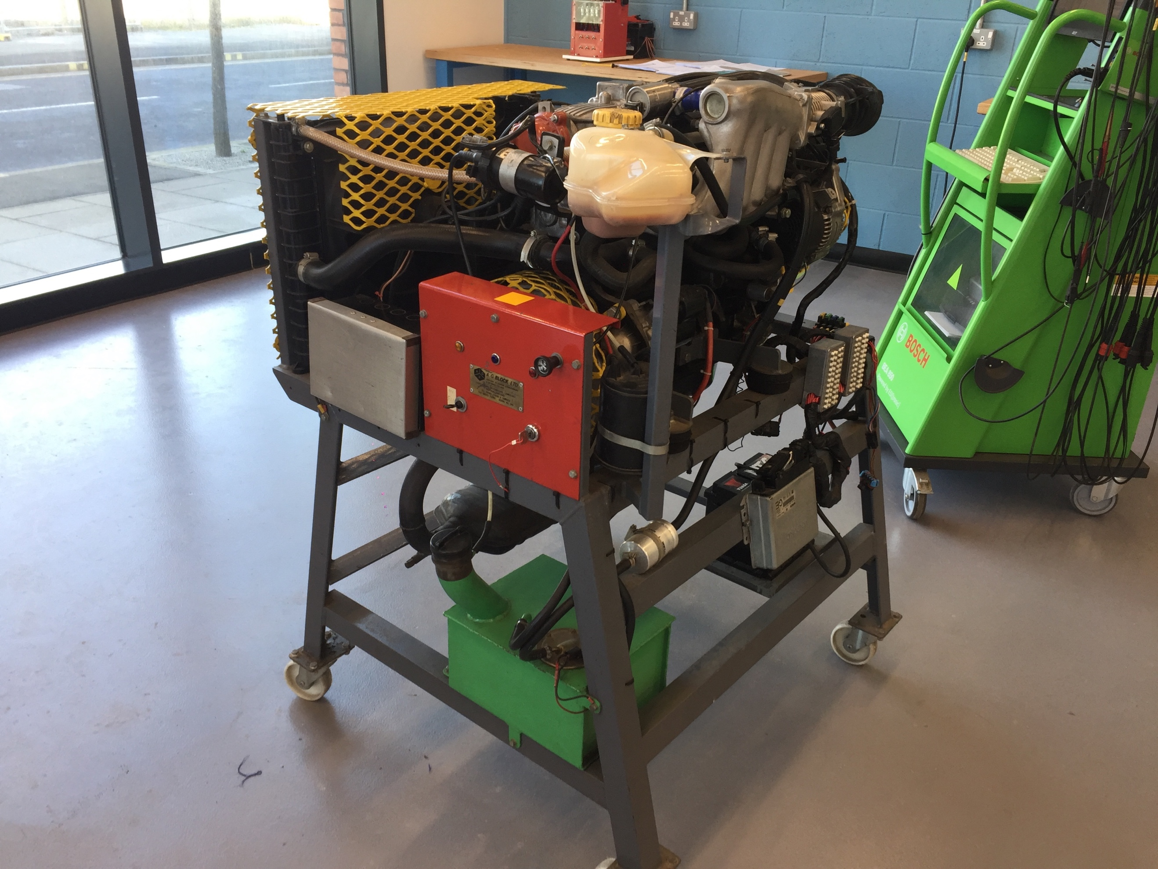

-Figure 1: Testing Rig

Abstract

This report summarises the systematic testing of two engine control systems, where the electronic injection and fuel injection of both systems has been analysed using the appropriate equipment and methodology to carry out full testing of the two systems. A depth analysis into both the control systems, including an analysis of the wave forms, scope patterns and voltage readings obtained from the testing of both engine has been carried out for all the electronic sensors and actuators within both systems. Both control systems have then been compared against each other where appropriate to give an in-depth view of both the control systems including reference to factory specification tolerances set for each sensor and actuator tested within both systems.

Where appropriate, conclusions have been made about both the control systems including the evaluation and reasoning for any modifications that could be made to each system to increase the efficiency and performance of the control system.

Contents Page

Title Page……………………………………………………………………………………………………………………..Page 1 Abstract……………………………………………………………………………………………………………..………..Page 2
Contents Page……………………………………………………………………………….……………………………..Page 3
List of Figures………………………………………………………………………………………………..……………..Page 4
Introduction………………………………………………………………………………………………………..……….Page 5
Research………………………………………………………………………………………………………….…..………Page 6
Methodology………………………………………………………………………………………………………….……Page 9
Results/ Analysis…………………………………………………………………………………………………..…….Page 10
Conclusions and Modifications.…………………………………………………………………..…………..…Page 19
References……………………………………………………………………………………………………………..….Page 22
Appendices……………………………………………………………………………………………………………..…Page 24

List of Figure
Figure 1………………………………………………………………………………………………………Testing Rig, Page 1
Figure 2……………………………………………….…… Engine Cranking from Cold Scope Pattern, Page 11
Figure 3………………………………………………………….……… Snap Acceleration Scope Pattern, Page 12
Figure 4………………………………………………………….………………Deceleration Scope Pattern, Page 13
Figure 5……………………….....……… Idle Speed at Operating Temperature Scope Pattern, Page 14
Figure 6……………………………………………………….……… LE3 Throttle Switch Position Table, Page 15
Figure 7………………….…………………………………… Motronic Throttle Potentiometer Table, Page 15
Figure 8……………………………………………………………………… LE3 Injector Valves Resistance, Page 15
Figure 9………………………………………………………….… Motronic Injector Valves Resistance, Page 16
Figure 10……………………………………………………………………….…… LE3 HT Leads Resistance, Page 16
Figure 11…………………………………………………………………… Motronic HT Leads Resistance, Page 16
Figure 12……………………………………………………………………………….…… LE3 Coil Resistance, Page 16
Figure 13…………………………………………………………………………… Motronic Coil Resistance, Page 16
Figure 14……………………………………………..………… Motronic Coolant Temperature Table, Page 17
Figure 15………………………………………………………………………………… Lambda Sensor Table, Page 17
Figure 16………………………………………………………………………………… Air Flow Sensor Table, Page 17
Figure 17…………………………………………………………………… Motronic NTC2 Voltage Graph, Page 18
Figure 18………………………………………………………………….………… LE3 NTC2 Voltage Graph, Page 18
Figure 18………………………………………………………….…… Motronic NTC2 Resistance Graph, Page 18
Figure 20……………………………………………………………..………… LE3 NTC2 Resistance Graph, Page 18

1. Introduction

This report is going to include the systematic testing, comparison and discussion of two types of engine control systems, a Vauxhall LE3 and a Vauxhall Motronic 1.5 system. Testing sessions will be performed on both systems in the University’s engine stand workshop, where the correct equipment will be used to produce accurate voltage, current, resistance and power readings from a range of pins in the ECU and other electronic control sensors being used within the two engine systems. Whilst recording these readings, a Botch Oscilloscope machine will be used to produce scope patterns for both engines. These patterns produced will then be compared, to see how the two systems are affected differently, after running them from cold engine cranking to operating temperature, whilst saving all the scope patterns and data in excel for further analysis. Finally, the readings recorded will be compared against the manufacturer’s specifications for both engines to see how efficient they are now, compared to the factory data.

Once all the systematic testing required is complete the two engines will be compared and discussed together where possible, whilst suggesting for improvements by removing sensors and adding more up-to date and appropriate technology. All sensors will be evaluated and their characteristics discussed to see if a more appropriate sensor could be fitted to either system to improve the system’s efficiency or performance.

Both engine control systems being tested on can be easily improved, due to both engines still using older technology compared to today’s standards. Meaning any improvements made to either system will be explained and analysed with evidence to support the improvements made. This evidence will include graphs produced from all the data recorded in excel, alongside the analysed scope patterns produced, to back up a fair reasoning for an improvement to be made.

The aims for this report are to collect the appropriate data needed from both engines to be able to compare, discuss and analyse the features within the two systems, whilst evaluating sensors to see for possible modifications to be made.
2. Research

During this report, the two systems being tested are both Vauxhall control systems from the 1990’s, which both have older generation and out of date sensors, compared to today’s modern electrical sensors. During this section, research into both systems will be performed to give an understanding of the main aspects of the two engines that are similar and different. Whilst performing this research, a brief insight into new improved modifications that could be made to either engine will be shown and then further analysed in the conclusions and modifications section later providing evidence to support any changes made. A brief insight into the equipment used will then be shown, providing reasoning for the benefits of using each piece of equipment.

2.1 LE3 and Motronic Systems

Both engine systems being tested use solenoid injectors, which use electro magnetism to send signals to activate sensors to improve the efficiency of the engine during different phases for the fuel system.

“Traditional diesel injectors use electromagnetic, or solenoid, controls. The electronic engine management system sends an electrical signal to activate the mechanical valve that controls fuel flow through the injector”.
(Weernink, 2006)

As stated by Weernink, solenoid injectors are effective at controlling the fuel flow, “but solenoid injectors tend to vibrate more than piezo units, creating more noise” (Weernink, 2006). Due to this factor as said by Weernink, newer improved injectors would benefit the engine as a modification but there are more important sensors that would greatly benefit the system, which will be discussed later.

2.1.1 LE3

The Vauxhall LE3 control system has a 2.0 litre engine and is one generation before the Motronic system was introduced, it supplies battery voltage of 12 volts to all sensors and uses both oil and water temperature sensors. These sensors help to measure all engine temperatures, helping to eliminate any failures due to over heating or a too rich or lean fuel ratio. An example is the engine coolant temperature sensor that detects when the engine is cold and can change the fuel ratio to make the engine richer or leaner.

“Temperature sensors tend to measure heat to ensure that a process is either; staying within a certain range, providing safe use of that application, or meeting a mandatory condition when dealing with extreme heat, hazards, or inaccessible measuring points”.

(Matha, 2010)

As stated by Matha, the use of temperature sensors can increase the efficiency and safety of the engine when cold cranking to make sure the oil in the engine is heated up to operating temperature to prevent any possible safety hazards.

2.1.2 Motronic

The Vauxhall 1.5 Motronic control system has a 2.0 litre engine and is the generation after the 4.1 Motronic system. The newer 1.5 system that will be tested is fitted with a throttle position sensor, rather than the older throttle position switch. This improvement made can now identify all throttle positions, alloying for accurate measurements for how much the throttle is open at all points, which works with the air flow meter to better understand the load of the engine and to allow for better measuring and controlling of air flowing into the engine.

The Motronic system supplies around 5 volts to sensors in the unit, rather than the use of battery voltage at 12 volts like the LE3 system supplies. This will cause the results from testing to differ from the LE3 testing results but can still be analysed in the same way and compared to the factory specifications tolerances.

2.1.3 Modifications

There are many possible modifications that can be made to either of the engine control systems but the main improvements that could be made to each system as seen from an overview before testing would be; adding a lambda sensor to the LE3 engine and adding a knock sensor to both the systems to sense vibrations and send signals created by engine knock. The signals created will then be used to adapt the ignition by retarding or advancing the timings to protect the engine from pre-detonation.

2.2 Oscilloscope

During testing a Bosch FSA 760 oscilloscope is going to be used to perform in-depth testing on the two control systems. An oscilloscope has been the chosen piece of equipment because it is the most effective at producing accurate readings for all sensors, actuators and temperatures within the engine system with the use of two channels to record two waveforms at the same time.

“Concise and clearly arranged menu structure with test steps and optional vehicle-specific reference values, Software with test steps and component tests for checking vehicle electronic and electrical systems”
(Bosch 2019)

As stated by Bosch, an oscilloscope is very efficient at testing all the electrical features and sensors in any vehicle system, so when performing testing the oscilloscope will be used to record and analyse waveforms producing live graphs that will be paused and saved. Whilst testing is being carried out the axis values for power and frequency on the oscilloscope can be changed to see smaller waveforms as well as larger ones.

2.3 Multi-metre

The second piece of equipment being used during testing is a multi-metre, this is the chosen piece of equipment because it has the functions of an ammeter, voltmeter and ohmmeter all combined. Due to these functions a multi-metre is the ideal and perfect piece of equipment to record the voltage readings for the fuel pump, lambda sensor and ignition feed. During testing the multi-metre will be used to check a range of readings and then the values recorded will be checked against the factory specification tolerances for each electrical sensor to see if the values are within tolerance.

3. Methodology

During the lab sessions, the LE3 and 1.5 Motronic engine control systems are going to be compared by performing systematic testing of both the vehicle’s electronic systems, collecting voltage, current, resistance and power readings from a range of automotive circuits and sensors. The tests will be carried out in the engine stand workshop, where the correct PPE will be used, including steel toe cap safety boots and lab coats to prevent any accidental injuries whilst performing testing. During testing the doors will be open to allow for any fumes to leave the workshop, an extractor fan will also be connected to the exhaust of the engine system when any testing is being carried out.

Whilst testing a multi-meter and a Bosch oscilloscope machine will be used to record voltage readings and waveforms for all the electrical sensors and actuators and from every pin that is available in the ECU, along with the resistance in the HT leads. All the readings will be taken at ignition on engine not running, engine cranking from cold, engine warm-up, acceleration, deceleration and idle speed.

All the data will be recorded and saved in excel and scope patterns paused and saved for further analysis. The readings recorded on the multi-metre will then be compared against the manufacture’s data to see if the readings taken are within the tolerances given by the manufacture. After the testing is carried out the data and scope patterns obtained from the multi-metre and oscilloscope from both engines will then be compared and analysed using graphs where appropriate to explain the operations of sensors, actuators and displays used within the two systems.

Finally, the characteristics of different sensors in each system will then be evaluated to see if there are any other possible areas that could be modified by adding new sensors to improve either system, with reasoning and evidence for why each modification is needed and how it will improve the system.

4. Results/ Analysis

The equipment as described in the research and methodology has now been used to collect the appropriate data for the voltage readings at engine off and ignition on from all the used pins from the 55 pin ECU in the 1.5 Motronic system and all the used pins from the two 15 pin ECU’S in the LE3 system. After this the oscilloscope was used to create scope patterns from waveforms created, along with a multi-metre to check the throttle switch position, open and close, the coolant temperature, auxiliary air valve resistance, all four injector valves and finally the resistance in the HT leads along with the primary and secondary coil resistance.

The data recorded was then compared to the manufactures factory tolerances to check whether the values recorded are within the tolerances set. All the data collected is shown in the appendix of this report and where appropriate has been shown in the analysis, including scope patterns, tables and graphs to help to evaluate the two systems.

4.1 How Injection on Time is Addressed During All Operating Conditions
During this section of the analysis, the basic interpretation of how the injection on time is addressed during all six phases of the engines operating conditions will be explained including scope pattern where appropriate to help to support and explain the operating conditions including advancing and retarding the ignition timing.

4.1.1 Ignition on, Engine not Running
Whilst testing all the pins from the ECU’S in both systems were tested using a multi metre with the ignition on and engine not running. The readings produced from the LE3 system were all 0 volts due to no power being supplied to the sensors because they are not in use. Similarly, on the Motronic system most of the pins were 0 volts, except for the permanent live pins such as the fuel pump and computer memory which were battery 12 volts. These permanent live pins still have power supply so that they can be primed before the engine is cranked.
- 4.1.2 Engine Cranking, From Cold
When cranking an engine from cold it has not yet had time to warm up to the ideal operating temperature, so the injection timing needs to be advanced to create the perfect spark when the piston reaches top dead centre in the cylinder. To reach this perfect detonation within the cylinders the fuel to air burn ratio needs to start before top dead centre is reached because when cold cranking an engine the fuel burn takes much longer.

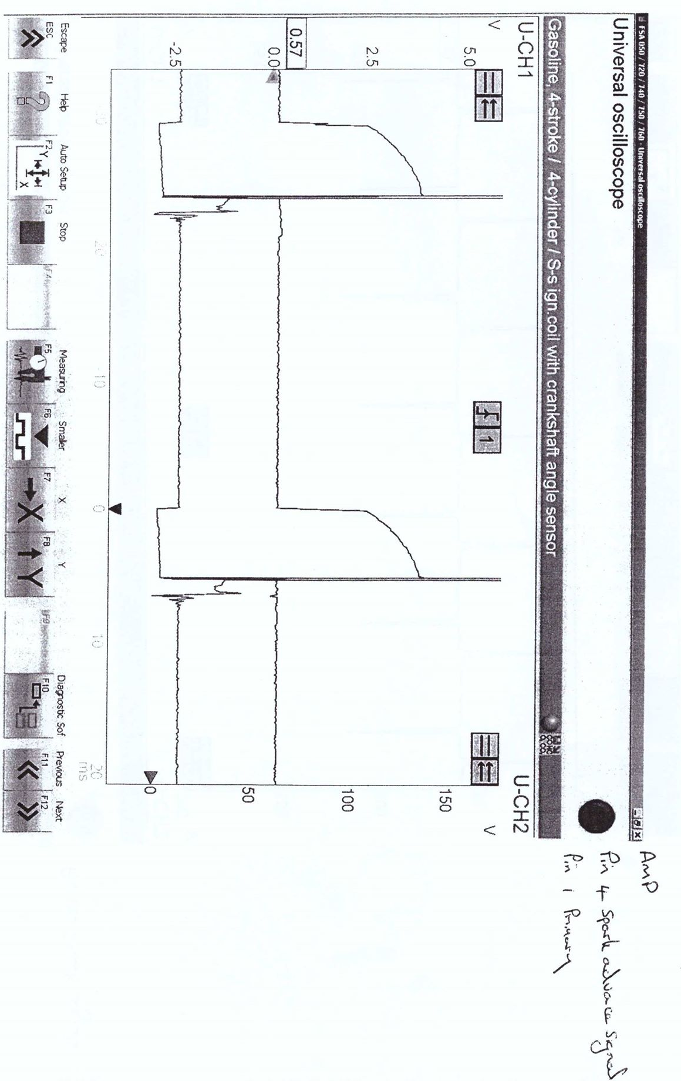
Whilst advancing the ignition it must not be too far advanced otherwise engine knock will occur in the piston causing damage to the engine. To overcome any engine knocking in the cylinders from the ignition being too far advanced, a modification that could be made to both the engines would be to add a knock sensor to determine whether an advanced or retardation is needed in the ignition. This possible modification will be further discussed later in this report in the conclusions and modifications section.

-Figure 2: Engine Cranking from Cold Scope Pattern
Figure 2 shows the waveform created from the Motronic system whilst the engine was cranking from cold, this waveform was created using the oscilloscope and shows how the injection on time is advanced to create a more effective burn and a richer air to fuel ratio mixture. This type of ignition detonation helps both the engines to run at their peak performance during a cold start.
4.1.3 Engine Warm-up
During both the engines warm up phases the ignition must still be slightly advanced to start the burn of the air and fuel ratio in the combustion chamber just before top dead centre has been reached to produce the most effective detonation making both engines run as fuel and economy efficient as they can. This type of ignition timing is needed to create a rich air to fuel ratio due to engine and coolant temperature still being very low.
- 4.1.4 Acceleration
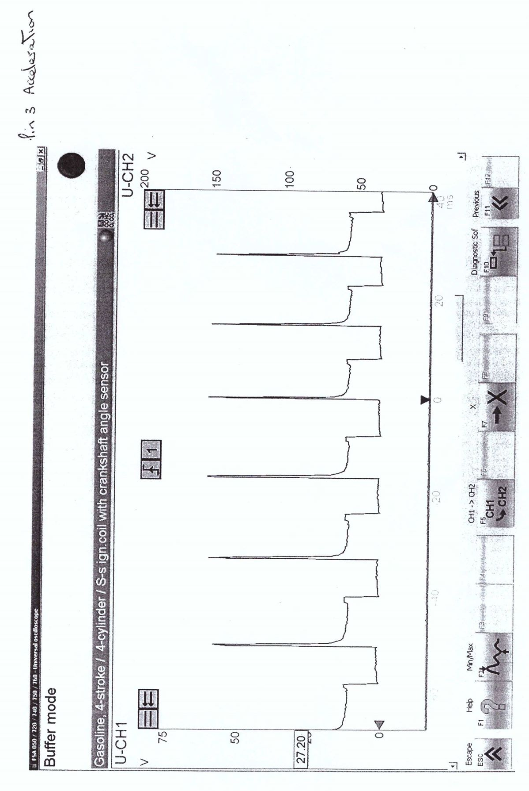
Whilst the snap acceleration phase was present during testing a slight retardation in the ignition timing is needed to cause the spark plug to spark in the combustion chamber just before top dead centre is reached causing a larger amount of torque to be produced, allowing for faster acceleration to be easier and instantaneous.

-Figure 3: Snap Acceleration Scope Pattern

As shown in figure 3 are the waveforms created from the oscilloscope which shows the ignition timing during the snap acceleration phase, this shows the ignition being retarded before top dead centre has been reached allowing for more torque to be produced and therefore a faster acceleration. At this phase in the engines ignition cycle more air is flowing into the engine, meaning more fuel is also needed creating a rich air to fuel burn ratio.
4.1.5 Deceleration
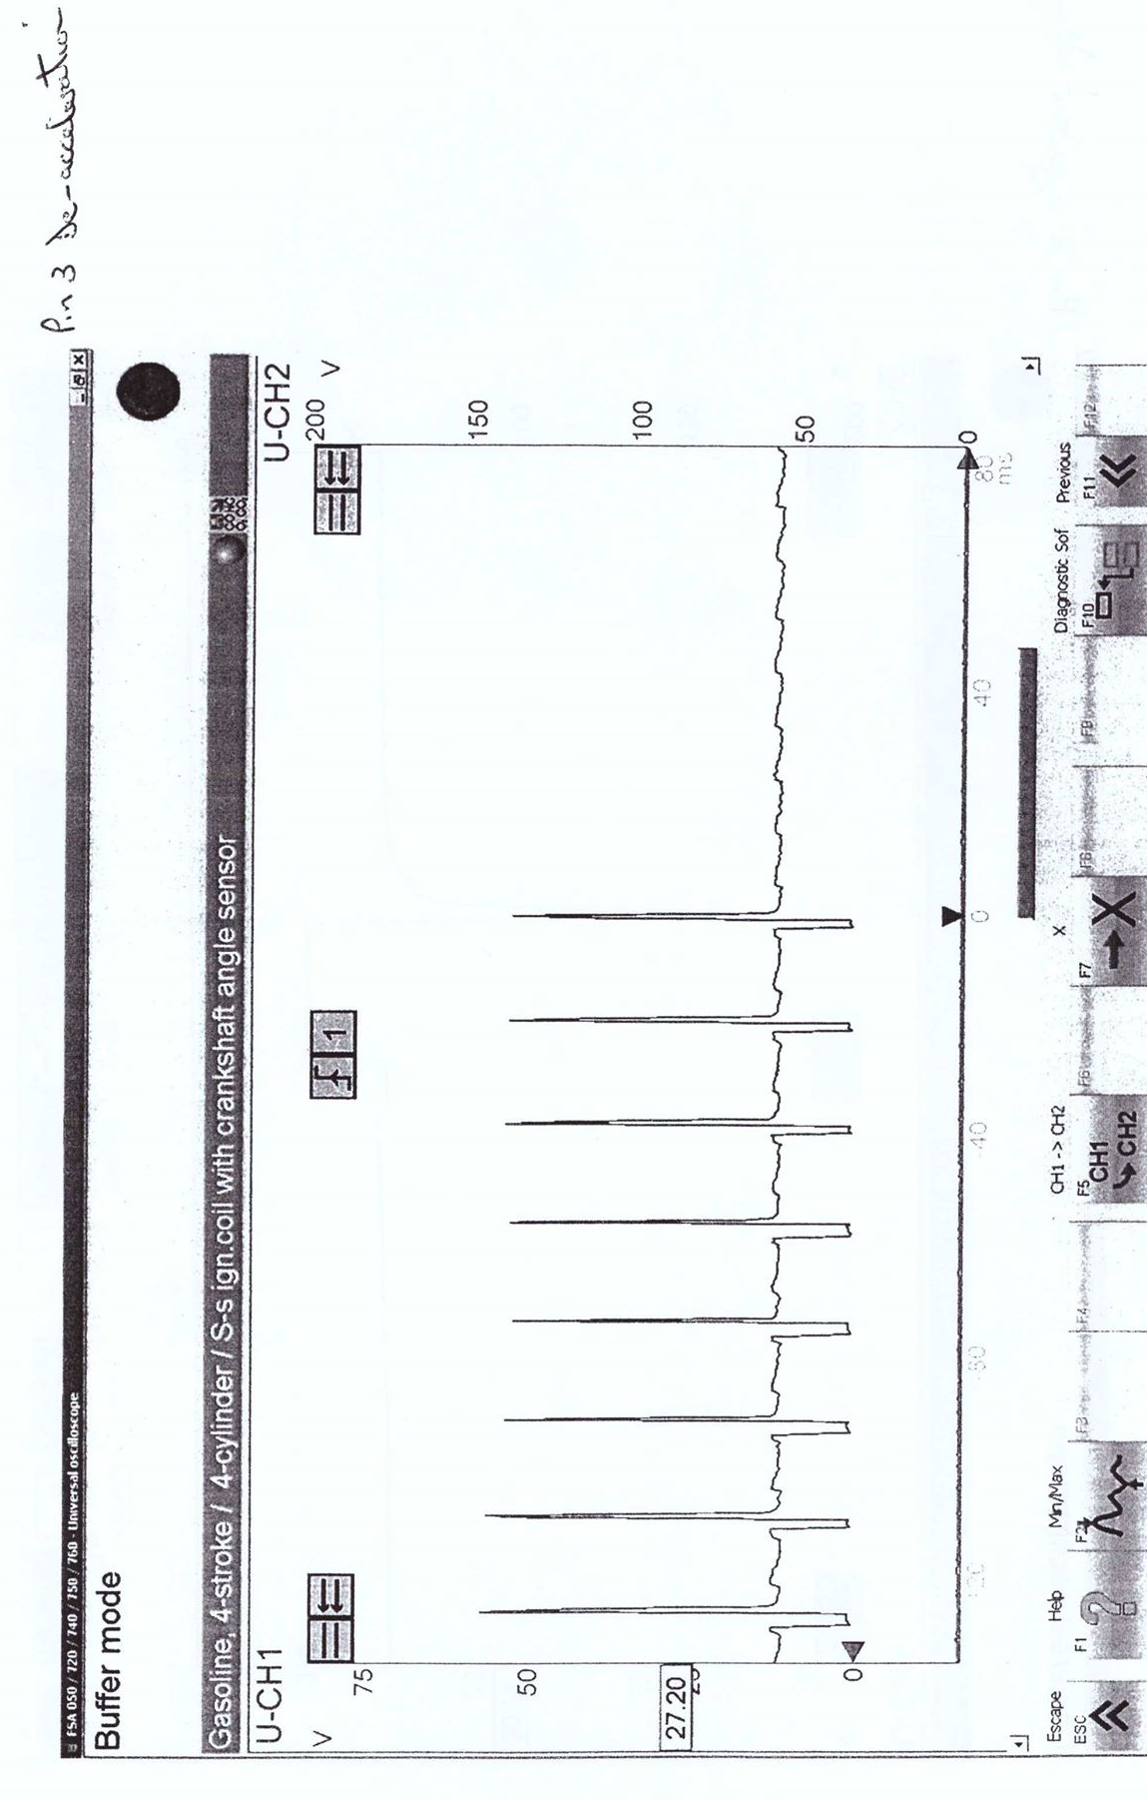
During the deceleration phase of a vehicle’s engine cycle, the ignition timing is retarded to slow down the fuel to air burn ratio causing the engine to lose power and significantly slow down. When the ignition is retarded, the unburned fuel in the combustion chamber is then detonated in the exhaust of the vehicle commonly causing pops and bangs where the fuel is being purposely detonated too late to reduce performance causing engine breaking slowing the vehicle down.

-Figure 4: Deceleration Scope Pattern

Shown above in figure 4 is the scope pattern wave-form created from the Motronic system during the deceleration phase. As explained before you can see the retardation occurring just after the top dead centre is reached, at this point zero power output is needed from the engine so the fuel ratio is reduced creating a leaner mixture.

4.1.6 Idle Speed, Engine at Operating Temperature
During idle speed of a vehicle the engine and coolant temperatures are at the ideal operating temperature, so a leaner mix is created in the combustion chamber which is close to the theoretical air to fuel ratio for the vehicle.
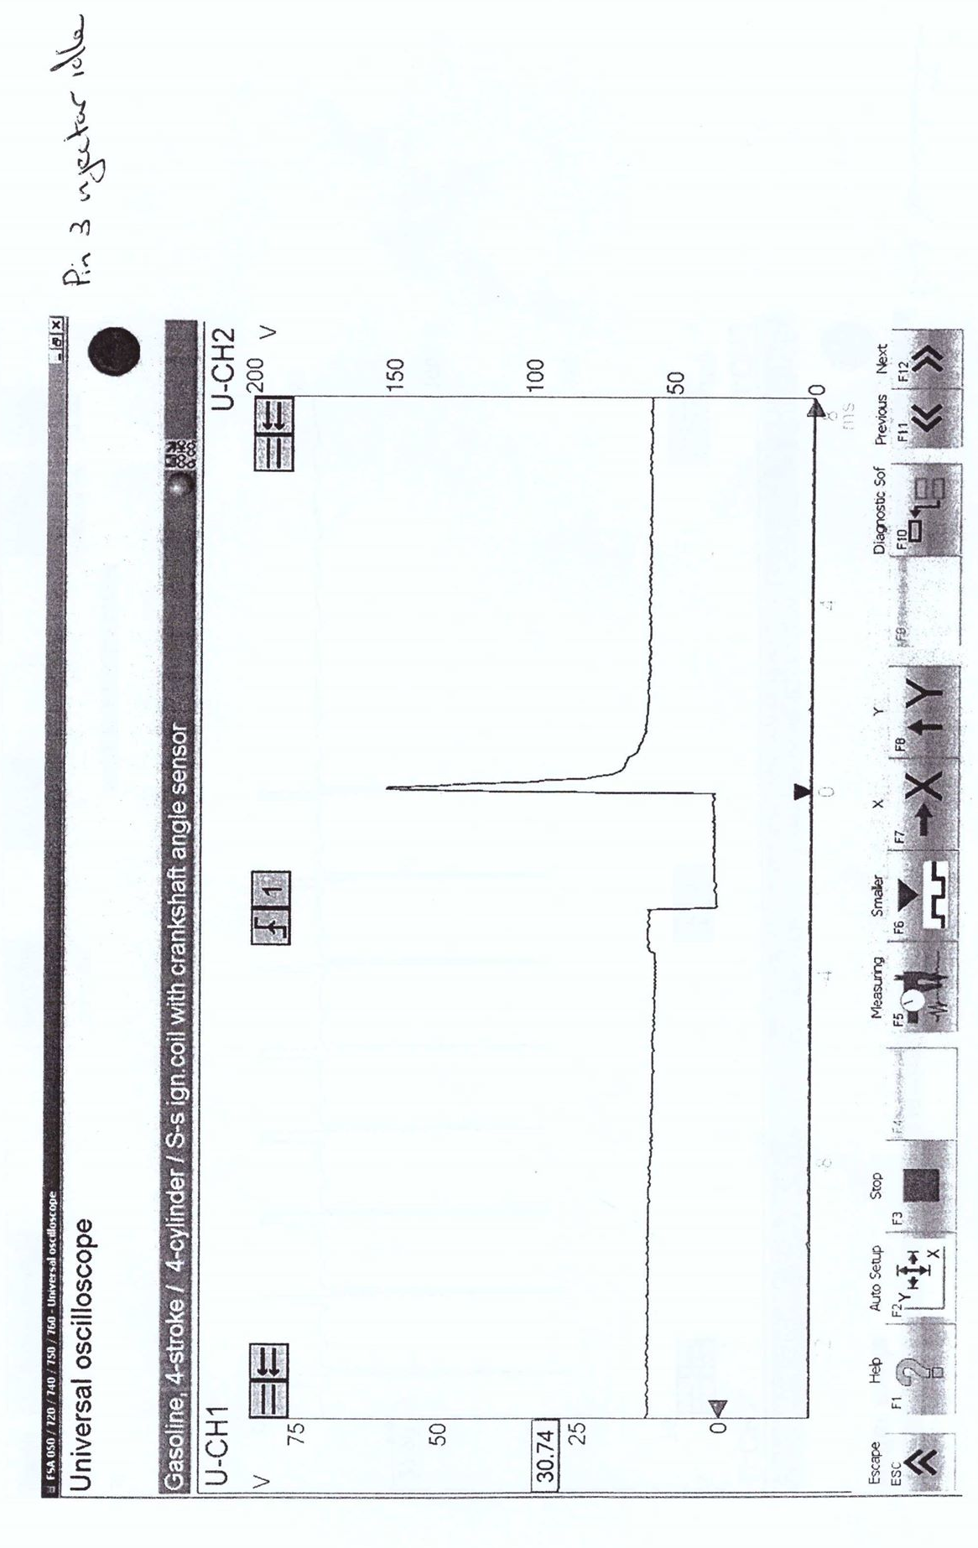

-Figure 5: Idle Speed at Operating Temperature Scope Pattern

Figure 5 above shows the scope pattern created using the oscilloscope for the idle speed of the injectors at the ideal operating temperature of the engine control system. As you can see from the wave-form created a slight retardation occurs in the injection timing to create a faster burn in the combustion chamber causing a constant power output.

4.2 Test Readings Obtained, Compared Against Manufactures Specifications
During this section of the analysis the actual voltage and resistance readings obtained from testing are going to be compared against the manufactures factory specification tolerances for each sensor and actuator tested. The factory specifications have been sourced using an Autodata Fuel Injection volume 3 book relating to vehicles introduced between 1990 and 1991 (Autodata).

The first electrical sensors to be compared is the throttle switch on the LE3 system and the throttle potentiometer on the 1.5 Motronic system.
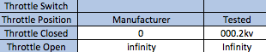

-Figure 6: LE3 Throttle Switch Position Table

Figure 6 above shows the table of results produced from testing for the throttle switch when it is open and closed, these results are shown on the right against the manufacturers tolerance specifications which shows the values recorded are within the tolerances set.
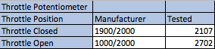

-Figure 7: Motronic Throttle Potentiometer Table

Figure 7 above shows the results recorded from the throttle potentiometer when the throttle is in the open and closed position. As the table shows the results recorded are slightly out of the tolerances margin set by the manufacture, this is due to a new throttle potentiometer being fitted to the 1.5 Motronic system at some point in its life causing the values to be slightly higher.

Whilst testing both engine management systems, the resistance in the injections valves was tested and recorded to see if there were any anomaly results. These results were then compared against the manufacturer specifications as shown in figure 8 and 9.
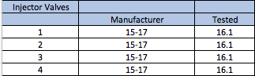

-Figure 8: LE3 Injector Valves Resistance
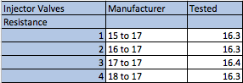

-Figure 9: Motronic Injector Valves Resistance

As shown in figures 8 and 9 are the resistance values for all four injector valves from both the LE3 and the Motronic systems. These tables show that both systems are within the manufactures tolerances and they are all working efficiently without any power drains.
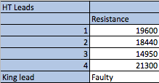
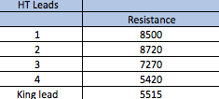

-Figure 10: LE3 HT Leads Resistance -Figure 11: Motronic HT Leads Resistance

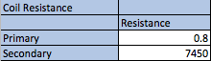
Figure 10 and 11 above show the resistance from all the HT leads from the LE3 and the Motronic systems, these values could not be checked against the manufactures specifications and are not a true representation due to the fourth HT lead on both systems being faulty and producing inaccurate readings. Reasoning for the inaccuracy of the values recorded can be down to the HT leads wearing away over time.
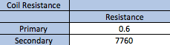
-Figure 12: LE3 Coil Resistance -Figure 13: Motronic Coil Resistance

The coil resistance tables shown in figures 12 and 13 show that both the LE3 and Motronic primary coil resistance are around 0.6 and 0.8 ohms which does not need to be checked against the manufactures specifications because primary coil resistance should always be between 0.4 and 2 ohms. The secondary coil resistance is also within the tolerances because these should always be between 6,000 and 10,000 ohms which both the LE3 and Motronic systems are.
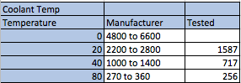

-Figure 14: Motronic Coolant Temperature Table

Figure 14 above shows the coolant temperature of the Motronic system increasing by 20 degrees at a time. These values tested are shown to the right and the manufactures next to them, none of these values are within tolerance due to the engines age causing anomaly results.
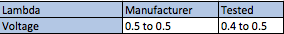

-Figure 15: Lambda Sensor Table
Figure 15 above shows the lambda sensor values tested on the Motronic system, but as a team we were unable to test the LE3 lambda because it is not factory fitted to the system. The readings recorded are within the tolerances and should always be less than 1.0. After testing it is clear the benefits of having a lambda sensor are massive for creating an economy efficient engine management system.
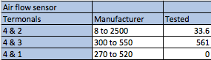

-Figure 16: Air Flow Sensor Table

The air flow sensor table shown in figure 16 shows the manufactures specifications against the results obtained from testing. This table shows only one of the of the terminals is within the tolerances and this will be down to the engine being removed from the vehicle and less air being able to flow into the system.
4.3 LE3 and Motronic Negative Temperature Coefficient Graphs
-Figure 17: Motronic NTC2 Voltage Graph -Figure 18: LE3 NTC2 Voltage Graph

Figures 18 and 19 above show the NTC2 voltage graphs for both the LE3 and Motronic systems, these graphs show that as the engine temperature increases, the NTC2 voltage slightly decreases and then starts to increase again. These values obtained were within the normal range of between 1 and 3 volts, but are slightly different to what was expected because normally as the temperature increase the voltage also constantly increases.
-Figure 19: Motronic NTC2 Resistance Graph -Figure 20: LE3 NTC2 Resistance Graph

The two graphs above show the NTC2 resistance against engine temperature, it was expected that as the engine temperature increased, the resistance would decrease because commonly as the temperature and voltage increase, the resistance decreases due to the non-linear relationship between the NTC2 resistance and engine temperature.

5. Conclusions and Modifications

After performing testing and an in-depth evaluation and analysis of both systems, any possible modifications that are necessary to improve either system will now be shown. As stated before in the research section of this report both systems use older technology compared to the electrical sensors and actuators that are fitted to modern engines today. Due to this factor, there are many possible modifications that can be made, but only the most effective and necessary improvements will be made to either system, with reasoning why each modification is needed and explanations provided.

The first modification that is necessary to improve both the LE3 system and 1.5 Motronic system is to add a knock sensor to both the engines to maximum the perform and economy. A knock sensor is fitted to the cylinder block and is used to determine whether the ignition should be advanced or retarded to make the fuel ratio leaner or richer. Knock sensors can hear when top dead centre (TDC) is reached and the cylinder is active, at this point it sends signals to the ECU where it can then determine which cylinder is knocking and can adapt the ignition until any problems disappear. Engine knock occurs at top dead centre (TDC) and only lasts for about 3 to 15 milliseconds, but can be vital to improve the performance and economy of both engines to make sure they are always running as efficient as possible. Knock sensors are now fitted to every modern vehicle and by modifying these engines by adding this electrical sensor will help to achieve the best possible angle for detonation within the cylinders.

Another modification to be made to benefit the LE3 system is to add a lambda sensor, which is commonly known as an oxygen sensor which helps to monitor the amount of pollution created from a vehicle. Due to the number of automobiles rapidly increasing, the air pollution caused by an automobile exhaust is becoming more and more prominent (Zhang et al. 2018). Lambda sensors which are now factory fitted to all vehicles are the most effective modern electrical sensor for reducing the emissions produced from the growing number of vehicles on the road. “It is well known that air-to-fuel ratio (A/F) control is one of the most effective methods for controlling automobile exhaust” (Zhang et al. 2018), as stated by Zhang a lambda sensor is the ideal modification to be made to the LE3 system due to the wide range of benefits it creates.

“Oxygen sensor functions are essential in ensuring the performance of modern car engines. Not only can they ensure that a car engine produces less emissions, but ensure that the vehicle is using its fuel efficiently”
(Denso 2018)

As stated in Denso, the lambda sensor is fitted to the exhaust of the vehicle and helps to ensure the engine is working as efficient as possible. “The benefits of the oxygen sensor are simple. The combustible engine will perform better, it will have better fuel efficiency and dispel less pollution” (Campbell, 2019). As stated by Campbell the lambda sensor increases the fuel efficiency by monitoring the air to fuel ratio being burned within the combustion, this is then sent to the ECU through voltage signals, so that the engine system will know whether a leaner or richer mixture is needed at every operating condition that the engine is confronted with. This then allows the system to be able to create the perfect ratio to increase performance and efficiency of the engine in all gears and speeds.

The flywheel sensor on the LE3 and 1.5 Motronic systems both use an analogue sensor which are significantly less as accurate to that of a digital sensor. “These basic analogue hall sensors can be sensitive to different variations in temperature, so signal conditioning electronics can be incorporated into the sensors to compensate for any fluctuation in temperature” (Honeywell inc). To overcome any inaccuracies produced by these sensors, both systems are going to be modifying by adding digital hall sensors to improve the accuracy for monitoring speeds, whilst sending constant precise voltage signals to the ECU to determine these speeds and positions of the flywheel to allow for the ideal injection timings. “A flywheel sensor is configured to determine a flywheel operating parameter and supply a flywheel feedback signal indicative of the flywheel operating parameter” (NewsRx, 2015), as stated by NewsRx the flywheel sensor sends feedback voltage signals to the ECU to supply an overview of the operation conditions of the flywheel to increase the efficiency and performance of the electrical control system.

The Vauxhall 1.5 Motronic system has a lot more up to date technology than that of the LE3 system, but the OBD sensor within the Motronic system is now the third-generation old sensor and can be improved by modifying the system by fitting the newer generation OBDII sensor to produce more accurate and efficient self-diagnostic of the system. The OBD sensor works by sending signals to the dash to allow the driver to know when the vehicles emissions are rising due to a faulty sensor or damaged engine components.

“Illuminate the Malfunction Indicator Lamp (MIL) anytime a vehicle’s emissions exceed 1.5 times the federal test procedure (FTP) standards for that model year of vehicle. That includes anytime random misfires cause an overall rise in HC emissions, anytime the operating efficiency of the catalytic converter drops below a certain threshold, anytime the system detects air leakage in the sealed fuel system, anytime a fault in the EGR system causes NOX emissions to go up, or anytime a key sensor or other emission control device fails. In other words, the MIL light may come on even though the vehicle seems to be running normally and there are no real driveability problems”

(AutoTap, 2012)

As stated by AutoTap, the newer OBDII sensor can detect anytime the engines system is causing an irregular fault, that if not accessed could cause damage to the vehicles engine control system or cause the vehicle to produce more emissions and leaving the vehicle less fuel efficiency and down on performance. By adding this newer OBDII sensor will therefore increase the overall efficiency of the control system by making sure every sensor and component is always working at 100% efficiency.

To conclude all the modifications stated in this section of the report are all deemed worthy and necessary to improve either the Vauxhall LE3 system or the 1.5 Motronic system. All modifications made have been evaluated with the necessary reasoning’s and evidence providing how each system will be benefited by the sensor or actuator.

References

Autodata. Fuel Injection 3 Vehicles Introduced between 1990 and 1991, pp. 514-517
(Accessed: 14th February 2019)

AutoTap. (2012) OBDII: PAST, PRESENT & FUTURE [Online] Available at: http://www.autotap.com/Articles/OBDII_Past_Present_Future.pdf
(Accessed: 5th May 2019)

Bosch, R. (2019) Bosch Workshop World [Online] Available at: https://ru-ww.bosch-automotive.com/en/products_workshopworld/testing_equipment_products/engine_system_testing/fsa_760_1/fsa_760
(Accessed: 22nd April 2019)

Campbell, J. (2019) What Are the Signs That You Need an 02 Sensor [Online] Available at: https://itstillruns.com/signs-need-sensor-5042280.html
(Accessed: 9th May 2019)

Denso. (2019) Advanced oxygen sensor functions take engine performance to the next level [Online] Available at: https://www.denso-am.eu/media/corporate-news/2018/20181501_advanced-oxygen-sensor-functions-take-engine-performance-to-the-next-level/

(Assessed: 5th May 2019)
Honeywell inc. Hall Effect Sensing and Application [Online] Available at: https://sensing.honeywell.com/hallbook.pdf
(Accessed: 2nd May 2019)

Matha, C. (2010) Temperature Sensors [Online] Available at: https://www.digikey.com/en/articles/techzone/2011/oct/temperature-sensors-the-basics
(Accessed: 24th April 2019)
NewsRx. (2015) Journal of Engineering; Atlanta [Online] Available at: https://search.proquest.com/docview/1685240195?accountid=130472
(Accessed: 5th May 2019)

Weernink, W. (2006) Injector wars: piezo vs. solenoid [Online] Available at: https://europe.autonews.com/article/20061113/ANE/61109031/injector-wars-piezo-vs-solenoid
(Accessed: 18th April 2019)

Zhang, M. et al. (2018) Sensors and Actuators [Online] Available at: https://doi.org/10.1016/j.snb.2018.04.095
(Assessed: 1st May 2019)

Appendix
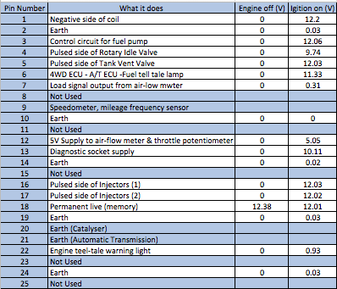

Appendix

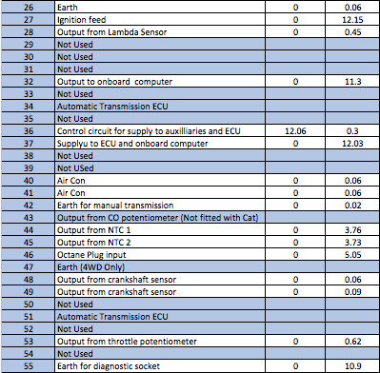

Appendix

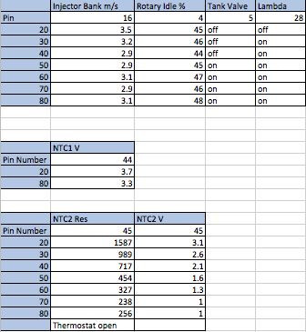

Appendix
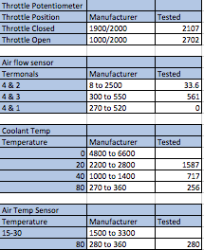

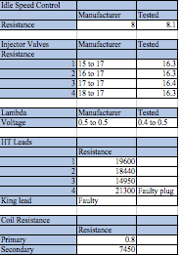

Appendix

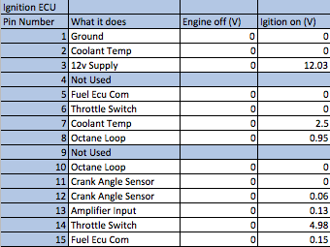

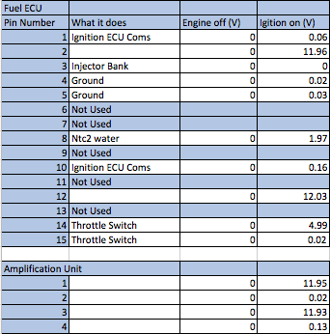

Appendix


