Student name: Mariana Lavinia Neda
Student id: 2312753
Module title &code: Managing Projects In Organisations BMSW5009
Assessment type : Written report & Reflective blogs

Managing Projects in Organisations
Written report & Reflective blogs

Table of Content
Task 1: Blogs 3
Blog 1: Brief Introduction of Project Management Tools 3
Blog 2: Utilisation of Different Project Management Tools in Real-World Operations 4
Blog 3: Utilisation of Different Project Management Tools to Foster Effectiveness 5
Blog 4: Benefits of Using PM Tools in Real-Time Projects 6
Blog 5: Critical Evaluation of My Skills and Competencies 7
Reference List 8

Task 1: Blogs

Blog 1: Brief Introduction of Project Management Tools
Different project management tools bring opportunities for organisations and project managers to conduct project work efficiently and utilise different resources of project management in productive ways (Ćirković et al. 2022). Project management tools open multiple windows in front of project managers and assist teams from planning to executing, including monitoring and guiding as per the project’s requirements. These unique features offer a structured approach with a handful of resources to promote internal collaborations and make project operations worthwhile. You can enhance team performance and abilities to meet deadline requirements by using project management tools. These also promote accuracy, along with strong control over entire project aspects.
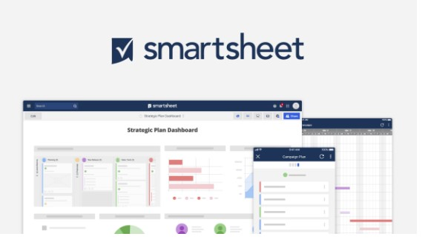

Smartsheet of PMP
(Source: Ćirković et al. 2022)
Due to the rapid development in organisational environments and industrial segments becoming more competitive, project management tools are equipped with multiple innovative features, such as time tracking, scheduling, documenting and sharing information mutually (Sensini et al.
2021). In today’s industrial environments, project management facilities promote different updated features, including Kanban Boards and Progress Dashboards, to make operations smarter and easier. With different types of project management tools, you can enhance your opportunities of performing seamlessly and meet competitiveness more prominently than conventional project management operations. These bring versatility among various industrial segments and support the constant development of project performance without facing major difficulties.

Blog 2: Utilisation of Different Project Management Tools in Real-World Operations
Due to the rapid development in project management performance, different project management tools and techniques have become essential for conducting competitive approaches and obtaining overall success more effectively. It has been observed that these tools efficiently enhance transparency in operations, internal coordination and resource utilisation throughout different project phases. Some innovative and updated project management tools are:
- CPM (Critical Path Method): This tool helps project managers to identify the most effective and longest chains of dependent activities and prioritise time efficiency for completing tasks. CPM is mainly used in logistics-based projects (Radujkovic and Sjekavica, 2021).
- Gantt Charts: To divide large tasks into small and achievable parts and make a schedule for each task, the Gantt Chart helps project managers to complete critical work efficiently. It also helps in tracking overall progress and determining potential gaps. In construction and manufacturing projects, Gantt Charts are mainly used.
- Work Breakdown Structure: Instead of conducting large, monotonous tasks, you can divide your entire task into small and achievable parts through Work Breakdown Structures (Radujkovic and Sjekavica, 2021).
- Project Management Software: Technological advancement also brings opportunities for project management activities. In current days, Asana, MS Project and others have become popular and prominent PM software that promote real-time updates, collaborations and uninterrupted connections throughout different teams.
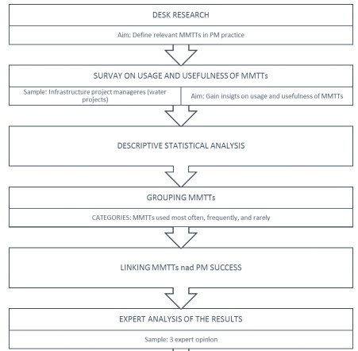
Breakdown of Large Projects
(Source: Radujkovic and Sjekavica, 2021)

Blog 3: Utilisation of Different Project Management Tools to Foster Effectiveness
Advanced Project Management Tools bring a big revolution in industrial spheres. With the advent of multiple innovative approaches, PM operations have become smarter and easier. Let’s go deeper.
- Program Evaluation and Review Technique (PERT): While completing a project, it is essential to consider statistical tools to evaluate the development of allocated tasks involved in the entire operation. PERT helps to sort out unsolved projects by multiple statistical perspectives and analyse through database analytics (Thesing et al. 2021).
- RACI Matrix: Within a project management work, it becomes important to clarify the different roles and responsibilities of the involved team members. You can easily prevent confusion and make clear instructions for your team members by utilising the RACI Matrix (Kotb, 2025). This matrix involves Responsibility, Accountability, Consulted and Informed.
- Risk Register: To identify potential risk factors and determine the most efficient strategies to overcome issues, the risk register helps a project manager to identify and assess these risk factors by utilising well-maintained documents and digital spreadsheets.
- Milestone Tracker: To identify whether a project is going in the right direction or not, it becomes important to analyse milestones with ongoing factors. Milestone tracker helps project managers to maintain projects’ progress and determine limitations efficiently.
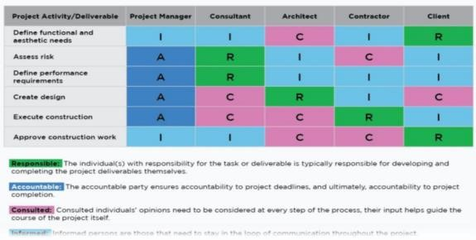
Examples of RACI Matrix
(Source: Kotb, 2025)

Blog 4: Benefits of Using PM Tools in Real-Time Projects
Within the real-time organisational work, project management plays an important role in enhancing overall efficiency along with success rate, because it assists project developers to meet all criteria and complete within the deadline efficiently. Usually, project management tools are highly centralised on project planning, executing, monitoring and finalising. Thus, it becomes important to make strong collaboration between different associated parties. PM tools increase internal collaboration between different team members and help them to perform collectively to achieve planned objectives (Pomaza-Ponomarenko et al. 2023). By utilising advanced project management tools, such as Asana, Trello, WBS, Gantt Chart and others, project associates can break large and critical tasks into small and manageable forms, which can easily meet deadlines (Crawford, 2021). Additionally, it is also important to note that project management tools help to increase real-time tracking and identify better alternative solutions to make the proper utilisation of resources towards project objectives (Pomaza-Ponomarenko et al. 2023). One can easily manage potential risk factors by utilising these tools and conducting operations accordingly. PM tools also support making efficient documentation and finalising projects properly.

Blog 5: Critical Evaluation of My Skills and Competencies
To conduct a critical reflection on my skills and abilities in project management, I have found several strengths and weaknesses in this area. Being a part of a project management team, I can easily make transparent communication channels between team members and utilise different project management software to conduct complex tasks. I can utilise different digital tools, such as Microsoft Project, Trello, Jira and others to make effective monitoring. However, I have found that my risk management abilities and budgeting skills are not so good. I can not handle statistical data analysis properly to develop further progress. In this context, I need to develop my limitations by using an advanced action plan in my professional life. Action Plan
Skills | Targeted Actions | Time
Risk Management | I will join short-term courses on PMP and learn effective risk management strategies, based on real-life problems. | 06 months
Stakeholder Management | I will enrol in different workshops and webinars to learn about advanced stakeholder management in PM. | 03 months
Data Analytics | Along with joining data analytics courses, I will devote more time to free online courses, based on project data analytics and divide my tasks into small and achievable parts. | 04 months

Reference List
Ćirković, M., Čubrić, G. and Čubrić, I.S., 2022. Project Management Tools for the Fashion and Apparel Industry. ENTRENOVA-ENTerprise REsearch InNOVAtion, 8(1), pp.40-47.
Crawford, J.K., 2021. Project management maturity model. Auerbach Publications.
Kotb, A., 2025. Help For Project Management To Finish Projects On Time.
Pomaza-Ponomarenko, A., Kryvova, S., Hordieiev, A., Hanzyuk, A. and Halunko, O., 2023. Innovative risk management: identification, assessment and management of risks in the context of innovative project management.
Radujkovic, M. and Sjekavica Klepo, M., 2021. A study of project managers’ choice on key methods, tools and techniques in managing engineering projects. Organization, technology & management in construction: an international journal, 13(1), pp.2327-2340.
Sensini, L., Shan, A. and Vazquez, M., 2021. Project management tools and techniques and SME performance: Empirical evidence in the context of developing countries. International Journal of Economics and Financial Issues, 11(5), p.45.
Thesing, T., Feldmann, C. and Burchardt, M., 2021. Agile versus waterfall project management: decision model for selecting the appropriate approach to a project. Procedia Computer Science, 181, pp.746-756.

